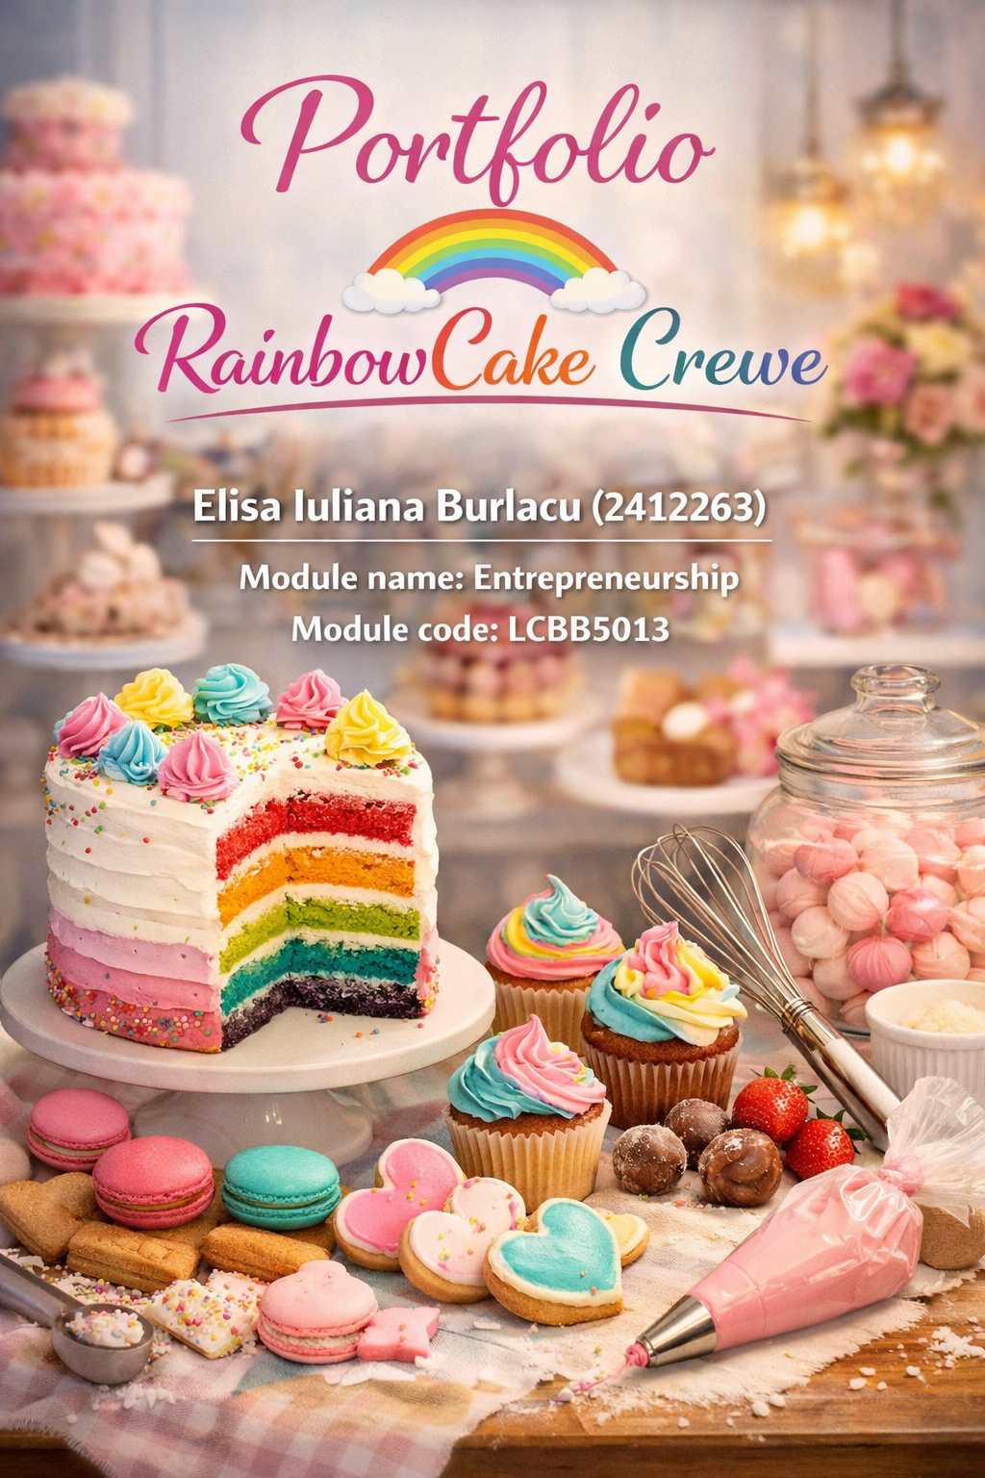

RainbowCake Crewe

Reflection on Entrepreneurship

Entrepreneurship has always interested me, not only as a career path but as a way of thinking and living. My motivation to pursue this direction did not appear suddenly; it developed over time through the people who influenced me the most. Two individuals in particular—my godmother and my mother—shaped my understanding of what it means to be an entrepreneur. Through their example, I learned that entrepreneurship requires discipline, responsibility, and continuous effort, not just ambition. This reflection explores how their experiences and values have inspired my own desire to build something of my own in the future.
From a young age, I admired my godmother for the way she carried herself. She has always been an incredibly organized, disciplined, and determined woman. Whenever I visited her workplace, I noticed how professionally she handled every situation, no matter how small. She believed that success in business comes from being serious, responsible, and consistent, and she lived by those values every day. Watching her manage her business taught me that entrepreneurship is not just about earning money. It is about commitment, leadership, and the willingness to put in the hard work even when no one is watching.
What impressed me most was how she balanced her professional and personal life. Becoming an entrepreneur gave her more independence and control over her time, but it also demanded long hours, constant problem‑solving, and a strong sense of responsibility. She never complained; instead, she embraced every challenge as an opportunity to grow. Seeing her confidence and determination made me realise that entrepreneurship is a lifestyle—one that requires courage, discipline, and a desire to continuously improve.
However, the person who has had the greatest impact on my entrepreneurial journey is my mother. She has been an entrepreneur for more than eight years, and throughout this time, I have seen firsthand the dedication and perseverance she puts into her work. Unlike my godmother, who inspired me from a distance, my mother allowed me to learn directly from her experience. She taught me how a business operates, how to communicate with customers, and how important it is to stay motivated even when things become difficult.
My mother’s leadership style is something I deeply admire. She is hardworking, patient, and incredibly focused on her goals. At the same time, she treats people with respect and builds strong, genuine relationships with customers and partners. Through her example, I learned that success does not happen overnight. It requires time, persistence, and the ability to learn from mistakes without giving up. Her support has helped me develop confidence in my own abilities and encouraged me to believe that I, too, can build something meaningful.
Both my godmother and my mother have shaped the way I think about entrepreneurship. One showed me what a strong, organized businesswoman looks like; the other gave me the chance to experience entrepreneurship from the inside. Their influence has motivated me to follow a similar path and work toward creating a business that reflects the values they taught me: responsibility, determination, and continuous growth. In the future, I hope to build something that honours their example and carries forward the lessons they have passed on to me.

