BEng Manufacturing Systems Engineering
Manufacturing Design and Technology
M5X02070
Computer Aided Manufacturing and Design for Additive Manufacturing Technologies
Task 2 – A Report On The Concept Of A Jaw Gripper
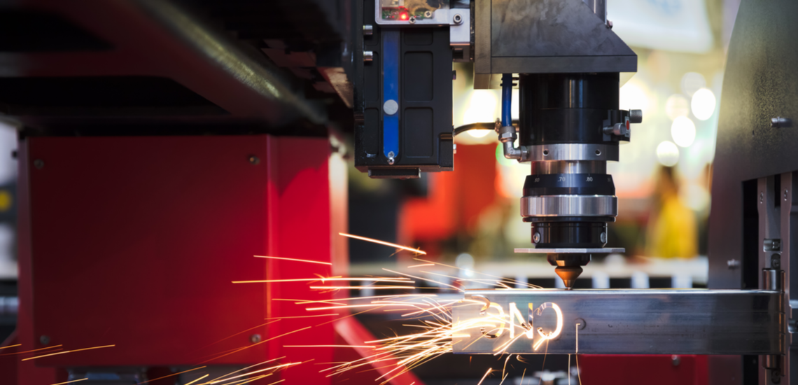
By Saeid Salimi – 1911294

Table of Contents
Introduction 2
Appraisal of concept system 3
The Motor 3
The Jaw (Fingers) and Join 3
The Cylinder 4
Drive plate 4
Shaft 5
The Worm 5
The manufacturing process Principles 6
Introduction 6
6
6
Identify Value 7
Value Stream Mapping 7
Flow 7
Pull 7
Pursue Perfection 7
The manufacturing processes 8
Injection moulding 8
Die casting 8
Manufacturing process design 9
Conclusion 12
Bibliography 13

Introduction
In this report I have critically evaluated a design concept of a jaw gripper system. Throughout the report I’ve mentioned alterations I made to the original design. I also talk about the materials used for this concept and the benefits of using these materials. In this report I talk about the manufacturing processes I would use to manufacture these parts. In this report I’m assuming these parts will be manufactured at a large scale and I also talk about the other benefits of using these manufacturing processes. Included in this report is a design process assembly of the jaw gripping system followed by a conclusion of the whole concept.

Appraisal of concept system
In this section I critically evaluate the original design of the jaw gripper system. I also mention the alterations I made to the original design. The materials used to manufacture each component along with the reasons for the choice of material.

The Motor
The motor design allows for the part to be quickly changed. During an intense production period, a shift worker needs to address a small issue on one of the gripping systems. The issue is that one of the fingers has stopped working. In this instance, having a quick change tooling system for the gripper is vital to avoid delays in production [1]. For a large organisation, these delays would heavily impact their profitability. This impact could really affect an organisations competitive edge in their field.
“Whether working with static or live tools, anytime you change a tool, you’re not making parts” [2].
As the main component of the gripper system, the material used to manufacture this part is important. This part will have to endure long periods of use in a workshop. This part will also go through increases in temperature when used continually. The material used for the motor is a ductile iron. The preferred use of a ductile iron over a steel is due to a number of factors. The ductile cast iron is more machinable than steel. The ductile iron possesses strength that is comparable to carbon and other free machining steels [3]. You now have a part, that has been machined easily and with a much improved surface finish, that has the same strength to weight ratio that a steel component would have [4].
This in my opinion is a great design and choice of material for the motor. The motor will be sourced as a completed part for this assembly.

The Jaw (Fingers) and Join
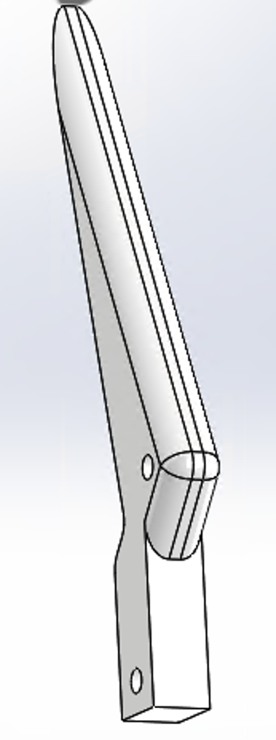
The original design concept of the jaw is excellent. The aim of the jaw is to open and close when in use. The jaw is linked to the drive plate via the joins and the motor will action the jaw by threading the worm through the drive plate. The design of the triple jaw is more favourable than a double jaw gripper. The triple jaw will centre itself over the object [5]. You now have three points of contact towards the centre location.This increases the reliability of the grip.
A couple of minor adjustments to the original jaw design were made. The adjustments made were mainly aesthetic. The changes do improve the overall look of the jaw whilst reducing the amount of material needed to manufacture it. The design of the jaw can be altered depending on the application it will be used for.
The design of the join is simple yet effective. No alterations were made to this. The join allows the jaw (fingers) to move in a fixed range of motion. Without the join, you cannot achieve any movement in the fingers.
The material used to manufacture the jaw and the join is plasticized PVC (0.007). PVC (Polyvinyl Chloride) is a strong plastic that has many benefits. This plastic is widely used in construction [6]. It is an alternative to materials such as copper or ductile iron due to its strength. The added plasticizer is used as a softening agent. This is to make the PVC softer and more flexible. For the application of the jaw, ensuring it doesn’t damage/leave marks on objects is an important consideration to make as this could lead to quality failures in a continuous process. Some other benefits of PVC are a resistance to corrosion, expanding its use in various applications. PVC can also replace materials such as wood, metal, concrete and rubber due to its low cost. This is a good choice of material for the gripper jaw and join.

The Cylinder
The original design of the cylinder allows the fingers to be easily attached. The fingers are attached to the small blocks on the cylinder. The fingers have enough room for manoeuvrability. The only alteration made was to the small blocks that the fingers attach to. The edges were altered to give it a smoother and more rounded look. This also reduces the amount of material needed to produce the part. The size of the cylinder can be altered depending on the use.
An Aluminium alloy, specifically 1060 alloy is used to produce the cylinder. This alloy is almost pure Aluminium (99.6% minimum) and it can retain its strength at low temperatures without becoming brittle [7]. It is a lightweight metal that has corrosion resistant characteristics along with good thermal and electrical conductivity.
To achieve the desired design of the cylinder, the application of the gripper needs to be clearly indicated. The choice of an Aluminium alloy (1060 alloy) for the cylinder component is a good one. The cylinder can withstand the heat produced during application. This is because of the heat resistant properties this alloy possesses. This will increase the life cycle of the part.

Drive plate
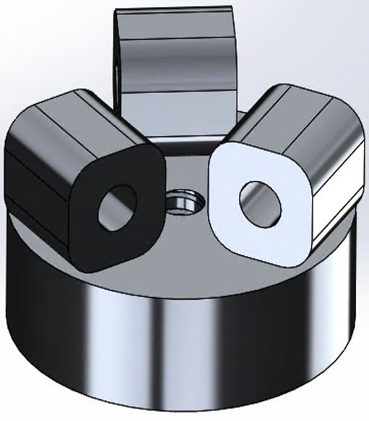
The drive plate is the attachment that helps create movement in the system. The drive plate also has a threaded centre that allows the worm to thread into during application. This system, along with the attachment of the join and fingers, creates the movement in the concept.
The original design accounts for easy attachment of the fingers. The threaded centre is important in this design. Alterations were made to the edges of the blocks to make them more rounded. This small change gives the system a smoother look and also reduces the amount of material needed to manufacture the part.
The material used for the drive plate is a 1060 aluminium alloy. This is a great choice of material for this part of the system due to the excellent properties this alloy possesses. The drive plate is more exposed to the application of the gripper jaw. The corrosion resistant properties of this alloy will stop the part from corroding after continuous use. The strength to weight ratio is larger with aluminium alloys. This will decrease the overall weight of the component whilst retaining high material strength [8].
The surface finish for the drive plate will have a slight roughness to it. This is to lubricate the worm during application. The slight rough surface finish has features the worm will utilise. The “peaks” on the surface of the drive plate rub against the worm, displacing particles [9]. The displaced particles from the worm now act as the lubricant. They do so by filling in the gaps on the surface area of the drive plate during the worms application. This is very necessary when using a bronze alloy. The roughness helps prevent direct metal on metal contact which can decrease the wear life of the parts. It is important that the surface of the drive plate isn’t too rough as this could also directly affect the wear life of the component and cause the assembly to fail at an earlier rate.

Shaft
The shaft is located in the centre of the component, joining the motor and worm. The purpose of the shaft during the application of the gripper jaw is to connect the movement of the worm to the motor. The motor provides the torque in this system. This torque is transmitted through the shaft and the worm. The shaft needs to withstand the torque generated by the motor to allow for a smooth operation of the system.
The material used for this component is a 1060 alloy. The shaft will possess a lot of strength due to the material used. The shaft will be durable and highly resistant to multiple elements during application.

The Worm
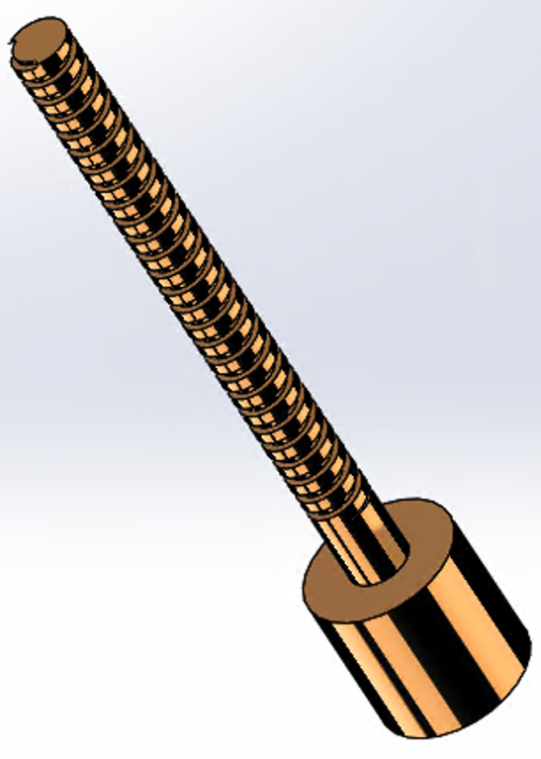
The purpose of the worm is to allow a smooth transition of the jaw during application. The concept is essentially a screw that threads into the centre of the drive plate. The benefits of a worm gearing method is that high levels of torque is generated. This allows the user to operate at lower speeds whilst maintaining optimal function during application. The original material chosen for this part component is 1060 alloy.
The change I would make to this part is the material used. Instead of 1060 alloy, I would use an aluminium bronze alloy. There are a number of benefits to using aluminium bronze for the worm component. A part made of a bronze alloy will have characteristics such as a low coefficient of friction. Some other desirable characteristics of a bronze alloy are high material strength and a superior resistance to wear/fatigue [10]. Frictional coefficients for bronze alloys against steel range between 0.08 and 0.14. This far outweighs the use of aluminium against steel. The coefficient of aluminium against steel ranges between 0.18 to 0.30, a significant difference [11].
Changing the worm material from a 1060 alloy to an aluminium bronze will increase the life cycle of the part significantly.

The manufacturing process Principles

Introduction
As a manufacturer, gaining a competitive edge in your market will really set you aside from other competitors. Improving your process to create your products should always be the main priority. Once the optimum level of quality is reached, looking to increase speed of production and reducing costs would be the next direction. Improvements can be made by following a number of key principles. These principles are known as “Lean Manufacturing Principles”. These principles will help increase production, improve quality of your products and reduce total costs throughout the process [12].

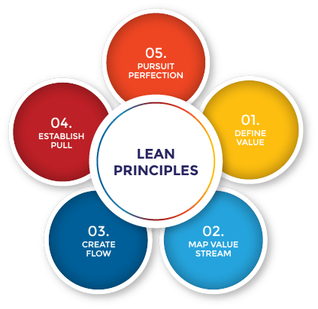

Figure 1 - The five lean principles [13]

Identify Value
The first step to becoming lean is clearly identifying the value in the products you produce. “Does your product meet the needs of the customer you are producing for?” Taking this consideration further, undergoing extensive research is a necessity. You can do so by performing surveys, questionnaires, votes and accumulating likes on platforms like social media. This research can help in understanding what your customers really want, what your customers are able to afford and how they want the service to be delivered. This principle is ample for a manufacturer to become lean [13].

Value Stream Mapping
Once you have defined the value in your products, it is important to improve the steps that are required to deliver your product or service. Using a flowchart, you can visually identify the key steps in your process from start to finish. The flowchart can identify steps in the process that aren’t necessary. By eliminating these steps, you are maintaining your focus on bringing value to the customer. This is another step to maintain your competitive edge in your market [14].

Flow
The next step in following the lean principles is creating a flow. By evaluating your process, you can eliminate steps that affect this flow. By eliminating these steps you are eliminating the “waste” that is generated. By performing this step, you are creating a chain of events that interlink with one another. This chain is the optimum pathway to deliver your product from start to finish without any risk to quality or safety [15].

Pull
This system allows an organisation to eliminate activities seen as waste during the production process. By not overproducing, you can optimize your resources more efficiently and calculate costs accurately. This principle also reduces the need for overstocking. Production only takes place if the demand is there [16]. Another consideration to make around overproduction is not stocking away products. This eliminates the risk of damaging the products when they are in storage.

Pursue Perfection
For an organisation to become lean, the first 4 steps must be implemented in order to reduce waste. The fifth step to becoming lean is the ongoing pursuit of process improvement. Alongside this the continuation of bringing value to the customers by understanding their needs is also a part of this principle. By this stage, the workforce will have already established a clearer vision for the organisation. Amongst the vision, a highly motivated workforce is also established. This workforce will be the driving factor to continually deliver value to customers whilst maximising their own profits along the way [13].

The manufacturing processes

Injection moulding
The first process I want to mention is Injection moulding. This manufacturing process is widely used to manufacture a large quantity of components. It is also used to produce parts that may have complex geometries. This process can be time consuming if detailed molds need to be machined. This being said, once everything is set up and running, this process can mass produce millions of parts in a very short space of time [17]. With this process, the option to adjust integrating ribs and gussets is available [18]. This allows the user to create a part that is more rigid or flexible. For the manufacturing of the gripper jaws, having this option will deliver a more desirable finish.
Another desirable benefit of using injection moulding is that this process will have zero waste during production. The necessary amount of PVC material is fed into the mold in the form of a resin powder. Any surplus in material is then reused for the next component. This will significantly reduce costs as there is no wasted material [19].

Die casting
For the aluminium components a die casting process will be used. This process is an efficient and economical process that offers great range to produce parts with more complex dynamics to them. This process can mass produce parts with minimal to no tooling required afterwards. This process produces multiple parts that will be durable and dimensionally stable. This is even more important for parts that have thin walls. The strength of the part comes from the alloy and this manufacturing process will utilise that strength during casting. This process can also provide joining elements to the formed parts. External threads can be cast easily along with holes for any of your joining parts [20].
Using this process for producing a large scale of parts will be the most cost effective. The tight tolerances of any part of this assembly can be manufactured without compromising any strength [21]. The worm can be machined easily to achieve the desired thread size.

Manufacturing process design

- The first step of the assembly is the motor. Outsourcing this part will greatly increase speed of assembly and also reduce manufacturing costs. If I did have to manufacture this part the method of manufacture would be a hot press. This process costs less than other processes and deliver’s a much quicker forming time. This type of method will ensure the thickness is consistent across the part. The geometries around the quick change design can be easily formed using this method [22].
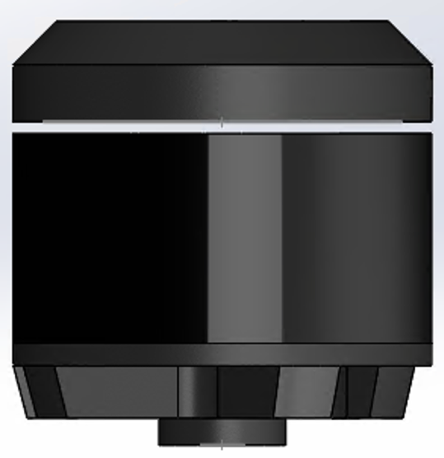
Step 1

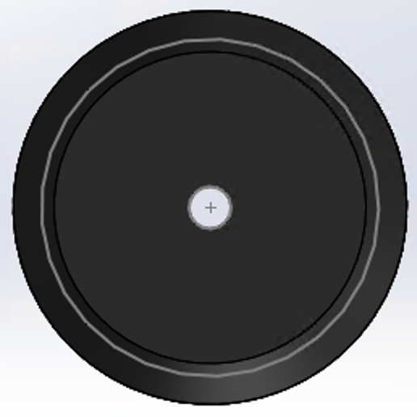
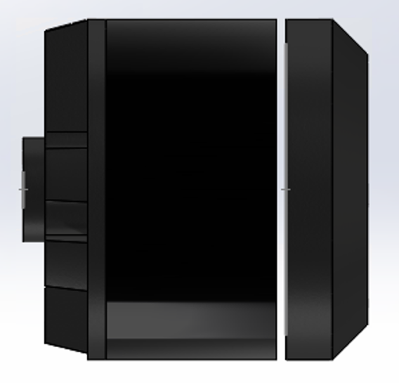

Side view | Top View | Front View
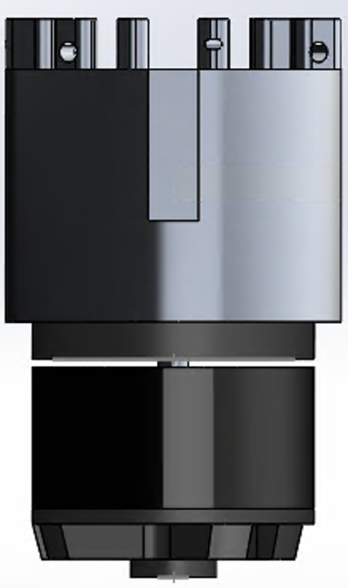
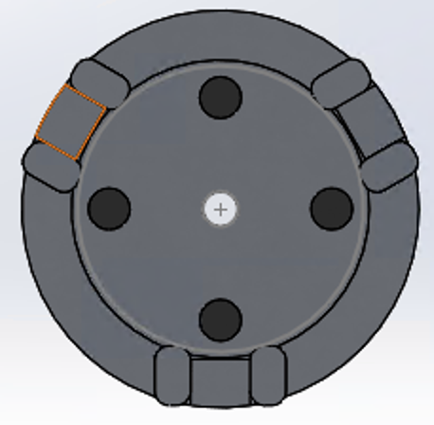
Step 2
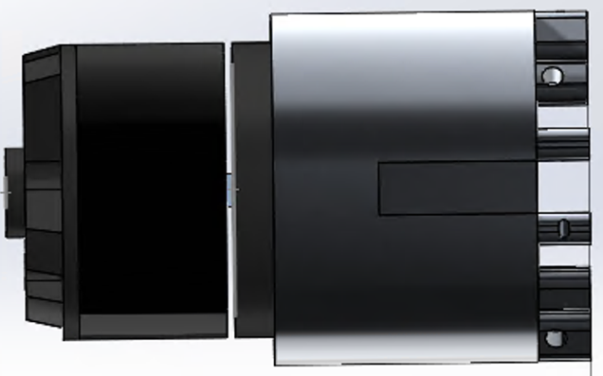

- The second step is to add the cylinder to the motor. The cylinder is manufactured using a die casting process. Using this process will create a lightweight cylinder. Due to the characteristics of the element. This process will allow the alloy to retain high dimensional stability when a thin gauge part is produced [23]. The cylinder will be corrosion resistant, increasing the life cycle of the part.
- In this step the shaft is attached to the motor. The shaft is also manufactured in a die casting process. The shaft will have a smooth surface finish greatly increasing its resistance to corrosion.
Step 3
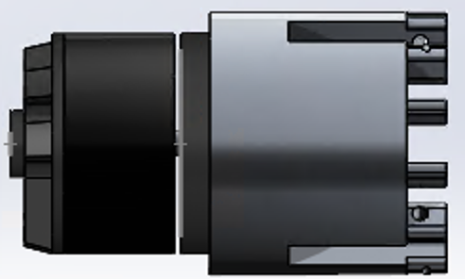
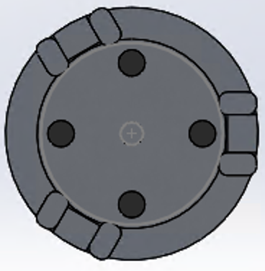
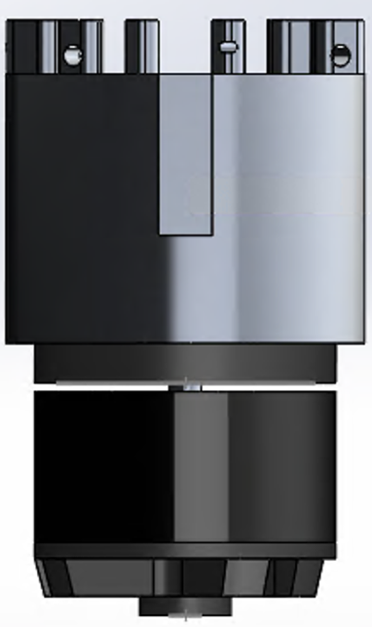

Side view | Top View | Front View
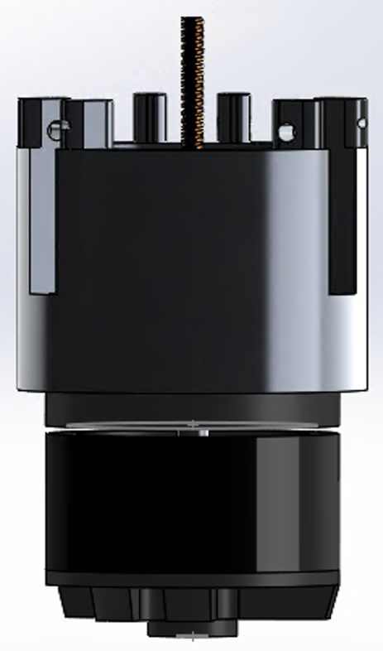
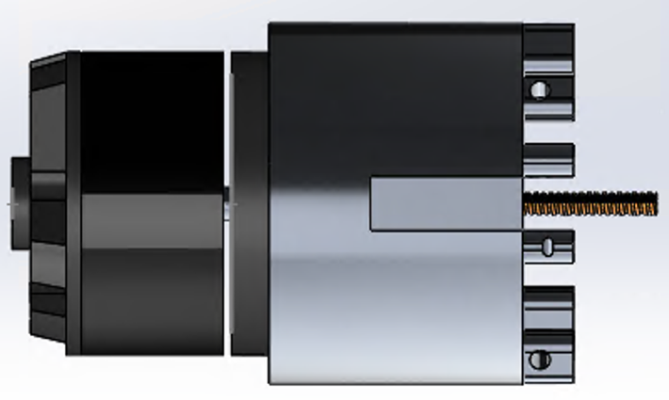
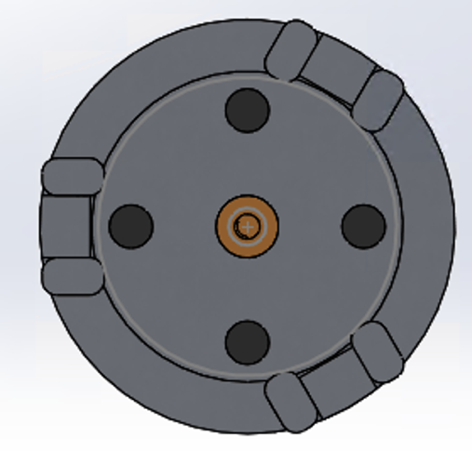
Step 4

- In this step, the worm is now attached to the shaft. The worm Is now able to transition up and down when powered by the motor.
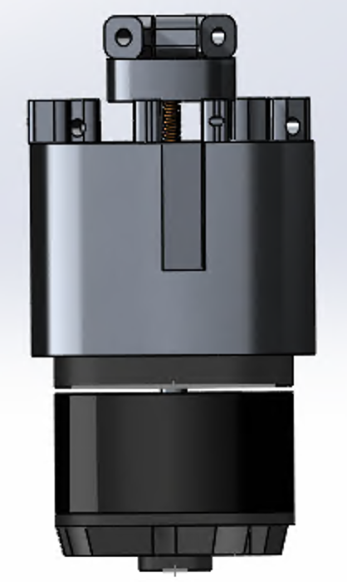
- In this step the drive plate is now attached to the worm. The worm is able to thread up and down the drive plate when the motor activates the assembly. The surface finish on the drive plate should have a slight rough finish to create lubrication for the worm during application.

Step 5
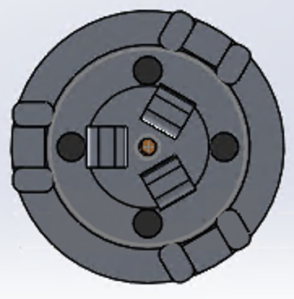
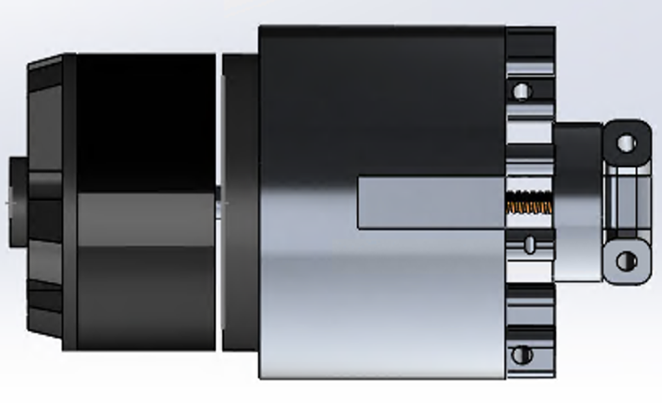

Side view | Top View | Front View

Step 6
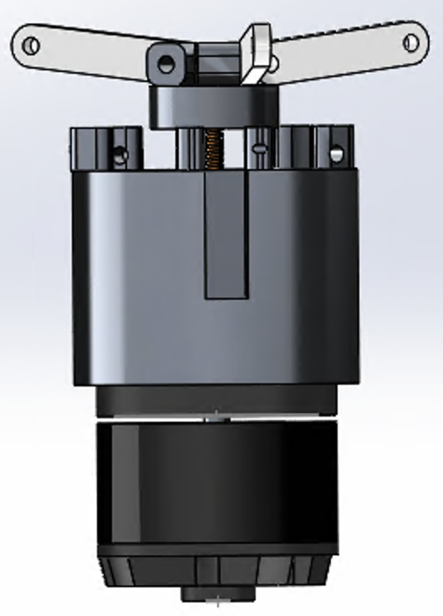
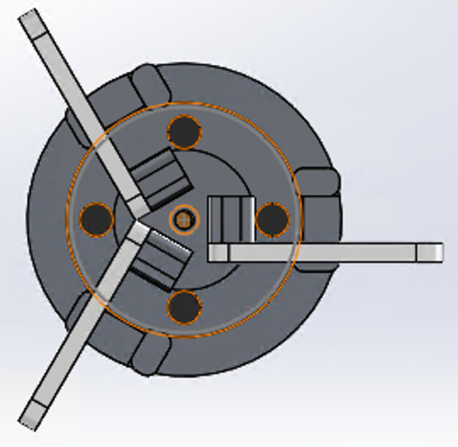
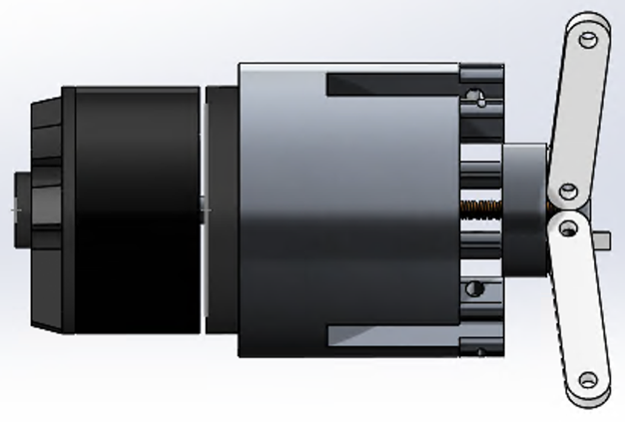

- In this step the joins are attached to the blocks on the drive plate.

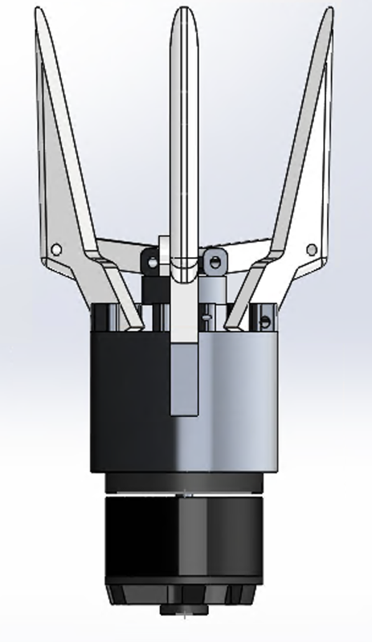
- The final step is to attach the jaw (fingers) to the assembly. Once attached the assembly is now fully functional and ready for application.
Step 7
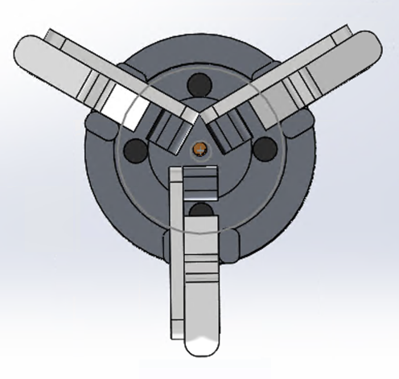
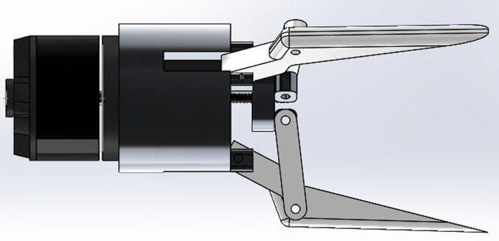

Side view | Top View | Front View

Conclusion

To conclude my report, the original design of the jaw gripper was a good design and had many great qualities. Along with the design the materials chosen were also excellent due to the desirable characteristics these materials have e.g. high resistance to wear, high resistance to corrosion, high strength and lightweight. I believe the alterations I made to the design will make for an efficient and highly durable product. The change in material for the worm will greatly increase the amount of use this product can withstand. The processes chosen to manufacture this assembly will give a greater return on investment due to the capability of mass production. The materials chosen work best with these chosen processes. The chosen processes also decrease the likelihood of defects appearing in any of the components post manufacture.
Whether you want to produce this product on a super large scale, or you want to produce on a much smaller scale, the ability to alter the components to suit your desired needs is available. The manufacturing processes are chosen to deliver the optimum capability of this product at a larger scale. To produce at a much smaller scale, there are some excellent alternative processes that would deliver similar results. The main focus around producing this product is to ensure quality is always reached.

Bibliography

[1] G. E. Staff, “Implementing Quick-Change Tooling and Machining Fixtures - Grainger KnowHow.”
[2] H. B. Martin, “Consider the benefits of quick-change tooling systems | Cutting Tool Engineering.” https://www.ctemag.com/news/articles/consider-benefits-quick-change-tooling-systems (accessed Jun. 21, 2020).
[3] A. Hitchcox, “Ductile iron holds advantages over steel and cast iron | Hydraulics & Pneumatics.” https://www.hydraulicspneumatics.com/technologies/manifolds-hics/article/21883685/ductile-iron-holds-advantages-over-steel-and-cast-iron (accessed Jun. 22, 2020).
[4] Ductile Iron Society, “Why Convert To Ductile Iron?” https://www.ductile.org/dimg/orangechart.html (accessed Jun. 22, 2020).
[5] M. Bélanger-Barrette, “Why Use a Robot Gripper with 3 Fingers,” ROBOTIQ, 2015. https://blog.robotiq.com/why-use-a-robot-gripper-with-3-fingers (accessed Jun. 22, 2020).
[6] Omnexus, “Polyvinyl Chloride (PVC) Plastic: Uses, Properties, Benefits & Toxicity,” 2018. https://omnexus.specialchem.com/selection-guide/polyvinyl-chloride-pvc-plastic (accessed Jun. 22, 2020).
[7] United Aluminium, “Chemical Composition and Properties of Aluminum Alloys,” Uac, pp. 1–7, 2013, Accessed: Jun. 22, 2020. [Online]. Available: https://www.unitedaluminum.com/chemical-composition-and-properties-of-aluminum-alloys/.
[8] R. de Azevedo, “Benefits and disadvantages of aluminium alloys as a replacement for structural steels in ships - Engineering Stack Exchange.” https://engineering.stackexchange.com/questions/21555/benefits-and-disadvantages-of-aluminium-alloys-as-a-replacement-for-structural-s (accessed Jun. 22, 2020).
[9] D. Collins, “Two things you need to know when selecting shafts for linear bearings.” https://www.linearmotiontips.com/selecting-shafts-for-linear-bearings-two-things-you-need-to-know/ (accessed Jun. 23, 2020).
[10] Accurate Specialties Inc, “How to Make Bronze for Worm Gear Applications - ASI.” https://www.accuratespecialties.com/how-to-make-bronze-for-worm-gear-applications/ (accessed Jun. 22, 2020).
[11] Copper Development Association, “Applications: Industrial - Selecting Bronze Bearing Materials.” https://www.copper.org/applications/industrial/bronze_bearing.html (accessed Jun. 22, 2020).
[12] J. Thurston and U. Jeffrey, M., “The Principles of Lean Manufacturing,” Franklin Bus. Law, vol. 2016, no. 2, pp. 57–71, 2016, Accessed: Jun. 23, 2020. [Online]. Available: https://www.manufacturing.net/home/article/13193437/the-principles-of-lean-manufacturing.
[13] D. Doanh, “The Five Principles of Lean,” The Lean Way Blog, 2017. https://theleanway.net/The-Five-Principles-of-Lean (accessed Jun. 23, 2020).
[14] Lucidchart, “What is Value Stream Mapping | Lucidchart,” 2019. https://www.lucidchart.com/pages/value-stream-mapping#discovery__top (accessed Jun. 23, 2020).
[15] EBA, “Implement Lean Flow - Reduce waste and increase profitability in your business,” 2016, 2016. https://www.educational-business-articles.com/lean-flow/ (accessed Jun. 23, 2020).
[16] Kanbanize, “What is a pull system? Details and Benefits,” Kanbanize, 2019. https://kanbanize.com/lean-management/pull/what-is-pull-system (accessed Jun. 23, 2020).
[17] Formlabs, “Guide to Manufacturing Processes for Plastics,” Formlabs, 2018. https://formlabs.com/uk/blog/guide-to-manufacturing-processes-for-plastics/ (accessed Jun. 23, 2020).
[18] J. Worth, “Major Advantages of Plastic Injection Molding | The Rodon Group®.” https://www.rodongroup.com/blog/6-major-advantages-of-plastic-injection-molding (accessed Jun. 23, 2020).
[19] CODA Plastics, “Reducing Waste and Costs with Injection Moulding.” https://www.coda-plastics.co.uk/blog/reducing-waste-and-costs-with-injection-moulding (accessed Jun. 23, 2020).
[20] R. F. Schmied, “What are some of the advantages of die casting? | Pace Industries.” https://paceind.com/die-casting-101/die-casting-faqs/advantages-of-die-casting/ (accessed Jun. 24, 2020).
[21] Northern Iowa Die Casting Inc., “Why Die Casting.” http://www.nidcinc.com/why_casting.htm (accessed Jun. 24, 2020).
[22] Thermal Engineering, “Hot Forming – Senior Aerospace Thermal Engineering are leading specialists in hot forming of metals for aerospace manufacturing,” 2018. https://www.thermalengineering.co.uk/capabilities/metal-forming/hot-forming/ (accessed Jun. 23, 2020).
[23] DYNACAST, “Aluminum Die Casting Alloys | Aluminum Casting | Dynacast,” Dynacast, 2018. https://www.dynacast.com/en/knowledge-center/material-information/die-cast-metals/aluminum-die-casting-metals (accessed Jun. 23, 2020).

