Visual Enquiry 2
Ben Evans 1911027
M5X01609

Proposal

My proposed subject area/concept for my final year major project is based around the story of Eyob Tefera from Ethiopia who travelled to Swansea and died after throwing himself to the waters of the Marina. I believe his story is one that we must not forget as it shows the economic inequalities of the world we now live in and of societies failures to help our fellow man when in deepest need. Some of this story was exhibited in the Opusculus exhibition in March 2020 but I felt I needed to expand on it further and develop it to highlight more of the journey he took to get here and the problems he faced when here.
I intend to research about his origins with the Oromo tribe in Ethiopia, how British colonialism might have to this day caused the instability of the country and why the British state declined 2 asylum applications and therein the usual £35 a week for him to survive on.
I would also like to create something to show the path Eyob took to get to Swansea based around what is known as the Central Mediterranean route that he likely took.

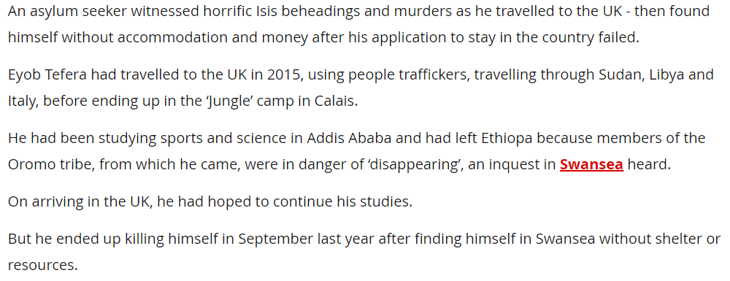
Visual Diary
I intend to develop my skills in photoshop over the summer as I enjoy editing my images but feel I am not proficient in utilizing it yet. I also need to practice my camera skills and have some ideas about images I would like to create for this project.



