
Master of Business Administration
International Business pathway

Assessment 1: Individual report
Module Name: International Business Concepts
Module Code: LCMB7034

Lecturer: Jean Wang

Student Name: Md Rabiul Hassan
Student ID: 2504429

Word Count: 5473
Submission Date: 27th April 2026

AI use acknowledgement
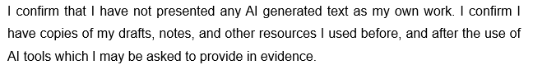

“An International Business Analysis Report on the U.S. Semiconductor Industry”

Industry: Semiconductor / Technology
Company: Taiwan Semiconductor Manufacturing Company (TSMC)
Home Country: Taiwan | Host Country: United States |

Table of Contents
Section 1 6
1. Introduction 6
2. Industry and Country Overview 7
Size, Scope, and Economic Importance 8
Domestic Firms and Foreign MNCs in the U.S. Semiconductor Industry 9
Opportunities and Challenges for TSMC in the U.S. 10
3. Application of Michael Porter’s Diamond Model of National Advantage 11
Factor Conditions 11
Demand Conditions 12
Related and Supporting Industries 12
Firm Strategy, Structure, and Rivalry 13
Government 13
Chance 14
4. Evaluating the Conditions for TSMC’s Success in the U.S. Semiconductor Industry 15
Identification of a Major Foreign MNC/TNC Operating in the Country-Industry Pair 15
Critical Evaluation of Factors Impacting TSMC’s Operations in the U.S. Semiconductor Market 16
Recommendations 22
5. Conclusion 23
Section 2 24
Reflective Account Using Gibbs’ Reflective Cycle 24
Reference List 27

Figures
Figure 1: Global Semiconductor Market (Deloitte, 2026) 6
Figure 2: US Semiconductor Market Size (McKinsey & Company, 2025a) 7
Figure 3: Semiconductor Workforce Gap (SIA and Oxford Economics, 2023) 8
Figure 4: Scalability of Semiconductor (McKinsey & Company, 2025a) 9
Figure 5: Porter's Diamond Model (Business‑To‑You, 2018) 11
Figure 6: PESTLE Analysis (Ormston, 2025) 16
Figure 7: Costs of Semiconductor (McKinsey & Company, 2025b) 18
Figure 8: Concentration of Materials (McKinsey & Company, 2025b) 19
Figure 9: Country Comparison USA vs Taiwan (The Culture Factor Group, 2026) 20
Figure 10: Annual Revenue Shares (OECD, 2025) 21
Figure 11: Gibbs Reflective Cycle (Athal, 2025) 24
Section 1

1. Introduction
The semiconductor sector across the world has recorded commendable growth and it is forecasted to reach $1 trillion dollar market in 2027. In figure 1, Deloitte (2026) indicates that the market was worth $440 billion in 2020, and then $556 billion in 2021, and has been projected to grow to $574 billion in 2022. The semiconductor market is projected to hit $772 billion by 2025 and to hit $975 billion in the year 2026. This trend indicates the importance of the industry in driving major technologies such as artificial intelligence, 5G, and autonomous cars (Deloitte, 2026). Taiwan semiconductor manufacturing company (TSMC) has a significant role in this case and its increasing investments in semiconductor manufacturing in the U.S serve as a critical factor.
Semiconductors are the backbone of technology, enabling advances in areas like artificial intelligence (AI), 5G and self-driving cars. Semiconductors play a vital role for enabling sophisticated electronic devices, data processing and telecommunications networks as technology increasingly becomes embedded in our lives. This increasing need for semiconductors, especially in the U.S., highlights the critical importance of the industry to economic growth, national security, and technological innovation.
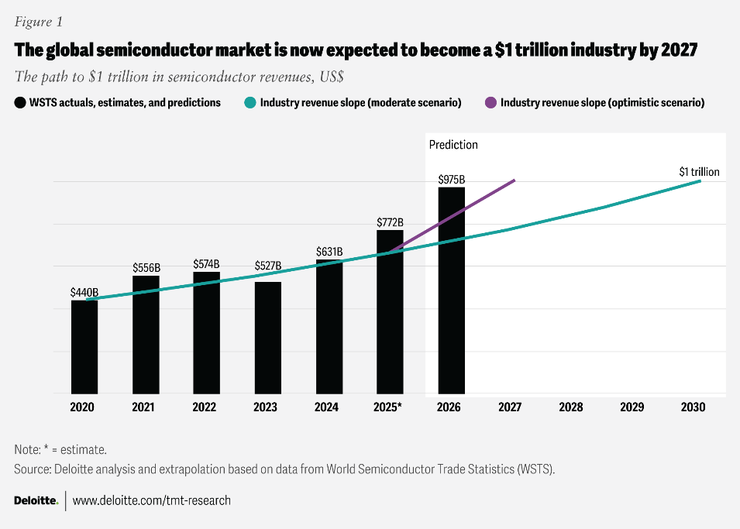
Figure 1: Global Semiconductor Market (Deloitte, 2026)
This report will examine the issues affecting the growth of TSMC in the U.S. market, its investment strategies as well as challenges that TSMC faces in the global semiconductor ecosystem.

2. Industry and Country Overview
The semiconductor industry is a critical part of the present-day global economy, as it drives various technologies in the field that are an inseparable part of everyday life. In the United States, the industry has developed at a high rate and would keep on increasing as a result of the rising demand in various areas including automotive electronics, data storage, and consumer electronics.
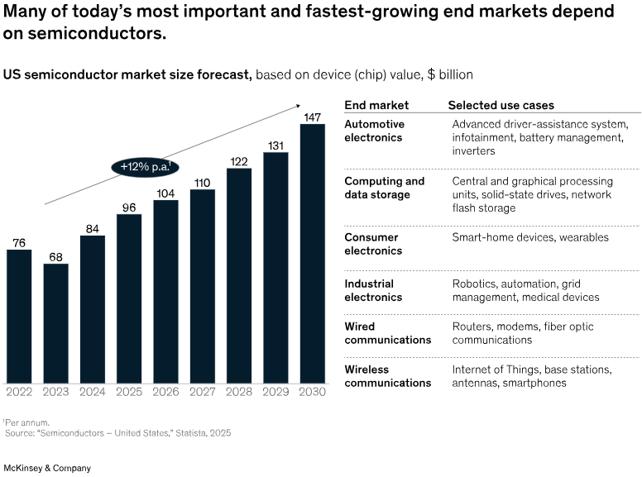
Figure 2: US Semiconductor Market Size (McKinsey & Company, 2025a)
The U.S. semiconductor market size will grow to $147 billion dollars by 2030 with a compound annual growth rate (CAGR) of 12% (Figure 2) on top of its 2022 level of $76 billion dollars (McKinsey & Company, 2025a). The main forces for growth include technology development in the automotive industry, i.e. sophisticated driver assist system (ADAS) and in computing, wireless communication and industrial electronics. The semiconductor industry in the U.S. is the centre stage of the technological revolution and its role to the economy cannot be over emphasised.

Size, Scope, and Economic Importance
Modern electronics rely on semiconductors and allow innovative technologies to be implemented in such areas as AI, 5G networks, or the Internet of Things (IoT). Semiconductor industry in the U.S. plays a very important role in the economy and national security of the country. In a report published by McKinsey & Company (2025a), the semiconductor industry is projected to expand significantly in the next few years to reach $147 billion dollars by 2030. This has been fuelled by the consumer electronics demand as well as the increased use of semiconductors in other sectors such as automotive and health sectors.
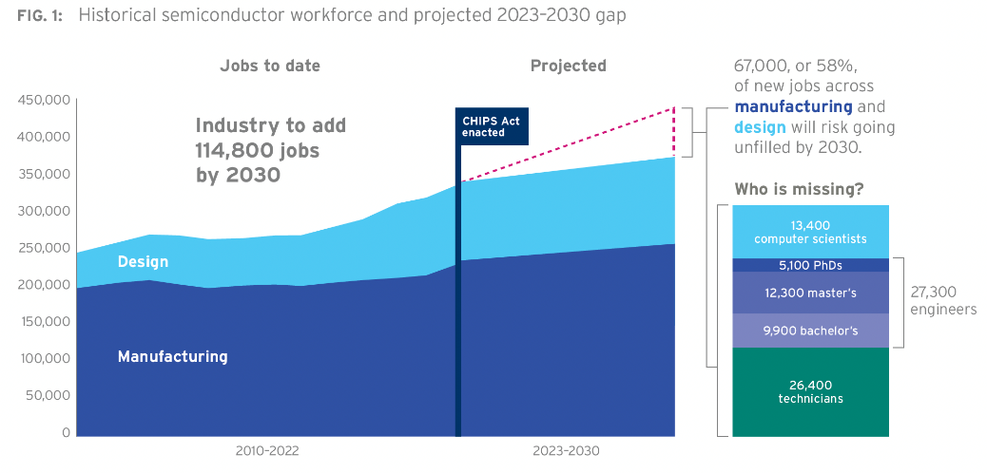
Figure 3: Semiconductor Workforce Gap (SIA and Oxford Economics, 2023)
The expanding market of the U.S. semiconductor can be indicated by the growing number of employees. According to Figure 3, in 2030 there will be an additional 114,800 workers required in the U.S. semiconductor industry. Nevertheless, the risk lies in the large gap in the workforce since the sector experiences a problem with attracting skilled labour force. Specifically, such a lack of technicians, engineers, and computer scientists is acute, and a significant number of new jobs in the manufacturing and design fields are likely to remain vacated (SIA and Oxford Economics, 2023). This is one of the major challenges facing the U.S. semiconductor industry, which is trying to make the growing need of chips and make sure that the domestic production capacity is able to compete with the foreign manufacturers.

Domestic Firms and Foreign MNCs in the U.S. Semiconductor Industry
The dynamics in the U.S. semiconductor industry is characterized by interplay of local companies and foreign multinational companies (MNCs), and not power of one group of companies. Chip design, research and platform development, and downstream technological integration, are especially strong in domestic firms, and the role of foreign MNCs in fabrication capacity, process technology, and global supply-chain coordination is becoming increasingly important (OECD, 2025). Consequently, the competitiveness of the United States is not merely based on local innovation potential, but also its attraction and retention of foreign direct investment in state-of-the-art semiconductor manufacturing.
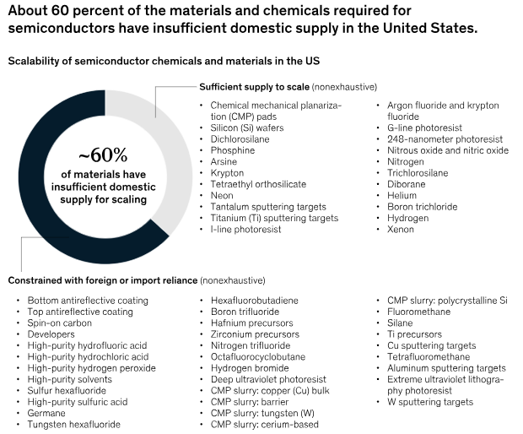
Figure 4: Scalability of Semiconductor (McKinsey & Company, 2025a)
The United States has a regional advantage of domestic semiconductor companies, access to research universities, venture capital networks, defence-related innovation networks, and a high client base in rapidly growing uses of semiconductors, including cloud computing, AI, consumer electronics, and automotive technology, to the advantage of domestic semiconductor firms (McKinsey & Company, 2025a). They are frequently competitive based on the capability to design, intellectual property, software-hardware integration and gaining access to the market instead of fabrication scale itself. In comparison, foreign MNCs also play a role in the U.S. semiconductor sector by introducing advanced manufacturing skills, investment, and incorporation into the global production networks (OECD, 2025). Figure 4 indicates that there has been low domestic supply of semiconductor materials such as silicon and phosphine, which are vital in the production of chips. Approximately 60 percent of this material is imported outside the U.S. and so it shows that more has to be produced domestically and this is where companies such as TSMC come in to fill this gap (McKinsey & Company, 2025a).

Opportunities and Challenges for TSMC in the U.S.
TSMC has a good strategic opportunity in entering the United States. To begin with, the semiconductor market in the U.S. will experience a powerful surge due to the demand in AI, high-performance computing, wireless communications, automotive electronics, and industrial applications (McKinsey and Company, 2025a; Deloitte, 2026). This puts TSMC in a favourable position since competitive advantage is in advanced-node semiconductor manufacturing that is in high demand by these industries. Second, U.S. government has taken a more interventionist industrial policy via the CHIPS Act, which provides funding and policy subsidies to increase local production of semiconductors (NIST, 2024). This will mitigate some of the investment risk in setting up fabrication facilities in a high-cost environment.
The other significant opportunity of TSMC is strategic location to large customers and to the larger technology ecosystem in the U.S. (TSMC, 2024). With numerous of the most significant semiconductor clients in the world being linked to the U.S. market, producing in Arizona will empower TSMC as a consistent supply-chain partner over the long term and will help in diversifying the supply chains at a geopolitical uncertain time (TSMC, 2025b). In that regard, the U.S. investment by TSMC is not merely a commercial one, but also strategic.
Nevertheless, TSMC has significant issues with the U.S. market too. Cost is one of the most crucial. Higher labour, construction and compliance costs in the United States compared to Taiwan are linked with semiconductor manufacturing, which could lower the operating efficiency that has long been a legacy of TSMC in gaining global leadership (McKinsey & Company, 2025b). Moreover, the semiconductor sector in the U.S. has a significant lack of skilled labor, particularly technicians, engineers, and computer scientists, which can limit growth and raise the expenses of recruiting and training (SIA and Oxford Economics, 2023).

3. Application of Michael Porter’s Diamond Model of National Advantage
The Diamond Model is a model applied in the analysis of competitive advantage of nations by Michael Porter. It concentrates on four general characteristics developing the international competitiveness of a particular industry, which are factor conditions, demand conditions, related and supporting industries, and firm strategy, structure, and rivalry (Porter, 1990).
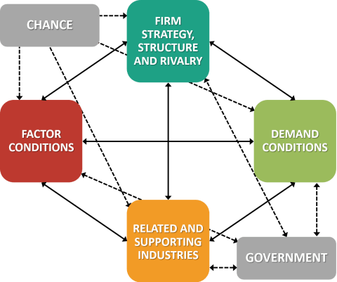
Figure 5: Porter's Diamond Model (Business‑To‑You, 2018)

Factor Conditions
Factor conditions are the capability of the country to endow its resources including skilled labour, infrastructure, and capital. The U.S. semiconductor industry also enjoys the well-established infrastructure, research and development (R&D) centres and the high-tech manufacturing plants. Nevertheless, based on Figure 3, there is an acute issue of labour shortage in the industry, specifically in manufacturing and design. In the U.S., 114,800 more jobs are projected to be created by 2030, and many of them will remain vacant because the country lacks skilled employees (SIA and Oxford Economics, 2023). Although the CHIPS Act has already been a good measure to encourage domestic semiconductor manufacturers, the number of engineers, technicians, and computer scientists is still a challenge to the operations of such companies as TSMC, Intel, and AMD (TSMC, 2022).
Also, the U.S. has been very dependent on international supply chains of semiconductor material as almost 60% of vital materials, including silicon wafers and high-quality chemicals, are imported (SIA, 2025). Such dependence on foreign imports is a weakness to the supply chain and a constraint to scalability by the U.S. semiconductor industry. Consequently, reshoring manufacturing has a tremendous push, and TSMC has the first move with projects to establish advanced fabrics in Arizona (TSMC, 2024).

Demand Conditions
The U.S. semiconductor industry is experiencing positive demand conditions as the demand in various industries is high. With the automotive electronics, computing, industrial, and wireless communications, as Figure 4 illustrates, the U.S. semiconductor market will experience significant growth, with an increase to $147 billion in the year 2030 (McKinsey & Company, 2025a). The growth in the use of semiconductors by the automotive industry in advanced driver-assistance systems (ADAS), in infotainment and in battery management systems is a major factor behind this growth (Deloitte, 2026).
Also, the trend of innovative technologies, including smartphones, wearables, and smart home devices, among others, is the reason why U.S. consumers are still demanding semiconductors. This results in a flourishing local market, which means that the U.S. semiconductor firms, such as Intel and NVIDIA, are in a good position to respond to the local and global needs. The recent pace of AI development and the rising demand of powerful computing chips have contributed to the further rise in semiconductor demand (McKinsey & Company, 2025b).

Related and Supporting Industries
The semiconductor sector in the U.S. has an excellent system of associated businesses such as research and development, software designing, and the electronic production. NVIDIA, the manufacturer of graphics cards, is a top corporation in these fields in the U.S., and Apple is a high-tech corporation that can hardly do without semiconductors in their products (NVIDIA, 2025). Also, the nation has a stable source of raws and chemicals in semiconductor fabrication, although it has difficulties with local supply as illustrated in Figure 2 (McKinsey & Company, 2025a). The CHIPS Act issued by the U.S. government is intended to partially resolve some of these problems in the supply chain by encouraging the production of semiconductors and other materials domestically (NIST, 2024).

Firm Strategy, Structure, and Rivalry
The competition, organisation, and planning used by the companies that are engaged in the semiconductor sector in United States are the crucial elements in ensuring that global competitiveness is achieved. Large companies such as Intel, AMD, NVIDIA and TSMC have embraced the idea of being aggressive to gain market share and stay on top of technology. The move of Intel to the more advanced manufacturing technologies, including its 7-nanometer process, makes the company competitive in the high-performance computing market with other major participants (Intel, 2024). Meanwhile, the focus of TSMC in developing its manufacturing facilities in the U.S. enables it to access the increasing demand of the advanced semiconductor technology, especially in the area of AI and 5G usage (TSMC, 2020).
Competition in American semiconductor industry is stiff, and firms are always attempting to continually innovate and cut expenses. This competition compels companies to embrace the latest technology and spend a lot in research and development. Nevertheless, according to Figure 4, the barriers to scale are equally strong in the industry, especially related to the development of workforce and the lack of material supply (McKinsey & Company, 2025a).

Government
The competitiveness of the U.S. semiconductor industry is mainly influenced by the government. Government impacts on national advantage in a more extended Diamond Model by Porter, who relates to the incentives of investment, regulatory conditions, support of research and development of industries. With regards to the United States, the CHIPS Act has dramatically transformed the competitive landscape with subsidies and policy support strategies to the semiconductor manufacturing and supply chains (NIST, 2024). This has seen the U.S. become more appealing to the domestic firms as well as foreign investors like TSMC.
In the case of TSMC the government aid is most significant since the fabrication of semiconductors demands a very large initial capital investment and lengthy payback time. These incentives (open to the public) mitigate part of this risk and enhance the commercial viability of growing manufacturing in Arizona (TSMC, 2024). Nevertheless, government interference also provokes hopes concerning local employment, resilience of the supply chains and contribution to technological leadership of the U.S. Hence, government is not a mere supportive factor, but also strategic factor that influences the way foreign firms are supposed to operate in the host country.

Chance
Chance is unforeseen external changes that redefine the competitive terms and alter the comparative advantage of companies and countries. Chance events can be very important in the semiconductor industry, which has experienced this in the past few years. The effects of global supply-chain disruptions, the COVID-19 pandemic, geopolitical tensions, export controls, and the fast expansion of AI have all heightened the strategic significance of semiconductor production capacity and decreased the level of geographic concentration in supply chains (Deloitte, 2026).
In the case of TSMC, opportunity and risk have been created by these chance events. The supply-chain instability, geopolitical tensions on the one hand have led to the United States encouraging localised semiconductor production that is beneficial to the U.S. investment strategy of TSMC (NIST, 2024). Conversely, uncertainty in international trade, customer demand patterns, and cross-border technology governance, also increases with the same developments. Thus, the success of TSMC in the United States has been enhanced by chance and at the same time, its strategic environment has become more complex (TSMC, 2025b).
The Porter’s Diamond Model analysis shows that while facing difficulties, including the talent shortage, TSMC benefits from other factor conditions (infrastructure and R&D institutes) in the U.S. These factors, alongside robust demand and supporting industries, play a role in TSMC's success in setting up cutting-edge manufacturing in Arizona.

4. Evaluating the Conditions for TSMC’s Success in the U.S. Semiconductor Industry

Identification of a Major Foreign MNC/TNC Operating in the Country-Industry Pair
The move by TSMC to the United States must be seen not just as a foreign investment move, but also as a strategic solution to the dynamics in the global semiconductor industry. Successful operation of the company in the U.S. is preconditioned by the influence of political support, demand on the market, integration with the ecosystem, availability of labour and adjustment of institutions (NIST, 2024). Even though TSMC has got the capability of technology and dominance in the semiconductor foundry services worldwide, these strengths are not enough to ensure that they succeed in the American market. Rather, the success over the long term will be determined by the ability of TSMC to translate policy support and market opportunity into effective local operations within the economic, legal and organisational environment of the United States (TSMC, 2025a).
The United States interests in TSMC operating in the United States is important in the quest of federalism in achieving semiconductor self-sufficiency since the United States has depended more on the foreign companies to fulfil the increasing supply of advanced chips. The CHIPS Act promoted expansion of the company in the U.S. because it needs to build semiconductor manufacturing plants in the U.S. to prevent risks linked to dependency on the foreign chipmakers, particularly in the current geopolitical conflicts (NIST, 2024). One of the acts that TSMC has performed to indicate its willingness in the U.S. market is its investment worth $12 billion of its funds in its plant in Arizona (Reuters, 2026b).
The capability of TSMC to produce the best semiconductors on a large scale, coupled with its strong research and development (R&D) competency provides it with a competitive edge within the American market (SIA, 2025). The company has been able to position itself as a leading force in semiconductor fabrication, and this has also helped it to reinforce its strategic significance in the technological supply chain of the U.S. and the world market.

Critical Evaluation of Factors Impacting TSMC’s Operations in the U.S. Semiconductor Market
TSMC is the Taiwan Semiconductor manufacturing Company which is the market leader in semiconductor foundry in the globe and has significantly penetrated in the U.S. semiconductor market. Growth of the TSMC business in the U.S is timely as the supply chains of semiconductors are questioned, particularly the increasing worry about reliance on the foreign suppliers. The CHIPS Act of the U.S. government is designed to encourage the production of semiconductors in the country, which gives TSMC significant financial support in U.S. investments (NIST, 2024).
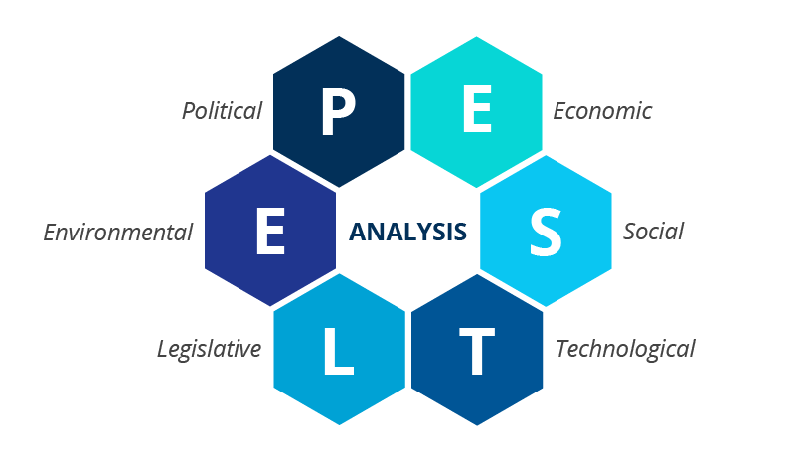
Figure 6: PESTLE Analysis (Ormston, 2025)
Political Factors: The political environment will be a key factor in determining the operations of TSMC in the U.S. The first reason is that the U.S. government developed strategic measures to promote the production of semiconductors on its territory. There has been an essential role of the CHIPS Act (enacted in 2022) in offering monetary incentives to overseas and local companies, such as TSMC. The bill offers up to $6.6 billion of direct subsidies to TSMC plant in Arizona, which is part of the bigger picture of decreasing the reliance of the U.S. on suppliers of semiconductors, especially Chinese (NIST, 2024).
Nonetheless, the U.S.-China political conflicts present a threat to the U.S.-based operations of TSMC. The current trade war between China and the United States has involved imposing tariffs on the products involved in semiconductor (Reuters, 2026a). Since TSMC produces chips on behalf of clients in China and other nations, any trade restrictions or sanctions may affect its capacity to service the demand and damage its business profitability.
Economic Factors: The U.S. has both opportunities and threats to the operations of TSMC in its economic environment. The U.S semiconductor market is growing at a very high rate, and it is estimated that the market is going to grow by $147 billion by the year 2030 (OECD, 2025). This opens up huge growth prospects to TSMC that is in a good position to satisfy the growing semiconductor demand and in particular in areas such as AI, 5G, and car electronics. There is also the experience of the semiconductor industry in the U.S. being heavily supported by government funding like the CHIPs act that promotes investments such as the one by TSMC.
On the other hand, labour costs are an issue to the operations of TSMC in the U.S. Labour costs in the U.S. according to Figure 6 are four times more than that in China, and this can have an effect on the profit margins of TSMC (McKinsey and Company, 2025b). Also, skills gaps in high-end semiconductor production and research in America would be a setback to production schedules, making it more expensive to employ skilled labour. To seal this gap and maintain a consistent workforce, TSMC will have to invest in training programmes (SIA and Oxford Economics, 2023).
The fact that the U.S. economy increasingly uses sophisticated technologies increases the popularity of the market. The move taken by TSMC on the Arizona fab is to respond to rising demand of high-performance chips, and the industries that require high-performance chips are data centres and automotive electronics.
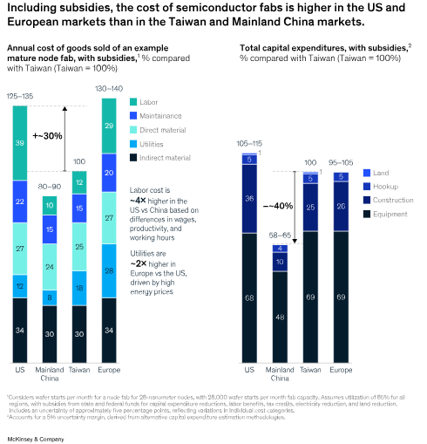
Figure 7: Costs of Semiconductor (McKinsey & Company, 2025b)
Legal Factors: There are a number of legal factors that favour TSMC in the U.S. especially with regard to the protection of intellectual property (IP). The U.S. has one of the strongest IP laws in the globe, so the innovation of TSMC will be secure. It is crucial in the semiconductor industry, as the basis of the competitive advantage of the company has been patents and trade secrets. These legal safeguards will serve to the advantage of TSMC and the R&D activity as the company will be able to maintain the positive implications of its innovations (Intel, 2024).
Nevertheless, issues of legal hurdles may arise as a way of adhering to environmental laws. The semiconductor manufacturing process in the U.S. is very energy consuming and the environmental laws are very stringent in the U.S. as compared to Taiwan. To prevent the possible punishment, TSMC has to adhere to the local environmental regulations regarding the waste disposal, water usage, and emissions. According to Figure 7, the supply chains can be more costly and complex, and these costs and the complexities can rise as the labour and environmental regulations become more strict in the U.S. (McKinsey & Company, 2025b).
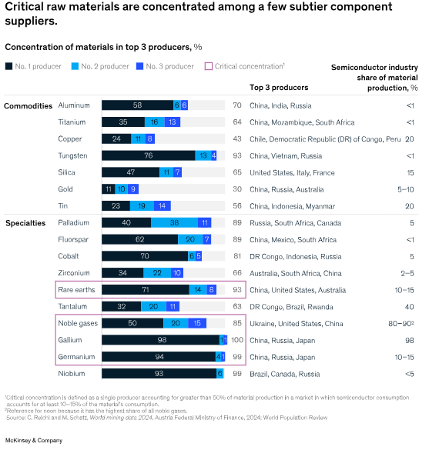
Figure 8: Concentration of Materials (McKinsey & Company, 2025b)
Also, anti-trust regulations might become a problem in the market where there are few major participants such as TSMC. The competition regulation in the U.S. is high and merger and acquisition relationships in semiconductor industry might be subject to scrutiny by the regulatory agencies.
Cultural Factors: Instead of looking at culture as a mere national difference between Taiwan and the United States, culture could be analysed in the context of managerial and organisational adaptation. The problem that TSMC is facing in the U.S., is not that the American and Taiwanese business culture is different, but that this could have a bearing on the effectiveness of its operations in the host country setting because of expectations of leadership style, communication, autonomy, and employee relationships.
The success of Taiwan Semiconductor Manufacturing Company (TSMC) in the U.S. depends on managing cultural differences. Although TSMC's hierarchical and long-term approach is different from the U.S.'s individualistic and short-term approach, TSMC has adapted its management approach. Through teamwork and cultural adaptation, TSMC has seamlessly merged with the U.S. market.
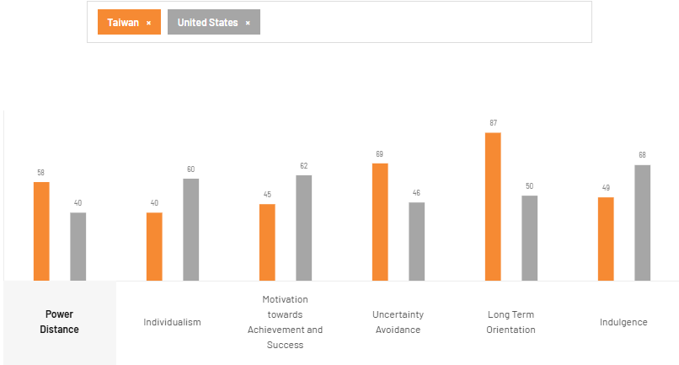
Figure 9: Country Comparison USA vs Taiwan (The Culture Factor Group, 2026)
The evidence on national culture indicates that the disparities in the relationships of authority, individualism, and decision-making standards may influence cooperation and integration within organisations in multinational companies (Beugelsdijk, Kostova and Roth, 2018). Thus, the ability of TSMC to adjust to the management practices to the local employment demands and retain production discipline and strategic consistency will be one of the determinants of its success in the U.S.
Technological Factors: The technological advantage of TSMC in advance technology in semiconductor manufacturing is amongst the main factors that have led to its success in the U.S market. TSMC has been in the vanguard of coming up with the best fabrication processes such as 7nm, 5nm, and 3nm which is necessary in future of computing and AI applications. The research and development (R&D) are one of the strong areas of the company, which makes it a primary force behind technological innovations in the U.S. semiconductor market (TSMC, 2022).
The problem of supply chains limits TSMC operations as the company expands its operations in the U.S. Semiconductor production has many critical materials, and most of them are imported by China and other nations as seen in Figure 9. The semiconductor ecosystem is also very concentrated in the world, and the three leading companies that produce the major materials such as rare earths and tungsten are located in areas such as China that produces 93 percent of the rare earths (McKinsey & Company, 2025). Any disruption in these supply chains would adversely affect the capability of TSMC to continue with its production programmes resulting in possible delays and cost increase.
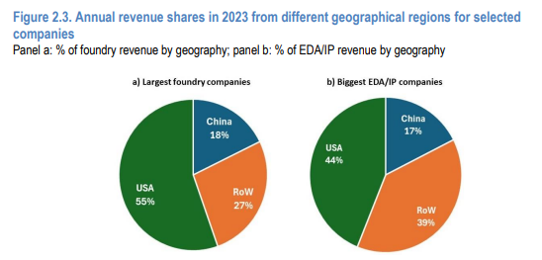
Figure 10: Annual Revenue Shares (OECD, 2025)
In addition, the environment is an important factor to TSMC success in the U.S. Semiconductor manufacturing is energy-consuming, and TSMC is required to follow the strict environmental rules of the United States. The Arizona fab should adhere to the legislative requirements of water consumption, emission, and waste management of chemicals. The cost of semiconductor fabs in the U.S. is 30% higher than semiconductor fabs in Taiwan, and labour expenses in the U.S. are about 4x more than in China (McKinsey & Company, 2025b).
Environmental Factors: Semiconductor manufacturing has a high energy consumption and is one of the industries that have a lot of environmental impact. With the expansion of its operations in the U.S., TSMC will be exposed to more pressure to identify with the environmental sustainability practises, which are of utmost importance in the U.S. market. The environmental regulations in the U.S. are one of the strictest in the international environment, especially in such industries as the semiconductor manufacturing that has highly energetic processes and produces a significant amount of waste (McKinsey & Company, 2025b). TSMC will be obliged to ensure that its Arizona fab is in compliance with the local environmental law such as water usage, emission bills as well as chemical waste disposal.
One of the environmental issues that TSMC will face is the carbon footprint. The electricity used in the semiconductor manufacturing process is excessive, and a significant portion of it is now powered by the fossil fuels in the U.S. (McKinsey and Company, 2025b). The company will be forced to invest in green technologies and renewable sources of energy in order to counter the effects on the environment due to the increasing trend towards sustainability.
Also, supply chain sustainability is emerging as an important concern. Since the U.S. semiconductor industry is moving toward more and more global supply chains of materials such as rare earth metals, TSMC will be required to establish their responsible sourcing and minimised environmental footprint throughout all the production cycles (OECD, 2025). In addition, the demands of consumers in terms of green products and corporate social responsibility (CSR) are increasing. To retain its competitiveness, TSMC should insist on practises that are in tandem with the regulatory requirements as well as market expectations of sustainability. Expansion into the U.S. market by TSMC is a strategic step to take advantage of increased demand of the high-technology semiconductors on the one hand, and entrench itself well in the U.S. market on the other hand.
The PESTLE analysis shows that TSMC’s performance in the U.S. is influenced by government incentives, such as the CHIPS Act, which offset the risks posed by high U.S. labor costs. Also, the cultural and technological environments pose risks and opportunities, as TSMC tailors its operations to the U.S. market.

Recommendations
In order to enhance its long-term standing in the U.S. semiconductor industry, TSMC ought to focus on operational localisation, as opposed to physical expansion. It must establish labour-related relationships with universities and technical institutes to overcome labour skills shortages (SIA and Oxford Economics, 2023). It must also enhance local supplier networks within Arizona to enhance integration of the ecosystem and diminish the reliance of operations on external inputs. Moreover, TSMC needs to fit the management practices to the U.S. organisational environment and ensure that expansion does not conflict with U.S. industrial policy and remain commercially viable in the long-term (TSMC, 2024).

5. Conclusion
Finally, TSMC entering the U.S. semiconductor market is a major opportunity and is supported by the U.S. government and the increasing demand of sophisticated semiconductors in sectors such as AI, 5G, and automotive electronics. The CHIPS Act and other financial incentives give TSMC a good base to leave a great mark in the U.S., eliminating the need to depend on foreign suppliers and maximising the level of national security. Nevertheless, the issues revolving around labour expenses, shortage of skills and geopolitical risks are still critical forces that TSMC should address properly. Cultural differences, the capacity to adjust to these differences, efficiency in production, and adherence to the regulations provided by the United States, particularly with regard to environmental sustainability will determine the success of the company. TSMC can acquire the top position in the semiconductor industry in the U.S. using its technological skills and global experience, therefore, developing the country economically and technologically.

Section 2

Reflective Account Using Gibbs’ Reflective Cycle
During the research and preparation of the foregoing sections of this report, I used the Gibbs Reflective Cycle to inform my reflection. The Gibbs cycle (1988) can be used as a helpful model of self-reflection in the structured form as it includes six steps: description, feelings, evaluation, analysis, conclusion, and action plan. This reflection will enable me to assess the approach I used towards the task and what I have learned and how I can work on my approach on future assignments.
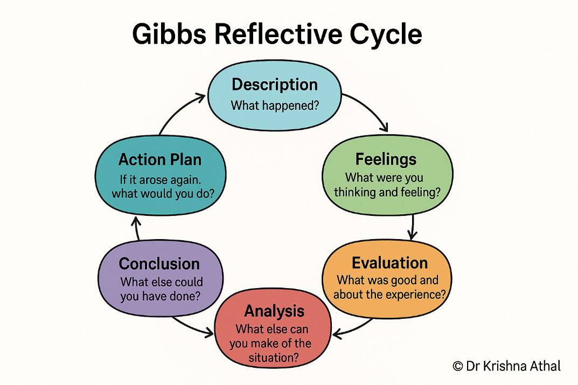
Figure 11: Gibbs Reflective Cycle (Athal, 2025)
1. Description: The primary assignment was to critically assess those factors that may affect the success of the operations of TSMC in the United States with special emphasis on political, economic, legal, and cultural factors. I applied the PESTLE model to the evaluation framework, as well as the Porters Diamond Model to examine the competitive landscape of the industry on a broader global basis. To emphasise the present state and strategic issues leading to challenges TSMC has to address in the U.S., I have used a variety of materials, such as McKinsey and Company (2025a) and OECD (2025). I also assessed facts of different figures which have been presented in the report.
2. Emotions: I believed that the experience of data collection and the need to combine several frameworks was complicated but satisfying. The amount of information was enormous, but the application of the Gibbs’ cycle helped to divide it into systems. Although at first I was shocked by the number of data, I liked how the frameworks would lead me to the analysis of particular aspects of TSMC functioning. Moreover, I found it intriguing that the process of applying cultural frameworks, such as the cultural dimensions model developed by Hofstede, to Taiwan-U.S. business interactions, was illuminating and that the difference in cultures can potentially affect the decision-making (Beugelsdijk, Kostova and Roth, 2018).
3. Evaluation: The report writing procedure enabled me to review the external and internal difficulties experienced by TSMC. On the one hand, the U.S. political environment was encouraging to the growth of TSMC, with its CHIPS Act (McKinsey and Company, 2025b). Conversely, the economic reasons, including labour expenses and supply chain problems (OECD, 2025), were problematic. Cultural differences of Taiwan and the U.S. also impacted the management decisions of the company because the power distance (Ghemawat, 2001) and individualism (Beugelsdijk, Kostova and Roth, 2018) may have influence on the organisational structure and decision-making processes in a multinational environment.
4. Analysis: I applied the Diamond Model of competitiveness by Porter to perceive the competitiveness of the American semiconductor industry and the importance of the factor conditions, including labour expenses and scarce raw materials (McKinsey & Company, 2025b). The PESTLE analysis has enabled me to evaluate the legal and political environment that includes influences of the U.S. regulations on the operations of TSMC. Investigating the global semiconductor market, it became clear that the global semiconductor market may limit activities of TSMC in the U.S. in terms of supply chain risks and concentration of resources (McKinsey & Company, 2025b) and the environmental sustainability conditions were also important, based on the energy used to manufacture semiconductors.
It was interesting especially the cultural analysis. The cultural values of Taiwan have influenced TSMC business practises and leadership styles and they are hierarchical and long-term oriented (The Culture Factor Group, 2026). This may cause conflict between these aspects and more individualistic and short-term oriented American corporate culture and there may be difficulties in integration.
5. Action Plan: In future work, I will enhance my research by collecting more primary data to complement secondary research. I will also work on the more efficient synthesis of findings by establishing the clearer relationships between the theory and practical applications. In the scenario of the growth of TSMC, further investigation of the cultural frameworks and more extensive data on the supply chain risks might yield more information on the areas, which influence the success of TSMC in the U.S.
To conclude, the application of the Gibbs’ Reflective Cycle has enabled me to critically evaluate the multi-faceted issues that TSMC is encountering in U.S. and I feel that through the economic, political, legal and cultural issues I was able to understand more about the issues that are involved with conducting business internationally.
6. Conclusion: I found out in this exercise that strategic adaptation to political, economic, legal and cultural environment of the U.S will be the major determinant of success of TSMC in the U.S. The U.S. policy initiatives such as the CHIPS Act (NIST, 2024) have been shown to have a significant political influence in TSMC, yet it will have to deal with the high labour costs and energy prices (McKinsey & Company, 2025b) of the U.S. and will need to adjust to the cultural specifics to provide a seamless experience of collaboration with the teams based in the U.S.

Reference List
AMD (2025) ‘AMD reports fourth quarter and full year 2024 financial results’. Available at: https://ir.amd.com/news-events/press-releases/detail/1236/amd-reports-fourth-quarter-and-full-year-2024-financial-results (Accessed: 20 March 2026)
Athal, D.K., (2025). Gibbs Reflective Cycle Explained: A Framework for Structured Self-Reflection. [online] Available at: https://drkrishnaathal.com/blog/gibbs-reflective-cycle-explained-a-framework-for-structured-self-reflection/ (Accessed: 12 March 2026)
Beugelsdijk, S., Kostova, T. and Roth, K. (2018) ‘Dimensions and dynamics of national culture: Synthesizing Hofstede with Inglehart’, Journal of International Business Studies, 48, pp. 146–170. Available at: https://pmc.ncbi.nlm.nih.gov/articles/PMC6191680/ (Accessed: 13 March 2026)
Business-To-You, (2018). Porter’s Diamond Model EXPLAINED with EXAMPLES. [online] Available at: https://www.business-to-you.com/porter-diamond-model/ (Accessed: 21 March 2026)
Deloitte (2026) 2026 global semiconductor industry outlook. Available at: https://www.deloitte.com/us/en/insights/industry/technology/technology-media-telecom-outlooks/semiconductor-industry-outlook.html (Accessed: 14 March 2026)
Ghemawat, P. (2001) ‘Distance still matters: The hard reality of global expansion’, Harvard Business Review, 79(8), pp. 137–147.
Gibbs, G. (1988) Learning by Doing: A Guide to Teaching and Learning Methods. London: Further Education Unit.
Intel (2024) Annual reports. Available at: https://www.intc.com/filings-reports/annual-reports (Accessed: 16 March 2026)
McKinsey & Company (2025a) ‘Creating a thriving chemical semiconductor supply chain in America’. Available at: https://www.mckinsey.com/industries/chemicals/our-insights/creating-a-thriving-chemical-semiconductor-supply-chain-in-america (Accessed: 21 March 2026)
McKinsey & Company (2025b) ‘Semiconductors have a big opportunity—but barriers to scale remain’. Available at: https://www.mckinsey.com/industries/semiconductors/our-insights/semiconductors-have-a-big-opportunity-but-barriers-to-scale-remain (Accessed: 23 March 2026)
NIST (2024) ‘Biden-Harris Administration announces CHIPS incentives award with TSMC Arizona to secure U.S. leadership in advanced semiconductor technology’. Available at: https://www.nist.gov/news-events/news/2024/11/biden-harris-administration-announces-chips-incentives-award-tsmc-arizona (Accessed: 20 March 2026)
NVIDIA (2025) Annual reports and proxies. Available at: https://investor.nvidia.com/financial-info/annual-reports-and-proxies/default.aspx (Accessed: 13 March 2026)
OECD (2025) Mapping the semiconductor value chain. Paris: OECD. Available at: https://www.oecd.org/content/dam/oecd/en/publications/reports/2025/06/mapping-the-semiconductor-value-chain_5ba52971/4154cdbf-en.pdf (Accessed: 12 March 2026)
Ormston, A. (2025). PESTLE Analysis: Understanding Market Influences for Better Decision-Making. B2B International. Available at: https://www.b2binternational.com/2025/04/03/pestle-analysis/ (Accessed: 25 April 2026)
Porter, M.E. (1990) The Competitive Advantage of Nations. New York: Free Press.
Reuters (2026a) ‘Trump imposes 25% tariff on imports of some advanced computing chips’, 15 January. Available at: https://www.reuters.com/world/us/trump-imposes-25-tariff-imports-some-advanced-computing-chips-2026-01-14/ (Accessed: 12 March 2026)
Reuters (2026b) ‘Taiwan contract chipmaker TSMC’s U.S. investments’, 16 January. Available at: https://www.reuters.com/world/asia-pacific/taiwan-contract-chipmaker-tsmcs-us-investments-2026-01-16/ (Accessed: 13 March 2026)
SIA (2025) 2025 state of the U.S. semiconductor industry. Available at: https://www.semiconductors.org/2025-state-of-the-u-s-semiconductor-industry/ (Accessed: 13 March 2026)
SIA and Oxford Economics (2023) Chipping Away: Assessing and Addressing the Labor Market Gap Facing the U.S. Semiconductor Industry. Available at: https://www.semiconductors.org/chipping-away-assessing-and-addressing-the-labor-market-gap-facing-the-u-s-semiconductor-industry/ (Accessed: 12 March 2026)
The Culture Factor Group (2026) Country comparison tool. Available at: https://www.theculturefactor.com/country-comparison-tool (Accessed: 11 March 2026)
TSMC (2020) ‘TSMC announces intention to build and operate an advanced semiconductor fab in the United States’, 15 May. Available at: https://pr.tsmc.com/english/news/2033 (Accessed: 11 March 2026)
TSMC (2022) ‘TSMC announces updates for TSMC Arizona’, 6 December. Available at: https://pr.tsmc.com/english/news/2977 (Accessed: 11 March 2026)
TSMC (2024) ‘TSMC Arizona and U.S. Department of Commerce announce up to US$6.6 billion in proposed CHIPS Act direct funding, the company plans third leading-edge fab in Phoenix’, 8 April. Available at: https://pr.tsmc.com/english/news/3122 (Accessed: 12 March 2026)
TSMC (2025a) 2024 annual report. Available at: https://investor.tsmc.com/static/annualReports/2024/english/index.html (Accessed: 12 March 2026)
TSMC (2025b) ‘TSMC intends to expand its investment in the United States to US$165 billion to power the future of AI’, 4 March. Available at: https://pr.tsmc.com/english/news/3210 (Accessed: 12 March 2026)

