Name: Mengxi Fu (Sherry)
Student ID: 2107121
Institutional Affiliation: Dprof of Art and Design, UWTSD
June, 2022

Methodologies

Research Question: To study the uniqueness of VR as an art medium, to find out the specific factors that VR can empower for art, so that artists can understand more clearly what VR can do for their art concept, and to play the role of VR medium more effectively when creating.

Philosophic Framework
Ontology: The nature of virtual reality art.
Epistemology (Knowledge): Concepts / Literature review / Researcher’s background
Axiology (Value): Why choose this topic? What is the gap? Is there any potential contribution?
Methodology: Phenomenology / Action Research (autoethnography) / Comparative Experiments

Round 1 Objective: Build up the factors that VR can empower for art.

Method 1: Phenomenological Research
About: Phenomenology originated with Emund Husserl and was expanded by Heidegger, Sartre, Merleau-Ponty and others. Phenomenology is both a philosophical argument and a methodology. According to Van Manen (2014) the term practical phenomenology is adopted to describe the meaning-giving approach of phenomenology. But in any case, what phenomenology and phenomenological research have in common is the study of people's lived experiences, the idea that these experiences are conscious (Van Manen, 2014), and the description of the nature of these experiences.

Characteristics of phenomenology include: 1. an emphasis on the phenomenon to be
explored, expressed as a single concept or idea. 2. exploring the phenomenon with a
group of people who have all experienced it. 3. having a philosophical discussion of
phenomenology. 4. "Epoche," in which the researcher excludes himself or herself from
the study of an individual's experience of a phenomenon, so that the researcher can
focus on studying the experiences of the participants. 5. A data collection process that
usually involves interviewing individuals who have experienced the phenomenon,
including documents, opinions, poems, paintings, etc. 6. The data analysis can follow a
systematic procedure and focus on a summary of what the individual has experienced
and "how" they have experienced it (Moustakas, 1994). 7.The phenomenology
concludes with a descriptive paragraph discussing the essence of the individual's
experience.

Purpose Statement: The purpose of this phenomenological study is to discover the factors that VR can empower for artists when they are creating. At this stage in the research, the empower factors will be generally defined after interviewing relevant artists and analyzing recorded data.

Paradigm: Interpretivism (Social Constructionism) Since phenomenological research deals with real interviews and personal experiences, it is descriptive and requires the researcher's interpretation, and thus it must be interpretivism or social constructionism, and belongs to a qualitative approach (QUAL).

Procedure: 1. I should determine if the research problems are best examined by the phenomenological research (Creswell, 2013). According to the Round 1 Objective, the purpose is to build up the factors that virtual reality can empower for art. I think it is reasonable to find out the key words or phenomenon by using this method. 2. I should identify the phenomenon, which is the VR art experience by relevant artists. 3. Distinguish and define phenomenology's broad philosophical assumptions. A blend of objective reality and personal experience, for example, can be written down. Furthermore, these lived experiences are "aware" and "object-specific." I must describe their personal experiences in as much detail as possible in order to fully characterize how participants see this phenomenon. 4. I need to collect data from individual artists who have experienced this phenomenon through in-depth and multiple interviews. 5. Next I will generate themes from the analysis of important statements. 6. Based on the significant statements, I have to write a description of what the artists (participants) experienced and what influenced their experiences. According to Crewswell, this step is also called “textural and structural descriptions”. 7. Using the materials I got from the previous steps to find out the essence, or key factors. 8. Sort out and write down the understanding of the essence in a formal form.

Data Collection: Interview
Interviews are an important step in phenomenological research. Since the focus of phenomenological research is on the shared experience of a number of individuals, Polkinghorne (1989) suggests that researchers interview between five to 25 people who have experienced the phenomenon. So I will choose around 10 artists as the interviewees. Two broad general questions were posed to participants (Morse, 1994): What has been your personal experience with this phenomenon? What kinds of conditions or contexts tend to influence or affect your perception of this phenomenon? Other open-ended questions can be asked, but these two focus on gathering information that will lead to a textual and structural description. It emerges that my interview questions include, but are not limited to：
- Can you share your personal experience with virtual reality art?
- What kinds of conditions or contexts tend to influence or affect your perception of virtual reality art?
- What’s the difference between making art through VR with other mediums?
- Do you think VR has brought anything to your artistic ideas?
- Do you have any concerns or worries about creating with VR at this stage?
In the form of recorded interviews, Van Manen (1990) refers to recorded conversations; formal written responses; and descriptions of alternative experiences of theater, film, poetry, and fiction. Of course, the artist's work can also be included.

Data Analysis: The analysis of interview data requires the use of epoche, a term used by Husserl to refer to the process by which researchers avoid biases and preconceived ideas about the phenomenon they are trying to study. This is the essence of the method of bracketing. Since the data collected are diverse, including interviews with audio, video, images, text, etc. These materials are interpretative, so narrative analysis and visual metaphors are needed to assist in analyzing the data, while ATLAS, a nature study data analysis software, can be used to help process the data.

Ethic: 1. the interviewees' consent should be obtained in advance, and the interviewees should be voluntary and informed. 2. the privacy of the interviewees and the copyright of their works should be protected. As the interviewees are artists, permission should be obtained for the display and research of their works and the copyright of the works should be respected. 3. The researcher should try to avoid overly oriented questions during the interview process, avoid incorporating their own subjective consciousness, and respect the interviewees' descriptions of their experiences. 4. All data should be recorded honestly and stored properly to avoid data leakage.

Advantages:
- Phenomenological research relies on in-depth interviews and does not typically involve the use of expensive technology to collect and evaluate data, making them ideal for small-scale (5-25 persons) research with well-controlled budgets.
- Phenomenological research describes the daily lives and experiences of participants and is more easily empathize with.
- Phenomenological research can dig deeper into complex empirical facts.
- Phenomenological research requires that researchers suspend their own experiences and antecedent perspectives so that participants are fully respected.

Challenges:
- Since phenomenological research is subjective, descriptive, and interpretive, it is relatively devoid of positivist objectivity in analysis and measurement.
- Because of the small sample size of phenomenological research, the universality of the findings remains in doubt.
- Although phenomenological research requires "epoche", it is difficult for researchers to completely exclude their own experience and consciousness at the practical level.

Method 2: Action Research (Autoethnography)
About: According to Creswell (2018), action research is usually associated with small-scale research projects in which the researcher is personally involved. In addition, action research should consider "change" as part of the research process, rather than change after conclusions have been drawn. Action research therefore values the research process and encourages the researcher to be both the research subject and the practitioner. He emphasized that "only practitioner research conducted by professionals who specialize in research can be called action research. ...... They study their own practice." To be in the ethos of action research, the researcher needs to explore his own practice, change it and benefit from it. This leads to four features of action research: practicality, change, cyclical process, and participation.

Purpose Statement: The purpose of this autoethnographic study is to discover the factors that VR can empower for artists when they are creating. At this stage in the research, the empower factors will be generally defined after self practicing and reflecting the experiences.

Paradigm: Interpretivism (Social Constructionism) Since action research deals with professional practice, it needs to be recorded and written down the researcher's reflection, and thus it must be interpretivism or social constructionism, and belongs to a qualitative approach (QUAL).

Procedure: The process of action research is cyclical, with the crucial point being that the research is fed directly back into time and the process is ongoing. Practitioner reflection is particularly important as a means of improving practice or evaluation. 1. According to the Round 1 Objective, the purpose is to build up the factors that virtual reality can empower for art. In order to gather a more comprehensive understanding and feeling of VR art, it was necessary for me to not only interview the artists, but also to include my own VR practice experience with a background in art making. Therefore I think focusing on professional practice and reflective action research is an approach that can be used as an adjunct to research. 2. I will use HMD devices to create VR art as an art practitioner and document the process. 3. I will write down my critical reflections for each stage of art practice. 4. Keyword extraction and research of self-reflection in relation to the research questions. 5. Propose new strategies and plans for improvement based on the autoethnographic research. 6. Act again to use the updated practice plan.

Data Collection: Self-Practice (Sample Size: 01) Action research is initiated by the practitioner; in other words, the practitioner drives the research. Thus the practitioner plays a major role in the data collection step of action research. Although the relationship between the researcher and the practitioner needs to be balanced and the attribution of research rights needs to be considered, it would be much easier if both were myself.
Concrete practice plan: 1. find inspiration, determine a creative theme and the VR creation software to be used. 2. familiarize with the software and do some practice beforehand. 3. use the software to create a series of creations, you can try different artistic styles of the same theme and record videos. 4. try to export VR works to different forms and interface with other platforms. 5. try different forms of displaying works. 6. write down personal feelings about the impact of using VR platforms on the creation of different artistic styles, the form of output and subsequent transformation and display with other platforms, etc. 6. Write down personal feelings about the creation, including the comparison of the impact of using the VR platform on the creation of different artistic styles, the form of output of the work and the subsequent transformation and display with other platforms, etc.

Data Analysis: Visual Analysis / Critical Reflection
In the data analysis of the self-practice action research, since the data collected is diverse, including video, images, text, etc. These materials are interpretive in nature, so narrative analysis and visual analysis are needed to assist in analyzing the data, along with the use of critical reflection. Throughout the analysis process, I have to be careful to distinguish the two roles of researcher and practitioner, try to remain objective, and avoid letting these two roles influence each other.

Ethic: 1. respect both identities as researcher and practitioner. 2. provide adequate protection for included data and documents. 3. be transparent about the progress of the work and accept the opinions of others. 4. Ensure the impartiality of the study. In particular, as both a researcher and a practitioner, I have a significant right to modify the research plan and should be extremely careful to avoid arbitrary tampering.

Advantage:
- Action research contains the process of participation, and will fully respect the practitioner's knowledge.
- As both a researcher and artist, I could take advantage of the practice by improving or developing professional abilities.
- According to Somekh, action research could make a difference and bring tangible improvements in practice.
- Because action research is cyclical, it allows for more practical and effective adjustments or changes to the research plan, allowing the researcher to obtain more in-depth and comprehensive results.

Challenge:
- The necessity for practitioners to participate in action research, especially in my program, where I am both practitioner and researcher, limits its scope and scale and thus affects its extent and generalizability. The potential downside is the proximity to case studies, which may lack representativeness and credibility.
- In a collaborative framework of practitioners and researchers, it is easy to dispute who leads the research and who has the ownership of the research.
- Action research usually adds extra workload to researchers and practitioners, and it is important to be aware of planning time and effort.
- Although the need for impartiality in research has been emphasized, and I should be careful to distinguish between the roles of researcher and practitioner, it is still difficult to do so in practice. I need to jump out of my role and look at the situation objectively and impartially.

Round 2 Objective: Test and develop the factors that VR can empower for art.

Method 3: Mixed Method
About: Mixed methods approach, also known as Multimethodology, is a method of study in which researchers collect and analyze both quantitative (QUAN) and qualitative (QUAL) data in one research study (Braun, 2013). Mixed methods research includes the following characteristics: the integration of several types of research into a single project; a preference for viewing research problems from various viewpoints; and the selection of methods for a certain problem by a problem-driven approach (Creswell, 2018).

Purpose Statement: The purpose of this mixed method study is to discover, test, and develop the factors that VR can empower for art. At this stage in the research, the empower factors will be generally defined after qualitative and quantitative research.

Paradigm: Pragmatism
According to Cherryholms (1992) and Murphy (1990), pragmatism isn't tied to a single philosophical or reality paradigm. Researchers have a lot of freedom in terms of selecting the methods and procedures that best suit their needs and goals. Pragmatism is usually tied with mixed methods or multi-methodology. Researchers will use multiple methods of data collection and data analysis, so that to better implication.

Procedure:
Since mixed research will use both qualitative and quantitative methods, which strategy to use at which step of the research, and the proportion of weighting, etc. need to be figured out in advance. My VR art research is currently divided into two preliminary rounds. The first round is to find the specific factors of VR empowerment for art, and the second round is to verify these factors. The first round of research takes a primarily qualitative approach, collecting and analyzing data through phenomenological research and self-action research (see above for details), and interpreting it using an interpretivist paradigm. The second round of the study took a primarily quantitative approach, collecting and analyzing data through a comparative study method with controlled variables and a questionnaire, relying on a positivist paradigm to guide the entire research process. It follows that the entire mixed-methods study is sequential, with qualitative first and then quantitative. In terms of relative importance, the first round of factors found in my overall study design is more important, so qualitative research is given more weight, with quantitative research serving as secondary validation. Of course, the whole process is propulsive, and the research derived from one method will guide the next phase of the study.

Data Collection: Interview/ Self-Practice / Controlled Variable Experiments / Surveys
In the first round of the study, I will use interviews and self-practice to collect data (see above for details). In the second round of the study, I will use controlled variable experiments and questionnaires to collect data.
Controlled variable experiment: Several factors of VR empowered art found in the first round of research will be used in the creation of art. The artists participating in the experiment will be asked to create art using each of these factors. Tentatively, they will be divided into two control groups：

Group A: The same artist uses different factors and the researcher records the creative process, results, artist's feedback and reflections.
Group B: Different artists use the same factor, and the researcher records the creative process, results, artist's feedback and reflection.

Survey: The survey included both the artists who participated in the experiment and the audience who watched the results of the experiment, i.e., the finished artwork created by the participating artists using VR empowerment factors. The purpose was to discover and evaluate the effectiveness of the VR empowerment factors. The format of the questionnaire will be determined by the way in which the experimental works are presented. If the artwork is displayed online, then the questionnaire will also be distributed in online format; if the work is displayed offline, such as actually holding an exhibition at the venue, then the questionnaire will be available for the audience to fill out on site as part of the exhibition. The survey questions will be determined based on the findings of the first round.

Data Analysis: Triangulation
Mixed methods are predestined to adopt multiple perspectives, so triangulation of data collected by multiple methods should be used to improve the accuracy and comprehensiveness of the findings, i.e., to compare findings from different methods (Denzin, 1997). Throughout my research analysis I will use: narrative analysis (A), critical reflection (B), survey analysis (C), and comparative experiment. analysis (D), which will result in three combinations of cross-evidence based on triangulation:
A-B-C, B-C-D, and A-C-D. In the first round, the findings from the phenomenological narrative analysis and the autoethnographic critical reflection are compared, and in the second round, the data from the artists' creative feedback and the questionnaires in the comparative experiment are compared, and the data from the first and second rounds are compared, so that these data can prove and complement each other to obtain an accurate and comprehensive the data from the first and second rounds will be compared to prove and complement each other to obtain an accurate and comprehensive research result.

Advantage:
- Mixed methods can increase the validity and accuracy of research through triangulation of mutual evidence, allowing the researcher to have a more comprehensive interpretation of the research question.
- The philosophical paradigm of mixed methods is pragmatic, providing the researcher with an effective problem-driven approach that incorporates practice and avoids falling into the position of a single philosophical framework.
- Mixed methods offer a variety of research techniques and encourage the researcher to clearly explain how different methods and data complement each other, allowing for more objective research results.
- Each research strategy and method has its own strengths and weaknesses, and mixed methods allow researchers to build on their strengths and avoid their weaknesses.

Challenge:
- Because mixed methods require researchers to master and use multiple methods, including both qualitative and quantitative studies, research practice and costs may increase.
- Studies derived from different methods need to be confirmed by each other, and if they fail they need to be explained.
- The philosophical position of positivism may be perceived as utilitarian and lacking in principle. In order to avoid research methods that are mistaken for "anything goes", researchers need to be more rigorous in their choice and use of methods at each stage.

Research Findings

Art Creation Process

Takeshi Okada (冈田 猛), who is the professor of Graduate School of Education at University of Tokyo, specifying his research on Cognitive Psychology of Creativity. In his paper “How Does Art Viewing Inspires Creativity?” (Ishiguro and Okada, 2021) He summarized that In the literature of psychology, aesthetics and creativity are essential concepts for understanding the mechanisms of artistic activities such as viewing and making art. Consequently, there is limited research on the relationship between the two activities. Tinio, a psychologist on aesthetics, highlighted this issue and claimed the necessity to start new studies to understand the relationship between the two activities. I can see that the development of creative expertise can be considered as a type of learning in a social context. This paper has reviewed research on art viewing and creativity to illustrate how individuals experience inspiration to create artworks through art viewing. Takeshi and his team had demonstrated a dual focus, which centers on both evaluating artwork and reflecting on individuals' artistic activities, and integrates the processes of being inspired by and inspired to.

In another of his articles studied Analogical modification in the creation of contemporary art.
In order to capture the analogical process in the context of creation, Takeshi and his team focused on ''analogical modification" for generating differences in the analogical process. Analogical modification is a cognitive process used to generate a new target, in the context of creation, by changing values of a source to make differences during analogical mapping. Thus, analogical modification for creation is different from adaptation for understanding and problem solving in the sense that it has the function of target generation. From this article, I found that artistic creation can be better understood as the dynamic process of interaction between activities in a short time period, such as analogical modification, and activities over a long time span, such as the development of creative vision. This article showed that such a cognitive process for difference making has been used frequently by artists in order to create new artwork series. There are three types of analogical modification, ''subject modification", ''structure modification", and ''concept modification”. By using this framework to accumulate data on the creative process of various artists, people can understand the contents of creative vision and superordinate concepts, as well as the way in which each artist combines three types of analogical modification. In the field of modern and contemporary arts, this article found that artists often used analogical processes with which they mapped a technique or a concept onto a new situation to create a new artwork. However, such a process is somewhat different from analogical processes in the context of understanding and problem solving.
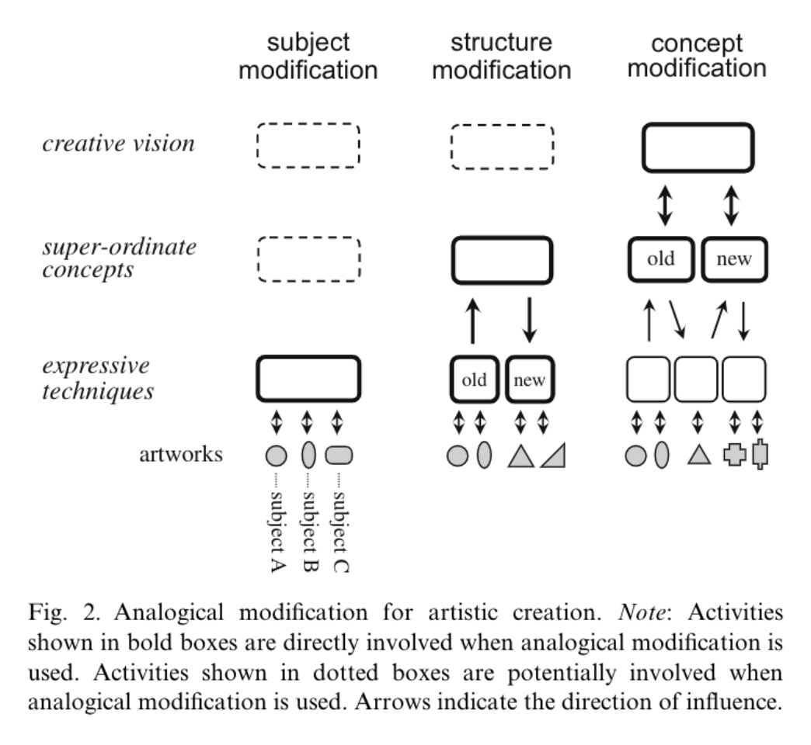

Virtual Reality

This is a chronology that I made. We can see the 360 degree immersive multi-sensory experience from the concept of science fiction gradually to reality. From the 60's it had some attemptions and tested, and in the 80's and 90's it was prototyped by major organizations, but many projects failed due to technical limitations until the 21st century when the advent of the smart age provided mature technical conditions for the development of VR, and several leading companies emerged to build VR hardware and ecosystems.
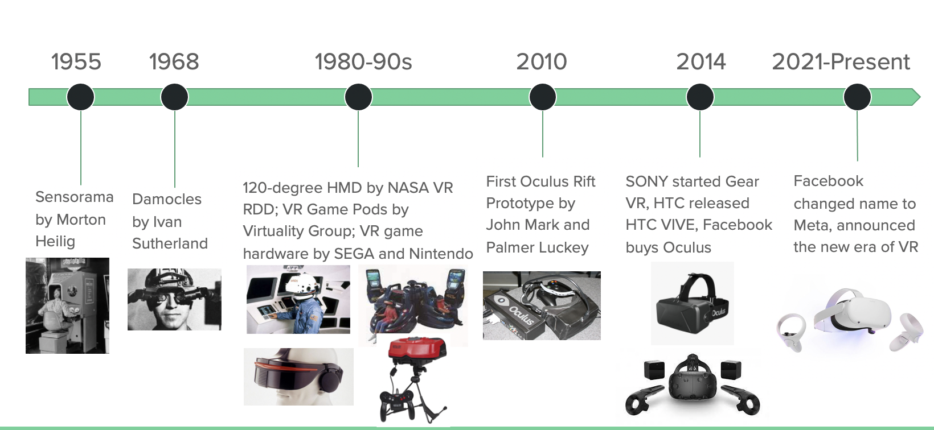

According to Kim and Lee (2022), VR can be defined as a simulated environment in which people feel “present”， many scholars point out that immersion, presence, and interactivity are regarded as the core attributes of VR technologies. presence is defined as “a psychological state in which the virtuality of experience is unnoticed” . interactivity can be described as the degree to which a user can modify an object in the VR environment in real-time. Low latency and a clear environment enhance user immersion, and good interactivity enhances the user's sense of presence, all three of which influence each other.

Post-phenomenology, as a complement to Husserl's phenomenology, emphasizes the relationship between humans and technology. Like Dutch philosopher Peter Paul Verbeek said it questioned How technology affects people's behavior, choices, and experiences. (Joakim, V. and Barbara, W. 2021) ​​Joakim Vindenes and Barbara Wasson focus on post-phenomenology as a framework for the application of user-environment relationships in immersive VR environments, and then they draw a model to help us understand the role of VR as a technological medium in the relationship between humans and the technology of the world. In this model, "human" specifically refers to the participant or researcher, and then we transfer the consciousness to the "user" through subjective transfer, such as the creation of an avatar, and then the "user The "user" and the "virtual environment" are then exposed to the "virtual environment", and then the environment eventually delivers the data objectively. During this time user and environment together form the medium, and VR amplifies this user-environment relationship. These two scholars propose two kinds of user-environment relations: “Subjectivity and Objectivity Inversion”, and “Subjectivity and Objectivity Synchronization”.

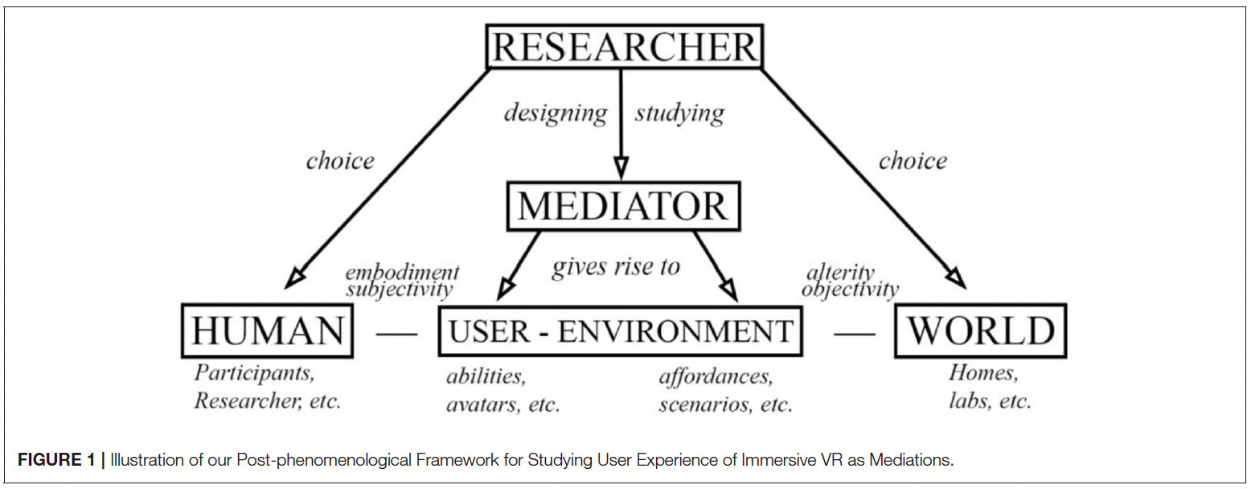

VR Market:

A virtual reality report, Virtual Reality Market Size, Share & Trends Analysis Report By Technology (Semi & Fully Immersive, Non-immersive), By Device (HMD, GTD, PDW), By Component (Hardware, Software), By Application, By Region, And Segment Forecasts, 2022 - 2030, hereinafter referred to as the Report (Grand View Research, 2022). According to the Report, the global virtual reality market was worth USD 21.83 billion in 2021, and it is predicted to increase at a 15.0 percent compound annual growth rate (CAGR) from 2022 to 2030. Virtual Reality (VR) is a digitally created experience that simulates a three-dimensional real-world environment. VR equipment such as gloves, headsets or glasses, and bodysuits are used to provide viewers with an immersive experience. By allowing users to immerse themselves in a fully realistic environment, virtual reality has changed the gaming and entertainment industries. In addition, the expanding usage of this technology in instructional training, such as for instructing engineers, mechanics, pilots, field workers, military warriors, and technicians in the manufacturing and oil and gas industries, is fueling market expansion.

The virtual reality market is segmented on the basis of technology into non-immersive, semi-immersive, and fully immersive based technologies. Among these semi-immersive and fully immersive VR technologies are enabled by devices such as VR projectors, display walls, shutter glasses, and motion devices that stimulate the user to experience immersion or presence by using a wide field of view to engage the user in a partially or fully immersive environment. Non-immersive VR technologies allow interaction with the surroundings using a joystick or mouse, with the user remaining stationary in the physical space and interacting with the virtual space. Semi-immersive and fully immersive technologies hold the largest share of about 8O.0% in 2020 due to the preference for HMD-based VR devices. Devices based on semi and fully immersive technologies include HMDs, goggles, data gloves, treadmills, foot controllers, body units, GTD, and PDW, which provide users with an immersive virtual environment experience. These VR devices help users achieve maximum isolation from the real world dimension in the virtual world. Modern VR devices provide visual, auditory and haptic feedback.

The Head-Mounted Display (HMD), Gesture Tracking Device (GTD), and Projectors Display Wall (PDW) are the segments of the virtual reality device market that have been identified. Due to the increased development of cutting-edge portable VR gear, HMD is anticipated to be the dominant segment over the projected period. The importance of VR HMDs in business and consumer applications is propelling the segment's expansion. Additionally, the variety and adaptability of HMDs, including self-contained, tethered, and hybrid HMDs, are credited with the increase. The sector for gesture-tracking devices (GTDs) is anticipated to experience the highest CAGR of 2.0% throughout the forecast period. Therefore the scope of my research will focus on semi-immersive and fully immersive VR technologies.

According to the Device Type Segmentation Analysis chart, the head-mounted display device segment accounted for the largest revenue share of over 60.0% in 2021 and is expected to dominate the market from 2022 to 2030. The growing importance of VR headsets in commercial and consumer applications is propelling their demand in the market. In order to provide customers with a greater immersive experience, companies are constantly involved in technological developments in this field. Meta acquired Ready at Dawn, a VR-based video game developer, and entered into an agreement to develop games for Oculus Studios that incorporate VR-based content. Companies are focusing on offering quality services to their viewers with innovative content and examining new fields with VR solutions as the market becomes more competitive. Many companies have realized the potential of the enterprise sector in the VR market and have forayed into the lucrative market.

The internal segments of VR software, such as those for application development, training, simulation, virtual tours, gamification, game development, segmented reality, and learning experience platforms, are where VR entrepreneurs are creating their service offerings. According to the Application Segmentation Analysis chart, Virtual reality market segments include aerospace & defense, commercial, consumer, enterprise, healthcare, and others.
In the other section, there is a VR theme park, a VR art exhibition, and a VR musical experience. During the forecast period, the market is anticipated to expand at a CAGR of 18.4%. With a projected revenue of approximately USD 8,000 million in 2019, the commercial application dominates the worldwide VR market. During the projection period, the segment is anticipated to expand at a CAGR of 19.5%.

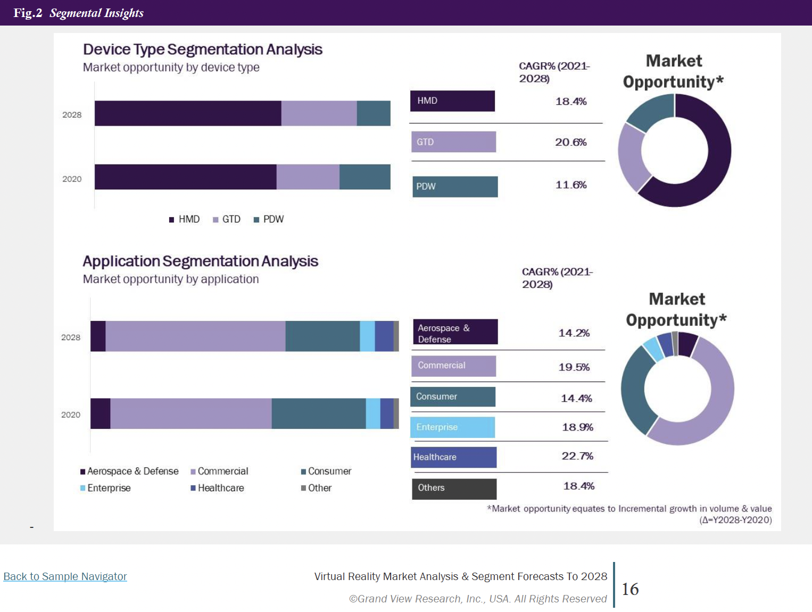

According to the Report, the market is anticipated to see a decline during the projected period as a result of the illnesses and disorders that are steadily worsening the health of VR gadget enthusiasts. To combat this, the corporations are establishing the rules and giving their users a manual with suggestions that could assist balance the usage of these systems over the long term. Additionally, it is strongly advised against using VR headsets on minors, and companies like Samsung and Oculus advise taking a ten-minute pause after using them for a continuous half-hour to give the user's eyes a rest.

VR Art

(Art Basel) For artists, because it can contain visual, spatial, sonic, and haptic components, VR offers a degree of sensory immersion and a potential for interaction beyond any other presently available medium. Artists could consider virtual reality to be an exciting opportunity. The technology's immersive nature, which allows the artist to embody the spectator within their work, creates a really phenomenological experience. This gives artists a very potent means of communication. If the goal of art is to change our perspective of the world, virtual reality accomplishes this in the most literal sense. (Artvisor, 2018)
The medium theory proposed by Marshall McLuhan has provided theoretical support for a number of new media arts. In his book, he writes: "The medium is the message." This echoes Don Ihde's postphenomenology. The wheel…is an extension of the foot…The book… is an extension of the eye…Clothing, an extension of the skin…Electric circuitry, an extension of the central nervous system… All media are extensions of some human faculty- psychic or physical.” VR as a new artistic medium has spawned a wealth of applications for artistic creation on the HMD platform in recent years.
Marina Abramovic collaborated with Acute Art, which is a pioneer art institution that dedicated to working with artists to create works using VR, AR, 360-degree video and other related technologies, to create her virtual reality art "Rising" (Abramovic, 2018), which made me realize the moral and ethical ability and attraction of virtual reality art. According to Acute Art (2018), every audience in this work would wear an immersion earphone. They would come face-to-face with the artist's charter, who beckons from within a glass tank that is slowly filling with water from her waist to her neck. Then the audience would be surrounded by a dramatic scene of melting of the polar ice sheet. The audience should choose whether to reduce the water level in the water tank to save the artist and the environment. What struck me about Abramovic's work was not only that she made good use of VR technology to create impressive works, but that she didn't stop at the creative level, but went deeper to discuss how the immersive nature of VR technology can be used to stimulate moral emotions. Abramovich gave an interview at the “Behind the Scenes” meeting and explained.
In 2016, Google released Tilt Brush, a VR painting tool that allows people to create immersive 3D paintings inside a VR headset. Subsequently, VR drawing tools for different fields of art and design were introduced in the market, such as QUILL for illustration and animation creation, Gravity Sketch for 3D model design, etc (Lang, 2021). Many artists are trying these tools, including Anna Zhilyaeva from France, who uses VR and Tilt Brush to paint. Using virtual spaces and unique brush effects, Anna created a large number of female portraits, and later, at the invitation of Louvre, she turned the world-famous paintings into 3d immersive scenes (Zhilyaeva, 2016).
According to Lavelle (2018), virtual reality is still gaining traction in the art world; unlike traditional forms of art, virtual reality works are infinitely replicable. Due to the high value of digital artwork, innovative methods such as blockchain and watermarking have been developed to prevent this from happening. Virtual reality art is an experience rather than a solid object. VR disrupts traditional art processes and art market standards in this way, mimicking the radical video and performance art of the late 1960s and 1970s. VR art, like other once-radical, institutionally critical art movements, is likely to become a paradigm in art history and a popular commodity in the art market. Some artists choose to create limited editions with proof of authenticity. In this case, there are some restrictions on sales. For example, the buyer cannot make any representations or distribute them; the buyer cannot lend them without the artist's consent. The artist must be consulted before the work is publicly displayed.

Danish artist Christian Lemmerz created a piece of VR art that was exhibited by the Faurschou Foundation in Venice. The artwork, titled La Apparizione, was presented in a three-by-three meter room. The viewer, once inside the room, puts on a headset and is transported into outer space, with a levitating golden Jesus in the center.

Another new factor to consider when selling VR artwork is the hardware. A headset is usually included in the price of the artwork. HTC Vive and Oculus Quest are the industry's leading headsets, each costing around £300. Acute Art is a free smartphone software that lets you view virtual reality and augmented reality art on your phone using Google Cardboard. Although the art is free, there is a membership option that costs £23 per year and gives you access to premium stuff. Christo and Jeanne-Claude, Marina Abramovic, and Olafur Eliasson are among the artists actively participating in the app. Music is now accessed through a subscription to Spotify, books through Amazon Kindle, film and tv through Netflix. Subscription based gaming sites threaten to do the same to the game industry. This poses the question: could the future of the digital art market be subscription based too.

At Art Basel, participants also mentioned that dealers and collectors are dubious about the ability for the artworks to be sold. Yet, as all speakers noted, this is a historical constant: buyers had been just as uncertain about the salability of video, and film and photography before that. Perhaps, rather than justifying the use of VR due to its novelty in tech-centric modes of presentation, it would also benefit from curatorial juxtaposition with works from a wide variety of media.

About Web 3.0 and Metaverse

What is Web 3.0?
(CoinMarketCap, 2021) Web 3.0, the upcoming third generation of the internet, will enable websites and apps to process information in a smart, human-like manner with technologies like machine learning (ML), big data, decentralized ledger technology (DLT), etc. Tim Berners-Lee, the creator of the World Wide Web, first referred to Web 3.0 as the Semantic Web. Its goal was to create a more independent, intelligent, and open internet. The definition of Web 3.0 can be broadened to include the following: data would be connected in a decentralized way, which would be a significant improvement over our present internet generation (Web 2.0), in which data is primarily held in centralized repositories. The four characteristics of web 3.0 are：
- Ubiquitous; Web 3.0 makes the Internet accessible to everyone, anywhere, anytime. Connected devices will no longer be concentrated on computers and smartphones as in Web 2.0, because IoT (Internet of Things) technology will bring a plethora of new smart devices.

- Semantic Web; semantics is the study of relationships between words. Thus, according to Berners-Lee, the Semantic Web enables computers to analyze the vast amount of data from the Web, including content, transactions and connections between people. Applying semantics in Web 3.0 will enable machines to decode meaning and sentiment by analyzing data. As a result, Internet users will have a better experience through enhanced data connectivity.

- Artificial Intelligence: Because Web 3.0 machines can read and decipher the meaning and emotion conveyed by a set of data, it brings intelligent machines. While Web 2.0 offers similar capabilities, it is still mostly human-based, while web 3.0 brings intelligent connectivity.

- 3D graphics: Some futurists also refer to Web 3.0 as the Spatial Web, because it aims to make three-dimensional (3D) virtual worlds explicit by revolutionizing graphics technology to blur the line between physical and digital.

Related to art in Web 3.0 is Non-Fungible Tokens (NFTs) . According to Ante 2021, Non-fungible tokens (NFTs) are transferable rights to digital assets, such as art, in-game items, collectables or music. The phenomenon and its markets have grown significantly since early 2021. This paper investigates the interrelationships between NFT sales, NFT users (unique active blockchain wallets), and the pricing of Bitcoin and Ether.
The current applications of Web 3.0 based on blockchain technology include: Cryptocurrencies, Smart Contracts, Non-Fungible Tokens (NFTs), Decentralized Autonomous Organization (DAO), Decentralized Finance (DeFi), Decentralized Game Finance (GameFi, refers to Play-to-Earn), etc.

What is Metaverse?
ROBLOX went public on the New York Stock Exchange in March 2021, and shares have been heavily invested ever since, with investors enthusiastic about its position as a world leader in the metaverse. At the end of October 2021, Facebook held a press conference at which Mark Zuckerberg announced that he would change the company name to META, focusing on things related to the metaverse (Meta, 2021). What is the metaverse? According to Nevelsteen (2016, p. 24), the Metaverse is the topology of multiple virtual worlds in future. Hence there is a digital experience of the Metaverse. it refers to a future virtual area that grants access to different variations of entertainment. And the project uses the entire range of augmented reality. Unlike online games, metaverses present a single seamless, persistent world where users can transparently roam around without predefined objectives. An analysis of Second Life illustrates the demands such applications place on clients, servers, and the network and suggests possible optimizations (Kumar et. al., 2008). The reason why the Internet is not recognized as a virtual world is that it does not meet criterias of 1T - one time area (Nevelsteen, 2016, p. 7), Rt - real-time (Nevelsteen, 2016, p.8), 1Sh - one shard (Nevelsteen, 2016, p. 8), and P - persistence (Nevelsteen, 2016, p.12), and that is why the metaverse is different from the Internet:

The Internet has multiple spatiotemporal shards, the Internet is perhaps more closely related to a ‘world of worlds.’ Because the Internet is already mixed reality (e.g., with video conferencing, web cameras depicting a live video feed of cities in the physical world, tele-operations, and projections from the net onto buildings), it is possible to conclude that the Metaverse will be necessarily mixed as well.
(Nevelsteen, 2016, p. 24)

What is the difference between Web 3.0 and Metaverse?
In the metaverse used by the blockchain, you can interact with things in three dimensions, and users interact with other users and virtual goods through virtual reality glasses. But on the other side, Web 3.0 is a huge advancement in running digital assets and online identities. It allows users to create, control and monetize their content. As such, Web 3.0 is a vision of a future version of the Internet in which people own the authorship to their creations.

One of the key elements of the Web 3.0 and metaspace comparison is the underlying technology. While there are many key technologies for running the entire ecosystem from hardware and software in the metaverse, such as virtual reality and augmented reality. But Web 3.0 aims to create a decentralized network based on blockchain and bitcoin alone. The blockchain allows users to interact with online services and manage them through a decentralized network of computers. People in Web 3.0 can earn benefits from public blockchain technology and its work.

Another contrast is its possible applications. For movies, entertainment, games, education, simulation-based training, and social media, metaspace is the new dimension of convergence, but applications for the metaverse are still under development. For future iterations of the Internet, Web 3.0 is a specification. As such, Web 3.0 will apply to the entire Web framework, not specialized applications.

Even in the age of Web 3.0, the Web is still the Web. It is a virtual location and will remain that way. For the virtual world and the real world, Metaverse computing is meant to be combined. While the metaverse and Web 3.0 are different things, and both imply a decentralized future for the Internet and social media, they are also related. For example, for an avatar worn in the metaverse, a digital artist might create a costume as an NFT to make money through auction. In addition, it would provide the buyer with exclusive ownership of the band, even if others copied it. In other words, many assets in the metaverse can be cryptocurrency-ized and NFT-ized.

Gap, Research Question, and Contribution

We are jumping in an era of iterative technological innovation, just as the age of computers and the Internet stimulated a large number of artists to turn to digital art creation and gave rise to new aesthetic trends in art; now VR technology is relatively mature, a new generation of art is sprouting in this hotbed. Virtual reality technology, as one of the basic technologies of the metaverse, also seems to have potential intersections with Web 3.0 at present. Artwork created with virtual reality has the potential to be valuable in the metaverse and web3.0 in the future, in addition to its traditional value in the real world.

Even art creation has been extended in the VR field, but there is a lack of more vertical in-depth research. How does VR art fit in with commercial consumption, how will the creation of VR art iterate in the future, and how can VR empower art to give full play to its characteristics as an artistic medium and find those empowering factors? Based on the findings so far, I think these are questions worth investigating.

References

- Technology, G.D. & Technology, G.D., 2022. History of virtual reality: Timeline. Verdict. Available at: https://www.verdict.co.uk/history-virtual-reality-timeline/#:~:text=Invented%20in%20the%201950s%2C%20VR's,Jaron%20Lanier%20in%20the%201980s [Accessed April 1, 2022].
- Meta (2021) The Metaverse and How We'll Build It Together -- Connect 2021, Available at: https://www.youtube.com/watch?v=Uvufun6xer8 (Accessed: 2 December 2021).
- Nevelsteen, K.J.L. (2016) ‘Virtual world, defined from a technological perspective and applied to video games, mixed reality, and the Metaverse', Computer animation and virtual worlds, 29(1), pp. 1-36.
- Abramovic, M. (2018) Rising [VR Installation]. Available at: https://acuteart.com/artist/marina-abramovic/ (Accessed: 5 December 2021).
- Acute Art (2018) Behind the Scenes, Available at: https://acuteart.com/marina-abramovic-behind-the-scenes/ (Accessed: 5 December 2021).
- VR Roundtable (2017). Virtually There: The History of Virtual Reality (documentary). [online] Available at: https://www.youtube.com/watch?v=4BOwLCoBqCs&t=193s&ab_channel=VRRoundtable [Accessed 8 Jun. 2022].
- coinmarketcap.com. (2021). What Is Web 3.0? | CoinMarketCap. [online] Available at: https://coinmarketcap.com/alexandria/article/what-is-web-3-0 (Accessed: 5 June 2022).
- ‌Art Basel. (n.d.). Will virtual reality conquer the artworld? [online] Available at: https://artbasel.com/news/virtual-reality-technology-and-art.
- ‌Lavelle, S. (2018). What VR Means for Artists, Galleries and the Art Market. [online] Artvisor. Available at: https://www.artvisor.com/what-virtual-reality-means-for-artists-galleries-and-the-art-market/.
- ‌Grand View Research (2022). Virtual Reality Market Size | Industry Growth Analysis Report, 2025. [online] Grandviewresearch.com. Available at: https://www.grandviewresearch.com/industry-analysis/virtual-reality-vr-market.
- Joakim, V. and Barbara, W. (2021) A Postphenomenological Framework for Studying User Experience of Immersive Virtual Reality，Frontiers In Virtual Reality. April 2021 | Volume 2 | Article 656423.
- Kim, Y. and Lee, H. (2022) ‘Falling in Love with Virtual Reality Art: A New Perspective on 3D Immersive Virtual Reality for Future Sustaining Art Consumption’, International journal of human-computer interaction, 38(4), pp. 371–382. doi:10.1080/10447318.2021.1944534.
- Ishiguro, C. and Okada, T. (2021) ‘How Does Art Viewing Inspires Creativity?’, The Journal of creative behavior, 55(2), pp. 489–500. doi:10.1002/jocb.469.
- Van Manen, M. (2014) Phenomenology of practice : meaning-giving methods in phenomenological research and writing. Abingdon: Routledge Left Coast Press.
- Denscombe, M. (2021) The good research guide : research methods for small-scale social research projects. Seventh edition. London: Open University Press.
- Creswell, J.W. and Poth, C.N. (2018) Qualitative inquiry & research design : choosing among five approaches. Fourth edition. Los Angeles: SAGE.
- Creswell, J.W. (2013) Qualitative inquiry and research design : choosing among five approaches. 3rd ed. Los Angeles: SAGE Publications.
- Polkinghorne, D.E.(1989). Phenomenological research methods. In R. S. Valle & S. Halling (Eds.), Existential phenomenological perspectives in psychology (pp. 41-60). New York, NY: Plenum Press.
- Morse, J.M. (1994). Designing funded qualitative research. In N. K, Denzin & Y. S. Lincoln (Eds.), Handbook of qualitative research (pp.220-235). Thousand Oaks, CA: Sage.
- Van Manen, M. (1990). Researching lived experience: Human science for an action sensitive pedagogy. Albany: State University of New York Press.
- Braun, V. and Clarke, V. (2013). Successful Qualitative Research: A Practical Guide for Beginners. London: Sage.
- Denzin, N.K. (1997). Strategies of multiple triangulation, In N.K Denzin (ed.) The Research Act in Sociology: A Theoretical Introduction to Sociological Method. New York: McGraw-Hill.
- Cherryholmes, C.H. (1992). ‘Notes on pragmatism and scientific realism’. Educational Researcher, 14, 13-17.
- Murphy, J.P. (1990). Pragmatism: From Peirce to Davidson. Boulder, CO: Westview Press.
- Bowers B , Cohen LW , Elliot AE , et al . Creating and supporting a mixed methods health services research team. Health Serv Res 2013;48:2157–80.doi:10.1111/1475-6773.12118

