What is the role of the designer in the 21st century and how might this change in the next 10 years? Discuss ideas with reference to two practitioners/designers.
Student Number: 1703616
BA SPD
Word Count: 1948
Tutor: Julia Lockheart

What is the role of the designer in the 21st century and how might this change in the next 10 years? Discuss ideas with reference to two practitioners/designers.

The role of artists and designers in the 21st century has been to speak out about the problems we face as a society, involving political affairs and environmental issues. Artists and designers, much like celebrities, have themselves a platform, where they are in the spotlight, easily seen and easily heard. Some of which have used this platform for the greater good, to voice their opinions on social matters artistically and encourage the general population to change or help fight against these issues. An important and heavily debated social issue currently is climate change, and industries such as the fashion industry, are contributing hugely in the form of textile waste. These designers have a responsibility to ensure that they themselves are not feeding these problems, and that what they produce is sustainable and environmentally friendly. A responsibility to change, to stop climate change.
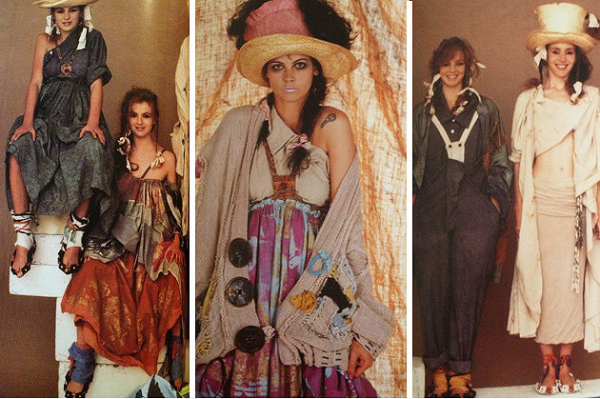
Vivienne Westwood, a fashion designer who showcased her first catwalk show ‘Pirates’ in 1981, is an activist who has included her messages within the clothing and styles she creates. Environmental issues, particularly climate change and textile waste, has been a common theme, appearing as far back as 1983, with her show ‘Punkature’. A spring/summer collection that featured recycled materials/objects and distressed fabrics, drawing from the inspiration of the post-apocalyptic film ‘Blade runner’ and the ‘desert landscape’, a baron earth (Westwood.com, 2017). She has since continued to dominate fashion magazines and the media with acts of protest through fashion and her collections, which makes her a key figure when predicting how roles in the fashion industry will be developing in the future.
Figure 1 'Punkature' collection by Vivienne Westwood
As well as designing in a way that expresses her views about social and political issues, she also now mainly campaigns, and writes a blog on her website ‘Climate Revolution’. “climate change, not fashion, is now my priority” (Vanessa Thorpe, 2014). The website consists of diary/blog entries where she openly records her life, activities and goals as she joins the fight against climate change. Climate change in particular is an issue that Westwood is very passionate about, which is seen through her work and now the work she does for the campaign. In her own words, Westwood equates activism with notions of a war fought for the resources of the planet. On her blog she writes,
“It’s a war for the very existence of the human race. And that of the planet. The most important weapon we have is public opinion: go to art galleries, start to understand the world you live in. You're a freedom fighter as soon as you start doing that.” – Vivienne Westwood (2016)
This shows her passion and fight to make people think and change their attitude towards climate change, and to see it as a serious matter and change their environmentally damaging habits. She values public opinion as ‘the most important weapon we have’, to encourage others to follow is important in overcoming these social and environmental issues.
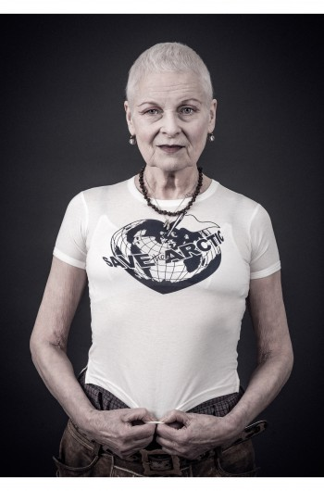
Westwood had recently been involved in the ‘save the arctic’ campaign with the political party ‘Greenpeace’. Westwood’s ‘save the arctic’ t-shirt collection, printed on ‘organic unbleached cotton’, was worn by 60 celebrities, Westwood included. They were photographed, and the portraits displayed in an exhibition which featured at London Waterloo Underground station. All profits went to Greenpeace and the campaign helped ‘raise awareness for the protection of the unique and fragile arctic’ (Westwood 2017).
Figure 2 Vivienne Westwood portrait wearing a 'Save the Arctic' T shirt
But still creating in the fashion industry, Westwood is ensuring to make her business ‘more sufficient and self-sustaining’ showing that it is ‘possible to walk a line between high end fashion and activism’ (Westwood 2017). Her attitude towards climate change and her initiative to make her business more sustainable, is something that could encourage a new movement of fashion. A highly respected, high end designer such as Westwood, making these changes within her business and speaking very openly and boldly about the problems that we as a society face, could encourage other big designers and brands to do the same.
“The Revolution is already begun. The fact of man-made climate change is accepted by most people. Through every walk of life people are changing their values and their behaviour. This continues to build the Revolution. The fight is no longer between the classes or between rich and poor but between the idiots and the eco-conscious.” - Vivienne Westwood (2016)
She believes in a revolution, one that is now between those who waste unnecessarily and those who are conscious of their actions and trying to change it, as she has done with her fashion business, proving you can be both successful and resourceful and environmentally friendly within the fashion industry, and ultimately, the design world.
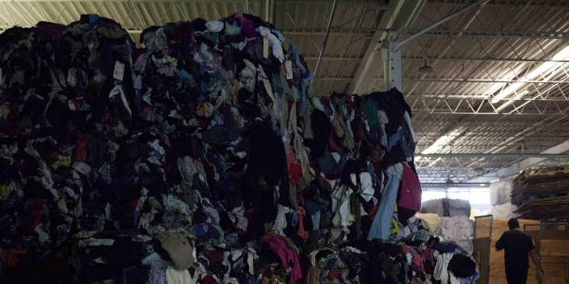
The production of clothing and the harmful materials and processes used isn’t the only thing the fashion industry is contributing to climate change. It’s also waste. Waste is playing a huge part in the destruction of the environment, and textile waste is at an all-time high, with 14 million tons of textile waste going to landfill each year in America alone (Alden 2016). This is largely in aid of the fast fashion industry. The fast fashion industry has been born of fast production. Manufacturers are producing clothing much quicker with the help of new technology and CAD/CAM systems, resulting in new lines of clothing sold on the high street as often as three times a week. As clothing is made and sold much more frequently, the trends are changing quicker too, and as the trends change quicker, the sooner the demand is for the next trend. The cycle keeps speeding up, and its consumers that are as much to blame as the manufacturers are.
Figure 3 pile of wasted clothing and textiles
It is designers and fashion brands that should be taking responsibility for textile waste created, and need to encourage and adopt a more sustainable way of designing. Stella McCartney is another designer who has spoken out against the fashion industries’ wasteful habits and says her industry is “incredibly wasteful and harmful to the environment” (Laville 2017), she responded to a report that revealed the scale of the problem saying
“The report … opens up the conversation that will allow us to find a way to work together to better our industry for the future of fashion and for the future of the planet” – (Laville 2017)
McCartney is speaking out against her own industry as Westwood has, and is contributing to setting a new example to be more environmentally friendly, to others, who could follow. But designers making their businesses more sustainable and production more environmentally friendly may not be enough alone to combat the problem of climate change. This is where thinking speculatively is important. Speculative thinking/designing is to speculate. To think ‘what if’. Designing in a way that is theoretical, but not completely unrealistic.
We are in an age of technological revolution, and have the tools to engineer products and machinery that could truly change the future and benefit the planet, and technology is only going to evolve even further over the next ten years. It’s the speculative designers and thinkers that could make change happen. For years we have tried to change the planet through using less and producing less, the word sustainable alone shows we are only sustaining, and not moving forward, not making real change and progress. Innovative and life changing technology is not being used where it should, and hasn’t been for decades, as Nigel Whitely expressed back in 1993, stating,
‘There is the appalling gap which now exists between that which technology could provide for society, and that which it actually does provide. We have a level of technological sophistication such that we can design and produce Concorde, yet in the same society we cannot provide enough simple heating systems to protect old age pensioners from hypothermia’ (Whitley 1993).
Whitley here is saying how technology is being used not for the benefit of society and the general public, but for the government, and simple problems that could easily be solved with this technology, is being overlooked.
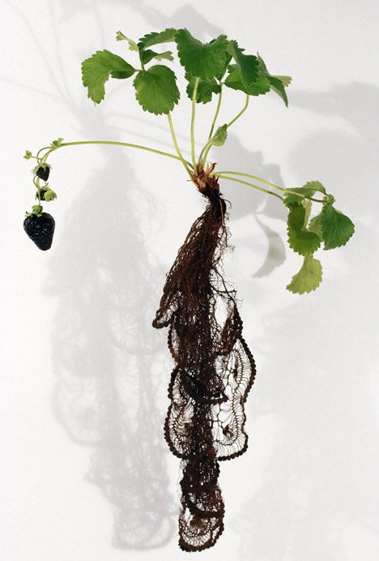
A speculative thinker who has designed a project that could completely change the way fabric is made, is the deputy director of the Textile Futures Research centre at Central Saint Martins, Carole Collet. Collet has designed a project, in which plants are genetically modified, to produce fabric. The project is called ‘Biolace’, and Collet believes that with new technologies improving in genetic modification, plants could be engineered, so that the roots grow to create woven lace that is soft enough to wear. These plants would not only be able to feed the ever-growing population, but also potentially produce textiles, in a completely clean and natural way, also meaning that when disposed of, can easily biodegrade with no damage to the environment. To some this would seem unrealistic, but it’s thinking like this that could someday become a reality and have a massive positive impact on the environment.
Figure 4 Genetically modified lace strawberry plant – prototype, by Carole Collet
Collet has also worked on a project called ‘Suicidal Poufs’, which was in collaboration with John Sulston. ‘Suicidal Poufs’ is her design and creation of garden poufs that biodegrade over time. The poufs are made from hemp, jute, abaca, paper, yarn and sisal, all of which are natural and sustainable materials. The poufs therefore biodegrade safely over time, and as they degrade, change shape, giving a new aesthetic within each cycle, and degrades quickly when composted. This ensures people buy less, as they have multiple pieces of furniture in one, and there is no waste due to it biodegrading. Collet is keen on exploring sustainable materials and what they can do for us, and states,
“for me, sustainability is just a natural part of textile design, not something that you try to add to the process later on” (Quinn 2010)
Collet is saying that using sustainable materials and designing with sustainability in mind from the beginning, should be a part of the textile design process and come naturally, it’s the designers’ responsibility to ensure their products are not destroying the environment, and they should adopt these values if climate change is going to be improved. If other designers particularly within the fashion industry, which generates a huge amount of waste, thought, and designed more like this and used these materials, we would be able to decrease the amount of textile waste created, and slow down the process of climate change.
The speculative thinkers and designers, in combination with the strong, encouraging figures such as Vivienne Westwood, could change the destructive actions of the fashion and textile industry. They have a following and an influence on others, and therefore responsibility. Westwood, a highly respected, high end fashion designer, has strongly and passionately made a point of how serious climate change is, and how important it is for the industry and its’ consumers to change its’ ways. Westwood and McCartney are also thinking about how they themselves could make changes within their own businesses, using more sustainable, environmentally friendly materials, so they are not only trying to change the industry by speaking out about its’ problems, but also by what they do, and how they change their businesses, that sets an example for others. As technology also changes and improves over the next 10 years, the responsibility that these people then have is to ensure that it is used wisely and for the best purposes it can be used for, pushing innovative and life changing ideas forward, that could ultimately have a much bigger impact on climate change, than the incredibly slow progression accomplished so far.

Bibliography
B. Anna (2014) How many clothes do you throw away every year? Available at: http://www.care2.com/causes/how-many-clothes-do-you-throw-away-every-year.html [Accessed 4/12/15]
G. Alyn (2013) Genetically engineered crops could grow lace amongst their roots. Available at: http://www.care2.com/causes/how-many-clothes-do-you-throw-away-every-year.html [Accessed 9/12/17]
L.C. Abreu (2015) The Climate Revolution of Vivienne Westwood. Available at: http://www.fashionmeetsrights.com/page/viewp/the-climate-revolution-of-vivienne-westwood [Accessed 23/11/17]
L. Sandra (2017) The Guardian. Stella McCartney calls for overhaul of ‘incredibly wasteful’ fashion industry. Available at: https://www.theguardian.com/environment/2017/nov/28/stella-mccartney-calls-for-overhaul-of-incredibly-wasteful-fashion-industry [Accessed 30/11/17]
T. Vanessa (2014) The Guardian. Vivienne Westwood: climate change, not fashion is now my priority. Available at: https://www.theguardian.com/lifeandstyle/2014/feb/08/vivienne-westwood-arctic-campaign [Accessed:25/11/17]
Q. Bradley (2010) Textile Futures: fashion, design and technology. Berg. P. 140 – 144
Vivienne Westwood (2017) Save the Arctic. Available at: http://www.viviennewestwood.com/en-gb/save-the-arctic [Accessed 25/11/17]
Vivienne Westwood (2017) Climate Revolution. Available at: http://climaterevolution.co.uk/wp/category/viviennes-diary/ [Accessed 23/11/17)
Vivienne Westwood (2016) Climate Revolution – Vivienne’s Diary. Available at: http://climaterevolution.co.uk/wp/2016/09/20/viviennes-diary-june-august-2006-part-2/ [Accessed 25/11/17]
Vivienne Westwood (2016) Fashion, Designer, and Activist. Available at: http://www.viviennewestwood.com/en-gb/blog/12-days-christmas-day-5-fashion-designer-activist [Accessed 23/11/17]
Vivienne Westwood (2017) The Early Years. Available at: http://www.viviennewestwood.com/en-gb/history/early-years [Accessed 23/11/17]
W. Alden (2016) Fast fashion is creating an environmental crisis. Available at: http://www.newsweek.com/2016/09/09/old-clothes-fashion-waste-crisis-494824.html [Accessed 4/12/17]
W. Nigel (1993) Design for Society. Reaktion Books Ltd. P. 107
Figures:
Figure 1 – ‘Punkature’ collection by Vivienne Westwood. Available at: https://c1.staticflickr.com/9/8094/8503120886_c99b4c3b03_z.jpg
Figure 2 – Vivienne Westwood portrait wearing a ‘Save the Arctic’ t shirt. Available at: http://www.viviennewestwood.com/en-gb/save-the-arctic
Figure 3 – pile of wasted clothes and textiles. Available at: http://www.newsweek.com/2016/09/09/old-clothes-fashion-waste-crisis-494824.html
Figure 4 – Genetically modified lace strawberry plant – prototype, by Carole Collet. Available at: https://www.dezeen.com/2013/11/30/genetically-engineered-plants-that-produce-edible-textiles-by-carole-collet/

