Liam James Stephenson (2011145)

study skills assignment
Liam Stephenson - Self-evaluation

Contents
Section 1: Presentation 2
Section 1.1 Brief Introduction into the Author/Presenter 2
Section 1.2 : Include 4 screengrabs from your initial PowerPoint presentation that introduced yourself. 3
Section 1.3: List the key points that you learnt when trying to produce and deliver a successful PowerPoint presentation 4
Section 1.4: Describe what aspects you feel you could improve on to enhance your future presentations. 6
Section 2: Skills Evaluation 7
Section 2.1: Perform your own research to identify the skills required for successful learning in a Higher Education environment. 7
Section 2.2 : Similarly, Identify the generic, transferrable skills employers look for in prospective job candidates. 9
Section 2.3: Conduct Self Evaluation exercises to discover your strengths and weaknesses, personality type, suitable career suggestions etc. 9
Section 2.4: Short term and long-term goals (academic and/or personal ones) 13
Section 2.5 : Creation of action plans 14
Section 3: Application 15
Section 3a.1: Looking after your data - Describe the backup strategy you created 15
Section 3a.2: List of possible disaster scenarios for the system 17
Section 3a.3: Reference to ransomware exercise 18
Section 3b.1: Time management and self-organisation 18
Section 3b.2: evidence of completed e-Portfolio/PDP implementation 19
Section 4: Conclusion 21
Section 5: Appendices 22
Section 6 :Bibliography 24

Section 1: Presentation
- 1.1 Provide a brief overview of yourself as per your class presentation exercise.
- 1.2 Include 4 screengrabs from your initial PowerPoint presentation that introduced yourself.
- 1.3 List the key points that you learnt when trying to produce and deliver a successful PowerPoint presentation
- 1.4 Describe what aspects you feel you could improve on to enhance your future presentations.

Section 1.1 Brief Introduction into the Author/Presenter

Information taken from the presenters 5-minute presentation about themselves.

Early Life/where they live.
- The presenter was born and bred in Wiltshire, which was clear from their accent where they are from.
- Grew up in Salisbury which is known either known for its 123M spire or from the Novichock spy poisonings in early 2018.
- They live very close to Stonehenge in Amesbury.
- This is where they went to school before moving to the new forest for their college studies in engineering.
- Through and after college worked in various places including shops and engineering workshops before beginning an Apprenticeship with DSTL in 2016, during this time attending the QinetiQ training school at Boscombe down camp.

Current Role
- The presenter completed their apprenticeship qualified in mechanical engineering, now works in the workshops and has picked up skills in electronics and electrical work.
- Part of the Trials and Instrumentation team at DSTL
- Day to day work includes use of Pressure gauges, blast gauges, high speed cameras etc.
- Part of a small tight knit team that work closely together.

Hobbies and interests.
- The presenter mentioned they are someone with far too many hobbies and interests. - rare they sit still.
- Been into BMX and skateboarding since they were 13
- Now a keen surfer and hoping to get surfing whilst down In Swansea
- Very into their cars, currently restoring a few old VWs including a mk1 Golf GTI

Presenters Personality.
- A passionate person about anything they are involved in
- Driven to succeed and complete things IE car projects.
- Whatever is started they desire to finish and to a high standard, mainly relating to being a practical person and having engineering background, this is mostly related to cars and other projects done at home such as raspberry pi and computer bits.

Floors/Weaknesses
- Quite analytical which frustrates them, they need to fully understand something before being able to start a task.
- Poor ability to switch off from ongoing projects and work, often find themself awake at night thinking about car wiring looms and intricate problems like that, requiring a lot of thought. Also, how to fix problems come across during the day.
- Ironically to the presentation, one of their weaknesses is public speaking or presenting. They tend in a twist and get awkward especially in unfamiliar circumstances.

What the presenter would like to get out of the course.
- Bridge the gap between engineering knowledge and the systems themselves, they work very closely with people who gets hands on with the explosives and their depth of experience is detting up and stemming charge. In comparison this is very basic.
- Would like the use the knowledge from the course to move forward in their career role to be more hands on and have the understanding and also have the tick in the box that they have a greater depth in the field than being qualified as an engineer.

Section 1.2 : Include 4 screengrabs from your initial PowerPoint presentation that introduced yourself.

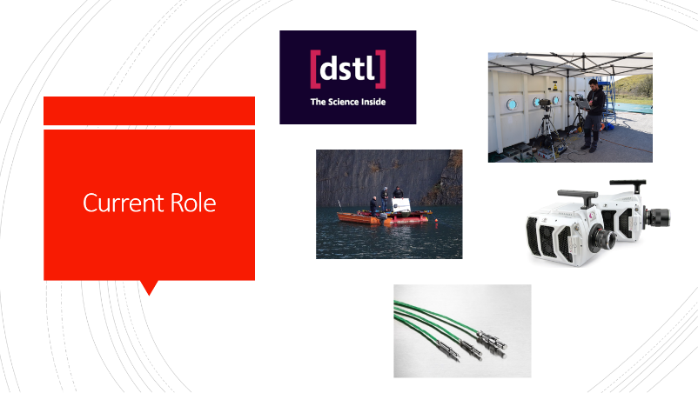
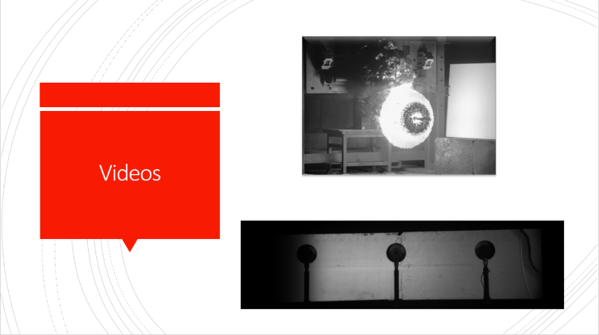
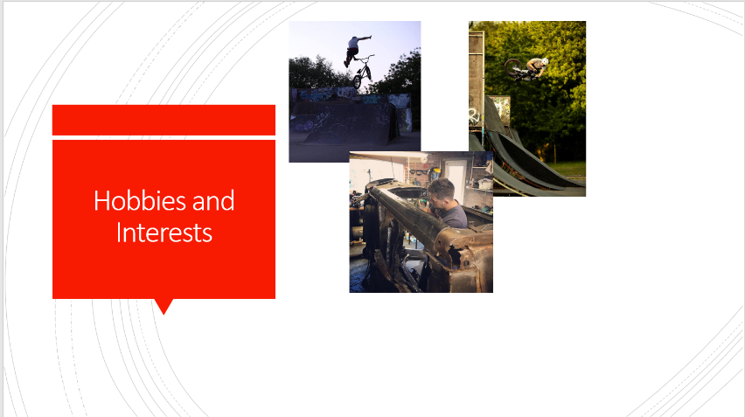
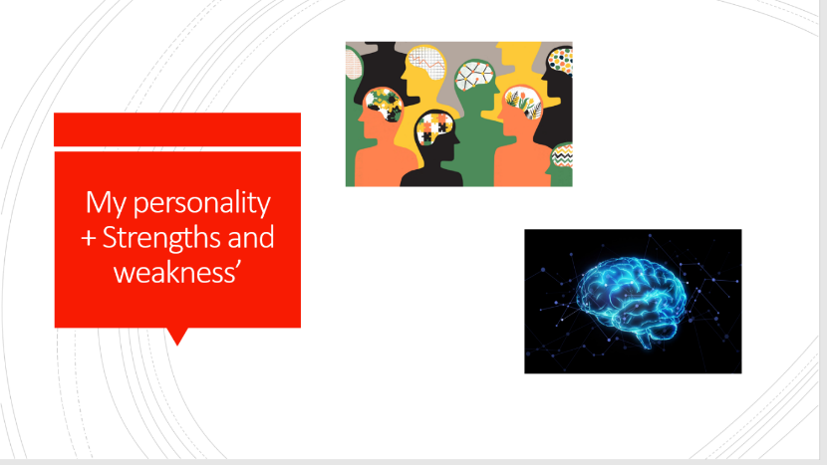
Figure 1: Screenshots of Slides from Presentation

Section 1.3: List the key points that you learnt when trying to produce and deliver a successful PowerPoint presentation

As a preliminary part of the OME level 4 introduction day, students were asked to give a 5-minute presentation about themselves to a small group, the audience consisted of around 10 people at a similar starting level on the first day of their HNC at UWTSD. The audience included employees from the companies of DSTL and AWE so any content discussed would need to be discreet in terms of not discussing and company-based IP in these presentations. As per the information discussed in Section 1.1, the topics to be discussed were.
- Where you grew up/Where you live
- What are your likes/dislikes?
- Describe your personality.
- What do you consider your strengths and weakness’ to be?
- Describe what you’d like to get out of the course and where you would like to see yourself in the next 5-10 years.

These topics helped students to break the ice as this was the first time they had ever met each other face to face after a couple of sessions online via Microsoft teams.
These areas of discussion are said to be very effective ways of breaking the ice when meeting people for the first time, as it allows people to relax more and allow them to have fun with the people around them. It was effective in this situation due the fact everyone was in the same position and able to have things in common with other presenters. By doing this the audience was able to “create a positive atmosphere and allow other students to lower their defence mechanisms.” [1]

Preparation

In the preparation stage of making this presentation it was found that there were quite a few hurdles to jump in order to get all ideas down on paper. This was due to the presenter being very inexperienced at giving talks and discussions to an audience. The audience was unknown to them which causes more time needing to be spent on preparation due to needing to make it suited to a wider range of people. It can be presumed that in this kind of situation many of the sections may have had to go through several reiterations in order to be suited to this wide, unknown audience. This can affect time management, which was already tight, this is due to it being the first time the presenter had to balance workload, personal life and own time study. Not as much time has been spent detailing and organising the slides as possible, this is evident from the lack of detail shown on the slides in terms of text in comparison to the number of photos. Due to the nature of the course and the topics discussing the presenters work area and expertise, with companies like DSTL and AWE intellectual property is very important, and some information cannot be shared openly. Because of this, the presenter mentioned that they had to speak to their company’s human resources department about the information and videos they planned to share during the introduction exercise to check they were not liable as IP and could be shared with any audience.

Upon carrying out research to reflect on preparing a presentation it can be see through reading Ozgun Ozpinars information about common presentation preparation problems [2] ,this can be confirmed as mistakes made when in the beginning stages of writing and creating slides to be used in PowerPoint.

The Presentation

When the presentation was delivered there was roughly 10 people present in the room including the lecturer for the study skills module. The presenter was very clearly nervous beforehand due to visually shaking whilst walking up the front to give their presentation. This was made even more clear by the way they stiffed up and as they gave very limited visual communication whilst at the front of the room, their body language was very stiff including keeping arms very close to the body, usually showing someone is nervous about the situation they are in.
The presenter’s ability to speak with clarity was easy to acknowledge as looking around the room there were plenty of nods and signs that they were captivating the audience enough for them to take in information. Despite this their nervousness still affected the pauses between the points they were discussing, there was many ‘errms and umms’ filling the gaps which is not good practice and takes away from the content being discussed.
Due to this being the first time the presenter had used their presentation on the UTWSD network they had not had the opportunity to do a run through of the PowerPoint in the environment beforehand. This led to technical issues like the videos used in slide 3 not playing at all on the screen, and just showing still frames of the clips. The fallout of this was that the timings of the presentation were thrown off by this, students were told that should be 5 minutes in length, no more no less. Without the videos this reduced the time of the presenters talk by quite a margin. It is common for an event like this to halt a presentation and its flow, despite this the student was able to recover quickly and move on with confidence.

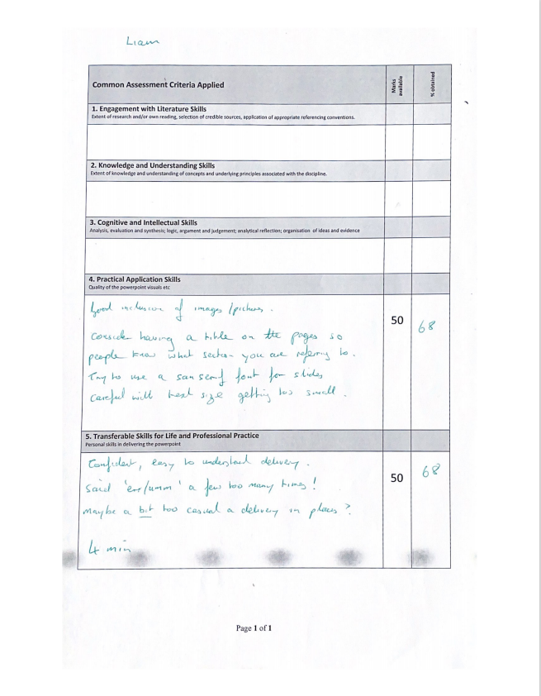
Figure 2: Presentation Feedback from Gareth Jones

Section 1.4: Describe what aspects you feel you could improve on to enhance your future presentations.

Upon reflection to this task it is best to look at both positive and negative aspects of the presentation. In most presentations, the delivery is only as good as the preparation given beforehand, starting at the initial planning stage.
It is clear from the presentation that the presented was aiming for a minimal format on the slides, the problem with this is that it leads the audience to pay more attention. Through watching the YouTube tutorial by ‘Practical Phycological’ [3]

The creator Dana Blouin discusses that the importance of knowing your audience to best capture their attention and best convey the points you want to get across to the listener. He talks about the difference in detail, choice of wording and level of formality between talking to a group of students in comparison to talking to high level investors to a company. In comparison to the presentation given at UTWSD the presentation met the audience well due to the presenter knowing the level that the audience would be at, although a lot of the points talking about their work were worded from a technical mindset from someone who already knows the topic they were talking about. An improvement for the future would to be to talk in less depth about the topic and explain in more general terms so all members of the audience are engaged by the subject matter.
Blouin states at 2:06 in the video about the importance of using of visuals, at that on average 65% of most audiences are visual learners so will take in a lot more of what you have to say if there is something visible on screen to back up what they are hearing. The presenter used still photos with minimal text used on screen, it would be beneficial to them in the future to include key words to back up that the photos that are on screen, otherwise listeners only have what you are saying to them and the photos to engage them. Similarly, the presenter’s slides were very static, meaning they had no moving aspects to them between slides or anything to reveal photos. This can give away all the information you are about to say and allow listeners to get ahead of the presenter, this could be rectified with the addition of transitions and animations. It is important to not overdo this, and again make sure they are suited to the audience who will be viewing the slides.
The use more dynamic movement with increased visual communication instead of standing at the front is suggested in [4], it will draw the listeners in and allow the presenter to maintain a captive audience.

Section 2: Skills Evaluation

Section 2.1: Perform your own research to identify the skills required for successful learning in a Higher Education environment.

When beginning a new course in higher education it is important to think about which route you have taken to get to this point. Especially with a course like the OME level 4, where students may have come from all different backgrounds and have varying experience in topic areas. This includes the level and type of education they have completed previously, for example a student who has recently completed a level 3 NVQ will hold different skills to one who has completed A level exams.
Time management is one of the key areas required for personal development and success at university as discussed by Ella Patenall in her careers advice section on TopUniversities.com [5]
Patenall mentions how important it is to master these time management skills as they are essential to being able to meet deadlines. If time management is poor student will not be able to set out their time for each aspect of study and begin to rush and not have enough time to study to the best of their ability. Patenall also discusses that you should “Manage your workload”. This includes the balance of university study and activities outside of curriculum. More specifically to the OME course this will be more relatable to the balance between working life and university work. It is important to make both career progress and progress in study and development on the units. Moreover, personal life needs to be balanced in with this so it is important to plan out time in the week in order to ensure enough time is spent on all 3 in order to succeed.
The main key to success is discussed by S. Ruby [6]To be maintaining study motivation throughout a course. By keeping motivated it allows a student to be keen to study and open their mind to take in information. By maintaining motivation, they will be more likely to be enjoying their study and the topics they will be learning about. In a course directly related to OME students’ area of work this should be easily attainable as the units will be used in the workplace from then onwards.
Ruby highlights the importance of setting “Realistic study goals” when planning study activities. This is important due to the ability to achieve these targets. If goals are set too far out of reach and are unattainable motivation will be lost, leading to a student not completing work or lowering their likelihood of being successful.
Throughout the page Ruby highlights the link between general organisation and success. For example “I usually have one ring binder per module. On each ring binder, I have a post it with my tasks for the week.” Shows her giving examples of her own organisation which led to her success at university. Methods like this minimise the likelihood of mistakes like losing work or not making progress. The use of binders allows for document control and organising these folders correctly can allow a student to find any information they need from lectures in one place. Improving the ability to go over work outside of lectures and create a portfolio of related information to a topic.
Similarly, a student’s ability to carry out self-research away from the topics discussed in class, this in itself is an effective skill. As this will give a wider depth of knowledge around a topic and allow them to improve their problem-solving skills which will be very useful when answering exam questions.

Section 2.2 : Similarly, Identify the generic, transferrable skills employers look for in prospective job candidates.

It can be assumed that the initial skill that employers will look for in a recruit, is their social and people skills. This is because it will be the first interaction they will have with a potential new employee. This is discussed by Paul Watson in his article for www.nature.com [7]. Especially where he mentions “Good people skills are very important to employers.” This is due to the employer needing to envision a potential recruit within a team in their workplace, and how they will fit into the work environment and atmosphere already in place in the company/organisation. The networking and presenting as part of the OME level 4 course should allow students to develop this skill and improve their ability to communicate information.
Watson explains that “Employers give top marks to candidates with a proven ability to juggle multiple priorities and responsibilities”, this confirms the points raised in Section 2.1. The use of time management is an effective life skill needed for all aspect of life. Including education/study, the workplace and personal life. In the working world deadlines and deliverables are equally important as those at university and failure to meet this will lead to repercussions. The skills of learning to plan out time and work to deadlines can be developed and improved through university study to provide a student their own effective way of planning before they go out into the working world.
It important to an employer coming prepared with a list of transferable skills, showing preparation and an applicant has done prior research that the role prior to applying. This is backed up by Elizabeth Baccus [8].
Baccus explains about how the use of problem-solving skills are effective not just in a role you have secured, but to the application progress itself. This includes the ability to write a CV that encapsulates skills you currently have and how to ensure you have the right skills for a job before applying, changing this if necessary. The skill of problem solving applies to a wide range of aspects at university including planning, organisation, assignments and more, this is a transferrable skill between Uni and the workplace.

Section 2.3: Conduct Self Evaluation exercises to discover your strengths and weaknesses, personality type, suitable career suggestions etc.

As a preliminary exercise prior to any research online or further into their self-evaluation the student was asked to describe their main personal qualities and characteristics.
The points discussed in the PowerPoint were.
- That they are a big team player in their current role at work.
- A very passionate and devoted individual.
- Driven by success.
- Many hobbies, an outgoing person in this respect.
- An analytical person who is prone to procrastination.
- Lacking in confidence and an introvert.
- Not a fan of public speaking or confrontation.
- Problem solver.
- Best suited jobs; hands on, thought provoking and the ability to be busy.
- Mechanical skillset.
- Regularly down and sad.

The student then fist carried out the career test at Career test result - free career test taking online at 123test.com, found in figure 3. The results of this test show that that the student is more suited to a realistic type of work. As described in the HopkinsMedicine.com explanation of the “Hollands Theory” [9]“Realistic individuals are active and stable and enjoy hands-on or manual activities, such as building, mechanics, machinery operation and athletics. They prefer to work with things rather than ideas and people.” This statement from ‘Hopkins Medicine’ agrees with the points made by the student before taking the test, they are hands on and have a mechanical skillset. They also lack the social skills of speaking or confrontation, this is highlighted as a quality of a realistic worker.
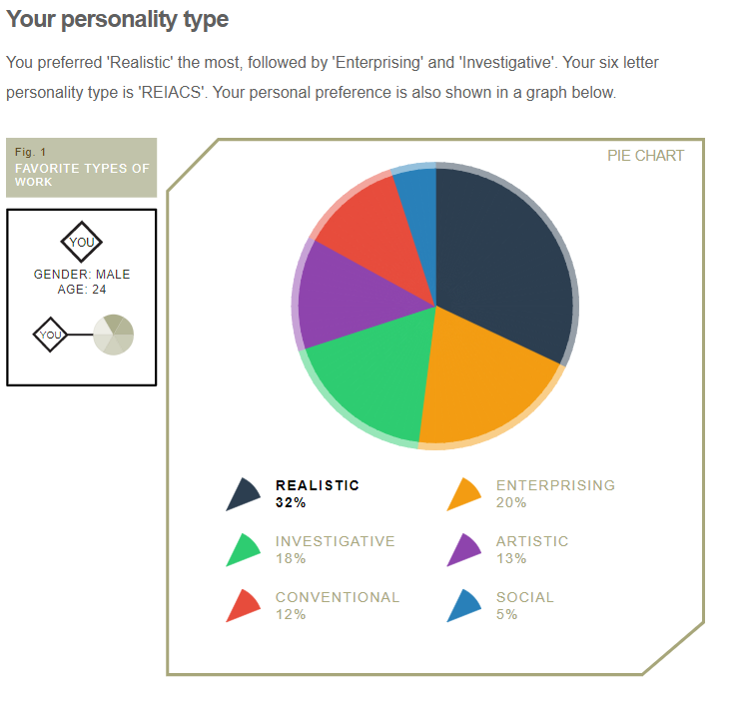
|Figure 3: Results from Career test - Career test result - free career test taking online at 123test.com
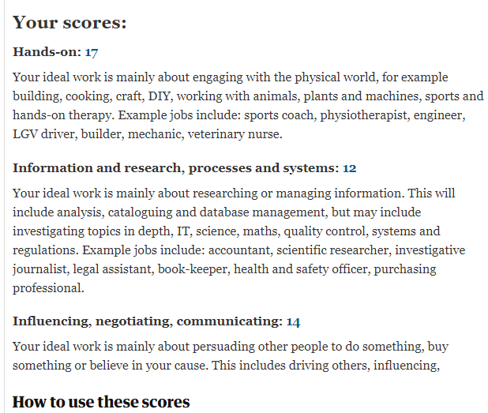
Figure 4: Results from ‘Independent’ personality test. Personality test: what job would make you happiest? | Life and style | The Guardian

It is clear to see that the results from ‘careertest123’ are confirmed by the results of this test taken on ‘The Guardian’ website. It shows that the career role most suited to the student is a job involving hands on, practical work. During their presentation the presenter alluded to their current job role being in instrumentation and data capture. This career personality test agrees with this suiting their skill base as this role involves a lot of in-depth work with computers and systems regulation. The student stated previously that they do not have strong social skills and struggle with public speaking. This test disagrees with this completely, stating that the presenter has strong skills in influencing, negotiating and communicating. This may suggest that the test is not completely accurate, or the student may have better social skills than they had thought.

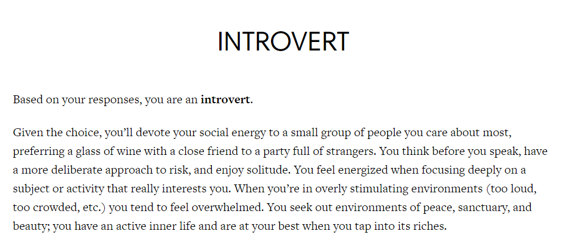
Figure 5: Results from introvert/extrovert test INTROVERT - Quiet Revolution

This figure shows the results from the Presenter taking the ‘Introvert or Extrovert quiz’. From the results it is clear to see that this quiz has given the result of the presenter being and ‘introvert’. This agrees with the statement made by the student that they think they are an introvert. It also agrees with the ‘careertest123’, stating that the study is only scored very low for being social.

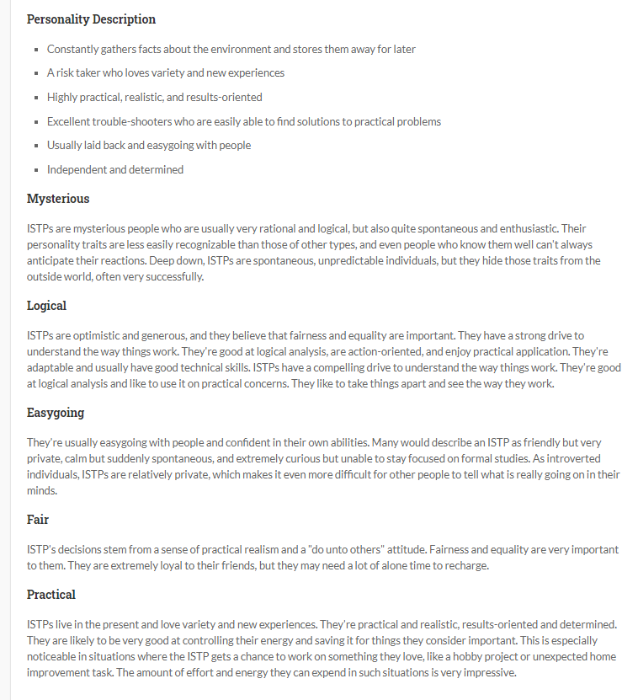
Figure 6: Results from ISTP Questionnaire. ISTP Personality Type | Read The Free Profile Description | Personality Perfect

Next the student completed the ‘ISTP Personality Type’ questionnaire shown in Figure 6. The results suggest that the presenter is a logical person, who puts a lot of thought into analysis of the situation before making a decision. This ties into where the student talks in their presentation, they have to have all information about something before starting a task. The results list them and being ‘Independent and Determined’. They described themselves as this before taking the tests. This questionnaire suggests these results are an accurate representation of the presenter.

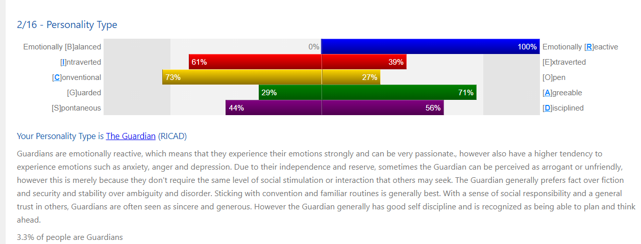

Figure 7: Personality type results Liam's Personality Report (seemypersonality.com)

Next the student completed the ‘seemypersonality.com’ questionnaire personality test. This brought them new results in comparison to the other tests/quizzes. The report states that the student is ‘Emotionally reactive’ which is the opposite on the scale compared to emotional stability. This shows the students feelings and emotions are dependent as to the situation they find themselves in. As discussed in the introvert/extrovert quiz this is a sign of a strong introvert.

From this research the student will have learnt a lot about themselves if they have not completed this type of test before. It gives an outside aspect to them in several different situations and is able to even give a suggestion about what type of career is best suited to the student. Personality tests are becoming an increasingly popular in job interviews so is beneficial for students to get practice in with these types of tests. Similarly, the tests allow a new way for the student to view themself, meaning they can self-reflect and look at their strengths and weaknesses, including anything they would like to change.
Viewing the tests completed it covers a broad range of topics and does not allow for much comparison, it could be recommended that the student carries out more personality tests that are similar in order to create a stronger comparison for their research.

Section 2.4: Short term and long-term goals (academic and/or personal ones)

Short Term Goals
- Make an effective start to the OME course
- Complete OME Lvl4 study skills unit
- Improve networking skills
- Lose 1 stone of weight for summer
- Improve sleeping pattern
- Reduce amount of hobbies
- Increase time spend relaxing
- Improve on pessimistic attitude

Long Term Goals
- Increase discipline regarding study.
- Move away from being a completely introverted individual.
- Progress career in a practical application.
- Save up for moving out of home.
- Lose 2 stone before Christmas 2021
- Plan a big holiday to Australia
- Reach level 4 employment

Section 2.5 : Creation of action plans

The student has carried out a Personal development plan from the outcome of their personal study. It highlights the points they felt needed change from the findings. It shows two long term and two short term goals and how they plan to go about improving upon them. This can be seen in figure 8.

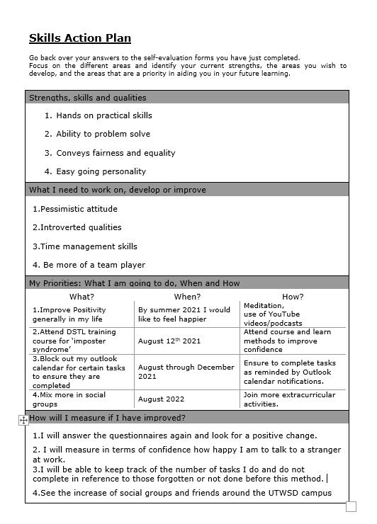
Figure 8 :S.M.A.R.T objectives

Section 3: Application

Section 3a.1: Looking after your data - Describe the backup strategy you created

Data management is very important especially in academia and University studies. This is because any loss of data could lead to loss of material for knowledge, for example losing saved notes from a module whilst coming up to an important exam/revision period. The use of data management allows an individual to know that their data is protected as this is valuable information to them. Especially in a university setting where work can be viewed and plagiarised, it gives the latest time of back up and assurance to an invigilator if something were to happen. The importance of backing up data is explained by Bob Shaker of Norton Antivirus [10]. He hints at if you have data saved in one location and it becomes corrupt or damaged you have access to it from another place it has been saved. If you have a backup at the worst case the file can be accessed from an earlier save copy.
The ability to back up and look after data is very important skill. Especially in the application of OME apprentices as they are likely to have to look after sensitive information and documents during their career. If this is not done well there will be repercussions or loss of employment.

The presenter used a backup process for their work involved a rule of three strategy when saving their work. That it needs to be backed up to the latest copy of the document/folder in at least 3 places at a given time. This includes saving in multiple digital locations as well as in physically different places. This will allow them to protect their data in a range of different ways. The methods chosen by the presenter are:
- A 2TB HDD inside their homebuilt desktop computer.
- A transportable, removable 32GB flash drive for transferring and taking data to Uni. it is usually stored at work with another spare at home just for use in transfers.
- Use of one drive system/cloud with unlimited storage.
- An automated back up to their home NAS set up (10TB) set to transfer on a fortnightly basis.
- Any files or data sent via email backed up by Outlook.
The use of this wide format of saving techniques will allow data to be backed up effectively. The work would be completed on the desktop computer and saved directly to the one drive, whilst placing a copy into the HDD on the computer each time a new file is made or changes to an existing file occur. The NAS system is set up to update its files from the HDD/cloud every other Sunday in order to create backups of files created.

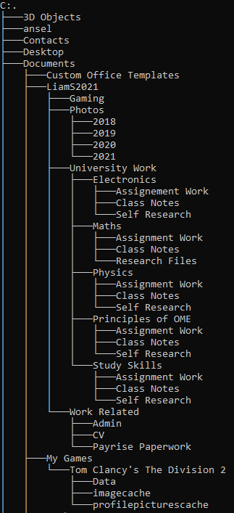
Figure 9: File Saving Tree

Section 3a.2: List of possible disaster scenarios for the system

There is a varying array of reasons that could cause a disaster to data storage, this could be something physical, something offense to the computer in a digital way or generally just mistakes made by human error.
One issue that occur to the system could be a damage to any of the storage components within the system. If the students HDD were to become damaged it would lead their files on that hard drive to be inaccessible, thankfully their system will have the files saved to the cloud automatically when they last saved. They would then be able to transfer their latest save to the NAS drive if required.
Another likely disaster would be the physical theft of the computer from the student’s home. This would mean that they lose all work saved to their HDD, also it may allow the thief easier access to their cloud storage if it was left open or password clues were on the computer. The data would be backed up onto the NAS drive but could have been up to 13 days out of sync with the one drive at that point, meaning not all their files are lost but if they had been working on assignment work during the days leading up to the theft all progress would be lost.
It is possible that the computer could become damaged from accidentally spilling fluids whilst working at the desk. It is quite likely that a HDD would still be useable if liquid was spilt on peripherals but in a disaster situation it could have been spilt directly into the tower. In this situation it is fortunate that the student has use of the cloud as all work will be accessible after an even like this. (With use of another device).
It is likely that at some point the student could accidentally delete a file they were attempting to move between folders. The students saving system includes OneDrive which includes a recycle bin which allows recently deleted files to remain recoverable for up to 30 days after the action was made.
If ransomware was to remove the users’ access to their OneDrive HDD files, they would not need to pay any form of ransom fee because their files will be backed up on the NAS system backup. Although as mentioned before if it were a recent file creation it is possible it could be lost due to the delay in backup time in the student’s system.
In the worst-case scenario, if the student’s home were to burn down or be hit by natural disaster their files would be safe to access again. This is due to them default saving to the cloud whenever the file is created or updated. After the incident they would be able to log onto their cloud on any device and gain access to their files. Although anything saved to the NAS but not the cloud would be lost.
If the NAS drive were to fail any of the student’s data would be saved to the Cloud and vice versa if they became locked out of their OneDrive account. The student should bear in mind that all points discussed above are subject to them maintaining their backups and ensuring to keep all locations at the latest file updates. Failure to do this will cause the system to not be effective, leading to a higher likelihood that items could be lost. The student’s system was found to be effective against a range of different disaster scenarios, although it was found that their backup to NAS was not automated and only done on a fortnightly basis. It is recommended that the student updates this system to have a more frequent automated backup.

Section 3a.3: Reference to ransomware exercise

Looking at figure 12 it is clear to see the student has put effort into their prior research into virus and malware prior to creating their backup system. Poor understanding and knowledge of malware can lead to losing personal data. If this data is personal and important to the individual, they may have to pay the ransomware to get that back. The student needs to ensure they are using antivirus and malware software especially due to university deadlines. If they were to be attacked just before a submission, they could lose their work or have to pay the ransom to retrieve their data.

Section 3b.1: Time management and self-organisation

From the presenter’s personal study shown in section 2, test such as the ‘introvert/extrovert’ quiz it can be seen that they struggle with stress levels. Moreover, other tests taken show signs of poor organisational skills leading to low productivity.
The presenter mentions they are quite prone to procrastination. Through reading the guide for ‘how to stop procrastination’ [11] There is a wide range of methods available to improve the skills the student is lacking. The mind tools team mention that the best solution is “to become the master of scheduling and planning”. It is recommended to block a planner for everything you need to get done and in what time scale in order to ensure goals are achieved. The student has created an electronic calendar entry with recurring and changing events. As explain by ‘MindTools’ this will allow them to plan their time a lot better and ensure that tasks will be completed. The calendar shown displays an improved use of time management skills, which as a result will alleviate stress of upcoming deadlines or needing to fit everything in time wise in a busy week. It is discussed in the procrastination guide as an effective method of increasing productivity when struggling to get things done.
It is important that the student continues to make these weekly and monthly calendar planners if it is proven to be an effective method for their improvement. Further steps to take for improvement would be to get a buddy to check up on them to ensure they were keeping up or making progress on both Uni and personal life work. If the student continues to develop stress they can contact the university for advice and guidance.

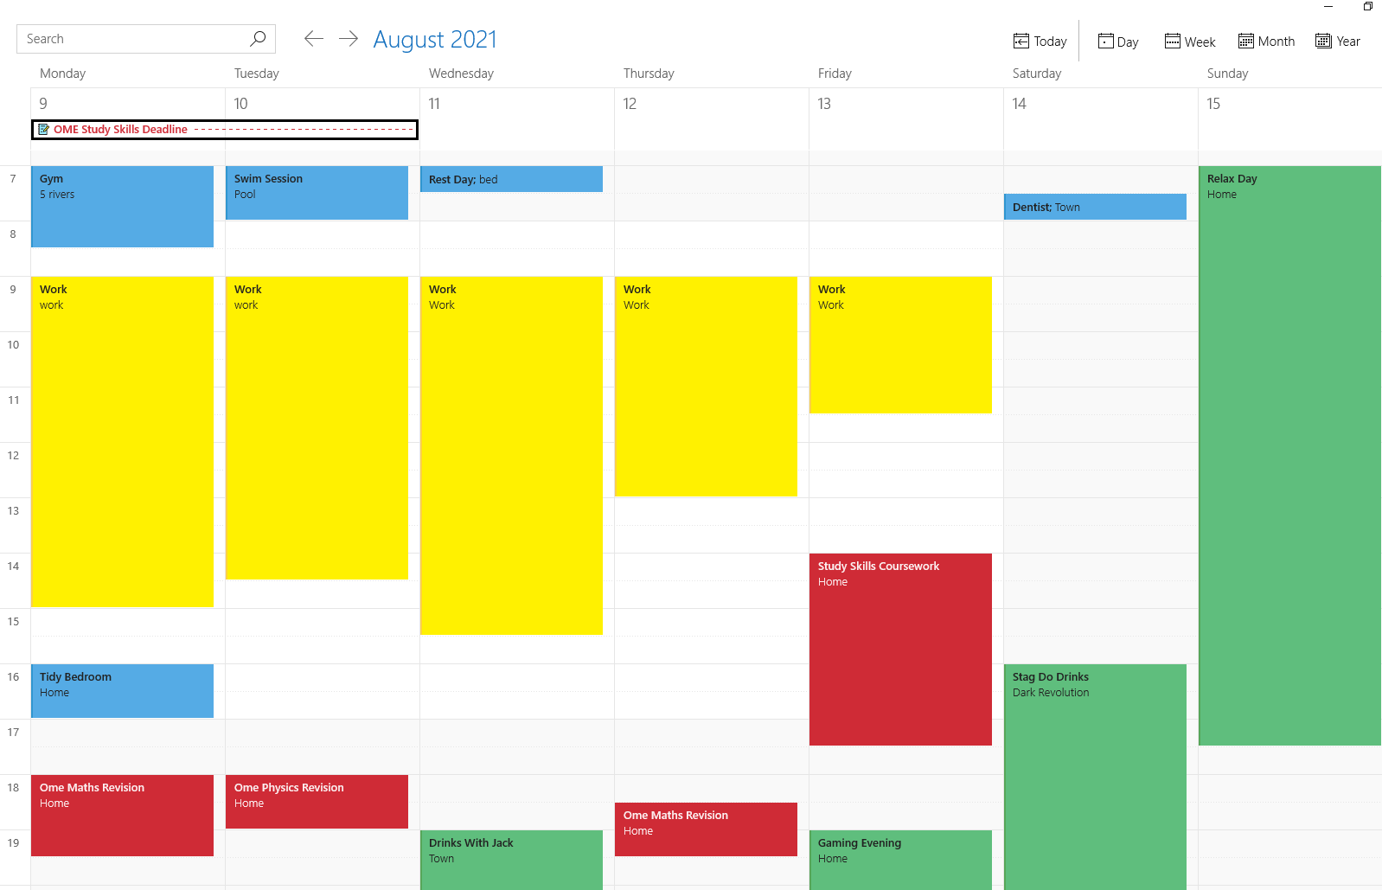
Figure 10 – View of current weeks Outlook Calendar for student

Section 3b.2: evidence of completed e-Portfolio/PDP implementation

By looking at Figure 11 it can be seen that the student has produced a Gantt chart to track their progress on their personal goals. Through their research they have found that there are key items to allow them to improve and develop themselves and their happiness. As stated by Vanessa King [12], exercise is one of the top ways to improve overall happiness, as well as making a big difference to appearance at the same time. Others of these “Keys to Happiness” include ‘awareness’, ‘resilience’ and ‘direction’. Through the topics/goals the student has used they will be using all of these. They have planned out to lose weight, progress on their OME course and improve in their workplace, the gantt chart allows them to have a time frame goal for each of these tasks and track their progress throughout. The used of percentages will allow them to see if they are on track for their goal or ahead or behind of schedule, this is useful when quite a few things are attempting to be achieved at once.
All of the goals the student is trying to achieve are quantifiable, percentage of weight goal over time, number of units completed in each topic compared to the total on the OME course, the online training courses provide you with a percentage completed at any given time.
This will be an effective method of ensuring progress and the relieving of stress, although this is dependent on the student ensuring to update and continue to fill in their gantt chart.

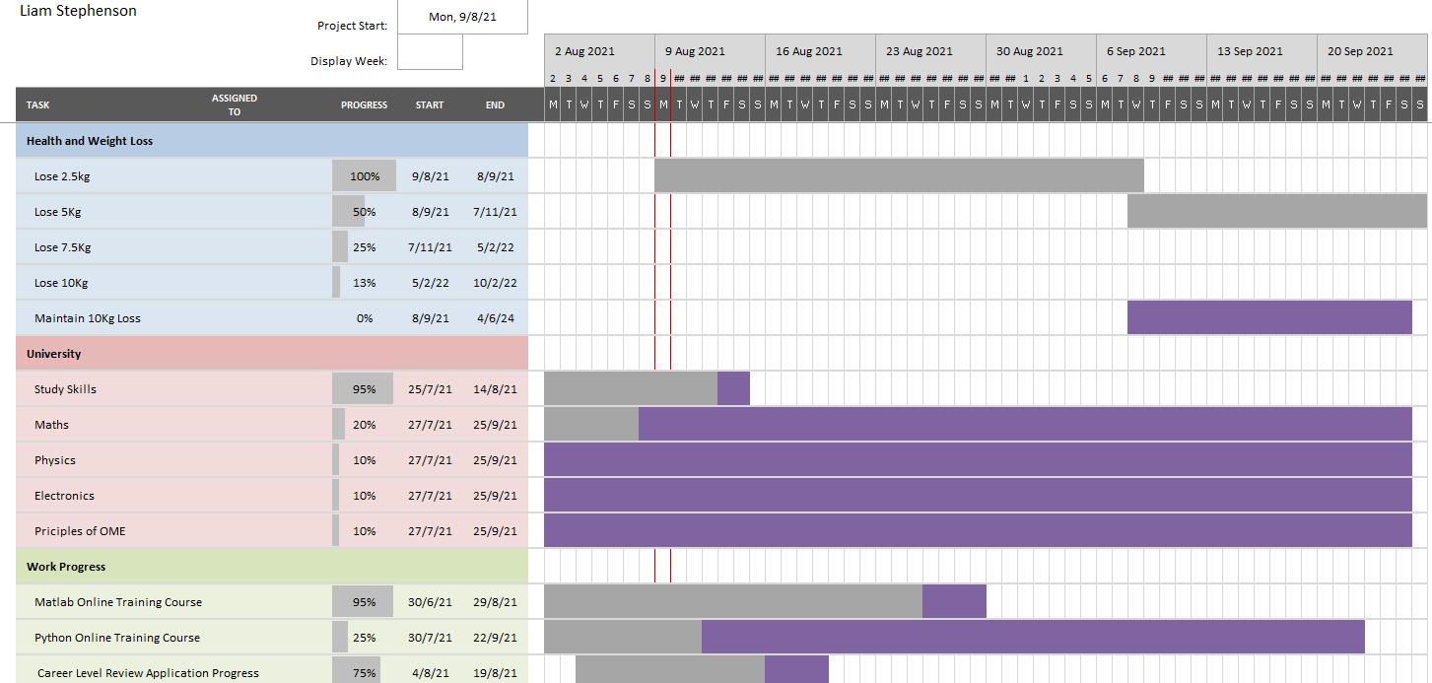
Figure 11 – Gantt chart

Section 4: Conclusion

During this report the presenters’ skills to give an in-person delivery to a new group of people. It was found that this was outside of their skillset and was a new concept to them. Through reflecting on their presentation with sources such as feedback from the tutor and a personal reflection it was possible to find skills and weaknesses with their ability to deliver an effective presentation. Through looking into weaknesses, it is possible to know areas of improvement and how to do better the next time they are asked to give a group presentation. This includes confidence, use of visual effects and giving an overall more dynamic delivery.
Through providing the topic of strengths and floors, the student was able to look at themselves and think about what they excel and fall short of in their work, home life and personality overall. Upon reflection and research into this through personality and career suitability tests the student was able find that their current career route is suited to them and their attributes. They were also able to confirm in some tests that they were introverted person with little emotional stability. Through research it was found this was relatable to poor organisation and little effort into health and wellbeing. Because of this the student was able to create S.M.A.R.T targets with a plan and timescale of how to achieve them. In addition, they created a Gantt chart to achieve these long-term goals and increase the likelihood of success. Their planning and organisational skills were improved with the suggested use of blocking out their outlook calendar for each week to give alerts/queues of when they need to be working on their assignment or attending the gym to improve health.
In preparation for the beginning of their journey on the OME apprenticeship, the student was asked to analyse and evaluation the effectiveness of their saving method as discussed in section 3. It was found that their file naming system and folders would be effective for organisation of their data and could be fine-tuned throughout the course. Next they looked at the safety and security of their backup method

Section 5: Appendices

Figure 12 – Ransomware research completed in class.
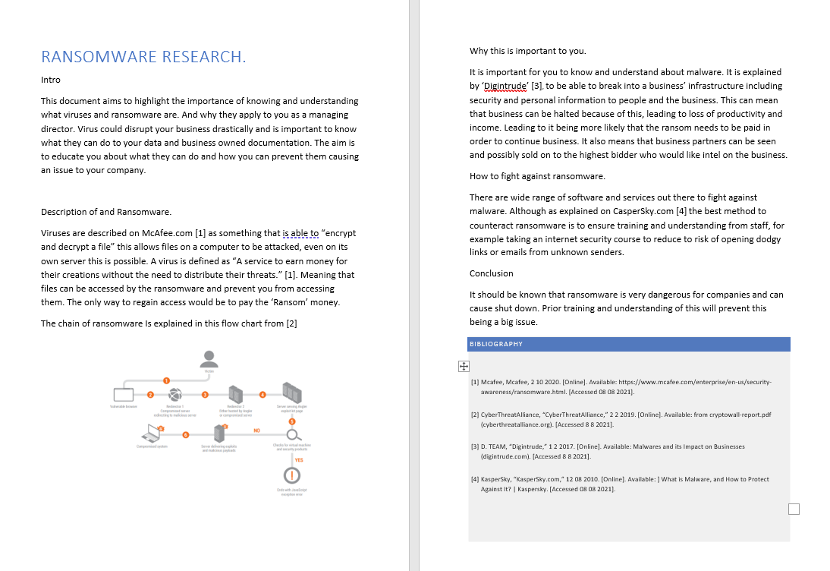

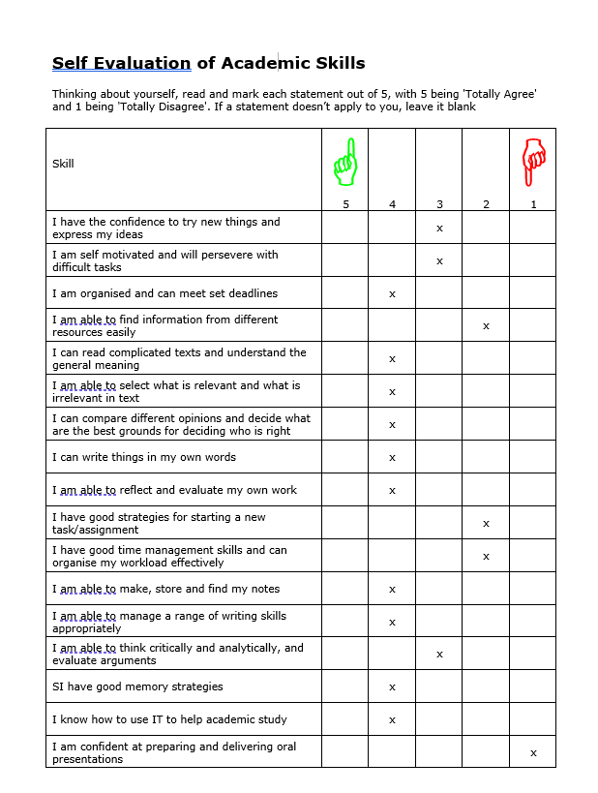
Figure 13: Self Evaluation

Section 6 :Bibliography

[1] | A. ARRIESGADO, “Icebreakers For Your Next Presentation,” 01 08 2019. [Online]. Available: 36 Fun Icebreakers For Your Next Presentation (24slides.com). [Accessed 02 08 2021].
[2] | Ö. ÖZPINAR, “www.medium.com,” 03 08 2018. [Online]. Available: https://medium.com/@zgnzpnar/six-common-problems-while-preparing-presentations-and-their-solutions-aa1c3fb7e29c. [Accessed 2021 07 29].
[3] | D. Blouin, “HOW TO Give a Great Presentation - 7 Presentation Skills and Tips to Leave an Impression - YouTube,” YouTube, 2020.
[4] | D. Hebblethwaite, “Skills You Need.com,” 01 02 2018. [Online]. Available: https://www.skillsyouneed.com/present/presentation-tips.html. [Accessed 01 08 2021].
[5] | E. Patenall, “Topuniversities.com,” 02 05 2021. [Online]. Available: https://www.topuniversities.com/student-info/careers-advice/five-soft-skills-you-develop-university. [Accessed 02 08 2021].
[6] | S.Ruby, “University of London,” 26 02 2018. [Online]. Available: https://www.topuniversities.com/student-info/careers-advice/five-soft-skills-you-develop-university. [Accessed 08 08 2021].
[7] | P. Watson, “Nature.com,” 01 05 2018. [Online]. [Accessed 29 07 2021].
[8] | E. Baccus, “Changing your career: How to identify your transferable skills,” no. https://www.theguardian.com/careers/careers-blog/changing-your-career-how-to-identify-your-transferable-skills, p. 1, 2019.
[9] | J. H. S. o. Medical, not stated. [Online]. Available: https://www.theguardian.com/careers/careers-blog/changing-your-career-how-to-identify-your-transferable-skills. [Accessed 02 08 2021].
[10] | N. A. Team, unknown 2017. [Online]. Available: https://uk.norton.com/internetsecurity-how-to-the-importance-of-data-back-up.html. [Accessed 29 07 2021].
[11] | Mind Tools Content Team, “https://www.mindtools.com/pages/article/newHTE_96.htm,” How to Stop Procrastinating, vol. 1, no. 1, p. 3, 2021.
[12] | V. King, “Action For Happiness,” unknown 2018. [Online]. Available: https://www.actionforhappiness.org/10-keys. [Accessed 08 08 2021].

