(M5X01568)

Outreach Roadshow
  - Report

Project outline & Aims

For this project, my class, as a whole, were required to create a set of 4 workshops that, lasting an hour each, gave a concise introduction to various aspects of creating audio for film. This included film music and scoring, recorded sound effects (or foley), synthesized sound effects and dialogue recording. I was assigned to the group responsible for dialogue. As a class, we had decided that the best way to introduce newcomers to the different concepts involved within film audio was to take a short piece of film, completely cut out the audio and work with the people undertaking the workshop to replace the it with sound effects and music that they had a hand in creating themselves. The piece of film that was chosen by the class was a 1m 32s long clip from the Disney-Pixar animated film WALL-E. As a group we decided that it was important not to focus on solely recreating the original audio of the piece from what we, or the people taking the workshop, could remember the film sounding like. However, the film in question was rated as #29 on the list of the greatest 100 films of the 21st century (Bbc.com, 2016) and was incredibly popular upon release in 2008, making this consequence difficult to avoid.

Research & Context

In regards to research, I personally decided to study the processes and styles of working that different production studios within the film and television industry undertook in order to record and edit dialogue for their respective projects. It seemed almost necessary, therefore, to begin with analysing how Pixar Studios and Walt Disney Studios created the sounds, and more importantly, the vocal styles for WALL-E, including which effects were used and how their general process works. What I discovered about the film, first of all, was that, as is apparent in the film itself, Ben Burtt, the head sound designer, entered into production with the idea that traditional dialogue would not necessarily play a role, at least in regards to the two lead characters, robots WALL-E and EVE, this is apparent when he is quoted as stating: “Sound and the robot voices were going to play such an unusual role that I couldn’t help but be inspired.” (Anon, 2008). This suits the design of the characters as they are robots with specific purposes wherein conversation does not play an active role. Pixar are said to have studied and drawn inspiration from the silent films of Charlie Chaplin and Buster Keaton throughout the design process and especially in regards to the opening scenes, which our chosen piece of film is (McGovern, 2012).

Process

My partner and I began by assessing the role of the characters within the clip, what their lines were, whether there could be any variations within these lines, given that they were animated characters, and what the characters could sound like. A basic script was constructed for all three characters that increased the amount, and complexity of, the lines in order to give the characters more substance and to help cross over into more conventional methods of voice acting. My group decided that, as the main characters in the scene were two robots, we should conduct each instance of the workshop in the mind-set that the participants would, more often than not, wish to create strictly traditional robotic tones for their voices and so we began experimenting within the studio as to which types of plugins and parameters would yield the most efficient results related to that outcome. This was done not only to guide the participants, but to ensure that, come the event of little to no participation, my partner and I would possess the knowledge and technique to create a backup in a limited amount of time so that the people we were working with would not leave empty-handed.

We then moved onto considering the production process itself and the practicalities of different methods. We debated on the pros and cons of of recording into pre-sets, either ready-made or built with the participants before the recording itself took place, and recording the voices first and then working with the students to build distinct vocal timbres for each of the characters. We decided upon the latter option as we thought it easier to work on the voices on-the-fly. This is because some students’ voices may differ and some may want to create abnormal voices, not usually present within the traditional ideas of robotic voices. This style of recording also helped to fill out an hour’s workshop that we were worrying was going to end too soon due to the simplicity of recording only 2 voices, in addition to this we also decided to work with a voice for the character of the cockroach seen in the clip, this also gave another student a chance to be represented within the final product. Our equipment list was simple, focusing on using logic’s on-board effects, with only a condenser microphone, a mac and a soundcard, as well as XLR leads and a microphone stand. This suited the style of project by making our workshop sufficiently portable and helped to limit the amount of technical glitches that could occur. Our process of recording on the day was finalised as, firstly, letting the students observe the silent film as well as letting them read over the lines and decide who was going to take the roles of the characters, then, we began by recording each individual character separately and spending around 10 minutes editing each character’s voice to the students’ preferences before finalising and exporting. We figured this would last around an hour and that that if there was additional time left over, that more time could be spent refining the voices themselves.

Target Audience

The consideration for the target audience began upon the class pitching ideas for what kind of activities the workshop was going to consist of and what we would be aiming to achieve in the final product. Upon learning that the audience we were going to be working with was a group of college students we agreed on a compromise of a workshop consisting of a hands-on approach in regards to the methods employed, but wrapped up within the context of a larger project that was consistent throughout all four sections of the workshop. This would be logical as the students themselves would likely work in terms of overarching projects within their everyday study. The choice of film, we thought, had to be something that would be simple, yet engaging, whilst being vaguely known to the students themselves but not relying too much on knowledge of the film, so as not to influence their decision-making. WALL-E seemed to be a favourable choice as it was a popular film but was released long enough ago so as not to be fresh in the minds of the participants.

Risk Awareness

A concept that is of paramount importance to any interaction with studio equipment is that of the safe operation of different pieces of apparatus and knowledge of the specific risks associated. I feel that my group was well aware of this and attached is a risk assessment table that was drawn up after we had first conceptualised our workshop.

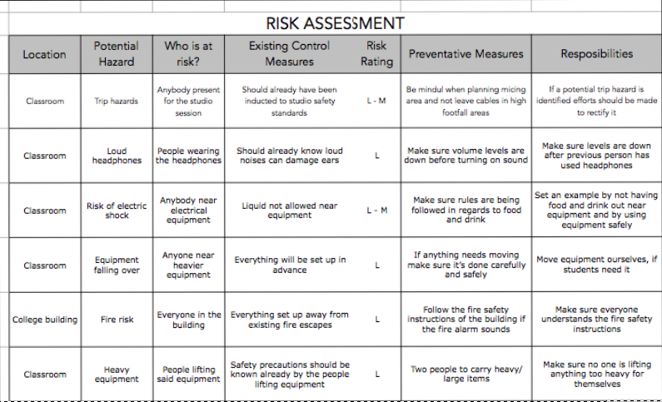

Analysis of Final Product

When it came to the delivery of our part of the workshop, I believe it went better than my group originally expected. In the weeks running up to the performance of the workshop nerves were a big issue. Personally, I had never taught or delivered any kind of experience similar to this in the past. This meant that I was under the impression that if the students felt uneasy about participating, I would find it difficult to bring the situation under control. Although there was always a risk of this happening, I felt that the students themselves were more than welcoming and seemed eager to participate. This, I feel, was helped by the refinements made to the workshop over the two months we spent working on it to make it more streamlined and engaging. The length and minimal complexity of the project suited the small group sizes of the students perfectly and helped to get everyone involved within every step of the dialogue process. The small size of the equipment list definitely helped the portability of the workshop itself and made sure that setup in the morning was quick and economical, allowing us more time to iron-out any technical glitches that could have occurred. A by-product of this extra time was being able to set up the environment safely, with the express purpose of reducing the risk of trip, fire and other such hazards. The workshop, in its simplicity, is one that I believe would be repeatable which was one of the main aims of the project. My partner and I were able, partly due to there only being two of us within the group, to be involved equally in the workshop. This was achieved by taking turns supervising the recording process and the process of applying effects to the vocal tracks. This was easily achieved due to the modular process that we structured the workshop around, treating the process as two distinct stages of recording and effecting. It is my understanding that the students we taught were engaged throughout and enjoyed the process which constitutes a large part of the success of any project.

Project Summary

In summation, I believe the vision of a workshop that encapsulates the basics of dialogue recording within the film industry that my group set out to achieve has been successful. Not only did I feel it was able to efficiently teach the fundamentals of that part of audio design but I feel that we were able to impart various small techniques, especially within DAW’s, that help to speed up the production process of any project. This is due to the hands-on process that we felt was necessary to teach the concepts to the students quickly. This process, however, had its drawbacks. I feel that if I were to create a workshop similar to this project again, I would require a longer allocated slot of teaching time. Although we were able to confidently and efficiently give the students the basic information needed, it felt that the final product they created was rushed and needed a larger period of experimentation. We were only able to show the students around a few audio effects before they had to decide, due to lack of time, which they were going to use to get the effect they were attempting to portray. However, as this workshop was only based around giving a taste of differing concepts, perhaps the fundamental knowledge was all that needed to be taught as, if all four groups were given more time, there may have been issues of fatigue within the students and they may have been less attentive and able to learn.

  - Bibliography

- McGovern, B. (2012). Wall-E: Pixar’s Lasting Tribute to the Power of Art. [online] Tor.com. Available at: https://www.tor.com/2012/06/19/wall-e-pixars-lasting-tribute-to-the-power-of-art/ [Accessed 2 Jan. 2019].

- Bbc.com. (2016). The 21st Century’s 100 greatest films. [online] Available at: http://www.bbc.com/culture/story/20160819-the-21st-centurys-100-greatest-films [Accessed 2 Jan. 2019].

- Anon, (2008). WALL-E Production Notes. [online] Available at: https://web.archive.org/web/20110711103245/http://adisney.go.com/disneyvideos/animatedfilms/wall-e/media/downloads/WALLEProductionNotes.pdf [Accessed 2 Jan. 2019].

