[Date]
Student name Ralph Saramaduo-Hart
Student ID number 2411210
Programme: BSc Applied Computing
Module: Business and Web Management
Module code: ACCA 5019
Lecturer: Dr Suneth Fernando
Assignment title: Component 1 – Website Redesign for Online Business Presence

Contents
Task 1 4
Introduction 5
2. Healthy Harvest Website Analysis 5
2.0 Heuristic Evaluation of the Existing Healthy Harvest Website 5
Table 1. Heuristic Evaluation of the Existing Healthy Harvest Website 5
Discussion 6
2.1 Analysis of the Current Website 7
Visual Identity 7
Mobile Responsiveness 7
Product Transparency 7
Checkout 7
Accessibility 7
2.2 Proposed Design Solutions 8
Information Architecture 8
Visual Design 8
Product Pages 8
Personalization 8
Performance 8
3. Responsive Design 8
4 Implementation 9
4.1 Wireframes 9
4.2 Mood Board 9
4.3 Interactive Prototype 9
4.4 Influence of Wireframes and Mood boards 9
5 Conclusion 9
References 9

Task 1
https://www.figma.com/design/fuLvWwp46siRN9AkIUruYB/ACCA-Assignment?node-id=11-12&t=Wvq6M4SnjuyHCz6R-1

Introduction

Healthy Harvest is a specialist e-commerce company selling premium extra virgin olive oils, infused oils, balsamic products, olives, gift collections and selected wellness products. Its value proposition is based on direct relationships with small family farms, organic and environmentally responsible production, independent laboratory testing and product traceability. The existing website communicates much of this information; however, its content structure, visual hierarchy and purchasing journey could be improved to make the proposition easier to understand and the product range easier to navigate. Healthy Harvest currently places particular emphasis on family-owned farms, cold-pressed production, laboratory verification and traditional sourcing from Greece and Italy.

This report proposes a user-centred redesign of the Healthy Harvest website. The redesign addresses navigation, product discovery, visual consistency, mobile responsiveness, accessibility, trust, subscription visibility and checkout efficiency. The proposed solution is informed by human-centred design, information architecture, usability principles and e-commerce conversion practices. The design process is demonstrated through low-fidelity wireframes, a mood board and a five-page interactive Figma prototype.

2. Healthy Harvest Website Analysis

2.0 Heuristic Evaluation of the Existing Healthy Harvest Website
Before proposing a redesign, the existing Healthy Harvest website was evaluated using Jakob Nielsen's Ten Usability Heuristics, one of the most widely adopted heuristic evaluation frameworks within Human–Computer Interaction (HCI). Heuristic evaluation is an expert inspection method used to identify usability issues by assessing an interface against recognized usability principles rather than relying solely on user testing (Nielsen, 1994). Applying this framework provides an evidence-based justification for the proposed redesign by systematically identifying where the current interface supports or hinders usability.

Table 1. Heuristic Evaluation of the Existing Healthy Harvest Website
Nielsen Heuristic | Evaluation of Healthy Harvest | Proposed Improvement
Visibility of System Status | website provides confirmation when products are added to the basket, but feedback during navigation and filtering is limited. Users may not always receive immediate visual confirmation of actions. | Introduce clearer interaction feedback, loading indicators, active navigation states and animated confirmation messages to improve user awareness.
2. Match Between the System and the Real World | Some technical product information may not be immediately understood by less experienced customers. | Present technical information using plain language supported by tooltips and expandable explanations to accommodate both novice and experienced users.
3. User Control and Freedom | There is limited support for quickly undoing actions, comparing products or editing subscription selections during the purchasing journey. | Provide clear "Undo", "Remove", "Edit Basket" and "Edit Subscription" options throughout the shopping process.
4. Consistency and Standards | Page layouts and call-to-action placements vary between pages, reducing interface predictability. | Standardize navigation, button placement, typography, spacing and page layouts using a reusable design system within Figma.
5. Error Prevention | Forms generally rely on validation after errors occur rather than preventing mistakes beforehand. | Introduce inline validation, input guidance, autofill support and clearly labelled required fields to reduce user errors before submission.
6. Recognition Rather Than Recall | Users must sometimes remember product characteristics while navigating between products because comparison functionality is limited. | introduce persistent filters, recently viewed products, comparison features and specification cards to reduce memory load.
7. Flexibility and Efficiency of Use | Experienced users have limited shortcuts for repeat purchases despite subscription products being available. | Add personalized recommendations, saved favourites, subscription management and quick reordering functionality to improve efficiency for returning customers.
8. Aesthetic and Minimalist Design | Some pages present large volumes of text that compete for user attention. | Improve visual hierarchy using whitespace, collapsible content sections, icons and specification cards to make information easier to scan without removing valuable content.
9. Help Users Recognize | Error messages are functional but limited guidance is provided to help users resolve mistakes during form completion. | Provide clear, user-friendly error messages with suggested solutions and contextual guidance.
10. Help and Documentation | Practical shopping guidance such as subscription FAQs and delivery information could be easier to locate. | Introduce a dedicated Help Centre, searchable FAQ section, subscription guidance and contextual help throughout the purchasing journey.

Discussion
Several usability improvements can be made to enhance the efficiency, accessibility and overall user experience without compromising the brand's identity. The evaluation highlights recurring issues relating to information architecture, visual hierarchy, interaction feedback, error prevention and purchasing efficiency.
The principle of Recognition Rather Than Recall supports the introduction of clearer product categorization, filtering options and specification cards that enable customers to compare products more efficiently. Similarly, Consistency and Standards underpins the development of a unified design system, ensuring consistent navigation, typography, spacing and interaction patterns across every page. Improvements relating to Flexibility and Efficiency of Use justify the introduction of subscription management, saved favourites and personalized recommendations, while Aesthetic and Minimalist Design supports restructuring lengthy product information into expandable sections and visual specification panels that reduce cognitive load without sacrificing transparency.
Rather than relying solely on subjective design preferences, each improvement presented throughout this report is explicitly linked to recognized usability principles, ensuring that the redesigned website is both evidence-based and aligned with contemporary user-centred design practices [9], [10], [11], [12].

2.1 Analysis of the Current Website

The existing Healthy Harvest website presents several usability challenges. Firstly, the navigation structure and information architecture make it more difficult than necessary for users to locate products efficiently. According to Norman [10], interfaces should minimize cognitive effort by matching users' mental models, while Krug [11] argues that navigation should require minimal conscious thought. Recent research further demonstrates that intuitive website navigation positively influences customer satisfaction and conversion rates [1], [2].

Visual Identity

Secondly, although the website effectively communicates sustainability and artisan sourcing, its visual hierarchy could more clearly emphasize the company's unique selling proposition. Garrett [9] suggests that visual hierarchy is fundamental to creating effective user experiences, while recent research indicates that website aesthetics significantly influence trust, perceived quality and purchasing intention [4], [2].

Mobile Responsiveness

The website also requires improved responsiveness across mobile devices. Mobile commerce now represents a substantial proportion of online retail activity, making responsive design essential for customer retention and commercial performance [1], [3], [13]. Furthermore, Google's Core Web Vitals demonstrate that page speed and mobile usability directly influence both user experience and search engine visibility [15].

Product Transparency

Healthy Harvest already provides extensive information regarding sourcing, laboratory testing and product provenance. However, presenting this information more prominently through specification cards and structured layouts would improve scanability and reduce cognitive load. Consumers increasingly value transparency regarding ethical sourcing and product authenticity, particularly within premium food markets [2], [8].

Checkout

The checkout process could also be streamlined through clearer progress indicators, guest checkout functionality and simplified form design. Research consistently demonstrates that reducing checkout friction lowers cart abandonment and increases successful transactions [16], [6].

Accessibility

Accessibility remains another important consideration. Compliance with WCAG 2.2 recommendations—including sufficient colour contrast, keyboard navigation and descriptive alternative text—ensures that the website is usable by a broader range of users while improving overall usability [14], [12].

2.2 Proposed Design Solutions

Information Architecture

The redesigned navigation adopts a simplified hierarchical structure consisting of Shop, Olive Oils, Balsamic & Pantry, Gifts, Subscribe & Save, Recipes and Our Story. This structure follows recognized information architecture principles by reducing cognitive load and improving product discoverability [9], [10], [2].

Visual Design

A refreshed visual identity using natural colour palettes, generous whitespace, improved typography and high-quality product imagery is proposed to reinforce Healthy Harvest’s sustainable brand positioning. Research suggests that visually coherent interfaces increase trust, perceived professionalism and customer engagement [4], [2].

Product Pages

Product pages will present key purchasing information—including origin, harvest date, laboratory testing, tasting notes and certifications—within concise specification cards positioned above the fold. This approach enables faster decision-making while preserving detailed supporting information further down the page [16], [2].

Personalization

Personalized recommendations, recently viewed products and subscription prompts will be incorporated throughout the customer journey. Personalization has been shown to improve engagement, increase average order value and strengthen long-term customer relationships [5], [6].

Performance

Website performance will be improved through image optimization, responsive image delivery, lazy loading and efficient coding practices. Faster loading speeds contribute to improved user satisfaction, stronger SEO performance and higher conversion rates [15], [1].

3. Responsive Design

Responsive design represents one of the most important aspects of contemporary e-commerce development. A mobile-first strategy ensures that layouts adapt effectively across desktop, tablet and smartphone devices while maintaining usability and visual consistency [3], [13], [12].

Flexible grids, responsive imagery and scalable typography allow users to interact with the website efficiently regardless of screen size. Consistent interaction patterns reduce cognitive effort and create a seamless shopping experience [9], [10].

From a commercial perspective, responsive websites improve customer satisfaction, reduce bounce rates and contribute positively to search engine rankings through Google's mobile-first indexing and Core Web Vitals metrics [15], [1].

Nevertheless, responsive design requires balancing functionality, aesthetics and performance. Excessive visual complexity may negatively affect loading times, emphasizing the importance of iterative testing and optimization throughout development [7], [15].

4 Implementation

4.1 Wireframes
Wireframes define the structural organization of each webpage before visual styling is introduced. By concentrating on navigation, content hierarchy and user flows, wireframes allow usability issues to be identified and resolved early in the design process, reducing development costs and improving interface quality [10], [11], [12].

Home Page and Shop Page
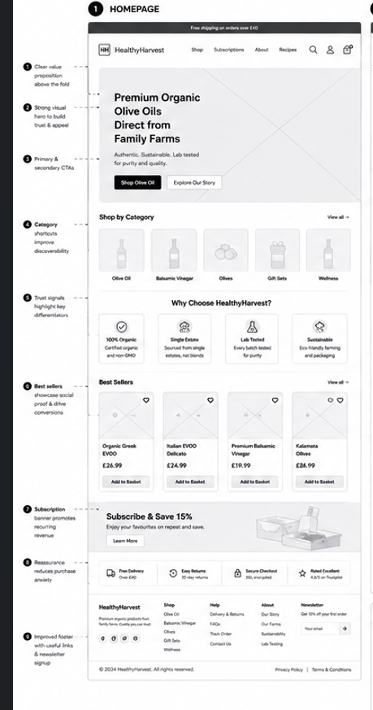

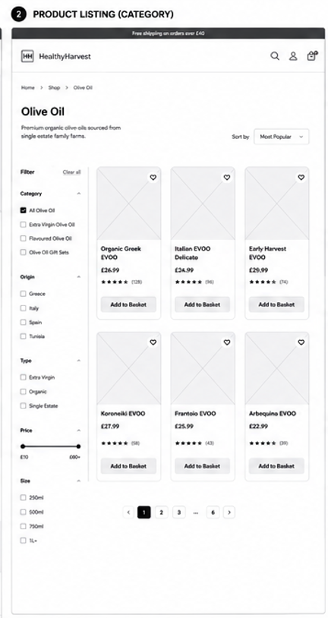

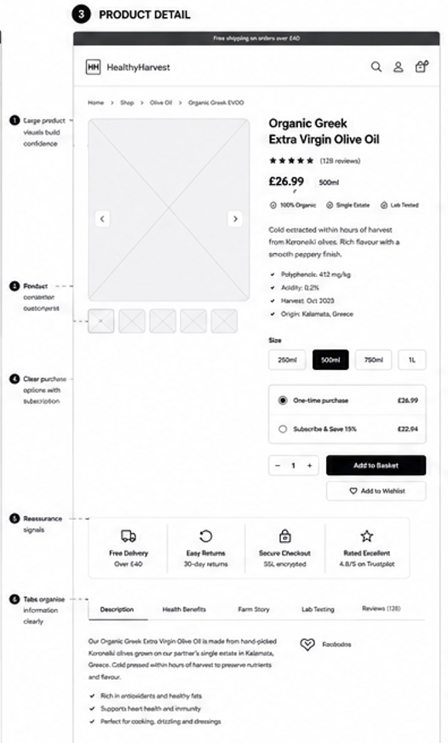
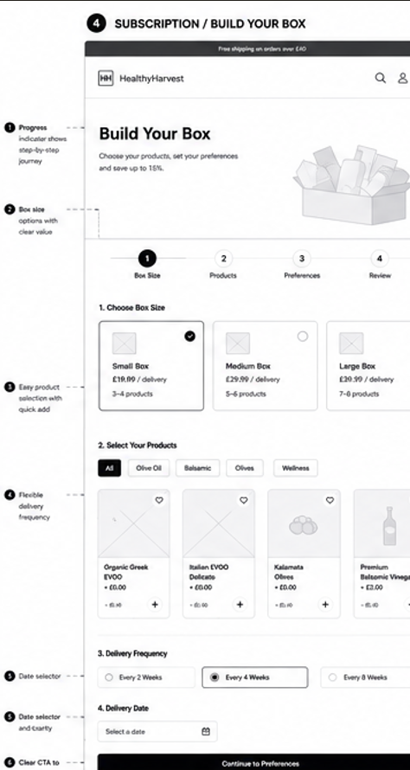
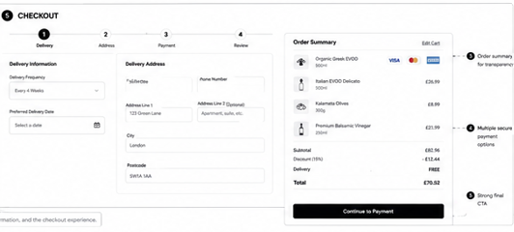

4.2 Mood Board
The mood board establishes the visual language of the redesigned website through carefully selected colour palettes, typography, imagery and interface components. Mood boards provide an essential bridge between research and interface design by ensuring visual consistency before detailed interface development begins [9], [12].

HOMEPAGE
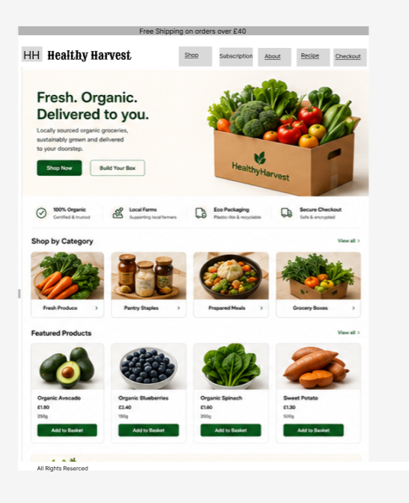

PRODUCT PAGE
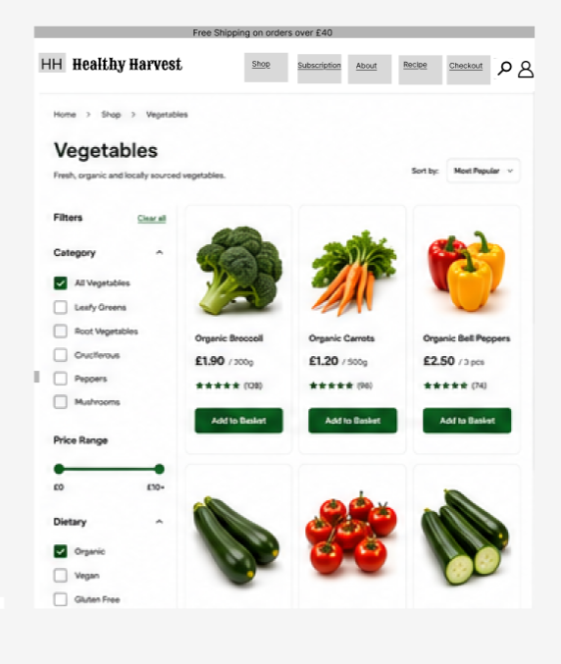

PRODUCT DETAILS PAGE
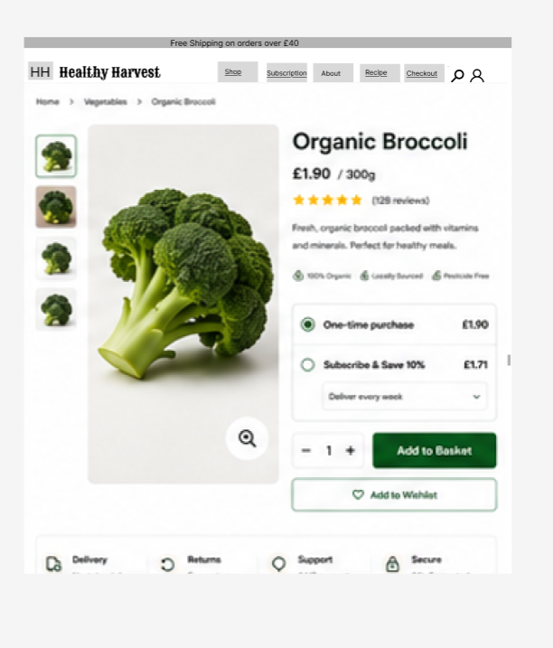

SUBSCRIPTION PAGE
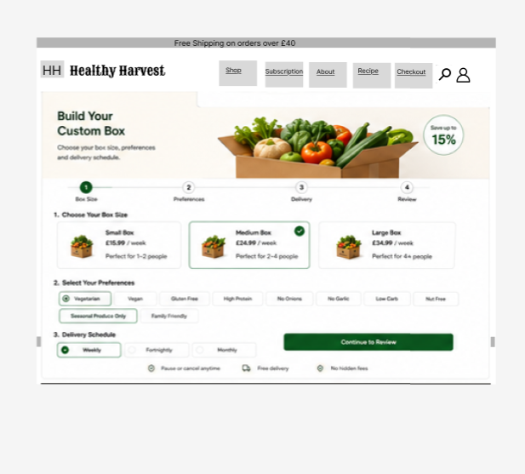

CHECKOUT
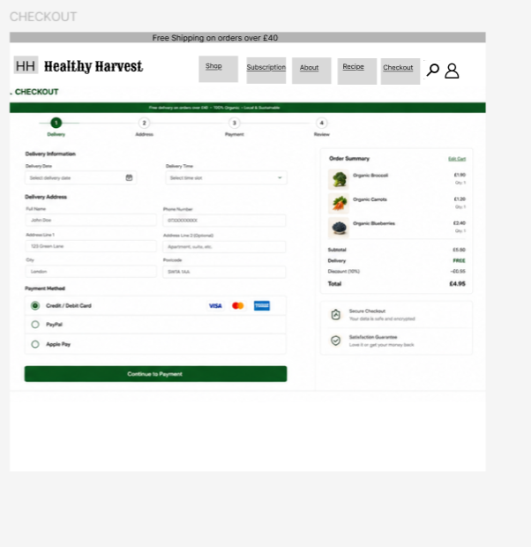

4.3 Interactive Prototype
The interactive prototype was developed using Figma, allowing user journeys, interface interactions and navigation flows to be simulated prior to implementation. Interactive prototyping enables designers to evaluate usability, gather stakeholder feedback and refine interfaces before development begins [9], [12].

4.4 Influence of Wireframes and Mood boards
The mood board informed the visual identity, while the wireframes established the information architecture and interaction patterns. Together these design artefacts ensured that aesthetic decisions supported usability objectives rather than competing with them. This iterative approach aligns with human-centred design methodologies described within ISO 9241-210 [12].

5 Conclusion
The proposed redesign applies established principles of user-centred design, responsive development and e-commerce optimization to improve navigation, accessibility, product discovery and purchasing efficiency. By combining recognized UX frameworks with current research into e-commerce usability and conversion optimization, the redesigned Healthy Harvest website is expected to provide a more intuitive, trustworthy and commercially effective user experience [1], [2], [9], [10], [12], [15].

References
[1] | Nawir & Hendrawan (2024) – Website usability and mobile optimization
[2] | El-Manstrly et al. (2024) – Website efficiency versus experience
[3] | Vinerean et al. (2024) – Mobile consumer behaviour
[4] | Lin et al. (2024) – Mobile website aesthetics
[5] | Ologunebi & Taiwo (2024) – Personalization and conversion
[6] | *Customization at a Glance* (2024) – Journal of Retailing and Consumer Services
[7] | HTTP Archive – *Web Almanac: Ecommerce* (2024)
[8] | Rodríguez-Carmona et al. (2024) – Systematic review of retail e-commerce usability
[9] | Garrett, *The Elements of User Experience* (2011)
[10] | Norman, *The Design of Everyday Things* (2013)
[11] | Krug, *Don't Make Me Think* (2014)
[12] | ISO 9241-210:2019 – Human-centred design
[13] | Baymard Institute – E-commerce UX Research
[14] | W3C – WCAG 2.2
[15] | Google – Core Web Vitals
[16] | Baymard Institute – Checkout Usability Research
[17] J. Nielsen, Usability Inspection Methods. New York, NY: John Wiley & Sons, 1994.

