12/15/2025
Afshana Begum (2337226)
univercity of walws (london campus)
Project Management and Innovation.

Table of Contents
Introduction 2
Task 1 2
Q1. Project Management and Planning 2
Technology Stack and Resources 2
Timeline & Schedule 3
The Gantt Chart 4
Development Method 4
Q2. Project Design Documentation 4
Design Artefact 1 4
Functional Requirements 4
Non-Functional Requirements 5
Design Artifact 2 6
Flow Chart (Lucidchart) 6
Entity-Relationship Diagram (ERD) 7
Task 2 7
Innovation 7
Q1. 7
PEST Analysis 8
SWOT Matrix (Internal and External Position) 8
Legal & Ethical Considerations 8
Q2. Applying Innovation to the Autism Support App 9
Concepts 9
Methods 9
Practices 9
Tools 10
Evolution 10
PEST Diagram 10
SWOT Matrix 11
Task 3 11
Project Reflection Using Gibbs’ Reflective Cycle 11
Description 11
Feelings 11
Evaluation 11
Analysis 12
Conclusion 12
Action Plan 12
Risk Mitigation 13
Conclusion 13
References 14
References 14

MyGuide: Intelligent Behavioural Support Application for Autism Spectrum Disorder (ASD)

Introduction
This document delivers a thorough exploration of the conception, organisation, and critical assessment of MyGuide: an Intelligent Behavioural Support Application tailored for individuals with Autism Spectrum Disorder (ASD). The initiative is driven by the recognised demand for reliable, accessible digital solutions that assist families and caregivers in addressing everyday behavioural challenges through evidence-based strategies.
In the first section, the report describes the chosen project management structure, preferred technology stack, and essential design artefacts, illustrating the influence of Agile methodologies and human-centred design in shaping the solution. The second section conducts an innovative review, employing PEST and SWOT analyses—with Microsoft serving as a reference point—to evaluate the landscape and hurdles within the assistive technology domain. The third section employs Gibbs’ Reflective Cycle to appraise the project, emphasising both technical and ethical dimensions, and uncovering opportunities for professional development.
Together, these sections establish a robust scholarly and practical framework for advancing inclusive digital technologies that benefit neurodiverse populations and their communities.

Task 1

MyGuide: Intelligent Behavioural Support Application for Autism Spectrum Disorder (ASD)

Q1. Project Management and Planning
The MyGuide project is a mobile application developed to provide behavioural support to autistic children and their parents. The core solution architecture is a user-centred, evidence-based tool that combines personalised suggestions, visual aids, and progress tracking, aiming to deliver practical, accessible guidance and ensure inclusivity across diverse needs. [1] [2]

Technology Stack and Resources
The project relies on a modern, cross-platform technology stack to ensure efficiency and scalability. Human resources include specialised expertise for clinical validation.
Category | Component/Technology | Rationale
Development Framework | Flutter or React Native | Chosen for robust cross-platform support.
Backend and Services | Firebase | Provides authentication, cloud storage, and analytics.
Database | NoSQL (MongoDB) | flexible data storage of behaviour logs.
Personnel | Developers, UX Designers, Autism Specialists and testers | Essential for clinical validation and high-quality user experience.
Design tools | Figma for wireframes, Lucidchart for UML diagrams. | For designing
[3] [4] [5] [6]

Timeline & Schedule
The project will run over 18 weeks, divided into six stages:
Requirements gathering (2 weeks)
Design (3 weeks)
Development (6 weeks)
Testing (3 weeks)
Deployment (2 weeks)
Evaluation & feedback (2 weeks)
[7]

The Gantt Chart
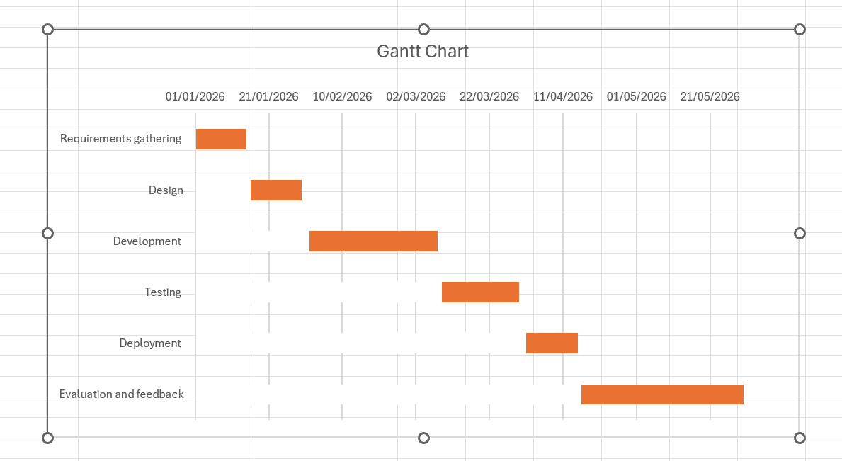
Key Constraints: The project operates under strict budget and time constraints (academic deadlines), necessitating a focus on core features (MVP). Ethical considerations mandate that all advice must be evidence-based, and data privacy compliance (GDPR/HIPAA) is critical for handling sensitive child data. [3] [9]

Development Method
The Agile methodology is employed. This method supports iterative development, allowing for frequent feedback from parents and specialists across short (2–3 week) sprints. This ensures flexibility and continuous improvement centered around user needs.

Q2. Project Design Documentation

Design Artefact 1
The following requirements define the essential functions and quality attributes of the application:

Functional Requirements
Parents must be able to log child behaviours and triggers.
The app must provide tailored suggestions (calming techniques for sensory overload).
The system shall integrate visual schedules and communication boards for children.
A progress tracking dashboard must be available to visualise behaviour patterns.

Non-Functional Requirements
The application must adhere to Accessibility compliance (WCAG 2.1) standards.
It must ensure secure authentication and encrypted data storage.
The user interface must be simple and intuitive for non-technical users.

Design Artifact 2

Flow Chart (Lucidchart)
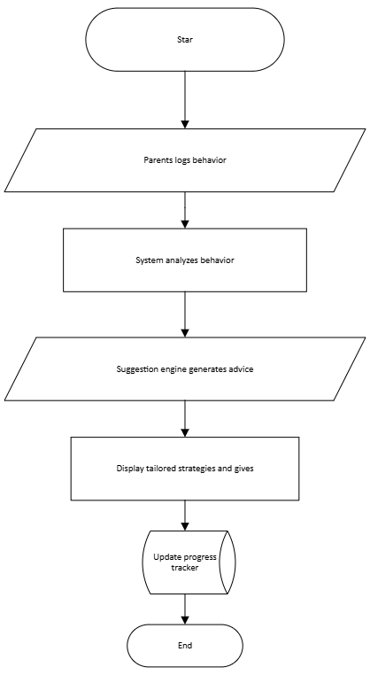

This flow Chart ensures a closed feedback loop, where parent input continuously improves the app’s recommendations.

Entity-Relationship Diagram (ERD)
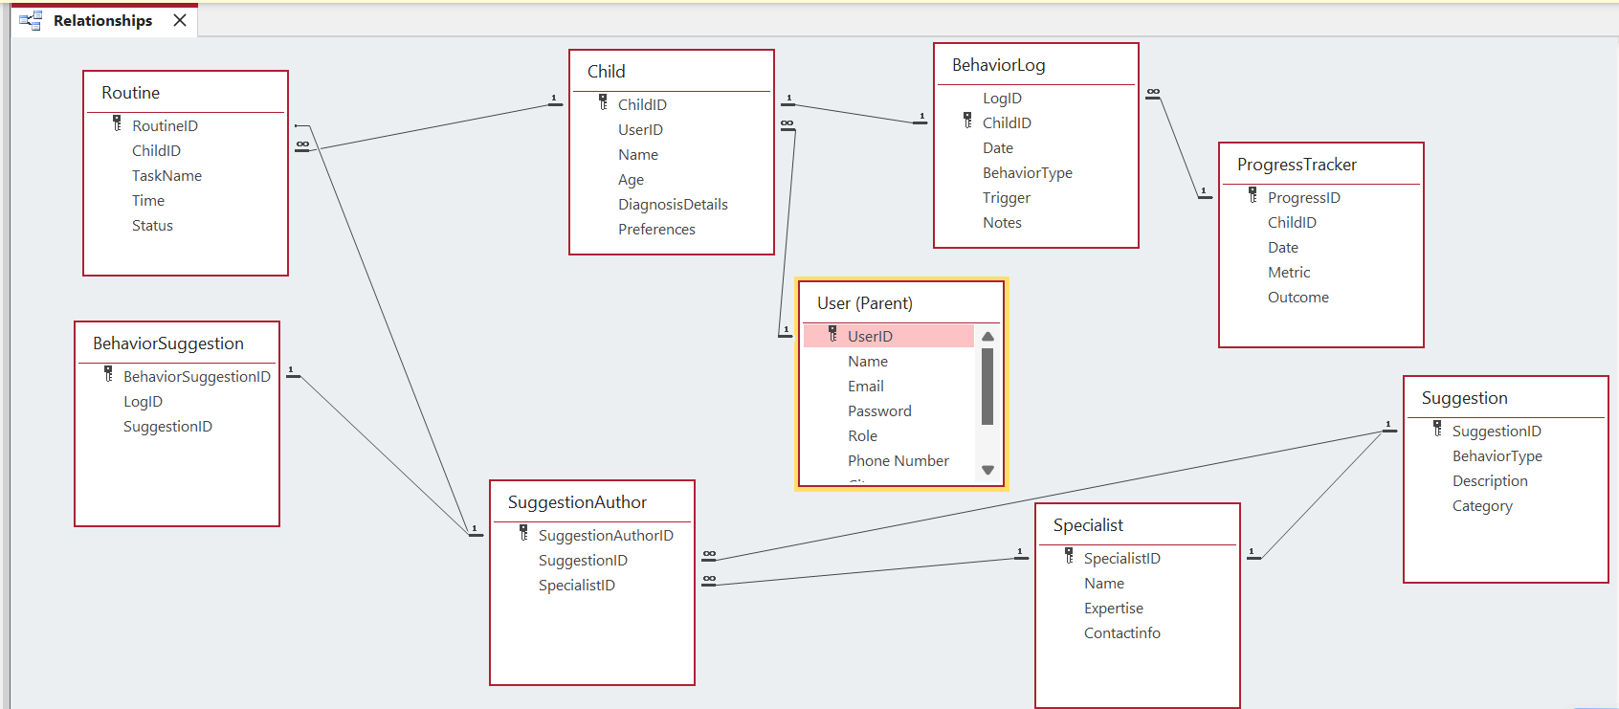
The ERD details the database structure, establishing integrity and the functional relationships between data entities.
Key Data Relationships: The model centres on the Child entity. The User (Parent) manages the Child (1:N), and the Child generates multiple BehaviorLogs, Routines, and ProgressTracker entries (1:N). The critical many-to-many relationship between BehaviorLog and Suggestion is resolved by the LogSuggestion junction table, which tracks intervention outcomes.

Task 2

Innovation
Q1. PEST & SWOT Analysis of Microsoft
Microsoft is one of the world’s largest technology companies, with a diverse portfolio including cloud computing (Azure), productivity tools (Office 365), and accessibility initiatives. Its scale and influence make it a useful case study for innovation in assistive technology.

PEST Analysis
Political: Microsoft must comply with international data privacy regulations (GDPR, HIPAA) and accessibility standards. Political tensions and trade restrictions can affect global operations. [9]
Economic: Strong demand for cloud services and enterprise software supports growth, but inflation and global recessions can reduce IT budgets. [10]
Social: Rising awareness of inclusivity and neurodiversity creates opportunities for autism-friendly applications. Microsoft’s accessibility programs align with these social trends. [4]
Technological: Advances in AI, machine learning, and mobile frameworks enable personalised assistive solutions. Microsoft invests heavily in AI research and cloud infrastructure. [11]
Legal: Intellectual property protection and strict compliance with child data regulations are critical. Microsoft faces ongoing antitrust scrutiny in multiple jurisdictions. [13]
Environmental: Microsoft has pledged to achieve carbon neutrality by 2030, reflecting sustainability pressures in the tech sector. [9]

SWOT Matrix (Internal and External Position)
Strengths (Internal) | Weaknesses (Internal)
Microsoft's strong brand trust, vast R&D resources, and existing Azure cloud integration. [14] | Potential slowness due to regulatory scrutiny, reliance on clinical licensing for content, and complexity of global data compliance. [14]

Opportunities (External) | Threats (External)
Rapid growth in the assistive technology market, potential for integration with educational/healthcare platforms. | Intense competition from specialised health tech startups, evolving cybersecurity risks, and changes in clinical guidelines. [10]

Legal & Ethical Considerations
Microsoft must ensure compliance with GDPR and HIPAA, safeguard intellectual property, and maintain transparency in data use. Ethically, it must avoid bias in AI-driven recommendations, ensure inclusivity, and protect vulnerable users such as children. [9] [14]

Q2. Applying Innovation to the Autism Support App
If the autism support app were implemented within a large organisation such as Microsoft, several concepts, methods, practices, and tools would be required to ensure successful development, deployment, maintenance, and evolution.

Concepts
User-Centred Design: The app must prioritise accessibility and usability for parents and children. This involves iterative testing with real users to refine features.
Evidence-Based Practice: Content must be validated by autism specialists to ensure accuracy and safety.
Scalability: The app should be designed to handle large volumes of users globally, leveraging cloud infrastructure.

Methods
Agile Development: Iterative sprints allow continuous improvement and integration of feedback from parents and specialists.
DevOps Practices: Continuous integration and continuous deployment (CI/CD) pipelines ensure rapid updates and bug fixes.
Accessibility Audits: Regular testing against WCAG 2.1 standards ensures compliance and usability for diverse users.

Practices
Cross-Functional Collaboration: Teams of developers, UX designers, autism specialists, and data security experts must work together.
Data Privacy and Security: Encryption, secure authentication, and anonymisation of sensitive child data are essential.
Monitoring and Feedback Loops: Parents’ usage data and feedback should inform ongoing improvements.

Tools
Development Tools: Visual Studio, GitHub, and Azure DevOps for coding and version control.
Cloud Infrastructure: Microsoft Azure for hosting, authentication, and analytics.
Design Tools: Figma for wireframes, Lucidchart for ERD and flow diagrams.
Analytics Tools: Power BI for monitoring app usage and identifying trends.
Collaboration Tools: Microsoft Teams for communication across global teams.

Evolution
Continuous Improvement: Regular updates informed by user feedback and emerging research in autism support.
Integration with Other Services: Linking the app with Microsoft’s accessibility suite or healthcare platforms.
Global Expansion: Localising content for different languages and cultural contexts.
Sustainability: Ensuring the app aligns with Microsoft’s environmental commitments by using energy-efficient cloud services.

PEST Diagram
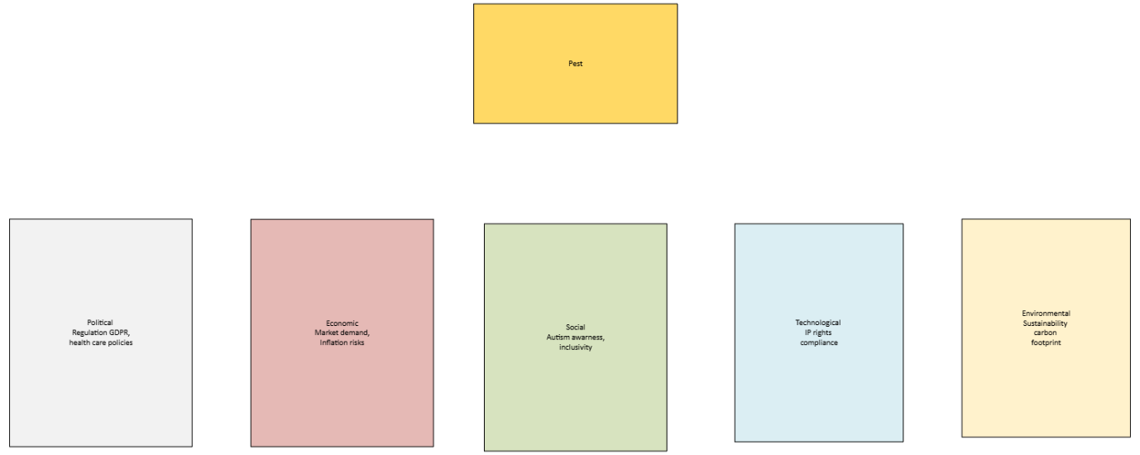

SWOT Matrix
Strengths | Weaknesses
Brand trust, R and D | Regulatory scrutiny, reliance on licensing [15]

Opportunities | Threats
Assistive tech growth | Cybersecurity risks, competition [14]

Task 3

Project Reflection Using Gibbs’ Reflective Cycle

Description
The project I intend to take forward involves designing a mobile application that supports autistic children and their parents by offering behaviour-based suggestions, visual routines, and progress tracking. This idea emerged from my academic interest in assistive technology and user-centred design. The app aims to bridge the gap between clinical advice and everyday parenting by providing accessible, evidence-based strategies.

Feelings
Initially, I felt both excited and overwhelmed. The opportunity to create something meaningful for families navigating autism was deeply motivating. However, I was also concerned about the technical complexity and ethical responsibility involved in designing for vulnerable users. These mixed emotions pushed me to reflect more critically on my role as a designer and the skills I needed to develop.

Evaluation
One positive aspect of this project is its alignment with inclusive design principles and social impact. It allows me to apply academic knowledge in a real-world context while learning new technical and interpersonal skills. However, the project also presents challenges, such as ensuring data privacy, maintaining accessibility standards, and validating behavioural strategies with clinical experts. These issues require careful planning and collaboration.

Analysis
This project offers a valuable opportunity to develop both hard and soft skills. Technically, I will enhance my proficiency in mobile development frameworks (Flutter), database design (ERD modelling), and visual documentation tools (Figma, Lucidchart). [2] [4] I will also deepen my understanding of accessibility standards such as WCAG 2.1 and ethical design practices. Soft skills such as stakeholder communication, iterative feedback integration, and project management will be essential throughout the development cycle.
The societal impact of this project is significant. Autistic children often face barriers in communication and routine management, and parents may lack immediate access to tailored support. By offering a digital tool that adapts to individual behaviours and provides visual guidance, the app can promote independence, reduce stress, and foster better parent-child interactions [1] [3]. Moreover, the project contributes to the broader movement of inclusive technology, aligning with UN Sustainable Development Goals related to health and education.

Conclusion
Reflecting on this project through Gibbs’ cycle has helped me identify key areas for growth and impact. I am committed to using this opportunity to build technical competence, ethical awareness, and collaborative skills. The project is not only academically enriching but also socially meaningful. It reinforces the importance of empathy, evidence-based design, and continuous learning in technology development. [10]

Action Plan
To move forward, I will take the following steps:
Skill Development: Enrol in short courses on Flutter, accessibility design, and ethical UX practices.
Stakeholder Engagement: Consult with autism specialists, educators, and parents to validate app features.

Risk Mitigation
Data Privacy: Implement GDPR-compliant encryption and anonymisation protocols. [14]
Accessibility: Conduct regular audits using WCAG 2.1 checklists. [17]
Content Validity: Collaborate with clinical advisors to ensure behavioural suggestions are safe and effective.
Project Management: Use Agile methodology to structure development into sprints, allowing for iterative refinement and feedback.
Evaluation: Set up metrics to assess usability, engagement, and impact, using tools such as Power BI and user surveys.
[11]

Conclusion
The MyGuide project demonstrates how structured project management, innovative design practices, and reflective analysis can converge to produce a socially impactful application. By integrating Agile methodology, accessibility standards such as WCAG 2.1, and evidence-based behavioural strategies, the project ensures both technical robustness and ethical responsibility. The innovation analysis of Microsoft contextualises the app within broader industry trends, emphasising opportunities in assistive technology and challenges in regulatory compliance and cybersecurity. Reflection through Gibbs’ cycle reinforces the importance of empathy, collaboration, and continuous learning in technology development. Ultimately, this project not only advances academic knowledge but also contributes to the wider movement of inclusive digital solutions, aligning with global commitments to accessibility, sustainability, and social equity.

References

References

[1] | Autism360, "Assistive Technology for Autism: How It Helps," 2025. [Online]. [Accessed 10th December https://www.autism360.com/2015].
[2] | T. A. (. Cardon, Technology and the Treatment of Children with Autism Spectrum Disorder, SpringerLink, 2016.
[3] | M. A. A. E. Mahmoud, "A Comparative Study of Cross-Platform Mobile Application Development Frameworks," 2021.
[4] | J. H. E. L. G. a. D. J. Han, "Survey on NoSQL Database," 2011.
[5] | K. I. G. M. S. a. W. S. C. Boser, "Technology Tools for Students with Autism," 2014.
[6] | Y. S. H. a. P. J. Rogers, Interaction Design: Beyond Human-Computer Interaction (5th Edition), Wiley, 2019.
[7] | Boardmix, 2025. [Online]. Available: https://boardmix.com. [Accessed 11th December 2025].
[8] | I. X. (. team), "Assistive Technology Device for People with Autism," 2021.
[9] | GOV.UK, 2025. [Online]. Available: https://www.gov.uk. [Accessed 11th December 2025].
[10] | E. Help, 2025. [Online]. Available: https://www.economicshelp.org. [Accessed 11th December 2025].
[11] | K. I. G. M. S. a. W. S. C. Boser, Technology Tools for Students with Autism, Brookes Publishing, 2014.
[12] | Creately, 2025. [Online]. Available: https://creately.com. [Accessed 11th December 2025].
[13] | Arbitrae, 2024. [Online]. Available: https://arbitrae.com. [Accessed 11th December 2025].
[14] | I. Xplore, "The Cloud and Microsoft Azure Fundamentals," 2022.
[15] | R. Whalen, "Defining legal technology and its implications," 2022.
[16] | G. Gibbs, Learning by Doing: A Guide to Teaching and Learning Methods, 1988.
[17] | W. (. W. W. Consortium), 2018. [Online]. Available: https://www.w3.org/TR/WCAG21/>. [Accessed 11th December 2025].
[18] | U. o. Edinburgh, 2025. [Online]. Available: https://reflection.ed.ac.uk/reflectors-toolkit/reflecting-on-experience/gibbs-reflective-cycle. [Accessed 11th December 2025].

