Internet Technology and Security

  - Synthesize a Solution to a Potential
  - Real Life Scenario

Sarah Rule – 1810755
1810755@student.uwtsd.ac.uk
Contents
1. Abstract 1
2. Introduction 1
3. BYOD – Bring your own Device / BYOT – Bring your own Technology 2
3.1 Background 2
3.2 Advantages 2
3.3 Disadvantages 2
4. Network Architecture 3
4.1 Security Considerations 3
4.2 Network Design 3
4.3 Firewalls, DMZ and Proxy Servers 4
4.3.1 Firewalls 4
4.3.2 Proxy Servers & DMZ 4
5. Policies and Procedures 4
5.1 General Data Protection Regulations - GDPR 4
5.2 Hyper-fort BYOD Policy 4
6. Mobile Device Management Software 5
6.1 MDM Comparison 5
6.2 MDM Recommendation 5
7. Conclusion / Recommendation 6
7.1 Conclusion 6
7.2 Recommendation to Hyper-fort 6
8. Appendices 6
8.1 Hyper-fort BYOD Policy 6

Abstract
Hyper-fort is a large company in the energy sector with a major global presence looking to implement ‘Bring Your own Device’ (BYOD) within the workplace. This report will provide an overview of what BYOD is, how best to implement this, with the use of Policies and Mobile Device Management (MDM) Software. This report will also go through the network requirements and why the network would benefit from being structured this way. The final section of this report will provide a recommendation to Hyper-fort on whether BYOD should be implemented within their company or not.

Introduction
Hyper-fort is a consultancy agency within the energy sector. Hyper-fort has an extensive presence around the globe, due to this there is a great deal of pressure on them to allow their staff and their customers to use their personal devices to access the company network.

This report will discuss the advantages and dis-advantages of Bring Your Own Device (BYOD), an analysis of a Mobile Device Management solution, including a comparison of solutions that Hyper-fort require. The report will also include a proposal and recommendation for the framework for BYOD to be implemented on the Hyper-fort Enterprise Network.

BYOD – Bring your own Device / BYOT – Bring your own Technology

Background
Bring Your Own Device (BYOD), also known as Bring Your Own Technology (BYOT), refers to the use of personal devices such as mobile phones, laptops etc. within a company setting. It allows employees to use access their work from home, or on the go, instead of inside a company building. Ovums 2014 Employee Mobility Survey indicated that 46.8% of employees are using personal devices for work. 30% of those going directly against a company policy. [1] The chances are that, even if you say no to your employees using their personal devices, they still are. Therefore, is it better to manage the use of BYOD as opposed to having staff use their own devices anyway potentially subjecting you to a security breach.

Advantages
There are a number of advantages for everyone when it comes to BYOD. For small businesses the most significant advantage is a reduction in costs such as hardware spend and software licensing, as this can be reduced. [1]
When it comes to the employee and employer there are a number of advantages for both parties, these are but not an exhaustive list;
- Personal choice
- Better work life balance
- Improved productivity
- No cost for equipment
- Decreased support and training costs [2]

Disadvantages
As expected there are also disadvantages associated with BYOD, these are;
- Financial responsibility
- ‘Always Available’
- Loss, theft or damage
- Information and network security
- Increased support costs [2]
Some of these disadvantages contradict the advantages, for example, where you see ‘Better work life balance’ as an advantage, meaning employees can use their devices from home for family reasons but then you also have ‘always available’ for disadvantages. This means that employees can log on from home late at night if they need to finish something, or they may feel pressured into working at home instead of spending time with their family as they have the means to do so.

Network Architecture
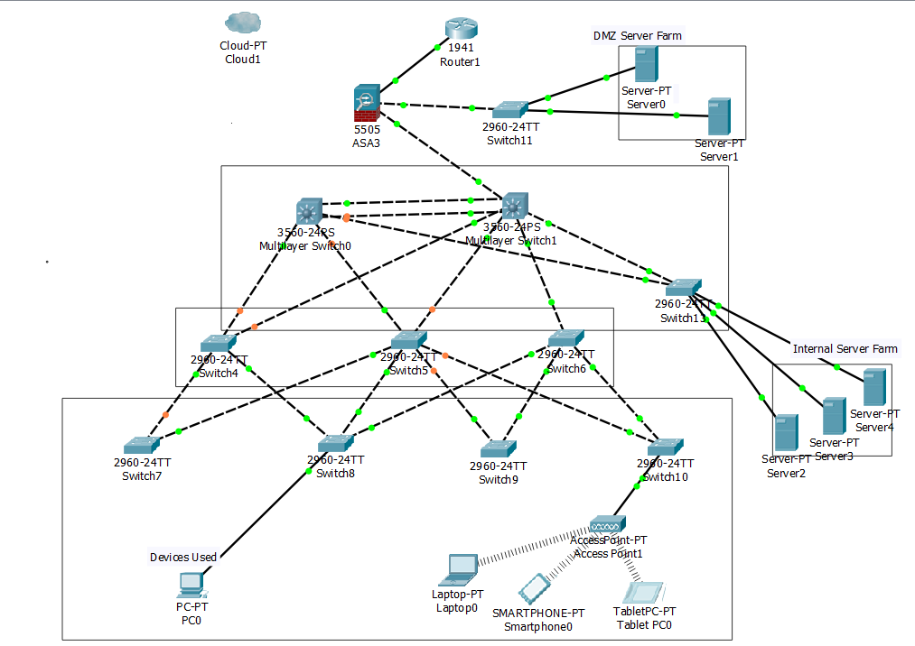
Distribution
Core
Access

Security Considerations
In the image above, you can see that the author has created a small network diagram as a representation of the Hyper-forts network. This is a very small diagram of the network and does not represent the enterprise network as a whole, but it simply shows that the network is broken down into three main layers. There is a core layer (top layer), the distribution layer (middle layer) and an access layer (bottom layer).

Network Design
The author has used a three-tier Hierarchical setting, consisting of the core layer, which is the top layer of the network diagram. The core layer is considered the back bone of the network and consists of the fastest, most expensive and biggest routers with the highest model numbers. Core layer routers are used to merge geographically separated networks. The switches that operate at the core level switch packets as fast as possible, and moves information on the network as fast as possible as well. [3]
The distribution layer is the second layer in the Hierarchical setting, this is the layer that provides policy-based connectivity and controls the boundary between the access and the core layers. The distribution layer is the focal point in the wiring closets. A route or multilayer switch is used to segment workgroups and isolate network problems in an enterprise environment. A distribution layer switch may provide upstream services for many access layer switches. [4]
The Access layer is the bottom layer of the hierarchical setting, it provides users with access to the network and ultimately gives them the access to the company network. The access layer serves a number of functions, including:
- Layer 2 switching
- High availability
- Port Security
- QoS classification and marking and trust boundaries
- Address Resolution Protocol (ARP) inspection
- Virtual Access Control lists (VACLs)
- Spanning tree
- Power over Ethernet (PoE) and auxillary VLANs for VoIP [4]

Routers, Switches and Passwords
The author has made sure to identify what routers and switches are best used in which layer. The author has made sure to disable any unused ports on the switches and routers used within the packer tracer. Passwords have been enabled on all the console ports and SSH lines.

Wi-Fi
When implementing the use of Wi-Fi, Hyper-fort will have to consider corporate use and guest use. For Hyper-for to maintain the confidentiality and integrity of the data they store, the author suggests that they have a main corporate SSID with WPA2 Enterprise, meaning that it works based off certificates so they know exactly what devices they have connecting to their network without the need to connect using a username and password every time. Alongside that, would be Guest Cloud Wi-Fi for customers to connect to while attending meetings for example, but not compromising the data stored in the corporate servers.

Firewalls, DMZ and Proxy Servers

Firewalls
Network firewalls are security devices used to stop or mitigate unauthorized access to private networks connected to the internet, especially intranets. The only traffic allowed is delayed via firewall policies, any other traffic is blocked. Without firewalls, if a computer has a publicly addressable IP – for instance, if it is directly connected via Ethernet – then any network service that is currently running on that device may become accessible to the outside world. [5]

Proxy Servers & DMZ
Proxy Servers are in the DMZ. The users go through the proxy servers, this means that when users go through the internet, the proxy server can only see the DMZ and not individual laptops. The DMZ is separated from the internal servers in the core, any threats from external sources means that the servers cannot connect to the core, which is where confidential data is stored, so it stays uncompromised.

Policies and Procedures

General Data Protection Regulations - GDPR
In May 2018, a new GDPR framework was released to replace the previous 1995 data protection directive. GDPR requirements apply to member state of the European Union, aiming to create more consistent protection of consumer and personal data across EU nations. Some of the key privacy and data protection requirements of the GDPR include;
- Requiring the consent of subjects for data processing
- Anonymizing collected data to protect privacy
- Providing data breach notifications
- Safely handling the transfer of data across borders
- Requiring certain companies to appoint a data protection officer to oversee GDPR compliance. [6]
The new GDPR regulation allows SAs to issue larger fines than the Data Protection Directive. Fines are determined based on the circumstances of each case and the SA may choose whether to impose their corrective powers with or without fines. For companies that fail to comply with certain GDPR requirements, fines may be up to 2% or 4% of total globe annual turnover or €10m or €20m, whichever is greater. [6]

Hyper-fort BYOD Policy
The purpose of a BYOD policy is to set the guidelines for the use of personal and mobile devices within the workplace. A BYOD policy will outline the pros and cons and the minimum requirements needed to be able to maintain a secure environment.
The document will set the guidance and best practices for implementing BYOD and ensuring that the security of the company does not get compromised whilst staff and employers alike are utilizing BYOD.
Attached in the appendices, the author has created a draft policy outlining what is expected from employees when signing up to companies, specifically Hyper-fort in this case. It outlines what the employers expect from employees when using their own device.

Mobile Device Management Software

MDM Comparison
The author has researched and tabled three of the top Mobile Device Management Software for 2019 from a PC Website [7]. Below is a detailed recommendation of what the author recommends Hyper-fort to implement when implementing BYOD.

 | VMware Airwatch | Microsoft Intune | Citrix XenMobile
Locate Phone | Yes, All Platforms Supported | Yes, But iOS Only | Yes, All Platforms Supported
Windows Phone 10 | Yes | Yes | Yes
Android & iOS App | Yes | Yes | Yes
Blackberry Version | --- | --- | Yes
Remote Lock | Yes | Yes | Yes
Remote Wipe | Yes | Yes | Yes
Granular Selective Wipe | Yes | Yes | Yes
Mobile Expense Management | Yes | --- | ---
Single Sign-On (SSO) for all Apps | Yes | Yes | Yes
Geofencing | Yes | Yes | Yes
Knox Support | Yes | Yes | Yes

MDM Recommendation
After comparing several Mobile Device Management software applications available on the market, the author thinks that the best software for the company would be VMWare Airwatch. The reasons for this are that VMWare Airwatch supports all devices, Blackberry, iOS and Android. It supports all platforms when it comes to locating phone, this could be a very useful tool if there are any instances where the phone is lost, however, this would be down to the specific company on how they would implement the use of this. This is because many, if not all employees, would be happy with a locate my phone application on their personal phone. There would need to be a very specific policy available to protect both the employer and employee in cases where this would need to be activated. [7]
VMWare Airwatch also has the capability to remote lock and remote wipe phones with VMWare Airwatch installed, therefore the use of the locate phone capability is wiped. This function allows the employers, again with a very secure policy of what is acceptable and not acceptable, to have the right to wipe the phone if the employee gets fired, for example. It also has a function to be able to granularly selective wipe the phone and delete only work related items from the BYOD device. This is essential in ensuring that confidential company data is secure even after the employee has left the company, but not compromising any of the personal data stored on their phone, for example, family photos etc. [7]
The remaining two MDM software applications available were also good when it came to remote wiping, they offered the same capability. Microsoft Intune were only able to offer ‘Locate phone’ to iOS devices only, this limits the use of BYOD if you tell employees what brand of phone they are allowed to use for work purposes. Microsoft Intune and Citrix XenMobile also failed to offer the ‘Mobile Expense Management’ function. This is essential if the company are paying for calls, texts and data usage for work purposes. There is no way to define and segregate work and personal calls, text and data without a function like this. Again, this may never be something that a company would use, and being able to use your own device is enough of a benefit that generally this wouldn’t come into play, however, the option is there if need be.

Conclusion / Recommendation

Conclusion
The author has spent time researching the advantages and dis-advantages of implementing BYOD within a big company such as Hyper-fort. During this research the author has recommended how best to implement BYOD to be able to monitor it effectively and ensure that they (Hyper-fort) as a company, maintain security and the high standard of customer service they currently offer. Hyper-fort have been advised by the author on ways to set up their network to ensure it remains strong and had the integrity to enable a vast amount of users to access the corporate network and not fail.
The author has concluded, that upon investigation, BYOD is an advantage to more companies, whether they are big or small. The advantages may differ, but in general, is very beneficial for both the employer and the employee.

Recommendation to Hyper-fort
The author recommends that Hyper-fort implement BYOD for their staff and customers. The energy sector it is only getting bigger, therefore, as a company Hyper-fort need to keep up to date with the latest technologies available in order to keep their staff and customers alike happy.
Hyper-fort have been advised of the advantages and dis-advantages of BYOD so need to take these into consideration when finalising their use of BYOD. There are many advantages of BYOD when it is implemented correctly. Hyper-fort will need to ensure that a policy is implemented to maintain the confidentiality, integrity and accessibility of the company, staff and customers data.
The author thinks that BYOD will be beneficial to the company as it already has a global presence so this will only increase productivity of staff. This is because staff are being able to manage work and life better, ensuring that work commitments aren’t being jeopardised but at the same time, family life isn’t being sacrificed in order to complete work. It is about ensuring that your workforce are happy therefore being productive, ensuring that the company thrives and reaches the potential it is able too.

References

[1] | Your IT department, “The Advantages and Disadvantages of BYOD,” 01 June 2017. [Online]. Available: https://www.your-itdepartment.co.uk/news/advantages-disadvantages-byod/. [Accessed July 2019].
[2] | P. Adams, “The advantages and disadvantages of BYOD,” 28 October 2014. [Online]. Available: https://www.fieldservicenews.com/blog/advantages-disadvantages-byod. [Accessed July 2019].
[3] | Omnisecu, “Cisco Three Layer / Three-tier Hierarchial Network Model,” [Online]. Available: http://www.omnisecu.com/cisco-certified-network-associate-ccna/three-tier-hierarchical-network-model.php. [Accessed July 2019].
[4] | C. N. A. -. C. Press, “Cisco Networking Academy Connecting Networks Companion Guide: Hierarchical Network Design,” 09 May 2014. [Online]. Available: http://www.ciscopress.com/articles/article.asp?p=2202410&seqNum=4. [Accessed June 2019].
[5] | Barracuda, “Network Firewalls,” [Online]. Available: https://www.barracuda.com/glossary/network-firewall. [Accessed July 2019].
[6] | J. D. Groot, “A Definition of GDPR (General Data Protection Regulation),” 15 May 2019. [Online]. Available: https://digitalguardian.com/blog/what-gdpr-general-data-protection-regulation-understanding-and-complying-gdpr-data-protection. [Accessed July 2019].
[7] | P. Ferrill, “The Best Mobile Device Management (MDM) Solutions of 2019,” 08 January 2018. [Online]. Available: https://uk.pcmag.com/cloud-services/76018/the-best-mobile-device-management-mdm-solutions. [Accessed June 2019].
[8] | C. Brooks, “What is BYOD (Bring Your Own Device)?,” Business News Daily, 22 May 2013. [Online]. Available: https://www.businessnewsdaily.com/4526-byod-bring-your-own-device.html. [Accessed 07 January 2019].
[9] | B. Chignell, “The Advantages of BYOD,” CIPHR All About People , 28 February 2013. [Online]. Available: https://www.ciphr.com/advice/the-advantages-of-byod/. [Accessed 07 January 2019].

Appendices

Hyper-fort BYOD Policy
Bring Your Own Technology/
Bring Your Own Device Policy

Author: Sarah Rule

Contents
1 Purpose 2
2 Scope 2
3 Background 2
4 BYOD / BYOT Benefits 3
5 Hyper-fort BYOD / BYOT Policy (Recommendation) 3
6 References 3

1 Purpose
The purpose of this document is to provide information for Bring Your Own Device (BYOD), also known as Bring Your Own Technology (BYOT) and the benefits that it has.
2 Scope
This document will give information on BYOD and the benefits that they hold for large companies utilising them or wishing to utilise them. It will outline the pros and cons and the minimum requirements needed to be able to maintain a secure environment.
The document will set the guidance and best practices for implementing BYOD and ensuring that the security of the company does not get compromised whilst staff and employers alike are utilising BYOD.
3 Background
Many large companies use the BYOD policy to enable staff and customers better and more frequent access to the company network on personal devices to complete work inside and outside of the office.
While more companies are using BYOD as an excellent way to increase productivity, it does come with drawbacks. Security issues are of great concern to businesses looking to implement BYOD policies, and the biggest deterrent for those who don’t. [1]
While companies are using BYOD, they still need to be able to govern what is acceptable and unacceptable on the company network. This is done by creating a policy which staff will have to sign as an agreement between the employee and the employer.

4 BYOD / BYOT Benefits
There are many benefits for companies to bring in BYOD and allow employees to use their personal devices, the main one being that it increases productivity. Allowing staff to use their own devices means that employees can always be available to work at all times. It removes the limitations of the 9-5 workday, allowing employees to work on the journey to work, or check emails whilst on holiday, employees are able to get work done out of the normal office hours. [1]
There are many other benefits of using BYOD, these include:
• Cost effectiveness – allowing employees to use their own personal hardware, companies are not having to fork out the cost of laptops, computer etc. as well as the software and maintenance of the device. BYOD shifts the burden to the employee. [1]
• Familiarity – employees will naturally be more familiar with their own personal device, and therefore more proficient. They may have tailored their device to their own personal needs that isn’t possible with company property. [2]
• Employee Care – employees are more than likely to take better care of their device if they have had to purchase it themselves, and have to then replace it should it get broken. Using the device at home as well as the office means that the updates are done when required and the device as a whole is kept up to date. Giving employees a choice of using their own device for work purposes will increase employee satisfaction and productivity. [2]

5 Hyper-fort BYOD / BYOT Policy (Recommendation)
When employees are utilising the BYOD scheme, the following policy MUST be followed and employees must act accordingly. Failure to follow the below policy will result in company discipline.
5.1 Software Updates
Software updates MUST be done within 1 week of the update coming out. If the update affects the device being used, you MUST take it to the IT department within 2 days for it to be repaired. If this is not possible then you MUST call the IT department to seek advice of what to do next. Any employee not applying software updates, without good reason, within the time frame will be subject to company discipline.
5.2 Password Protection
ALL devices used by employees for company purposes as well as personal use, MUST have a PIN protected password. For Two-Factor authentication purposes, you SHOULD add a second password on the device, whether this is biometric or a character password. This will give the device the highest possible security should a disaster occur, e.g. loss of device. Any employee that loses a device MUST contact the IT department as soon as they are aware the disaster has occurred.
5.3 Security and Privacy Risks
Employees MUST ensure that they are actively preventing data breaches by ensuring this policy is followed. They MUST ensure that they are accessing secure sites and securing any work files on the device before accessing personal sites such as Social Media. ALL security breaches MUST be made aware to the IT department as soon as the employee is aware.

5.4 Data Breaches
ALL data breaches MUST be made aware to the IT department, your 1st line manager and the data breach policy MUST be followed.

6 References

[1] C. Brooks, “What is BYOD (Bring Your Own Device)?,” Business News Daily, 22 May 2013. [Online]. Available: https://www.businessnewsdaily.com/4526-byod-bring-your-own-device.html. [Accessed 07 January 2019].
[2] B. Chignell, “The Advantages of BYOD,” CIPHR All About People , 28 February 2013. [Online]. Available: https://www.ciphr.com/advice/the-advantages-of-byod/. [Accessed 07 January 2019].

