University of Wales Trinity Saint David
Wales Institute of Science and Art


Engineering problem

Engineering design and principles

Lars milner
2404286
4/4/25
Contents
- Introduction
  - interpretation of client brief

- Design considerations
2.1 requirements
2.2 legislative and environmental requirements
3. initial design ideas
4. Design choice, materials and manufacturing processes

Introduction

This report aims to provide a plan to solve a problem with an anodising process used by an original equipment manufacturer. A few basic initial design ideas are included along with key requirements for the solution. A Technical drawing and CAD model of the final design are provided along with a justification of the design choice.
1.2 interpretation of client brief.
The lid of the anodising tanks filled with sulfuric acid are considered a safety risk because they are heavy, requiring two people to operate, and employees also experience difficulty in correctly locating the lid onto the tank. Modifications to the lid and tank must be made to reduce the risk of injury. The tank is required to receive objects lowered into it from above and the company uses a few hundred of them in total.

2. Design considerations

2.1 solution requirements
The final design must be safe to operate by a single person.
The tank can be modified but its dimensions and material must remain the same.
A few hundred tanks are in use so the solution must be viable in reasonably large numbers.
Plenty of clearance from above is required so as not to interfere with the process of dipping objects into the tank.
Materials used must not corrode on contact with 30% sulfuric acid and be able to withstand temperatures up to 25 degrees C.
The integrity of the original tank and lid must not be compromised
Ideally, minimal modification should be made to the tank and existing lid so production can carry on during the design and production of the solution.
Any mechanism used to lift the lid should be stable, reliable, easy to maintain and inspect and allow the lid to be easily located on the tank.
Opening and closing the lid should not require excess sideways force or sudden movement or impact to avoid splashing or spillage.
Aesthetics are largely unimportant but should look professional.

  - key legislative considerations
Regulation 4 of the “lifting operations and lifting equipment regulations 1998” (HSE 1998) require lifting equipment, any part of the load and anything attached to it to be of adequate strength and stability, in particular, regarding the stress induced at the load’s mounting point. Regulation 6 gives guidance on the installation and positioning of lifting equipment. It requires the equipment or mechanism to be positioned in such a way as to reduce the risk of the load being released unintentionally, drifting or trapping its operator.
Particular care needs to be taken to prevent the operator from coming into contact with the sulfuric acid. “EH40/2005 workplace exposure limits” states it is necessary to take precautions to the prevent contact with skin through localised contamination or inhalation from acid present in moisture in the atmosphere. The exposure limit to sulfuric acid through inhalation of mist or fumes is 0.05mg/m^3 over an 8 hour period. The lid should be secure to prevent fugitive emissions that are harmful to people and the environment (environment agency, 2009)
The manufacture of the final design should use processes that use the least resources, such as water, electricity and raw materials, and produce the least waste possible (engineering council, 2021)
If the tank is required to be drained for work to be carried out it should then be immediately washed in clean, cold running water and then rinsed in purified water at a temperature not exceeding 60 degrees C in accordance with DEF STAN 03-25.

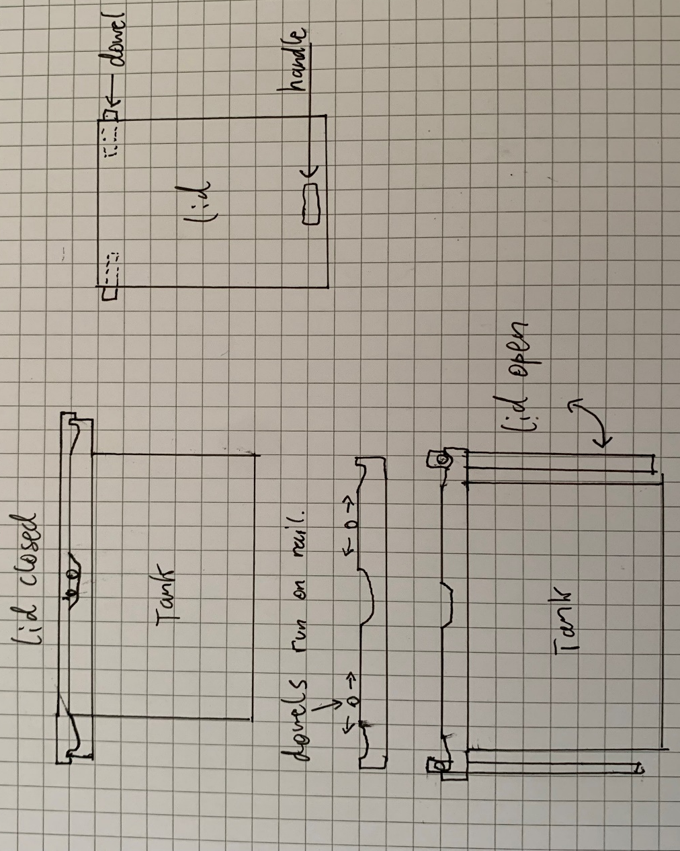
- initial design ideas

- Simple and cheap solution. Lightweight lid slides on rails that catch it before it falls off the end and allow it to swing down and be stowed out of the way.
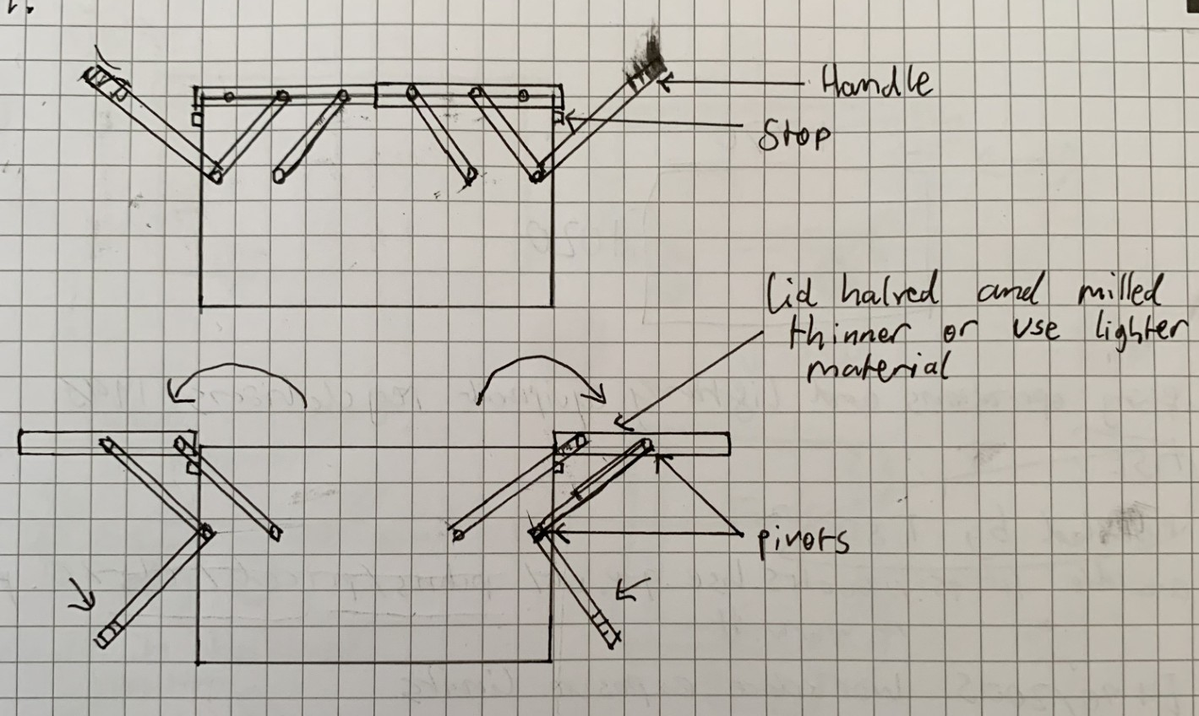
- Inspired by cantilever toolboxes.

Pros:

- The lever with the handle is longer than the arms supporting the lid allowing the operator to gain a mechanical advantage through leverage.
- Lid is supported whilst it is open.
cons:
- Requires work to be carried out on the tank, halting production of anodised parts during installation.
- Linkages would require regular maintanence
- The lid takes up space around the tank unnecessarily when in open position

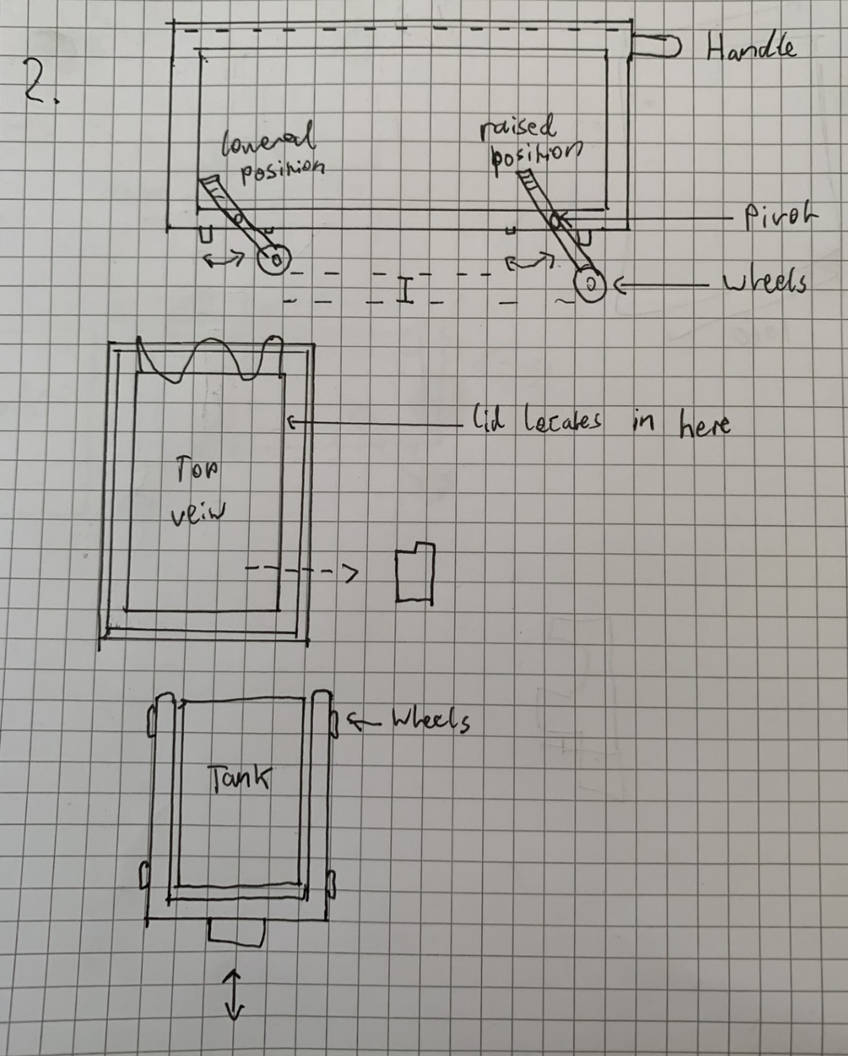

- Trolley welded from square steel tube open at one end to fit around the tank.
The idea for the lifting mechanism is from moveable football goals.

Pros:
- The lid is totally supported by the trolley after initial lifting and can be rolled out of the way.

Downsides:
- the lid is left off the tank during anodising so either a trolley would have to be made for every tank or the lid would still need two people to lift it off and onto the trolley.

- Design choice, materials and manufacturing processes.
Design 1 will be the final design and it’s chosen because of its simplicity. There are no linkages or tight tolerances required and the only moving parts are the two halves of the lid. The original lid is not modified so the entire assembly can be produced without disrupting the production of anodised parts and be retrofitted to the tank quickly using simple fasteners.
The lid will be made from polypropylene. 15mm boards are available to buy and the final shape of the lid can be cut from them by table saw and there is provision for the bottom surface to be milled around the edge up to 1mm depth to create a better seal if the flatness is out of tolerance when purchased. The dowel holes also need to be drilled. Polypropylene is resistant to sulfuric acid in high concentration and will not absorb moisture from the tank and swell or warp. It is also cheap and fatigue resistant which is important for a part that may be subject to stress applied from various angles.
Drawbacks of using polypropylene are its environmental impact as it uses a large amount of energy to produce. It also has a melting point of 130 degrees C so any if any milling work is required, they should take care not to raise its temperature by friction to a point where it would soften.
The guide rails and dowels will be made from the same stainless steel as the tank. Dowels can be bought and cut to length or turned on a lathe from larger pieces. The guide rails will be produced from 20x10mm bars which will require cutting to length and milling. It is likely that the bars will be within tolerance for flatness when they are bought as they don’t require tight tolerances. Stainless Steel is inexpensive, durable and won’t corrode on contact with sulfuric acid.

- Conclusion

References
- Environment Agency
(2009)
The treatment of metals and plastics by electrolytic and chemical processes.
https://assets.publishing.service.gov.uk/government/uploads/system/uploads/attachment_data/file/297005/geho0209bpip-e-e.pdf

- Health and safety executive
(1998)
Lifting operations and lifting equipment regulations
Published by: The Stationary office
https://books.hse.gov.uk/

- Health and safety executive
(2005)
EH40/2005 workplace exposure limits
Published by: The Stationary Office
https://books.hse.gov.uk/pubns/priced/eh40.pdf

- Engineering council
(2021)
Guidance on sustainability
https://www.engc.org.uk/sustainability

- Ministry of Defence
Issue 4 (2003)
Standard 30-25 Sulfuric acid anodising of aluminium and aluminium alloys

