Task 2- Simulated Interview

Shortlisting

01/05/2025- We met up as a group to discuss our shortlisting matrix and ranked our candidates using this scoring system:

- Does not meet criteria
- Partly meets
- Fully meets
- Exceeds

Candidate 001

ATTRIBUTES | ESSENTIAL | DESIRABLE | TOTAL
Qualifications | GCSE Grade C or above in core subjects (eg. English and Maths) | Food Standards Agency Certificate in food allergy and intolerance | 0
Experience |  | Previous experience in hospitality/customer service | 1
Knowledge | Knowledge in customer service  Knowing information about allergies |  | 1
Skills | Attention to detail/ Problem solving  Team work |  | 1
Personal qualities | Enthusiastic individual | Empathy | 1
Additional Requirements | Right to work in the UK | Flexibility  Weekend availability | 1
TOTAL SCORE |  |  | 5

Candidate 002

ATTRIBUTES | ESSENTIAL | DESIRABLE | TOTAL
Qualifications | GCSE Grade C or above in core subjects (eg. English and Maths) | Food Standards Agency Certificate in food allergy and intolerance | 2
Experience |  | Previous experience in hospitality/customer service | 3
Knowledge | Knowledge in customer service  Knowing information about allergies |  | 3
Skills | Attention to detail/ Problem solving  Team work |  | 2
Personal qualities | Enthusiastic individual | Empathy | 2
Additional Requirements | Right to work in the UK | Flexibility  Weekend availability | 2
TOTAL SCORE |  |  | 14

Candidate 003

ATTRIBUTES | ESSENTIAL | DESIRABLE | TOTAL
Qualifications | GCSE Grade C or above in core subjects (eg. English and Maths) | Food Standards Agency Certificate in food allergy and intolerance | 0
Experience |  | Previous experience in hospitality/customer service | 0
Knowledge | Knowledge in customer service  Knowing information about allergies |  | 0
Skills | Attention to detail/ Problem solving  Team work |  | 1
Personal qualities | Enthusiastic individual | Empathy | 2
Additional Requirements | Right to work in the UK | Flexibility  Weekend availability | 1
TOTAL SCORE |  |  | 4

We will be interviewing candidate 002, as they scored the highest with 14 points.

Food and Beverage Assistant Simulated Interview

We all put as many questions as possible that we could think of into our group chat and then decided which ones would be most appropriate for the food and beverage assistant role. We printed the interview packs, as we found it would be easier to write on paper, rather than using our laptops to type our notes.

Interview 05/06/2025
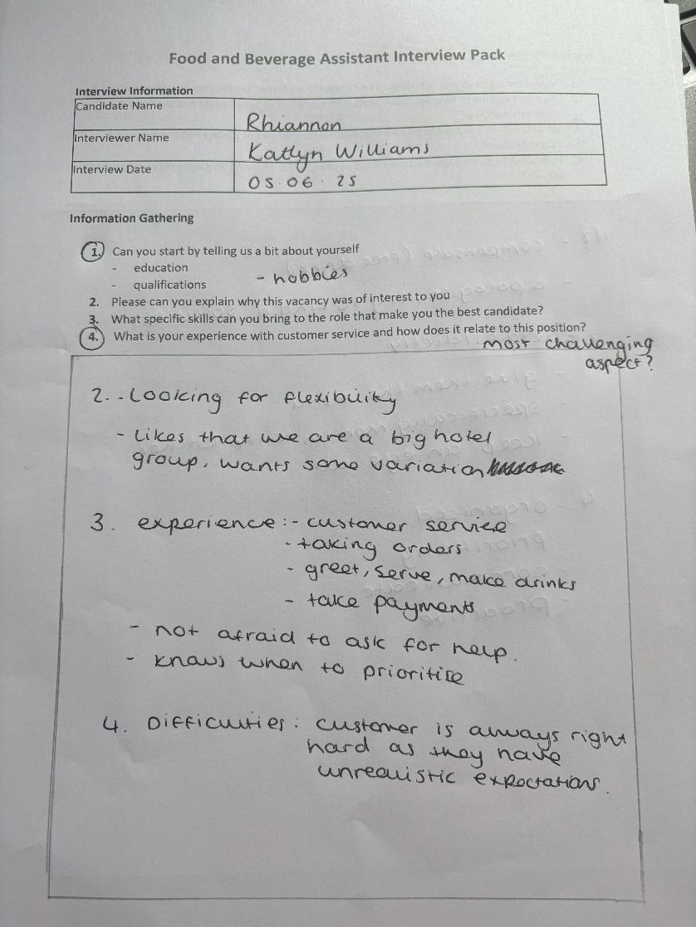
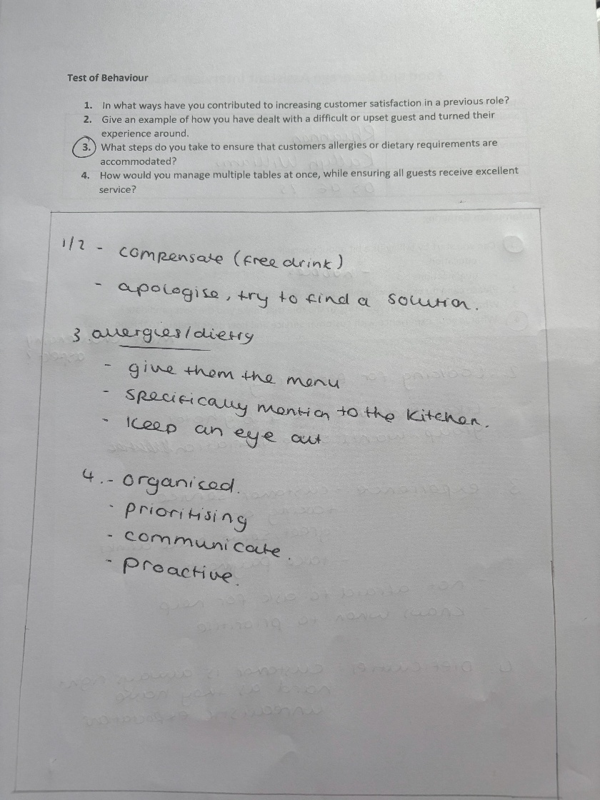

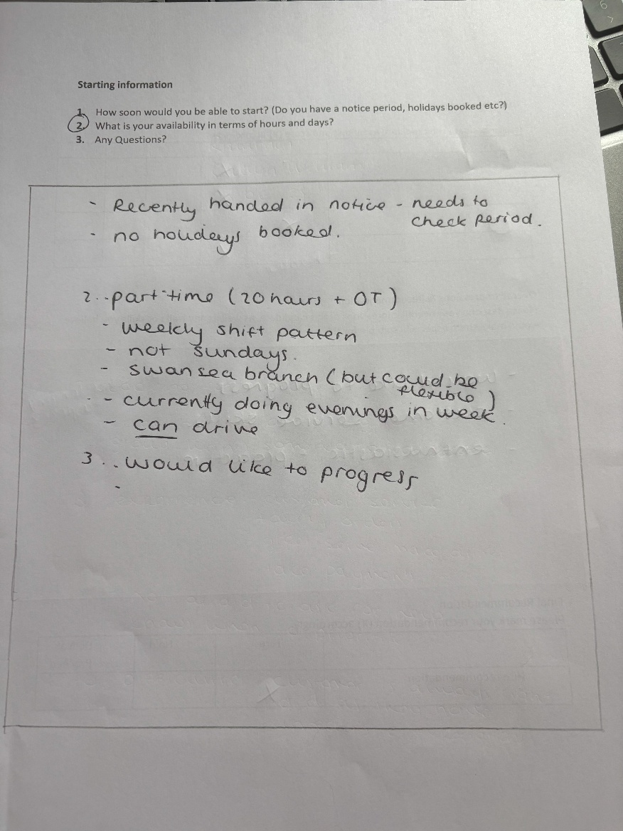
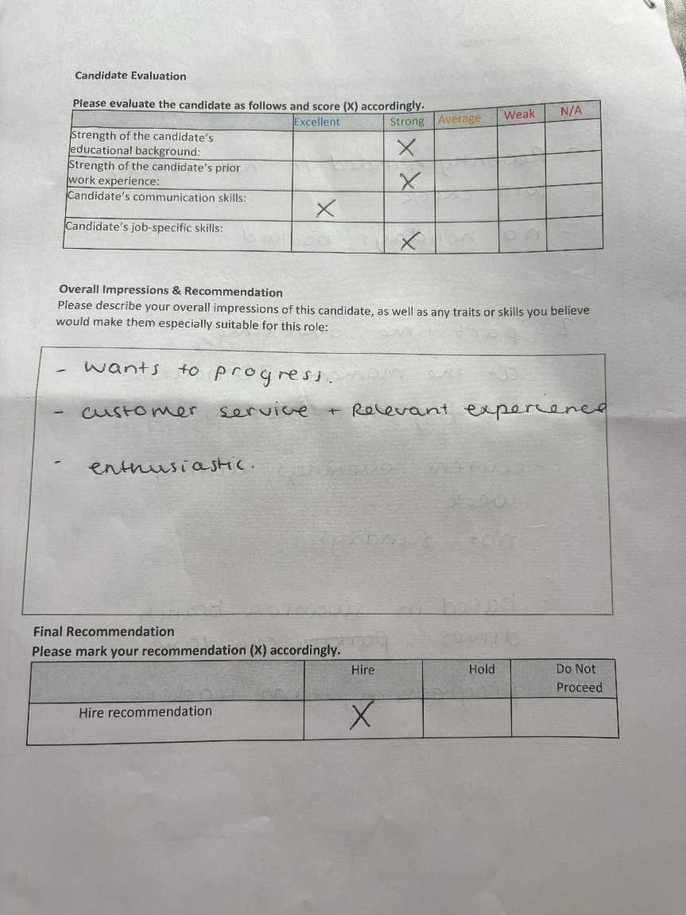

After conducting the interview, we rated the candidate and decided that we would like to hire. We felt that the candidate had a lot of enthusiasm and passion for the role. The skills and experience they possessed was relevant to the role, and the drive to progress was ultimately the deciding factor.

