https://github.com/vladimir796/level-5-code-/commit/4c9c8cf7296416459a803bf9830409522c113f28

Cover Page: Page 1
Name: Vladimir Quansah
Student number: 2419110
Course title: Scripting and Programming Concepts
Module name: ACCA5036
DATE: 23-07-26

Table of contents
Table of Contents
1.0 INTRODUCTION 3
2.0 REQUIREMENT ANALYSIS (300 WORDS) 3
3.1.1 Flowchart (500 words) 6
Pseudocode (500 words) 8
3.2 Implementation Decision 11
3.2.1 Data Structures (500 words): 11
3.2.2 Programming Constructs (500 words): 13
3.2.3 Python Modules and Libraries (500 words): 15
4.1 Role of Testing in Software Environment (200 words) 17
4.2 Type of Errors in Programming (200 words 17
4.3 Example of Test Cases (100 words) 18
Test case table 26
5.0 EVALUATION 27
Challenges Faced 27
Future Improvements 28
Self-Reflections 28
References 29

1.0 INTRODUCTION

For this case study, I need to identify a few things: how I can fix the problem with the increasing use of smart technologies within the educational environment, which has enabled schools and training centers to improve in the classroom for management and create more efficient which is the goal and learning spaces for Bright Minds Academy and to introduce the smart classroom environment is to where the devices such as light projectors and thermostat that are connected through a central system however the academy need a range of improving such managing these devices manually making it difficult for the staff to monitor the devices availability the locations and the connection status the manual approach increase the like hood of human. Error. This will reduce efficiency and make troubleshooting more time-consuming.
The aim and purpose are to design and develop a Python-based smart home device manager that will provide a simple solution for recording and managing classroom devices rather than relying on Paper records or manual tracking, which could be time-consuming and prone to errors with the Python system it will allow them to add new devices update the device statuses and search for specific devices and display all registered devices using an easy to use command

2.0 REQUIREMENT ANALYSIS (300 WORDS)

Requirements analysis is very important because this stage will identify the software development needs as functional and non-functional. Requirements needed to make it successful, satisfy the user, and ensure the features in the software move smoothly and efficiently during the process also need to be defined before implementation begins. This is important because it will show that the final application meets requirements.
Following analysis of the case study, the primary users of the system are the administrators who respond to and manage the classroom smart devices for the software and must allow users to register new smart devices within classroom locations. Staff should also be able to modify each device, as well as its operational status, by selecting whether it is online, offline, or under maintenance. Another important requirement, for [1]maintenance purposes, is the ability to display all locations and current statuses; finally, the users should be able to enter their name and immediately view the corresponding information
Because the case study project is intended as a prototype and includes advanced features, it is important that the database and the network support user authentication and automation. Instead of storing device information, the program will use Python dictionaries and lists, which will satisfy the project requirement while keeping the program simple and efficient. [2]
The proposed solution will provide several benefits to Bright Mind Academy. This is because it will reduce manual record-keeping and improve overall accuracy; it will make device management more efficient and reduce errors, enabling quicker identification of faulty equipment and providing staff with a user-friendly system for maintaining classroom technology. These features directly address the problem identified within the project scenarios to see what went wrong or what was successful overall
Moscow prioritisation Table
Requirement | Priority | Reason
Add new device | Must have | Important function required by the staff
Update device status | Must have | Allows monitoring the devices
Display all devices | Must have | Required by assignment
Search devices | Must have | Required by assignment
Prevent devices of multiply devices names | Should have | Improves data quality
Input validation | Should have | Prevent from users’ errors
Delete device | Could have | Useful but not essential
Save to file / into database | Won’t have | Outside of assignment scope not entirely important

Structured diagram
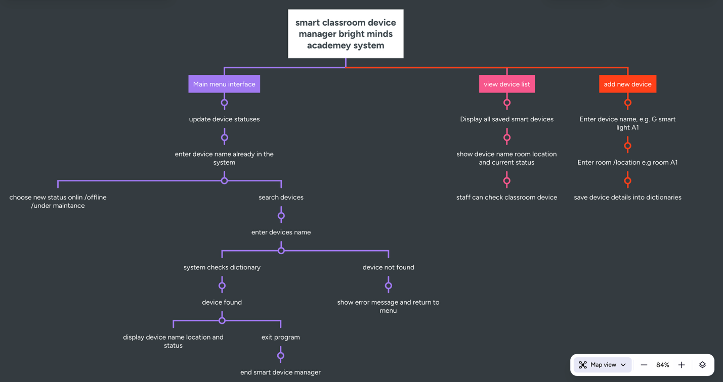
3.0 SOFTWARE DESIGN AND DEVELOPMENT
When it comes to the case study, the software design and development are essential stages within the software development because they transform business requirement into structured and functional software solution during the design phase got to be determine on how the system will operate by planning its architecture the user interaction and data structure and errors that will improve the maintainability and ensure that the software satisfies the user requirement for people will that advice from the bright academy
For the bright minds academy smart classroom device manager the software that will be designed is to modular approach to separate the different function of the application into manageable components rather than creating on large block of code which will make complex for the user and other to understand the individual function were develop for adding new devices updating device statues viewing the registered devices and searching for the specific code this allow and improve the code readability and simplifies the debugging and making future enhancement easier to implement for the programmer [3]
For the programmer, the implementation language is Python because of its clear syntax. The reason is because of its extensive built-in libraries and support for high-level data structures such as dictionaries and lists. These data structures also provide an efficient way to store and retrieve device information without the need for a database, and before implementation, both a flowchart and pseudocode are required for it to work properly. This creates a solid foundation and plan for the program logic and ensures that every user interaction follows a clear sequence. This planning stage reduced development time and complexity and provided the blueprint for translating the design into executable Python code

3.1.1 Flowchart (500 words)

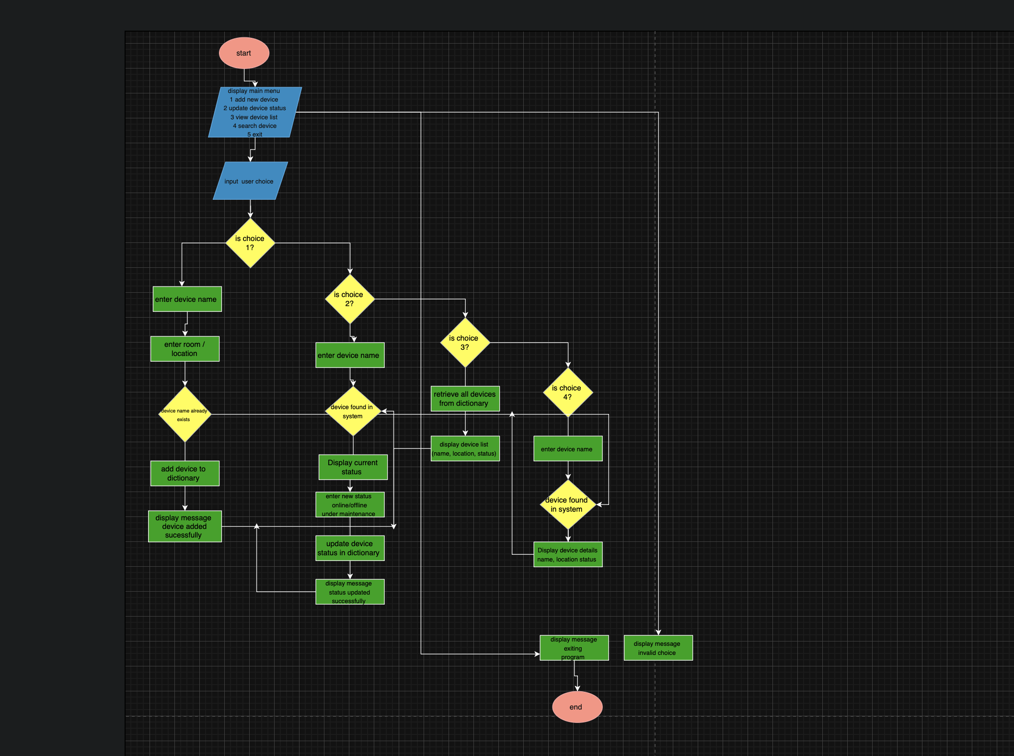
Firstly, a flowchart is a graphical representation of an algorithm or process that illustrates the sequence of operations required to complete a task, using standard flowchart symbols, including terminators, processes, and decision points. Input and output symbols represent the different stages of the program. The flowcharts enable developers to visualise the program logic before coding, easing the complexity of systems and making it easier to understand, communicate and debug
In the software engineering space, flowcharts are widely used during the design phase to simplify and solve problems; they also provide a structured overview of how information moves through a program. They also improve communication between developers and the project tester by providing a common visual representation of the software behaviour

The purpose of the flowchart
The flowchart for the Smart Classroom Device Location Manager serves as the blueprint for the entire application. It illustrates how users interact with the system, how decisions are processed, and how the program responds to different inputs. Designing the flowchart before writing the Python code helps identify the sequence of operations that is required for each function while reducing the possibility of any logic errors during implementation
The flowchart begins with the user launching the application. A main menu is displayed with five options: add device, update device status, view the device list, search for a device, and exit. The user selects an option using the keyboard input, after which the system evaluates the selection through a decision structure [4]
However, if the user chooses to add a device, the system requests the device name and classroom location, and once both values have been entered, the information is stored within the program dictionary and a confirmation message is displayed before returning to the main menu then selecting the update status prompt the user an existent device name the system checks whether the device is exist within the dictionary if it found the user selects on of the three status online offline or under maintenance the stored record is to update before returning to the main menu of if the device cannot be found an appropriate error message will be shown on the display instead [5]
The view device list option will retrieve all stored devices and display them, showing the corresponding location and operational status in a structured format. This will enable staff to quickly review all classroom equipment managed by the system. Moving forward, there will be a search device that will be selected when the user enters the device name; the program searches the dictionary and either displays the matching device information or informs the user that no matching record exists [6]
And finally, the selecting exit terminates the application safely, and throughout the flowchart, decision symbols ensure that incorrect inputs or unavailable devices are handled appropriately without causing the system to crash. This logical structure ensures that every process follows a clear and predictable path, contributing to a reliable and user-friendly software solution.

Pseudocode (500 words)
Add Pseudocode as Text and exclude it from the word count

START
CREATE an empty dictionary called device
REPEAT
DISPLAY “smart classroom device manager”
DISPLAY “1. Add new device “
DISPLAY ”2. Update device status”
DISPLAY “3. View device list”
DISPLAY “ 4. Search device “
DISPLAY “ 5. Exit “
INPUT user_choice

IF user_choice =1 THEN
INPUT device_name
INPUT device_location
IF device_name already exists in device THEN
DISPLAY “device already exists "
ELSE
STORE device_name in devices
STORE location as device_location
STORE status as “offline “
DISPLAY “device added successfully “
ENDIF
ELSE IF user_choice = 2 THEN
INPUT device_name
IF device_name exists in devices THEN
DISPLAY current device status
INPUT new_status
IF new_status is online or offline or under maintenance THEN
UPDATE device status
DISPLAY “ status updated successfully”
ELSE
DISPLAY “ Invalid status entered “
ENDIF
ELSE IF user_choice = 3 THEN
IF devices dictionary is empty THEN
DISPLAY “ no devices available “
ELSE
FOR each device in devices
DISPLAY device name
DISPLAY device location
DISPLAY device status
ENDOR
ENDIF
ELSE IF user_choice = 4 THEN
INPUT device_name
IF device_name exists in device THEN
DISPLAY device name
DISPLAY device location
DISPLAY device status
ELSE
DISPLAY “device not found
ENDIF
ELSE IF user_choice = 5 THEN
DISPLAY “exiting program “
STOP PROGRAM
ELESE
DISPLAY “invalid choice please try again “
ENDIF
UNTIL user_choice = 5
END

The pseudocode above represents the logic for the smart classroom device manager; it is to be developed for the Bright Minds Academy. It begins by creating an empty dictionary called devices to store all smart classroom device records. Each device name acts as a key, while the device’s location and status are stored as related values. This supports the assignment requirement that the system does not need a database and can instead use Python lists or dictionaries to manage information
The program then uses a repeated menu structure; this means the user is shown the main option repeatedly, non-stop, until they choose to exit. The menu will also include five choices: add new devices, update device status, view the devices list, search for a device and exit the program. The structure makes the system easy for staff to use; this will allow [7]
them to use the features and clearly present them from the main menu without any confusion
The first option allows staff to add a new smart device, which is helpful by entering the device name and room location. Before saving the device, the pseudocode checks whether the device already exists, which prevents duplicate records and improves system accuracy. However, if the device is new, it is saved into the dictionary with a default status of showing offline
The second option is to update a device status. The user enters the device name, and the system checks whether it exists. If found, the user can change the status to online or offline or under maintenance; this will reflect the case study requirement to track the device connectivity and operational condition [8]
The third option will be to display this, which will tell us and give us visual output of all the devices stored; if no devices exist, the program displays a suitable message; otherwise, it will loop through the dictionary and output each device name, location and status
Lastly, the fourth option will allow staff to search for a specific device. This is useful because the staff may not want to view the full list every time. The final option is the exit program, which will safely exit the program. The invalid menu choices are handled with an error message overall; the pseudocode provides a clear bridge between the flowchart design and the final Python implementation

3.2 Implementation Decision

3.2.1 Data Structures (500 words):

First, we need to understand what a data structure is: a method of organising and storing data that can be accessed, managed, and modified efficiently during program execution. The data structure enables developers to arrange information logically, thereby improving the performance, readability, and maintainability of a software application. Selecting an appropriate data structure is an important step in the design decision because it directly affects how efficiently information can be stored, searched and updated

In Python, common data structures include lists and dictionaries, each with distinct characteristics depending on the application's requirements. For this project, dictionaries were chosen as the primary data structure because they will allow information to be stored as key-value pairs, making data retrieval both fast and straightforward

The use of data structures for smart classroom device manager

The smart classroom device manager will be developed using a Python dictionary to store all smart device information, with each device name serving as a unique key, and the associated values storing the classroom information and the device's operational status. This structure allows the system to organise the device information efficiently without requiring a database, meeting the requirement outlined in the project specification [9]

This image arrangement enables the program to retrieve or update a device using its name without searching through multiple variables individually; as a result, the software performs efficiently even as additional devices are added

The clear use for choosing dictionaries

When it comes to dictionary data, the structure was selected because it provides several advantages for the Bright Minds Academy system

First, the dictionaries provide fast searching using unique keys; since every smart device has a unique name, the program can immediately locate the correct records when users choose the search device or update status option

The second part will be the dictionary that supports dynamic storage; new smart devices can be added as needed without changing the program's overall structure. This flexibility makes the software easier to expand in the future [10]

And the third part will be to improve code readability: instead of storing several independent variables for each device, all information is grouped into a single structure. This makes the Python code easier to understand, maintain, and debug, which will help a lot

And lastly, the dictionaries simply update the information when staff change a device's operational status from offline to online or to maintenance; only the relevant value in the dictionary needs to be modified, reducing unnecessary code.

The variables used within the program

When it comes to several variables used throughout the smart classroom device manager to manage user input and store system data

The device variables are the primary keys for our code, also known as the primary dictionary, that will store all the registered smart classroom status as the associated values

In this case, the device_name variable stores the name entered by the user when adding, searching, or updating a device; it is also used to determine whether the device already exists in the dictionary.
The device_location variable stores the classroom where each smart device is installed; this information will help staff quickly identify the physical location of equipment

The device_status variable stores the current operational condition of each device; the possible values are online, offline and under maintenance, allowing staff to monitor device availability and maintenance requirements

Lastly, the user_choice variable will store the menu option selected by the user. This variable controls the program’s flow by determining which function will be executed
During each iteration of the main menu

And for the conclusion
Overall, the use of dictionaries provides an efficient, organised, and scalable solution for storing smart classroom device information; combined with carefully chosen variables, this data structure enables the software to perform what is all required functions, including adding devices, updating statuses, displaying records and searching for the device in a simple and effective approach.

3.2.2 Programming Constructs (500 words):

The programming constructs are the fundamental building blocks used to develop software applications. They define how instructions are organised and executed, allowing the program to perform tasks and make decisions, repeat actions, and organise code into reusable components. The common programming constructs include sequence, selection, iteration and function, all of which contribute to creating logical, maintainable and efficient software solutions

When it comes to programming constructs, developers will look at what has been translated into working software in the algorithm, while improving readability, reducing duplication, and supporting future maintenance. Choosing appropriate programming constructs is essential because they determine how effectively a program responds to the user input and solves the intended problem

The programming construct used for the classroom device manager

They are several programming constructs were used during the development of the smart device classroom device manager to ensure that the application met the functional requirements provided by Bright Minds Academy

The sequence

The sequence is the simplest programming construct, in which instructions are executed one after another in the order they appear. For every feature of the smart classroom device manager, the sequence, for example, when adding a new device, the program first displays the menu, then accepts the user’s selection, then requests the device name and the classroom location, and finally stores the information within the dictionary, performing these actions in the order, ensuring that the program behaves predictably and processes information correctly [11]

The decision-making

Selection will allow the program to make decisions based on specific conditions. This project uses numerous IF, ELIF, and ELSE statements; these will control the flow of execution. For example, after the user selects a menu option, the program determines which operation to perform. Selection is also used to check whether a device already exists before adding it, whether a device can be found during a search, and whether the entered status is valid. If a condition is satisfied, the corresponding action is performed; otherwise, an appropriate message is displayed. This action structure improves the readability of the software by preventing invalid operations [10]

The loops

Loops allow a block of code to repeat until a condition changes; for example, in the smart classroom device manager, loops repeatedly display the main menu until the user chooses to exit the application. This will eliminate the need to restart the program every time a different function is required. A loop is also used for displaying every device as well in the dictionary; this will allow and enable the system to retrieve and present all registered devices efficiently

The functions

When implemented, the functions divide the application into smaller sections of code rather than writing a single large program. The individual functions were created for tasks such as adding devices, updating statuses, displaying devices, and searching for seconds. This modular design improves code readability, reduces repetition, and makes debugging much easier. If additional features are required in the future, the new functions can be added without affecting the existing structure

Error handling

With this project, a simple command-line interface and basic error handling were incorporated to improve usability. The program checks whether the menu selections are valid before executing an operation; it also verifies whether a device exists before updating or even searching for it. When invalid input is detected, an informative message is displayed instead of allowing the program to fail unexpectedly; this improves the overall reliability of the system and provides a better user experience

Conclusion

Overall, the combination of the selection-iteration sequence and basic error handling provides a well-structured solution for managing smart classroom devices. These programming constructs work together to ensure that the software is organised efficiently and easy to maintain while having a smooth functional requirement identified during the analysis stage

3.2.3 Python Modules and Libraries (500 words):

The role of Python modules and libraries

Python modules and libraries are prewritten code that allow developers to perform specific tasks without writing every function from scratch, making the process less time-consuming and reducing errors along the way. A module is a single Python file containing reusable functions, classes and variables; however, a library is a collection of related modules that can provide a wider range of functionality. Using modules and libraries increases development efficiency, improves the code, and makes it more organised; this also helps the programmer and the developer for the developers to reuse and test the code

Python provides two main types of modules: built-in modules, which come with the Python installation, and external libraries, which must be installed separately using the package manager. Choosing the right modules depends on the complexity and requirements of the software being developed for the projects

Python modules and libraries used in the smart classroom device manager

The smart classroom device manager was intentionally designed for a lightweight command-line application, and as a result, the programming primarily relies on Python built-in functionality rather than external libraries. This approach keeps the application simple and easy for people to use, understand, and relate to, and suitable for educational purposes while still meeting all the functional requirements specified by Bright Mind Academy. [12]

The program must make extensive use of Python; this means that the Python built-in functions, including input and print, and the dictionary methods enable the user to interact with the application by entering a menu selection, device names, classroom locations, and operational statuses. This interactive feature allows the administrative staff to communicate directly with the program during execution

The print function is used throughout the application to display the menus, confirmation messages, device information and error notifications; clear the output; and improve usability by guiding the users through each stage of the device management process and confirming whether requests have been completed successfully

However, the dictionary methods, such as keys, values, and items, are used to retrieve and organise stored device information efficiently; these built-in methods simply search, display, and update records while keeping the code structured, maintainable, and readable. The reason is that each smart device is stored using the key; retrieving information requires minimal processing, making the program efficient even if the number of registered devices increases

External libraries are not needed

Unlike some larger software systems that require a graphical user interface, networking or database integration, the smart classroom device manager was developed as a console-based application; this will consequently avoid external libraries such as SQLite that were not necessary because they would have introduced additional complexity without providing any significant benefits for the assignment objectives [13]

The project’s specification focuses on demonstrating fundamental programming skills, including variables, dictionaries, functions, loops, selection statements, and user interaction. The Python built-in features are more than sufficient to implement these requirements effectively using only the standard Python environment, also improving portability because the program can be used and executed on any computer with Python installed without requiring additional packages or software configuration

The benefits of using built-in Python features

Using Python built-in modules and their functions offers a range of advantages for this project; one is improved code readability, as standard Python functions are widely recognised and easy to understand. The second aspect will be built-in functions that are thoroughly tested and optimised, making the application more reliable and reducing the likelihood of software errors. Third, avoiding unnecessary external dependencies and simplifying their installation and maintenance allows the program to run immediately upon opening in a development environment such as PyCharm, which will be used for the Bright Mind Academy case study.

4.1 Role of Testing in Software Environment (200 words)

Testing involves examining the software application to determine whether it operates correctly and meets its requirements. It is also an important aspect of software development because it helps identify defects, reduces operational risk, and provides confidence that the finished system is suitable for its intended users; in this case, it will be the students in the Bright Minds Academy. The testing does not always guarantee the software contains no defects; however, it can provide evidence that important functions have been checked under both normal and abnormal conditions.

For this case, for the Bright Minds Academy Smart Classroom Device Manager, the testing must be conducted throughout the development rather than only after the whole program has been completed. For each function tested, this included adding, updating its status, displaying all registered devices, and searching for a particular record; This made it easier to locate faults because only a small part of the program needed to be examined when an unexpected result occurred.[14]

When both valid and invalid inputs were considered, for example, the valid testing involved adding a new smart light and a small light, confirming that its name, location, and default status were stored in a duplicate device, and searching for a device that did not exist. The expected output was compared with the actual result produced in PyCharm. Overall, this will allow testing to confirm that the program is working and meets the functional requirements while handling user errors without introducing unexpected errors along the way. [15]

4.2 Type of Errors in Programming (200 words

The three aspects that must be considered during the development of the smart classroom device manager are syntax errors, runtime errors, and logical errors (Python documentation). Syntax errors prevent the code from being interpreted correctly, and exceptions occur after the code begins executing.

A syntax error occurs when the Python rules are broken. For example, missing colons after an if statement, incorrect indentation, unmatched brackets, or misspelt keywords are common; these errors prevent the program from running and usually highlight the line where Python detected the problem.[16]

Runtime errors occur while the application is operating; for example, requesting information from a dictionary using a device name that does not exist could produce a key error. This risk could be reduced by using an IF condition on the device name in the device dictionary before accessing or updating a record

Last, debugging involves reading error messages, checking the relevant lines, and running each block of code or line. Features can be controlled: PyCharm breakpoints can pause the execution before the selected line, allowing you to inspect it, and the program steps through it step by step [17]

4.3 Example of Test Cases (100 words)
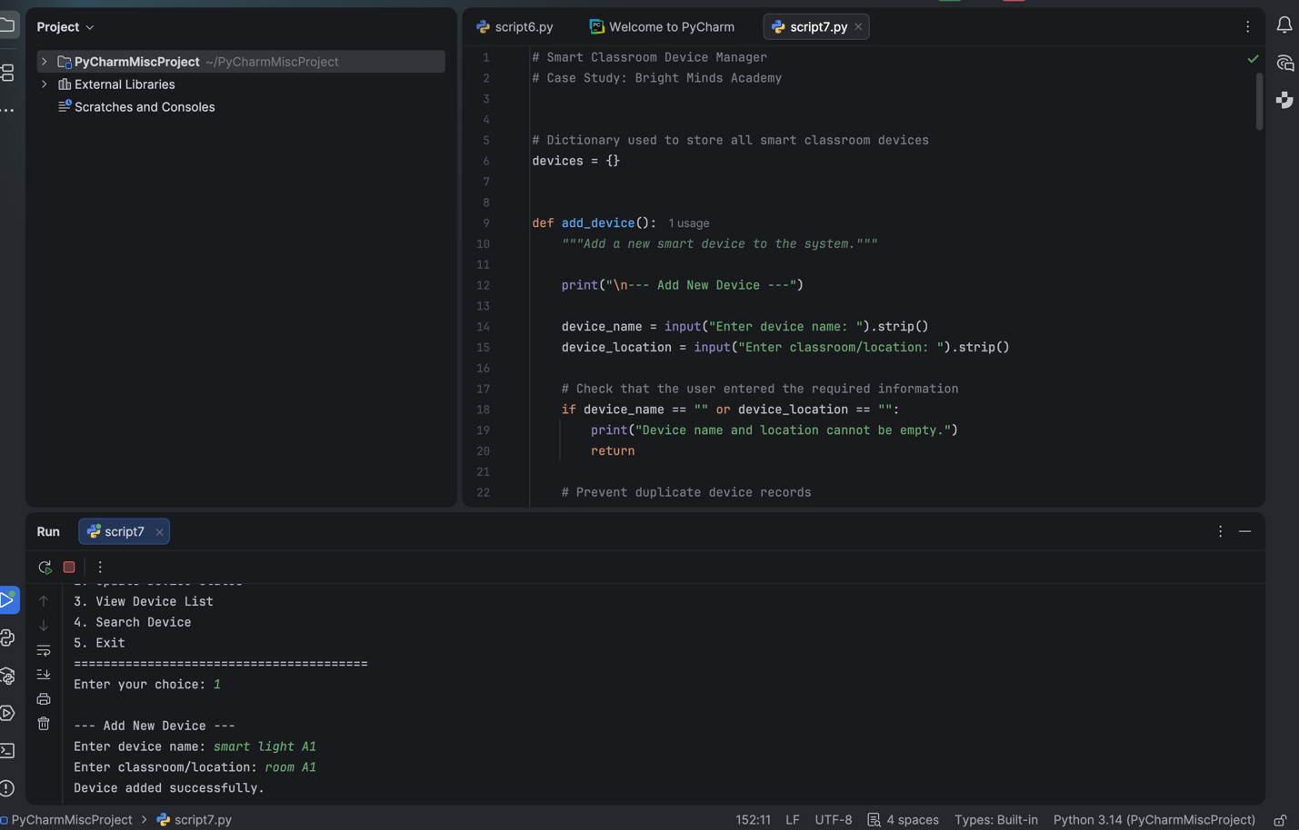

This screenshot shows how the user can successfully register a new start classroom device by entering the name;

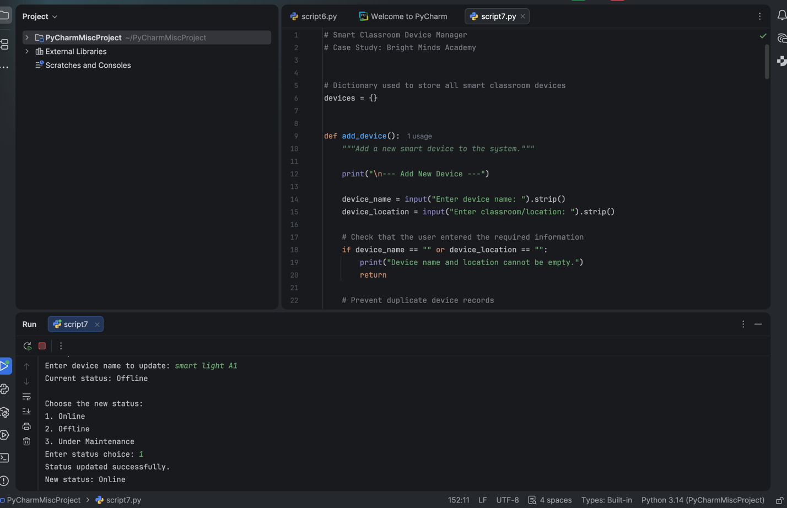

This screenshot shows the saucerful update of smart light A1, the device that was created from online to offline. The program finds it and displays that it has been updated.

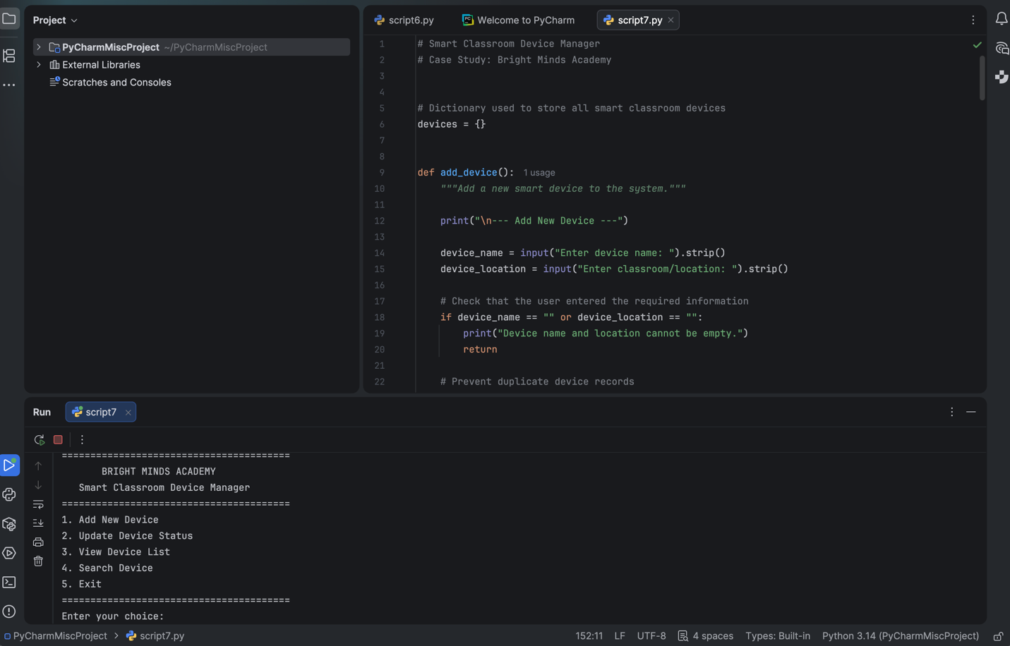

This screenshot shows that the program confirms the system return and displays all registered devices where to press

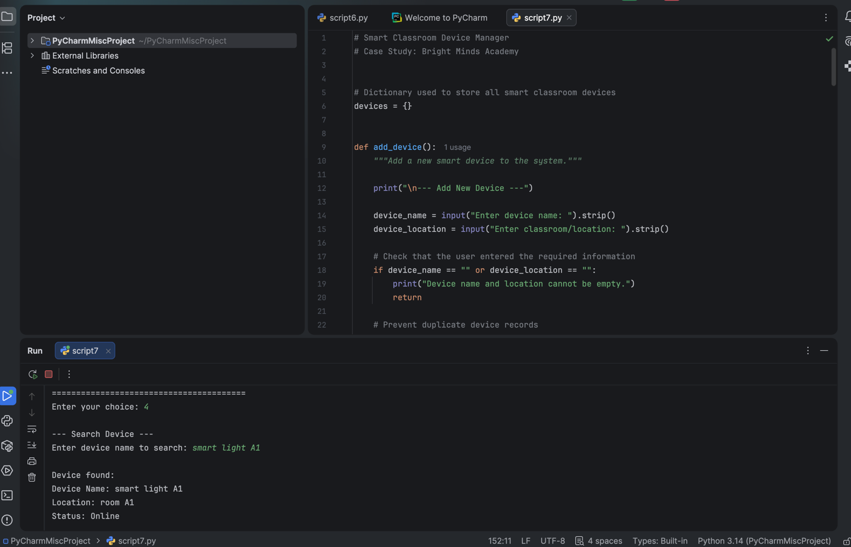

This screen shows the successful search for smart light A1 after the user enters the device name. This lets the program locate and find the dictionary record and display it on the system.

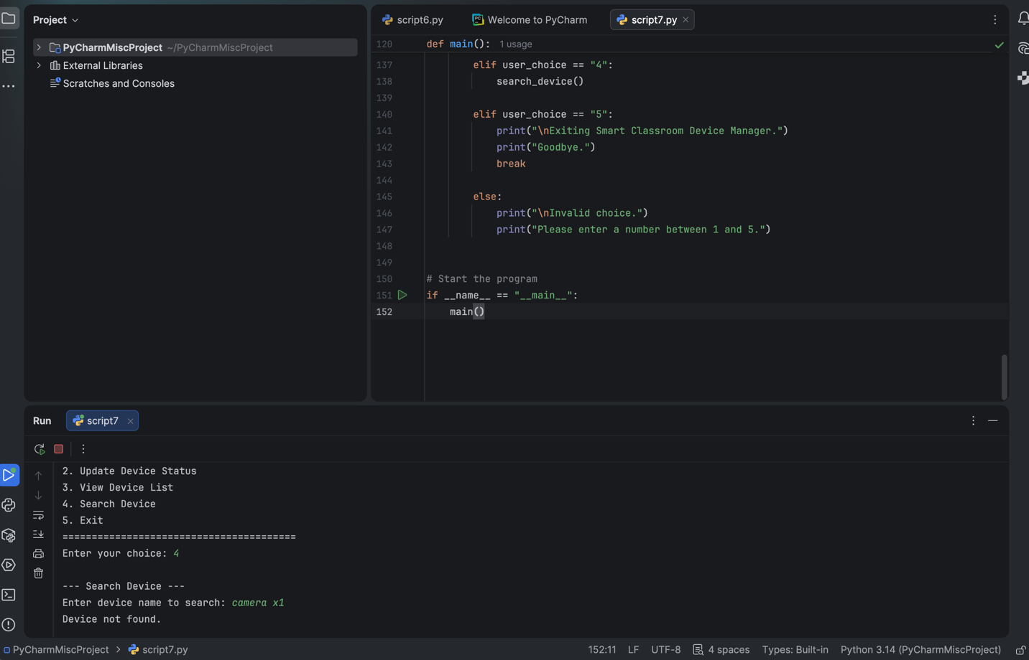

This screenshot shows how I can test the application responds if the user tries to add a different name for camera X1; the program responded with not found because it has not been registered in the program

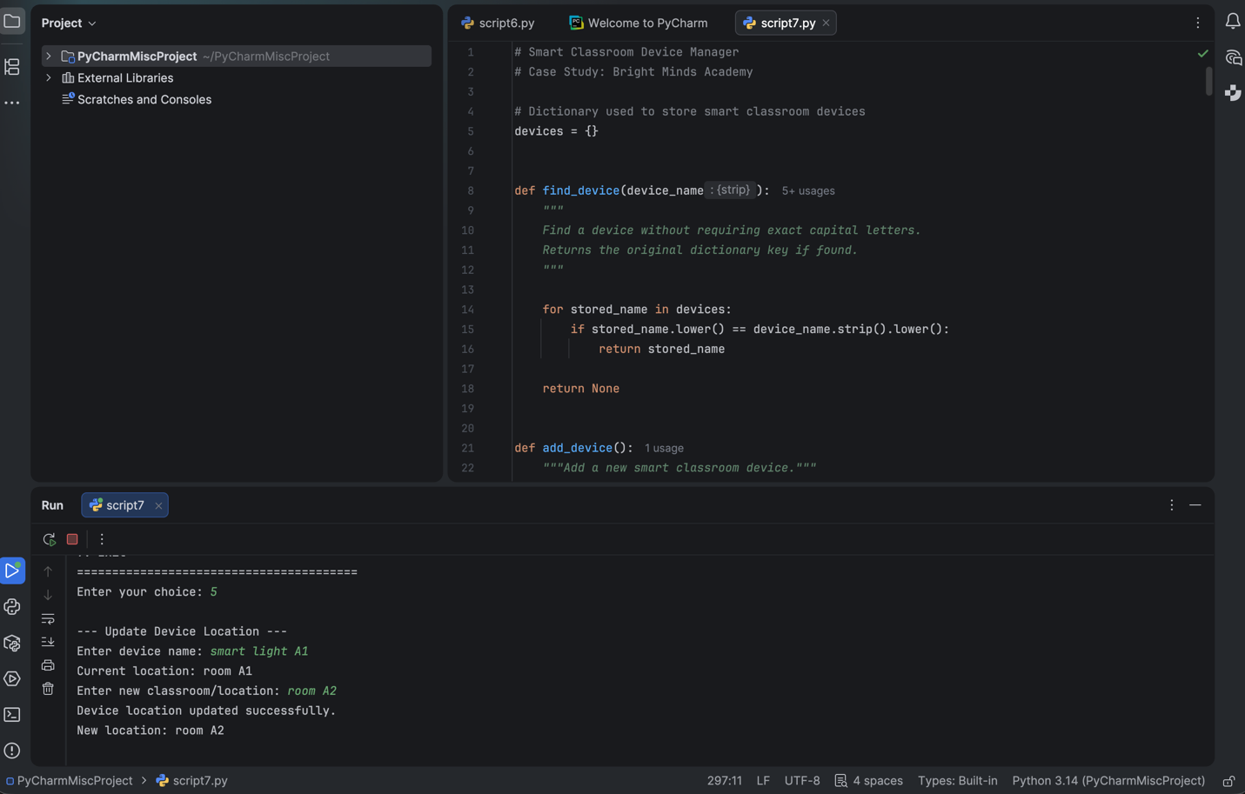

This screenshot shows the smart light A1 being moved from room A1 to room A2; the program displays and has accepted it new value

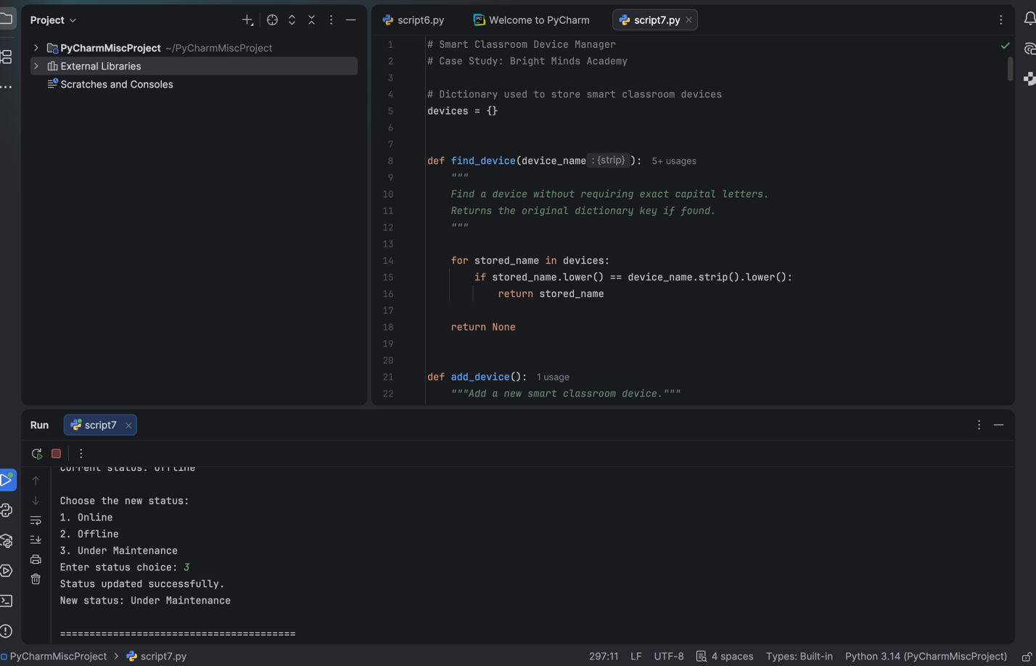

This screenshot shows the device been changed from offline to under maintenance in the system and verifies that it existed before updating the status

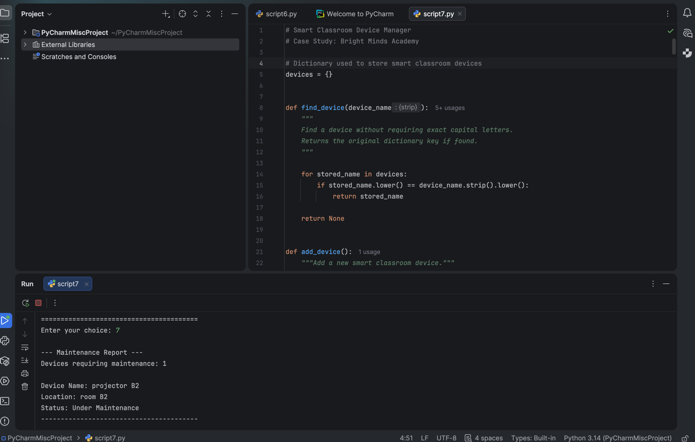
This screenshot shows the new device got projector B2. I have created multiple devices to show that some can be offline, and some can be under maintenance, and within the screen view, the report that is displayed in the system requires maintenance

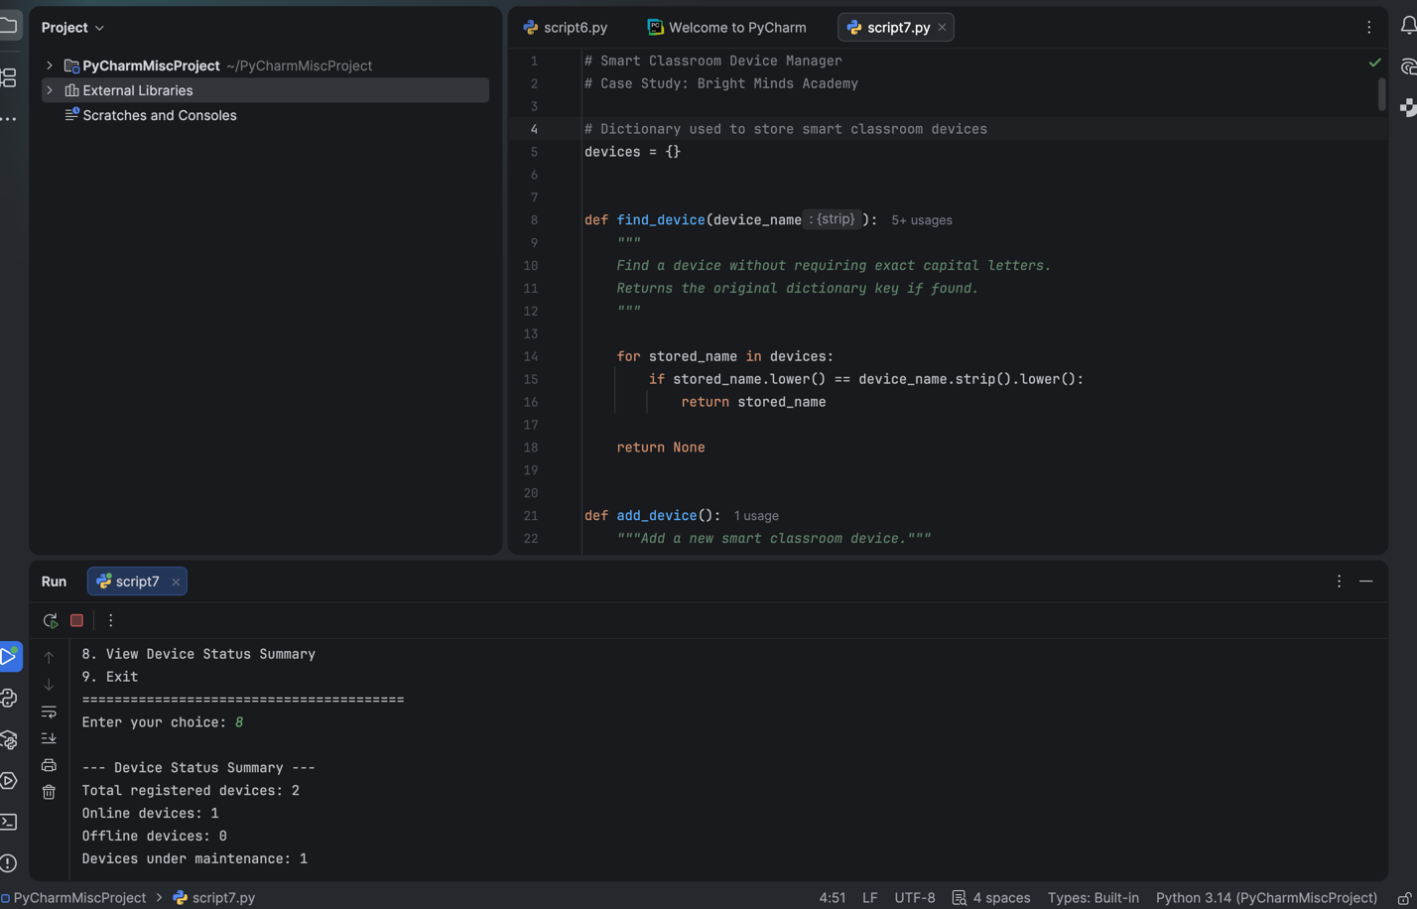

And lastly, this screenshot shows the status summary function of the system that counts all the registered numbers and makes separate devices and shows on the display which device is offline, online and under maintenance

Test case table
test ID | Function tested | Test input | Expected result | Actual result | Status
Test case 1 | Add new device | Menu option 1 smart light A1 room A1 | Device stored device stored status offline | Device added successful offline displayed | pass
Test case 2 | Update device status | Menu option smart light A1 status option | Device status changes from offline to online | Status updated successfully new status online | pass
Test case 3 | View device list | Menu option 3 | Display name and location and status | Smart light a1 room a1 and online displayed | pass
Test case 4 | Search existing device | Menu option 4 smart light A1 | Matching device records | Correct name location and status displayed | pass
Test case 5 | Search for missing device | Menu option 4 camera XL | System error with message | Device not found displayed system still working | pass
Test case 6 | Update device location | Menu option 5 light room a1 room a2 | Device location changes A1 to A2 room | Device location updated | pass
Test case 7 | Device under maintenance | Menu option 2 projector | The projector status changes offline under maintenance | Status updated successful new update and under maintenance | pass
Test case 8 | View maintenance report | Menu option 7 | Report displays all device under maintenance | Projector b2 room b2 undermaintained  Display | Pass
Test case 9 | View device status summary | Menu option 8 | The system displays accurate totals for each status device | Total device 3 online 0 offline 0 and under maintained 1 were displayed | Pass

5.0 EVALUATION

Challenges Faced

The first challenge faced was selecting an appropriate data structure to store smart device information; using separate variables for each device appeared to be a simple solution; however, the device needed new variables and additional ones in the code, and different options from the Python dictionaries using the key-value pairs. This also let me provide a more efficient method for storing and searching device records. Overall, overcoming these challenges strengthened the reliability of the smart classroom device manager and highlighted the importance of planning, testing and debugging throughout the PyCharm software

Future Improvements

A login and authentication system could also be secured by ensuring that authorised members of staff can access or modify the device records. Different user roles, such as administration, could be introduced with varying levels of access to the system’s functions

In addition, the report capabilities could further improve the software by automatically generating reports and recognising failing devices that have been produced, summarising the classroom equipment. This could help Bright Mind Academy in planning maintenance schedules and allocating the replacement budgets more efficiently

Self-Reflections

Developing the smart classroom device manager improved my understanding of the software and the design within PyCharm, the system programming, and thorough testing. I also learned how the flowchart is important for understanding how the computer processes this, which gives me a clear idea of how humans can see how it will be programmed; this now integrates pseudocode, and it can be guided and developed before the coding even begins. The project also increased my confidence in using dictionary functions, loops, and conditional statements, testing each function, and helped me identify errors and solve problems more accurately. Adding the extra features will summarise and show how the software can be expanded beyond its original requirements. Overall, this project has strengthened my technical skills and problem-solving abilities over time; it has made me more efficient and helped me learn independently how to deal with code, the loops and blocks of code and identify why the dictionary is used for this for each function and creating an organised software solution for realistic situations and future projects that lead to a professional software development workspace environment

References

[1] “System Requirements Analysis - Jeffrey O. Grady - Google Books.” Accessed: Jul. 23, 2026. [Online]. Available: https://books.google.co.uk/books?hl=en&lr=&id=FkpqAnHUNLYC&oi=fnd&pg=PP2&dq=requirement+analysis&ots=_TkWJvDxQU&sig=J2TYZLj-U7BIP9MfvxMQqGfeXqE&redir_esc=y#v=onepage&q=requirement%20analysis&f=false
[2] “Requirements Analysis: From Business Views to Architecture - David C. Hay - Google Books.” Accessed: Jul. 23, 2026. [Online]. Available: https://books.google.co.uk/books?hl=en&lr=&id=Qy6j2PemE8QC&oi=fnd&pg=PR15&dq=requirement+analysis&ots=CWcO4i095i&sig=H6P8m9cthuWjoqVeQe4p5Rfrnk0&redir_esc=y#v=onepage&q=requirement%20analysis&f=false
[3] “Requirements Analysis and System Design - Leszek Maciaszek - Google Books.” Accessed: Jul. 23, 2026. [Online]. Available: https://books.google.co.uk/books?hl=en&lr=&id=v7JL2oKwFEAC&oi=fnd&pg=PR27&dq=requirement+analysis&ots=VZpK24fdx1&sig=c_L1WJTe1qHuYFMlKwtCrVqjvDs&redir_esc=y#v=onepage&q&f=false
[4] A. Kuchiki, “A Flowchart Approach,” Industrial Clusters in Asia, pp. 169–199, 2005, doi: 10.1057/9780230523647_4.
[5] “The Multiple Meanings of a Flowchart | JSTOR.” Accessed: Jul. 23, 2026. [Online]. Available: https://www.jstor.org/stable/44667617
[6] S. M. Cormier, L. Zheng, R. A. Hill, R. M. Novak, and C. M. Flaherty, “A flow-chart for developing water quality criteria from two field-based methods,” Science of The Total Environment, vol. 633, pp. 1647–1656, Aug. 2018, doi: 10.1016/J.SCITOTENV.2018.01.137.
[7] A. Alhefdhi, H. K. Dam, H. Hata, and A. Ghose, “Generating pseudo-code from source code using deep learning,” Proceedings - 25th Australasian Software Engineering Conference, ASWEC 2018, pp. 21–25, Dec. 2018, doi: 10.1109/ASWEC.2018.00011.
[8] A. López-García, J. Urquiza-Fuentes, A. J. Mendes, and M. Caeiro-Rodríguez, “Improving University Students’ Learning of Programming Using Customised Pseudocode,” Computer Applications in Engineering Education, vol. 33, no. 4, p. e70061, Jul. 2025, doi: 10.1002/CAE.70061.
[9] E. Horowitz and S. Sahni, “Fundamentals of Data Structures”, Accessed: Jul. 23, 2026. [Online]. Available: www.itdevelopteam.com
[10] J. E. Richardson and M. J. Carey, “Programming constructs for database system implementation in EXODUS,” Proceedings of the ACM SIGMOD International Conference on Management of Data, pp. 208–219, 1987, doi: 10.1145/38713.38738.
[11] “Book Reviews/CS Magazines,” Computer (Long. Beach. Calif)., vol. 24, no. 02, pp. 122–127, Feb. 1991, doi: 10.1109/MC.1991.10016.
[12] “The Python Standard Library by Example - Doug Hellmann - Google Books.” Accessed: Jul. 23, 2026. [Online]. Available: https://books.google.co.uk/books?hl=en&lr=&id=cOSAzek6resC&oi=fnd&pg=PR9&dq=Python+Modules+and+Libraries+&ots=dDgSRbbJ4b&sig=Vf1treyG22etHhyXaPzs7UXq4LU&redir_esc=y#v=onepage&q&f=false
[13] “Python Projects - Laura Cassell, Alan Gauld - Google Books.” Accessed: Jul. 23, 2026. [Online]. Available: https://books.google.co.uk/books?hl=en&lr=&id=Cty6BQAAQBAJ&oi=fnd&pg=PP3&dq=Python+Modules+and+Libraries+&ots=nTWSWfbAp-&sig=36HFjaBAkGHYZeYpB6f5_NOFrE0&redir_esc=y#v=onepage&q&f=false
[14] “Introduction to Software Testing - Paul Ammann, Jeff Offutt - Google Books.” Accessed: Jul. 23, 2026. [Online]. Available: https://books.google.co.uk/books?hl=en&lr=&id=bQtQDQAAQBAJ&oi=fnd&pg=PR9&dq=Role+of+Testing+in+Software+Environment+&ots=fAbQaXY_iT&sig=WW4OptqWbHAdvrZ6Kx9P-7PlWQw&redir_esc=y#v=onepage&q=Role%20of%20Testing%20in%20Software%20Environment&f=false
[15] I. Hooda, R. Scholar, and R. Singh Chhillar, “Software Test Process, Testing Types and Techniques,” Int. J. Comput. Appl., vol. 111, no. 13, pp. 975–8887, 2015.
[16] M. L. Shooman and M. I. Bolsky, “Types, distribution, and test and correction times for programming errors,” ACM SIGPLAN Notices, vol. 10, no. 6, pp. 347–357, Apr. 1975, doi: 10.1145/390016.808457.
[17] “Types and Programming Languages - Benjamin C. Pierce - Google Books.” Accessed: Jul. 23, 2026. [Online]. Available: https://books.google.co.uk/books?hl=en&lr=&id=ti6zoAC9Ph8C&oi=fnd&pg=PR13&dq=Type+of+Errors+in+Programming+&ots=EEMdBEi0Ty&sig=8SQqODWKnw5wuHtTv-dBmhJkebU&redir_esc=y#v=onepage&q&f=false

