James Cawte (2313853)

Systems engineering

Contents
Table of Figures 2
Table of Tables 2
1 – Introduction 3
2.0 – Key Customer Requirements 3
3.0 – Critical System Functionality 4
4.0 – Concept Derivation & Design Choices 5
5.0 – Potential Failure Modes 5
6.0 – Critical Design Features 6
7.0 – Manufacturing Processes Involved 7
8.0 – Critical Process Steps 7
9.0 – Process Control Measures 7
10.0 – Waste and End of Life Disposal 7
11.0 – Test & Evaluation Safety 8
References 10

Table of Figures
Figure 1 – Feature Importances 6

Table of Tables
Table 1 – System Requirements 3
Table 2 – Functional Requirements 4

1.0 – Introduction
Systems engineering is used across various industries to reduce the wasted resources in iterating designs in the real world. Instead, it uses iterative methods to identify the best solutions at the concept stage.

2.0 – Key Customer Requirements
The key customer requirements were devised through consideration from the perspective of a procurement organisation requiring the capability specified in the brief. The requirements were reasoned out based on the brief and then the iterative nature of systems engineering allowed for the shortfalls to be rectified. Initially, there was no waste management considered in the system however that was quickly identified as a shortfall and dealt with.
Table 1 – System Requirements
The system shall detect buried or surface-laid mines typical of legacy and improvised mine threats.
The system shall render detected mines safe by removal, destruction, or permanent disabling.
The system shall be transportable and operable using light vehicles (Land Rover, Hi-Lux, or equivalent).
The system shall clearly mark mines cleared lanes and boundaries in a way visible to follow-on with light wheeled vehicles
The system shall function in high dust, sand, heat, and vibration conditions without degradation of performance.
The system shall clear the required route length within a time window compatible with urgent medical convoy movement.
The system shall limit blast, fragmentation, and collateral damage within the confined pass.
In the event of malfunction, the system shall default to a safe condition without creating additional hazards.
The system shall be designed to enable safe, compliant breakdown and disposal of all system components, including explosive payloads, electronic subsystems and structural elements in accordance with applicable environmental, explosive safety, and hazardous waste regulations at end of life.

Following the creation of these requirements, the system requirements were passed through a pairwise comparison to justify which requirements are critical to the success of the system. This lead to “The system shall render detected mines safe by removal, destruction, or permanent disabling” being the most important requirement for the system to achieve closely followed by “The system shall clearly mark mines cleared lanes and boundaries in a way visible to follow-on with light wheeled vehicles”.

3.0 – Critical System Functionality
With the key requirements identified, the requirements are turned into functional requirements. This means that they specify a function the system must be capable of.
Table 2 – Functional Requirements
Deploy Clearance Capability
Detect Explosive Hazard
Assess and Decide
Neutralise or Removal
Verify Clearance
Mark Cleared Route
Enable Convoy Transit
Recover and redeploy
Render Safe or Dispose of System

Each functional requirement was compared with each non-functional requirement to determine which function, or functions will be imperative for the system to fulfil the customer requirements. This stage is Quality Function Deployment (QFD) 1. QFD 1 has the advantage of highlighting relationships between functions and non-functional requirements that may have gone un-noticed. An example of this is the function “Mark Cleared Route” primarily contributes to the requirement “The system shall clearly mark mines cleared lanes and boundaries in a way visible to follow-on with light wheeled vehicles” but also affects “The system shall clear the required route length within a time window compatible with urgent medical convoy movement” because if the marking system is too complicated then it will delay the overall mission from being completed. Without this matrix, a very good but slow marking system could be implemented but this would be found to be a problem much too late. The result of QFD 1 was “Enable Convoy Transit” was the most critical function while “Neutralise or Removal” was the second most critical.

4.0 – Concept Derivation & Design Choices
The function means analysis exists to collate solutions to each function individually regardless of practicability or cost. For “Neutralise or Removal” some of the potential solutions were: Explosive effector, laser, seismic disturbance, do nothing and throw objects. Of these throw objects and seismic disturbance were ruled out for reasons of practicability while laser was ruled out due to battery and time costs associated with such as system. Explosive effector and do nothing were both suitable courses of action in different scenarios.
The method of coming up with every possible way to achieve an individual function forces consideration of methods which may sound unintuitive but do provide potential value to the system. Doing nothing to the mines seems like a pointless method to consider however if the mines can be safely avoided then the most efficient way to complete the mission would be to do so.
The final design solution was an unmanned aerial vehicle with a ground penetrating radar to sweep for the mines. Another UAV would deliver a disruptor onto any mines discovered. Once the disruptor has been delivered the drone returns and then it is detonated. A second scan of the area will confirm if the ordnance has been dealt with. Next, an unmanned ground vehicle with a plough mounted on the front will drive the intended path into the cleared minefield skimming all surface material to the edge of the intended safe channel to create a tactile, visible barrier. On its return journey it doubles the width of the safe channel and repeats the process of ploughing material to the edge. If any sensitive ordnance was missed the UGV will initiate it with minimal consequence. Once the channel is safe, operators walk along the edge marking it at most 10 metre intervals using UN standard minefield flags [1].

5.0 – Potential Failure Modes
Failure modes were considered for the trial and evaluation stage as well as for operational use. These were the primary areas of consideration for failure modes as there are events involving energetic materials taking place and depending on the failure outcome the consequences could be severe. By applying Failure Modes Effects Analysis (FMEA), every way an event can fail can be considered, analysed for causes to control, and have the effects understood and mitigated. Each failure was scored on likelihood of occurrence, severity of effect and ease of detection. These are multiplied together to provide a final value which can be compared across all failures to isolate the most severe. Anything above the threshold of 300, which moved them out of the tolerable bracket, was evaluated for any additional measures which could be put in place to prevent occurrence or mitigate the consequence.

6.0 – Critical Design Features
QFD 2 takes the elected solutions to each function from the function means analysis and compares the significance of each component against completing each function. This makes things like trained personnel immediately stand out as a critical part of the design due to almost every function being affected by them.
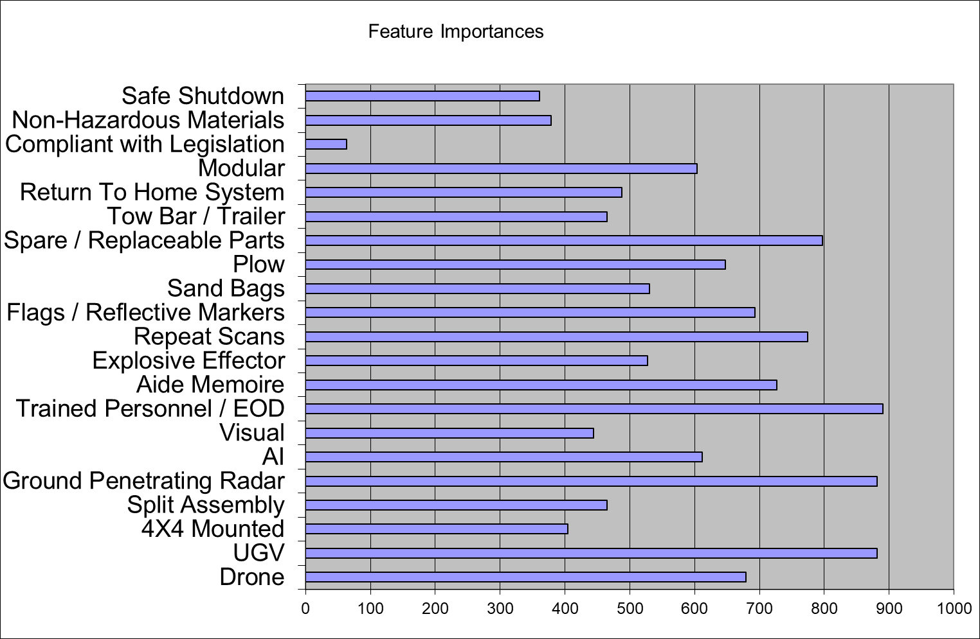
Figure 1 – Feature Importances
The tool shows that being compliant with legislation is the least important feature of the system when concerned with achieving the functionality required however this does not indicate that legislation compliance should be ignored. It just means that legislation compliance is unlikely to affect the system achieving any required functions.

7.0 – Manufacturing Processes Involved
The manufacturing processes were conceived based on the manufacturing requirements. These went through the same process as the initial customer requirements. A manufacturing function means analysis then took place to determine the most suitable method of production for each part of the system. The majority of the system was outsourced due to the design being centred around cheap and easy off the shelf equipment. The only part that was decided to be manufactured was the disruptor charge. Manufacturing QFD 2 compared the methods of manufacture decided on with the parts requiring production to determine any overlap.

8.0 – Critical Process Steps
The manufacturing processes involved in QFD 3 were: 3D printing, hand packing, mixing bowl, manual assembly, and chemical washing. The 2 processes which came out as critical were manual assembly and 3D printing. Being able to see the critical parts of the production process allows for planning of a more efficient production line. Most of the parts required are 3D printed then manually assembled making it crucial that these facilities are available.

9.0 – Process Control Measures
A P Diagram was undertaken to identify all the noises which may affect the quality of the production output. These are divided into external, unit-to-unit and deterioration noises. External noises are environmental factors affecting the quality, unit-to-unit are anything that affects the quality of one produced item to the next (such as fatigue), and deterioration is anything that wears down over time. The control measures can be utilised to counteract the noises and improve the quality of the produced items. Those identified in the manufacturing P Diagram were PPE, training, safety culture, supervision, experienced staff members, regular maintenance of kit, a sterile work environment, climate control and lighting.

10.0 – Waste and End of Life Disposal
Waste and disposal were considered in the toolset via the non-functional system requirement that passed all the way through the toolset: “The system shall be designed to enable safe, compliant breakdown and disposal of all system components, including explosive payloads, electronic subsystems and structural elements in accordance with applicable environmental, explosive safety, and hazardous waste regulations at end of life.” This meant that at all stages of the process thought was given to the end of life of the system. At the function means analysis stage the accepted solutions were for the system to be modular, compliant with environmental legislation (such as REACH [2] and COSHH [3]) and use non-hazardous materials. It was also decided the final system should incorporate a safe shutdown measure to make retrieval safe for the operators. Much of the equipment that makes up the system is off the shelf purchased meaning if there is surplus it can be returned or sold on rather than needing to be managed as waste. The energetic components can be disposed of through standard explosives ordnance disposal routes. Any damaged equipment will be recovered if safe and materials scrapped for recycling where possible. Batteries will need specialist waste recycling.

11.0 – Test & Evaluation Safety
The test and evaluation safety work began after the function means analysis had been completed and the method of achieving each function was decided. The trials were devised based on the functions needing to be demonstrated however they also needed to assess every component chosen for the task and make sure they all worked well in conjunction. For this purpose, a final operational evaluation was conceived to assess the speed and practicality of the system as a whole. As the trials were being decided the general safety considerations could be drafted. It was agreed with the trials manager that all trials that could still be meaningfully carried out in the absence of energetic material should be. This has benefits from both a safety and logistical angle. Any trial involving energetic material poses far more risk to the operators conducting it than a trial involving inert equivalent density shapes. For the planning and logistics side, any trial involving energetic material must be conducted on a suitably licenced range which makes organising the trials take longer and cost more.
Once all trials had been finalised, the FMEA was carried out on every trial to gauge the most serious consequences. This was done by scoring each failure on severity, detectability and likelihood. Those with high enough scores were deemed safety significant events that required additional mitigation.
For the threat detection trial: there were 4 potentially unsafe failures and 1 broadly unsafe failure. All of these were variations on failing to identify ordnance and all were able to be mitigated by only using energetic material for the final detection trial. Conducting this FMEA allows for identification of hazards that will exist in the real operation but will likely have far worse consequences due to the mitigations used for the trials cannot be applied to a real situation.
In the threat defeat trials, there were 3 potentially unsafe failures. The first was a partial detonation in the charge characterisation test. This could be caused by using out of date munitions or poor manufacture. This cannot be mitigated by removing the energetic material due to the purpose of the trial. The only mitigations possible to implement is to have heightened awareness for potentially dangerous UXO and to deal with it in accordance with the range’s procedures. The next 2 failures occur in the charge firing test against a munition. Either the charge was insufficient to render the munition safe, or an unexpected initiation occurs with either piece of ordnance. An insufficient charge would leave an insulted mine potentially very sensitive. In this instance it should be dealt with under the ranges UXO guidelines. For an unexpected initiation, it is an incredible event so long as good practice is being upheld. The only suitable mitigation is to ensure there are first aiders on site with access to trauma kits and a robust plan to get a casualty to the nearest suitable medical facility.
The only other potentially unsafe failure is in the Prove Render Safe Procedure. If there is an unexpected detonation, then the mitigation should be the same as for the firing test against a munition.
After the trials and evaluation work had concluded, information was passed onto the operational safety area to ensure that work done identifying hazards could be utilised. Lastly, for trial safety many assumptions can be made about the environment and conditions events are taking place in. In the real operation situations encountered may be far outside of what was tested for.

References

[1] | “A Guide to Marking and Fencing in Mine Action Programmes,” GICHD, 2008. [Online]. Available: https://www.gichd.org/fileadmin/uploads/gichd/Publications/Marking-and-Fencing-2008.pdf. [Accessed 3 4 2026].
[2] | “The REACH etc. (Amendment etc.) (EU Exit) Regulations 2019,” The National Archive, 2019. [Online]. Available: https://www.legislation.gov.uk/ukdsi/2019/9780111178034. [Accessed 3 4 2026].
[3] | “The Control of Substances Hazardous to Health Regulations 2002,” The National Archive, 2002. [Online]. Available: https://www.legislation.gov.uk/uksi/2002/2677/regulation/7. [Accessed 3 4 2026].

