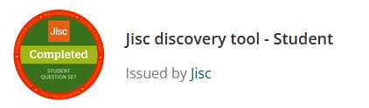
My Digital JISC Report
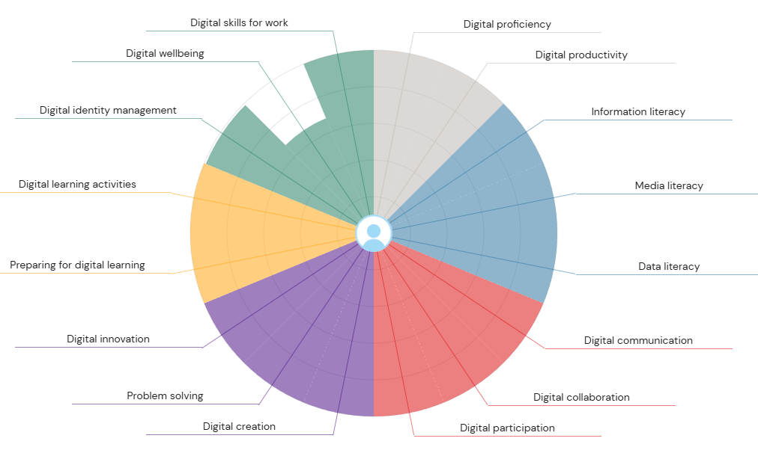

Digital skills are very important to have and to be able to use digital tools. From what I can see from my JISC Badge, I’m good at handling and finding information using online tools, while I’m not good at protecting my attention and wellbeing online. From what i can see from this the grey slice next to Digital Wellbeing is noticeably small. Despite being good at research and writing when eventually focus, my overall ability to structure time, avoid procrastination, use productivity-stack tools effectively, and maintain consistent output in a digital environment is underdeveloped. The irony-induced rabbit holes and constant context-switching are the visible symptoms of this weakness. Media Literacy is easily my strongest area, the massive light-blue slice. I’m good at spotting fake news, smelling bias a mile off, and knowing which sources are worth my time. It’s why I could scroll through endless Twitter threads and TikTok’s about distraction without getting completely sucked in by the nonsense; I can filter the noise fast. My second-biggest slice. I’m strong at tracking down high-quality sources, evaluating them properly, and organising everything so it makes sense later. That’s exactly how I ended up with those obscure leaked reports and cutting-edge studies that made my essay stand out. Even though I can produce good work when I eventually focus, my actual ability to sit down, stay on task, avoid rabbit holes, and string together focused hours, and feel in control of my digital workday is weak. To attempt to fix my Digital Wellbeing I allow myself two 20-minute windows per day for social media/notifications (e.g., 13:00 and 20:30). Everything else waits. I use the app Opal to auto-block everything outside those windows. Surprisingly liberating once the FOMO wore off after four days. Dropping from 7–8 hours to 2.5–3 hours of daily phone/screen time didn’t just give me “extra hours” – it completely changed how I feel and who I am day-to-day. My sleep is dramatically better. I fall asleep in <15 minutes instead of scrolling till 01:00, and I wake up without that groggy “I hate my life” feeling. I find with stopping my large use of media I’m bored again – and I love it. Boredom now turns into daydreaming, noticing things, humming, thinking of ideas instead of reflexively opening an app. My brain is mine again. I no longer feel like a slave to my phone. For years I joked “I’m addicted” and felt powerless. Now I feel like the phone is a boring tool that I pick up when I decide, not when it beeps. That sense of agency over my own attention is probably the best feeling I’ve had in adulthood. Although it was good to be off my phone I did miss a lot of major events I should of seen or missed a lot of calls. For the next three months I’m going to fix my tiny digital wellbeing and productivity slices once and for all, using everything I already learned from the digital-distraction essay and the screen-time drop that changed my life. Weeks 1–4 I’m locking in the non-negotiable foundations that worked before: phone charges outside the bedroom every single night, all screens off by 22:30 with blue-light blockers after 20:00, greyscale mode on permanently, the three worst apps deleted, everything else buried in a “Boredom Tax” folder, and only two 20-minute check-in windows a day enforced by Opal. I’ll keep tracking screen time and pickups every night and aim to be under 4–5 hours by the end of week 4. Weeks 5–8 I turn the saved time into real work: 20-20-20 rule, hourly 3-minute reset walks (no phone), lo-fi only when working, immediate browser close if I hit more than eight tabs, one full 24-hour digital sabbath every weekend, and a quick 200-word weekly reflection on whatever distraction pattern I noticed (mini versions of the essay that made me better last time). I’ll gamify it too — under 30 pickups a day earns me a fancy weekend coffee. Finally, weeks 9–12 I refine and lock it in: I’ll tweak whatever still feels clunky, add one new experiment if I plateau, redraw my radar chart on week 12 to see the green and grey slices grow, and celebrate if I’m consistently under 3 hours with a proper non-digital reward, and from then on keep the quarterly sabbaths and annual “distraction check-up essay” as permanent rituals. I’m doing this slowly and boringly on purpose, because I already know heroic overhauls make me quit — small, stupid, cumulative friction is the only thing that’s ever actually worked for me. By the end I want to feel again what I felt after the essay finished: calm, present, and completely in charge of my own attention.

Excel

Microsoft Excel, the world’s most widely used spreadsheet software, is so deeply embedded in modern life that it is easy to forget it once revolutionised how ordinary people manage numbers. Its origins stretch back to the early days of personal computing, long before cloud apps and touchscreens existed. Excel is a very handy digital tool, it has features that allow it to work out calculations like SUM or AVARAGE, these help visualize data better, Excel has just introduced a new feature which is an AI called Copilot which allows for web search integration and also has a feature called intelligent auto fill where it will fill the selected space with a formula which fits the best into the chosen cell, Copilot can also extract text from images and structure it into tables, you can also ask it what are trends in this data and it will showcase correlations to real life data. The benefits of Copilot are that it can boost your productivity for routine tasks and it also available in all Microsoft tools as it is their AI and they like to showcase it. While using excel you can also make graphs and charts out of the data that you hold in the cells, there are a number of graphs you can use, and a lot can be used to showcase your information in a way that is easy to understand for everyone. Excel is used widely across the world and across different industries which include, Finance, education, science and healthcare, in each industry it is used for different reasons, this shows it has a versatile use across different areas. There are many functions that are very useful to use in Excel, Each one has key categories include, Math and Trig which are SUM, AVERAGE, ROUND AND SIN, these tend to come in handy in the financial analysis and sales reporting side of excel as these allow for the user to work out large data sets very easily and make the data very concise and easy to read for themselves and others who ready it. Next is Statistical where, MEDIAN, MODE, COUNT, come into play, these are used for data analysis. Then you can have Date and Time where, TODAY, NOW, DATEDIF, EOMONTH all come in which is very handy for if you are using Excel to keep of record of things that happen each day and need dates for it, for example these are commonly used for project management as this can be used to keep a day to day diary and also be used to plan out spending over certain periods of time. These functions are also used to help inventory tracking as it someone can update a cell every time they take something out and once it gets low excel can give a warning that it is low by showing a red number or cell, it can also be used by HR departments to keep track of staff numbers, phone numbers, salaries and performance reviews. For this sheet the original spending plan was £6,770 – Fixed obligations were tightly estimated and mostly hit: mortgage/rent £1,200 (exact), council tax £150 (exact), utilities £175 budgeted vs £170 actual, phones £70 (exact), subscriptions £100 budgeted vs £90 actual. What I found from this excel sheet, is that the savings is £1705 which is much more than I expected. Doing this Excel sheet has helped me be able to budget properly and adjust my spending limits, even though this is for a family of 5 I have made one for myself where it has all my spendings, income, other expenses, I have found this very helpful as I always found I was very frugal with my spendings as I would not have any money left for myself at the end of the month. My Excel sheet also includes my student finance and my rent for my student accommodation. For this excel sheet I used my household income when I lived back with my parents and used their spendings, income and other obligations. This also includes my income when I lived with them as I had a job and put money towards the house and kept some for myself which I didn’t put that money into this spending sheet. The importance of Excel surpasses school work and further into life, for example I use excel in my work place where I have to do a head count of customers in every hour where I use the function SUM to work out the total for the hour, I then work out the amount of COIN IN throughout the day from 2pm till 5am where I use SUM again to work out the total amount of COIN IN throughout the entire day and I also use SUM again to work out the percentage to see if it passes a certain amount. I have also had to use a lot of Excel in GCSE in ICT where it was part of my major project at the end of the year to use it and write all about it, this course was 3 years, and I feel very confident about using it Excel. In conclusion, even though Excel can be very confusing to start it is a major help across industries and being able to use it with ease is a very important thing in a lot of workplaces now, it also can be free in some places like university or school.

My LinkedIn Certificates
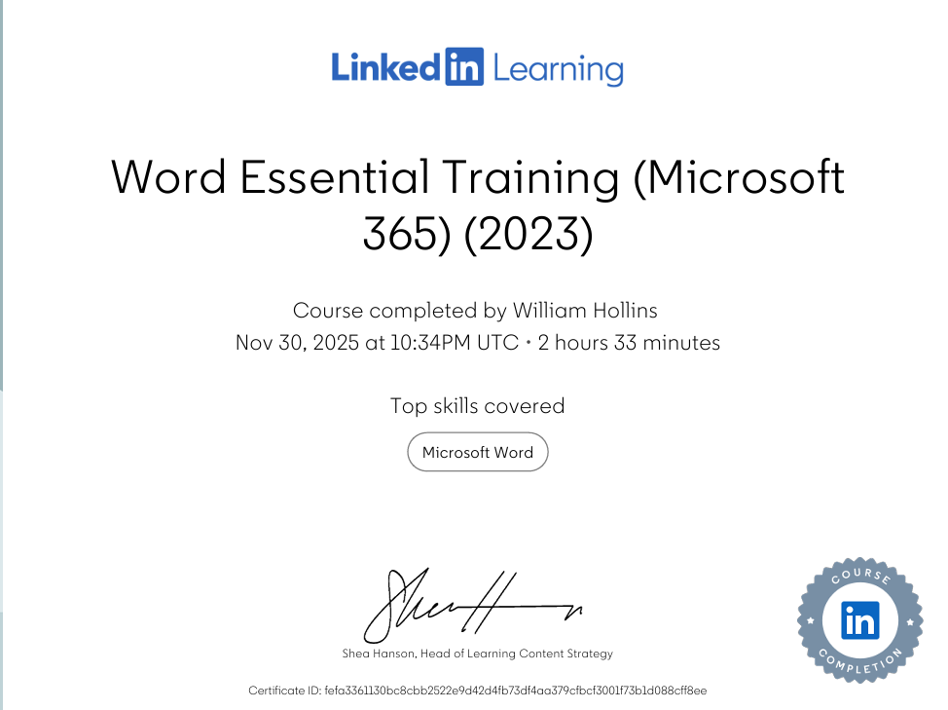

My Reflective PowerPoint


