Professional Career Development

My name is Eljo Ferzaj. The following essay will detail my life, career development and plans for the future.

In the first week of our lecture we were given a lifeline exercise this was the first portion of our assessment. Within this exercise I was asked to highlight my highs and lows from my youth to present day as an adult. This kind of exercise are there to help students understand how life events and difficulties have changed them, their attitude, their characteristics, their thoughts (Neal, Schor, Sabiers, 1998).

My highest points in life are when my parents moved from Albania to Italy when I was a child then at the age of 18 I received my Italian passport, this allowed me to travel freely within the European Union. My most recent high point was moving from Parma (Italy) to London (UK).

Turning points in my life that influenced my move from Italy to Great Britain was my ambition, I knew that the world was bigger than Italy.
At a young age I have always dreamt big and although I spent most of my life in Italy, I knew that I wouldn’t stay there. My sister was in London at the time, and she told me about the opportunities in London.

Highschool in Italy was not easy, but I was able to do well in my studies; in the 8th year of education we are given the choice to specialise in a desired field within the national curriculum. I was given the choice of IT, chemistry and mechanical sciences; chemistry was the most enjoyable subject for me, and it was my first choice. During these years, I had the opportunity to go to Strasbourg with my school on a trip where we had the chance to visit the European Parliament. We were given a tour of the building and we were able to hear a speech from an MP from the HGouse of Parliament and our tour guide explained to us how the EU functions in the world political arena. This was the first time that I have travelled outside of Italy, during my time in France it became clear to me that I need to travel more, to see more of the world. My sisters reasoning for this was because she was making progress in her career in the UK and she strongly believed that I would be able to build a career in any desired field of my choosing if I came to the UK.

After finishing my studies, I was confused and I wasn’t sure of what to do, so I did some temporary jobs, for example I began working as a body shop mechanic. Shortly afterwards I took an interest in hospitality within a small town in Langhirano which is in the province of Parma. I began to work for a friend who owns a bar. Despite not having the prior experience I had to learn on the job to successfully carry out the role. Shortly after a month it became very clear that I was progressing quickly, I looked online for tips and bottle tricks, I was often complemented for being a good talker.

My sister was already here in the UK working, that year I came to spend the Christmas holiday with her. I then returned to Milan to undergo a bartending school for two months. Shortly after I decided to move to London permanently. I was able to easily find a job in one week, my sister then returned to Italy and I was alone in London. Another highest point in my life that gave me confidence was In March 2018 when I decided to go a bar academy in Barcelona with Flair Crew for three days. On the third day I was one of the few people that passed the final exam and received a certificate. My career in bartending began from barback, at the time my level of English was not as good as it is now. After some time, I went from bar back to bartender to bar manager. Due to hard work, effort and improving my skills, I achieved my goals; this made me understand that if I want something, I can attain it.
After some time, members of my family from Greece came to London and I began to help them to find jobs and apply for NINO (National Insurance Number) and even accompanied them to interviews to translate languages. In total I helped up to thirty people, these individuals fell into the categories of singles and couples with children. In order for me to help them to find accommodation, I had to quickly learn how to develop relationships with estate agents and creatively find ways to look for rooms and houses where they can live. During this time, I was still bartending, and I was exceptionally good at it but I found it quite difficult. This is because of the highly demanding shift patterns at durations of 10-12 hours per shift, in addition to this it was a low paying wage and the leadership style of the manager was not good.
By helping out my family member and friends to find homes, I began to enjoy the excitement of making deals and arrangements in housing related matters, this is what in turn pushed me towards a career as estate agent.

A model of reflection that I have selected to add more structure to my essay is the Gibbs reflective cycle. ‘’Gibbs reflective cycle encourages narrators to describe the event that they wish to reflect upon (Description), to record what they felt at the time (Feel), to consider what was good or bad about what happened and the problems that arose (Evaluation), to contemplate alternative perspectives to figure out why the problems arose and whether others were similarly affected (Analysis), to draw personal and general inferences (Conclusions), and to think about what they would do in the future to deal with or prevent such events (Action plan)’’ (Dhaliwal, Singh, Singh, 2017).
My reason for choosing this particular cycle is due to its simple and clear nature when it comes to reflection. Throughout this essay I will be utilising Gibbs to progressively develop my assignment.
Below is the Gibbs cycle that I have used to show my progress in life thus far.
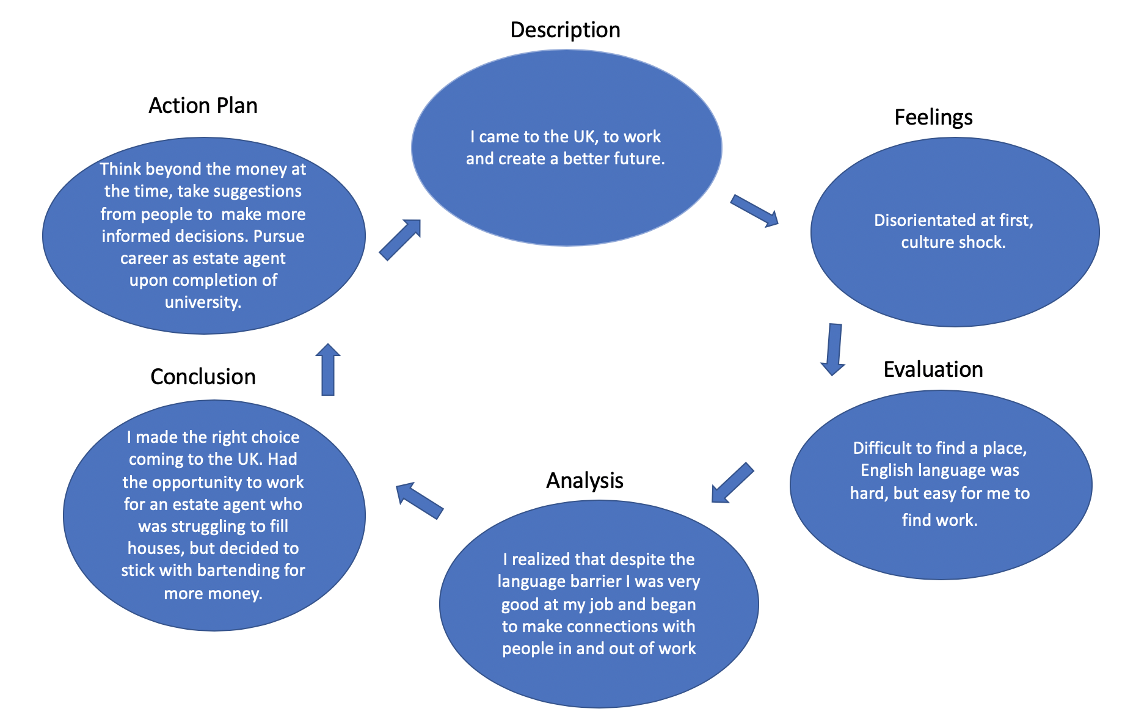

I am currently pursuing a career as a real estate agent, what heavily influenced me to begin this path was that I helped my family members and friends to find work and to arrange viewings for accommodation that they were seeking. An estate agent that I spoke to said that I was so good at finding people that need homes that I should initially work for him, but I chose to forgo this and stay with working in hospitality at the time. Upon reflecting on this choice, it appears that long term it is far greater long-term prospect for me to focus on building my career as an estate agent. Ever since arriving in the UK and finding homes for people I have been accustomed to the nuances of letting homes that I otherwise wouldn’t be aware of. Therefore, it is almost a twist of fate that I have learnt for successfully find people accommodation according to their preferences in a very short amount of time.
Also, an advantage for me in becoming a real estate agent is that when it comes to maintenance of property, I have established connections with independent contractors that are self-employed that can be deployed at a moment’s notice. Over time where I have stayed for the past two years, I have had tenants come and go and also, I have had to review contracts between tenants and landlords to ensure that both parties are satisfied with the terms stated.

Every person has a different learning style (Pritchard 2008); thanks to the exercise ‘’ What employers want’’ I notice that the following key competencies are the one that employers expect from employees: honesty and integrity, trustworthy, ability to listen and the ability to integrate quickly.
Moments of integrity: ‘’Integrity means that a person’s behaviour is consistent with espoused values and that the person is honest and trustworthy’’ (Yukl, Van Flett, 1992). Working in hospitality I proved that I was trustworthy; as a bar back, I have been in situations where other members of staff were late to set up the dining area, so I took it upon myself to set it up for them. When I become a bar manager, I had to manage money and supervise other staff members simultaneously and by reporting any issues up the chain of management showed the owners of the establishment that I can be trusted.
Trustworthy: “Five categories of behaviour capture the variant of factors that influence employees’ perceptions of managerial trustworthiness: 1. behavioral consistency, 2. behavioral integrity, 3. sharing and delegation of control, 4. communication (e.g. accuracy, explanations, and openness), and 5. demonstration of concern’’ (Whitener, Brodt, Korsgaard, Werner, 1998). While working at a nice restaurant in Carnaby Square, I have been asked to make purchases for the inventory of the restaurant where I worked.
When I become a bar manager, I tried to gain the trust of the bar backs and waiters. I delegated responsibilities to them for example taking care of the inventory and stock room when I wasn’t available to do so; before starting each shift, I would clearly communicate with staff brief them on what we were expecting from each team. During the company’s on-boarding of new employees, we ‘communicate’ them a daily checklist, breaks times, location of food and how to clock in and clock out; I always tried to do that in a clear and efficient way.

Work safely: World Health Organisation said that workplace safety is ‘’ …the promotion and maintenance of the highest degree of physical, mental and social well-being of workers in all occupations ‘’ (International Labour Organization, 1998). During my time in hospitality, I cleaned tables always with gloves, sanitised the table for the customers, being very careful with the knife when cutting fruit behind the bar. This would not be possible without fully understanding the health and safety regulation in the establishment, which is the first thing that I do when working in a new environment.
Ability to listen: ‘’ Communication is central to the smooth operation of all work environments...Listening skills also affect the efficient transmission and receipt of information in the workplace’’ (Carnevale and Smith,2013). Being aware of the environment first is important and the only way that I was able to successfully navigate within the work environment was to listen very closely to my manager, supervisor and colleagues. There were occasions where products had been moved from one place to another without my prior knowledge, in times like this instead of looking for it without knowing its location, I would first communicate with my fellow colleagues to ascertain where things were.
Integrate quickly: Thinking on my feet and being friendly, has always helped me, I have been very fortunate to work with other who are Italian and Albanian speaking that helped to create rapport amongst my peers in the workplace. I have always been able to integrate into new environments very quickly; this is a skill that I picked up as my family and I moved to different cities along the years.
Thinking about my skills and abilities acquired until now, gave me a lot of motivation to follow my career plan; I have a lot of excitement to become an estate agent. Self-motivation from my own perspective is having a desire that is so powerful you are compelled to move towards it against all odds. ‘’ Motivation concerns energy, direction, persistence and equifinality--all aspects of activation and intention…Perhaps more important, in the real world, motivation is highly valued because of its consequences: Motivation produces’’ (Ryan and Deci,2000).
For being self-motivated, an important factor is self-confidence; this is “valuable because it improves the individual’s motivation to undertake projects and persevere in the pursuit of his goals, in spite of the setbacks and temptations that periodically test his willpower’’ (Benabou, Tirole, 2002). The things that motivate me to become an estate agent range from financial rewards via bonuses in addition to receiving gratification and more responsibilities within the workplace.
I took part in a mindtools self-motivation quiz, my score was 42 according to the score system of the test, I fall within the 28-43 which states “you’re doing OK on self-motivation. You’re not failing – however you could achieve much more. To achieve what you want try to increase the motivation factors in all areas of your life”( https://www.mindtools.com/pages/article/newLDR_57.htm). This results that I obtained from the test imply that I clearly have room for improvement when it comes to self-motivation. As Bandura says ‘’self-efficacy refers to personal judgments of one’s capability to act in specific situation that may contain novel unpredictable, potentially, stressful encounters’’ (Propst, Koesler, 1998). These are the two critical things that I need to take into account if truly I want to reach the goals that I have set for myself.
From a young age in Italy I have been working in a lounge and café where I learned hospitality. Working at a young age influenced me to go to bartender school and develop my career in this field. I received an 83% pass mark from my results in bartender school, this also increased my self-motivation even further. Over the years as a bartender my confidence grew, I worked in Italy for some time and then here in the UK. Despite being a highly skilled bartender, I have come to realise that this is not my end goal, my career object is to become a real estate agent here in London.
Currently I have been re-modelling my CV and working on my LinkedIn profile to help shape my career plan in this direction. I already have some experience in finding homes for people and I have good people skills when it comes to negotiation and understanding the needs and further being able to match their needs in line with their budget.
4
One learning style is the VAK learning styles, it “refer to human observation channels: vision, hearing and feeling. It suggests that learners can be divided into one of three preferred learning styles, i.e. Visual, Auditory or Kinesthetic. Auditory Learners: These learners prefer to absorb information by listening. They learn best from listening to lectures, participating in discussions and talking things out. When they recall information, they will remember the way they heard it. Visual Learners: These learners learn best when information is presented in pictures, tables, charts, maps or diagrams. Seeing and reading are important activities for visual learners. Kinesthetic Learners: These learners learn best through feeling and doing. They prefer lab activities or field trips over classroom lectures. They like to be involved with physical experiences; touching, feeling, holding, doing, and practical hands-on experiences ‘’ (Surjono, 2011).
This theory has helped me to identify my learning style which is visionary and kinaesthetic. I am currently using my learning style to further develop my English and interpersonal skills further. For instance, I closely observe the mannerisms of people when they speak English and how people express themselves when they speak, and I mirror these interactions. This helps me to show my expressions better when communicating to people. Something that really help me to improve my English is watching movies and Tv series in English. At the beginning with the Italian subtitles, after with English subtitles; now I’m able to watch without subtitles and fully understand them. I also started to read English newspapers every morning, this helped me to improve my grammar.
Team sports such as football or basketball are good examples of activities that bond people together and can teach language at the same time. I have made valuable connection during sporting events and have even picked up some key words in English and other languages.
Another model is the Johari Window mode, this “is a disclosure / feedback model of self-awareness, an information processing tool. The Johari Window actually represents information – feelings, experience, views, knowledge, attitudes, skills, intentions, motivation, etc. within or about a person – in relation to their group, from four perspectives ‘’ (Newstrom, Rubenfeld, 1983).
Below is a Johari window that illustrates aspects of my character that are known to myself, unknown to myself, known to others and unknown to others. In order to get this information as accurate as possible I spoke to colleagues, family and friends and they gave me their honest feedback.
Another model is the force-field analysis, this “formulation highlights the work aspect of motivated cognition. Work involves struggle against obstacles, conceptualized as the interaction of different forces ‘’ (Kruglanski, Bélanger, Chen, Köpetz, Pierro, Mannetti, 2012).
Below is a force field analysis, this graphical representation highlights the skills and competencies that I possess in parallel with the requirements of my desired career.

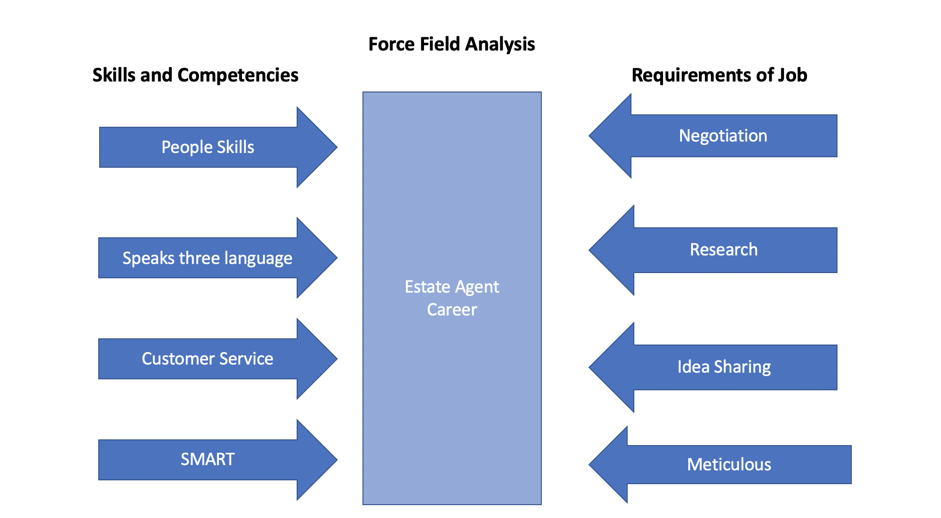

At the top we have negotiation, this is because it is regarded as an important skill in the role of estate agent. This skill is described as “reliance on a problem-solving orientation, wherein the party is seeking to engender trust and mutual support. The focus is on seeking an integrative solution that is achieved via open and accurate informational exchange, mutual concessionary behaviours and mutual respect for individual goals. (Alexander et al., 1994, p. 27).
In order to negotiate, my language skills and overall communication needs to be very good. A research proved that international employers think “that the graduates who have overseas professional work experience are more employable (Archer and Davidson, 2008)…The value of (a student’s) international experience goes beyond purely the acquisition of language – it lies in the ability to see business and personal issues from other than your own cultural perspective ‘’ (Poon, Hoxley, Fuchs, 2011).
Being meticulous is a key skill to have because as an estate agent you will be dealing with contracts and dealing with legal documentation, you need to be able to verify the documents and process them according to the standards and policies of the business. A research ‘’concluded that the employers have placed a strong emphasis on business and commercial awareness, in addition to personal qualities such as drive, enthusiasm and achievement, on graduates’ recruitment ‘’ (Poon, 2012).

SWOT Analysis is an acronym for: Strengths, Weaknesses, Opportunities and Threats; it is a structure that can be used for planning in a strategic way for reaching your goals.
Being able to speak three languages, has helped me to build relationships with different people who I ordinarily I wouldn’t have.
This advantage has helped motivate me to changing my career path from bartender to estate agent. Customers that speak Italian or Albanian would help me to establish a deep connection and help to build trust. According to Stoakes (2011) “being able to talk to client, finding out what they want, why they want it, what they will do with it and what they are prepared to pay’’ is fundamental. In addition, being able to speak to people in their mother-tongue is a great advantage.

I have been given positive feedback from the lecturer; however my presentation skills could be improved, but at present it is to a good standard.

Below there is my SWOT analysis.

My plan for the future is to become an estate agent. There are two paths for me to achieve this, one path is to complete the CPD diploma in estate agency. Another path is to take the route of apprenticeship where I will be taught on the job and trained for some time prior to becoming an agent. I have had a few interviews in the recent past for the role of estate agent trainee, I’m awaiting to hear back from the employers, I was given positive feedback.
Short term: Recently I have seen the CPD course online (via the reed.co.uk/courses-agent-diploma-CPD-certified/228161). This course needs no pre-requisite in order to enrol onto it and upon completing it I can add it to my CV, and it will make me more appealing to employer when applying for work. The duration of the course is 10 hours. Upon completing this course my chances of securing a role as an estate agent will be significantly increased. Acquiring certifications in my desired job role is a strategic move that will pay off in due time.
Medium Term: Advancing my English and familiarising myself with terms that are commonly used in real estate will go a long way. I plan to also take up improvisation classes in London, these classes can help vastly with improving my spoken English. My intention is to attend these classes twice a week after work. The sooner I can become more fluent the easier it will be for me to secure my role as an estate agent.
Long Term: Firstly, there are events publicised online of networking events within the housing market that I can attend.
Secondly, I can study for an advanced qualification in real estate, in housing there are various certifications that can be obtain through both independent study and in class courses that can be taken to gain a more superior qualification.
After successfully adding some certifications to my resume I would be seeking a promotion within my role as an estate agent.
Once being successfully promoted and moving up the management chain annually by way of earning large commissions for the house that I sell under the company, I may consider starting my own business further down the line, as over time I would have made more connections and gained more knowledge of the industry.
Looking towards the future, I have created a detailed plan of how I will successful progress in my career in a tabular format that contains specific action, measure and target date. Within my career plan I have included a specific category, these are: communications, time management, technology skills, team working, initiative and enterprise skills. All these segments of my plan when combined will give me not only guidance to achieve my career goals but also an opportunity to improve my personal development.

Development plan

What do I want/need to learn? | What will I do to achieve this? | What resources or support will I need? | What will my success criteria be? | Target dates for review and completion
Proficiency in English language | Listen to more English media, interact with more English people, learn new words and use new words in conversations. Also take up improvisation classes.  My learning style also states that Kinaesthetic is an efficient method for me to retain information. | LBC is a British radio channel that I can listen to, this can help me with learning how to speak English. Also watching videos on YouTube on how to learn and eventually master the English language. But most importantly it is down to speaking more English at each and every chance that I get more frequently.  Therefore, engaging in outdoor activities with other people who are fluent in English. Joining a local activity centre where I can play football in a small team once or twice a week. | My criteria for success will mainly be, increasing my fluency. Signs that I have improved will show by not having to ask people to repeat themselves during dialog and conversations.  Bonding with new people during sporting activity. | May 2020.  June 2020.
More about real estate in the UK. | Online research about the housing market this includes looking at the trends and how prices has risen and fallen over time.  Working for an Estate Agency as an apprentice and taking estate agent courses. | Looking at the areas with the real estate CPD qualification. | I will be testing my knowledge about the housing market at least once every two weeks. | July 2020

In conclusion provided that I stay on track and follow my plan through I can confidently say that before the end of 2020 I will secure my desired role as an estate agent. I am fully aware that despite my outline plan above I still do have weaknesses that I still need to overcome, the only effective way to do this is through self-reflection and discipline. There is no quick fix for this it will involve me observing my behaviour and tailoring it towards the attributes of a fluent English speaker with the knowledge of the British housing market.

Reference:
Alexander, J., Schu l, P. and McCorkle, D. (1994), “An assessment of selected relationships in a model of the industrial marketing negotiation process”, Journal of Personal Selling and Sales Management, Vol. 14, pp. 25-39
Archer, W. and Davidson, J. (2008), Graduate Employability: What Do Employers Think and Want?, CIHE, London.
Becker, T. E. (1998), Integrity in Organizations: beyond honesty and conscientiousness, Academy of Management Review Vol. 23, No.1, 154-161.
Benabou, R., Tirole, J. (2002), Self-confidence and personal motivation, The quarterly journal of economics 117 (3), 871-915.
Carnevale, A. P. Smith N. (2013), Workplace basics: The skills employees need, and employers want, Human Resource Development International 16 (5), 491-501.
Cornelissen, P.A., Van Hoof, J.J. and Van Vuuren, M. (2014), “Enabling Employees to Work Safely: The Influence of Motivation and Ability in the Design of Safety Instructions”, Technical Communication, Vol. 61 No. 4, pp. 232–244
Dhaliwal, U, Singh, S., Singh, N. (2017), Reflective student narratives: honing professionalism and empathy, Indian J Med Ethics 3 (1), 9-15.
Fleming, N. (2001), Teaching and Learning Styles: VARK Strategies, N. Fleming
Gibbs, G. (1998) Learning by Doing: A Guide to teaching and learning methods, Further Education Unit, Oxford Brookes University, Oxford.
https://www.mindtools.com/pages/article/newldr_57.htm
Jasper, M. (2006), Professional Development, Reflection and decision making, Blackwell Publishing Ltd, Oxford
International Labour Organization (1998), Technical and ethical guidelines for workers’ health surveillance. Retrieved from http://www.ilo.org/wcmsp5/groups/public/---ed_protect/---protrav/---safework/documents/normativeinstrument/wcms_177384.pdf
Kruglanski, A. W., Bélanger, J. J., Chen, X., Köpetz, C., Pierro, A., Mannetti, L. (2012), The energetics of motivated cognition: A force-field analysis, Psychological review 119 (1), 1.
Neal, J. A., Schor, S., Sabiers, M. P. (1998), This is your life! A lifeline exercise to promote discussion of differences, Journal of Management Education 22 (6), 745-752,
Newstrom, J. W., Rubenfeld, S. A. (1983), The johari window: A reconceptualization, Developments in Business Simulation and Experiential Learning: Proceedings of the Annual ABSEL conference 10.
Park, J. Y.&S., J. (2011), Expression and connection: the integration of the reflective learning process and the writing process into social network sites. Journal of Online Learning and Teaching, 7(1), pp. 170‐178.
Poon, J. (2012), Real estate graduates’ employability skills: The perspective of human resource managers of surveying firms, Property management vol.30, No.5, pp.416-434.
Poon, Joanna, Hoxley, Mike and Fuchs, Willow (2011), Real estate education: an investigation of multiple stakeholders, Property management, vol. 29, no. 5, pp. 468-487.
Pritchard, A. (2008), Ways of learning: learning theories and learning style in the classroom, Routledge
Propst, D. B., Koesler, A R. (1998), Bandura goes outdoors: Role of self‐efficacy in the outdoor leadership development process, Leisure Sciences 20 (4), 319-344.
Ryan R. M., and Deci E. L. (2000) Self-Determination Theory and the Facilitation of Intrinsic Motivation, Social Development, and Well-Being, American psychologist 55 (1), 68.
Surjono, H. D. (2011), The design of adaptive e-learning system based on student’s learning styles, International Journal of Computer Science and Information Technologies 5 (2), 2350-2353.
Stoakes, C. (2011), All You Need to Know About Commercial Awareness, Longtail Publishing Limited, London
Whitener, E. M., Brodt, S. E., Korsgaard, M. A., & Werner, J. M. (1998), Managers as initiators of trust: An exchange relationship framework for understanding managerial trustworthy behaviour, Academy of Management Review, 23, 513–530.
Yukl, G. A., & Van Fleet, D. D. (1992), Theory and research on leadership in organizations. In M. D. Dunnette & L. M. Hough (Eds), Handbook of industrial &organizational psychology (2nd ed.), vol.3: 147-197, Palo Alto, CA: Consulting Psychologists Press.

