BMSW4014 Problem Solving and Innovation

Individual Assessment
Student Name: Julia Heron
ID: 2413228

Slide 1
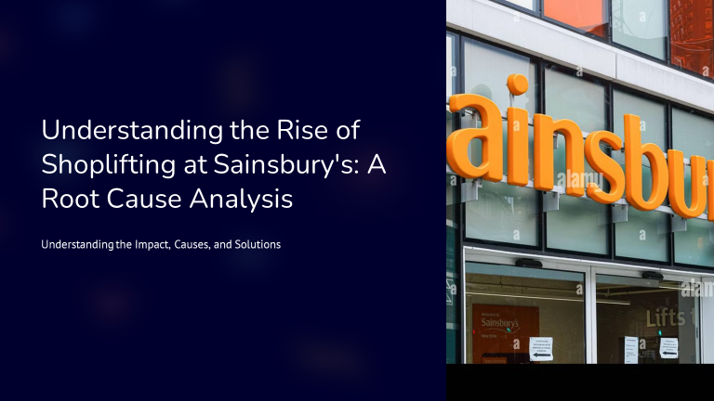
Good morning, everyone. Today, I will be focusing on the problem of shoplifting that is rising in the UK, especially in the Sainsbury company. In this presentation, we will consider all aspects of this problem, such as direct and indirect effects on the company, factors that contribute to the development of this problem and the possible ways to prevent the effects of this problem. This is a problem that is of paramount importance to retailers, and it is important to fully grasp this problem in order to be able to counter it.

Slide 2
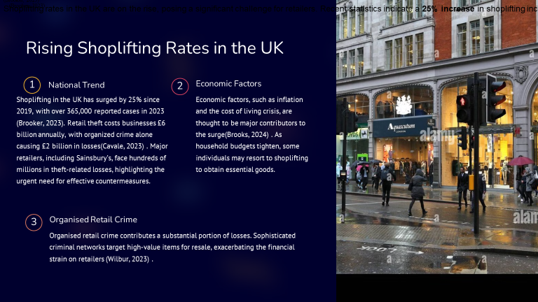
This is because shoplifting has increased by 25% in the UK compared to 2019. This has led to over 365,000 reported cases in the year 2023 (Brooker, 2023). The consequences are steep as retail theft impacts businesses in a negative manner, with a loss of £6 billion annually. Of this, £2 billion is contributed by organised crime (Cavale, 2023). Sainsbury’s, one of the leading supermarket chains, is a typical example; it has lost hundreds of millions of pounds (Brooks, 2024). This has underlined the need for proper measures to prevent this problem from escalating further (Wilbur, 2023). Now, let us turn to the numerous factors that have led to this increase in shoplifting.

Slide 3
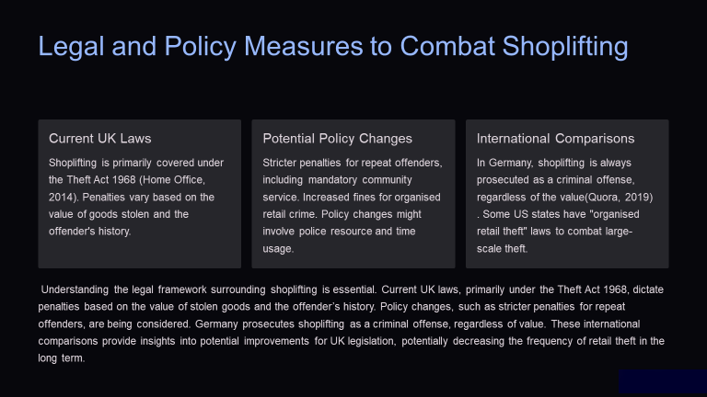
It is, therefore, important to have an understanding of the legal position with regard to shoplifting in order to be able to come up with the right measures to counter the vice. At the moment, shoplifting is governed by the Theft Act of 1968 in the UK, and the penalties are based on the value of the stolen merchandise and the previous records of the convict (Home Office, 2014). However, there is a rising concern about the policy measures that may be adopted, such as the enhanced harsh punishment for repeat offenders and enhanced fines for organised retail crime. These changes could have a bearing on the amount of resources and time that the police force will devote to the task. In this regard, like other countries, Germany considers shoplifting as a criminal offence irrespective of the value (Quora, 2019), whereas some states of America have laws against organised retail theft. A comparison with these countries’ legislation can be useful in identifying measures that can be taken in the UK to decrease retail theft.

Slide 4
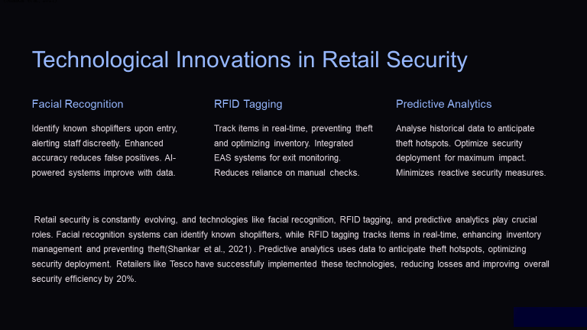
Technology is an important factor that has been adopted in retail security in the modern world. Facial recognition is also capable of identifying individuals who have shoplifted in the past and notifying the staff without making a scene. RFID tagging enables real-time tracking of items, which improves inventory as well as checks on theft, as pointed out by Shankar et al. (2021). Security analytics enable the identification of areas that are likely to be vulnerable to theft so as to ensure security is deployed where it can make the most difference. Such technologies that are adopted by various companies, such as Tesco, have been proven to have an impact on reducing losses and enhancing security efficiency by 20%.

Slide 5
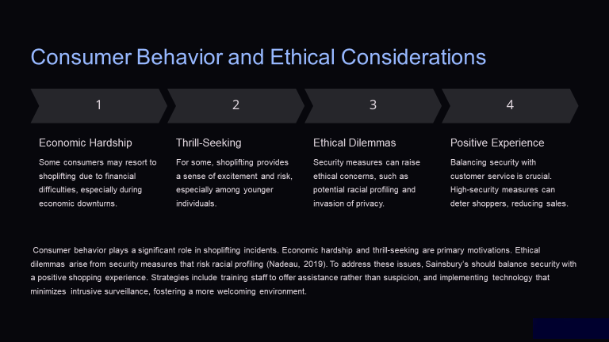
Criminality in shopping is another factor that contributes to shoplifting in relation to consumer conduct and ethical factors. Some people steal due to poverty, whereas others may engage in stealing as a way of getting a kick. Security measures, as much as they are needed, come with ethical issues like the ability to racially profile individuals (Nadeau, 2019). Sainsbury’s has to guarantee security while at the same time ensuring that a customer is not met with suspicion when asking for help or when using a card that has been flagged and to ensure that any technology used does not intrude too much on the customer’s privacy.

References
Brooker, A. (2023). Shoplifting surges by 25% in England and Wales - Better Retailing. [online] Better Retailing. Available at: https://www.betterretailing.com/shoplifting-surges-25-in-england-and-wales/.
Brooks, K.J. (2024). Shoplifters point to inflation and economy as main reasons for stealing from retailers. [online] Cbsnews.com. Available at: https://www.cbsnews.com/news/shoplifting-retail-theft-crime-stealing-inflation/.
Cavale, S. (2023). Explainer: ‘Organized’ retail crime: a ‘multi-billion dollar problem’. Reuters. [online] 29 Jun. Available at: https://www.reuters.com/business/retail-consumer/organized-retail-crime-multi-billion-dollar-problem-2023-06-29/.
Wilbur, J. (2023). Imagine entering your favorite retail store only to discover that its shelves are only half full, prices are skyrocketing, and there is an unsettling sense of insecurity in the air. Welcome to the new reality shaped by Organized Retail Crime (ORC)—both a covert and not so much covert operation that. [online] Linkedin.com. Available at: https://www.linkedin.com/pulse/rise-organized-retail-crime-societal-crisis-jason-wilbur
Home Office (2014). GUIDANCE Implementing Section 176 of the Anti-social Behaviour, Crime and Policing Act 2014: Low- value shoplifting Guidance for police in England and Wales. [online] Available at: https://assets.publishing.service.gov.uk/media/5a7deff5ed915d74e33eefe2/low_value_shop_theft_guidance.pdf.
Quora. (2019). What are the German laws in shoplifting? What are the punishments? What happens if you don’t speak German? [online] Available at: https://www.quora.com/What-are-the-German-laws-in-shoplifting-What-are-the-punishments-What-happens-if-you-don-t-speak-German
Nadeau, M.M. (2019). The psychology of shoplifting : empirical development of a new typology for repeated shoplifting. [online] Utexas.edu. Available at: https://repositories.lib.utexas.edu/items/d9b65a9d-d996-4b43-ab9b-174eb86ad642.
Shankar, V., Douglass, T., Hennessey, J., Kalyanam, K., Setia, P., Golmohammadi, A., Tirunillai, S., Bull, J.S. and Waddoups, R. (2021). How Technology Is Changing Retail. Journal of Retailing, [online] 97(1), pp.13–27. doi: https://doi.org/10.1016/j.jretai.2020.10.006.

