Research in Practice. Home, Vulnerable & Perception

Name: Corey Harry James McComb
Student Number: 2004966
Module Course: Research in Practice (ADA5004)
Course: BA (hons) Graphic Design
Word Count: 2462
Character Count: 13, 096
Lecturer: Donna Williams

Home. Vulnerable. Perception

Aiming to present ideas and ideologies to my keywords, I intend to explore matters surrounding those connotations, while propelling outlooks on the subject matter with a minimum of one image per word. Summarising the research the end result will allow for a question to be proposed that excels my third year dissertation. I want to present artists Pierre Bonnard (Home), Yoko Ono (Vulnerable) and Sun Yuan & Peng Yu (Perception) backed up by inciteful Theorists that navigate the conversation into a reflective piece that encapsulates a final outcome.

Home

Home can evoke a sense of belonging as well as alienation; ideas and emotions about home can be stretched across the world, connected to a nation and attached to a house; the spaces and imaginaries of home are central to the construction of people’s identities and are materially manifested in a wide range of home-making practices. (Blunt and Dowling, 2006, p.1)

We often think about bricks and water when discussing the term home. Dissecting the idea of a traditional home you are left with far more than material possession, Rather a thought or perhaps feeling, whether substandard or satisfactory. We place a semiotic visual veil on this territory as it our most habitual association. With a false pretence of passivism the idea strikes as an illusion (Pohl, 2016. p. 20) Discusses this phenomenon as a ‘Judgements of representatives’
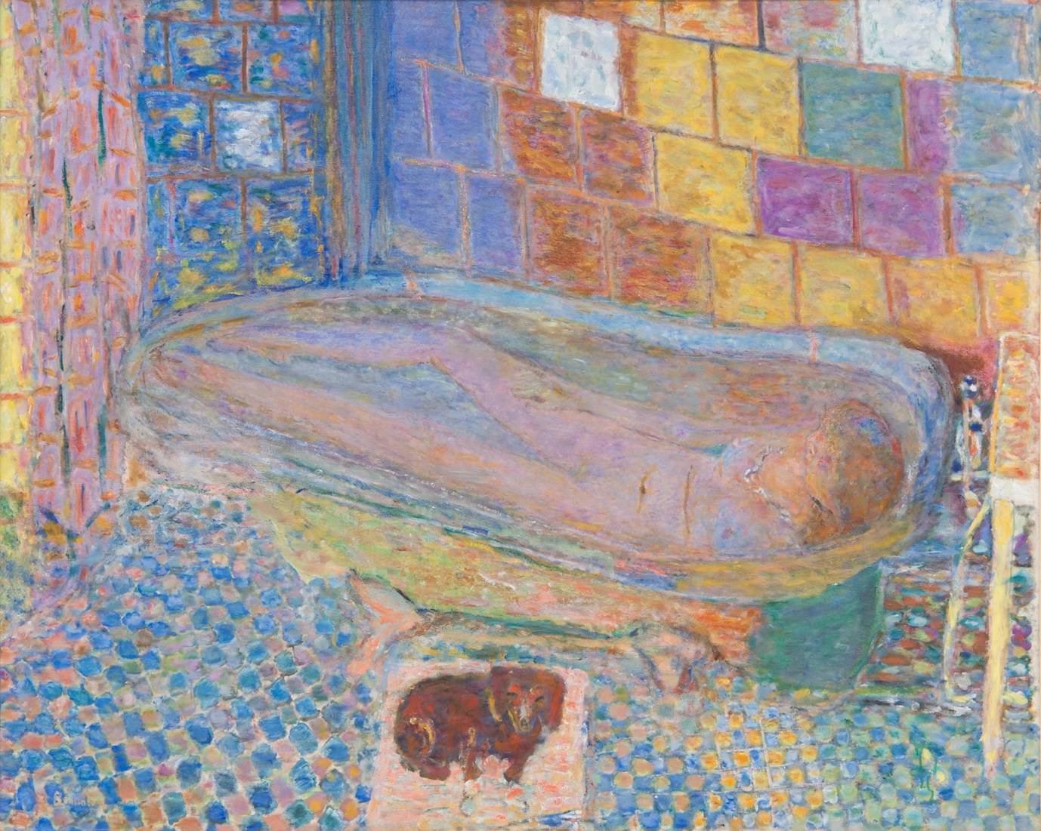

(Fig one) Pierre Bonnard, Nude in Bathtub, c.1940-1946

Fig one harnesses a soft yet elegant portrayal of a Lady in a bathtub, the dreamlike pastel colours overt the assumption of anything other than tranquillity in a personal and intimate setting, right down to the delicate brush strokes. Contrasting this rose tinted haze the subject has an ulterior viewpoint. Pierres wife, Marthe de Meligny, took baths regularly to replenish her tuberculosis, this ritual was to aid her ill health that was ever declining. A stark reality compared to what the audience assumes at first glance. I believe this to be of value as it challenges our perspective on space and home, not everything is as forgiving as it appears to be. While the subject is psychically at home, in her space. She is presumed to be somewhere else, escaping the reality of her condition, the dreamlike state inside the bathtub acts as a habitat for her body and mind. (Cruz ,2017) challenged the core idea of home specifically in the United Kingdom. Reflecting on fragility and gatekeeping due to the 2016 Brexit referendum. Analysing the threat U.K citizens felt on immigrants who arrived to start a new life with opportunities not previously been available. Home to these individuals is not merely as apparent as a structure, rather the land, culture and resources itself. Contradictory as ‘home’ has been punishable and relentless to these individuals seeking opportunities. Facundo, Jake, Silvia (2020). Other interpretations of home can span outside of our existence. Philosopher St Augustine (The Confessions, 2002. P 354) combats conceptions by theorising that our true home is life after death. An interesting proposal to question our mere existence on earth as a temporary housing unit, this discourse may lead to feelings of dissociation from the world and our relationships as it is all we are familiar with. The general synopsis of home is self-reflecting. (Guerney 2019) confronts one
to critically think of the home, question is it a place of quality or harm. In the same video a rhetorical question, people are what make a home, underpins social constructs and relative interactions as the foundations of a functioning home. For those who feel home is not a sanctuary rather a place of tenderness it can leave an individual feeling…vulnerable. (Martin, 2018) considers the damage of surrounding members in a traditional family home that make the feeling of safety non-existent, with these ramifications individuals who grow up in fractured living situations feel distanced from the rest of the world, factors including suppressed emotions, guilt, loneliness and numbness. The dysfunction of a conceived idyllic home has unfavourable effects on one’s image and identity, this security should be a necessity not a privilege. Home is not just one standing unit, arguably an elusive mindset as opinions on home are vague with no defining constituent. The interest of home is perception and vulnerability which will be discussed as the remaining key words. A favourable perspective looking at home is the idea of fragility, delicacy, illusion, fantasy, loss, reflection and healing, a response from examination and research.

Vulnerable

“the quality or state of being exposed to the possibility of being attacked or harmed, either physically or emotionally.” - Oxford Dictionaries Online

(Eysenck and Keane, 2015, P. 25) Defines the assessment of our decisions to be met by consequence. With this in mind, it is clear we annotate our choices whether big or small on the construction of fear. Instinctively we circumvent fear as the obstacle is perceived as too frightening, nevertheless we cannot succeed unless we are willing to fail. Mark Manson theorises his interpretation of success as a metric unit, (Manson, 2016 . P.9) substantial as breaking down personal boundaries and determining the value of success is not governed.

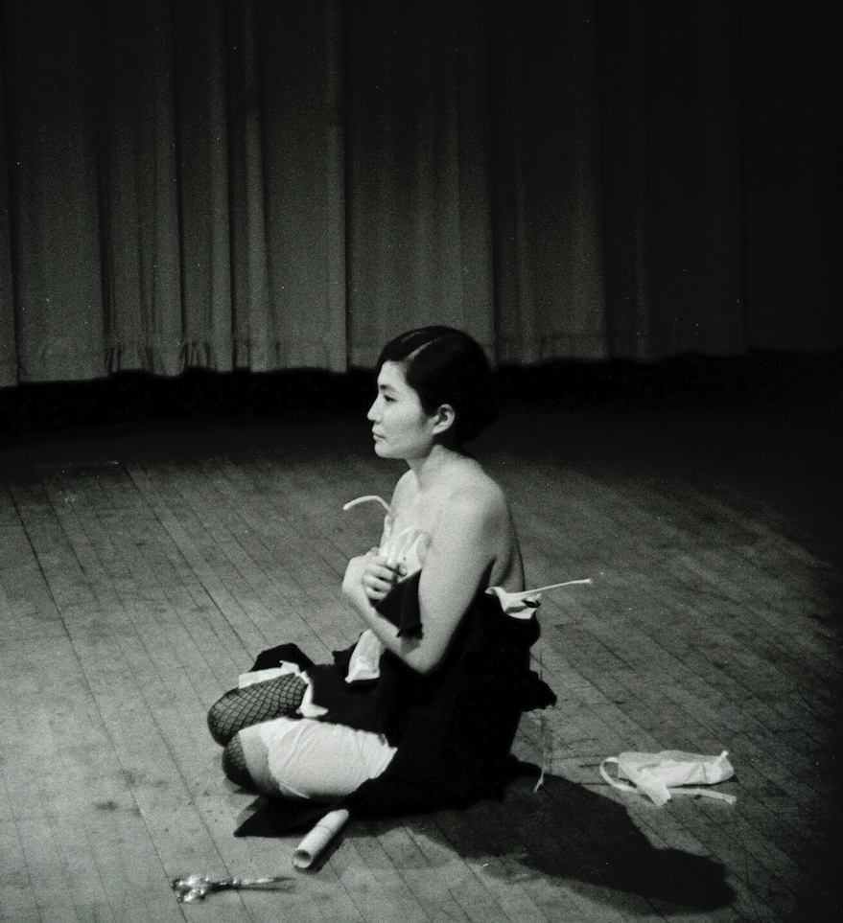

(Fig two) Yoko uno, Cut piece. July,1964. Yamaichi Concert Hall, Kyoto, Japan.

Looking at fig two an inundated feeling of giving strikes. Giving the psychical of the body away to the masses. For context Fig two is a still image of a live art interactive performance by Yuko Uno. Positioned on the floor with a pair of scissors by her side, members of the adjourning audience were granted permission to come up and cut off as much clothing as they feel satisfactory, upon which they were able to keep. Yuko challenged what people would take from her, testing decency or indecency (Yoko Ono collector of skies, 2013, p. 11) This piece is spectacular at demonstrating vulnerability in one’s self while also establishing a conversation about trust and ownership with others. This is a connection. (Brown, 2010) draws an interesting theory explaining vulnerability is the key to any and all human connection, internal shame has been a factor of the misrepresentation of others and values. Opening up a separate conversation about spite and the prejudice towards others. Does the core of this stem from internal solidarity? Covetousness despair of seeing others around us live a more free minded and fulfilling life? Vulnerability can open up emotions of self-doubt either through relation or envy. We can look at vulnerability beyond the foundations of art, if one wishes to accept a loving committed relationship, they must endure vulnerability to achieve a personal end goal. Linking envy to highlight a perspective. (Noam and fischer, 2013. P. 10) We are conditioned to seek vulnerability and growth when past experiences have halted our clarity. The association of vulnerability runs prevalent with Fig one, both demonstrate an intimate setting with ones self. One must ask what is the sole purpose of vulnerability in the arts, more often than not it can be overlooked by non-artists as a cry for attention or to put it quite simply ‘weird’. The notion of artists being unfairly represented may be self-inflicted, ‘Starving artists’ is a term thrown around in a self-deprecating manner to make light of a pressuring industry. (a.n, 2014) interpretants the ‘starving artist’ to reflect interest and respect from the public, we wouldn’t accept such pessimistic content from creators in the music industry, or actors. This leaves the artist defenceless in the staggering construct of doubt and judgment already prominent in the art world. However isn’t it comforting to see a body of work that distances itself from the conventional. Evokes an observation, perhaps an emotion. Philosophers Plato and Aristotle theorise on the idea that art is only valuable once the audience reacts with an emotional response, corrosive to the mindset of creators who rely on self-satisfaction and expression to be the driving point of their work (Gracyk, 2014. P.8). We often criticise what is not useful or respected information to us, failing to understand that self-interpretation from the artist can be enough. Does the work always have to satisfy the masses. Emphasising on others opinion to be fulfilling? Or is our own creation and outlook enough. Value is an interesting word, respectably nobody will have the same opinion on what is valuable, with such a complicated word harnessing no right or wrong answer we can start to see vulnerability as more attainable. Retaining back onto the exploration of vulnerably, avenues of direction have formed including, Value, Trust, Control, fulfilment, deprecating, jeopardy, freedom and independence which can open an expansive array of routes to be studied for a final conclusion.

Perception
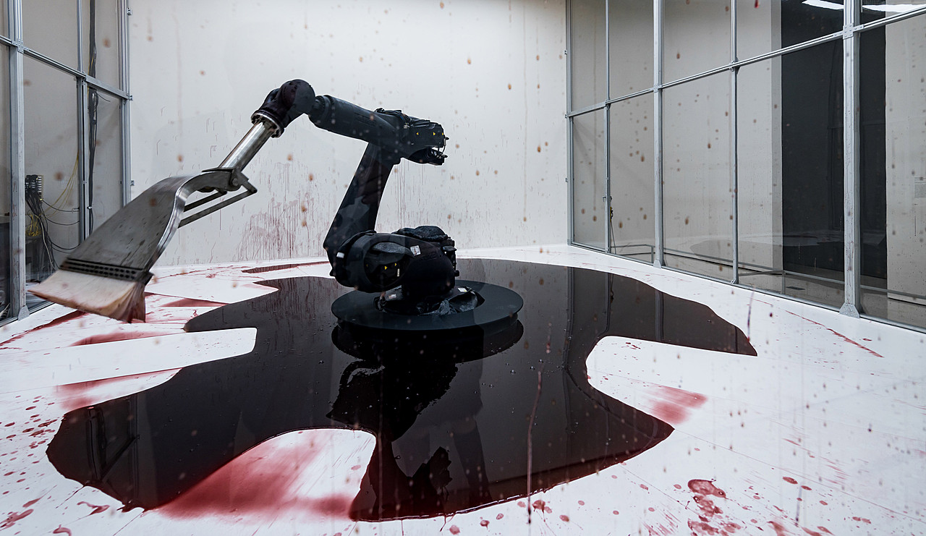

(Fig three) Sun Yuan and Peng Yu, Can’t Help Myself. 2016. Guggenheim Museum, New York

Perception is a term that has caused a sufficient amount of controversy within the realms of philosophy:

question of whether we can ever directly perceive the physical world”, where “the physical world” is understood in a realist way: as having “an existence that is not in any way dependent upon its being... perceived or thought about (Stanford, 2005)

To better grasp the idea of one’s perspective understanding in a modern day setting Fig three opens a comprehensive dialogue on a variety of interpretations of broad ranging opinions. ‘can’t help myself” shows a brutalist interpretation of a robotic arm simulating a clean-up of its own mess. Sensors engage when liquid reaches a distance away from the arm which allows the machine to sweep it away, only to leave more mess. Flinging substance on the glass case. Rapidly, repeatedly. The red tinted liquid has often been depicted as blood, however, to others the liquid represents oil to keep the machine running, preserving lifespan. Reflections on the piece include, Migration, Authority, Abuse and lack of self-control. An interesting observation is placed on the piece with many feeling empathetic towards the machine, this phenomenon can be referred to as digital humanisation (Zoovu, 2017) aside from how the audience interoperates the piece and the meaning ,the perception of the technology is now perceived to be humanistic. Reasonable responses to the environment, interpretation is a personal experience. Fig three has a broader open dialogue that stems further than the conversations of Fig one and fig two. In the absence of human figures the piece encourages an intuitive interpretation from one’s own life experience and views. “Be the Verb - not the Noun” Is an insightful talk by Deji Akingbade explaining his philosophy on perception, labelling it as the root of all evil. At first this sounds obstructive, when further explained it adds an interesting take on the selfishness off our systemic beliefs. Comparing how Hitlers soldiers saw Hitler, direct contrast to how individuals in camps saw the same person. One group was filled with praise, the other despise. A absolute truth is not a truth if there is room for disagreement or compromise. Distancing from the starting example of art, to a much more controversial outlook on perception. Is it the cause of all Evil? How can humble perceptive opinions on a robotic arm be linked as the same perceptive mindset used when initiating war, discrimination, exile. A volatile approach to compare the two, nonetheless important to highlight perception can be a sensitive area to cover when getting into strong belief systems. (Tiffee 2016) embarks on the ‘Hero’ ideology, the Hero complex situates itself in one’s mind determining that we are always the hero off our own story, our false perception of our reality is detrimental to our surroundings. One can look at any controversy and the superiority complex of both parties. This association ties up to conflict which within itself is an interesting topic. (Bar-Tal, 2011. P. 11) signifies the importance of viewpoint, delving into the territory of rigid beliefs set against another social group a result of perception, also known as stereotypes. Salacious stereotyping within a select social group can breed discrimination and harmful concepts based around an opposing group. Perception can come in many forms from an artist outlook, to insidious matters of segregation. There is vulnerability in perception (Davey, G., Sterling, C. and Field, A. (2014) spotlights the threatening impact of identity conflict, more commonly known as an identity crisis. This allows ones perception to be inaccurately melded as the insecurity of no sense of self belonging can steer an individual down a destructive path if believed to be of value to ‘fit in’ within a group. A perilous example within recent months has been the invasion of Ukraine. An ungracious Vladimir Putin constructing theories on his own people, enforcing false propaganda to masses of easily influenced groups. (Coda, 2022). Perception undoubtably has the power to dismantle, yet has the power to inspire and lead the imagination to conjecture. Exploring the word perception at the beginning led down a rabbit hole of opinion and viewpoints commanding endless possibilities within essay topic alongside work concepts. Viewpoints led to despair and the evaluation of conflict and one’s self-identity or lack thereof. A close correlation to vulnerability as a perspective outlook and outlining difference of opinion can leave an individual unguarded.

Keywords. Home, Vulnerable and Perception explored matters and connotations surrounding the fundamental themes Summarising on the contextual matters of the three keywords. a variation of proposals have emerged from consistent research matters. A starting draft for a final outcome could run along the lines off ‘How does a fragile home impact the perception of one’s cognitive development, can this be reversed’ is an offer of a formed independent research question. Leading from this question other proposals have formed, delving more into vulnerability and the target groups. what makes someone feel vulnerable, a pattern of fear and judgement become apparent in the writing stage of the essay with the three words displaying form of illusion, an open observation with many complex viewpoints that vary from unpresuming to cruel. Perhaps ‘Why does systemic perceptions and stereotyping drive minorities into feeling more vulnerable?’ ‘Will contemporary ideas of idealistic living form susceptible alliances amongst those who have a greater power?’, ‘Why minorities see the world as a brutalist home?’, ‘Is home our rise or fall?’, ‘Who cares about critique when we are the enablers?’, ‘Who saves a hero if we all interpretative ourselves as one? ‘Contradictory in conflict, why defeat the same team?’ ‘How is visual communication portraying against what it is trying to declare?’. Extending into other words, Saviour, winner, looser, minority, alliance, allegiance, defamation, fractionate, surrender, acceptance, forgiving, location, shelter, intimacy, privacy These starting points allow for a purpose of means to develop, navigating the words that drew from the original three. Dissecting these words, alongside their philosophies has opened a window to initiate a dissertation question for third year.
Proposed Dissertation Question:

‘Does contemporary culture neglect groups caused by their own fear of vulnerability and self-acceptance?’

Bibliography
Blunt, A. and Dowling, R. (2006) Home. 1st edn. (Accessed: 31 March 2022).
Rudiger F Pohl. (2016) Cognitive Illusions. 2nd edn. (Accessed: 31 March 2022).
https://helenldecruz.medium.com/where-is-home-a-philosophical-reflection-on-home-immigration-and-brexit-994f49c96cd5 (Accessed: 2 April 2022).
https://www.nottingham.ac.uk/research/groups/nicep/documents/working-papers/2020/nicep-2020-06.pdf (Accessed: 2 April 2022).
Augustine, Saint and Hippo, B. (2002) The Confessions of St. Augustine. (Accessed: 2 April 2022).
https://www.youtube.com/watch?v=3WRcK9FY7fs (Accessed: 2 April 2022).
https://sharonmartincounseling.com/the-effects-of-growing-up-in-a-dysfunctional-family/ (Accessed: 8 April 2022).
https://languages.oup.com/google-dictionary-en/ (Accessed: 10 April 2022).
Eysenck, M. and Keane, M. (2015) Cognitive Psychology. (Accessed: 10 September 2022).
Manson, M. (2016) The Subtle Art of Not Giving a F*ck. (Accessed: 13 April 2022).
Yoko Ono collector of skies. (2013) (Accessed: 13 April 2022).
Noam and Fischer (2013) Development and Vulnerability in Close Relationships. (Accessed: 13 April 2022).
https://www.a-n.co.uk/news/no-one-defends-a-starving-artist-why-professional-respect-begins-at-home/ (Accessed: 13 April 2022).
Gracyk, T. (2014) The Philosophy of Art. (Accessed: 15 April 2022).
https://plato.stanford.edu/entries/perception-problem/ (Accessed: 15April 2022).
https://www.pageuppeople.com/resource/five-ways-technology-is-becoming-more-human/ (Accessed: 20 April 2022).
Daniel Bar-Tal (2011) Intergroup Conflicts and Their Resolution. (Accessed: 20 April 2022).
Davey, G., Sterling, C. and Field, A. (2014) Complete Psychology. (Accessed: 24 April 2022).
https://www.codastory.com/newsletters/russian-propaganda-europe/ (Accessed: 25 April 2022).

Images
(Fig one) Pierre Bonnard, Nude in Bathtub, c.1940-1946 https://collection.cmoa.org/objects/51619113-31b2-4418-9d63-6ef4767882ee (Accessed: 31 March 2022).

(Fig two) Yoko uno, Cut piece. July,1964. Yamaichi Concert Hall, Kyoto, Japan.

https://www.e-flux.com/announcements/315928/yoko-onothe-learning-garden-of-freedom/ (Accessed: 31 March 2022).

(Fig three) Sun Yuan and Peng Yu, Can’t Help Myself. 2016. Guggenheim Museum, New York

https://www.guggenheim.org/artwork/34812 (Accessed: 31 March 2022).

