I was in charge of the brick work and the concrete block work on the east and north sides of the building. According to the plans, there is a 300 mm gap between the concrete blocks up to the 0.00 level. So, I calculated 5 brick layers with 10 mm of mortar between. Each brick is 215 mm x 112.5 mm x 65 mm. (see picture no. 1).
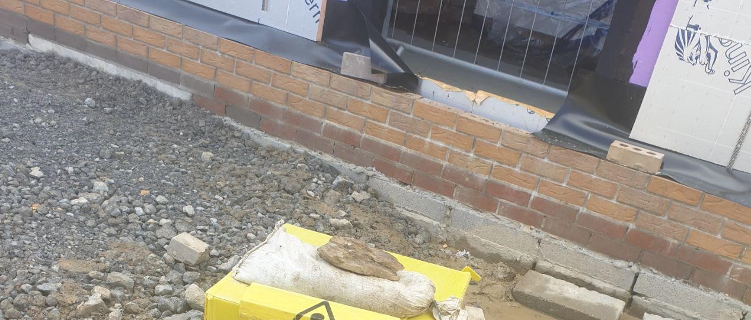
picture no. 1
On the east elevation of the building there is a large opening door. Over this opening door there will be a curtain walling which will include spandrels and opening lights. There is no brick work and heavy door will be set on a concrete upstand which is under the 0.00 level.
On the other side of the east elevation there will be a metal standing seam rain screen cladding which will be from the 0.00 level up to the roof. So we just do the 5 layers of bricks under the 0.00 level.

Also we use the half bricks as the first bricks nearest to the opening door and window. you can see this in the picture no. 2 and 3; Any bricks left over (which was around half) were kept aside and will be reused in another area.
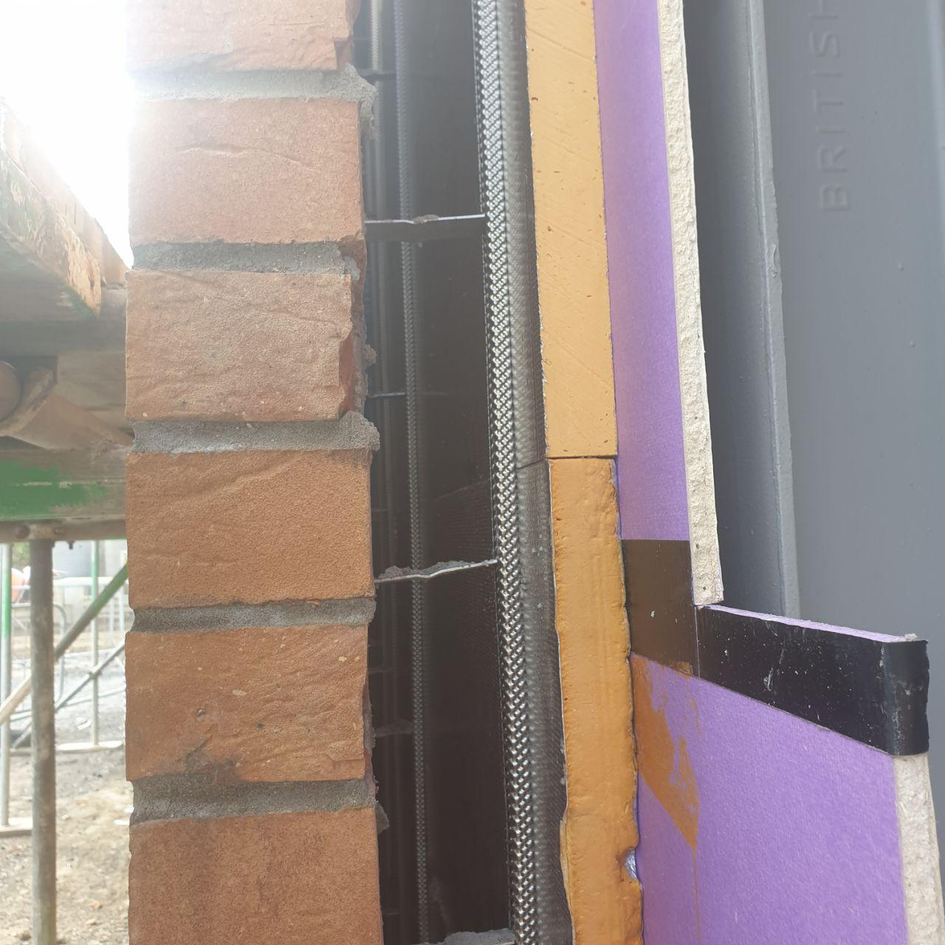 picture no. 2

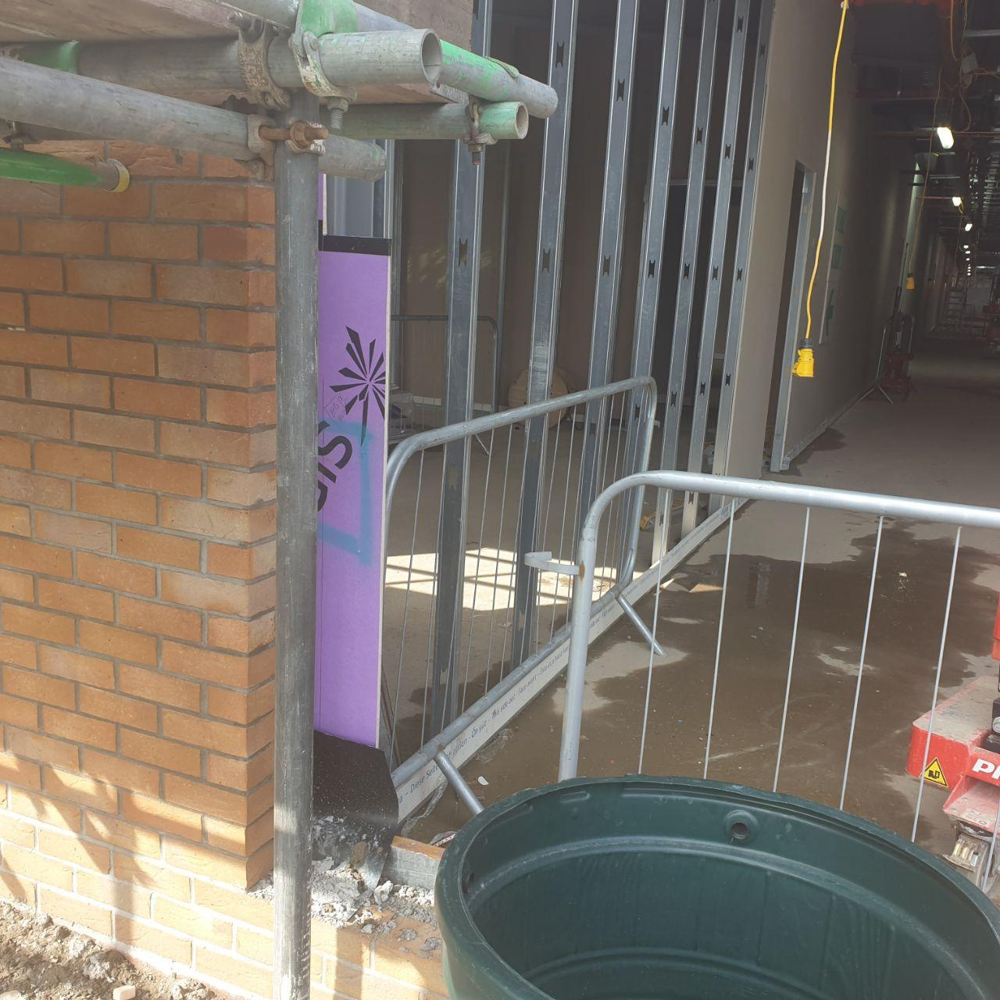 picture no. 3

Under the 0.00 level, behind the bricks, was filled with cement mortar so that the DPC membrane would cover the mortar with the rest of the bricks over the top. (see picture no. 4).

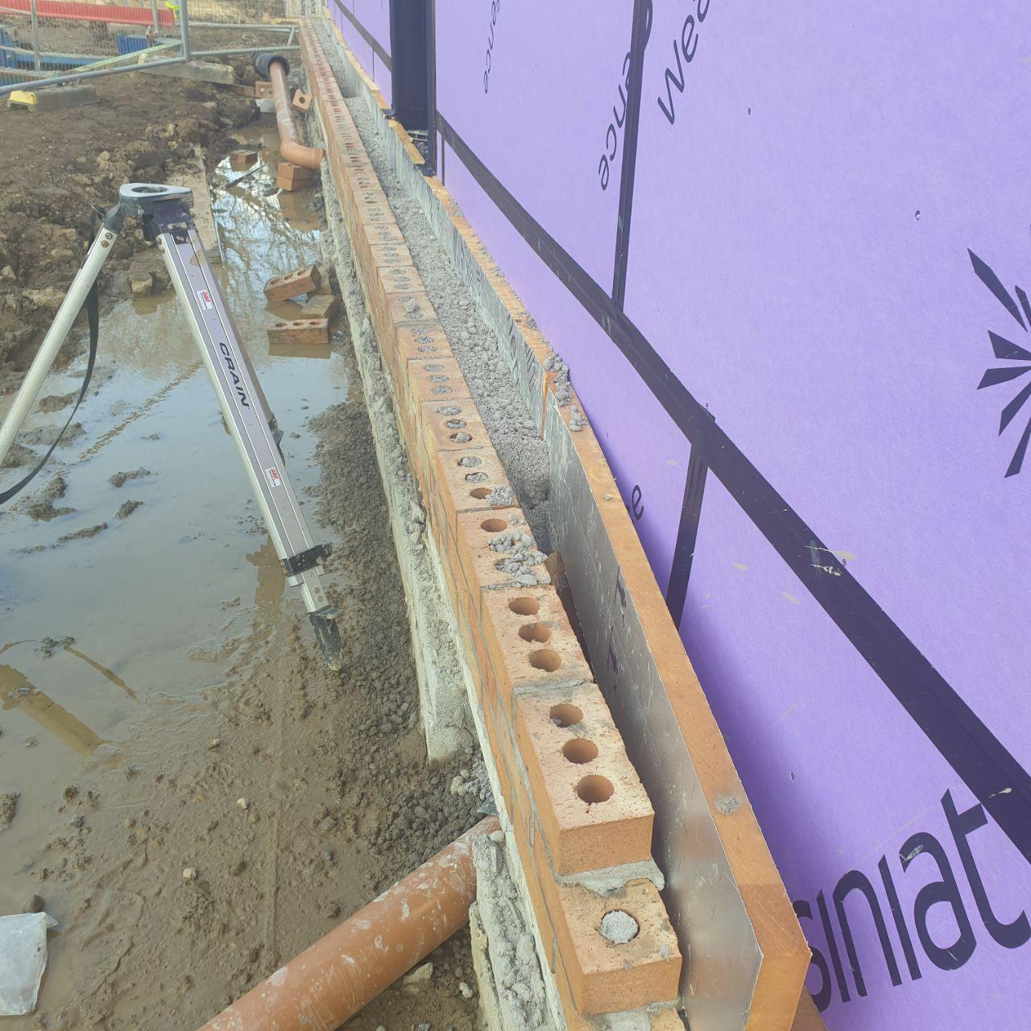 picture no. 4

We used thread and levels so that each brick layer would be evenly in line, neither forward or backward of the line, as per the traditional method. (see picture no. 5).
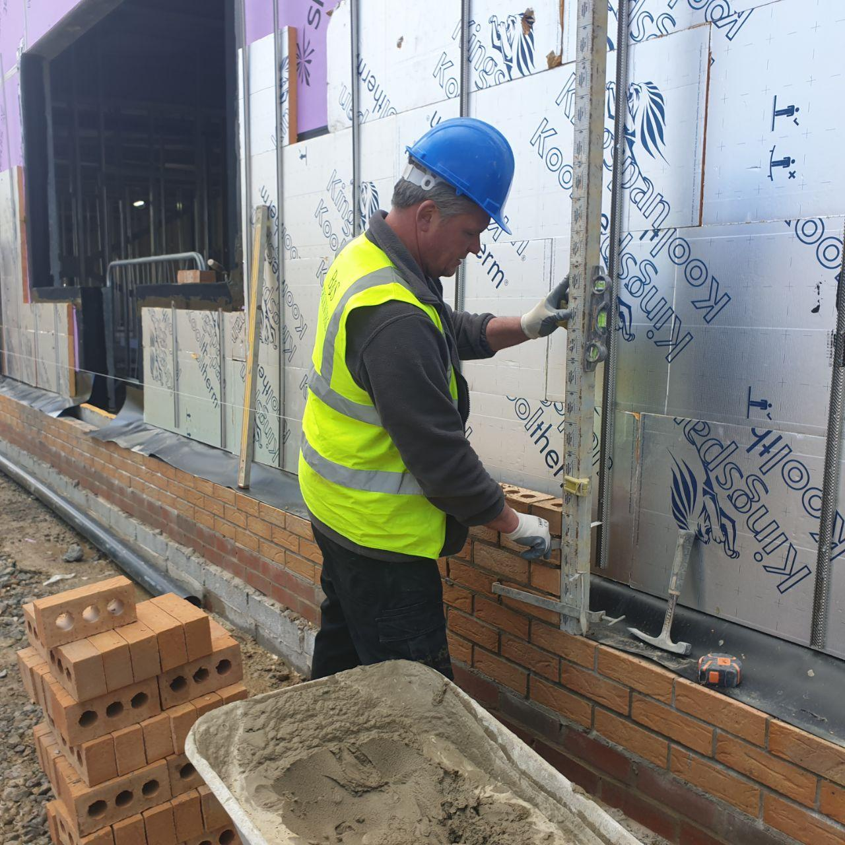 picture no. 5

0n the north elevation we had to use 5 brick layers under the 0.00 level. All around the windows and the door opening there are concrete block works which will later be painted in a different colour. In Picture no 6. we can see this work.
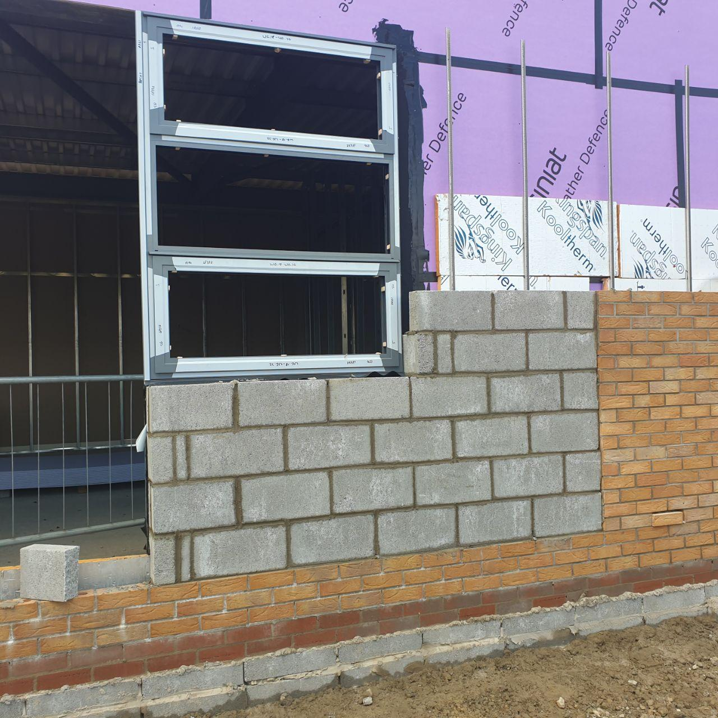 Picture no 6
In addition, there is a very small gap which is done deliberately so as to account for any future movement of the building, such as might be caused by an earthquake or strong wind. (see picture no. 7).
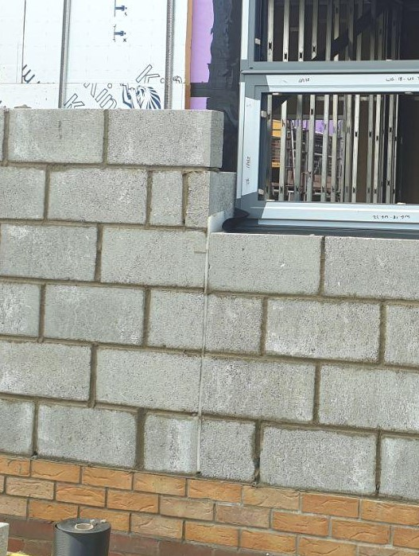 picture no. 7

This is a challenging area of the work as when we have to cut the concrete blocks or bricks to size as we have to be careful of any hazardous dust produced.

Every 2 m along the 0.00 level we place small 10 mm diameter pipes between the bricks so that any drops of water that condense between the insulation in the brick wall and the external wall can escape. It forms a weep brick role.

In some places, we have sewage or electronic pipes under the 0.00 level. Therefore, we need to use concrete lintels above the holes. As you can see in the picture below.
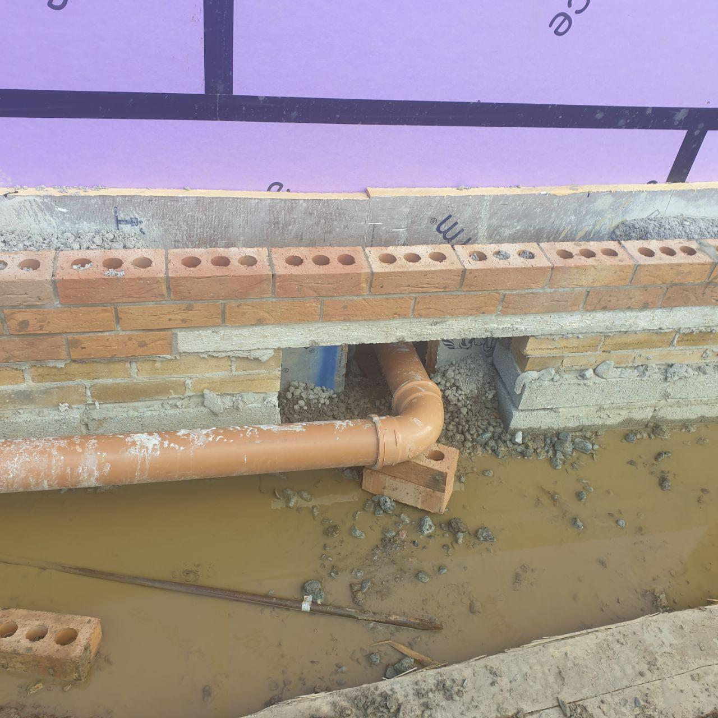 picture no. 8

