DS 1 Template

My Screenshots/Photos
- Please add 4–6 screenshots or photos of your digital life.
- You can use your phone or laptop.
- For each screenshot, write one or two sentences explaining what it shows.

Screenshot/Photo 1
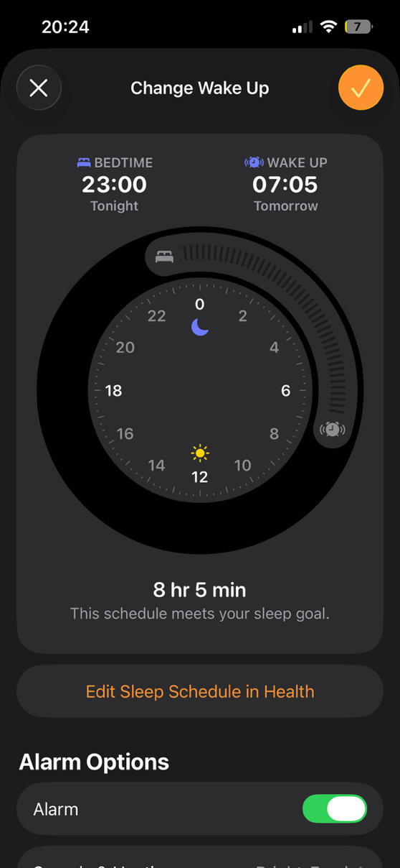
This is my alarm app I use the sleeping schedule to make sure I have enough sleep so I’m more focused at university.

Screenshot/Photo 2
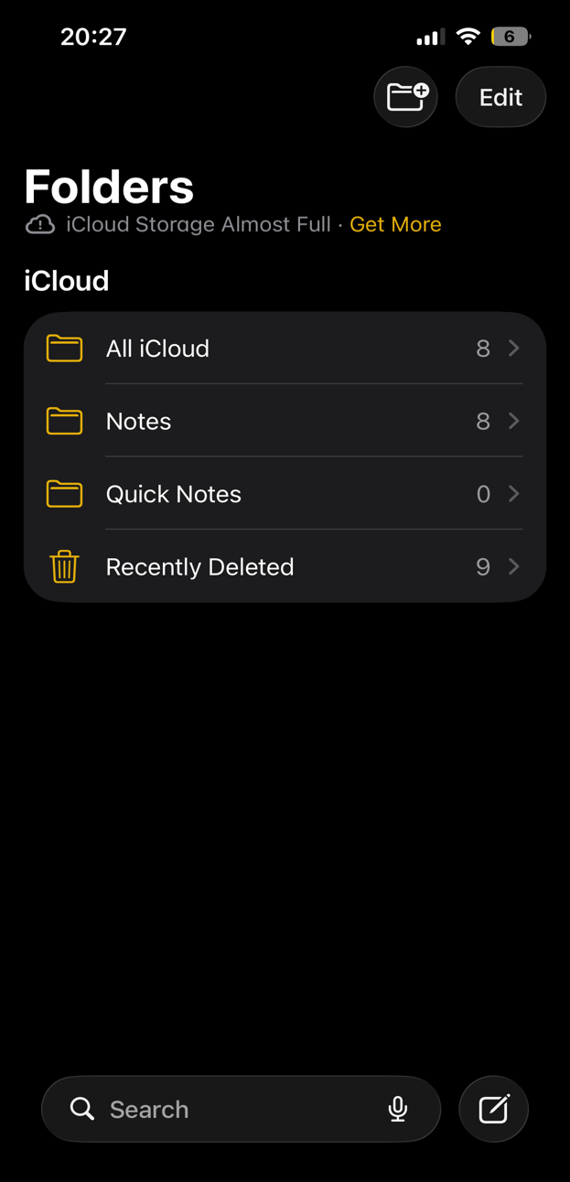
This is my notes app in my phone,I use this app to note down useful information from my university course or important things I need to remember so I don’t forget

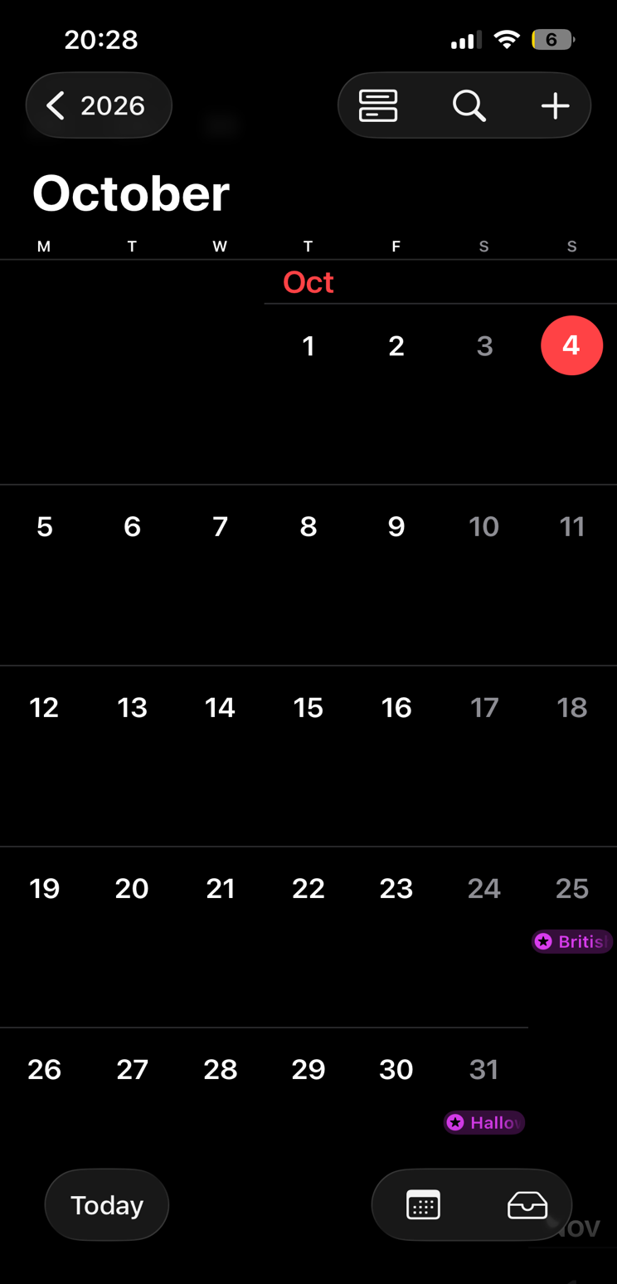
Screenshot/Photo

This is a image of screen shot from my calendar. I use this app to keep schedule and make sure I have plans on days I am not busy like days at university.
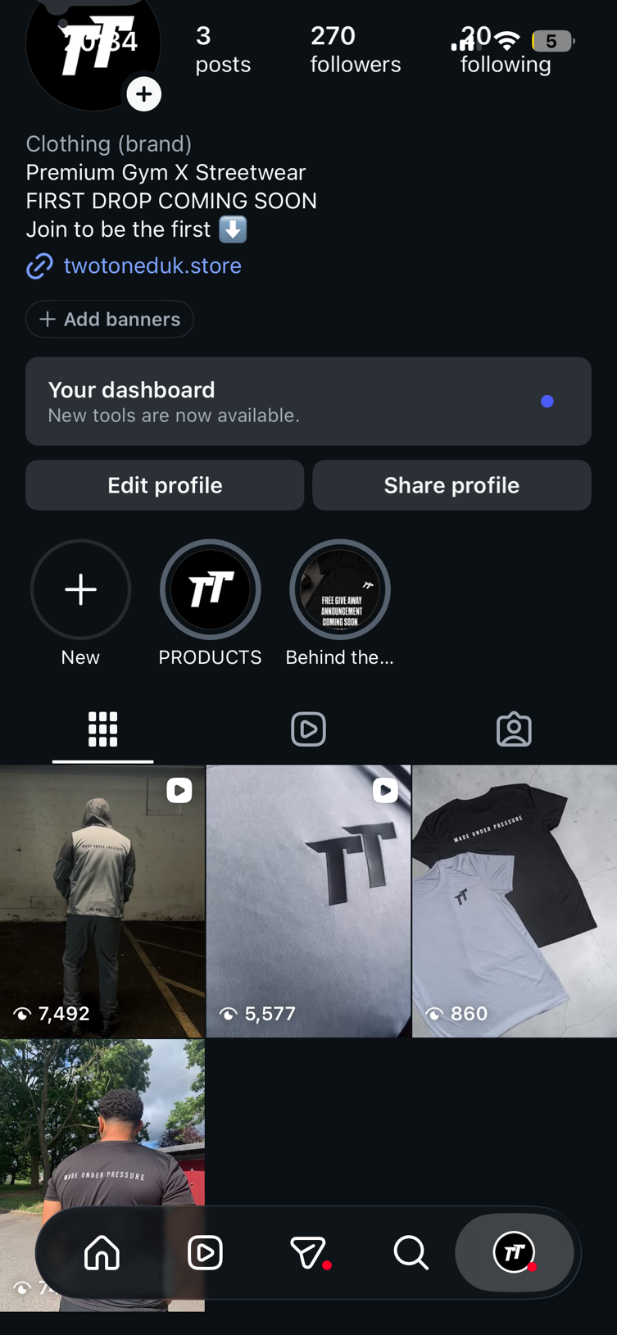
In this image it shows me using social media to promote and run my clothing brand project it gives me a idea of themes on the account before the launch of the product.]

Screenshot/Photo 4

My Short Reflection
- Write 5–8 simple sentences about your digital life.
- You can use the sentence starters below if helpful.
I use digital tools when I’m completing my university assessments especially on Microsoft word. Editing fonts,importing images and writing.
I feel confident when I’m writing on Microsoft word for my university studies as it helps me with presentation and structure.
I want to improve my knowledge on tools within Microsoft softwares as it can help the digital side of studying easier.
I often use these tools when I have incorrect spelling or to help having a different choice of words which can have a positive impact on myself and studies.
Sometimes I feel nervous about uploading documents correctly and laying out information to make sure it’s understandable for someone else to read it is a big change from pen and paper but can also make a massive positive impact.
Digital skills are important to me as it’s a way of life and new way of learning leaving old bad habits and becoming better due to digital knowledge.

Sentence starters
- I use digital tools to …
- I feel confident when I …
- I want to improve …
- I often use these tools: …
- I sometimes feel nervous about …
- I hope this module will help me …
- Digital skills are important for me because …
You can write more if you want.

Submission Checklist
Before you submit, please check:
​​​ ☐ I added 4–6 screenshots
☐ I wrote short sentences for each screenshot
☐ I wrote my short reflection
☐ My work is my own
☐ My file opens correctly
​​☐ My file opens correctly

