

Assessment 1
Supporting Paper

Student name: Bozica Katic
Student ID: 2008115
Module name: Mental Disorders and Psychopathology
Module code: BMHP6006
Lecturer name: Bianca Sanfilippo
Submission Date: 25 November 2022
Table of Contents

1. Introduction ……………………………………………….……………. 1
1.1. General Definition of Mental Health Disorder
and a brief overview of the UK context ……………………………. 1
1.2. WHOs International Statistical Classification
of Diseases and Related Health Problems ………………………… 1
2. Mental and Behavioural Disorders due to the use of
the psychoactive substance (caffeine) ……..…………………….. 2
2.1. Effect of caffeine on the nervous system ………………………… 3
2.2. Health impact of caffeine use ..………………………………………. 3
2.3. Caffeine addiction in the UK …………………………………………. 4
3. Causes of caffeine addiction ……………………………………….. 4
4. Symptoms of caffeine addiction …………………………………… 5
5. Diagnosis for caffeine addiction …………………………………… 5
6. Historical view and treatments for Mental Health
Diseases …………………………………..……………………………. 5
7. Current treatments (NHS) ……………………………....................... 6
8. Principles when working with people with Mental
Health Disorders …….………………………………………………… 7
9. Recommendation for the improvement ……………………………. 7
10. Conclusion ………………………………………………………………. 8
11. References ………………………………………………………………. 9
12. Appendix A: PowerPoint Presentation ……………………………. 12
B: The woman's petition against coffee-London 1674 ...… 19

- Introduction

This supporting paper describes mental and behavioural disorders due to the use of the stimulant caffeine, in the UK. The place in the ICD-10 classification, causes of the disease, data for the world and the UK, symptoms of the disease, historical treatments, current treatments in the UK, principles by which treatments are carried out, recommendations for improving treatments and conclusion will be discussed.

  - General definition of mental health disorder and a brief overview of the UK context

Mental health disorder or mental illness includes all conditions or disorders that have an impact on an individual's behaviour, thinking, feelings and mood (Mayo Clinic, 2022). In the UK, the most common mental illness is a combination of anxiety and depression. 7.8% of the UK population meets the criteria for diagnosis. These mental illnesses mostly affect the poor strata of society and people who are in a disadvantageous position. One in six people in the UK has had a mental disorder (Mental Health Foundation, 2022).

1.2 WHO’s International Statistical Classification
of Diseases and Related Health Problems

All mental illnesses are classified in WHO’s International Statistical Classification of Diseases and Related Health Problems, 10th Revision (ICD-10) Version for 2010. Mental and behavioural disorders due to the use of caffeine are placed in Chapter V in ICD-10. Chapter V classified all mental and behavioural disorders in blocks from F00 to F99. Block F10-F19 is called Mental and behavioural disorders due to psychoactive substance use and contains classification F15 which includes Mental and behavioural disorders due to the use of other stimulants, including caffeine (WHO, 2010).

2. Mental and behavioural disorders due to the use
of psychoactive substance (caffeine)

Mental and behavioural disorders due to the use of a psychoactive substance such as caffeine, are disorders that affect a person's behaviour, and change one’s state of mind (mental/emotional), and body. Stimulants can be smoked (nicotine), injected (heroine), snorted (cocaine) and drunk (caffeine). Caffeine is the most legally used psychoactive substance in the world (Res, 2013). It is found in many of today's favourite foods and drinks, often targeting children and adolescents (Gonzalez, Mares & Vinicio, 2014). In addition to coffee, it is also found in dark chocolate, tea, bottled coffee drinks, caffeinated water, soft drinks such as Cola, energy drinks (Red Bull), ice cream, yoghurt, caffeinated snacks, over-the-counter medications (medicine for migraine headaches and antihistamines) or dietary supplements (CSPI, 2021). Coffee is a ‘social drug’ (Top Tenz, 2017), the eighth most sold (Fxssi, 2022) and the oldest commodity in the world (Everyday coffee, 2022). Coffee farmers exploit children to work in the fields until exhaustion. Mexico alone has more than 3 million child labourers (World Vision Canada, 2021).

2.1. Effect of caffeine on the nervous system

Caffeine can block adenosine receptors in the brain and cause additional chemical reactions.
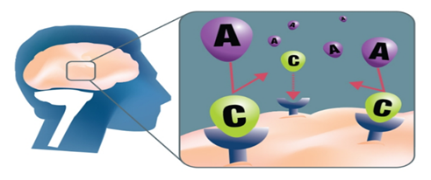
Source: Jorge Bach/CSP
Caffeine enters the bloodstream through the small intestine and reaches the brain via the bloodstream. As its chemical structure is similar to the structure of the adenosine molecule, caffeine binds to adenosine receptors in the brain and blocks them. Normally, when adenosine binds to its receptors in the brain, it creates a feeling of fatigue. However, when caffeine binds, a person feels alert and energetic until the caffeine is metabolized (Thoughty2, 2019). In addition, natural stimulants are released, such as dopamine, work even more effectively because adenosine receptors are blocked. On the other hand, an excess of adenosine stimulates the secretion of adrenaline (another stimulant) from the adrenal glands, which further reduces fatigue and increases alertness (Addiction Center, 2022).

2.2. Health impact of caffeine use

A safe amount of caffeine for a healthy adult is 400 mg/day, 300 mg/day for pregnant women, and 2.5 mg/kg/day for children and adolescents. This amount does not affect the health of healthy people, but it affects the health of more sensitive people who already have a disease (Wikoff et al., 2017). Exceeding this dose, even in young and healthy people, can cause health consequences and death (Bergen & Kevin, 2009). Although moderate intake is sometimes considered safe or even beneficial, caffeine use has been linked to several medical problems, including hypertension, heart problems, risk of pregnancy, anxiety, and insomnia (Striley, Griffiths & Cottler, 2011).

2.3. Caffeine addiction in the UK

Caffeine is still not officially classified as an addictive psychoactive substance. The reason for this is that caffeine does not stimulate the nervous system as strongly as other drugs (Addiction Center, 2022). In the UK, there are no legal restrictions on the sale or use of coffee, tea, cocoa, soft drinks, and chocolate confectionery. However, with the development of ICD-11, the discussion for classifying caffeine as a psychoactive addictive substance was stimulated. Many people who consume caffeine daily with long-term consumption become more resistant, so they need a higher dose of caffeine for the same stimulating effect, and more easily show signs of addiction (Heinz et al., 2020). Caffeine addiction is mental health illness (CBS news, 2013).
About 75% of those who regularly consume caffeine, in the UK, are addicted to it. Consuming as little as 200 mg of caffeine every day can lead to addiction and altered chemistry in the brain. It is necessary to gradually reduce the daily dose of caffeine to avoid unpleasant withdrawal symptoms. On average in the UK, consumers drink nearly 100 million cups of tea per day. Coffee is almost as popular as 95 million cups of coffee consumed a day. About 80% of coffee drank at home is instant coffee containing around 60 mg of caffeine per cup. In 2021, families with an older population (50 - 74 years old) spent the most on coffee (Statista, 2022).

3. Causes of caffeine addiction

People start drinking and eating products that contain caffeine for a variety of reasons. Social reasons include imitating others (family, friends) but also the wider social community that encourages consumption with attractive advertisements and lifestyle imposition (red bull gives you wings...), and easy availability of products. Psychological reasons for caffeine consumption include stimulation of increased alertness and focus, which is desirable during sports activities, night or long-term work and study; substitution for other more powerful drugs in the withdrawal process; encouraging the feeling of pleasure and euphoria (Porter, 2020). Some people consume caffeine for its health benefits. Science proven that caffeine has antioxidant and chemo-preventive properties and that it raises metabolism and blood pressure (Gökcen & Şanlier, 2019).

4. Symptoms of caffeine addiction

Symptoms of caffeine addiction for all age groups are craving, seeking, and using caffeine products despite adverse consequences (Heinz et al., 2020), an inability to perform daily activities of life without caffeine, unable to stop consuming, rapid speaking not listening, interrupting, headache, anxiety, sleep disorders (Porter, 2020).

5. Diagnosis for caffeine addiction

However, there are no specific guidelines for diagnosing problems caused by caffeine abuse, and the diagnostic criteria are the same as for other drug addiction disorders. According to the Diagnostic and Statistical Manual of Mental Disorders (DSM-5-TR) diagnosis of caffeine addiction is similar to symptoms of caffeine addiction (Ress, 2013).

6. Historical view and treatments for mental
health diseases

Treatments for the healing of mental illness have seen tremendous progress throughout history. The first theory was put forward by Hippocrates, in the 5th century BC, the so-called 'Humoral theory' to explain the causes of disease in humans and thereby reduce superstition. Treatments were based on bringing the four humors (four liquids in the human body) back into balance (Robb-Dover, 2021). There was a prevailing belief in society that the unusual behaviour of mentally ill people was caused by demons or evil spirits occupying their heads. In the 16th century, they were treated with the treatment of 'trepanning', a hole was drilled in the skull so that the evil spirit could escape. They would end up in prisons as convicted criminals. Later they were placed in insane asylums and sanatoriums (Bedlam in the UK) where patients were treated inhumanely. Children are treated in the same way as adults. Isolation of patients in psychiatric hospitals and insane asylums continued in the 18th and 19th centuries. During this time, treatments for treating mental health illnesses have seen great advances. Society's awareness of mental illnesses began to change thanks to the development of science and the introduction of new treatment methods. Freud's "talk therapy" (psychoanalysis) and electroconvulsive therapy (ECT) have greatly helped change society's perception of people with mental illness. The stigma on this topic has been reduced thanks to mental health activists who have recognized the benefits of hospitalization for people with mental illness. Dorothea Dix stood out for her work and advocacy for better conditions for patients in these institutions around the world (Balton Rouge Behavioural Hospital, 2022). In 1933, the use of antipsychotics for the treatment of mental diseases was introduced. Although they alleviate the symptoms of the disease, their use is questionable due to side effects (Johan & James, 2019). The stigma of a mentally ill person is still present and today. Treatments are more humane in some parts of the world, but in some parts of the world, mentally ill people are still treated by being kept in cages or chains by their families (Journeyman Pictures, 2009).

7. Current treatments (NHS)

Depending on the severity of the addictive behaviour (mild, moderate, or severe) there are different levels of psychological treatment provided by the NHS during the recovery process. Caffeine withdrawal treatments include talk therapy. A useful treatment is also education about the effects of caffeine, which increases the patient's knowledge and awareness of the patient's problem, which has the effect of empowering the patient in the intention to stop consuming caffeine. Self-help treatment includes referring the patient to join support groups of addicts who have the same problem (like the group Narcotics Anonymous) in which members exchange their knowledge and experiences (NHS, 2021).

8. Principles when working with people
with mental health disorders

Each patient, during the planning and the treatment itself, is approached as an individual with unique needs and desires, person-centred care. The person is treated with dignity, respect, empathy, good communication … According to the Equality Act 2010, each person with mental health disorder must be treated equally like all others, without discrimination. The Mental Health Act of 1983 ensures people with mental health diseases have their rights related to rights to treatment in hospitals and the community, the way they are admitted to and discharged from the hospital (Mind, 2022). Although, in general, health and social professionals try to meet the needs and wishes of the patient as much as possible, according to the Mental Capacity Act 2005 for people with mental illnesses, when decision-making about care or treatments, it is mandatory to take into account the mental capacity of the person (Social Care Institute for Excellence, 2011). Since 1998, when the Human Rights Act was introduced in the UK, according to Article 3 of that Act, no one may be treated inhumanely or humiliatingly, tortured, or punished. (Freedom from torture, n. y.).

9. Recommendations for the improvement

Recommendations to improve the treatments would be involving of meditation and practising mindfulness. Meditation balances neurotransmitters in the brain and thus stimulates brain function and naturally enhances cognitive functions of the brain (Trusted Science, 2021). Mindfulness involves increased attention to events in and around the person. Monitoring and awareness of one's thoughts and feelings, and a stronger connection with the physical body help to raise awareness of the present moment (NHS, 2022).

10. Conclusion

Today we have a contradictory situation: on the one hand, data is being collected and the clinical importance of caffeine addiction is being discussed, while new products with an increasing amount of caffeine, aimed at the young population, are being promoted and introduced in parallel (Budney & Emond, 2014). Caffeine is a legal, social drug. Although it is a psychoactive substance with a known impact on the body, that causes tolerance to caffeine, addiction and withdrawal symptoms, have not yet been officially classified as an addictive psychoactive drug. The reason for this is justified by the fact that it stimulates the nervous system not strong enough, like other psychoactive substances (Addiction Center, 2022). Increased consumption of caffeine, its harmful effects on the body, potential addiction that entails physical and psychological consequences for the individual, family and society, easy availability to children, early start of consumption increases the need to raise public awareness of the harmfulness of caffeine consumption and by public- health measures limit the use of caffeine. As caffeine starts to be consumed at a very early age, special emphasis should be given to raising the awareness of parents, teachers and everyone who comes into contact with children. In patients with mental health disorders, the daily intake of caffeine should also be taken into account as a significant factor in the patient's condition (Shobhit et al., 2017).

11. References

Addiction Center (2022) Caffeine Addiction and Abuse. Available at: https://www.addictioncenter.com/stimulants/caffeine/#:~:text=Most%20Caffeine%20addiction%20symptoms%20can%20be%20resolved%20in,in%20response%20to%20the%20sudden%20lack%20of%20Caffeine (Accessed: 7 November 2022).
Balton Rouge Behavioural Hospital (2022) The Surprising History of Mental Illness Treatment. Available at: https://batonrougebehavioral.com/the-surprising-history-of-mental-illness-treatment/ (Accessed: 27 October 2022).
Bergen, A., J. & Kevin, A. (2009) ‘Cardiac arrest in a young man following excess consumption of caffeinated energy drinks’, Medical Journal of Australia, 190 (1), pp. 41–43.
Budney, A., J. & Emond, J., A. (2014) ‘Caffeine addiction? Caffeine for youth? Time to act’, Addiction (Abingdon, England), 109(11), pp. 1771–1772.
CBS News (2013) Coffee addiction: Caffeine intoxication and withdrawal is a real diagnosis [video]. Available at: https://www.youtube.com/watch?v=1hI8xRrnbVY&t=2s (Accessed: 1 November 2022).
Centre for Science in Public Interest (2021) Caffeine chart. Available at: (https://www.cspinet.org/caffeine-chart (Accessed: 27 October 2022).
Everyday coffee (2022) Is coffee the most traded commodity?. Available at: https://www.everydaycoffee.ph/help/Is-coffee-the-most-traded-commodity (Accessed: 2 November 2022).
Freedom from torture (n. y.) Is torture legal?. Available at: http:// www.freedomfromtorture.org/what-we-do/fighting-torture/torture-and-the-law/is-torture-legal?gclid=Cj0KCQjwwfiaBhC7ARIsAGvcPe6XjZW_KZ2_-oXs8s9-ojDXLggdSk62HZYe241yAomrm31lzTQpdH4aAgX9EALw_wcB (Accessed: 30 October 2022).
Fxssi (2022) Top 10 Most Traded Commodities in the World – 2022. Available at: https://fxssi.com/top-10-most-traded-commodities-in-the-world (Accessed: 7 November 2022).
Gonzalez, M., E., Mares, R. & Vinicio, M. (2014) ‘Impact of caffeine and coffee on our health’, Trends in Endocrinology and Metabolism, 25(10), pp. 489–492.
Heinz, A. et al. (2020) ‘Addiction theory matters—Why there is no dependence on caffeine or antidepressant medication’, Addiction Biology, 25(2), pp.1273.
Johan, R. & James, W. (2019) ‘Positive and Negative Effects of Antipsychotic Medication: An International Online Survey of 832 Recipients’, Bentham Science Publishers, 14(3), pp. 173-181.
Journeyman Pictures (2009) In Bali the Mentally Ill a Treated Like Animals [video]. Available at: https://www.youtube.com/watch?v=zdUrrlRgMFw (Accessed: 27 October 2022).
Mayo Clinic (2022) Mental illness. Available at: https://www.mayoclinic.org/diseases-conditions/mental-illness/symptoms-causes/syc-20374968#:~:text=Mental%20illness%2C%20also%20called%20mental,eating%20disorders%20and%20addictive%20behaviors (Accessed: 27 October 2022).
Mental Health Foundation (2022) The most common mental health problems: statistics. Available at: https://www.mentalhealth.org.uk/explore-mental-health/mental-health-statistics/most-common-mental-health-problems-statistics (Accessed: 27 October 2022).
Mind (2022) Disability discrimination. Available at: https://www.mind.org.uk/information-support/legal-rights/mental-health-act-1983/about-the-mha-1983/ (Accessed: 30 October 2022).
NHS (2021) Addiction: what is it. Available at: https://www.nhs.uk/live-well/addiction-support/addiction-what-is-it/ (Accessed: 28 October 2022).
NHS (2022) Mindfulness. Available at: https://www.nhs.uk/mental-health/self-help/tips-and-support/mindfulness/ (Accessed: 1 November 2022).
Porter, D., A. (2020) Caffeine Addiction: Signs, Symptoms & Treatments. Available at: https://www.choosingtherapy.com/caffeine-addiction/ (Accessed: 27 October 2022).
Res, J., C. (2013) ‘Caffeine Use Disorder: A Comprehensive Review and Research Agenda’, Journal of Caffeine Research, 3(3), pp. 114–130.
Robb-Dover, K. (2021) The Humors: Ancient Perspectives on Mental Health. Available at: https://fherehab.com/learning/humors-ancient-mental-health (Accessed: 27 October 2022).
Shobhit, J. et al. (2017) ‘Caffeine addiction: Need for awareness and research and regulatory measures’, Asian Journal of Psychiatry, 41, pp. 73–75.
Social Care Institute for Excellence (2011) Introducing the MCA. Available at: https://www.scie.org.uk/mca/introduction/mental-capacity-act-2005-at-a-glance?gclid=Cj0KCQjwwfiaBhC7ARIsAGvcPe6cosch7KFF5VuQMtV3qZLhnFO8zPx-vduRxz46JJI0B55v2m4sckUaAskzEALw_wcB (Accessed: 30 October 2022).
Statista (2022) Consumer spending on coffee, tea, and cocoa in the United Kingdom from 2005 to 2021 (in million GBP). Available at: https://www.statista.com/statistics/289932/expenditure-on-coffee-tea-and-cocoa-in-the-united-kingdom-uk (Accessed: 2 November 2022).
Striley, C., L., W., Griffiths, R., R., & Cottler, L., B. (2011) ‘Evaluating Dependence Criteria for Caffeine’, Journal of Caffeine Research, 1(4), pp. 219–225.
Thoughty2 (2019) The Shocking Effects Caffeine Has on Your Brain and Body [video]. Available at: https://www.youtube.com/watch?v=ohHCyf-UaX4 (Accessed: 19 November 2022).
Top Tenz (2017) Caffeine is More Like an Illegal Drug Than You Realized [video]. Available at: https://www.youtube.com/watch?v=OLCPW5XC5pc (Accessed: 2 November 2022).
Trusted Science (2021) Can Meditation Help Your Mental Health. Available at: https://trusted-science.com/health-articles/meditation-and-mental-health/#:~:text=Meditation%20has%20a%20profound%20impact%20on%20mental%20health,health%20chemicals%20are%20called%20dopamine%2C%20norepinephrine%2C%20and%20serotonin (Accessed:1 November 2022).
WHO - World Health Organisation (2010) ICD-10 - International Statistical Classification of Diseases and Related Health Problems 10th Revision. Available at: https://icd.who.int/browse10/2010/en#/V (Accessed: 27 October 2022).
Wikoff, D. et al. (2017) ‘Systematic review of the potential adverse effects of caffeine consumption in healthy adults, pregnant women, adolescents, and children’, Food and Chemical Toxicology, 109(1), pp. 585–648.
World Vision Canada (2021) Child Labour in the Coffee and Sugar Industry | World Vision Canada [video]. Available at: https://www.youtube.com/watch?v=7ZwH6Op_KTE (Accessed: 2 November 2022).

12. Appendix A: PowerPoint Presentation
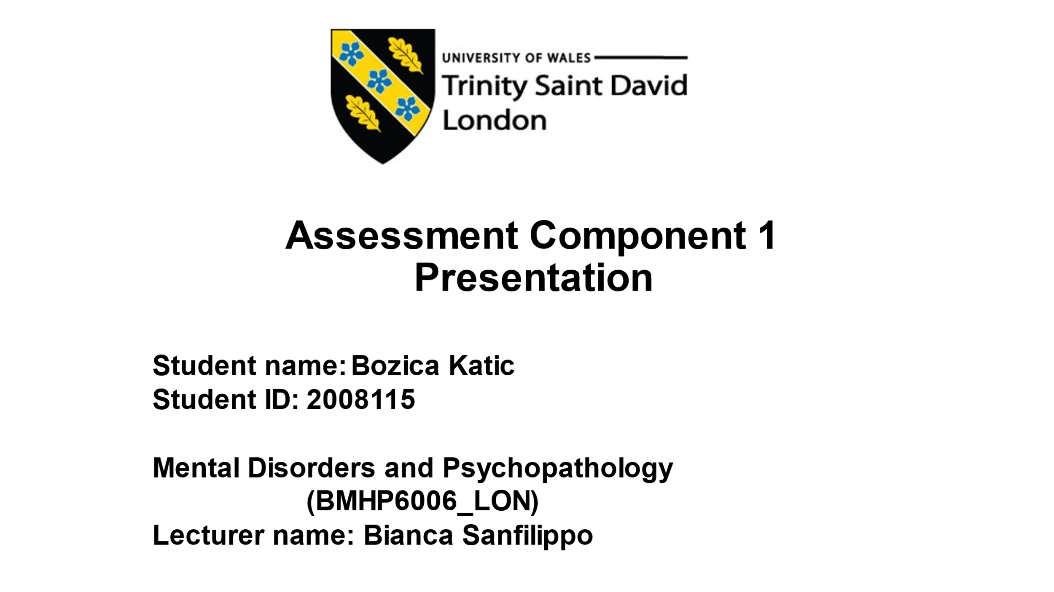

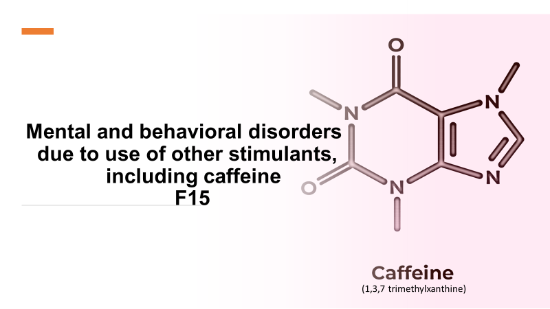

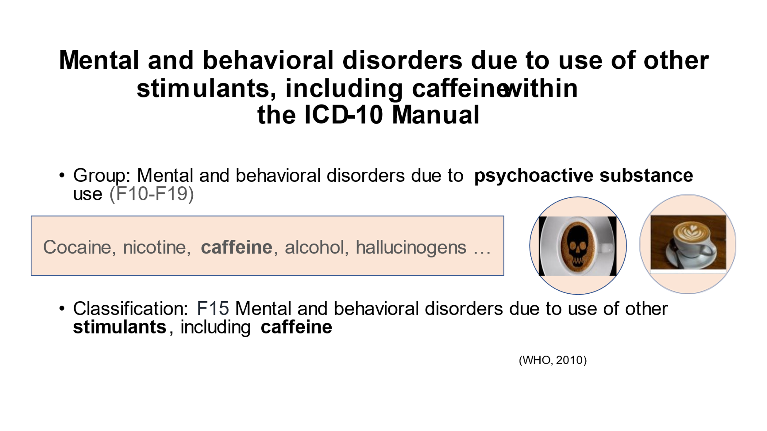

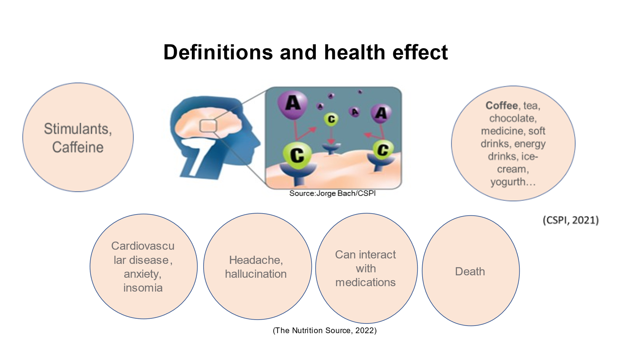

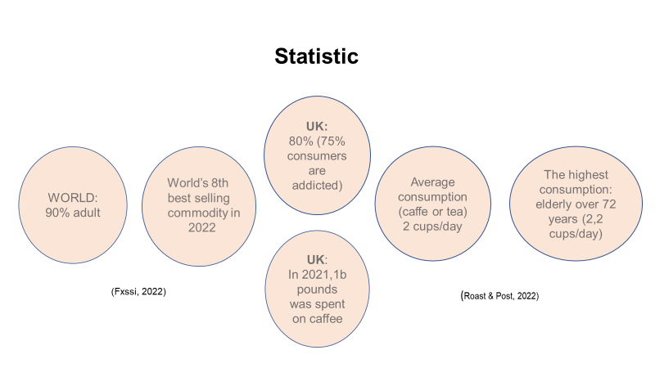

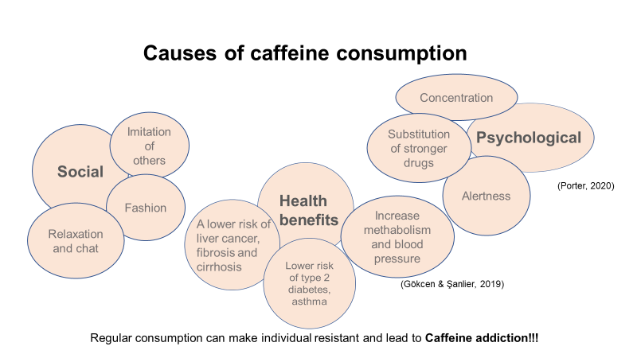
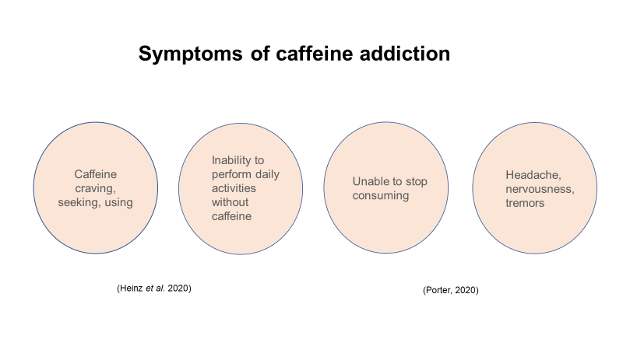

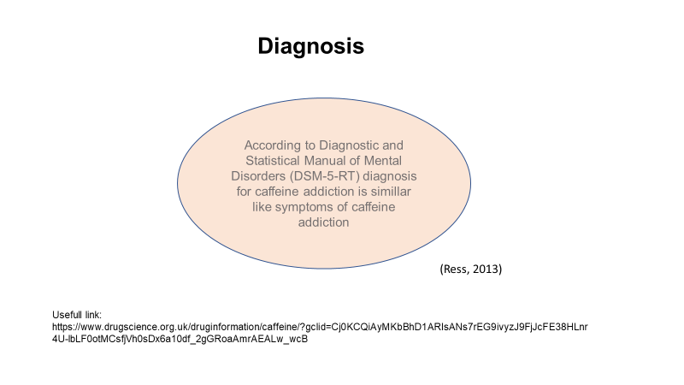
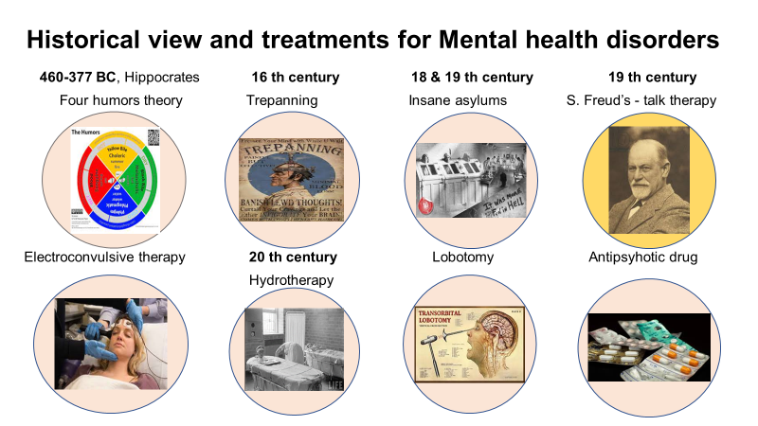

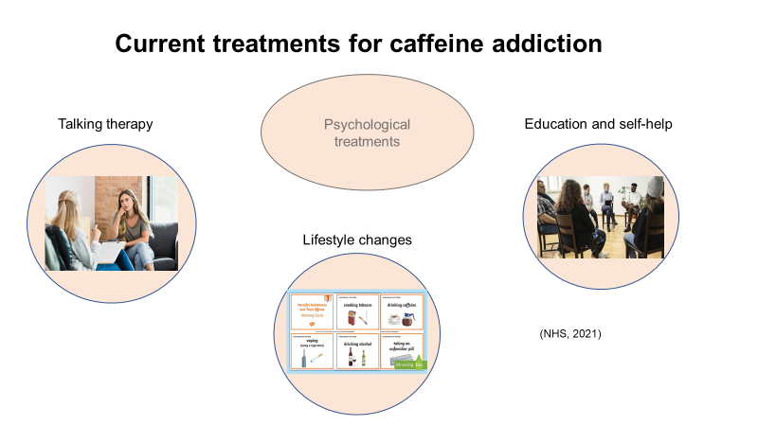
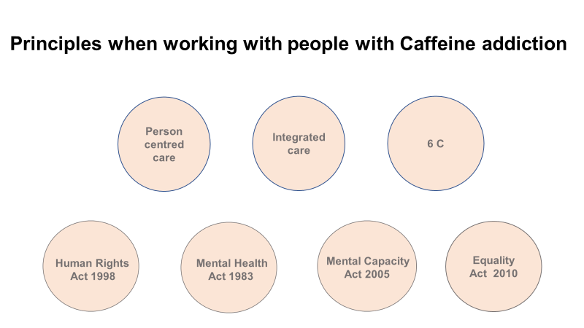

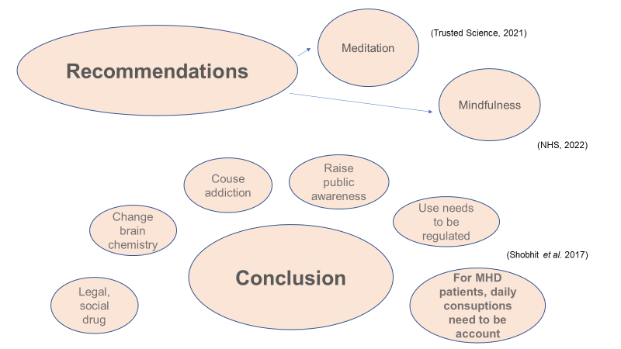
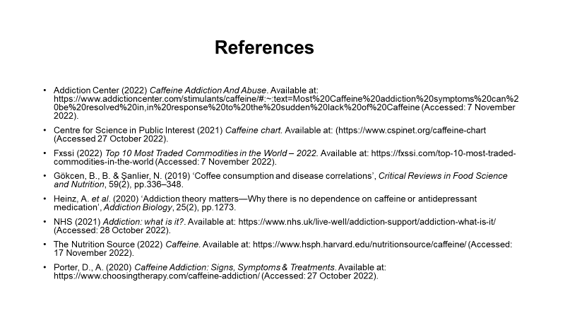

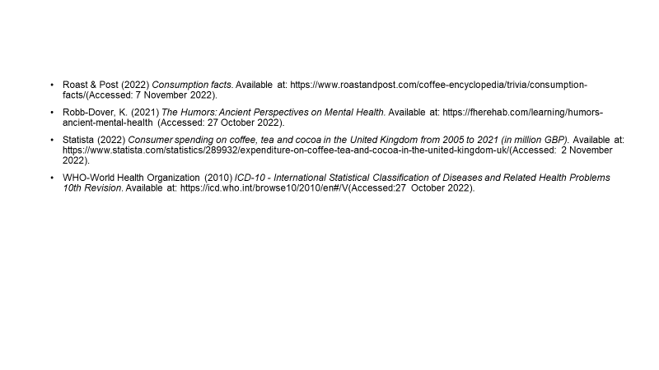

Appendix B: The womans petition against coffee,
London 1674



