

ASSESSMENT 1

HUMAN RESOURCE MANAGEMENT

Name: Dimple ben Patel
Student ID: 2207957
Module Code: LCMB7000
Lecturer: Dr. Mushfiqur Rahman
Submission Date: 04/1/2023

Table of Contents
Introduction 4
The Current State of the Labour Market in the UK 4
Unemployment Rate in the UK 4
Wage Growth in the UK 5
Labour Force Participation in the UK 5
The Emerging Changes in Human Resourcing Strategies in the Post-Covid External Environment 6
Increased Use of Remote Work 6
Need to Manage Workforce Reductions 7
Increased Focus on Health and Well-Being 7
The Emerging Changes in Human Resourcing Strategies in the Post-Brexit External Environment 8
Addressing Changes to Immigration and Employment Rules 8
Increasing Focus on Skills and Training 9
Reviewing Supply Chain and Sourcing Strategies 10
Managing the Impact of Currency Fluctuations 10
Promoting Diversity and Inclusion 11
Conclusion 12
References 13

Figure1 Increased Use of Remote Work 6
Figure 2 Increased Focus on Health and Well-Being 8
Figure 3 Addressing Changes to Immigration and Employment Rules 9
Figure 4 Increasing Focus on Skills and Training 9
Figure 5 Reviewing Supply Chain and Sourcing Strategies 10
Figure 6 Promoting Diversity and Inclusion 11

Introduction
The existing state of the labour marketplace in the UK has been heavily impacted by the COVID-19 pandemic and the Brexit process. The COVID-19 pandemic has caused a significant financial interruption, with several industries obligatory to close or reduce their operations. This has harmed employment, with several individuals losing their professions or facing reduced hours. The unemployment rate in the UK has increased as a consequence of the COVID-19 pandemic, with the Office for National Statistics (ONS) reporting that the unemployment rate was 4.5% in the three months to September 2021. This represents an increase from the pre-pandemic unemployment rate of 3.8% in February 2020 (Marsden and Ryan, 2019). The UK's exit from the European Union (EU) has brought about deviations to the rules governing the movement of people between the UK and the EU, and there are concerns that this may impact the availability of skilled labour in certain sectors.

The Current State of the Labour Market in the UK
The labour market in the UK is characterized by a high level of flexibility, with a relatively low level of regulation compared to some other countries. The UK has a diverse economy with a range of sectors, including manufacturing, finance, healthcare, and technology. In recent years, the UK labour market has been strong, with low unemployment rates and strong wage growth.

Unemployment Rate in the UK
The unemployment rate in the UK is a measure of the percentage of the labour force that is dynamically looking for work but is incapable to find it. It is intended by separating the number of unemployed individuals by the total number of people in the labour force (which includes both employed and unemployed individuals). In recent years, the unemployment rate in the UK has been relatively low, hovering around 4% in the years leading up to the COVID-19 pandemic. However, the pandemic has had a substantial influence on the labour market, resulting in a spike in unemployment in 2020 and 2021. Several factors can influence the unemployment rate in the UK (Brell, et. al., 2020). These include economic conditions, such as the level of economic growth, changes in demand for goods and services, and the availability of jobs. The government can also influence the unemployment rate through its economic policies, such as its spending and tax policies, and its labour market regulations, such as minimum wage laws and unemployment insurance programs. Overall, the unemployment rate is an important indicator of the state of the labour market and the economy and can have significant implications for individuals, businesses, and society.

Wage Growth in the UK
Wage growth refers to the rate at which wages and salaries increase over time. It is an important indicator of the state of the labour market and the overall economy, as it can reflect the balance of supply and demand for labour and the level of productivity and competitiveness in the economy. In the UK, wage growth has been strong in recent years, with average weekly earnings increasing at a faster rate than inflation. However, wage growth has been uneven, with some sectors and regions experiencing stronger wage growth than others. Several factors can influence wage growth in the UK (Inanc, 2018). These include economic conditions, such as the level of economic growth and the rate of inflation, as well as the supply and demand for labour in different sectors and regions. Other factors that can affect wage growth include the level of productivity in the economy, the level of competition in the labour market, and the level of education and skills of the workforce. Government policies, such as minimum wage laws and collective bargaining agreements, can also influence wage growth in the UK.

Labour Force Participation in the UK
Labour force participation refers to the proportion of the population that is either employed or actively seeking work. It is an important indicator of the state of the labour market and the overall economy, as it reflects the level of supply and demand for labour and the level of economic activity in the country. In the UK, the labour force participation rate has been relatively high in recent years, with a high percentage of the population in work. The UK has a diverse and highly developed economy, with a range of sectors including manufacturing, finance, healthcare, and technology. Several factors can influence the labour force participation rate in the UK. These include economic conditions, such as the level of economic growth and the availability of jobs, as well as demographic trends, such as the aging of the population and changes in the number of people entering or leaving the labour force (Etheridge and Spantig, 2020). The UK has a relatively high level of female labour force participation, and the government has implemented a range of policies aimed at promoting gender equality in the workplace. This includes initiatives such as the introduction of shared parental leave, which allows both parents to take time off work to care for their children, and efforts to increase the representation of women in leadership roles. Government policies, such as unemployment insurance programs and training and education programs, can also influence the labour force participation rate in the UK.

The Emerging Changes in Human Resourcing Strategies in the Post-Covid External Environment
The COVID-19 pandemic has had a momentous influence on the global economy, including the labour market in the UK. As a result, many organizations have had to adapt and adjust their human resource (HR) strategies in response to the changing external environment.

Increased Use of Remote Work
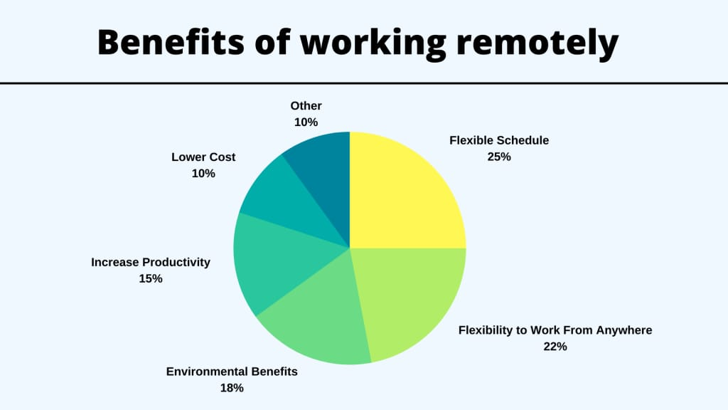
Figure 1 Increased Use of Remote Work
Sources: Revutska, 2021
The increased use of remote work as a human resource (HR) strategy in the post-COVID environment has been driven by the need to maintain business continuity and protect the health and safety of workforces in the face of the COVID-19 pandemic. As a result of the pandemic, many organizations have had to quickly implement measures such as remote work policies and digital technologies to allow employees to work from home or other locations. An example of an organization that has implemented remote work as an HR strategy in the post-COVID environment is the company, Sony. In response to the pandemic, Sony implemented a company-wide remote work policy and provided employees with the necessary tools and support to work remotely. This included providing employees with laptops and other equipment, as well as offering virtual training and development programs to help them adapt to the new way of working. The adoption of remote work as an HR strategy has had several benefits for both employees and organizations (Revutska, 2021). For employees, remote work can offer greater flexibility and control over their work environment, as well as the ability to balance work and personal commitments. For organizations, remote work can help to reduce costs, increase productivity, and improve employee retention. However, the transition to remote work has also presented challenges and required organizations to adapt their HR strategies to support remote employees.

Need to Manage Workforce Reductions
The need to manage workforce reductions as a human resource (HR) strategy in the post-COVID environment has been driven by the influence of the COVID-19 pandemic on the global economy and the labour market. Many organizations have had to reduce their workforce in response to the economic downturn and declining demand for goods and services. To manage workforce reductions as an HR strategy, The company Sony has implemented a range of measures such as layoffs, furloughs, and voluntary redundancy programs. These measures can help to reduce costs and support the organization through difficult economic times (Slavić, et. al., 2021). In addition to managing workforce reductions, organizations have also implemented HR strategies such as training and development programs, career transition support, and employee engagement initiatives to support their employees through these challenges. Overall, the need to manage workforce reductions as an HR strategy in the post-COVID environment has been driven by the influence of the COVID-19 pandemic on the global economy and the labour market and has required organizations to implement a range of measures to support their employees through these challenges. The company has faced major challenges in managing employment values and accessibility. To overcome such challenges distinct approaches are being considered with the objective of evaluating change practices. The company is ensuring to develop the changes which help in implying better areas of business improvements.

Increased Focus on Health and Well-Being
The increased focus on health and well-being as a human resource (HR) strategy in the post-COVID environment has been driven by the impact of the COVID-19 pandemic on the mental health and well-being of many individuals. As a result, Sony has implemented measures to support the health and well-being of their employees. One example of the company's HR strategy that has focused on health and well-being in the post-COVID environment is the implementation of flexible working arrangements (Hu, 2022). The organization has implemented measures such as flexible working hours and the ability to work from home to support the health and well-being of its employees. This can help to reduce stress and improve work-life balance, which can in turn improve employee engagement and productivity. Another example of an HR strategy that has focused on health and well-being in the post-COVID environment is the implementation of mental health support programs.
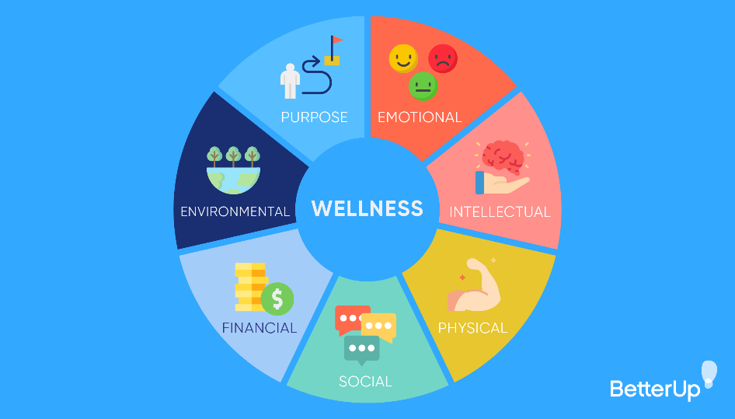
Figure 2 Increased Focus on Health and Well-Being
Sources: Hu, 2022
The pandemic has had a momentous influence on the mental health of many individuals, and organizations have had to respond by implementing measures such as counselling and employee assistance programs to support their employees through these challenges (Oseghale, et. al., 2022). Other HR strategies that have focused on health and well-being in the post-COVID environment include the promotion of healthy lifestyle practices, such as exercise and stress management, and the implementation of policies and practices to support work-life balance, such as generous leave policies and flexible working arrangements.

The Emerging Changes in Human Resourcing Strategies in the Post-Brexit External Environment
The UK's exit from the European Union (Brexit) has had a substantial influence on the global economy, including the labour market in the UK. As a result, many organizations have had to adapt and adjust their human resource (HR) strategies in response to the changing external environment. Some of the evolving fluctuations in HR approaches in the post-Brexit atmosphere in the UK may include:

Addressing Changes to Immigration and Employment Rules
One of the evolving deviations in human resource (HR) approaches in the post-Brexit external environment in the UK has been the need to address changes to immigration and employment rules. The UK's exit from the European Union (Brexit) has resulted in changes to the rules governing immigration and employment, and many organizations have had to adapt and adjust their policies and practices in response to these changes. For example, before Brexit, EU citizens were able to work in the UK without a visa (Moradlou, et. al., 2022). However, following the UK's exit from the EU, EU citizens are now focusing on the same migration rules as non-EU citizens and may be required to obtain a visa to work in the UK.
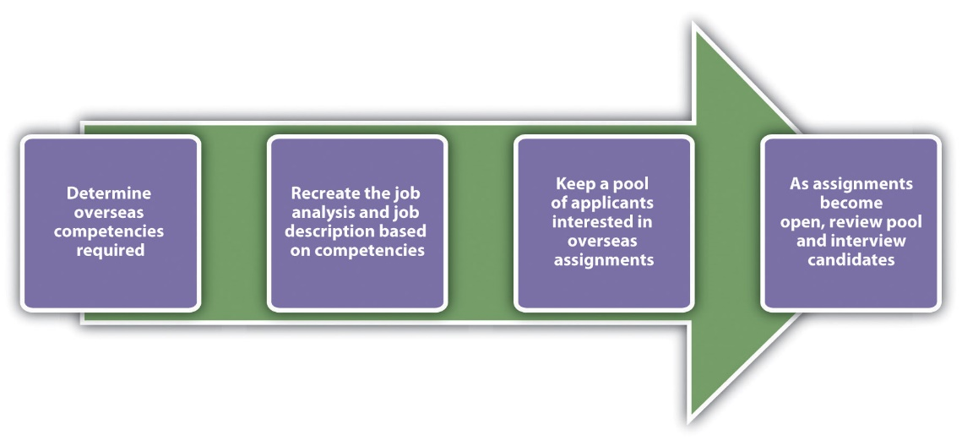
Figure 3 Addressing Changes to Immigration and Employment Rules
Sources: Moradlou, et. al., 2022

Increasing Focus on Skills and Training

Figure 4 Increasing Focus on Skills and Training
Sources: Cumming, et. al., 2020
Another emerging change in human resource (HR) strategies in the post-Brexit external environment in the UK has been the increased focus on skills and training. The UK's exit from the European Union (Brexit) has raised concerns about the availability of skilled labour, and many organizations have had to implement measures such as training and development programs and apprenticeship schemes to address these concerns (Cumming, et. al., 2020). For example, the Brexit process has resulted in changes to the rules governing the movement of people between the UK and the EU, and there are concerns that this may impact the availability of skilled labour in certain sectors.

Reviewing Supply Chain and Sourcing Strategies
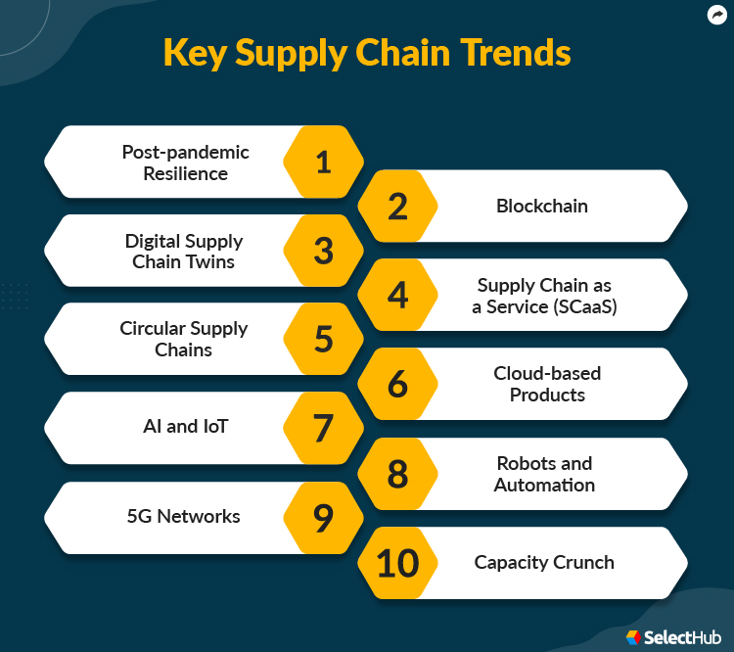
Figure 5 Reviewing Supply Chain and Sourcing Strategies
Sources: Smith, 2019
Another emerging change in human resource (HR) strategies in the post-Brexit external environment in the UK has been the need to review and adapt supply chain and sourcing strategies. The Brexit process has raised concerns about the potential impact on supply chains and sourcing, and organizations may need to review and adapt their strategies in response to these changes. For example, the UK's exit from the European Union (EU) has led to changes to the rules governing trade between the UK and the EU, and this may impact the cost and availability of goods and materials (Smith, 2019). As a result, organizations may need to review their supply chain and sourcing strategies to minimize disruptions and ensure that they can access the materials and resources they need.

Managing the Impact of Currency Fluctuations
The Brexit process has had an impact on currency markets, and organizations may need to implement measures to manage the impact of currency fluctuations on their operations. For example, the UK's exit from the European Union (EU) has occasioned in variations to the exchange rate between the pound sterling and other currencies, and this may impact the cost of goods and materials that are imported or exported. To manage the impact of these currency fluctuations, organizations may need to implement measures such as currency hedging or price adjustments to mitigate the impact on their operations (ElCheikh, et. al., 2020). In addition to managing the impact of currency fluctuations, organizations may also need to review and adapt their financial and budgeting processes to better manage their financial risks in the post-Brexit environment.

Promoting Diversity and Inclusion
The Brexit process has raised concerns about the potential impact on diversity and inclusion, and organizations may need to implement measures such as diversity and inclusion training and initiatives to support their employees through these challenges. For example, the UK's exit from the European Union (EU) has resulted in changes to the rules governing the movement of people between the UK and the EU, and there are concerns that this may impact the diversity of the workforce in certain sectors (Moradlou, et. al., 2022). In response to these concerns, many organizations have implemented diversity and inclusion initiatives to support their employees and to promote an inclusive workplace culture.
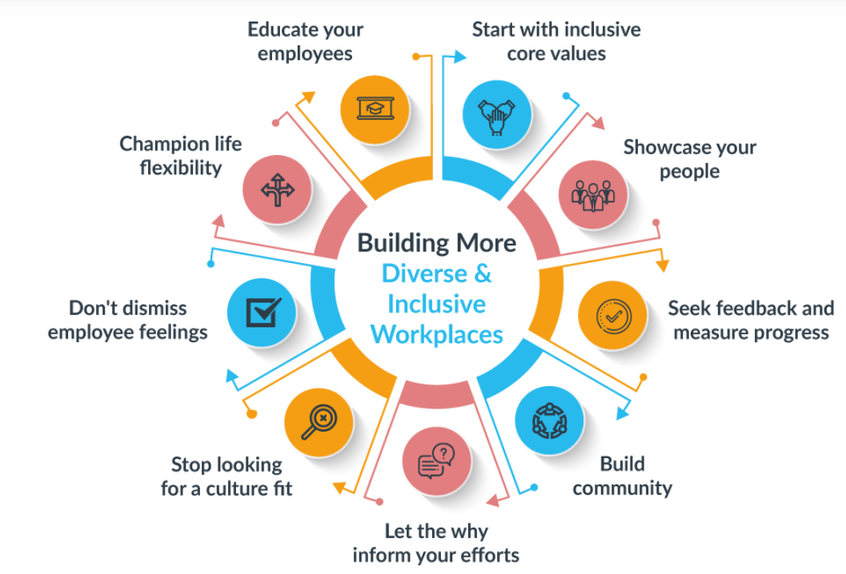
Figure 6 Promoting Diversity and Inclusion
Sources: Moradlou, et. al., 2022
Overall, the Brexit process has had a significant impact on the labour market in the UK and has required organizations to adapt and adjust their HR strategies in response to the changing external environment. These strategies may focus on addressing the challenges posed by changes to immigration and employment rules, promoting skills and training, reviewing supply chain, and sourcing strategies, managing the impact of currency fluctuations, and promoting diversity and inclusion.

Conclusion
The COVID-19 pandemic and the Brexit process have had a significant impact on the labour market in the UK. The COVID-19 pandemic has resulted in a rise in unemployment, with the unemployment rate increasing from 3.8% in February 2020 to 4.5% in the three months to September 2021. The Brexit process has also had an impact on the labour market, with changes to the rules governing the movement of people between the UK and the EU raising concerns about the availability of skilled labour in certain sectors. Despite these challenges, the labour market in the UK has shown some signs of resilience. Wage growth has remained relatively stable, and the level of labour force participation has remained relatively high.

References
Brell, C., Dustmann, C. and Preston, I., 2020. The labour market integration of refugee migrants in high-income countries. Journal of Economic Perspectives, 34(1), pp.94-121.
Cumming, D.J., Wood, G. and Zahra, S.A., 2020. Human resource management practices in the context of rising right‐wing populism. Human Resource Management Journal, 30(4), pp.525-536.
ElCheikh, M., Cojocaru, A., Theaker, M. and AlSheikh, D., 2020. Analyzing the effect of Brexit on the British construction industry using fuzzy sets theory. Frontiers in Built Environment, 6, p.8.
Etheridge, B. and Spantig, L., 2020. The gender gap in mental well-being during the Covid-19 outbreak: evidence from the UK (No. 2020-08). ISER Working paper series.
Hu, Y., 2022. Research on Human Resource Management Strategy of Small and Medium Enterprises in Post-Corona era. Journal of Education, Humanities and Social Sciences, 2, pp.49-55.
Inanc, H., 2018. Unemployment, temporary work, and subjective well-being: The gendered effect of spousal labour market insecurity. American Sociological Review, 83(3), pp.536-566.
Marsden, D. and Ryan, P., 2019. Initial training, labour market structure and public policy: intermediate skills in British and German industry. In International comparisons of vocational education and training for intermediate skills (pp. 251-285). Routledge.
Moradlou, H., Fratocchi, L., Skipworth, H. and Ghadge, A., 2022. Post-Brexit back-shoring strategies: what UK manufacturing companies could learn from the past?. Production Planning & Control, 33(14), pp.1319-1336.
Oseghale, R., Ochie, C., Dang, M., Nyuur, R. and Debrah, Y., 2022. Human Resource Management Reconfiguration Post-COVID Crisis. In Organizational Management in Post Pandemic Crisis (pp. 139-159). Springer, Cham.
Revutska, O., 2021. Human Resource Management: a shift towards agility due to a pandemic of COVID-19. In the 15th International Conference: Liberec Economic Forum (pp. 423-430).
Slavić, A., Poór, J., Berber, N. and Aleksić, M., 2021, July. Human Resource Management in the Time of Covid-19 Pandemic: Trends and Challenges. In International Scientific Conference Str ategic Management and Decision Support Systems in Strategic Management (pp. 48-55).
Smith, M., 2019. The European Union and the global arena: In search of post-Brexit roles. Politics and Governance, 7(3), pp.83-92.

