Geodemographic Analysis Using GIS Software

Wayne Howell (2207408)
Geographical Information Systems (ACCB5027)
BSC2-PT Computing: Data & Information Systems
University of Wales Trinity Saint David
Contents
1.Introduction 3
2.Geodemographic Analysis 4
2.1 Cancer Incidence 4
2.2 Townsend Index 5
2.3 Adult Lifestyles 7
2.4 Age Demographics 11
2.5 Healthcare Access & GP Surgery Distance 12
2.6 Lung Cancer: Air Pollution, Smoking and Motorway Emissions 13
3.Conclusion 16
4.Appendix 17
Task 1 (Part B) 17
GIS Build 17
Boundary Data 17
Cancer Incidence 18
Townsend Index 21
Adult Lifestyles 23
Age Demographics 25
Healthcare Access and GP Surgery Distance 27
Air Pollution 29
Industrial Sites 30
Motorway Data 31
Backdrop Maps 32
Map Layering and Visual Configuration 33
5.Figures 34
6.References 35

1.Introduction
Cancer incidence varies geographically due to multiple factors, including socioeconomic status, environmental exposure, and lifestyle choices.
The report examines spatial correlations between cancer incidence in Wales from 2011 to 2019, with a specific emphasis on 2013, to understand the underlying factors that influenced cancer trends. To achieve this, MapInfo Pro 2023 was utilised to display cancer incidence patterns, conduct geographical analysis, and assess potential contributing factors such as deprivation, pollution, and healthcare accessibility. Thematic mapping and GIS techniques were applied to provide a spatial perspective on cancer distribution, highlighting locations with substantial changes in incidence over time. The findings are intended to assist healthcare authorities in resource allocation and targeted interventions, ensuring that public health strategies are informed by geospatial analysis and data-driven insights.

2.Geodemographic Analysis
This section investigates how spatial variations in cancer incidence in Wales are influenced by factors such as deprivation, lifestyle behaviours, environmental factors, age and access to healthcare services for the period 2011 to 2019.

2.1 Cancer Incidence
Cancer remains one of the leading causes of death in Wales. Thousands of new cases are diagnosed annually, making it a critical public health issue that requires prevention and early intervention strategies.
Figure 1: Cancer Incidence Rates in Wales between 2011 and 2019
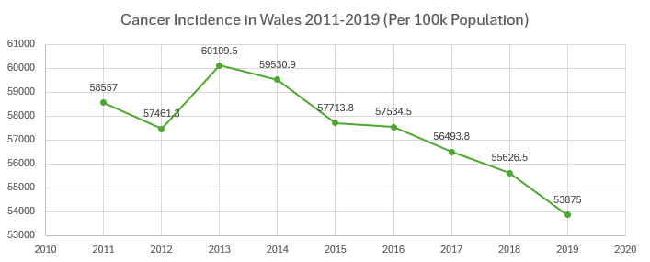
Figure 1 shows that between 2011 and 2019, cancer incidence rates in Wales fell steadily per 100,000 people. The rate decreased from 58,557 in 2011 to 53,875 in 2019, reflecting an approximate 8% decline over the nine-year period.
The initial spike in 2013 appears to be an anomaly and further analysis of the underlying causes during this year will be discussed within this report.
This downward trend shows that the overall risk of cancer in the Welsh population has been gradually decreasing over the years. This reduction could be attributed to effective public health measures aiming at cancer prevention, early detection programs, and advances in healthcare services. Furthermore, lifestyle improvements, such as lower smoking rates and increasing public awareness of cancer risk factors, could have had a substantial impact.
Although while the general incidence rate has decreased, differences may still remain among cancer types and demographic groups. Certain cancers, for example, may have seen considerable decreases while others remained stable or even grew.
Figure 2 shows a thematic map comparing the cancer incidence changes for the years 2011 ,2015, and 2019 at Upper Super Output Area (USOA) level.

Figure 2: Thematic Maps of Cancer Incidence in Wales 2011 to 2019 per 100k population (USOA)
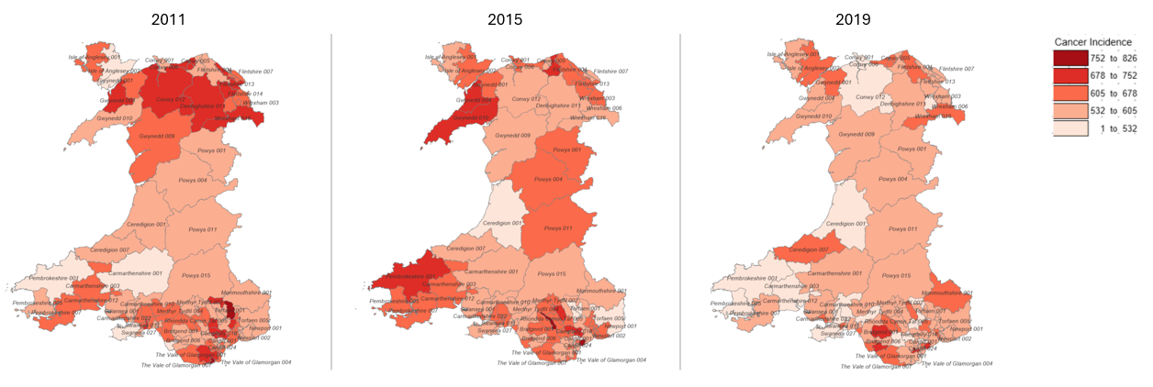
© Crown Copyright Upper Super Output Area Boundary
Observations find that in 2011 high-incidence areas were concentrated in North Wales (Gwynedd , Denbighshire, Wrexham and Conwy) and South Wales (Cardiff, Rhondda Cynon Taf, Bridgend, Neath Port Talbot), with several areas recording 705–826 cases per 100,000 people. By 2015, some reductions were observed, particularly in South Wales, though Pembrokeshire U001 saw an increase from 1 to 532 cases to 678 to 752 cases per 100,000 people. Finally by 2019, incidence declined further, with North Wales and South Wales showing reduced rates, while some Mid and West Wales regions remained above average.
The 2013 cancer incidence spike presented an opportunity to investigate the key factors that influenced cancer rates in Wales. Unlike other years, 2013 stood out as an anomaly, suggesting that external factors may have temporarily driven cancer rates higher. By focusing on 2013, it was possible to examine several influences such as environmental hazards (e.g., air pollution, industrial exposure), general health and lifestyle shifts (e.g., smoking, obesity, alcohol consumption), and deprivation in Wales.

2.2 Townsend Index
In 1987, sociologist Peter Townsend established the Townsend Deprivation Index, which measures material deprivation within a society [1]. It combines four census indicators to evaluate deprivation levels:
- Households without a car
- Overcrowded households
- Households not owner-occupied
- Persons unemployed
A study by K. Mason, N. Pearce, and S. Cummins found that living in more deprived neighbourhoods is associated with a higher risk of cancer-related hospital admissions [2]. The thematic map below illustrates cancer incidence in Wales in 2013, categorised by USOA. The Townsend Index values from the 2011 census were overlaid with cancer incidence rates to identify spatial correlations. Townsend Index scores above 0 are represented by blue human-shaped symbols. The bigger the symbol, the greater the deprivation.
Figure 3: Cancer Incidence in Wales 2013 Comparison to High Townsend Index Scores
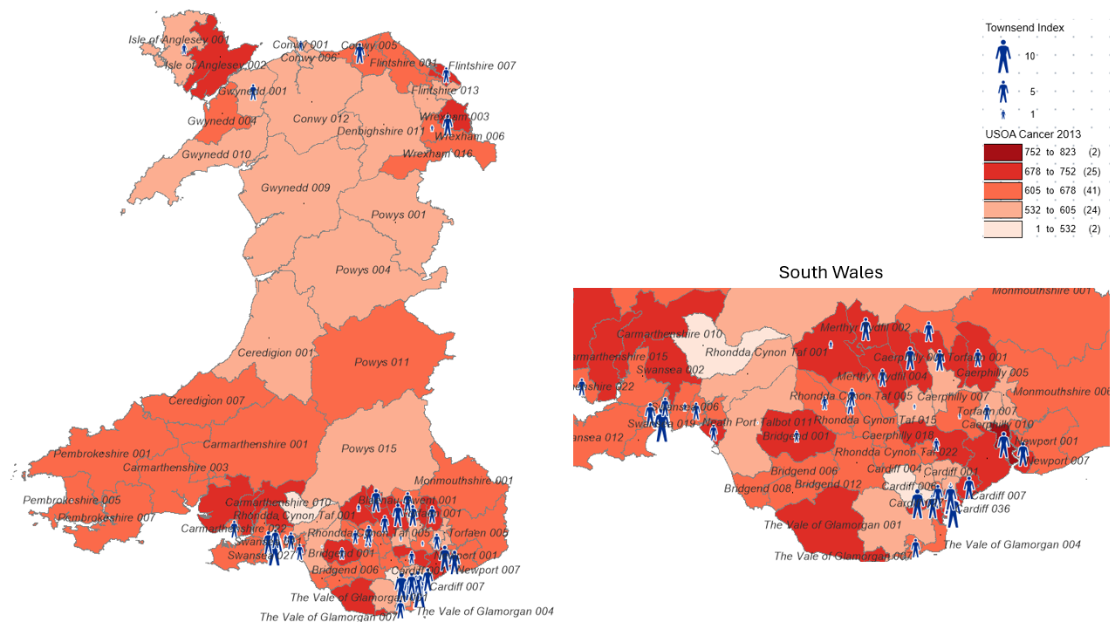
© Crown Copyright Upper Super Output Area Boundary
Areas with a higher density of Townsend Index markers tend to align with higher cancer incidence rates, particularly in South Wales. Rhondda Cynon Taf, Cardiff, Swansea, and Bridgend, shows a strong overlap between high deprivation and high cancer rates. North Wales also presents a similar pattern, with Flintshire, Wrexham, and Gwynedd displaying both high Townsend Index values and elevated cancer rates.
Figure 4 shows a comparison of deprivation levels across different years that suggests the link between high Townsend Index scores and cancer incidence is not unique to 2013. Similar spatial patterns were observed in 2011 and 2015. They remain high in North and South Wales indicating a persistent trend in cancer risk in deprived areas. To support this, affluent areas of cancer incidence show low (below 0) Townsend Index scores.
Figure 4: Cancer Incidence in Wales 2011 to 2015 v Townsend Index
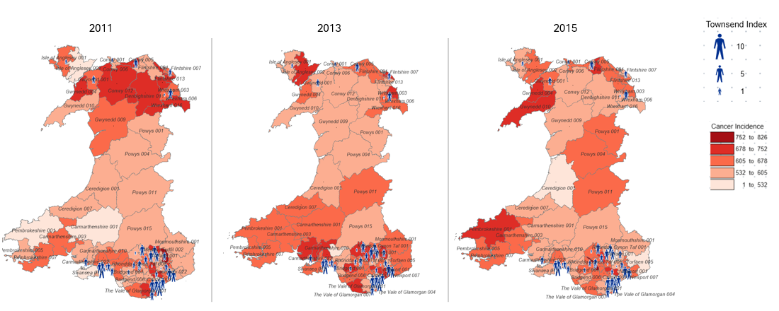
© Crown Copyright Upper Super Output Area Boundary
N.B. 2019 cancer data was not used with 2011 Townsend Index data as it could introduce misleading conclusions due to significant changes in socioeconomic conditions within the period.
Figure 4 also revealed several outliers, where cancer incidence does not fully align with deprivation levels. These outliers suggest that additional factors beyond socioeconomic deprivation contribute to cancer incidence. For example, in 2015 Pembrokeshire 001 has a high cancer incidence rate (683.2 per 100k population) yet its Townsend Index is fairly low (-4.19). Further research is needed to identify further causes.

2.3 Adult Lifestyles
Socioeconomic factors significantly influence lifestyle choices, and unhealthy behaviours are strongly associated with deprivation.
The assumption is that obesity, physical inactivity, smoking, and alcohol consumption play a major role in increasing cancer incidence, with deprived populations often experiencing higher exposure to these risk factors.
This section looks at the factors mentioned above with lifestyle data obtained from StatsWales [3]. The Townsend Index is overlaid to compare against deprivation.
According to Cancer Research UK, smoking is the biggest cause of lung cancer and accounts for six out of every ten cases [4]. Figure 5 compares cancer incidence in Wales 2013 against smoking data.
Figure 5: Cancer Incidence in Wales 2013 v Smoking Data
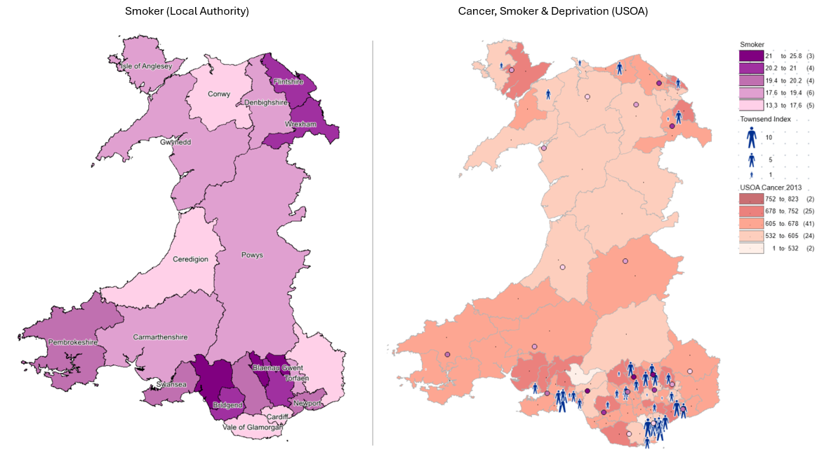
© Crown Copyright Upper Super Output Area and Local Authority Boundary
There is a clear and strong correlation between high smoking rates and elevated cancer incidence, particularly in deprived areas. The strongest correlation is seen in South Wales, specifically in Rhondda Cynon Taf, Blaenau Gwent, Merthyr Tydfil, and Caerphilly where there is a history of economic deprivation, industrial decline, and high smoking prevalence. However, the thematic map shows outliers such as Pembrokeshire do not follow this trend. The smoking rate in Pembrokeshire is in the 19.4 to 20.2 range yet it has an above average cancer incidence rate and low Townsend Index score suggesting other factors are contributing to cancer incidence rates.
Alcohol consumption is associated with liver, bowel, breast, and oesophageal cancer. Figure 6 shows the average annual alcohol consumption against cancer incidence.
Figure 6: Cancer Incidence in Wales 2013 v Average Annual Alcohol Consumption
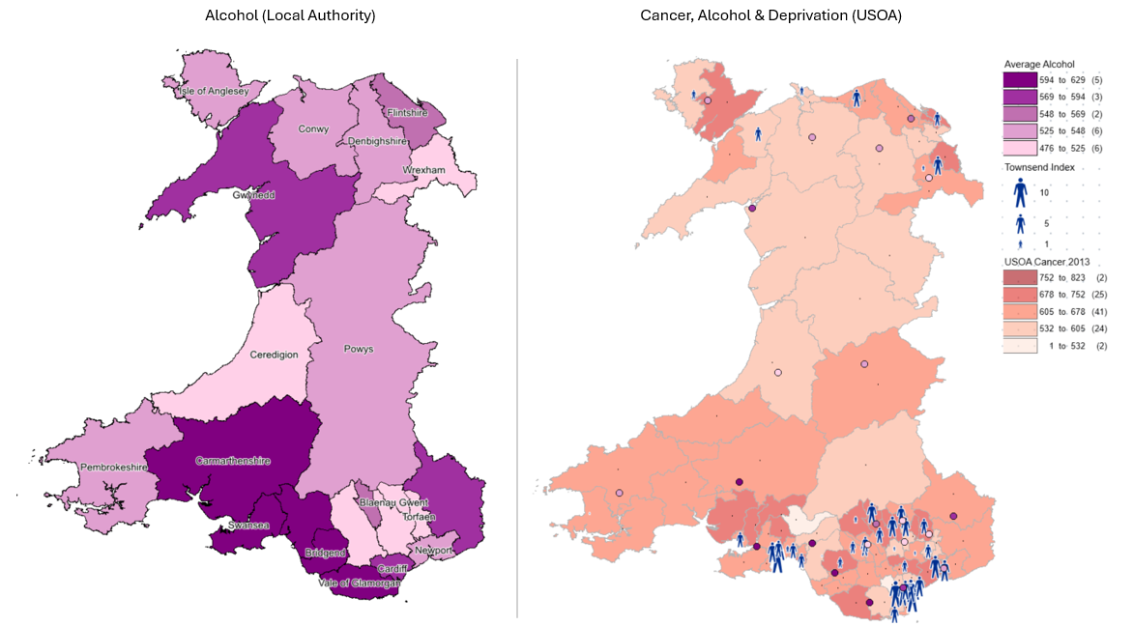
© Crown Copyright Upper Super Output Area and Local Authority Boundary
The average annual alcohol consumption varies across Wales, with some regions consuming significantly more than others. Neath Port Talbot (628.91 units), Bridgend (603.02 units), and Carmarthenshire (597.85 units) have some of the highest alcohol consumption rates (dark purple area/spots).
There is a moderate correlation between high alcohol consumption and elevated cancer incidence. The strongest correlation is again observed in South Wales. However, outliers exist where this trend does not hold. Cardiff and the Vale of Glamorgan have above-average alcohol consumption but do not exhibit the highest cancer incidence rates. In contrast, Isle of Anglesey and parts of North Wales show moderate alcohol consumption but higher cancer rates, which advocates that alcohol consumption is one of several contributing factors to cancer incidence but does not fully account for regional differences.
Figure 7: Cancer Incidence in Wales 2013 v Over 30 BMI (Obese)
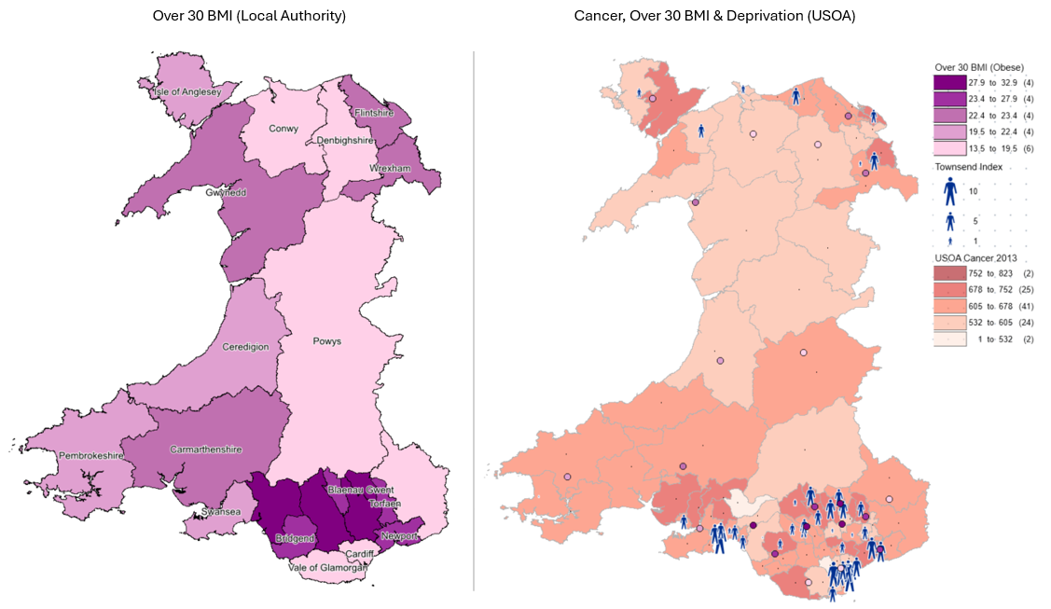
© Crown Copyright Upper Super Output Area and Local Authority Boundary
Obesity is a well-established cancer risk factor, particularly for colorectal, breast, and endometrial cancers.
Figure 7 shows a comparison of cancer incidence and a population with a BMI of 30 or more. It displays a very strong correlation in deprived areas, where obesity is worsened by economic hardship, with limited access to healthy food, alcohol consumption and lack of physical activity. In support, Cardiff, Conway and Denbighshire display low obesity levels (13.5 to 19.5) have a low cancer incidence rate (below 605 per 100k population) and low Townsend Index score (below 0).
Figure 8 compares cancer incidence against a population that do less than 30 minutes physical activity per week.
Figure 8: Cancer Incidence in Wales 2013 v Less than 30 mins Physical Activity per Week
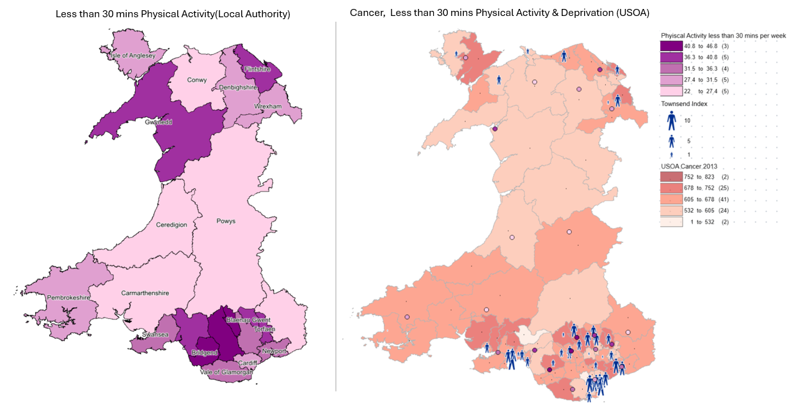
© Crown Copyright Upper Super Output Area and Local Authority Boundary
The is a strong correlation between physical inactivity, deprivation and cancer incidence in South Wales. The highest inactivity rates (40.8 to 46.8) being in Bridgend, Rhondda Cynon Taf and Merthyr Tydfil who also display high cancer incidence and score high on the Townsend Index. However Pembrokeshire, Carmarthenshire and parts of North Wales (Ise of Anglesey and Wrexham) have low physical inactivity but moderate cancer incidence rates.
Gwynedd appears to be an anomaly, showing high levels of physical inactivity yet relatively low cancer incidence. This suggests that in this region, other protective factors such as lower deprivation, healthier environments, or reduced exposure to other risk factors may mitigate the impact of inactivity on cancer outcomes.
The thematic maps of individual lifestyle factors may show different trends, making it difficult to determine which areas face the greatest overall risk. A Lifestyle Risk Index (LRI) calculation was created from the data to allow for a more accurate analysis of cancer incidence from adult lifestyles.
The calculation summed the following fields to provide an overall index score.
- E-cigarette user
- Smoker
- Average weekly alcohol consumption - above 14 units (over guidelines)
- Average weekly alcohol consumption - harmful (over 50 (m) / 35 (f) units)
- Average weekly alcohol consumption - hazardous (over 14 units, up to 50 (m) / 35 (f))
- Active less than 30 minutes in previous week
- BMI 30+ (obese)
- BMI under 18.5 (underweight)
- Fewer than 2 healthy behaviours
Figure 9 compares the Lifestyle Risk Index and cancer incidence in Wales.
Figure 9: Cancer Incidence in Wales 2013 v Lifestyle Risk Index
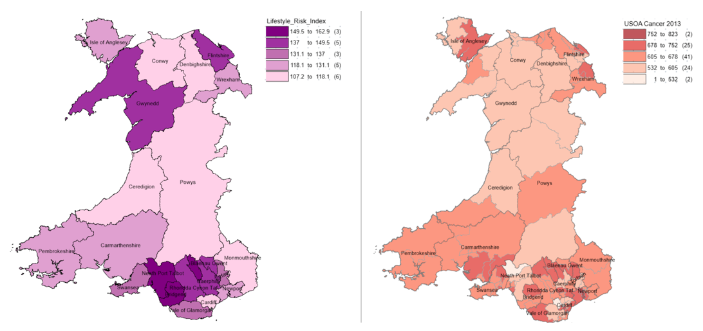
© Crown Copyright Upper Super Output Area and Local Authority Boundary
Observations show a strong correlation between high LRI scores (dark purple on the left map) and high cancer incidence (dark red on the right map) in the South Wales area. These are also areas with high deprivation which reinforces the link between socioeconomic status and poor health outcomes.
Some areas deviate from the expected correlation between LRI and cancer incidence. Gwynedd is a prime example. It has an LRI index of between 137 to 149.5 yet has predominantly low cancer incidence. Possible explanations include cleaner air and fewer industrial pollutants, it being a rural area with deprivation being relatively low.
In summary, the assumption is largely correct as lifestyle factors are significantly higher in deprived populations. However, they do not act alone. Other factors need to be considered to develop more targeted public health interventions in high-risk regions.

2.4 Age Demographics
Since cancer risk increases significantly with age, mapping average age data allows for the identification of regions with older populations that may be more vulnerable. Integrating this data helps to highlight potential hotspots for cancer and supports more targeted public health planning and resource allocation.
Figure 10: Age Demographics and Cancer Incidence in Wales 2013
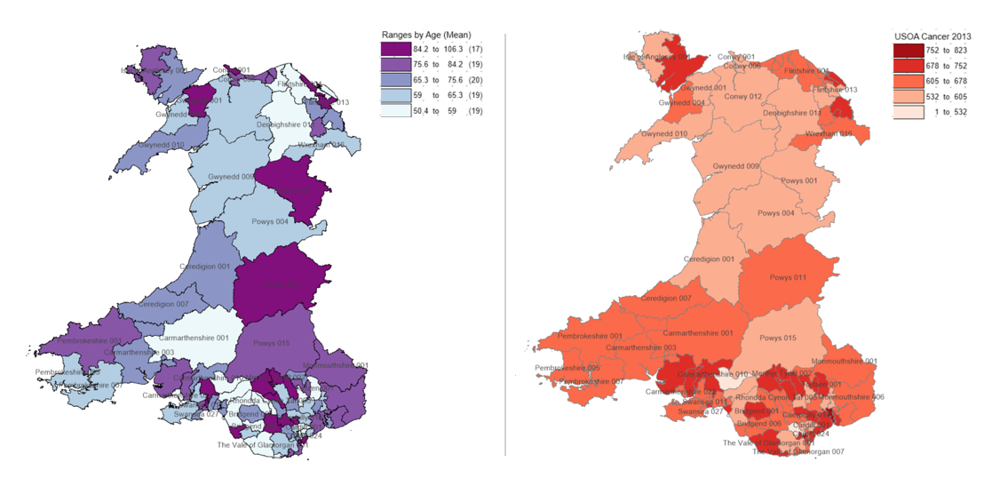
© Crown Copyright Upper Super Output Area Boundary
Figure 10 presents a comparative view of average age distribution (left) and cancer incidence (right) across Wales. The age distribution map shows that the highest average age groups are predominantly located in rural and central-western regions of Wales, including Powys, Ceredigion, Monmouthshire, and Pembrokeshire. In contrast, younger populations are more concentrated in urban and industrial areas such as Cardiff, Swansea, Rhondda Cynon Taf, and Wrexham.
Areas like Pembrokeshire and Monmouthshire show both high average age and elevated cancer incidence, supporting the known link between age and increased cancer.
However there are inconsistencies as Powys 001 and 015 have among the oldest average populations but relatively low cancer incidence. This suggests other factors (e.g. healthier lifestyles, better air quality, lower deprivation) may reduce cancer risk despite age.
In contrast, South Wales have high cancer incidence despite not having the oldest populations. This suggests deprivation, smoking, pollution, and lifestyle factors likely play a more significant role than age alone in these areas.
While age is a contributing factor to cancer risk, the maps indicate that age alone does not fully explain the spatial variation in cancer incidence across Wales.

2.5 Healthcare Access & GP Surgery Distance
Limited access to healthcare can lead to delays in diagnosis, reduced uptake of screening programmes, and later-stage detection of cancer. By mapping travel distances to GP surgeries, the analysis aimed to identify whether rural or remote areas with longer travel times correlate with higher cancer incidence.
Figure 11: Average Distance (km) to GP Surgeries in Wales (USOA)
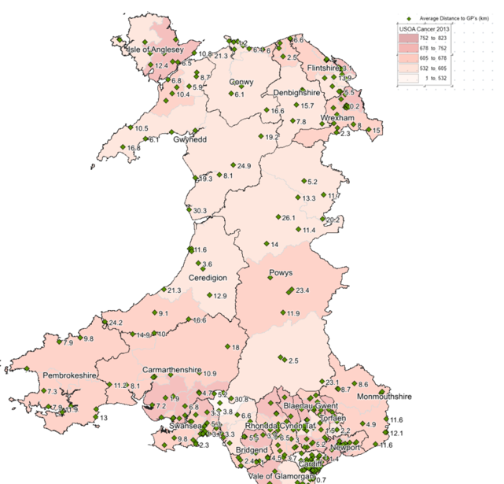
© Crown Copyright Upper Super Output Area Boundary
Key observations find that rural areas, especially in Mid Wales show the longest average distances to GP surgeries (e.g. 30.3km, 26.1km, and 24.9km). Urban and densely populated areas have shorter distances, reflecting denser healthcare infrastructure. However, there is no direct correlation with cancer incidence and distance to GP Surgeries. Areas with longer distances to GPs like Gwynedd, Powys and Ceredigion have lower cancer incidence whilst urban areas have shorter distances but higher cancer rates. This implies that other factors, such as lifestyle behaviours, environmental exposure, deprivation, and healthcare engagement, may play a more significant role in influencing cancer than accessibility to health care services.

2.6 Lung Cancer: Air Pollution, Smoking and Motorway Emissions
According to statistics from Cancer Research UK, lung cancer is the third most common cancer in the United Kingdom, with approximately 48,500 new cases diagnosed annually. It is also the leading cause of cancer-related mortality, accounting for 21% of all cancer deaths in the UK, of which 72% is caused by smoking, 13% by occupation and 8% air pollution [5].
A study by J.Yoo et al [6] highlights a significant link between air pollution, specifically particulate matter (PM), and lung cancer, especially in populations that have never smoked.
PM2.5 and PM10 are the main contributors.
Figure 12: Air Pollution (PM2.5 and PM10) v Lung Cancer Incidence in Wales 2013
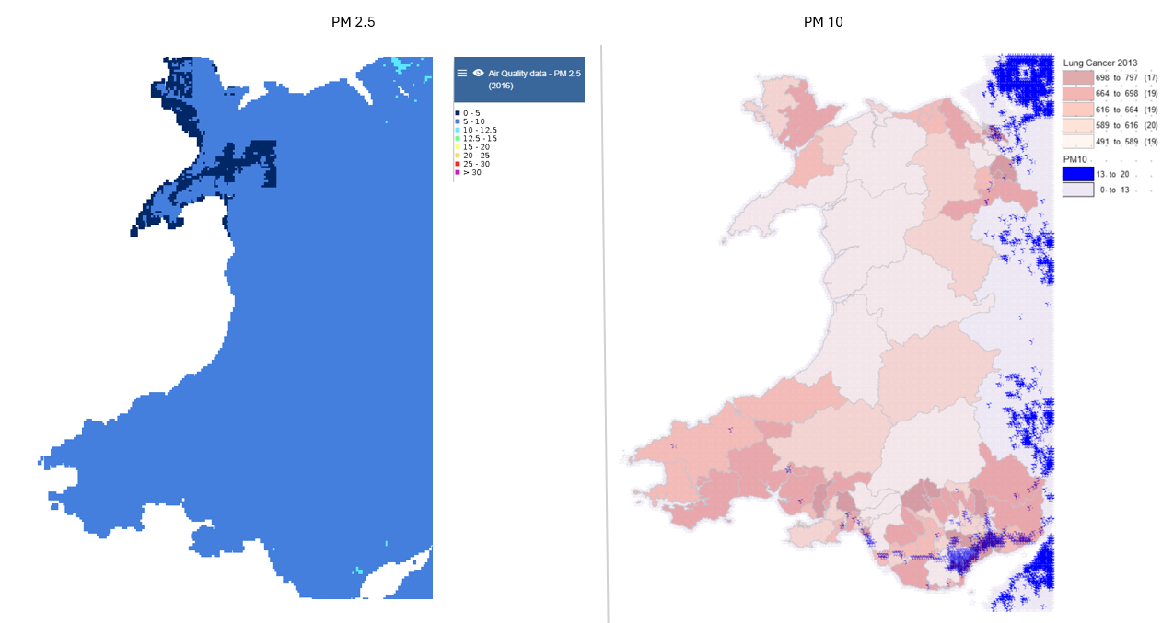
© Crown Copyright Upper Super Output Area Boundary
The highest PM2.5 (light blue) and PM10 levels (dark blue) are concentrated in South East Wales, particularly around Cardiff, Newport, and urbanised and industrial regions. These areas also show higher lung cancer incidence rates, suggesting a potential correlation between air pollution and lung cancer prevalence. Mid Wales has low PM2.5 and PM10 levels which correspond with low lung cancer incidence rates and supports the expectation that rural areas with better air quality have lower lung cancer cases.
PM10 is heavily linked to industrial areas. Figure 13 delves into the South Wales Industrial Corridor with added smoking data.
Figure 13: PM10 and Lung Cancer in the South Wales Industrial Corridor
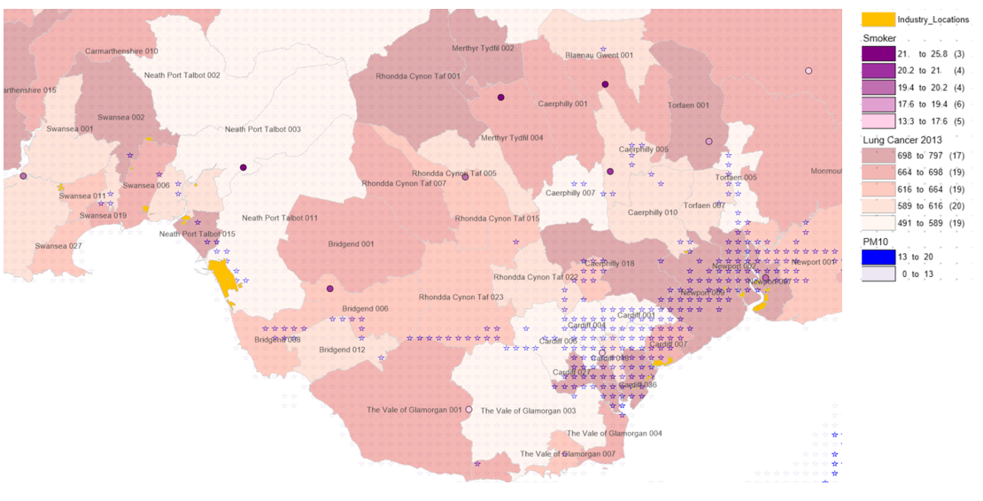
© Crown Copyright Upper Super Output Area Boundary
The highest concentration of PM10 levels are observed around Port Talbot (Tata Steelworks), Newport and Cardiff. The PM10 levels overlap strongly with high lung cancer incidence rates (particularly in Newport) suggesting a positive correlation. The added smoking data shows that these areas have high smoking rates which are an additional contributing factor to lung cancer.
Figure 14: PM10, Lung Cancer, Motorway Proximity in the South Wales Industrial Corridor
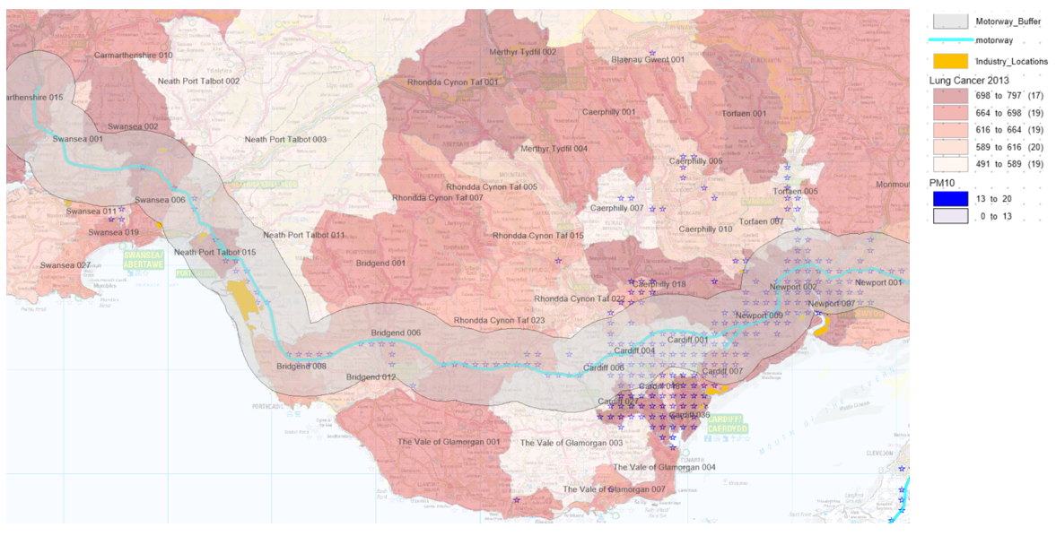
© Crown Copyright Upper Super Output Area Boundary
The inclusion of motorway data (Figure 14) offers further information about the environmental context of lung cancer incidence in South Wales. Major transport corridors, notably the M4, pass through high-incidence locations like Cardiff, Newport and Port Talbot. The motorway buffer zone (2 km) enabled the identification of areas living in close proximity to these routes, where long-term exposure to traffic-related air pollution may be higher.
The combination of excessive PM10 levels, a high prevalence of lung cancer, and proximity to a motorway reinforces the belief that air quality has a substantial impact on respiratory health. This is especially visible in Newport and Cardiff, where industrial activity, traffic density, and urbanisation meet.
Cardiff, surprisingly, presents an unique case. While smoking rates are relatively low (13.3-17.6), PM2.5 and PM10 concentrations are high (13-20) along with lung cancer incidence. This implies that, in some regions, air pollution (both from industrial sources and from road emissions) may be a more significant contributor in lung cancer risk than smoking alone and this aligns with the study conducted by J.Yoo et al [6].
In contrast, areas further from the motorway and industrial zones, such as rural Mid Wales, had lower PM2.5 and PM10 concentrations and lower lung cancer incidence rates, confirming the theory that cleaner air contributes to lower respiratory disease.

3.Conclusion
This geodemographic analysis has demonstrated the value of GIS in identifying spatial patterns of cancer incidence across Wales. Through the combination of multiple datasets the GIS helped a broad exploration of cancer incidence, revealing that it’s strongly influenced by the joining of socioeconomic, behavioural, and environmental factors.
The spatial distribution of cancer incidence consistently showed higher rates in South Wales. These areas are characterised by high deprivation scores, poor health behaviours, and elevated levels of air pollution. In contrast, rural areas like Powys, Ceredigion, and Gwynedd, despite having older populations and longer average travel distances to GP surgeries, tended to show lower cancer rates, suggesting that deprivation and lifestyle factors may be more significant drivers of cancer than age or geographic accessibility alone.
The analysis also highlighted strong correlations between individual lifestyle risk factors and cancer incidence. Smoking showed the clearest spatial relationship with elevated cancer rates, followed by obesity and low physical activity levels. The creation of a Lifestyle Risk Index (LRI) allowed for a more comprehensive assessment by aggregating multiple behavioural factors. High LRI scores aligned closely with areas of high cancer incidence, reinforcing the understanding that lifestyle is a critical component of cancer prevalence, particularly in deprived communities where exposure to multiple risk factors is common.
Environmental exposure also played a key role in cancer incidence, especially in relation to lung cancer. The inclusion of PM2.5 and PM10 pollution data revealed strong correlations between poor air quality and lung cancer prevalence in industrialised and urban areas, such as Port Talbot, Cardiff, and Newport. The analysis of motorway proximity further supported the link between traffic-related air pollution and respiratory health outcomes. Interestingly, Cardiff emerged as a notable case where lung cancer rates were high despite lower smoking prevalence, indicating that environmental exposure may outweigh lifestyle risks in certain areas.
Despite comprehensive insights, the analysis was limited by the availability and age of data. Deprivation (Townsend Index) and Age was measured using the 2011 Census, which may not accurately reflect current socioeconomic conditions, especially in areas that have undergone significant change. Similarly, most cancer and lifestyle datasets used were outdated (2016), limiting the ability to assess recent trends or the effectiveness of more recent public health interventions.
Future improvements would benefit from access to updated cancer incidence data, 2021 Census deprivation metrics, and more granular datasets at the MSOA or even LSOA level. Additional data on screening uptake, cancer diagnosis, and ethnic or occupational demographics would allow for more precise targeting of interventions. In conclusion, this report demonstrates that effective cancer prevention strategies must be spatially targeted, addressing deprivation, lifestyle, and environmental exposure collectively. These insights can support public health policies focused on reducing cancer incidence across Wales. Recommendations include targeted schemes such as smoking programmes in high-risk areas, obesity and alcohol reduction initiatives, improved access to early cancer screening, and environmental health strategies to mitigate air pollution in urban and industrial zones.

4.Appendix

Task 1 (Part B)
This section outlines the technical process undertaken to build the GIS for analysing cancer incidence across Wales. Using MapInfo Pro 2023, multiple datasets were sourced, cleaned, transformed, and spatially integrated to support thematic mapping and spatial analysis. Key datasets included cancer incidence rates, deprivation scores (Townsend Index), adult lifestyle indicators, air pollution measures, healthcare access points, and demographic data.
A structured file management system was created in Windows to organise and store all project data sources. Separate folders were used to categorise cancer risk factors for efficient navigation when linking data to MapInfo Pro 2023.
A document log was created using Microsoft Excel to track datasets, sources, links, file formats, attributes, year of dataset and their purpose. Additional fields such as processing notes, limitations and linking fields were added as the project progressed. This log served as a central reference point throughout the project, improving transparency and project management.
The figure below shows the document log.
Figure 15: GIS Documentation Log
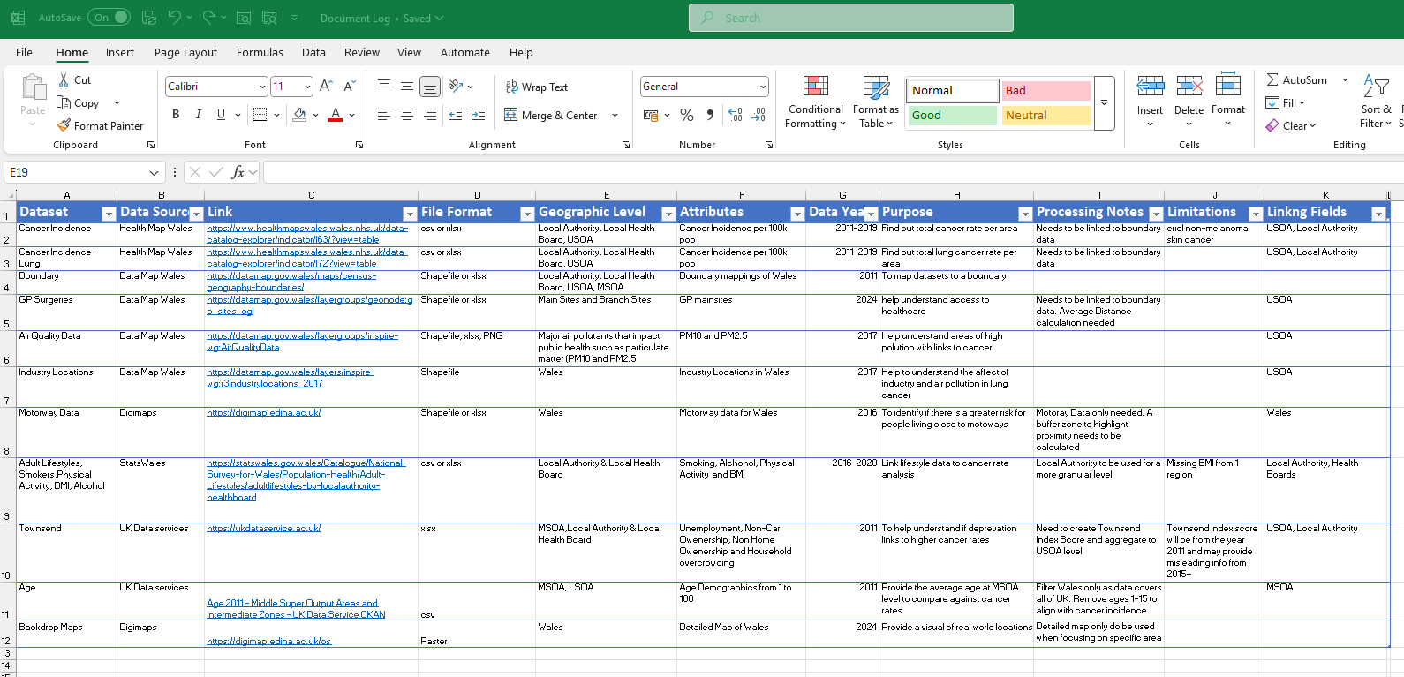

GIS Build

Boundary Data
Boundary data is a fundamental component of a Geographic Information System (GIS) as it provides the spatial framework required to analyse and interpret data within a specified area.
Boundaries:
- Upper Super Output Area (USOA) – an amalgamation from the Middle Super Output Areas
- Local Authority (LA)
File Types: Shapefiles
Data Source: Data Map Wales [7]
The shapefiles were imported into MapInfo Pro 2023 and configured to show labels and boundary data effectively.
Figure 16: USOA Boundary Configuration and Setup
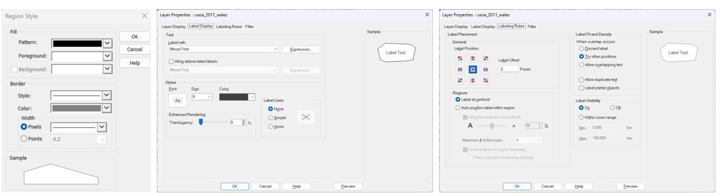
Figure 16 shows the configured boundary data for USOA and LA.
Figure 17: USOA and LA Boundary Data
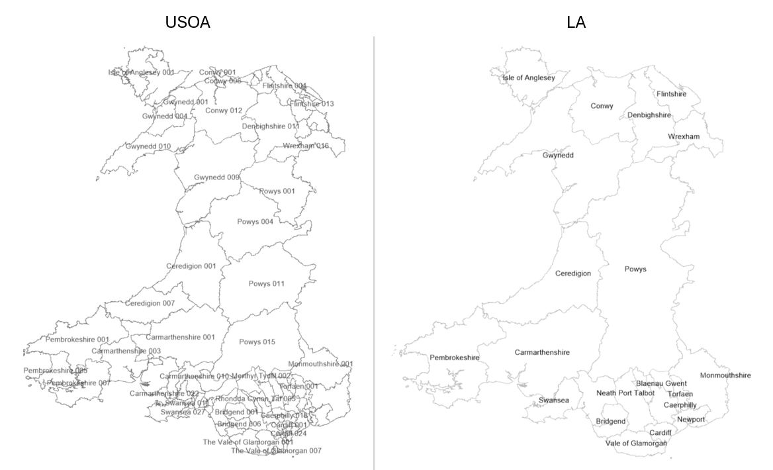

Cancer Incidence
Cancer incidence data provided the key metrics for understanding the spatial distribution of cancer across Wales.
Cancer Data:
- All cancers, excluding non-melanoma skin cancer) per 100k population (2011-2019)
- Lung cancers per 100k population (2011-2019)

File Types: CSV
Data Source: Health Map Wales [8]
Data Cleansing and Transformation:
‘All cancers’ data couldn’t be linked back to the USOA boundary data so a file obtained through Health Map Wales helped to link the data together via the INDEX MATCH function in Excel.
Figure 18: Boundary Data Reference File
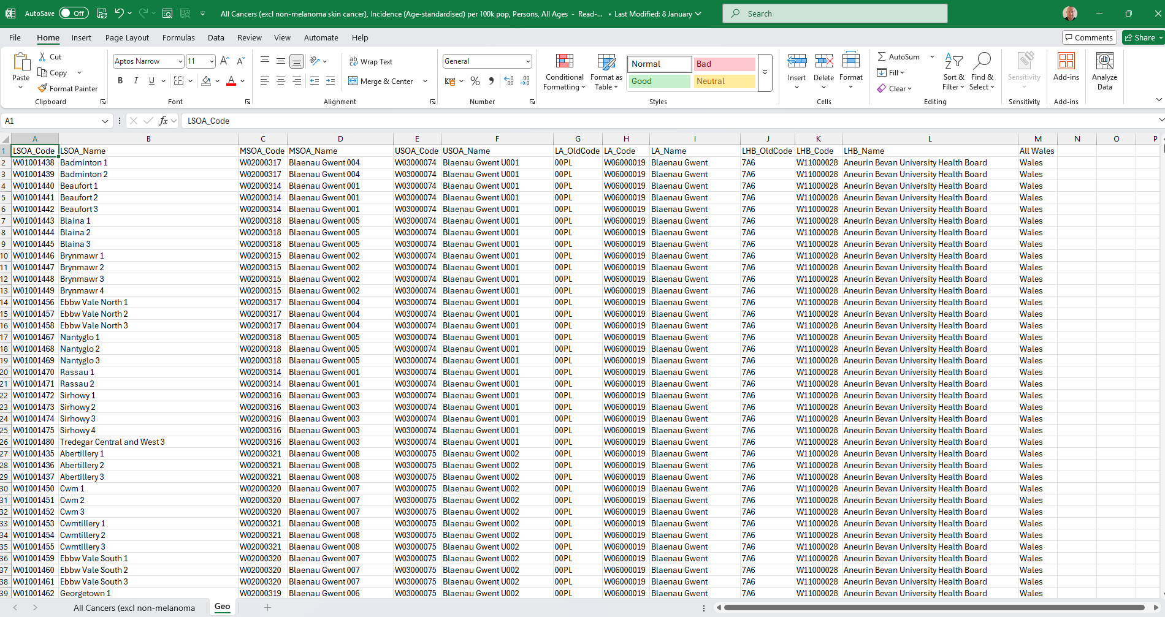
The function retrieved the USOA code from the ‘GEO’ reference sheet via the USOA Name.
Figure 19: Index Match Function to Generate USOA Code
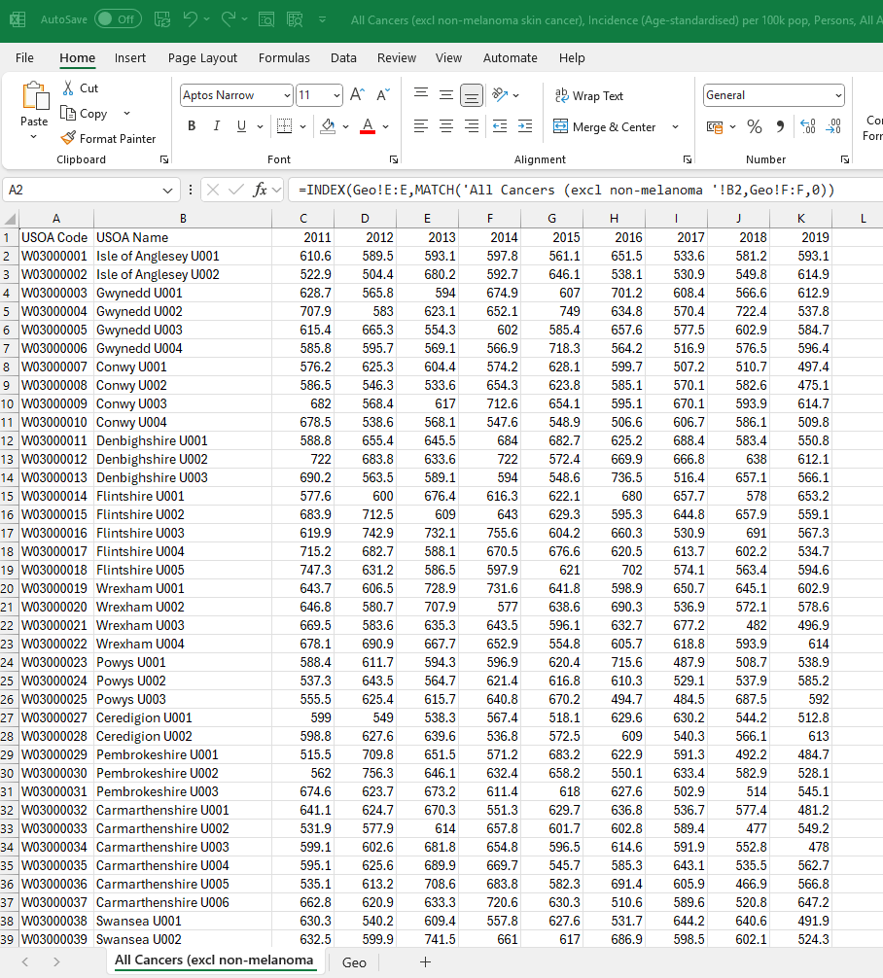
The files were then converted to Excel.xls 97-2003 and uploaded to MapInfo Pro 2023 where they were geocoded so that the data can be mapped and analysed spatially.
Figure 20: Geocoding All Cancer Wales data to USOA Boundaries
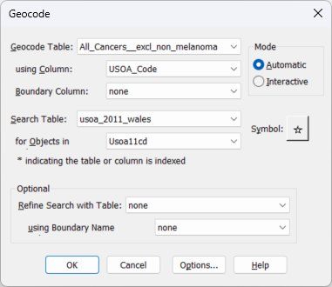
Visualisation:
Thematic maps were then created to show cancer incidence historically and to identify relationships and correlations when overlaid with other datasets. The figure below demonstrates the creation of a thematic map using all cancer data within the USOA boundaries.
Figure 21: Creation of a Thematic Map of Cancer Incidence in Wales
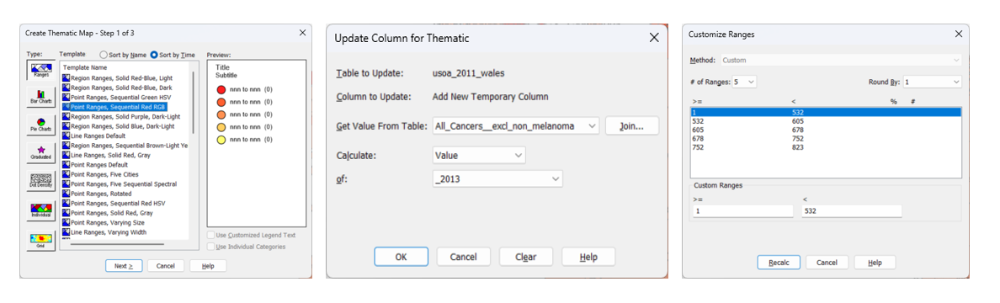
The legend key was created by analysing the minimum and maximum values of cancer incidence within the dataset. It was then divided into five equal range intervals to ensure consistency across different years, allowing for clearer and more accurate comparisons over time.
Figure 22: GIS Workspace - Thematic Map of Cancer Incidence in Wales 2013
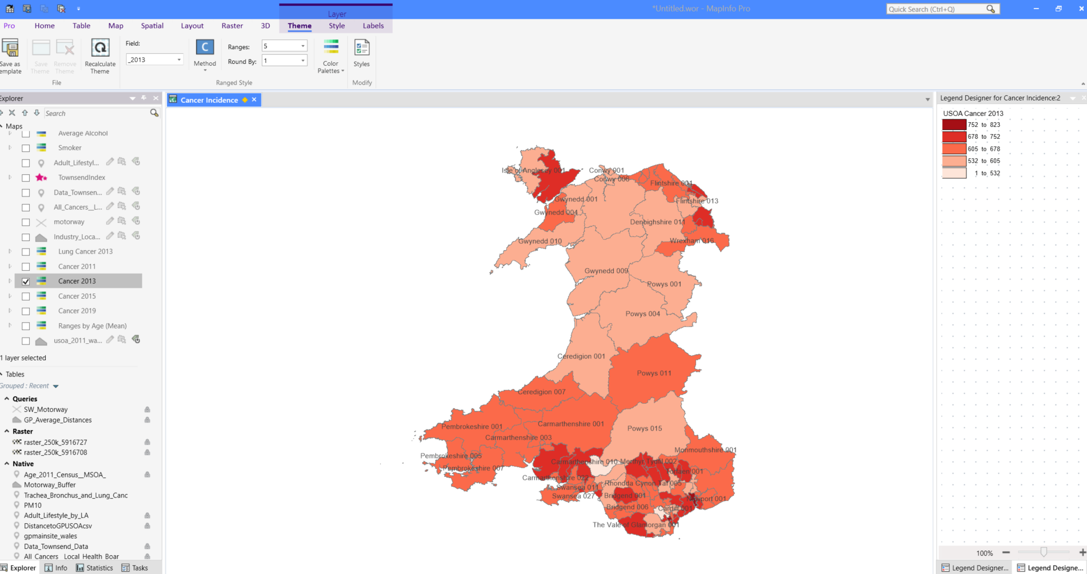

Townsend Index
The Townsend Index, a measure of material deprivation, was used to assess levels of socioeconomic disadvantage across Wales. This index was overlaid with cancer incidence data to explore potential correlations between deprivation and cancer rates, helping to identify whether more deprived areas experienced higher levels of cancer incidence.
Townsend Data: Wales Census 2011
File Types: Excel.xlsx
Data Source: UK Data Service [9]
Data Cleansing and Transformation:
The 2011 census data was only available at MSOA level and below, so the boundary reference file from Health Map Wales was utilised again to aggregate data to the USOA level.
The Townsend Index had to be created within the dataset. The index was built using four census variables.
- Households without a car
- Overcrowded households
- Households not owner-occupied
- Persons unemployed
The unemployment and overcrowding percentages (+1) were transformed using a logarithmic function to normalise the raw data, which are typically very skewed. All four variables are then standardised with a Z-score (subtract the mean and divide by the standard deviation). These four standardised scores are then added together to provide a single result, the Townsend deprivation index.
Figure 23: Creation of the Townsend Index Data
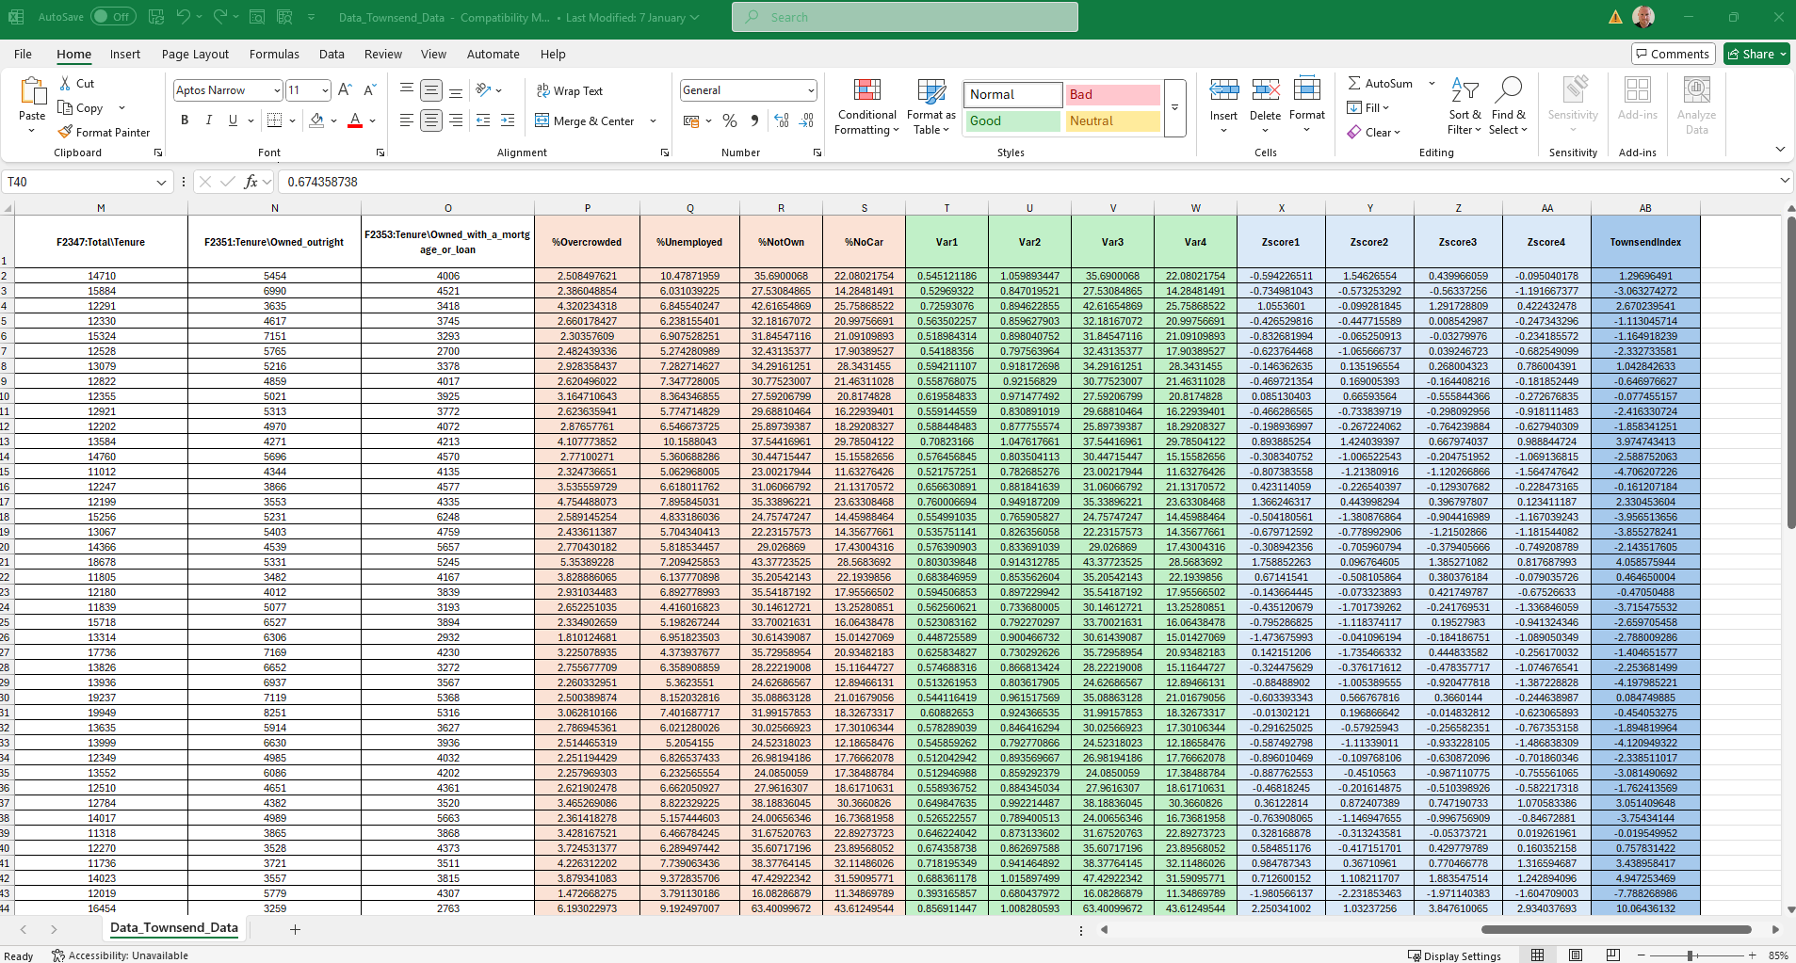
The file was converted to CSV and then uploaded to MapInfo 2023 and geocoded to the USOA boundary.
Visualisation:
A graduated thematic map with symbols of varying sizes was used to represent specific locations with high Townsend Index scores.
Figure 24: Creation of a Graduated Thematic Map for the Townsend Index
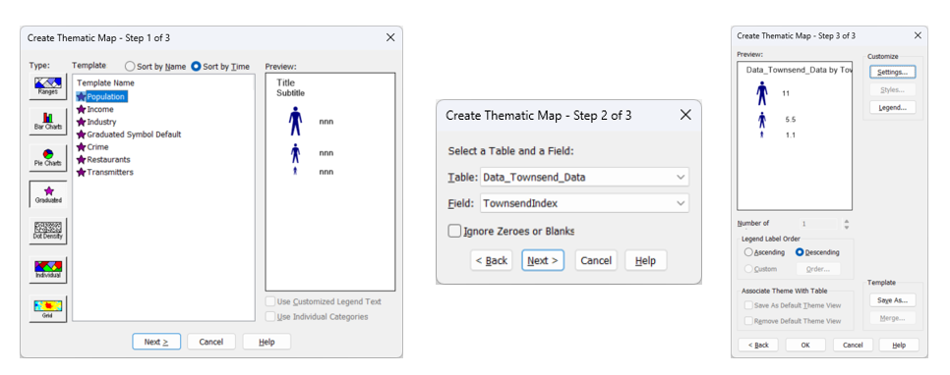
The figure below displays the Townsend Index layer, which served as a base for overlaying additional datasets
Figure 25: GIS Workspace - Townsend Index
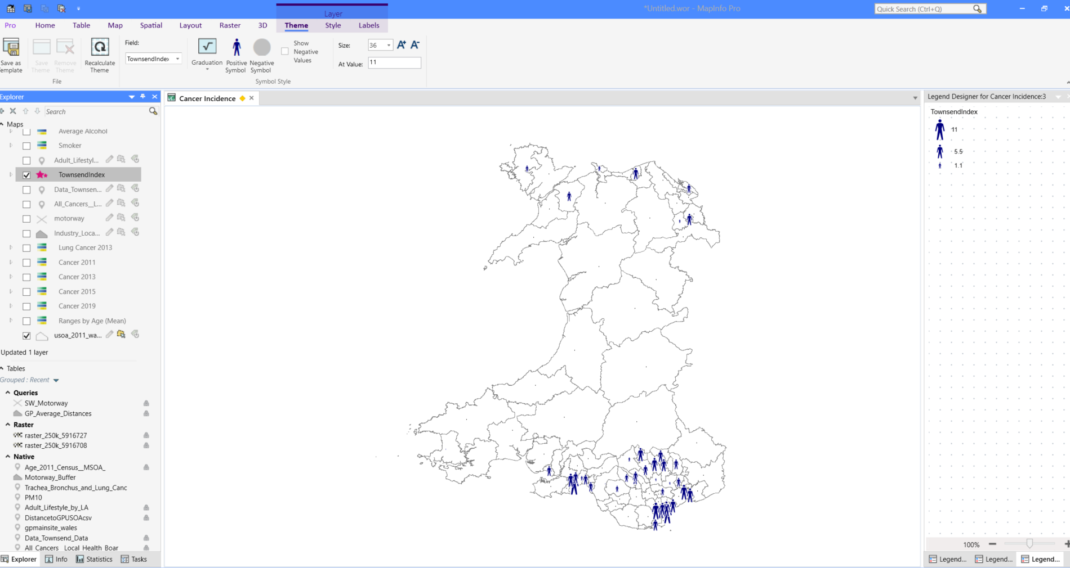

Adult Lifestyles
Adult lifestyle data was added to the GIS to explore how behavioural factors such as smoking, alcohol consumption, physical inactivity, and obesity contribute to cancer incidence across Wales.
Data: Adult lifestyles by local authority and health board, 2016-17 to 2019-20
File Types: CSV
Data Source: StatsWales [3]
Data Cleansing and Transformation:
The Local Health Board stats were removed and Local Authority data kept for its lower granularity. Having analysed the data it became clear that several adult lifestyle factors can contribute to cancer incidence so a Lifestyle Risk Index (LRI) calculation was added to the dataset to allow for a more accurate analysis.
The calculation summed the following fields to provide an overall index score.
- E-cigarette user
- Smoker
- Average weekly alcohol consumption - above 14 units (over guidelines)
- Average weekly alcohol consumption - harmful (over 50 (m) / 35 (f) units)
- Average weekly alcohol consumption - hazardous (over 14 units, up to 50 (m) / 35 (f))
- Active less than 30 minutes in previous week
- BMI 30+ (obese)
- BMI under 18.5 (underweight)
- Fewer than 2 healthy behaviours
Figure 26: Adult Lifestyle Data and Creation of Lifestyle Risk Index (LRI)
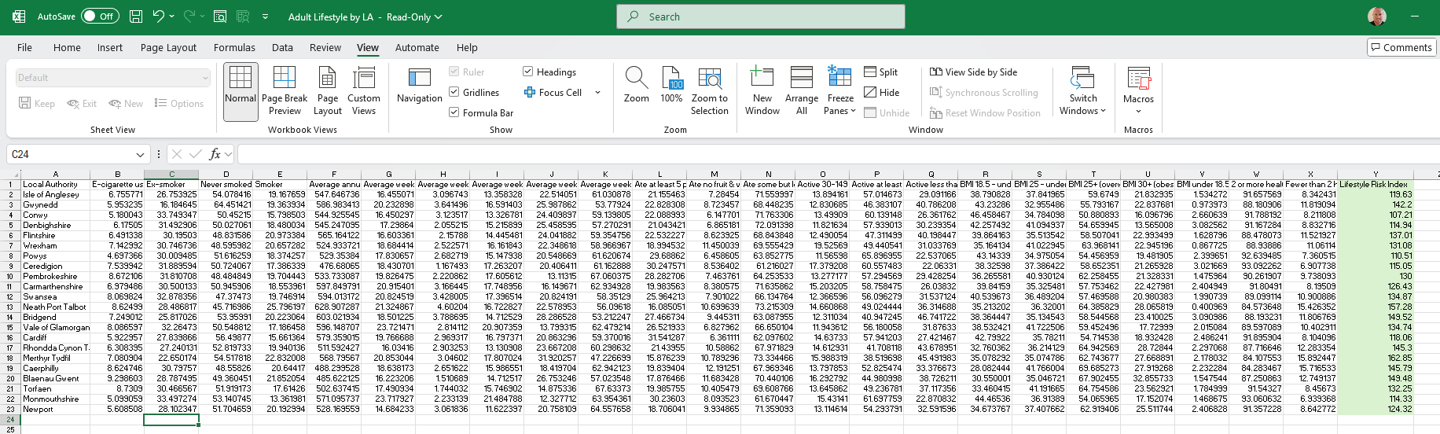
The file was uploaded to MapInfo 2023 as a table and geocoded to the LA boundary.
Visualisation:
Thematic maps were generated using Local Authority boundary data to visualise indicators such as smoking prevalence, alcohol consumption, BMI over 30, physical activity of less than 30 minutes, and the Lifestyle Risk Index (LRI) score. An example is presented below.
Figure 27: Creation of a Thematic Map of Smokers in Wales
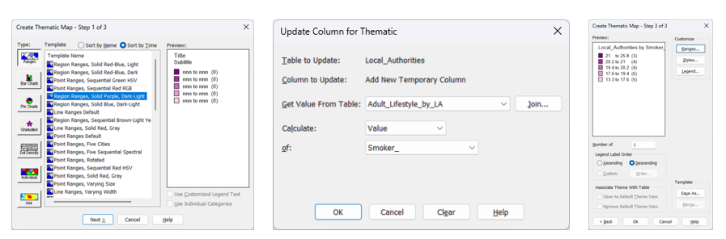
Figure 28: GIS Workspace - Thematic Map of Smoker Data
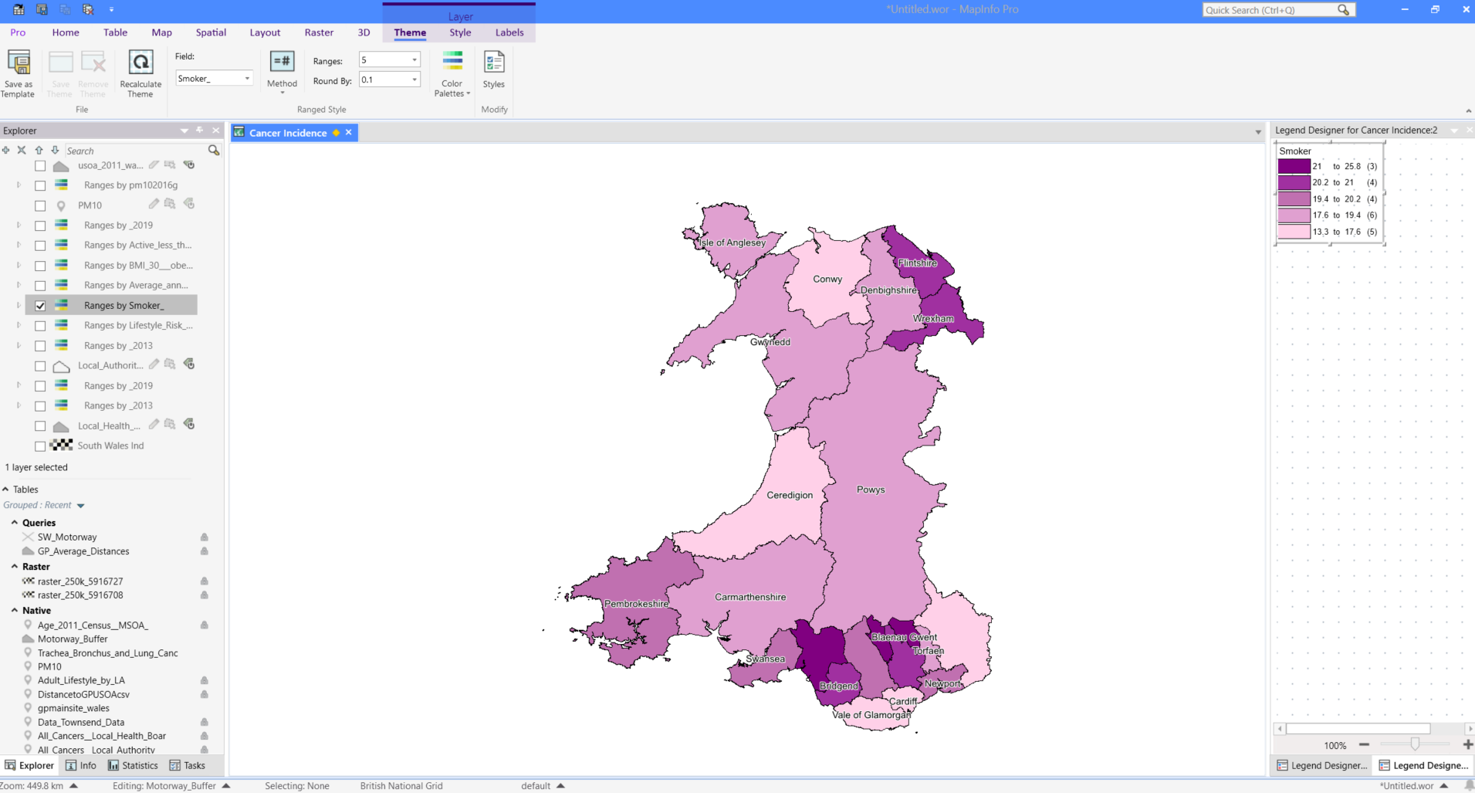
Additional thematic maps were created using the same factors, this time represented as point data to help easier overlay and integration with other spatial layers.
Figure 29: GIS Workspace - Thematic Points of Smoker Data
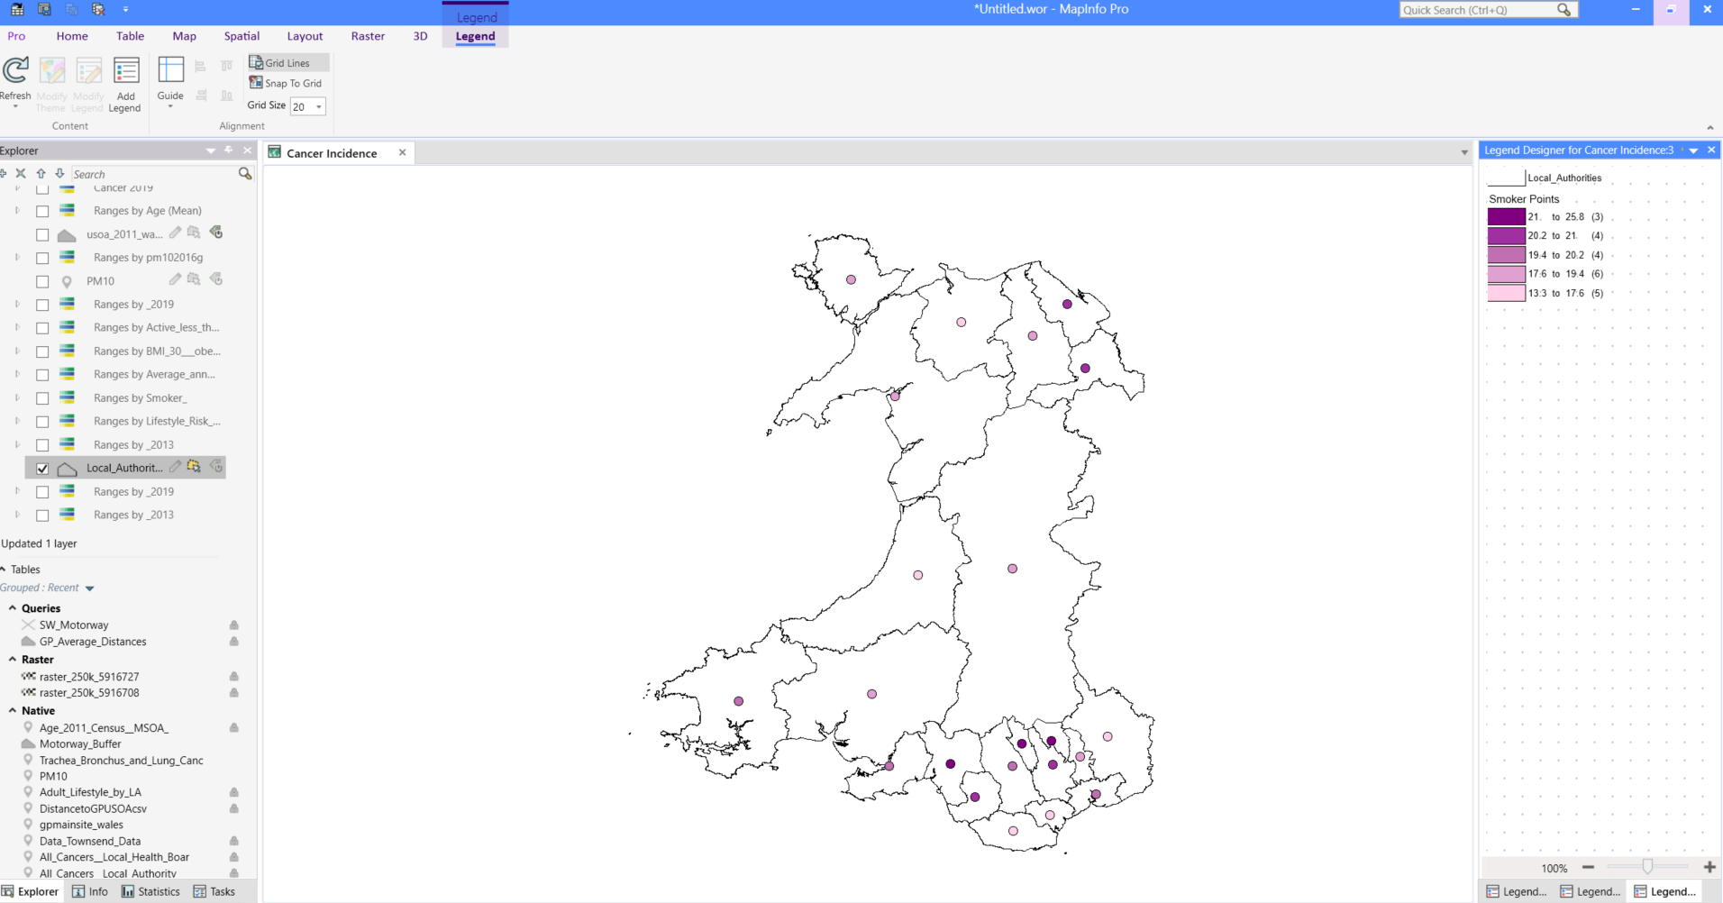

Age Demographics
Age demographics were added to investigate the relationship between population age structure and cancer incidence across Wales.
Data: Age - Census 2011 (MSOA)
File Types: CSV
Data Source: UK Data Service [9]
Data Cleansing and Transformation:
The original dataset included MSOA level data for England, Scotland, and Wales. To maintain relevance, only Welsh data was retained, with records from England and Scotland removed. Additionally, age groups between 1 and 15 were excluded to align with the cancer incidence data previously integrated into the GIS. To support further analysis, an updated column was created within the dataset to calculate the average age for each area, providing a single, comparable value across regions.
Figure 30: Age Census Data 2011
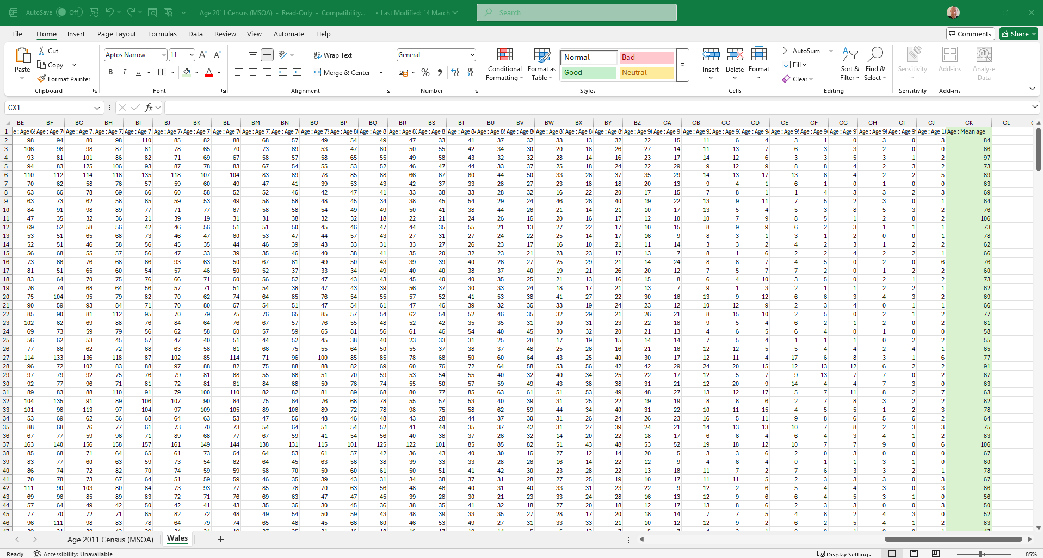
The file was uploaded to MapInfo Pro 2023 and geocoded to the USAO boundary via the MSOA name.
Visualisation:
A thematic map was produced at the USOA level to identify spatial patterns and potential correlations between average age and cancer incidence across Wales.
Figure 31: GIS Workspace - Thematic Map of Average Age Data 2011
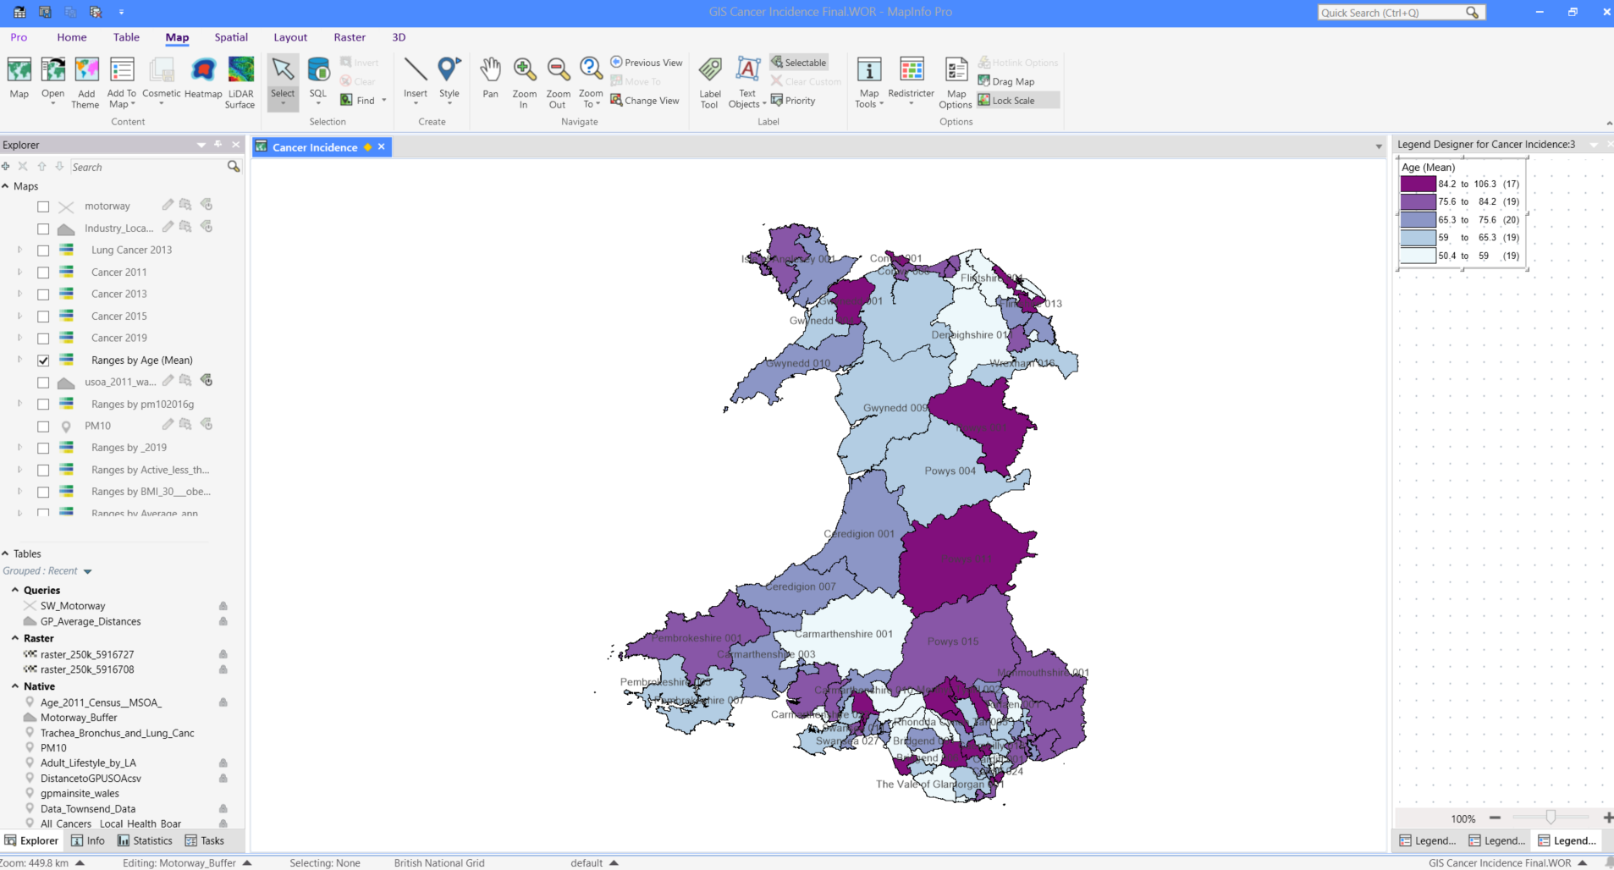

Healthcare Access and GP Surgery Distance
Healthcare access, specifically the average distance to GP surgeries, was incorporated into the GIS to assess whether geographic proximity to primary care services influences cancer incidence rates.
Data: Wales GP Surgeries (main sites)
File Types: CSV
Data Source: Data Map Wales [10]
Data Cleansing and Transformation:
As no data cleansing was required, the file was directly imported into MapInfo Pro 2023 and geocoded to the USOA boundary layer via the MSOA code.
Figure 32: GIS Workspace - Browser View of GP Surgeries Data
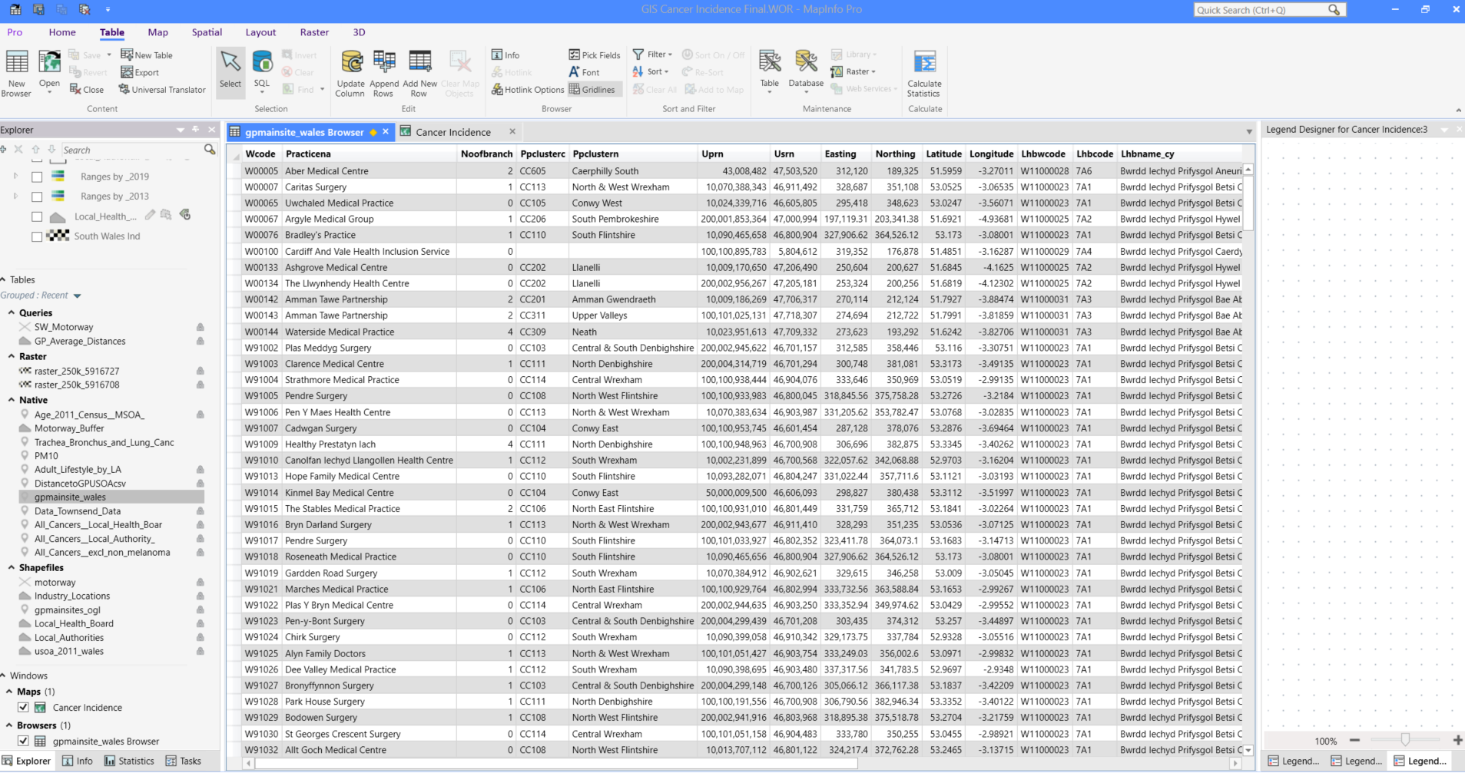
To calculate the average distance to a GP surgery, an SQL SELECT statement was built in MapInfo Pro 2023 to measure the distances from each USOA polygon centroid to surrounding GP surgery points.
Figure 33: SQL Statement of the Average Distance to GP Surgeries
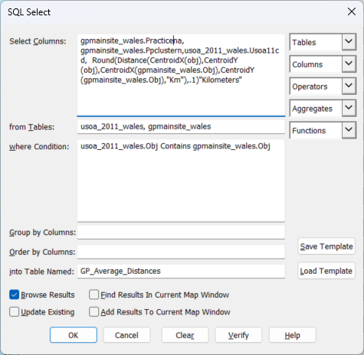
The resulting table from the SQL query was then exported back to the Windows folder where it was uploaded back to Map Info Pro 2023 and again geocoded to the USOA boundary.
Figure 34: Exporting the SQL Query Data
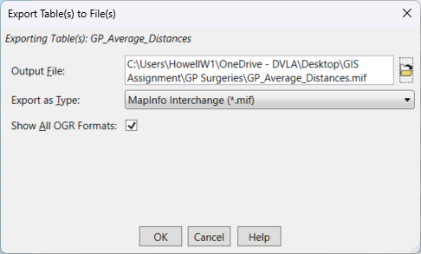
Visualisation:
A map was created that showed the average distances to GP Surgeries at USOA level.
Figure 35: GIS Workspace - Average Distance to GP Surgeries
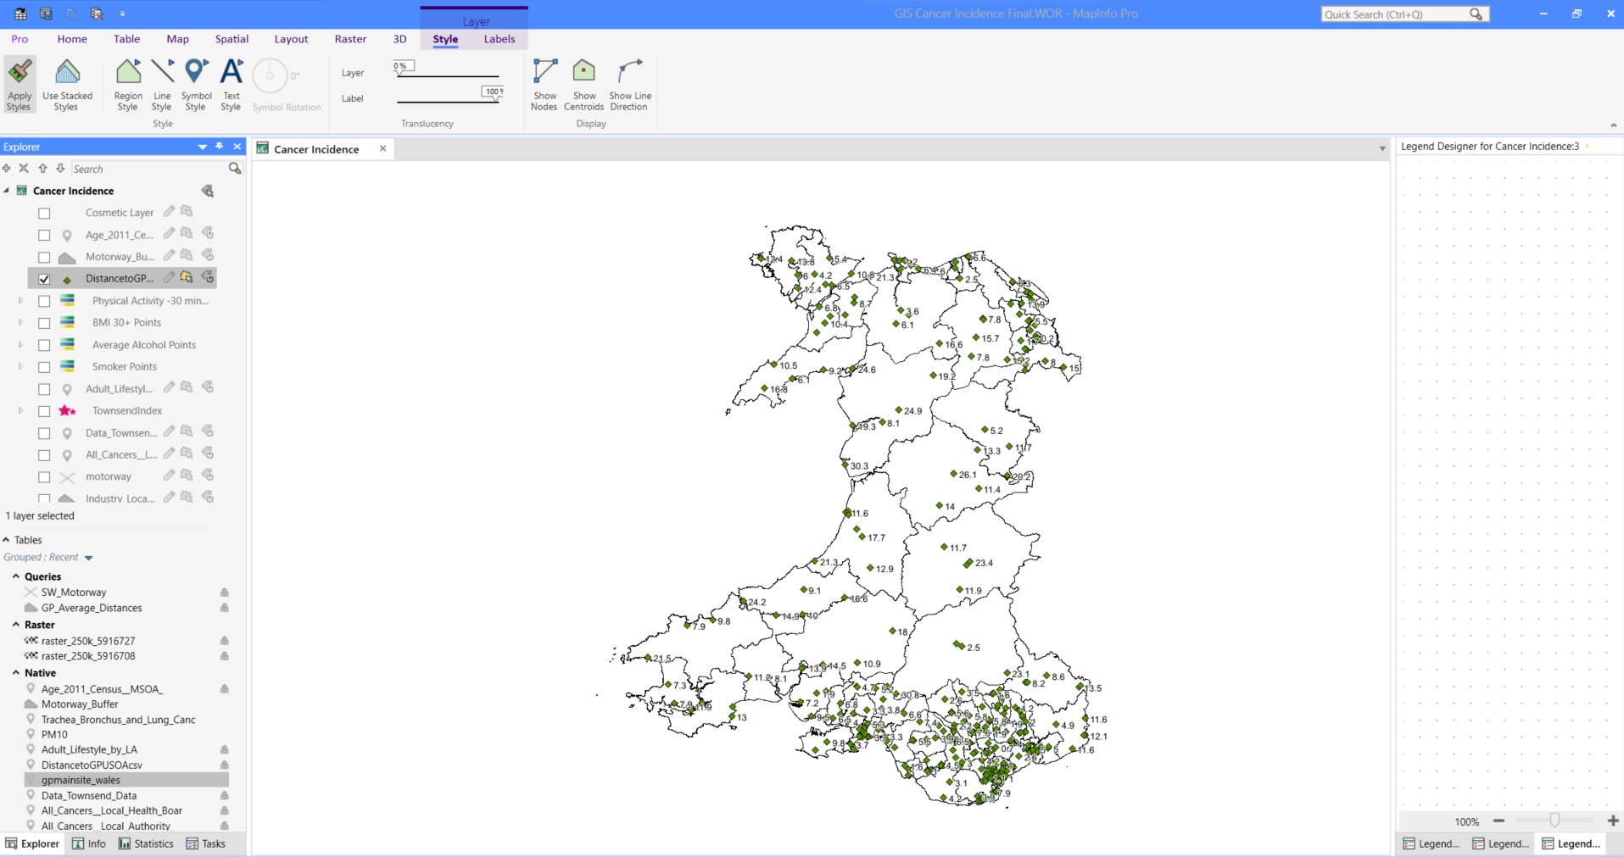

Air Pollution
Air pollution was added to investigate its potential role as an environmental risk factor for cancer, particularly in relation to lung cancer incidence in urban and industrial regions of Wales.
Data: PM2.5, PM10
File Types: PNG, Shapefile, Excel
Data Source: Data Map Wales [11]
Data Cleansing and Transformation:
The PNG and shapefile required no data cleansing and was successfully imported into MapInfo Pro 2023. However, issues arose when attempting to overlay the PM10 shapefile with the USOA boundary data. To investigate further, an Excel version of the dataset was downloaded, revealing that the coordinates were in British National Grid (BNG) format, which was incompatible with the USOA shapefile. To resolve this, an online grid reference conversion tool was used to convert the BNG coordinates to latitude and longitude, allowing the data to be accurately geocoded and integrated with the USOA boundary layer [12].
Figure 36: PM10 Data with Latitude and Longitude Coordinates
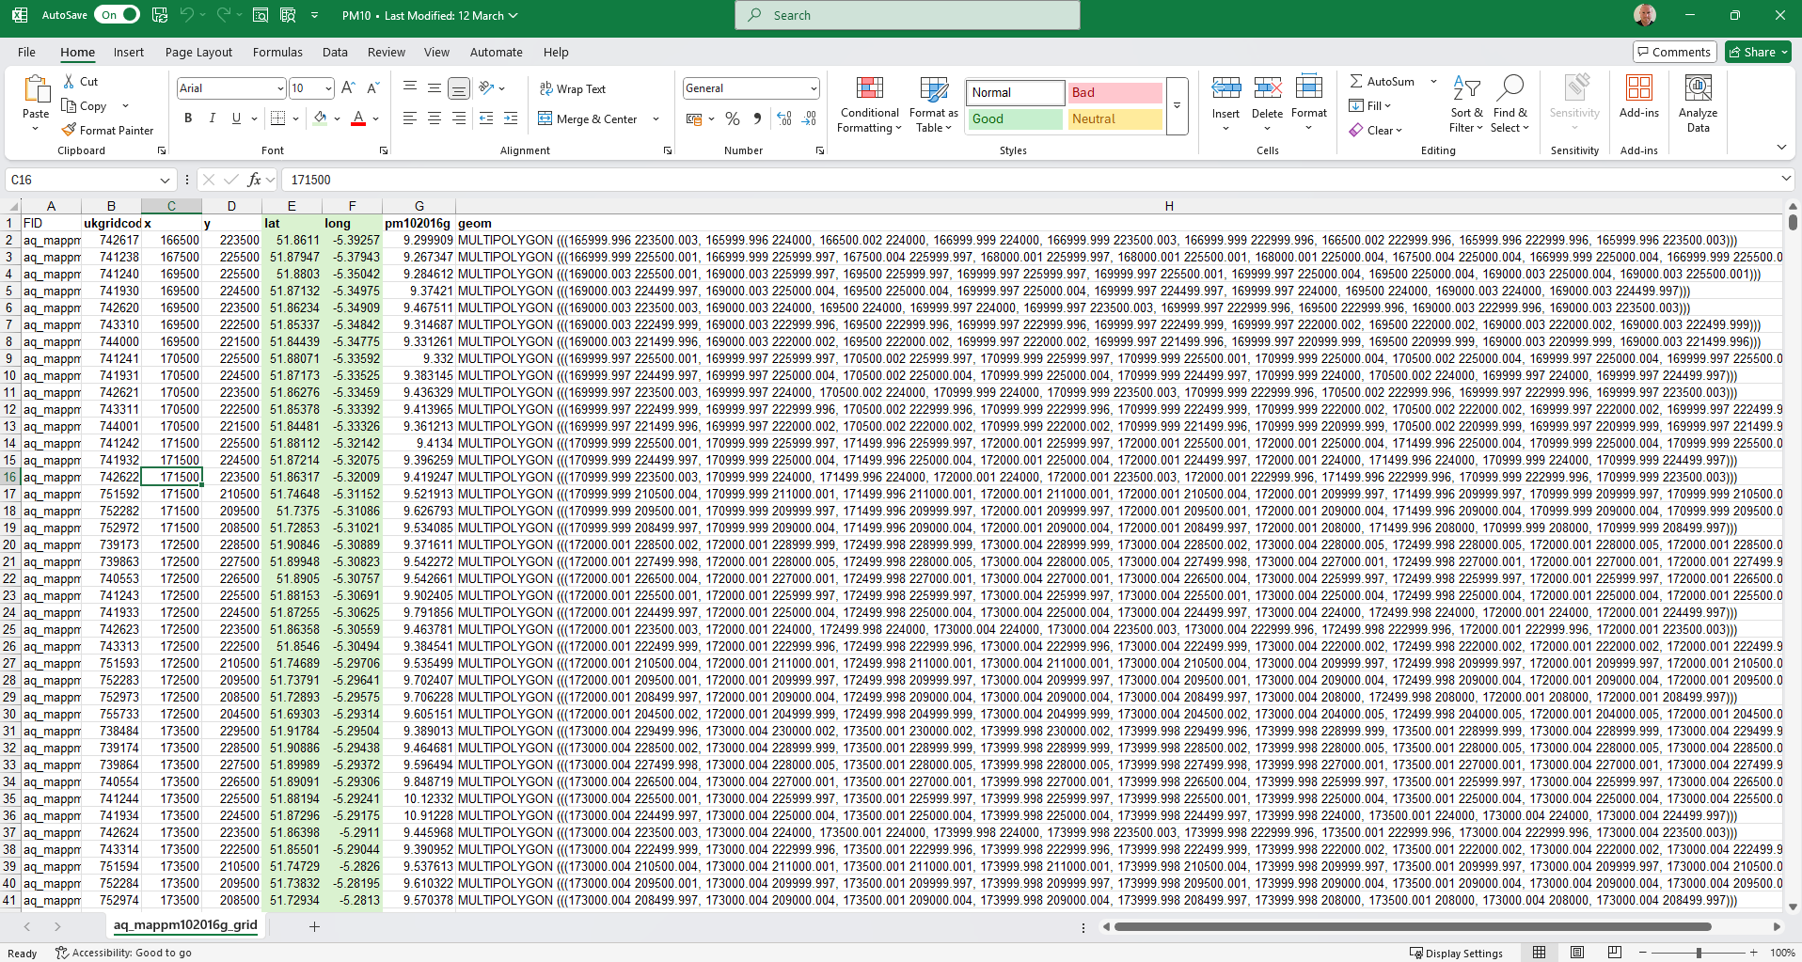
Visualisation:
A thematic map was created to show PM10 data at the USOA level
Figure 37: GIS Workspace - Thematic Map of PM10 Data in Wales

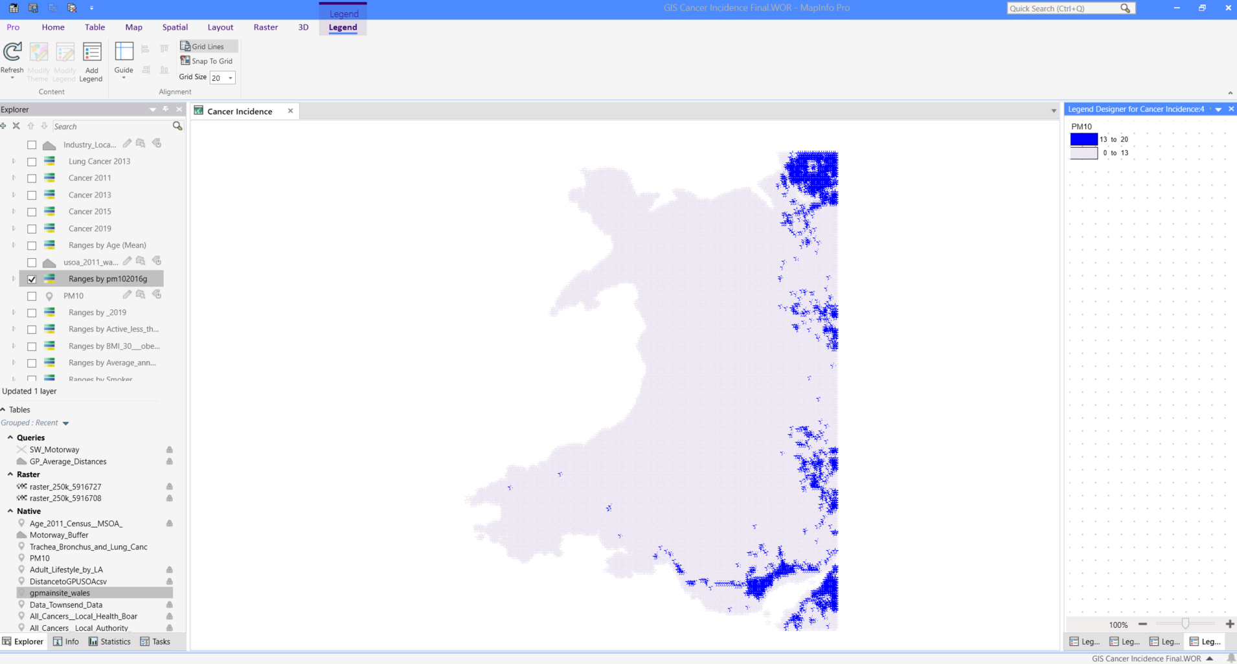

Industrial Sites
Industrial site locations were added to investigate potential environmental links between industrial activity, air pollution and cancer incidence in South Wales.
Data: Industry Locations
File Types: Shapefile
Data Source: Data Map Wales [13]
Data Cleansing and Transformation:
As no data cleansing or transformation was required, the file was directly imported into MapInfo Pro 2023.
Visualisation:
A map was produced to display the location of industrial sites across Wales. The symbol colour was changed to yellow to enhance visibility and make the sites easier to distinguish on the map.
Figure 38: GIS Workspace - Industry Locations
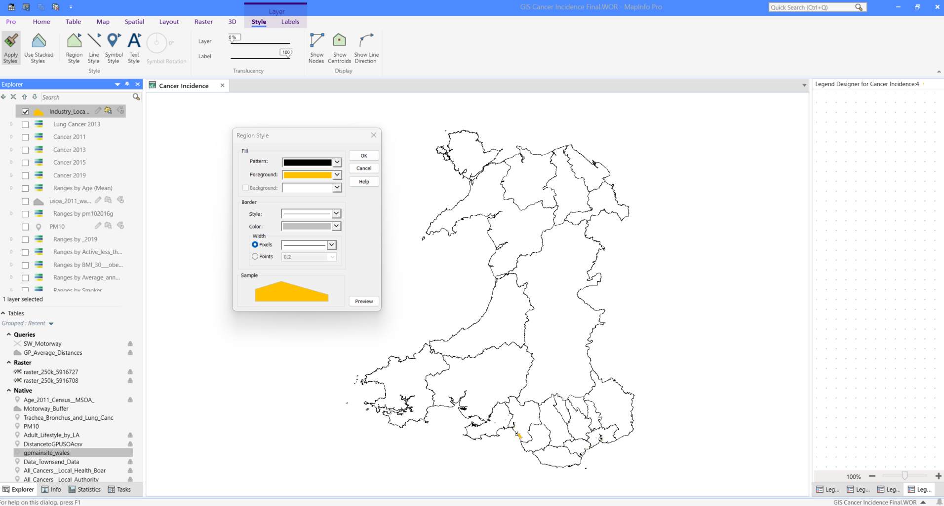

Motorway Data
Motorway data was added to enhance the analysis of lung cancer in South Wales.
Data: Strategi (Motorway Data)
File Types: Shapefile
Data Source: Digimap [14]
Data Cleansing and Transformation:
As no data cleansing or transformation was required, the file was directly imported into MapInfo Pro 2023.
A motorway buffer zone was created to assess the potential impact of proximity to major roads on cancer incidence. The figure below shows the creation of the buffer zone with an SQL ‘Select By Location’ query in MapInfo 2023 Pro.
Figure 39: Creation of Motorway Buffer Zone by SQL Location Query
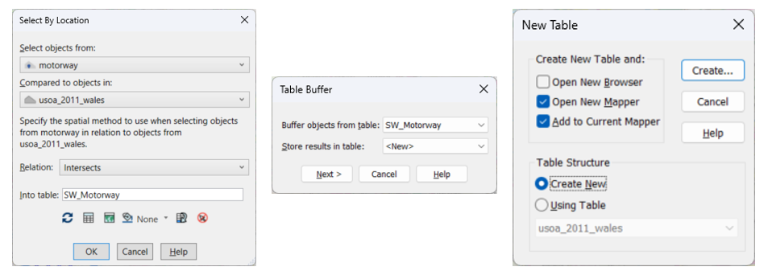
Visualisation:
A map was created from the resulting SQL table to display motorways and their associated buffer zones across Wales. The motorway symbols were styled in light blue to enhance visibility, while the buffer zones were given a light grey outline to allow for clear overlay with other spatial layers.
Figure 40: GIS Workspace - Motorway Locations and Buffer Zones
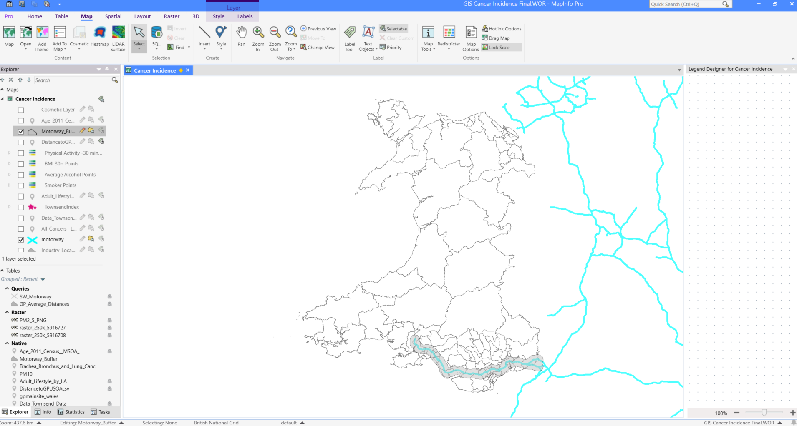

Backdrop Maps
Backdrop maps were added to provide geographic context for the data being analysed and visualised in South Wales, helping to understand where spatial features are located in the real world.
Data: Backdrop Mapping
File Types: Raster
Data Source: Digimap [14]
Data Cleansing and Transformation:
No data cleansing or transformation was required, the file was directly imported into MapInfo Pro 2023.
Visualisation:
Figure 41: GIS Workspace - Backdrop Map of South Wales
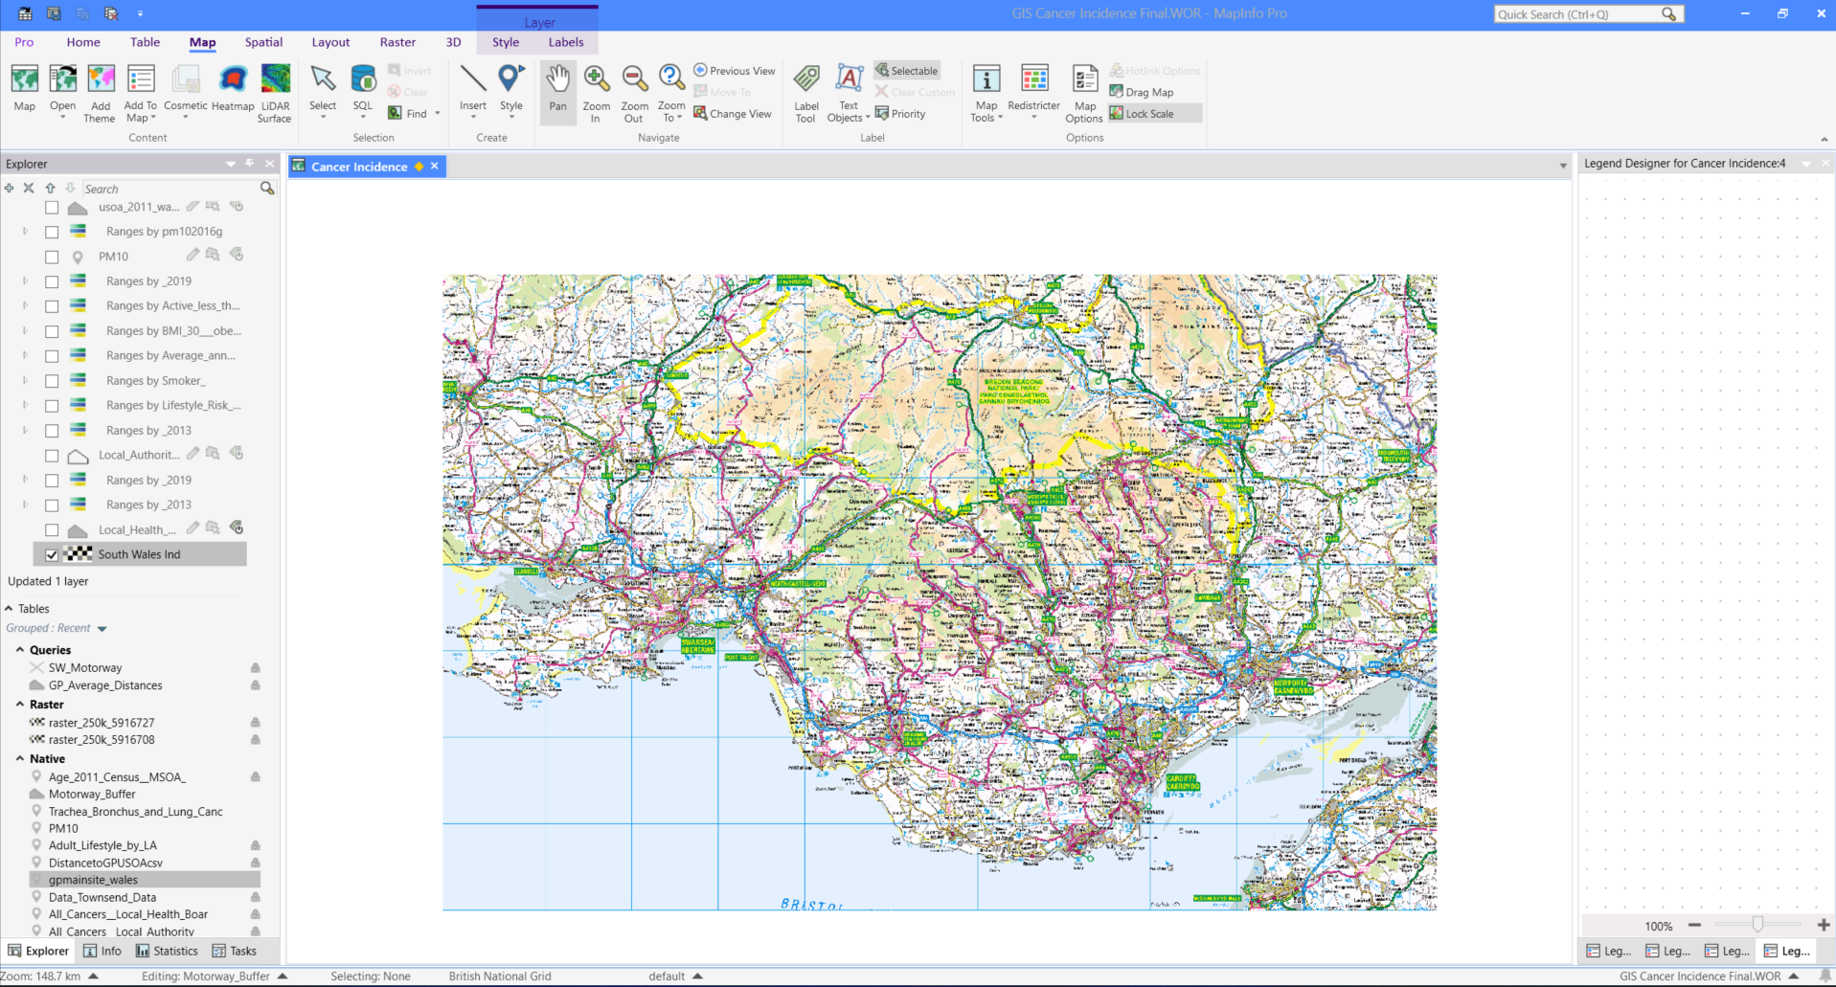

Map Layering and Visual Configuration
The process of layering maps in MapInfo Pro 2023 was essential for building a functional and informative GIS. Layers were organised in a logical order, ensuring that base maps (e.g. backdrops and boundaries) sat beneath thematic overlays for clarity. Thematic styles were chosen to ensure contrast and accessibility.
Label visibility was toggled on layers such as Local Authority or USOA boundaries, but often required trial and error to ensure labels did not overlap with map features or obscure key data. Font sizes, label positioning, and layer transparency were adjusted several times to achieve a visually balanced map. In some cases, labelling was disabled altogether and replaced with a clean legend to maintain clarity.
In conclusion, the map layering process played a critical role in producing the report. It allowed for the clear visual presentation of complex spatial data and supported the analysis.

5.Figures

Figure 1: Cancer Incidence Rates in Wales between 2011 and 2019 4
Figure 2: Thematic Maps of Cancer Incidence in Wales 2011 to 2019 per 100k population (USOA) 5
Figure 3: Cancer Incidence in Wales 2013 Comparison to High Townsend Index Scores 5
Figure 4: Cancer Incidence in Wales 2011 to 2015 v Townsend Index 6
Figure 5: Cancer Incidence in Wales 2013 v Smoking Data 7
Figure 6: Cancer Incidence in Wales 2013 v Average Annual Alcohol Consumption 8
Figure 7: Cancer Incidence in Wales 2013 v Over 30 BMI (Obese) 8
Figure 8: Cancer Incidence in Wales 2013 v Less than 30 mins Physical Activity per Week 9
Figure 9: Cancer Incidence in Wales 2013 v Lifestyle Risk Index 10
Figure 10: Age Demographics and Cancer Incidence in Wales 2013 11
Figure 11: Average Distance (km) to GP Surgeries in Wales (USOA) 12
Figure 12: Air Pollution (PM2.5 and PM10) v Lung Cancer Incidence in Wales 2013 13
Figure 13: PM10 and Lung Cancer in the South Wales Industrial Corridor 13
Figure 14: PM10, Lung Cancer, Motorway Proximity in the South Wales Industrial Corridor 14
Figure 15: GIS Documentation Log 17
Figure 16: USOA Boundary Configuration and Setup 18
Figure 17: USOA and LA Boundary Data 18
Figure 18: Boundary Data Reference File 19
Figure 19: Index Match Function to Generate USOA Code 19
Figure 20: Geocoding All Cancer Wales data to USOA Boundaries 20
Figure 21: Creation of a Thematic Map of Cancer Incidence in Wales 21
Figure 22: GIS Workspace - Thematic Map of Cancer Incidence in Wales 2013 21
Figure 23: Creation of the Townsend Index Data 22
Figure 24: Creation of a Graduated Thematic Map for the Townsend Index 23
Figure 25: GIS Workspace - Townsend Index 23
Figure 26: Adult Lifestyle Data and Creation of Lifestyle Risk Index (LRI) 24
Figure 27: Creation of a Thematic Map of Smokers in Wales 24
Figure 28: GIS Workspace - Thematic Map of Smoker Data 25
Figure 29: GIS Workspace - Thematic Points of Smoker Data 25
Figure 30: Age Census Data 2011 26
Figure 31: GIS Workspace - Thematic Map of Average Age Data 2011 26
Figure 32: GIS Workspace - Browser View of GP Surgeries Data 27
Figure 33: SQL Statement of the Average Distance to GP Surgeries 28
Figure 34: Exporting the SQL Query Data 28
Figure 35: GIS Workspace - Average Distance to GP Surgeries 29
Figure 36: PM10 Data with Latitude and Longitude Coordinates 29
Figure 37: GIS Workspace - Thematic Map of PM10 Data in Wales 30
Figure 38: GIS Workspace - Industry Locations 31
Figure 39: Creation of Motorway Buffer Zone by SQL Location Query 31
Figure 40: GIS Workspace - Motorway Locations and Buffer Zones 32
Figure 41: GIS Workspace - Backdrop Map of South Wales 33

6.References
[1] D. Martin, “Townsend Deprivation Index,” Geo-Refer projects, Nov. 23, 2007. https://www.restore.ac.uk/geo-refer/36229dtuks00y19810000.php (accessed Mar. 08, 2025).
[2] K. Mason, N. Pearce, and S. Cummins, “Neighborhood environment and socioeconomic inequalities in cancer admissions: a prospective study using UK Biobank and linked hospital records,” Cancer Causes & Control, vol. 33, no. 12, pp. 1431–1444, Sep. 2022, doi: 10.1007/s10552-022-01626-2.
[3] StatsWales, “Adult lifestyles by local authority and health board,” statswales.gov.wales. https://statswales.gov.wales/Catalogue/National-Survey-for-Wales/Population-Health/Adult-Lifestyles/adultlifestyles-by-localauthority-healthboard (accessed Mar. 09, 2025).
[4] Cancer Research UK, “How does smoking cause cancer?,” Cancer Research UK, 2019. https://www.cancerresearchuk.org/about-cancer/causes-of-cancer/smoking-and-cancer/how-does-smoking-cause-cancer (accessed Mar. 09, 2025).
[5] Cancer Research UK, “Lung Cancer Statistics,” Cancer Research UK, May 14, 2015. https://www.cancerresearchuk.org/health-professional/cancer-statistics/statistics-by-cancer-type/lung-cancer#heading-Zero (accessed Mar. 22, 2025).
[6] J. Yoo et al., “Update in association between Lung Cancer and air pollution,” Tuberculosis and Respiratory Diseases, Dec. 2024, doi: 10.4046/trd.2024.0092.
[7] Data Map Wales (2023). Census Geography Boundaries | DataMapWales. [online] Gov.wales. Available at: https://datamap.gov.wales/maps/census-geography-boundaries/ [Accessed 20 Mar. 2025].
[8] Heath Map Wales, “DHCW – Data Explorer,” Wales.nhs.uk, 2019. https://www.healthmapswales.wales.nhs.uk/data-catalog-explorer/ (accessed Mar. 21, 2025).
[9] UK Data Service, “UK Data Service,” Ukdataservice.ac.uk, 2012. https://ukdataservice.ac.uk/ (accessed Mar. 21, 2025).
[10] Data Map Wales, “GP Surgeries | DataMapWales,” Gov.wales, Jan. 16, 2024. https://datamap.gov.wales/layergroups/geonode:gp_sites_ogl (accessed Mar. 23, 2025).
[11] Data Map Wales, “Air Quality data (2016) | DataMapWales,” Gov.wales, May 15, 2017. https://datamap.gov.wales/layergroups/inspire-wg:AirQualityData (accessed Mar. 23, 2025).
[12] UK Grid Reference Finder, “Batch Convert Tool,” gridreferencefinder.com. https://gridreferencefinder.com/batchConvert/batchConvert.php (accessed Mar. 22, 2025).
[13] Data Map Wales, “Environmental Noise Mapping 2017 - (Noise Action Plan) Industry Locations, 2017 | DataMapWales,” Gov.wales, Dec. 2017. https://datamap.gov.wales/layers/inspire-wg:r3industrylocations_2017 (accessed Mar. 23, 2025).
[14] Digimap, “Digimap,” Edina.ac.uk, 2019. https://digimap.edina.ac.uk/os (accessed Mar. 22, 2025).

