Children and Young People In Focus (ECCH7002)- Reflective Account
Drugs, Gangs, Child Exploitation and… Wales: County Lines
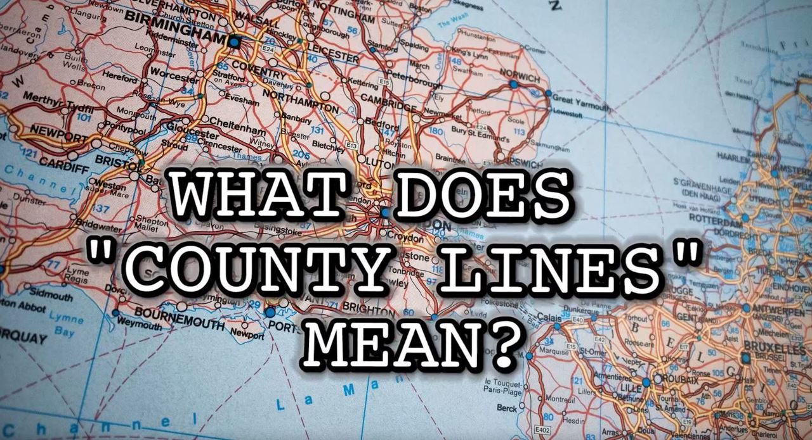
If asked to think of an area which is highly affected by street drugs and gang culture, I can honestly say my first thought would not be Wales. However, as someone who had very little knowledge of County Lines before taking part in this module, I will admit that I was unaware of the major issues in regard to drugs, gangs and child exploitation that was happening in our home towns and on our doorsteps.
(Wales Online, 2019)

County Lines was a term produced in 2013 which represented gang members use of phone lines to penetrate areas in which there is believed to be profit made from selling drugs. A vast majority of Wales have either been reported to having an established issue with County Lines, or an emerging problem (Williams & Fiona, 2019). The way drug dealers and gang members run these lines have been described as an enterprise, in which experienced members from areas such as London and Birmingham are recruiting young and vulnerable people in order to deliver drugs to more rural areas. They are recruiting these children and young people by manipulation, intimidation, violence and often by offering forms of payment or gifts to coerce them into crossing county lines in order to sell drugs (South Wales Police, no date). It is believed that children as young as 12 have been recruited to join these enterprises, in order to aid in gang members avoiding detection and being arrested (Robinson, McLean & Densley, 2018).

The children and young people involved in County Lines are at a considerably high risk of violence, drug addiction, trafficking, sexual exploitation as well as criminal conviction. This can have a detrimental impact on a child or young person (Williams & Fiona, 2019).
Typically, the children and young people that are groomed for drug running are already vulnerable to many of the aspects previously mentioned due to their background. Children and young people living in care homes are said to be incredibly vulnerable to grooming from gang members, with around half of police forces claiming that the children and young people involved were coerced from care homes. As well as this, young people with learning difficulties, mental health issues and those who have experienced severe trauma are also at high risk of being vulnerable to county lines drug dealers (Islington Safeguarding Children Board, 2016). Although males are more likely to be involved in gang and drug related activities, young girls are also at risk of becoming exploited by gang members. It is believed that young females are being sexually exploited without being aware of this due to the girls believing that they are loved by the gang members and having a sense of emotional and financial security, as well as social status. This often results in compliance in illegal doings as well as entering into an abusive relationship which has detrimental effects on their emotional and physical well-being (CSJ, 2014).
The targeted children and young people
(Independent, 2019)

It is incredibly unnerving to discover that due to county lines being a relatively new phenomenon, the full impact of it on the lives of children and young people still remains unknown.

So, what is being done in Wales to stop County Lines?
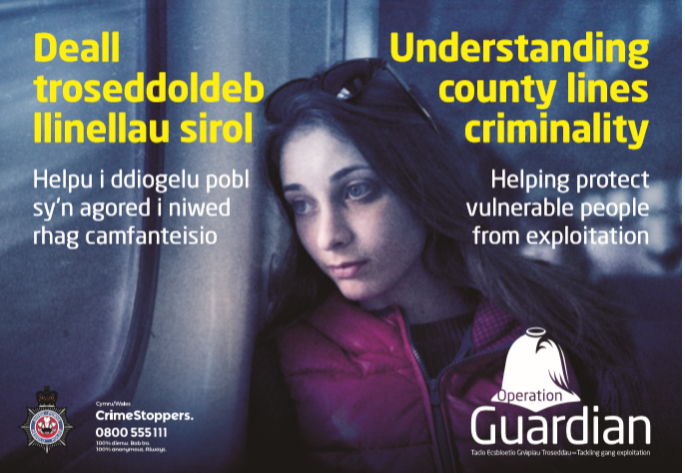
The United Kingdom Government released a guidance for practitioners document in 2019 which aimed to aid in ensuring the safeguarding of every child in regard to County Lines was taken into consideration by practitioners. Along with this, The County Lines Working Group was set up in 2016 with the hope working through multi agencies and government to raise awareness, tackle issues and cases as well as provide training for relevant practitioners (Ministry of Justice, 2019). However, through my research on County Lines I have discovered that there is little guidance or policy documents directly from the Welsh Government. Considering that County Lines has been described as an ‘epidemic’ which is known to put children and young people at risk (The Telegraph, 2019), I was shocked to see this was the case. Despite of the lack of guidance from Welsh Government, many of the Welsh police departments have set up programmes and operations in the hopes of combatting the drug running and child exploitation. One example of this is the Dyfed Powys Police department’s Operation Guardian. The campaign aims to tackle County Lines by working across agencies to safeguard the children and young people who are being exploited, rather than punishing them. This type of long-term approach aims to pursue perpetrators rather than the victims (Dyfed Powys Police, no date).
(Grimsby Telegraph, 2019)
(Dyfed Powys Police, no date)

Is it enough?
As a practitioner who has worked with vulnerable children for over eight years, I wonder how I wasn’t made more aware of County Lines. After speaking with others who work in the same field as myself and discovering that their knowledge on this topic was similar to mine.. minimal. I question how it could possibly be enough? How could more people not be aware of County Lines and the exploitation that is taking place where we live, where we work and where our children and families grow up. Others have similar opinions to myself on County Lines awareness, Donovan (2019) suggests that many have a similar view of myself at the beginning of this module, that this sort of this does not happen in Wales. How very wrong I was.
Despite of the £20million government funding which was given at the end of 2019 in order to combat County Lines, there is no quick fix, although it is suggested that a national as well as local plan desperately needs to be put in place so that there is opportunity to save these children and young people from a life of exploitation, gangs and drugs (The Guardian, 2019).

Reference List
Donovan, S. (2019) I’ve seen the child slavery of county lines up close. £20m won’t save it. Available at: https://www.theguardian.com/commentisfree/2019/oct/04/child-slavery-county-lines-criminals-provincial-towns Accessed: 29th February 2020
Dyfed Powys Police (no date) Operation Guardian. Available at: https://www.dyfed-powys.police.uk/media/6066/op-guardian-info-booklet.pdf Accessed: 29th February 2020
Grimsby Telegraph (2019) County lines drug dealing gangs. Available at: https://www.grimsbytelegraph.co.uk/news/grimsby-news/county-lines-humberside-police-children-2470210 Accessed: 29th February 2020
Independent (2019) A steep rise in children identified as potential victims of exploitation prompts fresh concerns about county lines. Available at: https://www.independent.co.uk/news/uk/crime/child-trafficking-county-lines-ganges-exploitation-modern-slavery-minors-home-office-drugs-a8830396.html Accessed: 28th February 2020
Islington Safeguarding Children Board (2016) Safeguarding children affected by gang related activity and/or gang-related serious youth violence. Available at: https://www.islingtonscb.org.uk/SiteCollectionDocuments/Gangs%20Safeguarding%20Protocol%20and%20Appendices.pdf Accessed: 29th February 2020
Ministry of Justice (2019) County Lines Exploitation. Available at: https://assets.publishing.service.gov.uk/government/uploads/system/uploads/attachment_data/file/839253/moj-county-lines-practical-guidance-frontline-practitionerspdf.pdf Accessed: 29th February 2020
Robinson, G., Mclean, R., and Densley, J. (2018) ‘Working County Lines: Child criminal exploitation and illicit drug dealing in Glasgow and Merseyside.’, International Journal of Offender Therapy and Comparative Criminology. 63 (5), pp. 694-711.
South Wales Police (no date) County Lines Criminality. Available at: https://www.south-wales.police.uk/en/advice/county-lines-criminality-drug-dealing-exploitation-vulnerable-people/ Accessed: 28th February 2020
The Centre for Social Justice (2014) Girls and Gangs. Available at: https://www.centreforsocialjustice.org.uk/library/girls-and-gangs Accessed: 29th February 2020
The Guardian (2019) The Guardian view on county lines. Available at: https://www.theguardian.com/commentisfree/2019/sep/16/the-guardian-view-on-county-lines-victims-villains-and-everything-in-between Accessed: 29th February 2020
The Telegraph (2019) County Lines epidemic blamed as number of children missing or linked to drug gangs doubled. Available at: https://www.telegraph.co.uk/news/2019/09/15/county-lines-epidemic-blamed-number-children-missing-linked/ Accessed: 29th February 2020
Wales Online (2019) The county lines routes continuously feeding Wales with drugs. Available at: https://www.walesonline.co.uk/news/wales-news/county-lines-routes-continuously-feeding-16288294 Accessed: 28th February 2020
Williams, A., and Fiona, F. (2019) ‘County Lines: How gang crime is affecting our young people.’, Archives of Disease in Childhood. 104 (8).
Technology and the digital natives


In an age where many children are able to use a tablet or smartphone before they are able to walk or talk, and the whole world becoming more digitally connected than ever before, it is no surprise to hear about the concerns raised by adults or ‘digital immigrants’ regarding the impacts of technology on the digitally native children of today’s society (OECD, 2019). Digital native is a term which was produced to acknowledge the younger generations saturation in technology and the children’s ability to natively speak the digital language of technology such as computers, smartphones and the internet (Prensky, 2001).
(McDavid, no date)
The media has produced many shocking headlines over recent years in regard to children’s use of technology which includes the accusation that the use of certain types of technology have destroyed a generation of young people, as well as that children’s brains are being re-wired by technology (OECD, 2019). But to what extent is this true? Is this simply a case of parents and practitioners being scare mongered by the media, or is there truly a cause for concern?
Over the last 20 years there has been a significant rise in the use of technology, which in turn has led to a rise in the concern of the impact it is having on children’s development and well-being. Links between technology and lack of social skills, child obesity, mental health conditions, poor concentration, poor attainment in school, as well as the overall danger of the internet have all been noted over recent years (Bavellier, Green and Dye, 2010). In order to combat some of these concerns the government has put advice in place to limit children’s screen time. However, the research into children’s use of technology is currently not in depth or robust enough to conclude that the limitations will be effective, as well as there still being a significant uncertainty on how the casual use of technology is impacting children’s lives (Orben and Przybylski, 2019).
It’s important to also mention that although there have been many concerns in regard to the negative impact technology has on young people, there is also just as many positive impacts which play a crucial role in children’s lives (Unicef, 2012). We are living in modern times and technology has the potential to offer positive opportunities and experiences to children and young people in all aspects of their lives, but in particular, in regard to education. In order to keep up with the fast paced and heavily digitally relied upon world we have come to know, children need to be educated differently to prepare them for their school, as well as work lives (Hatch, 2011). It was suggested by Prensky (2001) that the digitally native children of today are not the people in which the education system was designed to teach. Since then, there have been different digital changes put in place in schools in order to engage with the digital world and for children to receive the positive impacts of being digitally literate, particularly in the United Kingdom. Smartboards, tablets, apps and computers are regularly seen in classrooms today in order for children to make use of (Hoggins, 2020). Digital competency is also a focus of the new curriculum which is currently coming into place in Wales. Emphasis is placed on the vital need to be digitally competent as our lives are currently so intertwined with technology that we need to prepare the young people to be able to survive and thrive in the rest of their lives (Donaldson, 2015).
Many other positive impacts of young people’s use of technology has been noted in research, benefits such as improved creativity, more outlets to express themselves, more opportunities to develop independence, improved empowerment, better problem solving skills as well as perseverance, development of language skills, and improved hand eye coordination skills (Earp, 2017).

As a practitioner who works with young children in a school setting, it is important that I keep both the positive and negative impacts in mind. However, this also led me to question how it is possible to ensure that children are connected to the digital world without experiencing the negative impacts. This is where Goldilocks becomes relevant. Just like the children’s fairytale of a girl who wanted her porridge not too hot- and not too cold- but just right, similarities have been drawn upon in research into young people’s use of technology.
(Ness, 2017)
A study from 2017 has found that although children’s use of technology is a complicated field, the Goldilocks Hypothesis demonstrates that not only does high levels of screen time negatively impact a child’s well-being, but this is also the case for children who experience extremely low levels, or none at all (Marsden, 2018). The balance between too much and too little is clear to see from the research produced by Przybylski and Weinstein, who suggest that the although 2+ hours is classed as high levels, the optimum time should be just less than one hour per day in order to positively contribute to a child’s well-being (Przybylski and Weinstein, 2017).
With positives and negatives being weighed up, it becomes clear to me that there will forever be somewhat of a risk in most hobbies and activities children will take an interest in. Whether it be sports, animals, newest trends or technology. Children are seen as innocent beings in which adults’ natural instinct is to protect (Taylor, 2011). However, if we are unable to fully determine what is helpful and what is harmful, does that mean we wrap them up in cotton wool and shelter them from the everchanging digital world we live in, or give them opportunities to find out for themselves?

Reference List
Bavellier, D., Green, C. and Dye, M (2010) ‘Children, wired- for better or worse’, Neuron, 67 (5) pp. 692-701.
Donaldson, G (2015) Successful Futures. Available at: https://gov.wales/sites/default/files/publications/2018-03/successful-futures.pdf Accessed: 3rd April 2020
Earp, W (2017) Parenting in a Digital Age. Available at: https://swgfl.org.uk/magazine/what-are-the-benefits-for-my-child-of-using-techno/ Accessed: 3rd April 2020
Hatch, K (2011) Determining the effects of technology on children. Available at: https://digitalcommons.uri.edu/cgi/viewcontent.cgi?referer=https%253A%252F%252Fscholar.google.co.uk%252Fscholar%253Fq%253Dpositive%2520impact%2520of%2520technology%2520on%2520children&=&hl=en&=&as_sdt=0&=&as_vis=1&=&oi=scholart&=&httpsredir=1&=&article=1212&=&context=srhonorsprog&=&sei-redir=1#search=%22positive%20impact%20technology%20children%22 Accessed: 2nd April 2020
Hoggins, T (2020) Why Britain is top of the class for education technology. Available at: https://www.telegraph.co.uk/technology/2020/01/04/britain-top-class-education-technology/ Accessed: 3rd April 2020
Marsden, P (2018) The Goldilocks Hypothesis and ‘just right’ screen time. Available at: https://digitalwellbeing.org/the-goldilocks-hypothesis-and-just-right-screen-time/ Accessed: 3rd April 2020
McDavid, W (no date) Digital Natives in the Workplace. Available at: http://access-information.com/digital-natives-workplace/ Accessed: 2nd April 2020. [Image]
Ness, M (2017) Goldilocks and the Three Bears. Available at: https://www.tor.com/2017/05/11/she-doesnt-always-get-away-goldilocks-and-the-three-bears/ Accessed: 3rd April 2020. [Image]
OECD (2019) What do we know about children and technology? Available at: https://www.oecd.org/education/ceri/Booklet-21st-century-children.pdf Accessed: 2nd April 2020
Orben, A. and Przybylski, A (2019) ‘The association between adolescent well-being and digital technology use’, Nature Human Behaviour, 3, pp. 173-182.
Prensky, M (2001) ‘Digital Natives, Digital Immigrants’, On the Horizon, 9 (5).
Przybylski, A. and Weinstein, N (2017) ‘A Large-Scale Test of the Goldilocks Hypothesis: Quantifying the Relations Between Digital-Screen Use and the Mental Well-Being of Adolescents’, Psychological Science, 28 (2) pp. 204-215.
Taylor, A (2011) ‘Reconceptualizing the ‘nature’ of childhood’, Childhood, 18 (4) pp. 420-433.
Unicef (2012) Communicating with children. Available at: https://www.unicef.org/cwc/cwc_58701.html Accessed: 2nd April 2020

The Covid-19 Generation

Currently, there are 91% of all children worldwide that are out of education due to the Coronavirus outbreak which has seen a majority of the world placed in lockdown. An entire generation of children have witnessed their education be interrupted and their schools shut down as a result of this pandemic (Unesco, 2020), but what does this mean for the children? Not only do we need to consider the impacts to the children’s learning and academic achievements but these unprecedented times also have the potential to have an impact on all areas of the lives of the 1.57 billion students which are out of education currently (Unicef, 2020).
A significant amount of responsibility is being placed on parents and guardians in order to ensure that children are being educated at home during this crisis, which at first may seem to be productive. However, this input from families is believed to work best when it works hand in hand with traditional schooling in order to illuminate what has been taught. Although many people worldwide are successful in home-schooling their children, it is difficult to generalise to a range of families throughout the population (Burgess and Sievertsen, 2020).
There are many disparities amongst families which may affect how successful they are able to be in helping their children learn, these include how much time is available to purely focus on teaching- especially for those who are key workers during this pandemic, the ability and knowledge of the parents, as well as access to resources and online tools (Oreopoulos, 2006). These differences are likely to result in an increase in the inequality between children of different economic backgrounds and will leave children who live in deprivation at a significant disadvantage (Burgess and Sievertsen, 2020).
Although this pandemic will likely have some sort of impact on every child in the United Kingdom, children who live in deprivation and poverty are particularly at risk in other areas outside of learning. It is estimated that there are currently around 4 million children and young people who live in poverty in the UK, this does not include children who are living in households where there are problems paying bills and debts which accounts to a further 3.8 million children. In these households there is already a sense of financial instability without the fear of parents losing their jobs as a result of lockdown, as well as the increase in cost of living as children are at home for longer periods (Children’s Society, 2020).
In order to attempt to combat some of these issues for children who live in deprivation, the Government has continued their Free School Meals scheme whilst the schools are closed. This has been done by offering family’s meal packages as well as vouchers to ensure that children are receiving a similar amount of food and nutrition as what they would be if they were still attending school in order to relieve some financial pressures for parents and families (Gov.uk, 2020a).
Another major concern during this unprecedented time is the likely risk of an increase in child exploitation, violence and abuse. Similar trends were seen during the outbreak of Ebola in West Africa where there was a considerable rise in neglect, sexual abuse and violence (Unicef, 2020). With a large percentage of abuse taking place in the home, as well as schools being closed and social services being affected, it is no surprise that there is significant cause for concern for children during this time (Office for National Statistics, 2020a). As a way of trying to reduce the risk to these children, the UK Government recommends that children who are classed as ‘vulnerable’ are to attend school in order to try to ensure that the child’s safety is paramount, as well as having their rights met (Gov.uk, 2020b). However, statistics show that only one in seven people report abuse which suggests that a significant proportion of the UK’s children are at risk from abuse in their own home during this lockdown (Office for National Statistics, 2020b), without the option to attend school because they do not fit into the ‘vulnerable child’ category set out by the Government.
Lastly, early research produced by the University of Oxford which focusses on the impact that Covid-19 is having on children and young people’s mental health has shown that children aged four to ten are more worried about the virus than any of the older age ranges. Children are anxious over the risk to their family as well as themselves, so much so that they are afraid to leave their homes. Other worries included lack of food, missing schoolwork as well as lack of money coming into their households (Weale, 2020).
It Is understandable why these are such concerning times for children as well as adults, and although the priority at this time is to ensure that the outbreak is controlled, we cannot let the impact of this virus leave the children of the world as victims, with detrimental lifelong effects. It is our responsibility to ensure these children grow up happy, healthy, and knowing that someday, this will all be a distant memory.



(Rainbow Junktion, 2020)

Reference List
Burgess, S. and Sievertsen, H (2020) Schools, Skills and Learning: The impact of Covid-19 on Education. Available at: https://voxeu.org/article/impact-covid-19-education Accessed: 16th April 2020
Children’s Society (2020) The impact of Covid-19 on children and young people. Available at: https://www.childrenssociety.org.uk/sites/default/files/the-impact-of-covid-19-on-children-and-young-people-briefing.pdf Accessed: 17th April 2020
Gov.uk (2020a) Covid 19: Free School Meals guidance for Schools. Available at: https://www.gov.uk/government/publications/covid-19-free-school-meals-guidance/covid-19-free-school-meals-guidance-for-schools Accessed: 17th April 2020
Gov.uk (2020b) Supporting vulnerable children and young people during the Coronavirus outbreak. Available at: https://www.gov.uk/government/publications/coronavirus-covid-19-guidance-on-vulnerable-children-and-young-people/coronavirus-covid-19-guidance-on-vulnerable-children-and-young-people Accessed: 17th April 2020
Office for National Statistics (2020a) Child Abuse in England and Wales: March 2020. Available at: https://www.ons.gov.uk/peoplepopulationandcommunity/crimeandjustice/bulletins/childabuseinenglandandwales/march2020 Accessed: 17th April 2020
Office for National Statistics (2020b) Child abuse extent and nature, England and Wales: Year ending March 2019. Available at: https://www.ons.gov.uk/peoplepopulationandcommunity/crimeandjustice/articles/childabuseextentandnatureenglandandwales/yearendingmarch2019 Accessed: 17th April 2020
Oreopoulos, P. and Stevens, A (2006) ‘Does human capital transfer from parent to child? The intergenerational effects of compulsory schooling’, Journal of Labor Economics 24(4) pp. 729–760.
Rainbow Junktion (2020) Rainbow Junktion. [Facebook] Available at: https://www.facebook.com/rainbowjunktion/ Accessed: 17th April 2020. [Image]
Unesco (2020) Covid-19 Education Disruption and Response. Available at: https://en.unesco.org/covid19/educationresponse Accessed: 16th April 2020
Unicef (2020) Don’t let children be the hidden victims of Covid-19 pandemic. Available at: https://www.unicef.org/press-releases/dont-let-children-be-hidden-victims-covid-19-pandemic Accessed: 16th April 2020
Weale, S (2020) Fifth of children afraid to leave house over Covid-19, survey finds. Available at: https://www.theguardian.com/world/2020/apr/10/fifth-of-primary-children-afraid-to-leave-house-because-of-covid-19-survey-finds Accessed: 17th April 2020

