

Skills for the workplace

Student Name: | Laura cooper
Student Number: | 2125162
Module No: | BMSK4004
Module Title: | Problem Solving and Decision Making

Statement of Confirmation of Authenticity
By the act of making this submission, the student declares that this is the work of the student named above. The work has not, in whole or in part, been knowingly presented elsewhere for assessment, or where assessment has been built on a previous assessment, this has been identified. Where materials have been used from other sources it has been properly acknowledged. If this statement is untrue, the student acknowledges that an assessment offence has been committed.
Attention is drawn to the plagiarism and unfair practice policies of UWTSD.

Table of contents

- Define a complex problem within the workplace, including the scope and impact 2
- Analyze information on the identified problem, to help inform the decision-making process 2
- Propose a range of alternative solutions to the problem 2
- Using a decision-making technique, evaluate a range of solutions to identify the most appropriate option 2
- Develop a detailed plan for implanting solutions 2
- Communicate the plan to relevant stakeholders 2
- Assess appropriate monitoring and review techniques to ensure successful implementation of solutions …………………………………………………………………..
- References 2
- Appendix 1 2

Define a complex problem within the workplace, including scope and impact

Define a Problem within the workplace
There are many different problems within the current workplace that I reside at, but the most complex problem that I have come across is a new menu change within the hospitality business, with different seasons throughout the year, it is crucial to get the menu changes just right, a lot of different steps must be included with all the important decisions.
The factors that are a must to consider when a new menu change is happening-
- Suppliers
- Interest from consumers
- Marketing
- Time
- Training
- Compatibility from employees
- Seasons
It is critical to consider all the factors while making such a big decision with a change within the business.
The complex problem that I have come across within my workplace is that the wrong type of food menu was created, which wasn’t the style for the venue, with an outside company choosing the menu for the establishment, we had no prior training in to how to create specific dishes, the correct ingredients needed to make a basis of a dish which could not be received from the suppliers we already had, the correct type of equipment, storage facility for the amount of preparation that was needed or simply the man power.
The workplaces have numerous kitchens along different venues with one person in control of business aspects, with another underneath him in charge of the teams at different venues, me myself oversaw two joint kitchens next door to another.
So, the way the kitchens would work is we had one larger kitchen that was used as a full preparation kitchen for both venues, storage units and refrigerators and freezers for both venues and a full functioning kitchen for one venue, with the transformation of stock over to the venue next door. Both venues also ran under different opening times this caused another small problem.
The issue with this problem is that there was an outside company that the co-owners decided to use, they created a menu with no prior knowledge of the kitchen layout and decided to create a quick menu swap with team members having had no prior knowledge. The budget for the menu swap would have been over budget as we had to have several menu sheets reprinted with numerous mistakes, a complete wastage of stock that became undeniable which had to become discarded.
Everybody who works in the establishment has a responsibility to for the problem at hand, in order to raise awareness of the more senior staff members to then pass the messages onto the head off foods
Scope
The people that will be affected most by the direct problems would be the customers that the venue has been building up to become regulars along the way. The employees would also be affected by these changes with not just one venue but two. The establishment would take a hit with the loss of business with this also bringing in suppliers to be affected with a reduced number of orders.
Impact
A way in how the customers will be affected will be with having such a fast-paced menu realise that didn’t fully fit the style of a well-known retro-sporty bar which often served food until 1 am, The original menu would serve quick service food where people could walk about while eating the meals, the venue became quickly known for the style and service with the new menu disturbing normality.
Employee’s will be affected by the sudden change with having no experience of the new style of cooking with certain ingredients which resulted in numerous problems while preparation for the dishes to be complete, in addition to not having the correct equipment to carry out the execution of preparation and the service period. Which would mean poorly produced service of goods.
The venue would also be affected with the loss of business and the loss of build-up consumers over several years.

Analyse information on the identified problem, to help inform the decision-making process.

Brainstorming
As a collective team, we all formed together to have a formal meeting where we came up with some brainstorming ideas on a problem that all team members agreed on.
The first step of the brainstorming process included trying to find a solution to the problem which resulted in sales had dropped below drastic measures with an effect of poor menu planning.
The table below shows Ideas generated from brainstorming for a solution in a way to try to find the root cause of the problem.

Rewrite menu | Remodel of the kitchen
Change of menu to suit style | Offer discount for family and friends
Promotions | Offer free food
Special events with offers of food | Order the correct equipment
Training for staff members | Change suppliers
More storage facilities | Make a space for preparation
Hire more staff | More staff on shift
Close kitchen down | Change menu prices

Yes idea’s | No idea’s | Maybe
Promotions | Close the kitchen down | Training for more staff
Special events with offers | Offer free food | More storage facilities
Offer discounts for family and friends | Change suppliers | Hire more staff
More staff on shift together. |  | Make space for preparation
Rewrite menu |  | Order the correct equipment
Tweek menu to suit style of venue

Once the brainstorming process had ended, we came back the revisit the list to find out what solutions was more foreseeable, we categorised into three separate columns and decided what options were yes, no or maybe.
Stage 3 then included looking at the yes options and choosing the preferred option as a solution to the problem.

analysis
In my view, as a collective the main solutions to the problem, all range from change within the organizations way of how they choose to run operations.
The root cause of the problem that I believe is that the menu isn’t suitable for the establishment type, may this be from having the wrong types of meals for offer, or the wrong menu prices, with the ingredients not being accessible when needed.

Mind mapping
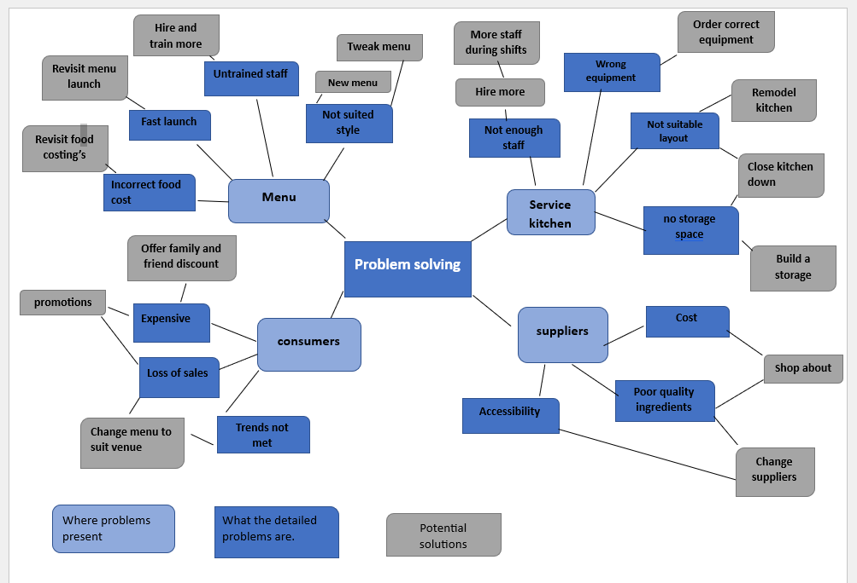

The above screen shot shows the process on how a mind map was created to try and find the root cause of the problem, creating a mind map the process helped greatly with complete understanding that all the potential problems are all linked in one way or another with a potential answer for possible solutions.

Analysis
- Menu
Apon analysing the mind map, I believe I came across one of the main factors of the root cause of the problem which includes the wrong style of food menu being permitted into the venue, with such a fast Launch of a menu with the prior kitchen team having no training in a different aspect of a menu this have proved to be problematic, the food cost prices that have been detailed within the specs of the food menus have proven to be inaccurate .

- Service kitchen
The main factor of an issue with service kitchen is that with such a minimum space this proved to be a little trickier with a higher demand of stock needed to fulfil the correct menu also including minimal space for well needed equipment, it was impractical.
The service kitchen only had room for one freezer with numerous fridges with main deliveries being delivered to a sistering venue up flights of stairs with the need to carry stock back in all different types of weather, this would mean numerous trips back and forth when stock was getting low.
Apon analysing the mind map I’ve concluded that the service kitchen’s key factor into the problem is that there just isn’t enough space, or the correct type of equipment being used, with a limited number of staff.

- Suppliers
During analysing the mind map the main factor I believe I can see all problem aspects are generally linked into one, with the fact that some ingredients are a little high costing with a poor-quality factor included, including an accessibility issue. Even though this key factor seems like a small one, it’s a very important key factor that controls the smooth running of all aspects of a business.

- Consumers
In conclusion with examining the data created within the mind map I’ve come to conclude with the prices expanding with a new menu launch that is not the normalised standard created within the business originally, there have been a generated loss of sales and regulation of consumers. The key factor for the problem that has affected the customers is with a menu change that is not well pleasant with a high price increase has created a loss of all.

5 why analysis
Loss of sales
Why?
Decrease of customers within a short time frame

Why?
Price increase with a change of menu

Increased food cost with more complicated food items
Why?

Why?
New ingredients with a higher cost increase to seem unique

Why?
A new type of cuisine to achieve a different clientele

A new cuisine style menu

Analysis
The 5 reasons why graph above takes us through very specific steps into achieving an understanding a reason on what the root cause of a problem is, by examining the graph I understand that the problem is presented as a loss of business, but the actual root cause of the problem is the new change of cuisine style to the menu.

Cause and effect analysis

Small kitchen with no storage
Staff
Venue
Incorrect equipment
Staff shortages
More described as a nightclub
Undertrained staff
Loss of sales
Increase pricing
Quick launched
High ingredient list
Under funded

Menu
Cost
High food costs
Over ambitious

Above shows a cause-and-effect diagram which helps determine some causes to the problem.
so, by examining the diagram I can conclude that the 4 main causes for the loss of earnings include staffing issues, venue issues, financial and finally the menu.
With the main four issues noted, the branches that lead of each different cause resembles a InSite into a potential solution.

Propose a range of alternative solutions to the problem
Kitchen
- One solution that could improve the problems regarding the kitchen aspect would be to have some more storage space to be able to hold the amount of stock that is needed for such a high demand menu.
- An increase in workable and functioning equipment to be able to produce the different menu items within a timely manner during service hours. With the option of newer and useful equipment this will help save a lot of problems and time.
- With the crisis of not having enough staff to deal with the demand and opening hours of the buisness, hiring and training newer staff would help take the burden of more sernior members of the team, with hiring and training and using the newest members of staff during peak times this gives an option for more sernior members to give full forcus during service hours, with having the extra help around with doing different jobs including preperations or stocking fridges up from sistering venue.
- a change in the layout of the kitchen could be a potential solution with adding in addition space, for items such as new equipment or storage facilitys, the only issue with this solution would be the kitchen would have to have a full remodel with a close of buisness to do so, with a higher loss of earning.
Menu
- One of the main causes of the problem is the fact that the menu isnt the correct style or cusine for the venue, so a potenial solution would be to revisit the menu, with checking through the consitancy of theme of the menu , with a potenial of a menu tweek or a whole new menu to suit the consumers wants.
- With having such a fast launch of a menu with no accerate time line, the whole team were unprepared, a potenial solution would be to close the venue, for the whole team. To have a day to provide staff the time and knowlegde needed to fully train and preare the staff , with creaiting specifications of how to correctly prepare and deliver a service. Creating a safe space to ask any questions of uncertainty.
- The menu cost was produced uncorrectly, this gave false information for both the priceing for ingredients and how much the cost was for a produced item. With the wrong costings complete this gave a lower profit margin. With also an increase in what the consumers were expected to pay , this contributed to a loss of customs. A potential solution would be to sit and tweek the menu and revisit all finacials, including item costings, production costs and food costs.
- Another solution would be to just monitor the progress of the how the newest menu change pans out with regualar assesments.
Suppliers
- There are a number of soltutions that could placed with in the suppliers chain ,one main solition would be with the effect of not having availbility for accessability to certain ingredients on times a change of suppliers, or to replace a menu item with a more accessible item.
- A more simpler solution would be to have an increase in suppliers with an idea of using a number of different suppliers to provide different services, this would be effective with costing issues.
Consumers
- A potential solution would be to offer a questionaire to consumers to help gain feedback from there experience.
- An offer of dicounts for quieter days will help increase consumers in the venue.
- Offer a family and friends rate for emplyees that can help bring buisness back into the venue
- Another potenial solution would be to create event nights where you offer a package including food ,drinks or a show , or a potenial for a game night with use of the game room including in packages.
Staff
- An increase in staff and training can help boost team moral, lower the load with offering normalised working hours, with the increase in acceptance with time off requests.

Using a decision-making technique, evaluate a range of solutions to identify the appropriate option

Grid analysis
Factors: | Cost | Time | Best for customer | Practical | Total
Weights: | 3 | 2 | 3 | 2
Menu tweak | 3 9 | 1 2 | 3 9 | 3 6 | 26
Menu change | 2 6 | 3 6 | 3 9 | 2 4 | 25
Increase suppliers | 3 9 | 2 4 | 2 6 | 2 4 | 23
Change suppliers | 2 6 | 2 4 | 1 3 | 1 2 | 15
Train staff | 2 6 | 2 4 | 3 9 | 3 6 | 25
Hire more staff | 2 6 | 2 4 | 3 9 | 3 6 | 25
Offer, discounts | 3 6 | 3 6 | 3 9 | 3 6 | 27
Remodel kitchen | 3 6 | 1 2 | 1 3 | 1 2 | 11
Close kitchen down | 0 0 | 0 0 | 0 0 | 0 0 | 0
Buy equipment | 1 3 | 3 6 | 1 3 | 3 3 | 15

The gride analysis above helps show the best possible solutions based on 4 main factors off the cost, the time scale, being in best interest of the customers and being practical. With creation of the grid analysis my top best possible solutions are:
- Offering discount offers through family and friends discounts , and speical events
- A small menu tweak which essentially means keeping the good parts of the menu and tweakinig the unpopular items.
- A equal draw on hiring more staff to join the team will all team members being kept upto date with training
- With finally an increase in suppliers, this basically means where a supplier is lacking in regards to the accessability of ingredients they can be sourced through another avenue.

Cost/benefit analysis

Cost analysis
Cost |  |  |  | Total of 4 weeks |  |  | Cost totals
 |  |  | Week 1 | Week 2 | Week 3 | Week 4
A full menu change |  |  | £5,000.00 | - | - | - | £5,000.00
Hire staff |  |  | £150.00 | £250.00 | £250.00 | £250.00 | £900.00
Train all staff |  |  | £1,200.00 | - | - | - | £1,200.00
Offer discount |  |  | £200.00 | £250.00 | £250.00 | £250.00 | £950.00
Buy new equipment |  |  | £5000.00 | - | - | - | £5,000.00
Total cost |  |  | £11,550.00 | £500.00 | £500.00 | £500.00 | £13,050.00

Benefit analysis

Benefits (cost) |  | Total of four weeks |  |  |  | Total
 | Week 1 | Week 2 | Week 3 |  | Week 4
Menu change | £5,000.00 | £5,000.00 | £5,000.00 |  | £6,000.00 | £21,000.00
Hire staff | £250.00 | £250.00 | £250.00 |  | £250.00 | £1000.00
Staff training | £150.00 | £150.00 | £150.00 |  | £150.00 | £600.00
Equipment | £200.00 | £200.00 | £200.00 |  | £200.00 | £200.00
Offers for customers | £1,000.00 | £1,000.00 | £1,000.00 |  | £1000.00 | £4000.00
Total cost | £6500.00 | £6500.00 | £6500.00 |  | £7500.00 | £27,000.00

The cost/benefit tables above are based on a 4-weekly status, that factors chosen both include cost incurred and benefits.
Based on the table above week 1 will sustain some high costs but will even out and eventually become a benefit for the organisation.
Training and hiring new staff will incur some costs to start but will eventually become a benefit as the venue will be more efficiently run with the potential to cater a higher demand.
The offer of promotions for customers will have a substantial amount of costs to begin with but will eventually bring more business into the venue.

Analysis

Total benefit = 27,000 = 2.1:1
Total cost 13.050

Net monthly benefit = Week 1 benefit – Week 1 cost =
6,500 -11,550 = -5050

Total weekly benefit = Total benefit -Total cost =
27,000-13,050= 13,950 / 4=
3,487.50 weekly benefit

By examining both the grid analysis and the cost-benefit analysis a full menu change is showing up as one of the best possible solutions with benefits in the long run, including hiring and training more staff all proves to be a benefit to the team and customers.

Develop a detailed plan for implementing solutions

C:\Users\Admin\Downloads\gavin\development plan-solutions .xlsx

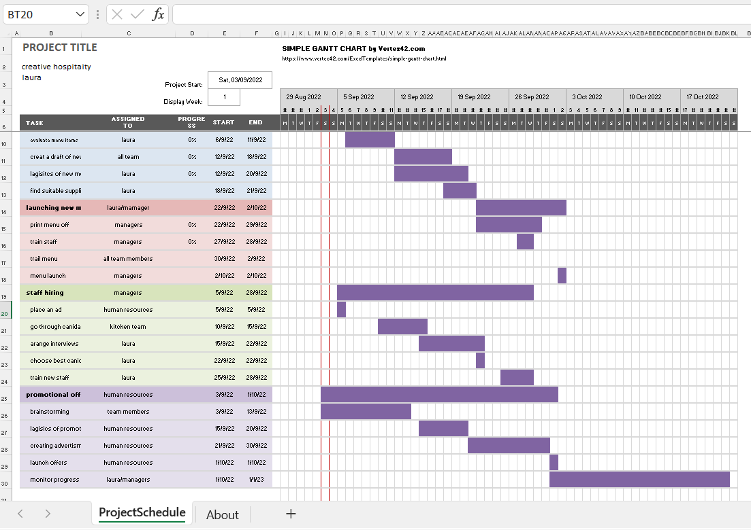

Above shows the process of how a solution will be implemented, with a timeline of when each solution would be concluded by all jobs have been delegated to different members of the teams, with even some teams to complete together. By creating a Gnatt plan the progress of the given solutions can be easily monitored with a specific timeline for each separate job to be completed by to complete a project in time.

Communicate the plan to relevant stakeholders

Relevant stakeholders to be communicated with.

Employees | Suppliers
Customers | Community surrounding
Human resources | Marketing
Menu printing services

Action plan of communication to relevant stakeholders.

Deliverable information | Recipients | Delivery method of communication | Schedule | Who’s responsible
Venue looking to hire more staff | - Employee  - Community  - Human resources  - Marketing | - Team meeting  - Emails  - Website  - Advertisements  - Social media marketing | When needed | - Kitchen manager  - General manager
Staff training | - All employees  - Human resources | - Team meetings  - Email  - Schedule training sessions | Keep informed of date scheduled  27/09/2022 | - Kitchen manager  - General manager  - Human resourses
Menu change | - Customers  - Employees  - Suppliers  - Menu printing services  - Community  - Marketing | - Team meetings  - Emails  - Face to face meetings  - Advertisements  - Website  - Social media | 3/09/2022  Kept up to date with relevant information  Regarding progress | - General manager  - Kitchen manager
Logistics of new menu | - Human resources  - Suppliers | - Face to face meetings  - Emails  - Phone calls | 12/09/2022  20-09/2022 | - Kitchen manager
Supplier changes and sorting stock lists out with pricing | - Employee  - Suppliers  - Human resources  - Owner | - Face to face meetings  - Emails  - Phone calls | Keep up to date on progress through out change | - Kitchen manager
When the menu will be printed and finalised | - Employee  - Human resources  - Community  - Menu printing services | - Face to face communication  - Emails  - Phone calls  - Website update | Keep in the loop of progress | - Human resources
When the Trail menu will launch | - Employee  - Suppliers  - Customers  - community | - Face to face communications  - Emails to all  - Advertisement strategies | 30/09/2022-  2/10/2022 | - Kitchen manager  - General manager  - Team members  - marketing
New Promotional offers | - Emplyee  - Customers  - Community  - Marketing  - Human resources | - Face-face meetings  - Emails  - Advertisement  - Phone calls | 3/09/2022 untilprogress is complete | - Kitchen manager  - Marketing  - Team manger  - Human resources
Details of when Full menu launch will be completed by | - Emplyees  - Customer  - Community  - Human resources  - Suppliers | - Team meetings  - emails  - advertisement  - phone calls | 2/10/2022 | - Kitchem manager  - General manager  - Human resources  - Marketing

Assess appropriate monitoring and review techniques to ensure successful implementation of solutions

To be able to monitor and review the success of the implantation of solutions there are a range of techniques that could be used. Monitoring the progress of the solution being implemented is an important aspect for success. The way’s in how we will monitor the progress would include:
- Gnatt charts
- The monitoring of sales
- Communication plans
- Questionairs
- Informal meetings
- Progress reports

With the Gnatt plan already produced with details of step-by-step tasks needed to be completed, with a certain deadline for the implantation of a solution to problem solve, A way in how I would monitor the progress of the plan would be to go to the relevant people the tasks have been assigned to and ask for a progress report of how the task is coming along.
The progress reports would include informal meetings for relevant people to give feedback on how their own tasks are coming along and if any issues have arisen, this is one way where vocal communication is best.
The monitoring of sales, once the relevant solution has been implemented is an important aspect to be able to see the progress of how the implemented solution is coming along, by monitoring sales we can check the progress of how this new solution to see an increase or decrease in sales.
Questionnaires and surveys are a useful tool to monitor progress, by using questionnaire techniques, the venue can have some honest feedback from the customers, this will help on receiving honest InSite into the progress of the solution.

References

Ayad, A. (2010). Critical thinking and business process improvement. The Journal of Management Development, 29(6), 556-564. 10.1108/02621711011046521
Belton, V., & Stewart, T. (2002). Multiple Criteria Decision Analysis an Integrated Approach (1st ed.). Springer US. 10.1007/978-1-4615-1495-4
Chevallier, A. (2016). Strategic Thinking in Complex Problem Solving. Oxford University Press.
Lu, Q. Y., & Wong, C. H. (2018). Additive manufacturing process monitoring and control by non-destructive testing techniques: challenges and in-process monitoring. Virtual and Physical Prototyping, 13(2), 39-48. 10.1080/17452759.2017.1351201
Mardani, A., Jusoh, A., MD Nor, K., Khalifah, Z., Zakwan, N., & Valipour, A. (2015). Multiple criteria decision-making techniques and their applications - a review of the literature from 2000 to 2014. Kosovska Istraživanja, 28(1), 516-571. 10.1080/1331677X.2015.1075139
Maund, A., Schriek, M., & Tinkler, P. K. (2017). Certificate in higher education: skills for the workplace student yearbook. Sage.
Proctor, T. (2018). Creative Problem Solving for Managers: Developing Skills for Decision Making and Innovation. Routledge.

