Name: Rashae Nikia Dennis
Student ID: 2008304@student.uwtsd.ac.uk
Module: Digital skills and research methods
Module Code: BMSW4003
Assignment Title: Component 2 Research Methods
Table of Contents
Contents page……………………………………………………………………………………………………………………………….1
(Introduction) 2
(About Angela Duckworth) 3
(Information) 4
(CRAAP) 5
(Knowledge) 6
(Data)…………………………………………………………………………………………………………………………………….. 7
(conclusion) ……………………………………………………………………………………………………………………………….8
(reference)……………………………………………………………………………………………………………………………….10

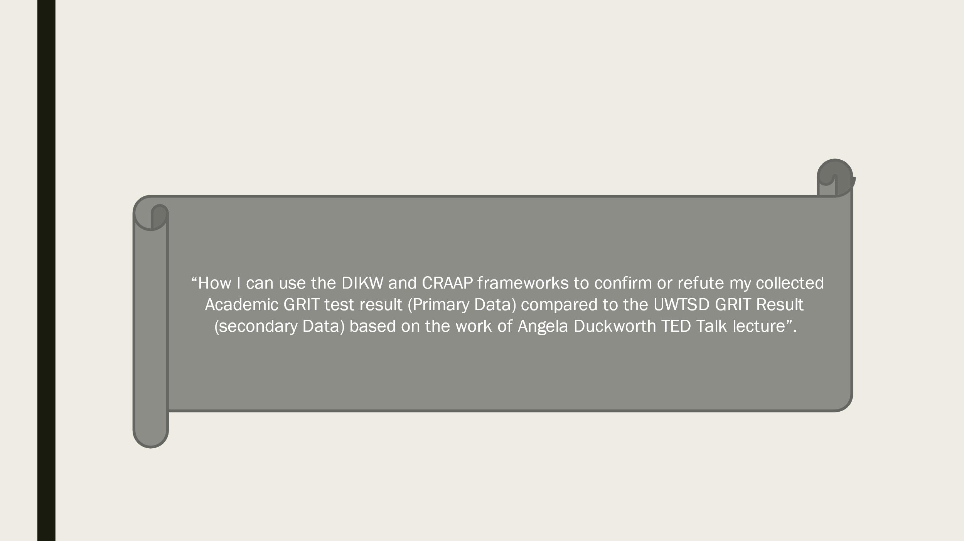

I am a student currently studying at UWTSD at the Sparkbrook campus. I am 22 years of age. In this report I will be demonstrating my digital skills by adding PowerPoint slides and excel onto a word document on the research methods and the use of grit that have been developed by Angela Duckworth. I will be demonstrating the use of graphs and collected data from forms to determine whether Angela’s theory passes the CRAAP test or not, using CRAAP and DIKW. By the end of this report, I will state whether I agree with Angela Duckworth or not and explain my reasons why.


Angela Duckworth Is a 51-year-old woman, from America. She is the founder and CEO pf character lab, which is a non-profit organisation to advance the scientific insights that help children thrive in their life. She is well known for her famous ted talk about grit: the power and perseverance. According to Angela the bigger the grit scores the higher the success. Is Angela’s theory, correct? In this report I will demonstrate whether Angela’s theory is correct or not. She has over 24 million views on her ted talk YouTube video. Do I trust Angela’s theory? To some extent because within our class we done the grit test and tested it against our highest level in education and the results corresponded with each other. What is academic grit? it is and individual characteristic or skill encompassing determination, resilience and focus on the pursuit of challenging long-term goals with the domain of education.

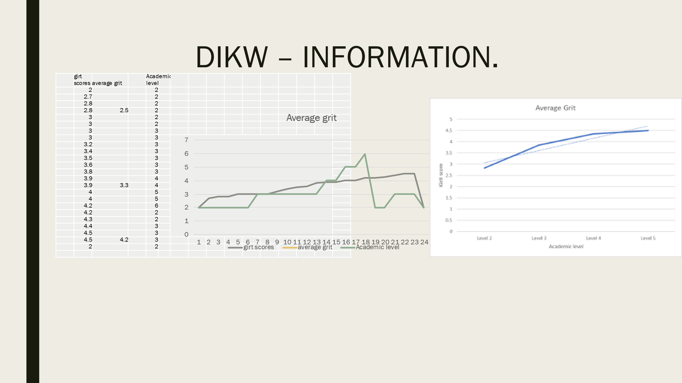
In our research for grit scores, the average grit in the class was 2.5, 3.3 and 4.2. with the academic levels ranging from level 2 – level 6. With this research it was shown that due to one person stating their highest academic level is a 6, it was trending down, however once the level 6 was removed from our data the scatter chart was trending up. We only had 14 people in our class to take part in our survey, whereas Angela had 1000s so that alone makes it weak evidence to use.
To make our research more accurate next time we would have to collect grit scores and academic levels from over at least 500 + people. Angela Duckworth stated that the higher the grit the grittier the person will be. During Angela’s ted talk she stated that she expected that her smarter kids with a higher IQ would get a higher grit score. But later researched and in conclusion came up with, what they need in education is a much better understanding of students and learning from a motivational and physiological perspective and wondered in your ability to do well in school and in life was based more than your ability to work quickly and easily (Duckworth, 00:1:25 – 00:1:50).
Many factors are included when a student is learning. In order for and individual to put their all in their work, they must be interested in it this way they’ll be more motivated in their learning and work. Getting enough sleep and eating well play a big part in why and how someone performs the way that they do in their studies, however that is not always the case grit is passion and perseverance for long term goals meaning sticking with your long-term goals and future for years not just the here and now, working hard to make sure you achieve that. So, people with a higher IQ may not always get high on the grit test due to their habits outside of learning. I found that for myself when I am producing an assignment or revising for a test I work best when I am in a room by myself and have my headphones on listening to music it helps me concentrate better.

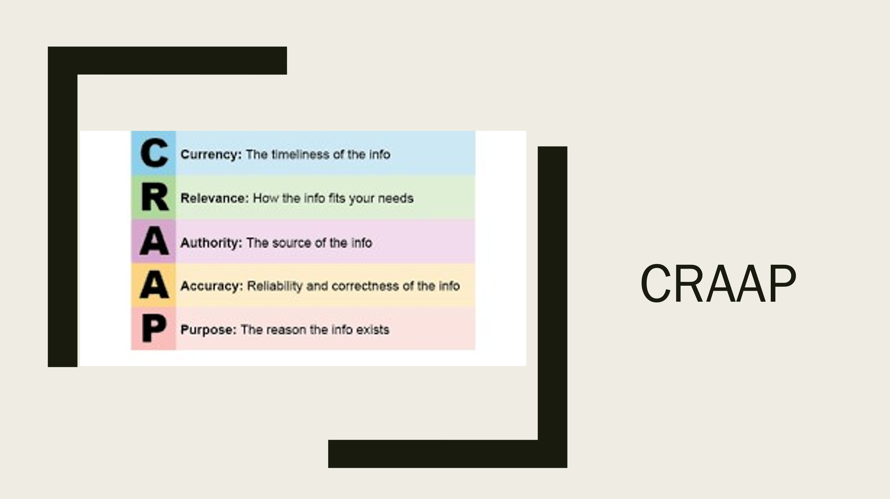
What is the CRAAP test? It is a test of one of the evaluation methods. I think that Angela Duckworth passes the CRAAP test and is deemed as credible because she has appeared in TED talks which is an honour to be invited to and you must show great leadership which Angela does very well. Angela knows what she is talking about and is very informative on her ideas she presents during her TED talk. Angela has published several journals, around 10 such as the roles of self-regulation and cognitive ability (Duckworth, 2021), the New York times and Chicago times. Angela’s research suggests that when it comes to high achievement, grit may be as essential as intelligence. Duckworth passes the CRAAP as she is still currently releasing interviews and journals to do with grit.
The information she releases is very credible as she has the science behind it to prove that grit is the power and perseverance to an individual’s intelligence. She completed her PhD in Psychology as a National Science Foundation Graduate Fellow at the University of Pennsylvania. So she has studied for numerous years and researched a lot to be able to deliver this information to us, also based on results of the research, Duckworth’s theory proves correct.



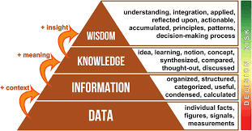(Ackoff, 2021)
Data to wisdom is a text produced by Russel L Ackoff, that appeared in journal of applied systems analysis in 1989. It is used to address the international society for general systems research (Essay Journal of Applied Systems Analysis 16: 3-9).
Relating to our research we had done as a class we had two sets of data, primary data which was our class results and secondary data which was given to us by the lecturer.
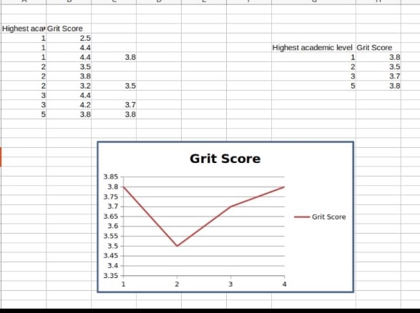 this graph is the secondary data and as you can see, it is showing that people with the lowest academic level has a high grit score in comparison to people with a level 2 and 3 academic level, which proves Duckworth right when she stated that its not always about how much smarter someone is than the next person but how determined the individual is to work harder towards their goal. In some cases, you have children whose highest academic level will be their GCSEs from when they leave school because they then go on to work an apprentice or for family members which is fine, but they still could be grittier than the child that went on to college and university. As they are focused on pursuing a lifelong goal in a different way opposed to the academic education.
PAGE 6 CONTINUED

This is the primary data from my classmates at university and as you can see it is different from the secondary data. This shows that the higher academic level the higher the grit. so this primary data corresponds with what Angela Duckworth was saying


During my research on Angela Duckworth, I created a form online for my classmates to answer two questions, their highest academic level and answer a few questions to determine their grit score. A URL form was sent to everyone in the class to collect the relevant data according to our class using Microsoft excel and I previously shown using the graphs. I collected everyone’s grit score from Angela Duckworth’s website and then went on the www.gov.uk website for everyone to select their highest academic level. The form was changed from qualitive to quantitative

As you can see here in this chart the primary data from my classmates shows that the higher the grit score the higher up you are academically. Therefore, we have clear trend line.

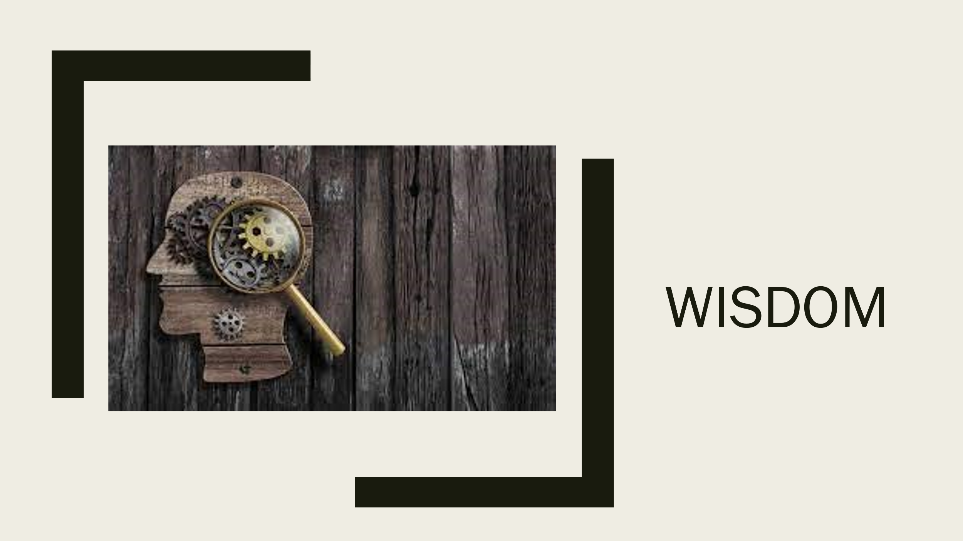
Wisdom is something we can use to improve someone’s grit. We can do this by pushing them through failure, instead of giving them a hard time for not getting it the first time; give constructive criticism, this way you could advise on what to do better next time and how they can achieve it. Keep going and going until you finally understand. Failure doesn’t mean the end. During Carol Dweck’s TED talk she stated that she learned that in Chicago high school students had to pass 84 units to graduate, and the students who didn’t pass this mark received a ‘not yet’ instead of a failure. This was because the teacher wanted to leave room for improvement and put them on a learning curve for the students and to give them the opportunity to have a ‘growth mindset’. (Dweck, 00:22 – 00:45).
This is allowing their core mindset to be tested. as most students run from difficulty but it is good to challenge the brain and allow yourself to fail and correcting your mistakes in your learning.
I also watched this video of Ron Berger who done a YouTube video called critique and feedback - the story of Austin’s butterfly. In this video he showed a group of kids a poorly drawn picture of a butterfly that a young boy drew, he then got the children to tell him what was wrong with the picture and what could be done better. Each child gave a critique, and each time Ron would show the improved portrait of the picture until it was perfect. The moral of this video was to not give up just because you didn’t get it right straight away, but to take constructive criticism and use that to improve and work on your work. This is helpful because something you may not understand the first time, someone else may understand or know a different way to do things which could help you do your best. This is a great way to teach people how to give and receive feedback.


To summarise I think that Angela Duckworth’s theory is correct. With all the research I have done everything correlates back to what she said about the bigger the grit scores the higher the success. The primary and secondary data graphs I have produced also correlate with this. How could we develop grit to improve students’ academic level, we could read informative books, share examples and ideas with each other, help students develop a growth mindset which leaves room for improvement I they don’t get it right the first time, reframe problems by using examples and stories to help get a better understanding and give them a perspective about problems to prevent them from giving up, quitting, or losing hope. People who are grittier can maintain their determination and motivation over long periods despite experiences with failure and adversity. Even though grit is defined as the combination of perseverance and passion its measurement has focused more on the perseverance and not so much the passion. I found that grit is made up of four physiological assets interest, practice, purpose and hope



- Ackoff, r., 2021. The DIKW model for knowledge management and data value extraction. [online] i-SCOOP. Available at: <https://www.i-scoop.eu/big-data-action-value-context/dikw-model/> [Accessed 9 December 2021].

- berger, r., 2008. [online] Youtube.com. Available at: <https://www.youtube.com/watch?v=hqh1MRWZjms> [Accessed 10 December 2021].

- Publicism - non-fiction documentary books. 2021. CONCLUSION - GROWING GRIT FROM THE OUTSIDE IN - Grit: The Power of Passion and Perseverance - Angela Duckworth. [online] Available at: <https://publicism.info/psychology/grit/14.html> [Accessed 10 December 2021].

- - Duckworth, A. L., Peterson, C., Matthews, M. D., Kelly, D. R. (2007). Grit: Perseverance and passion for long-term goals. Journal of Personality and Social Psychology, 92, 1087–1101.

- Duckworth, A. L., Quinn, P. D., & Tsukayama. E. (2021). Revisiting the factor structure of grit: A commentary on Duckworth and Quinn (2009). Journal of Personality Assessment. https://doi.org/10.1080/00223891.2021.1942022.
- Duckworth, a., 2021. ‘Grit,’ by Angela Duckworth (Published 2016). [online] Nytimes.com. Available at: <https://www.nytimes.com/2016/05/08/books/review/grit-by-angela-duckworth.html> [Accessed 9 December 2021].

- Dweck, c., 2021. [online] Youtube.com. Available at: <https://www.youtube.com/watch?v=hiiEeMN7vbQ> [Accessed 9 December 2021].

- duckworth, a., 2021. [online] Journals.sagepub.com. Available at: <https://journals.sagepub.com/doi/pdf/10.3102/0002831219843292> [Accessed 10 December 2021].

-Fessler, L., 2021. “You’re no genius”: Her father’s shutdowns made Angela Duckworth a world expert on grit. [online] Quartz. Available at: <https://qz.com/work/1233940/angela-duckworth-explains-grit-is-the-key-to-success-and-self-confidence/> [Accessed 10 December 2021].
- - Hong, Chiu, Dweck, Lin & Wan, 1999; Moser ET AL., 2011; Mueller & Dweck 1998; Nussbaum & Dweck 2008.

