Programme: M.Sc Engineering project Management
Module : Research Methods
Module Code: ACHA7027
Lecturer: Jordan Jenkins
Student Name: Md Saiful Islam
Student ID:2418665

Predictive Maintenance with machine learning models: integrating predictive maintenance to reduce manufacturing system downtime.

ABSTRACT
Research Problem:
Unplanned downtime is one of the outstanding issues in manufacturing systems and the research shows that industrial equipment failure can decrease the overall productivity by up to 20 percent and cost manufacturers billions of dollars per year. Conventional reactive and preventive maintenance approaches are usually ineffective, in that they cannot forecast failures effectively and give rise to either unnecessary maintenance or sudden failures.
Proposed Solution and Methodology:
This study hypothesizes the use of predictive maintenance models implemented by machine learning to resolve this problem. The study will work in a quantitative, simulation-based manner and employ the historical sensor data to create and test the predictive algorithms that would allow predicting the possible failures before they happen.
Aim and Significance:
The objective is to determine how well machine learning can be used to minimize downtime and enhance operational efficiency. This study, placed in the Industry 4.0 paradigm, is important because it fosters the shift toward intelligent, data-driven manufacturing systems, which makes them more reliable, cost-effective, and allows making decisions proactively.
Table of Contents

1. INTRODUCTION 1
1.1 Background Context 1
1.2 Problem Statement 1
1.3 Research Rationale 1
1.4 Research Aim 2
1.5 Research Objectives 2
1.6 Research Questions 2
2. LITERATURE REVIEW 2
2.1 Maintenance Strategy in Manufacturing 2
2.2 Predictive Maintenance (PdM) 2
2.3 Predictive Maintenance Machine Learning. 3
2.4 Industry 4.0 and Smart Manufacturing 3
2.5 Research Gaps 4
2.6 Conceptual Framework 4
3. RESEARCH METHODOLOGY 5
3.1 Research Philosophy 5
3.2 Research Approach 5
3.3 Research Design 5
3.4 Data Collection Methods 6
3.5 Data Analysis Techniques 6
3.6 Tools and Software 6
3.7 Justification of Methodology 6
4. EXPECTED RESULTS & DISCUSSION 6
5. EVALUATION & LIMITATIONS 7
5.1 Strengths 7
5.2 Limitations 7
5.3 Risk Factors 8
6. ETHICAL CONSIDERATIONS 8
7. TIMELINE of the project (GANTT chart) 8
8. CONCLUSION 9
References 10

1. INTRODUCTION

1.1 Background Context
The manufacturing systems are complex and intertwined environments where the efficiency of operations is paramount to the sustainability of productivity, cost control and competitiveness (Rahman and Schmidt, 2026). Maintenance strategies are one of the main factors of efficiency in such systems, as they guarantee efficient equipment reliability and availability. There are three major maintenance strategies which are traditionally adopted. Reactive maintenance is the act of fixing equipment once it has broken down, and this can be very expensive in terms of down time and lost production. Preventive maintenance on the contrary, plans the routine servicing to minimize the risks of failure, but may cause some unnecessary maintenance procedures and high operation expenses. Predictive maintenance is a more recent trend in the data-driven paradigm that relies on real-time monitoring and analytics to identify equipment failures before they happen.

1.2 Problem Statement
Unplanned downtime has been a major problem in manufacturing despite the improvement in maintenance strategies. Research indicates that unexpected equipment failures could contribute to a total of 30 percent of all production downtimes, with giant manufacturing companies incurring an estimated cost of $50 billion per annum in terms of unwanted downtimes. These disruptions not only escalate the cost of operation, but also the reliability of the supply chain and customer satisfaction. The conventional approaches to maintenance are constrained by the fact that they cannot handle real-time information and forecast failure precisely.

1.3 Research Rationale
This issue can be solved radically by the introduction of machine learning (ML) into predictive maintenance (Serradilla et al., 2022). ML empowers the use of data to make critical decisions as it analyses extensive amounts of sensor and operational data to identify trends and irregularities that could point to possible failures. This enables the detection of faults in real-time and planning maintenance more accurately, minimizing the amount of unnecessary interventions and avoiding unforeseen failures.

1.4 Research Aim
To explore the use of machine learning-based predictive maintenance models to minimize downtime in manufacturing systems.

1.5 Research Objectives
The research will assess the current methods of maintenance and also determine their shortcomings, examine different machine learning algorithms including regression and classification models, create a predictive maintenance system, and determine its success in minimizing downtime in a manufacturing setting.

1.6 Research Questions
This study aims to establish the effectiveness of predictive maintenance compared to the conventional methods, which machine learning models are the most effective in predicting downtimes, and what obstacles organisations encounter when implementing such sophisticated systems.

2. LITERATURE REVIEW

2.1 Maintenance Strategy in Manufacturing
The strategies of maintenance have changed considerably due to the growing complexity of industries and the necessity to be efficient in their operations (Firdaus, Ab-Samat and Prasetyo, 2023). The simplest technique is reactive maintenance, also commonly known as run-to-fail, wherein equipment is repaired on failure. Although this method is cheap in the initial setup, it has been largely criticised as the cause of high unplanned downtimes and massive production losses. Research has shown that emergency repairs and prolonged downtimes may raise maintenance expenses by 40 percent because of reactive maintenance. Preventive maintenance that is scheduled maintenance that is carried out on a time or usage schedule is designed to minimize unforeseen failures. Though it is more reliable than reactive approaches, it usually results in over-maintenance, which raises labour and material expenses, which are unnecessary.

2.2 Predictive Maintenance (PdM)
Predictive maintenance is a transformation of a schedule-based to condition-based maintenance. It is closely dependent on condition monitoring methods and in this approach sensors constantly gather information like temperature, vibration, pressure and sound signals of equipment. The main advantage of PdM is that it can ensure optimum maintenance planning, which will result in the minimisation of unnecessary interventions and the minimisation of downtime. Empirical data demonstrate that PdM adoption in companies can result in as much as 25% of equipment life and 10-20 percent of total equipment effectiveness (OEE) (Mandan et al., 2025). Nonetheless, PdM has its limitations. It relies greatly on the quality of data and the predictions made may be incorrect in the event of poor quality data.
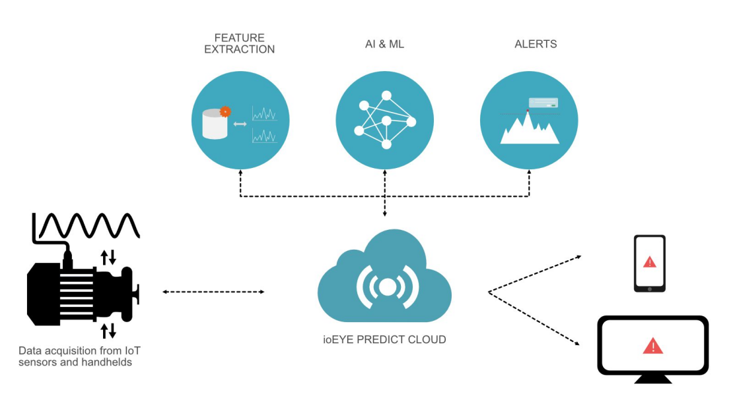
Figure 1: Predictive Maintenance
Source: (SenseGrow, 2023)

2.3 Predictive Maintenance Machine Learning.
Machine learning has become one of the most important facilitators of predictive maintenance by offering high-level analytical practices to process great amounts of industrial data. Random Forest and Supported Vector Machines (SVM) are examples of a type of supervised learning model that is popular in classification and regression problems, which include failure prediction and prediction of remaining useful life (RUL) (Mogal et al., 2024). These models are based on labelled datasets to learn the pattern that is related to equipment failures, and have proven to be extremely precise in this case under controlled conditions. Indicatively, the Random Forest models have been demonstrated to attain over 90 percent prediction accuracies in some industrial applications. Although effective, ML models have issues of overfitting, interpretability and require large, quality datasets. Moreover, the enactment of these models in real-time industrial systems is also a complicated endeavor that involves powerful computation systems.

2.4 Industry 4.0 and Smart Manufacturing
Industry 4.0 has also played a major role in hastening the use of predictive maintenance through the integration of digital technologies into manufacturing systems. The key aspect in this change is the Internet of Things (IoT) sensors, which enable continuous data gathering of machines and processes (Sallam, Mohamed and Mohamed, 2023). Big data analytics techniques are used to analyse these sensors to extract meaningful information in large volumes of data. The integration is further improved by cyber-physical systems (CPS) which create an opportunity to communicate between physical machines and digital platforms to monitor and have control in real-time. The latest industry news states that more than 70 percent of manufacturers are investing in Industry 4.0 to enhance their operational performance and decrease downtime. The IoT, big data, and machine learning are synergistic to provide the basis of intelligent maintenance systems that can self-diagnose and make autonomous decisions.

2.5 Research Gaps
Although there is an increasing amount of research related to predictive maintenance, there are still a number of gaps. To begin with, standardised machine learning models, an application of which can be generalised and used across various manufacturing environments, are missing. The majority of the research is specific to case scenarios, so the results can rarely be generalised. Secondly, proposed models cannot be validated in the real world as a lot of research uses simulated or small datasets. This casts doubt on the realism of these models in an ever-changing industrial environment. Third, the lack of extensive integration systems with machine learning models and current manufacturing systems is rather pronounced.

2.6 Conceptual Framework
The study is supported by a conceptual model that combines machine data, machine learning models, and maintenance outcomes. The input layer includes real-time machine data that is measured by sensors and contains parameters like temperature, vibration, and pressure. The data is fed to machine learning algorithms, which can detect patterns and anomalies that can signal possible failures. The result of this process is a forecast of equipment health, which allows the timely maintenance intervention. The end result of this framework is to minimise unexpected downtime, streamline the maintenance process, and make the system more efficient.
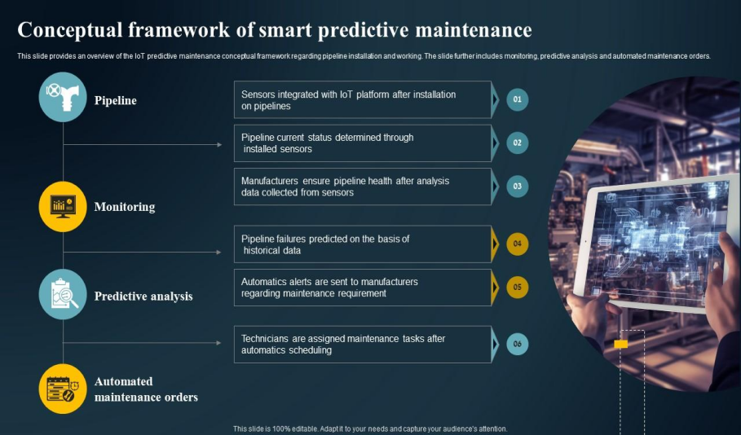
Figure 2: Conceptual Framework Of Smart Predictive IoT Predictive Maintenance
Source: SlideTeam (2024)

3. RESEARCH METHODOLOGY

3.1 Research Philosophy
The research philosophy used in this study is positivist, suitable in the study that is based on measurable, objective, and data-driven research (Lim, 2023). Positivism is an assumption that reality is measurable and observable based on empirical evidence, which is most applicable to engineering and manufacturing research. The predictive maintenance machine performance indicators include temperature, vibration, and failure rates, which can be objectively measured and analysed.

3.2 Research Approach
It uses a deductive research method since the study is based on the existing theories of machine learning and maintenance engineering. Deduction is the process of subjecting proven ideas and models to empirical data in order to test their relevance to a particular situation. To assess the effectiveness of predictive maintenance theoretical models and machine learning algorithms on manufacturing data, this study implements both models on manufacturing data to determine their efficiency in decreasing downtimes.

3.3 Research Design
The study follows a quantitative design, where it deals with numerical analysis and statistical analysis (Pregoner, 2024). The simulation-based or experimental design will be applied to model the real-world manufacturing scenarios. This architecture enables the experimental testing of machine learning algorithms in varying conditions, which is both consistent and reliable in the results. Such research is best applicable to quantitative research since it allows measuring accurately the performance indicators, e.g., prediction accuracy, downtime reduction, and system efficiency.

3.4 Data Collection Methods
The research will mainly be based on the secondary sources of data, where available industrial data and equipment sensors will be used. The variables usually found in these datasets include machine temperature, vibration levels, pressure readings and failure logs. Simulated datasets can be used in situations where there is no real-world data available to recreate manufacturing conditions. The secondary data are cost-effective and feasible since they ensure that large datasets required to train machine learning models are available (Dou et al., 2023).

3.5 Data Analysis Techniques
The collected data will be analysed using machine learning and predictive models will be created. Supervised learning algorithms such as logistic regression, decision trees and random forest will be applied in classification and prediction. Logistic regression gives a basic model on which to classify binary, whereas decision trees offer insight into the determination of decision rules.

3.6 Tools and Software
It will be analyzed with the help of Python, with the help of machine learning models development and assessment libraries, including Scikit-learn. Python finds diverse applications in industrial analytics because it is flexible, scalable, and has great support of data processing.

3.7 Justification of Methodology
The choice of a quantitative approach is explained by the fact that objective and data-oriented information is required regarding the equipment functioning and prediction of its failures (Eichenseer and Winkler, 2024). In comparison with qualitative methods, which are subjective in nature, quantitative methods allow determining the results and verifying them with statistics. This type of research is especially suitable where machine learning models are applied because these models can process large amounts of data and detect complicated patterns that cannot be detected by traditional methods of analysis.

4. EXPECTED RESULTS & DISCUSSION
This research project expects the use of machine learning (ML)-driven predictive maintenance models to substantially reduce unplanned downtime in manufacturing systems (Khan et al., 2026). According to previous empirical studies, predictive maintenance can potentially reduce downtime by up to 30-50 per cent and maintenance costs by some 20-30 per cent, which is why it has a high performance improvement potential. We expect that sophisticated ML models, especially the ensemble techniques like the Random Forest, will be more accurate in their predictions than the classical statistical models. Better forecasting of equipment failure will allow creating a more efficient maintenance schedule, minimizing unneeded interventions and avoiding the unexpected breakdowns.
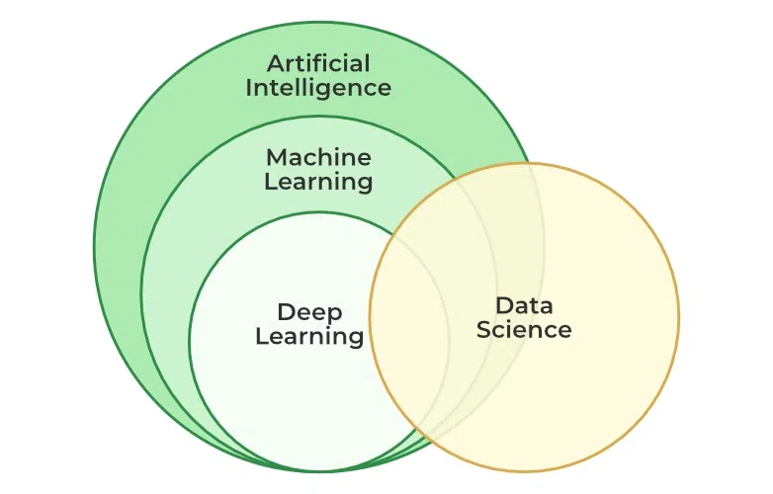
Figure 3: Machine Learning
Source: (GeeksforGeeks, 2025)

5. EVALUATION & LIMITATIONS

5.1 Strengths
The proposed research is reinforced by a data-driven approach, which makes the analysis objective and allows evidence-based conclusions (Lyu, 2025). Large and complicated datasets can be processed using machine learning models, which makes the results stronger and more legitimate. Also, the suggested predictive framework can be scaled and adapted to a range of manufacturing settings, which increases its expediency in the field. This is in line with the current trends in the industry where more than 60 percent of manufacturers are investing in data analytics in an attempt to enhance operational performance.

5.2 Limitations
Although the study has its strengths, it has a number of limitations. Among the key challenges is accessibility and quality of high-quality industrial data because a substantial number of organisations do not share their data because of confidentiality issues. Moreover, machine learning models can have accuracy limitations, especially when they are trained with small or unbalanced data.

5.3 Risk Factors
The main risks are those related to the quality of data, like the absence or poor quality of data, which can also impact the model performance very strongly (Aliferis and Simon, 2024). Also, one can easily overfit models, in which they work well on training data but do not generalise to reality. Data preprocessing, data validation methods and model selection will be used to mitigate these risks.

6. ETHICAL CONSIDERATIONS
The ethical considerations are the main focus of the given research, especially given the use of industrial data and machine learning models (Eyo-Udo et al., 2025). Privacy and confidentiality will be highly adhered to and the industrial datasets used will have to be anonymised and must not violate the data protection laws. Most manufacturing datasets have sensitive operational data; hence, there will be good data handling practices that will be adopted to prevent unauthorised access or misuse. The study will make sure that data will not be used in any commercial way.
There should also be transparency of model development and results. Machine learning models may easily be treated as black boxes, which begs the question of interpretability and trust.

7. TIMELINE of the project (GANTT chart)
- Month 1 – Literature Review
- Carry out intensive research on current academic publications and industry reports.
- Identify research gaps and define conceptual framework
- Month 2 – Data Collection
- Collect secondary industrial measurements (sensor measurements, failure measurements)
- Do data cleaning and preprocessing.
- Month 3 – Model Development
- Choose the right machine learning algorithms (e.g., Random Forest, Decision Tree).
- Optimise predictive models.
- Month 4 – Analysis & Results
- Measure model performance based on accuracy, precision and recall.
- Make conclusions and draw a comparison to the literature.
- Month 5 – Writing & Revision
- Prepare a report on findings of research.
- Revise, re-read, and polish messages.
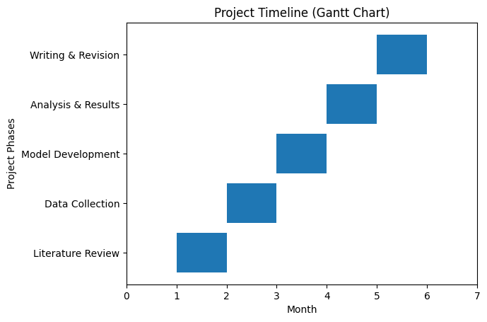
Figure 4 : Project Timeline
Source: Self Made

8. CONCLUSION
To summarize, predictive maintenance is an essential step in the contemporary manufacturing industry, as it helps to solve the old problem of unexpected downtime by using data-driven solutions. This study suggests the combination of machine learning models to improve the precision of failure forecasting and maintenance time optimisation. Its scholarly significance is that it expands existing information on predictive maintenance models, whereas its practicality is seen in the ability to enhance operational efficiencies, cost-reduction, and Industry 4.0 implementation. All in all, the study presents a strong basis of future study and practical application.

References
Aliferis, C. and Simon, G., 2024. Overfitting, underfitting and general model overconfidence and under-performance pitfalls and best practices in machine learning and AI. Artificial intelligence and machine learning in health care and medical sciences: Best practices and pitfalls, pp.477-524.https://link.springer.com/content/pdf/10.1007/978-3-031-39355-6_10.pdf
Dou, B., Zhu, Z., Merkurjev, E., Ke, L., Chen, L., Jiang, J., Zhu, Y., Liu, J., Zhang, B. and Wei, G.W., 2023. Machine learning methods for small data challenges in molecular science. Chemical Reviews, 123(13), pp.8736-8780.https://pmc.ncbi.nlm.nih.gov/articles/PMC10999174/pdf/nihms-1979743.pdf
Eichenseer, P. and Winkler, H., 2024. A data-oriented shopfloor management in the production context: a systematic literature review. The International Journal of Advanced Manufacturing Technology, 134(9), pp.4071-4097.https://link.springer.com/content/pdf/10.1007/s00170-024-14238-8.pdf
Eyo-Udo, N.L., Apeh, C.E., Bristol-Alagbariya, B., Udeh, C.A. and Ewim, C.P.M., 2025. Review of ethical considerations and dilemmas in the field of AI and machine learning. International Journal of Multidisciplinary Research and Growth Evaluation, 6(1), pp.827-834.https://www.allmultidisciplinaryjournal.com/uploads/archives/20250118181128_MGE-2025-1-124.1.pdf
Firdaus, N., Ab-Samat, H. and Prasetyo, B.T., 2023. Maintenance strategies and energy efficiency: a review. Journal of Quality in Maintenance Engineering, 29(3), pp.640-665.https://www.emerald.com/jqme/article-pdf/29/3/640/1711986/jqme-06-2021-0046.pdf
GeeksforGeeks (2025) What is Machine Learning? Available at:https://www.geeksforgeeks.org/machine-learning/ml-machine-learning/
Khan, U., Cheng, D.S., Setti, F., Fummi, F., Cristani, M. and Capogrosso, L., 2026. A comprehensive survey on deep learning-based predictive maintenance. ACM Transactions on Embedded Computing Systems, 25(2), pp.1-43.https://dl.acm.org/doi/pdf/10.1145/3732287
Lim, W.M., 2023. Philosophy of science and research paradigm for business research in the transformative age of automation, digitalization, hyperconnectivity, obligations, globalization and sustainability. Journal of Trade Science, 11(2-3), pp.3-30.https://www.emerald.com/jts/article-pdf/11/2-3/3/1719327/jts-07-2023-0015.pdf
Lyu, G., 2025. Data-driven decision making in patient management: a systematic review. BMC medical informatics and decision making, 25(1), p.239.https://link.springer.com/content/pdf/10.1186/s12911-025-03072-x.pdf
Mandan, A., Jamaludin, K., Mandan, S., Shah, S. and Soomro, A., 2025. Evaluating Readiness for OEE Aligned with Industry 4.0 in Pakistan’s Dates Packaging Industry: A Systematic Literature Review. International Journal of Academic Research in Business and Social Sciences, 15(11), pp.141-153.https://kwpublications.com/papers_submitted/19331/evaluating-readiness-for-oee-aligned-with-industry-40-in-pakistans-dates-packaging-industry-a-systematic-literature-review.pdf
Mogal, S., Bhandare, R.V., Phalle, V.M. and Kushare, P.B., 2024. Fault Diagnosis and Prediction of Remaining Useful Life (RUL) of Rolling Element Bearing: A Review State of Art. Tribologia-Finnish Journal of Tribology, 41(1–2), pp.28-42.https://journal.fi/tribologia/article/download/141503/93736
Pregoner, J.D., 2024. Research approaches in education: A comparison of quantitative, qualitative and mixed methods. IMCC Journal of Science.https://hal.science/hal-04879841/document
Rahman, A. and Schmidt, A., 2026. Exploring the Sustainability Metrics in AI-Enhanced Automated Manufacturing Systems. Available at SSRN 6285418.https://papers.ssrn.com/sol3/Delivery.cfm?abstractid=6285418
Sallam, K., Mohamed, M. and Mohamed, A.W., 2023. Internet of Things (IoT) in supply chain management: challenges, opportunities, and best practices. SMIJ, 2(2), p.32.https://smartfoodsafe.com/wp-content/uploads/2024/09/Internet-of-Things-IoT-in-Supply-Chain-Management.pdf
SenseGrow (2023) Predictive maintenance (PdM) solutions. Available at:https://www.sensegrow.com/solutions/predictive-maintenance-pdm
Serradilla, O., Zugasti, E., Rodriguez, J. and Zurutuza, U., 2022. Deep learning models for predictive maintenance: a survey, comparison, challenges and prospects. Applied Intelligence, 52(10), pp.10934-10964.https://arxiv.org/pdf/2010.03207
SlideTeam (2024) Conceptual framework of smart predictive IoT predictive maintenance guide. Available at:Conceptual framework of smart predictive IoT predictive maintenance guide

