

BEng Major Project for the Design and Development of a Turret Control System
by
Mr Harry McAuliffe
Supervisor: Dr Gary Jones
Second Marker: Dr John Rees

Project submitted as part of the requirements for the award of BSc(Hons) Test Range Engineering

June 2017

Declaration FORM AND FORM OF CONSENT
DECLARATION

I, Mr Harry George McAuliffe declare that I am the sole author of this Project; that all references cited have been consulted; that I have conducted all work of which this is a record, and that the finished work lies within the prescribed word limits.

This work has not previously been accepted as part of any other degree submission.

Signed: .............................................

Date: ...............................................

FORM OF CONSENT

I Mr Harry George McAuliffe hereby consent that my Project, submitted in candidature for the B.Sc. Test Range Engineering degree, if successful, may be made available for inter-library loan or photocopying (subject to the law of copyright), and that the title and abstract may be made available to outside organisations.

Signed: .............................................

Date: ...............................................

BEng Major Project for the Design and Development of a Turret Control System
This document will define the research, development, design and evaluation of a Turret Control System (TCS), produced as an individual BEng Major project.
Mr Harry McAuliffe
P144278
Major Project (All Year 3 Students, SOAC); M3X8645
Dr Gary Jones


Table of Contents

Declaration FORM AND FORM OF CONSENT
Table of Contents 2
Abstract 4
Acknowledgements 4
Table of Figures 5
1. Introduction 6
1.1 Aims 7
1.2 Objectives 7
2. Research and Literary Review 8
2.1 Existing Systems 8
2.1.1 CROWS & CROWS II 9
2.1.2 L118 Light Gun 9
2.1.3 L131 AS90 Self Propelled Gun 10
2.2 Closed-loop Control Systems 10
2.2.1 Absolute Rotary Encoder Servomotor 11
2.2.2 PWM Servomotor 12
2.2.3 PID Servomotor 13
2.3 Open-loop Angular Control Systems 13
2.3.1 Stepper Motor 13
2.4 Methods of Input 13
2.4.1 Manual Operation 14
2.4.2 Touchscreen Control 14
3. Project Plan 15
3.1 Project Targets 15
3.2 Project Plan 16
4. Design and Implementation 17
4.1 Design 17
4.1.1 Component Selection 17
4.2 System Hardware Overview 19
4.2.1 System Software Overview 20
4.2.2 System Software Concept and Operation 21
5. Manufacture and Development 23
5.1 Hardware Implementation 23
5.1.1 Hardware Development 34
5.1.2 Software Implementation 36
5.1.3 Software Development 37
6. System Evaluation and Review 38
6.1 Future Improvements 39
7. Project Evaluation and Review 39
7.1 Future Improvements 40
8. Project Conclusion 40
Bibliography 40
Appendices 42
Appendix A – Servomotor Signal Range Test Code 42
Appendix B – Joystick Micro-switch Response Test 43
Appendix C –Servomotor “Degrees-to-Duty Cycle” Comparison Code 44
Appendix D – Draft Joystick and Servomotor Code 45
Appendix E – Draft Touchscreen Input Code 47
Appendix F – Draft Directory Code 51
Appendix G – Amalgamated Final Code 52
Appendix H – Project Plan 60

Abstract

The project was conducted well in hindsight. The project progressed well against the established timeframe outline in appendix H. There are a number of minor changes to this timeline that I believe would have increased the quality of the product.
Firstly, more time should have been allocated to the literary and design review. This was a crucial stage in the project to determine and plan to best way to deliver the project requirements. It was however, treated as a roadblock, or a ‘paper exercise’ to fulfil the requirements of the Test Range Engineering Course.
Further to this, not enough time or care was dedicated to the development of the software prior to the initial delivery. This process was undertaken and recorded for the hardware component, however no alternative methods of software delivery were considered. By the time that the software was reviewed by the project consultants, the project was too near the delivery date to have attempted such a dramatic overhaul of the process. Allowing just three weeks at the end of the project to troubleshoot the various and numerous software and hardware errors was a gross underestimation of the workload.

Acknowledgements

The completion of this project would not have been possible without the participation and assistance of a great number of people. I would particularly like to express my deep appreciation and thanks to the following individuals:
Ms Vicky Boothman, Mr Reece Franklyn and Mr Gary Waller for their endless support in the development of both the hardware and software required to produce the working turret model.
Dr Gary Jones, Dr Stephen Mosey and Dr John Rees, who have given the guidance, support and patience necessary to assist in the delivery of this material.
Ms Julie Cope, Dr Rhydian Harries and Mr Clive Chapman and the respective QinetiQ teams that have provided me with the time and opportunity to pursue this project to its conclusion.
Finally, I would also like to extend my thanks to the relatives, friends and others who have, in one way or another, shared their support; morally, financially and physically.

Table of Figures

Figure 1. Existing Weapon Systems 6
Figure 2. Closed-loop Control Diagram 8
Figure 3. Digital to Analogue Convertor 9
Figure 4. Pulse Width Modulation Controlled Servomotor 10
Figure 5. System Hardware Overview 17
Figure 6. System Software Overview 18
Figure 7. SG90 Servomotor Accuracy Data 24
Figure 8. Joystick Controller Wiring 26
Figure 9. Turret Rig Sketches 29
Figure 10. Final Hardware Construction 31
Figure 11. Angular Error Data 33

Introduction
As the Information Age begins to reveal the possibilities of computing power and micro-electronics; remote turrets and fire control systems have begun to see greater use on the battlefield. From aim assistance computers like the L118 Layers Control Display Unit, to all-up remote weapon stations like CROWS II, these technologies are still in a relative state of infancy.
An array of countries ranging from the United States to Russia, South Africa to Germany, currently employ such equipment for military service. Superior accuracy, rapid engagement speed, improved low light visibility and threat detection software play a crucial role in the survivability of vehicles and troops on the ground. This technology has been responsible for saving many the lives of allied soldiers in conflicts over the last decade. (1)
The health and safety requirements applied to QinetiQ by the Health and Safety Executive (HSE) demand that personnel are competent, well trained and familiar with such systems when required to operate them for test purposes. (2) However, the frequency of such trials determines that knowledge fade is a significant issue for the company. For this reason, the company has been interested to develop training methods that can increase the retention rate of information for the operators.
Training aside, electronic assisted aiming is not new. The technology and ideology behind these innovations presses the boundries of Artificial Intellegence and autonamous weapon systems; capable of selecting and engaging targets without human intervention. To date, the United States, South Korea, China, Russia and Israel have openly expressed an interest in the benefits of such technologies. (3)
From a Test and Evaluation perspective, this surge of innovation poses a great many new challenges; How is it possible to safely evaluate an autonamous system? What are the implications of component failure? What assurances must we have that the device will always “Fail-safe” when damaged?
Any avid fan of the “Terminator” franchise will know that this subject Is fraught with controversy. Many activist groups, such as the “Campaign to Stop Killer Robots”create the demand that such work is carried out to the very highest standards of safety and care. (4) For these reasons, it is essential that personnel conducting such activities are sufficiently trained and understand the electronic principles in effect.
It is the intent of the author, to produce an engineering solution to the proposed issues. To create a training aid that will allow operators to practise and refine their skills of Target setting and Laying; while also providing instructors with a suitable model with which to explain the electronic principles at play.

Aims
The aim of this BEng Major Project is to research, develop and deliver a working model of a Turret Control System. This system is to be employed within QinetiQ as a training aid in the delivery of fire control principles to personnel operating within the Maritime, Land and Weapons Division.
The user is to input a firing solution, known colloquially as the point-of-aim. This will then be processed through one of two mediums. Either the director motors will orientate the model accordingly, or the user will manually operate these motors to achieve the desired direction. These two control systems correspond to two in-service large calibre gun systems with the British Army; AS90 & L118 Light Gun. It is hoped that this novelty aspect to the training will allow for better retention of the course material; and a cost effective, hands-on approach to the principles at play.
Furthermore, it is essential that the model software does not disclose any sensitive information as to the exact operation or limitations of its real life counterpart.

Objectives
The objective of this task is to develop a dynamic 3D model of a turret system, and a touchscreen graphical user interface to reflect the layer's display and control unit (LCDU) in both the AS90 & L118 weapon systems.
This System must include a 12V DC Power Input, regulated to 5V for use with the system controller; an On/Off Switch, coupled with an LED in series to provide feedback as to the on/off state of the circuit; two separate methods of user control, manual and automatic positioning; two planes of movement, limited to 360° and 90° respectively.
This system should include the capability to control directional output with sub-degree accuracy; the turret should have a damping element to prevent excessive oscillation; capability to allow unlimited rotation of turret shaft; and incorporate a physical visual angular reference beneath the turret.

Research and Literary Review

Existing Systems
The review of existing turret control systems within the defence sector is essential to achieve the aim of the project. As a training aide, the proposed system must be able to reasonably emulate the current in-service British software. It is also suggested that background information on each system is necessary to provide context as to the typical operation environment of such technology.
Weapon System | Calibre | Type | Image
M101 CROWS | Various:  5.56mm  7.62mm  12.7mm  40mm Grenade | All-up remote weapon station (RWS) | 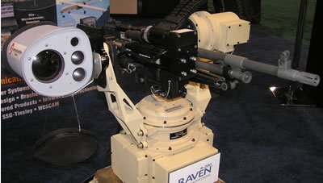
M153 CROWS II | Various:  5.56mm  7.62mm  12.7mm  40mm Grenade | All-up remote weapon station (RWS)  Improved Optics  Laser ‘Dazzler’ | 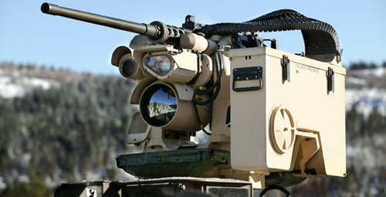
L118 Light Gun | 105mm | Aim Assistance | 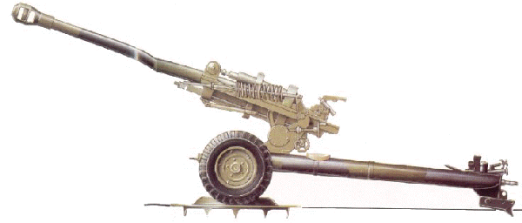
L131 AS90 SPG | 155mm | Aim Assistance  Autolay | 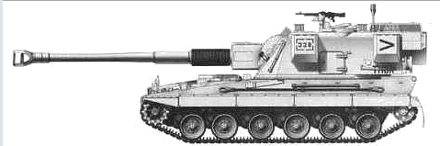
Figure 1. Existing Weapon Systems

CROWS & CROWS II
“The primary purpose of the CROWS is to get the gunner out of the turret, where he is exposed to enemy fire and fragmentation, and get him down inside the vehicle for protection”
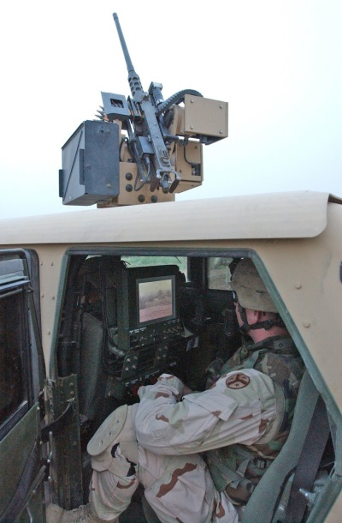
Sgt. 1st Class Sam Cottrell
The Common Remotely Operated Weapon Station (CROWS) is a computerised weapon mount; compatable with an array of weaponry. CROWS development stemmed from an Urgent Operation Need request by the US Military during Operation Iraq Freedom in December 2004; the system passed into service just two months later in february 2005. (5)
CROWS received mixed reviews from soldiers. The increased gunner protection, weapon accuracy, laser rangefinding, thermal imaging and optical zoom were significant improvements; some felt that the system took away from the battlefield awareness of the operators.
In 2009, the US Army contacted Kongsberg Protech Systems to develop a variant of their M151 PROTECTOR Remote Weapon System. This variant would later become known as CROWS II, featuring an increased field of view, greater optical zoom magnification, increased thermal imaging resolution, minor weight reduction and a laser “Dazzler”. This laser could be used as a non-lethal method of disabling targets who were not posing an immediate threat to life; such as drivers who fail to slow down when approaching checkpoints. Typical effects include dizziness, sickness and temporary blindness.
To date, the US has employed this weapon platform on a wide array of tanks, light-skinned combat vehicles and troop transports. It is estimated that well over a thousand units have seen operational use, a feat that is rarely achieved in modern warfare.

L118 Light Gun
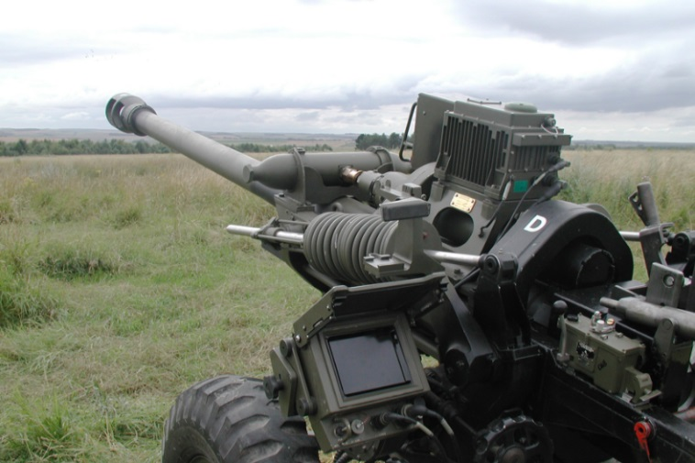
The L118 105mm Light Gun was developed at Fort Halstead by the Royal Armament Research and Development Establishment (RARDE), entering service in 1974. An L7A1 Optical Quadrant Elevation Dial Sight was used to aim the ordnance for indirect fire, and iron sights were mounted for direct engagements. Still in service today; the weapon system can be towed by most vehicles in service with the British military; slung beneath a Chinook helicopter for deployment at altitude; and at a carefully balanced 1.8 tonne, is light enough to be ‘run’ across flat terrain by two artillerymen. The system is very simple, low cost, versatile and combat effective. (6)
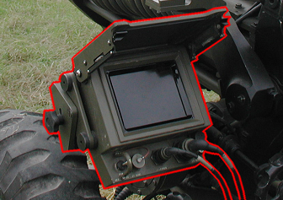
The L118 Light gun saw its first major upgrade in 2002, with the addition of the BAE Systems laser inertial artillery pointing system (LINAPS). Controlled from the Layers Control Display Unit (LCDU, shown right), this system used a trio of Ring Laser Gyros to measure Trunnion Tilt, Elevation and Azimuth. Self-survey GPS is used to determine the firing position while basic meteorological data is measured. When the layer inputs the desired point of impact, the system makes the necessary calculations to generate a firing solution. The software then guides the layer to manually traverse and elevate the gun to align the weapon with the designated point of aim; to an accuracy of 1mil (0.056°). This system was later improved with a larger screen; smaller and lighter electronic components and an overall weight reduction of the artillery piece. (7)

L131 AS90 Self Propelled Gun
The self-propelled 155mm AS90 came into service in 1992, and has since served extensively in Operation Iraqi Freedom. Developed to not require a spade, the vehicle uses an integrated turret recoil system, and hydro gas suspension to allow firing through any part of its 360° turret traverse. Equipped with an integrated automatic loading system, two AS90 Self-Propelled Guns demonstrated the ability of this system to place over a quarter tonne (261Kg) of high explosive ammunition onto a target within ten seconds. BAE Systems LINAPS, coupled with an automatic gun-laying system with both elevation and traverse drives, allows the AS90 to match a firing solution within just a few seconds; to an accuracy of 1 mil (0.056°). (8)

Closed-loop Control Systems
Closed-loop Control systems operate on a basis of feedback analysis. An example of this operation is given below.
x(s) = Target Signal
e(s) = Error Signal
y(s) = Position Signal
Figure 2. Closed-loop Control Diagram
H
G
Σ
y(s)
e(s)
x(s)

Consider an automatic focus camera lens. When the capture button is depressed, the camera emits a signal that allows it to determine the range in one dimension from itself to its target. This then corresponds with a lens alignment, to bring the subject into focus. Such a system involves Closed-loop control.
Into the system above, is the signal x(s). This signal is emitted by the camera processor, to set the target location for the lens. Let us presume that this is set at 50. This is then passed through the sum function. At the first cycle, the feedback has not yet been established. Thus our error, e(s), is 50. This value is then used to power G, the motor for 1 Cycle.
Position data, output through y(s), is returned in the feedback loop, and may be manipulated for an ideal response (Component H). Let us assume that the position of our lens is 10.
On the next cycle X(s) is still = 50; but when put through the summing amplifier,
E(x) becomes 50 – 10 = 40 causing the system to slow down as it nears its destination.
$$e_{(s)}= \int_{0}^{∞}{x_{(s)}}-y_{(s)}$$
This cycle ensures that until x(s) = y(s), the system will be in motion. Furthermore, any external force that tries to increase the Error, e(s), will be actively resisted.
Closed-loop feedback control forms the basis of the following devices.

Absolute Rotary Encoder Servomotor
An absolute rotary encoder is a sensor that emits a specific signal determined by the angular position of its component parts. These two parts incorporate electrical emitter/receivers with a digital output; and a code plate. One of these components must be stationary, while the other rotates mechanically with the shaft. (9)
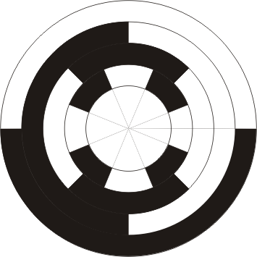
The code plate is a segmented disk which is precisely manufactured to block or pass the emitted signal depending on its position. At each disc position the component output is unique, limiting component precision to the number of bits. The example below incorporates a 4-bit encoder. 2⁴ = 16 unique disc Positions; 360°/16 = 22.5° accuracy.
In this example; white segments shall demonstrate a pass surface, while the black segments represent a block. Therefore, in binary, White = 1 and Black = 0. Each of the four red dots represents a light sensor, or data point.
In this instant, the sensed code = 1001. (Decimal 9)
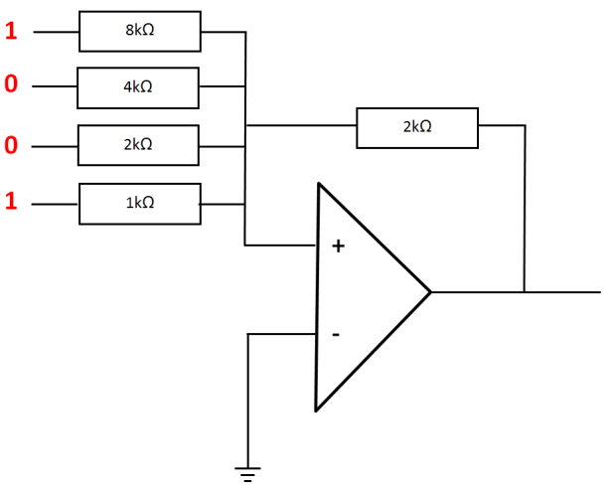
This information then may be integrated into a larger control system using the 4-bit digital word. Alternatively, this data may then be subjected to Digital-to-Analogue Conversion (DAC), to output this information as a single voltage. In this example;
Figure 3. Digital to Analogue Convertor
$$V_{out}= 5_{V}\left(\frac{1}{1×2}1+\frac{1}{2×2}0+\frac{1}{4×2}0+\frac{1}{8×2}1\right)$$
$$V_{out}= 5_{V}\left(\frac{1}{2}+\frac{1}{16}\right) = {2.8125}_{V}$$
$$Check: \frac{V_{out}}{5_{V}}=\frac{1001}{1111} or: \frac{x}{5_{V}}=\frac{9}{16}$$
$$x=\frac{{45}_{V}}{16}={2.8125}_{V}$$
This information can then be analysed and used to regulate the power input to the motor; when the binary code aligns with a target state, the system rests. Any external force that acts to change the alignment of the disk is opposed, providing that the force displaces the disk beyond the boundary of the target state.
The principle disadvantage of using this system is in fine tuning the motor feedback response. Rotary encoders can easily overshoot the target state and oscillate wildly. In some cases, they can overshoot by over 180°, leading to infinite rotation. Furthermore, incorporation in this project would require the construction of a mechanical feedback mechanism, which leads to reliability concerns.

PWM Servomotor
A large majority of hobby servomotors are controlled by Pulse Width Modulation (PWM) signals. These servos require three connections to function; a power source, a negative, and a command line. The servo arm provides the angular movement; this is limited to a 180° range. (10)
In general, most of these servomotors operate on a 50Hz frequency, providing a repetition rate of 20ms. Within this cycle, a 7.5% duty cycle is considered to provide a neutral position. As shown below, a 1ms pulse (Duty cycle, 5%) will turn the motor to its maximum limit left, while a 2ms pulse (Duty cycle, 10%) will turn he motor to it right limit. All values between these limits follow a linear response.
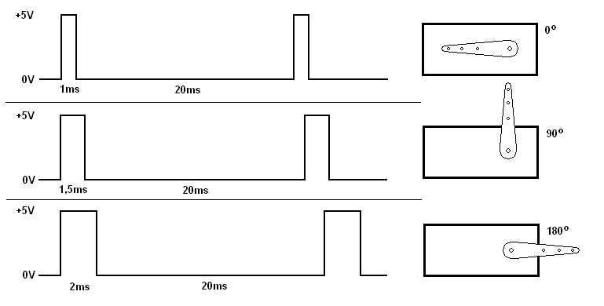
Figure 4. Pulse Width Modulation Controlled Servomotor
As the power supply and command line are separated, it allows the servomotor to be controlled by a variety of microchip outputs, radio receiver signals and single board computers; such as the Raspberry Pi or Arduino.
The two principle challenges in implementing these motors in the project are; limited movement to 180°, where the project requires 360° of freedom; and typically low torque output. These can be easily overcome by implementing a 2:1 gear ratio, and high torque motors.

PID Servomotor
Proportional-Integral-Derivative servomotors use mechanical feedback from the motor to drive a potentiometer. This drives a control circuit, which is subtracted from the input value to provide power, proportional to error. Furthermore, the input integral is summed with the input voltage to negate steady sate error, while the feedback derivative (rate-of-change) is subtracted, giving smooth and consistent movement, with little oscillation. (11)
The advantage of using this system lies in the project objectives. This system would reliably meet the target state required, allowing unlimited shaft rotation, and with a damping element to prevent oscillation.
The main disadvantage of this system is that it would require additional electrical components to operate, greater power consumption, and less system reliability on account of the author’s installation ability.

Open-loop Angular Control Systems
Open loop control systems are also a potential avenue for product delivery. Open loop control operates on a system of reference points, and incremental change. The primary issue with such a system is the inability to react to outside influence, until another reference point is able to ‘sense’ this event.

Stepper Motor
Stepper motors are used in a wide variety of applications, the most notable of which is in computer printers. This system proves to be a strong candidate to demonstrate the benefits of this method.
In a printer, the stepper motor reference is at the start of an ink line. The printer head deposits a specific dot of ink, and then the stepper motor moves the head along by a single increment. This cycle repeats until a specific number of steps have been completed. The printer then retracts the printer head to the reference point, steps down one ink line, and repeats the procedure until the image is generated.
This method can be applied to the project, by having a single reference point at 0°. However, to implement a stepper motor would require very precise gearing, potentially 3D printing a bespoke solution Furthermore, the model would not be able to respond to opposing external forces, unless the system aligned on the reference point.

Methods of Input
From the analysis of existing turret control systems, it is possible to further define the required methods of input. Systems such as CROWS, CROWS II and AS90 SPG, all use touch screen interfaces to direct the weapon system. While the AS90 SPG and L118 Light Gun use manual operation to appropriately orientate the platform. As such, the project will try to emulate both of these input methods.

Manual Operation
Manual operation falls under two categories; mechanical, and electro-mechanical. Mechanical operation can be seen in action with the Light Gun, where the operator is required to turn a hand wheel, suitably geared to move the weapon. This will not be featured in the final project as it provides no additional training benefit. It is assumed that those operating the equipment are capable of turning a hand wheel.
Electro-mechanical operation is typically achieved through joystick control, this is the case in the operation of the AS90 SPG, and will feature in the project delivery. While this may not seem to add value, it is important to retain an element of novelty in the product to aide retention of the course material.
Both of these methods provide reliable and practical movement of a weapon platform. Mechanical operation does have a significant weight increase, as the gearboxes need to be robust enough to withstand firing pressures. Electro-mechanical operation on the other hand, involves the inclusion of large servomotors and appropriate power supply, further increasing the weight of the system.

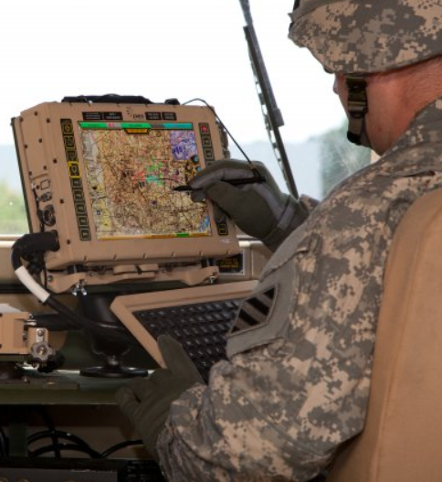
Touchscreen Control
In a similar manner to Manual Operation, touchscreen controlled software falls into two categories; GPS guidance and Gun Lay. In the case of the L118 light gun, an artillery support group is comprised of three components, a Forward Observer (FO), Battery Command Post (BCP) and at least one Gun Battery. The FO will operate a tablet computer, loaded with Map software, or a paper alternative. Upon spotting the target, the target grid is communicated via 2-way-radio to the BCP. This will typically comprise of a light vehicle outfitted as a communications array to the rest of the Battle Group; but will also incorporate computers for firing solution calculations. These are relayed via radio to the Gun Batteries. (12)
The gun batteries are given a firing solution in elevation and traverse. This is programmed into the LINAPS, and a series of arrows will appear to denote the required movement. This settles into a pair of crosshairs when he gun is properly orientated.
In the AS90 SPG, the BCP is not required. The FO will designate a grid reference, and the on-board Fire control system will plot the required firing solution. All the operator needs to do is to push and hold a button labelled “Auto-lay”, and the weapon will align with the solution automatically.
Due to the lack of mechanical operation, I will combine both of these elements. The user will input the required traverse and elevation, and have the system respond by automatically laying the gun on the specified value.

Project Plan

Project Targets
The project will be comprised of eleven stages, as specified below:
- Research and Literary Review
Conduct a review of the project requirement; collating and reviewing potential methods of delivery. This review should include both the military systems that the project is required to emulate, and the electronic principles best suited to this application. Discuss the strength and weaknesses of such technology in respect of utility within the final product.
- Initial plan of project delivery
Begin to formulate a plan to deliver the project requirements. This should consider the entirety of the work, from research and Literary Review to project and system evaluation. Furthermore, produce and display a Gantt chart of the project timeline, allocating Milestones as appropriate.
- Component Selection & Design
Considering the strength and weaknesses of control systems and inputs, discussed in the research and literary review; consider which components will be implemented in the product. These should be reasoned and specific to the requirement. Generate a block diagram detailing the design of both the Hardware and Software processes.
- Project Plan Review
Following the component selection, consider if the Project Plan requires revision. These should be detailed in a revised Gantt chart and project Milestones, with explanation of these changes in relation to the component selection and design information
- Software Development
With the components selected, begin to write and incrementally test the software code with the material components. This should include a detailed breakdown and flow diagram of the software operation, with suitable illustration. Also discuss error identification and resolution as a result of this process.
- Hardware Construction
Construct the Hardware components incrementally, in parallel with the code to assure correct operation of hardware components prior to final assembly. Create and develop a housing for the electronic components, such that they are easy to test, with consideration to the final build.
- Software Review and Revision
With regards to the incremental testing of hardware, document the operation of the code and the physical results. This may include tests to verify the servomotor range of movement, correct switch input values. Detail the Software and Hardware revisions as a result of these tests.
Furthermore, consider the project requirements; does the code in its current form meet the project aims and objectives?
- Hardware Review and Revision
As a result of the software and hardware incremental tests, consider revising the hardware to account for erroneous errors in inputs and outputs. This should be completed in parallel to the Software revision, to create a tuned and appropriate response in line with the project requirement.
- Final Construction
Construct the final hardware state, and install these components within the electronic housing. This will also include the construction of the “Turret” component and gearing ratio to deliver the project requirement.
- System Evaluation
Evaluate the final product with respect to the project requirement. What worked well? What could have been improved? Suggest potential changes that could be incorporated into future iterations of the product
- Project Evaluation
Evaluate the method of project delivery. What worked well? What could have been improved? Suggest potential changes that could be incorporated into future project plans.

Project Plan
The Project Plan has been developed as a Microsoft Project Document (.mpp) and has been regularly updated to reflect dynamic changes in the project delivery timescale. It includes the project headings defined above, with a detailed breakdown of the real steps taken to achieve the aim.
A PDF of this file can be found in Appendix H, or via email request to the author at mailto:mckazzer94@gmail.com.

Design and Implementation

Design
The initial design for the delivery of the project requirement stems from the research and literature review. This includes the selection of materials to undertake the input requirements, input/output logic, and product outputs. Reasoning for the component selection, system operation and configuration designs are demonstrated below.

Component Selection
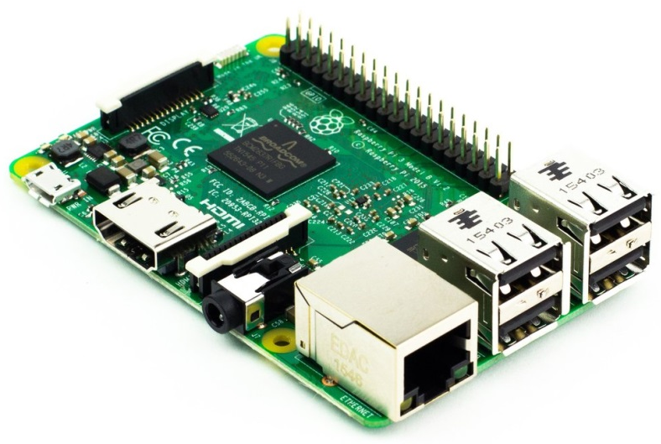
- Logic
In previous electronics projects, particular difficulty was found in the use of Microcontrollers for system logic. This stems from the ability of the author to only re-program and test chips when in attendance of the University of Wales Trinity & St. David. As a result of this issue, and with forethought to the implementation of a touchscreen display, logic will be controlled by a single-board computer; in this case, the Raspberry Pi 3 Model B+.
This component was chosen for use within the system as a number of touchscreen displays sport compatible drivers for this hardware. Furthermore, the computer features 40 GPIO (General Purpose Input-Output) pins that can be programmed and controlled directly from the desktop. This eliminates the need for the reprograming software and rigs associated with Microcontrollers.
The component requires a 5v Micro-USB power supply, can read inputs up to 3.3v, and outputs 5v on each GPIO pin. This GPIO output line is limited to small amplitudes however, and can only drive externally powered output components without causing damage to the board.
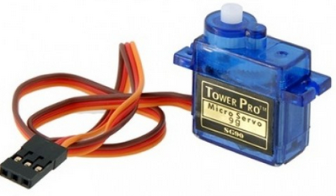
- Output
The output, in this instance will be comprised of two PWM servomotors. These have been selected as they have been optimised to use with the Logic controller, allowing the system to be controlled by a low power output. These motors require a 5v positive power supply, a 50Hz PWM control signal, and a negative.
Furthermore, I am not required to design and build a motor controller with feedback and a gear box, while retaining a small and lightweight solution for turret movement. In this instance I will be using a TowerPro SG90 micro servo.
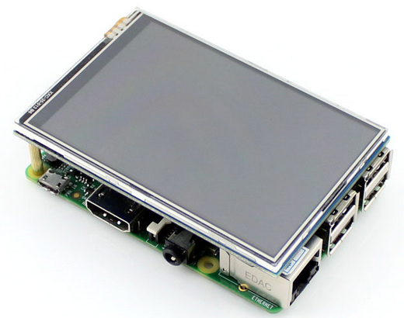
- Input
Input components, in line with the requirement are comprised of two parts; Touchscreen and Joystick control. The touchscreen component will be the Waveshare 3.5inch LCD Touchscreen, compatible with the Raspberry Pi 3 Model B. This is supplied packaged with a driver to synchronise the Raspian OS graphical interface with the component. And also incorporates a large amount of user support and guides to optimise the screen for use with the controller. The 3.5Inch model specifically was chosen for two reasons. Firstly is that the 3.5” screen uses 26 GPIO pins for its operation, allowing 14 Pins for use in receiving inputs from the joystick and providing outputs to the servomotors. And secondly, the 3.5” screen is the same dimension as the Raspberry Pi board. This provides support to the screen to ensure that the screen does not bend, crack or receive damage in transit or installation.
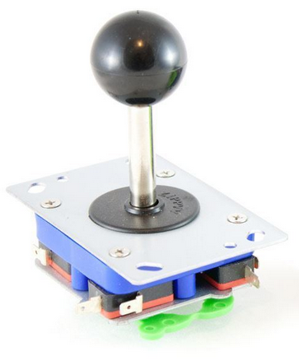
The joystick input, in the interest of simplicity, will be comprise of a 4-microswitch system produced by Zippy Ltd. This will be fed a 3.3v regulated power supply to the positive terminal, with the negative terminal connected to the allocated GPIO pin. Switches are held in the “normally open” position, meaning that when the switch is depressed, it will supply a “HIGH” value on the GPIO pin. This is the trigger for te controller to perform logic, converting this action into a controlled ouput. This particular component also has a “restiction panel”, limiting the joystick to two, four, or eight potential positions. This will be set at eight positions to allow elevation and traverse to occur simulaneously. He system also features a mounting plate for easy installation.

System Hardware Overview
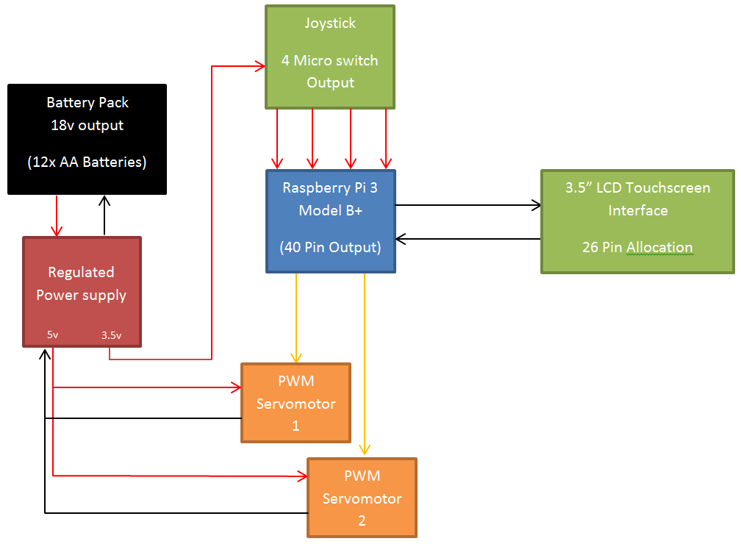
Figure 5. System Hardware Overview
The above diagram denotes the proposed hardware set-up of the final product. A bettery pack comprised of 12 AA batteries provides the DC power supply for the system to operate. This is then controlled by a power regulator. The regulated 5v supply is used to power servomotor operation. Meanwhile a 3.3v supply pulls the joystick switches high, ready to generate an input when the micro switches are closed. The Raspberry Pi is likely to be powered externally, and acts as the 5v DC supply allowing the Touchscreen to function.
Upon receiving an appropriate input from either the joystick or the touchscreen, the Raspberry Pi will perform logic as per the project software. This will be output on two signal lines, to each servomotor.
This set-up is minimal, straightforward and delivers the project requirement; assuming that the logic code is suitably complex to accommodate the components.

System Software Overview
Initialise Window
Generate 2 Buttons
Link Button 1 to Touchscreen Input
Link Button 2 to Joystick Input
MASTER.py
Import Tkinter
Check Button Logic
Start Main loop
Import Tkinter, Time & GPIO
Set-up GPIO Functions
- Allocate Pins
- Setup Input/Output Pins
- Setup PWM
Define “Exit” Subroutine
Initialise Window
IF statements (loop):
If switch 1 closed: PWM1 + 0.1
If switch 2 closed: PWM2 + 0.1
If switch 3 closed: PWM1 - 0.1
If switch 4 closed: PWM2 - 0.1

Generate “Exit” Button
Link “Exit” Button to “Exit” subroutine
Joystick.py
Start Main loop
Check Exit Button
TouchGUI.py
Import Tkinter, Time & GPIO
Initialise Window
Define button Subroutines
0123456789, Cancel, Clear
Set-up Trav/Elev Value variables
Set: PWM1 = (Trav/72) + 5
Set: PWM2 = (Elav/72) + 5

Generate all buttons;
0123456789, Cancel , Run, Clear
Set-up GPIO Functions
- Allocate Pins
- Setup Input/Output Pins
- Setup PWM
Define Run Button Subroutine to check for input error.

Check Button Logic
Start Main loop
Check for Input Errors
Figure 6. System Software Overview

System Software Concept and Operation
- MASTER.py

TOUCHSCREEN control
JOYSTICK control
Choose your desired control method.

This file acts as a main menu between the two control systems, and is always operational in the background. It comprises of an expanded window, with two buttons and an instruction; “Choose your desired control method.” The two buttons within this window will open either the “TouchGUI.py” or “Joystick.py” files as requested.
MASTER.py continues to run in the background, this window is only seen when either control method is terminated, closing the file and window, revealing the menu again.
- Joystick
Return to Control Selection

Joystick.py operates very simply. The window and button is initialised and the button function is defined. This is then checked once per cycle within the main loop. The GPIO input/output are defined, so too are the PWM Parameters and initial duty cycle.
The main loop then checks each of the joystick micro switches, adjusting the two PWM outputs as appropriate. This continues until the “Return” button is pressed. This exits the loop, shuts down the PWM and GPIO outputs to make the system safe. The window is then terminated, revealing the Menu window behind.

- Touchscreen GUI
123456789.0°

360°

Traverse

1

2

3

90°

Elevation

6

5

4

Cancel

9

8

7

Run

Clear

0

.

This program, at its most basic level, operates like a calculator. When a numeric value is pressed, the main display value is multiplied by 10, and the new numeral is added to the total. However, in place of mathematical functions, are 5 custom defined functions; Traverse, Elevation, Cancel, Run and Clear. These functions re explain below:
Traverse | - Assigns the main display value to the Traverse variable.  - Displays the Traverse Variable in the allocated box  - Resets the main display value to 0
Elevation | - Assigns the main display value to the Elevation variable.  - Displays the Elevation Variable in the allocated box  - Resets the main display value to 0
Cancel | - Shut down the GPIO outputs and PWM.  - Exit the program, and close the window.
Run | - Check the input values are within allowed limits.  - Convert Traverse Variable and elevation variable into PWM duty cycles  - Output new Duty Cycles to the Servomotors
Clear | - Reset main display value to 0

Assuming that the servomotor limits are at 1ms (0°) and 2ms (180°) as stated, and considering the 2:1 gear ratio applied to the traverse motor. The calculation to convert the numeric position into the corresponding duty cycle is:
$$(x/72)+5= {DCyc}_{Traverse}$$
Likewise, assuming the same limits and a direct drive system for the elevation servomotor; the calculation to convert the numeric position into the corresponding duty cycle is:
$$(x/36)+5={DCyc}_{Elevation}$$
As with Joystick.py, when the window is terminated, it reveals the MASTER.py window running in the background.

Manufacture and Development

Hardware Implementation
In order to successfully implement the hardware for the project, it is important to incrementally test the various component parts for correct operation and responses. The task of troubleshooting is made far more difficult when the entire system is assembled, as many different faults may have similar symptoms.
This arises from the “lessons learnt” electronics project from 2016, where the electronic product was dismantled and reassembled many times to diagnose an intermittent battery failure. This problem resulted in substantially less time to tune an optimal response from the system.
Four tests were conducted prior to assembly; the first two of which arise for the use of the TowerPro SG90 9g servomotor, which is supplied with a rather brief datasheet. From this documentation, it cannot be assured that the servomotor is calibrated to achieve 0° from a 1ms pulse, or 180° from a 2ms pulse. After the true motor limit values are established, it is also necessary to also determine the amount of load that can be applied to the servomotor without failing.
The last two hardware tests pertain to the joystick and touchscreen inputs. For the joystick, I must assure myself that the input pins will only read “HIGH” when the switch is closed, and that no erroneous readings are present. Furthermore, I must also check that the switches are wired up correctly with the specified pins in the software. On the other hand, the 3.5” LCD Touchscreen needs to be installed with the appropriate driver; the touchscreen response must be properly calibrated and tested with a draft code to ensure correct operation.
- Raspberry Pi, Python 2.7 - PWM Output Test
As this project is the authors first use of the programming language Python, it is important to ensure the commands issued for the following tests is correct. The code for the servomotor signal range test was written and tested before the components for the test were installed. Instead, the PWM signal was measured using an oscilloscope.
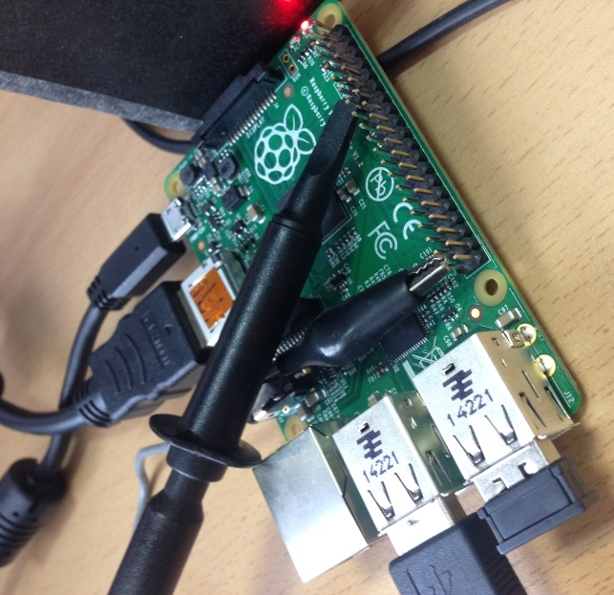

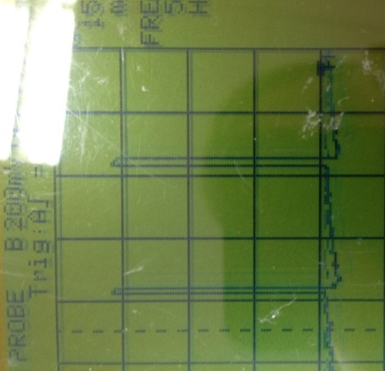 | 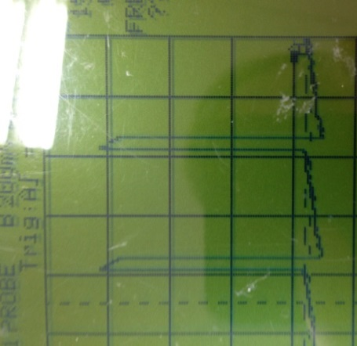 | 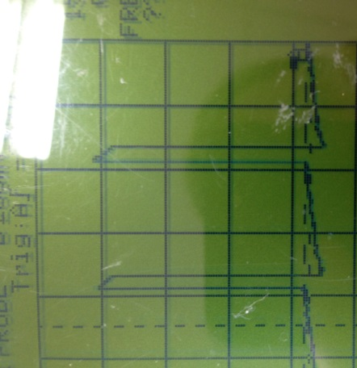
1ms – 5% Duty Cycle | 1.5ms – 7.5% Duty Cycle | 2ms – 10% Duty Cycle

- Servomotor Signal Range Test
The Servomotor signal range test operates on a trial and error basis to establish the true duty cycle values needed to achieve a specific motor orientation. The set up for this test is as follows:
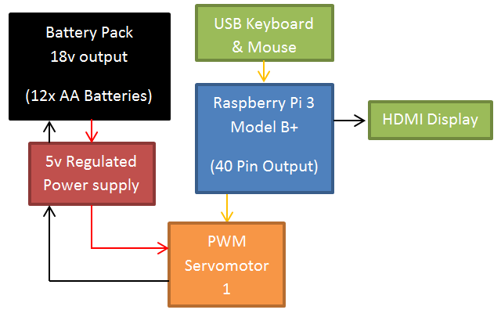
The code for this test is found in:
Appendix A – Servomotor Signal Range Test Code

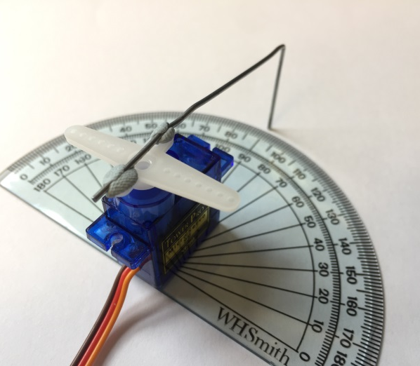 | 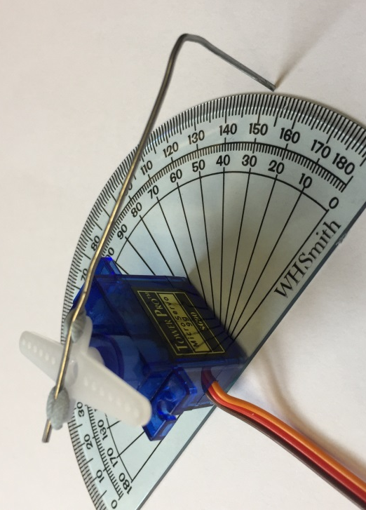

The servo is prepared for the test by applying a 1.5ms pulse to the motor (7.5% duty cycle). This is then determined to be the neutral point. A stiff straight wire, bent at a right angle to provide accuracy, is tacked onto the servomotor head, and aligned with the 90° mark on a protractor.
The code in appendix A is then run. The code cycles through each of the expected 0°, 90° and 180° positions, pausing for three seconds at each location. During this pause, the operator is to note down the actual position of the wire above the protractor. This repeated 10 times to ensure the validity of the results.
The results from the previous test is then analysed to generate new proposed duty cycles. These are then tested to determine the true value.
Figure 7. SG90 Servomotor Accuracy Data

From this test we can determine that:
- Servo 1 has a 0 – 180° range between 3% - 12% duty cycle; or 0.6ms – 2.4ms pulses.
- Servo 2 has a 0 – 180° range between 4% - 13.2% duty cycle; or 0.8ms – 2.64ms pulses.

- Servomotor Torque Suitability Test
The Servomotor will need to be able to turn a load through its 180° range, the SG90 datasheet claims to be able to operate under a 1.8kg weight. I need to perform a test to confirm that the rotational torque from the servomotor can move my proposed turret rig weight. I have estimated this to be less that 200g
This test used the same configuration and code as the Servomotor signal range test. This servomotor arm is affixed to an aluminium tray, located centrally to the motor. Load was then applied to the tray to assess the ability of the servomotor to rotate as designed. It was decided that brass weights, normally used in a counterbalance scale would be used.
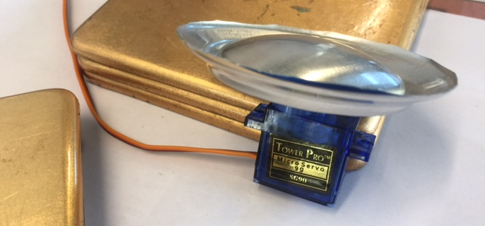

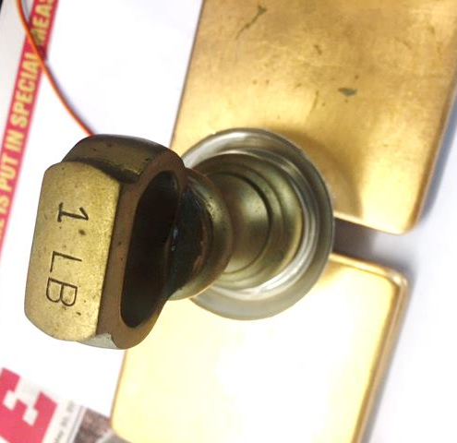 | 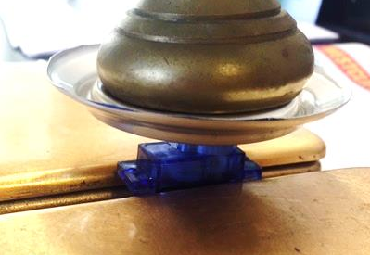

The servomotor was able to successfully rotate when a load of 454g was applied to the tray. This test was repeated ten times over the course of the code with identical results. This confirms that the servomotor is suitably rated to move the turret model.
- Joystick Micro-switch Response Test
Connecting the joystick to the Raspberry Pi, a quick test is conducted to ensure that the component is responding as required and is wired up correctly. The set up for this test is as follows:
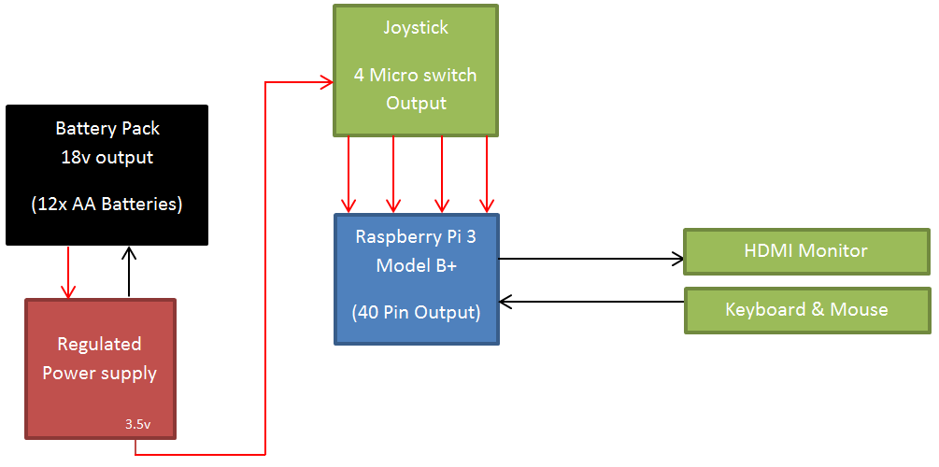
The code for this test is found in:
Appendix B – Joystick Micro-switch Response Test

The joystick response test comprises of 20 program loops. On each loop, the responses from the 4 micro switches are analysed. If any of the four GPIO pins read “HIGH”, the program will print “xxx Switch”; for example, if Pin 31 is read as ‘HIGH’, the program will print “Up Switch”
The initial results can be seen below. In this example, the joystick is at rest.
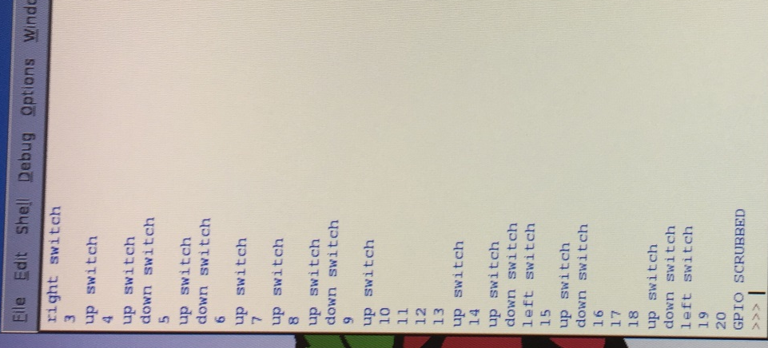
This result shows that the GPIO Pins are falsely reading as high, despite being supplied no power.
This result was initially dismissed as the result of interference, and determined that this effect could be mitigated by the inclusion of a 1k resister in series on all 4 input lines. This did not resolve the problem.
The second theory as to this erratic behaviour, is that the signal circuit would perhaps operate more conventionally if I incorporated a ground, taking the input from a variable voltage divider instead. This would also dampen the response of the controller to these low power false triggers. This did not resolve the problem, but it did reduce it to just a few false triggers per cycle.
The third approach began with a significant amount of research into Raspberry Pi GPIO Threshold voltages, and testing on a voltmeter. Various online sources quote the threshold for HIGH and LOW readings to be 1.34 - 3.30 V and 0 - 1.19 V respectively. However, my controller was reading high on voltages as low as 0.1V.
The issue was finally resolved by grouping the ground terminals for both the controller and the trigger voltage divider. This voltage divider was then replaced with a series of 10k and 1k resisters.
Figure 8. Joystick Controller Wiring
10k
10k
10k
10k
Joystick
Raspberry Pi 3
1k
1k
1k
1k

Adjusting the number of loops to 10, the test was conducted again with the following results.
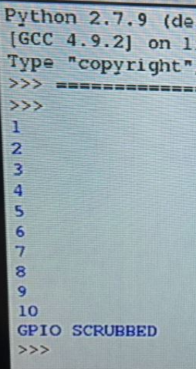 | 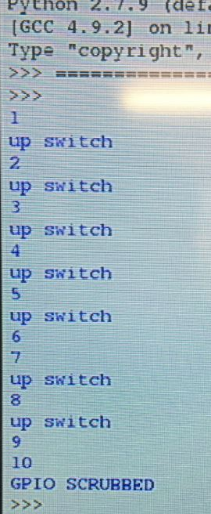 | 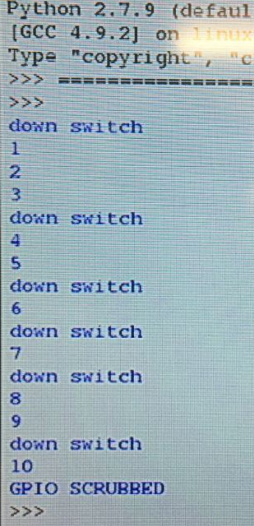
Joystick at rest | Joystick held up | Joystick held down

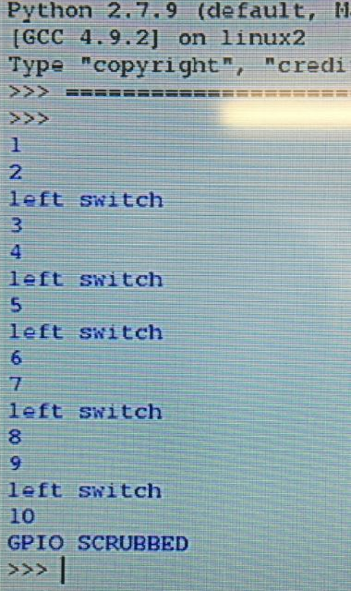 | 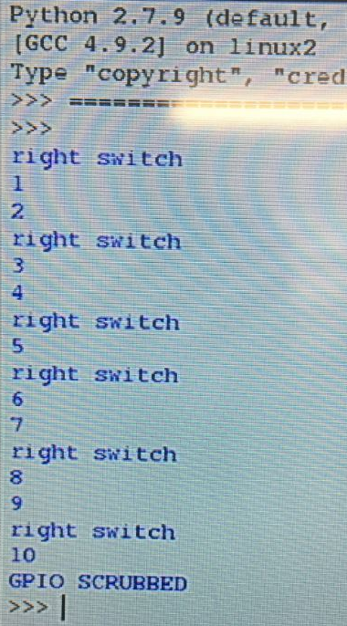
Joystick held left | Joystick held right

From this test, it has been established that the joystick input system is functional and correctly wired. There are no erroneous readings; however the response does appear to be intermittent. This may be investigated later, if the project timeline is sufficient.

- Touchscreen Alignment Test
Having developed the software to a point where the Touchscreen Graphical User Interface is operable. The touchscreen alignment test can be conducted. This involves the installation of the touchscreen driver from http://www.waveshare.com/ , and installation of the screen onto the GPIO pins of the Raspberry Pi 3. The software is loaded onto a memory stick, and a brief trial is carried out.
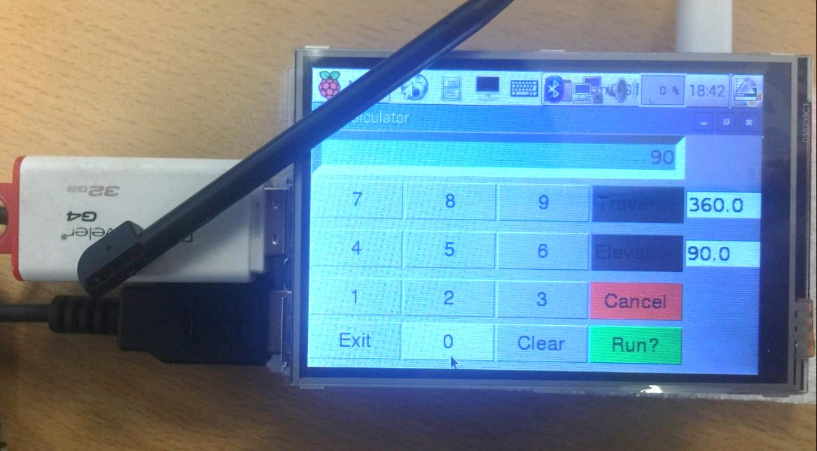
From this test, it was determined that the LCD Touchscreen and Raspberry Pi were configured properly, with minimal deviation in cursor position. Due to the time constraints of the project; the minimal offset is not considered to be a problem.

- Control Housing Manufacture
The control housing is comprised of two components. The first is a plastic container produced by Lock & Lock, capable of storing 1.9L of fluid. This provides the control systems and stripboard a suitable amount of space. Four holes are drilled in the base, while feet are attached via nut and bolt. A hole is bored in the side of the box to allow a power line in, and two servomotor signal lines out of the housing.
The lid of the container is removed and a window is cut to enable operation of the touchscreen. The window is slightly smaller (1mm border) that the total screen width and height. Also, an 18mm hole is drilled to allow the joystick amble movement to operate.
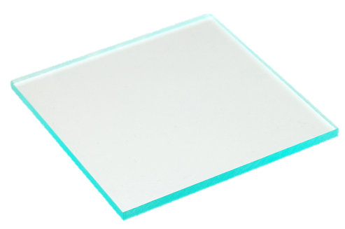
A sheet of 20mm clear acrylic is cut to the inner dimensions of the container lid. A window is cut to the same proportions as the container, and an 18mm hole is drilled to align with the container. Two joystick mounting holes are drilled and tapped, and the final two holes are machined through both the container lid and the acrylic.
The touchscreen is offered up to the acrylic sheet, with necessary changes made to ensure that essential control contacts are not obstructed. A 1mm edge chamfer is applied to the upper portion of the acrylic to seat the screen. The screen is then mounted on the acrylic; an image is also trapped in this layer for aesthetics, before the acrylic is bolted to the container lid. The joystick is mounted via the tapped mounting holes underneath.
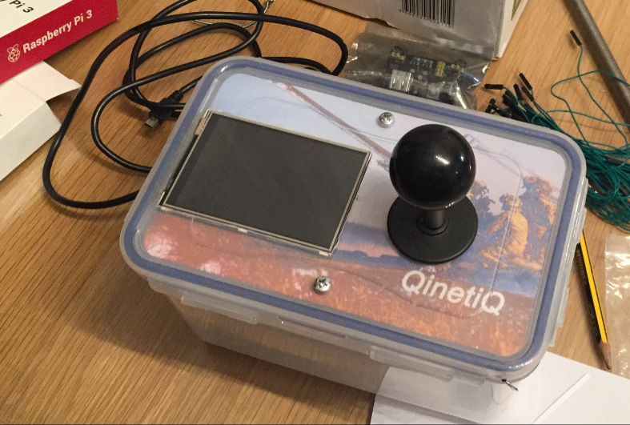
- Turret Rig Manufacture
Rig manufacture began with some preliminary design sketches. The purpose of which is to visualise how the servomotors will mount and interact with the rig.
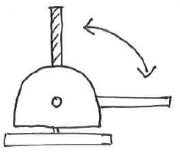 | 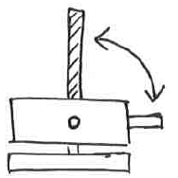 | 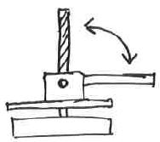 | 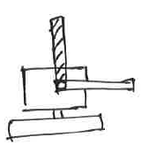  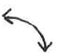
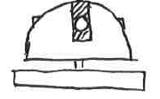 | 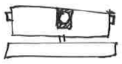 | 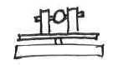 | 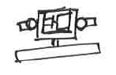
Dome Housing | Box Housing | Minimalist | Central Mount, Double
Figure 9. Turret Rig Sketches
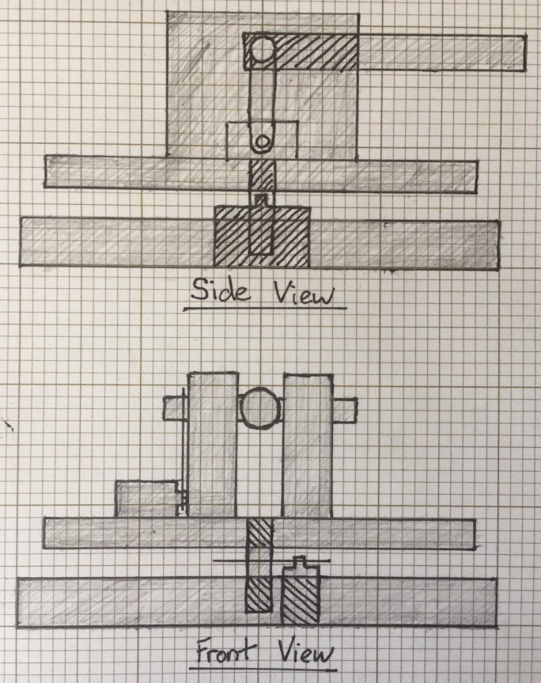
Each of these concepts are viable builds, however, some are easier to manufacture than others. The “Dome housing” variant has the benefit of replicating the 4.5” Mk 8 Naval gun, and is believed to be the most aesthetically pleasing. The “Box housing” variant is easy to produce, and provides plenty of potential mounting surfaces for the servomotors. The “Minimalist” variant removes the housing completely, stripping the system down to the bare-bones. This is likely to be the lightest of the rigs, and provides great access for troubleshooting. The “Central mount” variant features a hollow cube with 2 open faces. Barrels are mounted on each side of the rig. This definitely has a novelty video-game feel, and may help users to retain course content. At face value however, it is likely to be the heaviest rig design, and the most difficult to make.
On balance, the “Minimalist” rig was selected for production. If time allows later in the project, aesthetics may be considered – allowing the installation of a box or domed housing. The ability to easily access the motors during troubleshooting may be vital in project delivery. From this initial concept, design drawings are made to ascertain the appropriate dimensions for the rig design.
From these designs, a 3D Model of the rig was also produced to assist the author in the identification of potential complications.
In this case, drilling through the “barrel” may cause issues, as the tube has only 1.5mm of material above and below the axle. Any deviation could cause the material to rupture. As such, It may be more beneficial to file a flat into the surface before drilling the axle recess.

The final turret rig construction began with the base, primary shaft and upper platform cut as designed. A number of Mechano Gears, shafts and strips were used to make the upper turret mount, including a pulley tension alteration required to achieve suitable drive to the elevation axle. The base was then cut to accommodate the traverse servomotor, with the 3:1 gear system installed. The elevation gear is then installed via the pulley array. All wooden surfaces are then painted matt black.
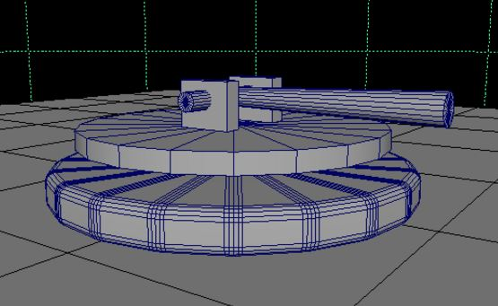
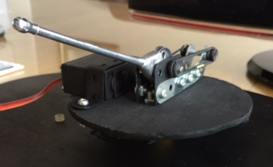 | 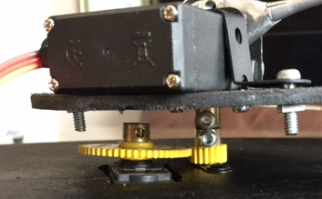
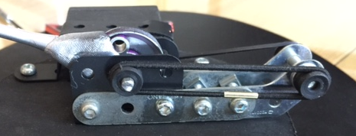
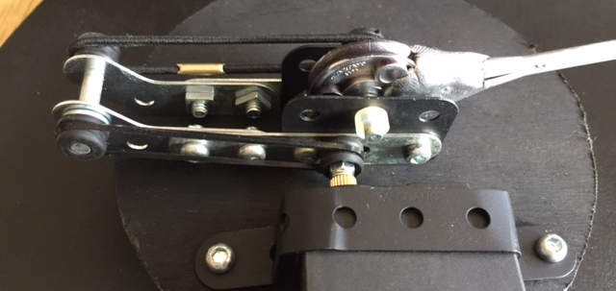
Figure 10. Final Hardware Construction

Hardware Development
As a result of the hardware preliminary testing, it was identified that the TowerPro SG90 servomotors had relatively poor signal range accuracy. It is well understood by the author that the trial-and-error servomotor signal range test is not accurate enough in itself to satisfy the project requirement. As a result of this factor, other servomotors were considered for use within the system.
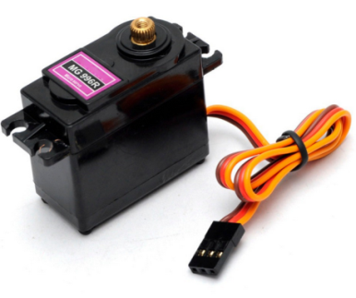
The TowerPro High-Torque MG996R servo claims a 9kg stall toque, and retains the 3-pin PWM controlled element as the SG90. It also boasts significantly higher accuracy that the SG90, and for this reason, it was identified as a potential replacement for the SG90. The primary concern for the use of the MG996R is that they are limited to 120° of movement. This means that the traverse motor would require a 3:1 gear ratio to achieve the project requirement, compromising the increased accuracy.
- Servomotor Signal Range Test
Using a similar set-up to the Servomotor Signal Range Test from 5.1.B, the MG996R servomotor is to be measured against the SG90. The method of test is as follows:
- The MG996R servomotor will be tested to establish guideline limits, using the procedure define in 5.1.B.
- Using these trial-and-error established limits, each servomotor will be issued five commands set in degrees; 0°, 10°, 20°, 40°, 60°. This will be processed using a customised code for this test.
- The angular error is measured at each location.
- The angular error will be multiplied by 2 (for the SG90) and 3 (for the MG996R); this is to represent the appropriate gearing ratios.
- The results are analysed to determine which servomotor is most appropriate for use in the final product.
The results from the Signal Range Test for the MG996R servomotors are as follows:

Where the following values are determined for each motor;

Degree Value = x
Duty Cycle = y
Maximum Degree of Movement = Range
Minimum Duty Cycle = MinDC
Maximum Duty Cysle = MaxDC
DCdiff = MaxDC - MinDC

y = DCdiff*(x/Range)+MinDC

 | SG90 - 1 | SG90 - 2 | MG996R - 1 | MG996R - 2
Range | 180 | 180 | 120 | 120
MinDC | 3 | 4 | 4.8 | 10.2
MaxDC | 12 | 13.2 | 4.9 | 10.1

The program defined in Appendix C is run, and the angular error measured;
 | Servomotors
Range (°) | SG90 - 1 | SG90 - 2 | MG996R - 1 | MG996R - 2
0 | 0 | 1 | 0 | 0
10 | 9 | 10 | 10 | 9
20 | 18 | 20 | 20 | 20
40 | 39 | 38 | 40 | 40
60 | 59 | 61 | 59 | 60
TOTAL Error | 5 | 4 | 1 | 1
Applied Gearing Ratio | 10 | 8 | 3 | 3
Figure 11. Angular Error Data

This test has shown the MG996R Servomotors to have a significantly greater accuracy than the SG90 servomotor despite the error amplification by the alternative gear ratio. This component will be incorporated into the final product.

Software Implementation
The software implementation began as scheduled in later-November. Up until early January, the author dedicated his time to learning the Python 2.7 programming language and applications; such as Tkinter and GPIO functions.
Two books were primarily used to develop a baseline understanding of the language; “Raspberry Pi User Guide” (13); and “Raspberry Pi in Easy Steps” (14). The former contains more information on the GPIO functionality of the logic controller, while the second focusses on using Tkinter to create simple graphical user interface elements. From this baseline, and with some assistance from http://www.raspberrypi.org online forums, the GUI specified in the initial software plan was created.
It should be noted that the programs would crash when ran on a computer other than the Raspberry Pi, unless the GPIO code was “hashed-out”. The 3 programs initially planned (stated in 4.2.1) were created early February, and can be seen in Appendix D, E & F.
The progress in getting the GPIO output functional was stalled for reasons that the author was not able to diagnose. This was then shown to two individuals, mentioned in the acknowledgements, who are far more familiar with the coding language than the author. From this consultation, the error was identified as an issue with the code structure. The code was trying to call and use GPIO functions within window Initialisation routines in all cases, causing it to fail.
The three graphical interfaces however, appear and operate as designed, The GPIO code was amended following an extensive overhaul of the code structure.
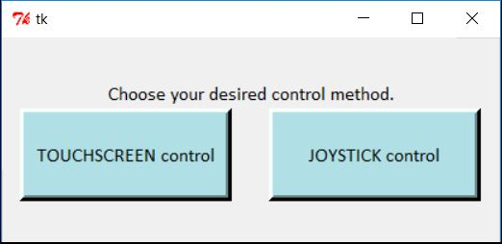 | MASTER.py  Control Selection Directory
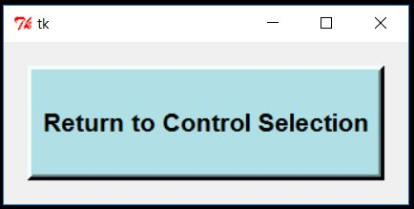 | Joystick.py  Joystick Servomotor Control
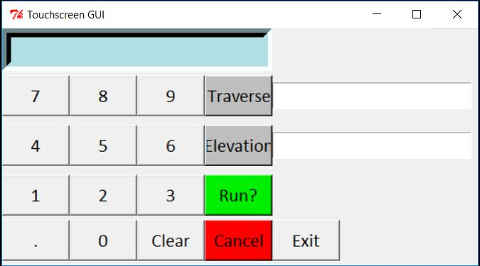 | TouchGUI.py  Touchscreen Servomotor Control

A number of other changes were suggested and implemented. These will be further explored within the software development section of this report.

Software Development
Three changes were highlighted by the consultants to improve the efficiency and functionality of the operating program. These include:
- The use of Frames and Classes, instead of New Windows, to open and close the various control mechanism interfaces. This improvement would dramatically increase the speed and efficiency of the code to operate, and allows the use of global GPIO values. Principally this means condensing the code into a single file.
- Generating a class to contain global GPIO values, allowing the user to switch between control methods without the need to reset the servomotor to the neutral position.
- Multithreading to allow the code to process multiple commands in different classes simultaneously. This is necessary for the other two functionality improvements to operate correctly.
Code Overview
Import Libraries; Tkinter, RPi GPIO, Multiprocessing, Time, Threading
Define button features; Font, height, width, colour
Initialize App()
App() acts as a container for the Graphical user interface frames.
Generate the three GUI frames (MainGUI, TouchGUI, JoySGUI).
Bring MainGUI to the top of the Z Order.
Define a function (showFrame) to bring a called frame to the top of the Z order.
MainGUI
Generate instruction Text (Choose your desired control method.)
Generate 2 Buttons (TOUCHSCREEN control, JOYSTICK control)
Define Button functions; showFrame TouchGUI & showFrame JoySGUI.
TouchGUI
Generate current Traverse and elevation values
Set Text Box features; border, font, alignment, colour, height, width.
Generate three text boxes; Display, displayTrav, displayElev
Generate all number buttons; 7894561230, and define their functions.
Generate all complex buttons and define their functions.
Produce a script to check for errors in input; (Traverse < 360 & Elevation < 90)
JoySGUI
Generate a single button; (Return to Control Selection)
Define Closing parameters. (The Joystick input listening code is a non-daemon thread. It MUST be closed whether the program is destroyed, killed, or if TouchGUI is closed using the button above.)

GPIOWrapper
Define GPIO mode, set Duty Cycle limits, set current and maximum Traverse and Elevation values.
Define variables for the degrees to Duty cycle conversion equation.
Define the GPIO pins to be used as variables, then set-up the GPIO pins
Define the two output pins as using Pulse width Modulation, then start this output using the defined values.
Define functions to read and write over the current Elev and Trav values.
Define Start and stop functions for GPIO processing
Create a function that will allow the GPIO settings to be wiped. (This prevents damage to the controller)
Define the process to operating the joystick.

Global Code
Run App() Mainloop.

System Evaluation and Review
The system performs in a sub-optimal manner. The servomotors seem to respond only to increments of 90°, as opposed to responding smoothly to the generated elevation and traverse values. Furthermore, the response of the motor is jerky, difficult to control and oscillates wildly. It has been considered that this response may be the result of “false triggers” as the joystick control method suffered terribly from a similar problem. However, grouping the servomotor, controller and joystick grounds did not resolve the issue.
The joystick control responds far better than the touchscreen command interface. It is believed that all of these effects are being caused by software conflictions, or failures to call, overwrite and process variables. Troubleshooting the code has been a very difficult process following the software overhaul, use of multithreading and the programmers inexperience with the programming language. These issues could well be overcome by extending the project deadline by a few weeks.
If this project was attempted again, the author would certainly avoid using PWM servomotors for this application. The servomotors rely on a very precise control method which is heavily distorted by noise and false triggers.
One component selection that would suffer far less from this problem would be the use of a rotary encoder, unlimited rotation motor and speed controller. In hindsight, it has been considered that this control method could be far more reliable and consistent.
A number of the components used in the design were selected based on ready availability rather than ideal properties. I feel that this also had a significant impact on the amount of troubleshooting required to get the model to function. In future iterations, the research and literary review must be more thorough, and directly impact the component selection process; as opposed to choosing components to hand that would potentially satisfy the requirement, but retain less desirable properties.
Furthermore, the controller for this system was selected to allow fast and easy reprogramming of the software element of the project. While this provided the developer great flexibility and rapid reconfiguration of the controller logic, the programming language was unfamiliar and difficult to understand. It is likely that future iterations of the project would use an Arduino, programmed in C to produce a similar result.
The Arduino also features an “Interactive Development Environment” (IDE) that has the capability to graphically ‘block-out’ programs. It is considered to be a learner friendly way of producing a result with little knowledge of the language. This could have allowed more time for the final troubleshooting.

Future Improvements
Future iterations of this system would include;
- More time allocated to the troubleshooting of hardware.
- More time allocated to the troubleshooting of software.
- Use of Rotary Encoders for angular position, as opposed to PWM servomotors.
- A greater emphasis on the outcome of the Research and Literary Review findings.
- Use of an Arduino, as opposed to a Raspberry Pi to allow the developer to program in a language that is better understood.

Project Evaluation and Review
The project was conducted well in hindsight. The project progressed well against the established timeframe outline in appendix H. There are a number of minor changes to this timeline that I believe would have increased the quality of the product.
Firstly, more time should have been allocated to the literary and design review. This was a crucial stage in the project to determine and plan to best way to deliver the project requirements. It was however, treated as a roadblock, or a ‘paper exercise’ to fulfil the requirements of the Test Range Engineering Course.
Further to this, not enough time or care was dedicated to the development of the software prior to the initial delivery. This process was undertaken and recorded for the hardware component, however no alternative methods of software delivery were considered. By the time that the software was reviewed by the project consultants, the project was too near the delivery date to have attempted such a dramatic overhaul of the process. Allowing just three weeks at the end of the project to troubleshoot the various and numerous software and hardware errors was a gross underestimation of the workload.

Future Improvements
Future iterations of this Project would include;
- More time allocated to research and Literary review phase of the project
- A greater emphasis should have been placed on the software design, with multiple methods of delivery proposed and evaluated against each other.

Project Conclusion
While this project has failed to meet the user requirement, the experience has been entirely positive. Give more time, it is certain in the authors mind that the project would have developed to a state where the design could be made to meet the established targets.
Furthermore, I feel that the program layout successfully emulated the L118 and AS90 software interface. This could still be used for training purposes, but loses the novelty element that the customer requested.

Bibliography
1. Kongsberg Protech Systems. M153 PROTECTOR: Remote Weapon Station Datasheet. Kongberg.com. [Online] 2013. https://www.kongsberg.com/~/media/KPS/Datasheets/Datasheets%2002-14/Dataark%20M153%20A4%20screen.ashx?la=en.
2. HSE. Competance in Health and Safety. HSE.gov.uk. [Online] http://www.hse.gov.uk/competence/.
3. Killer Robots. Human Rights Watch. [Online] 2010. https://www.hrw.org/topic/arms/killer-robots.
4. Strategypage.com. Weapons: The Relentless Terminator. Strategypage. [Online] 12 September 2013. https://www.strategypage.com/htmw/htweap/articles/20130912.aspx.
5. Axe, David. Gunners Train with Army Game. DefenceTech. [Online] 15 May 2006. https://www.defensetech.org/2006/05/15/gunners-train-with-army-game/.
6. L118. Army Guide. [Online] 2015. http://www.army-guide.com/eng/product1941.html.
7. Foss, Christopher F. Jane's Pocket Book 18; Towed Artillery. 1977.
8. Army Technology. AS90 "Braveheart" 155mm. Army-Technology.com. [Online] 2014. http://www.army-technology.com/projects/as90/.
9. Dickstein, Harold. Automatic shaft position data encoder. US 2826252 A 15 January 1955.
10. Introduction to Servomotors. Mechatronics. [Online] http://mechatronics.mech.northwestern.edu/design_ref/actuators/servo_motor_intro.html.
11. Siltamaki, Harold. Electric motor control system. US 2534801 A 11 March 1946.
12. UK Ministry of Defence. Artillery Pamphlet No. 19, Regulations for Planning, Control, Conduct and Safety for Firing Practices. [book auth.] UK MoD. 2015.
13. Upton, Eben and Halfacree, Gareth. Raspberry Pi User Guide . s.l. : Wiley, 2012.
14. McGrath, Mike. Raspberry Pi in Easy Steps . s.l. : Easy Steps , 2013 .

Appendices

Appendix A – Servomotor Signal Range Test Code

import RPi.GPIO as GPIO
import time

GPIO.setmode(GPIO.BOARD)
GPIO.setup(11,GPIO.OUT)

loop = 0 #Begin 10 Loops, repeat results improve test accuracy
while loop < 10:

pwm = GPIO.PWM(11,50)

pwm.start(7.5) #Duty cycle of 7.5%, the 90° position
time.sleep(3)

pwm.ChangeDutyCycle(10) #Duty cycle of 10%, the 180° position
time.sleep(3)

pwm.ChangeDutyCycle(5) #Duty cycle of 5%, the 0° position
time.sleep(3)

loop +=1
print(loop)

if loop == 10:
GPIO.cleanup()

Appendix B – Joystick Micro-switch Response Test

import RPi.GPIO as GPIO
from time import sleep

GPIO.setmode(GPIO.BOARD)

GPIO.setup(31,GPIO.IN)
GPIO.setup(33,GPIO.IN)
GPIO.setup(35,GPIO.IN)
GPIO.setup(37,GPIO.IN)

x = 0

while x < 10:

if GPIO.input(31) == 1:
print "up switch"

if GPIO.input(33) == 1:
print "down switch"

if GPIO.input(35) == 1:
print "left switch"

if GPIO.input(37) == 1:
print "right switch"

sleep(1)

x += 1

print x

GPIO.cleanup
print "GPIO SCRUBBED"

Appendix C –Servomotor “Degrees-to-Duty Cycle” Comparison Code

import RPi.GPIO as GPIO
import time
GPIO.setmode(GPIO.BOARD)
GPIO.setup(11,GPIO.OUT)

Range = 120
MinDC = 5
MaxDC = 10
DCdiff = MaxDC - MinDC

loop = 0
while loop < 1:

pwm = GPIO.PWM(11,50)

x = 0
y = DCdiff*(x/Range)+MinDC
pwm.start(y)
time.sleep(3)

x = 10
y = DCdiff*(x/Range)+MinDC
pwm.ChangeDutyCycle(y)
time.sleep(3)

x = 20
y = DCdiff*(x/Range)+MinDC
pwm.ChangeDutyCycle(y)
time.sleep(3)

x = 40
y = DCdiff*(x/Range)+MinDC
pwm.ChangeDutyCycle(y)
time.sleep(3)

x = 60
y = DCdiff*(x/Range)+MinDC
pwm.ChangeDutyCycle(y)
time.sleep(3)

loop +=1
print(loop)
if loop == 10:
GPIO.cleanup()

Appendix D – Draft Joystick and Servomotor Code
#GPIO SETUP & CONFIGURATION DEFINITION
import RPi.GPIO as GPIO
from time import sleep
import os
GPIO.setmode(GPIO.BOARD)

#VARIABLES & PIN SETUP
servoPin1 = 40
servoPin2 = 38
butPin = 36
upSw = 31
downSw = 33
leftSw = 35
RightSw = 37

minDuty=3
maxDuty=12

GPIO.setup(servoPin1, GPIO.OUT)
GPIO.setup(servoPin2, GPIO.OUT)
GPIO.setup(butPin, GPIO.IN)
GPIO.setup(upSw, GPIO.IN)
GPIO.setup(downSw, GPIO.IN)
GPIO.setup(leftSw, GPIO.IN)
GPIO.setup(rightSw, GPIO.IN)

#PWM SETUP
pwm1=GPIO.PWM(servoPin1,50)
pwm2=GPIO.PWM(servoPin2,50)

DCyc1 = 7.5
DCyc2 = 7.5

pwm1.start(DCyc1)
pwm2.start(DCyc2)

#MAIN LOOP
while (GPIO.INPUT(butPin) == True):

if (GPIO.INPUT(upSw) == True):
DCyc1 += 0.1

if (GPIO.INPUT(downSw) == True):
DCyc1 -= 0.1

if (GPIO.INPUT(leftSw) == True):
DCyc2 += 0.1

if (GPIO.INPUT(rightSw) == True):
DCyc2 -= 0.1

pwm.stop
GPIO.cleanup
print ("System will now shutdown...")
sleep(3)
exit()

Appendix E – Draft Touchscreen Input Code
from Tkinter import *

Elev = 0
Trav = 0

class Calc():
def __init__(self):
self.total = 0
self.current = ""
self.new_num = True
self.Elev = 0
self.Trav = 0

def num_press(self, num):
self.eq = False
temp = text_box.get()
temp2 = str(num)
if self.new_num:
self.current = temp2
self.new_num = False
else:
if temp2 == '.':
if temp2 in temp:
return
self.current = temp + temp2
self.display(self.current)

def calc_total(self):
self.eq = True
self.current = float(self.current)
if self.op_pending == True:
self.do_sum()
else:
self.total = float(text_box.get())

def display(self, value):
text_box.delete(0, END)
text_box.insert(0, value)

def displaytrav(self, value):
trav_box.delete(0, END)
trav_box.insert(0, value)

def displayElev(self, value):
elev_box.delete(0, END)
elev_box.insert(0, value)

def clear(self):
self.eq = False
self.current = "0"
self.display(0)
self.new_num = True

def setElev(self):
self.Elev = float(text_box.get())
self.display(" ")
self.displayElev(self.Elev)

def setTrav(self):
self.Trav = float(text_box.get())
self.display(" ")
self.displaytrav(self.Trav)

def cancel(self):
self.Trav = 0
self.Elev = 0
self.displaytrav(self.Trav)
self.displayElev(self.Elev)

def Exit(self):
global root
root.destroy()

def Error(self):
if (self.Trav) > 360:
self.Trav = str(text_box.get())
self.display("Error! Press Clear")
self.displaytrav(self.Trav)
self.Trav = 0
self.Elev = 0
self.displaytrav(self.Trav)
self.displayElev(self.Elev)

elif (self.Elev) > 90:
self.Elev = str(text_box.get())
self.display("Error! Press Clear")
self.displaytrav(self.Elev)
self.Trav = 0
self.Elev = 0
self.displaytrav(self.Trav)
self.displayElev(self.Elev)
else:
sum1.Run()

def Run(self):
print (self.Trav)
print (self.Elev)

sum1 = Calc()
root = Tk()
#root.attributes('-zoomed',True)
calc = Frame(root)
calc.grid()

ButH = 1
ButW = 6
ButF = 'calibri 16'
BGC = 'powder blue'
root.title("Touchscreen GUI")

text_box = Entry(calc, relief= SUNKEN, font = 'Calibri 16', justify='right', bd=10, bg=BGC)
text_box.grid(column = 0, row = 0, columnspan = 4, sticky = "NSEW")
trav_box = Entry(calc, font = 'Calibri 16')
trav_box.grid(column = 4, row = 1, columnspan = 1)
elev_box = Entry(calc, font = 'Calibri 16')
elev_box.grid(column = 4, row = 2, columnspan = 1)

numbers = "7894561230."
i = 0
bttn = []
for j in range(1,4):
for k in range(3):
bttn.append(Button(calc, text = numbers[i], font = ButF, height = ButH, width = ButW))
bttn[i].grid(row = j, column = k, pady = 5)
bttn[i]["command"] = lambda x = numbers[i]: sum1.num_press(x)
i += 1

ZeroBut = Button(calc, text = 0, font = ButF, height = ButH, width = ButW, command = lambda x = numbers[9]: sum1.num_press(x)).grid(column = 1, row = 4)
DeciBut = Button(calc, text = '.', font = ButF, height = ButH, width = ButW, command = lambda x = numbers[10]: sum1.num_press(x)).grid(column = 0, row = 4)
ClearBut = Button(calc, text = "Clear", font = ButF, height = ButH, width = ButW, command = sum1.clear).grid(column = 2, row = 4)
RunBut = Button(calc, text = "Run?", font = ButF, height = ButH, width = ButW, bg = 'green2', command = sum1.Error).grid(column = 3, row = 3)
TravBut = Button(calc, text = "Traverse", font = ButF, height = ButH, width = ButW, bg = 'grey', command = sum1.setTrav ).grid(column = 3, row = 1)
ElevBut = Button(calc, text = "Elevation", font = ButF, height = ButH, width = ButW, bg = 'grey', command = sum1.setElev).grid(column = 3, row = 2)
CancelBut = Button(calc, text = "Cancel", font = ButF, height = ButH, width = ButW, bg = 'red', command = sum1.cancel).grid(column = 3, row = 4)
ExitBut = Button(calc, text = "Exit", font = ButF, height = ButH, width = ButW, command = sum1.Exit).grid(column = 4, row = 4, sticky = 'NSW')

root.mainloop()

Appendix F – Draft Directory Code
import Tkinter as tk
import subprocess

from Tkinter import *

root = Tk()
root.wm_state('zoomed')

ButF = 'calibri 12'
ButH = '3'
ButW = '20'

def NumPad():
subprocess.call(["python", "TouchGUI.py"])

def JoyS():
subprocess.call(["python", "Joystick.py"])

class app(Frame):

def __init__(self, master = None):
Frame.__init__(self, master)
self.pack(expand=YES, fill=X)
label = Label(self, text = 'Choose your desired control method.', font = ButF)
label.pack(expand=YES, side=TOP, padx = 5)
button1 = Button(self, text = 'TOUCHSCREEN control', height = ButH, width = ButW, command = NumPad, bg = 'powder blue', bd = '5', font = ButF)
button1.pack(expand=YES, side=LEFT, padx = 5)
button2 = Button(self, text = 'JOYSTICK control', height = ButH, width = ButW, command = JoyS, bg = 'powder blue', bd = '5', font = ButF)
button2.pack(expand=YES, side=LEFT, padx = 5)

app().mainloop()

Appendix G – Amalgamated Final Code
import Tkinter as tk
import RPi.GPIO as GPIO
from multiprocessing import Process
from time import sleep
from threading import Thread

#define button parameters
buttonFont = 'calibri 12'
buttonHeight = '3'
buttonWidth = '20'
buttonColour = 'powder blue'

##################################################################
# Class : App
# Main class. Acts as a container for the UI frames
##################################################################
class App(tk.Tk):

def __init__(self, *args, **kwargs):
tk.Tk.__init__(self, *args, **kwargs)
container = tk.Frame(self)
container.pack(side = 'top', fill = 'both', expand = True)
container.grid_rowconfigure(0, weight = 1)
container.grid_columnconfigure(0, weight = 1)

# Add the UI frames to our frame array
self.frames = {}
for F in (MainGUI, TouchGUI, JoySGUI):
frame = F(container, self)
self.frames[F] = frame
frame.grid(row = 0, column = 0, sticky = 'NSEW')

# Show the main GUI frame
self.showFrame(MainGUI)

def showFrame(self, cont):
frame = self.frames[cont]
# Bring the requested GUI frame to the front and return a reference to it
frame.lift()
return frame

##################################################################
# Class : MainGUI
# The main GUI frame to show input selection button
##################################################################
class MainGUI(tk.Frame):
def __init__(self, parent, controller):
tk.Frame.__init__(self, parent)
# Keep a reference to this frame's parent and root
self.parent = parent
self.controller=controller
# Do UI layout
#self.pack(expand=tk.YES, fill=tk.X)
label = tk.Label(self, text = 'Choose your desired control method.', font = buttonFont)
label.pack(expand=tk.YES, side=tk.TOP, padx = 5)
button1 = tk.Button(self, text = 'TOUCHSCREEN control', height = buttonHeight, width = buttonWidth, command = self.showNumPad, bg = buttonColour, bd = '5', font = buttonFont)
button1.pack(expand=tk.YES, side=tk.LEFT, padx = 5)
button2 = tk.Button(self, text = 'JOYSTICK control', height = buttonHeight, width = buttonWidth, command = self.showJoyS, bg = buttonColour, bd = '5', font = buttonFont)
button2.pack(expand=tk.YES, side=tk.LEFT, padx = 5)

def showNumPad(self):
self.controller.showFrame(TouchGUI)

def showJoyS(self):
frame = self.controller.showFrame(JoySGUI)
frame.start()

##################################################################
# Class : TouchGUI
# Generate Touchscreen GUI buttons and define functions
##################################################################
class TouchGUI(tk.Frame):
# text_box = None
# trav_box = None
# elev_box = None

def __init__(self, parent, controller):
tk.Frame.__init__(self, parent)
# Keep a reference to this frame's parent and root
self.parent = parent
#self.pack(expand=tk.YES, fill=tk.X))
self.controller = controller
#self.controller.protocol('WM_SHOWWINDOW', self.onShow)
self.bind("<Expose>", self.onShow)
self.total = 0
self.current = ''
self.new_num = True
self.Elev = 180
self.Trav = 0
# Do UI layout
self.text_box = tk.Entry(self, relief = tk.SUNKEN, font = 'Calibri 16', justify = 'right', bd = 10, bg = buttonColour)
self.text_box.grid(column = 0, row = 0, columnspan = 4, sticky = "NSEW")
self.trav_box = tk.Entry(self, font = 'Calibri 16')
self.trav_box.grid(column = 4, row = 1, columnspan = 1)
self.elev_box = tk.Entry(self, font = 'Calibri 16')
self.elev_box.grid(column = 4, row = 2, columnspan = 1)

numbers = "7894561230."
i = 0
bttn = []
for j in range(1,4):
for k in range(3):
bttn.append(tk.Button(self, text = numbers[i], font = buttonFont, height = buttonHeight, width = buttonWidth))
bttn[i].grid(row = j, column = k, pady = 5)
bttn[i]["command"] = lambda x = numbers[i]: self.num_press(x)
i += 1

ZeroBut = tk.Button(self, text = 0, font = buttonFont, height = buttonHeight, width = buttonWidth, command = lambda x = numbers[9]: self.num_press(x)).grid(column = 1, row = 4)
DeciBut = tk.Button(self, text = '.', font = buttonFont, height = buttonHeight, width = buttonWidth, command = lambda x = numbers[10]: self.num_press(x)).grid(column = 0, row = 4)
ClearBut = tk.Button(self, text = "Clear", font = buttonFont, height = buttonHeight, width = buttonWidth, command = self.clear).grid(column = 2, row = 4)
RunBut = tk.Button(self, text = "Run?", font = buttonFont, height = buttonHeight, width = buttonWidth, bg = 'green2', command = self.Error).grid(column = 3, row = 3)
TravBut = tk.Button(self, text = "Traverse", font = buttonFont, height = buttonHeight, width = buttonWidth, bg = 'grey', command = self.setTrav ).grid(column = 3, row = 1)
ElevBut = tk.Button(self, text = "Elevation", font = buttonFont, height = buttonHeight, width = buttonWidth, bg = 'grey', command = self.setElev).grid(column = 3, row = 2)
CancelBut = tk.Button(self, text = "Cancel", font = buttonFont, height = buttonHeight, width = buttonWidth, bg = 'red', command = self.cancel).grid(column = 3, row = 4)
ExitBut = tk.Button(self, text = "Exit", font = buttonFont, height = buttonHeight, width = buttonWidth, command = self.Exit).grid(column = 4, row = 4, sticky = 'NSW')

def num_press(self, num):
self.eq = False
temp = self.text_box.get()
temp2 = str(num)
if self.new_num:
self.current = temp2
self.new_num = False
else:
if temp2 == '.':
if temp2 in temp:
return
self.current = temp + temp2
self.display(self.current)

def display(self, value):
self.text_box.delete(0, tk.END)
self.text_box.insert(0, value)

def displaytrav(self, value):
self.trav_box.delete(0, tk.END)
self.trav_box.insert(0, value)

def displayElev(self, value):
self.elev_box.delete(0, tk.END)
self.elev_box.insert(0, value)

def clear(self):
self.eq = False
self.current = "0"
self.display(0)
self.new_num = True

def setElev(self):
self.Elev = float(self.text_box.get())
self.display(" ")
self.displayElev(self.Elev)

def setTrav(self):
self.Trav = float(self.text_box.get())
self.display(" ")
self.displaytrav(self.Trav)

def cancel(self):
self.Trav = 0
self.Elev = 0
self.displaytrav(self.Trav)
self.displayElev(self.Elev)

def Exit(self):
self.lower()

def run(self):
gpioWrapper.setElev(self.Elev)
gpioWrapper.setTrav(self.Trav)

def onShow(self, event):
print('onShow')
# Update the display elevation and traverse as the joystick may have changed these whilst this frame was not visible
self.displayElev(self.Elev)
self.displaytrav(self.Trav)

def Error(self):
if (self.Trav) > 360:
self.Trav = str(self.text_box.get())
self.display("Error! Press Clear")
self.displaytrav(self.Trav)
self.Trav = 0
self.Elev = 0
self.displaytrav(self.Trav)
self.displayElev(self.Elev)

elif (self.Elev) > 90:
self.Elev = str(self.text_box.get())
self.display("Error! Press Clear")
self.displayElev(self.Elev)
self.Trav = 0
self.Elev = 0
self.displaytrav(self.Trav)
self.displayElev(self.Elev)
else:
self.run()

##################################################################
# Class : JoySGUI
# Class to show the UI for the joystick entry and manage the processing of input GPIO events
##################################################################
class JoySGUI(tk.Frame):
def __init__(self, parent, controller):
tk.Frame.__init__(self, parent)
# Keep a reference to this frame's parent and root
self.parent = parent
self.controller = controller
# Add a hook to catch if the window is closed so we can stop processing GPIO events and clean up resources properly
self.bind("<Destroy>", self.onDestroy)
self.controller.protocol('WM_DELETE_WINDOW', self.onClosing)
# Do UI layout
#self.pack(expand=tk.YES, fill=tk.BOTH)
button1 = tk.Button(self, text = 'Return to Control Selection', command = self.close, bg = 'powder blue', bd = '5', height = '3', font = buttonFont)
button1.pack(expand=tk.YES, side=tk.LEFT, fill=tk.BOTH, padx = 20, pady = 20)
self.start()

def close(self):
print('Closing')
# Indicate to the GPIOProcessor that it should stop listening for input
gpioWrapper.stopGPIOInput()
# Don't close this frame, just hide it below its parent frame
self.lower()

def onClosing(self):
# Indicate to the GPIOProcessor that it should stop listening for input
gpioWrapper.stopGPIOInput()
# Destroy the App to exit the program
self.controller.destroy()

def onDestroy(self, event):
# Indicate to the GPIOProcessor that it should stop listening for input
gpioWrapper.stopGPIOInput()
gpioWrapper.cleanupGPIO()

def start(self):
# Start listening for GPIO input
gpioWrapper.startGPIOInput()

##################################################################
# Class : GPIOWrapper
# Wrapper class for GPIO input and output. GPIO initialisation should be done in this class
##################################################################
class GPIOWrapper():
def __init__(self):
GPIO.setmode(GPIO.BOARD)
self.processGPIOEvents = True # Flag to indicate whether to process events or stop
#VARIABLES & PIN SETUP

self.currentElev = 0
self.currentTrav = 180
self.maxElev = 90
self.maxTrav = 360

#PWM SETUP
# Set Servomotor Variables
self.MinDC = 5
self.MaxDC = 10
self.Range1 = 360
self.Range2 = 180
self.DCdiff = self.MaxDC - self.MinDC
self.servoPin1 = 40
self.servoPin2 = 38
self.butPin = 36
self.upSw = 31
self.downSw = 33
self.leftSw = 35
self.rightSw = 37

GPIO.setup(self.servoPin1, GPIO.OUT)
GPIO.setup(self.servoPin2, GPIO.OUT)
GPIO.setup(self.butPin, GPIO.IN)
GPIO.setup(self.upSw, GPIO.IN)
GPIO.setup(self.downSw, GPIO.IN)
GPIO.setup(self.leftSw, GPIO.IN)
GPIO.setup(self.rightSw, GPIO.IN)

self.pwm1 = GPIO.PWM(self.servoPin1,50)
self.pwm2 = GPIO.PWM(self.servoPin2,50)

self.DCyc1 = 7.5
self.DCyc2 = 7.5

self.pwm1.start(self.DCyc1)
self.pwm2.start(self.DCyc2)

# Call the setElev/Trav methods to synchronise the turret position with the initial Elev/Trav values
self.setElev(self.currentElev)
self.setTrav(self.currentTrav)

# Utility methods to return the current elevation and traverse
def getElev(self):
return self.currentElev

def getTrav(self):
return self.currentTrav

# Utiity methods to set the elevation and traverse
def setElev(self, newElev):
self.currentElev = newElev
# Send the new elev to the GPIO
DCElev = self.DCdiff*(newElev / self.Range1) + self.MinDC
self.pwm1.ChangeDutyCycle(DCElev * 4)
print('Set new elevation position : ' + str(self.currentElev))

def setTrav(self, newTrav):
self.currentTrav = newTrav
# Send the new Trav to the GPIO
DCTrav = self.DCdiff*(newTrav / self.Range2) + self.MinDC
self.pwm2.ChangeDutyCycle(DCTrav / 2)
print('Set new traverse position : ' + str(self.currentTrav))

def stopGPIOInput(self):
self.processGPIOEvents = False
self.pwm1.stop()
self.pwm2.stop()
sleep(3)

def startGPIOInput(self):
t = Thread(target = self.run)
t.daemon = False
t.start()

def cleanupGPIO(self):
GPIO.cleanup()

def run(self):
print('Processing')
self.processGPIOEvents = True # Just set the flag in case it was stopped before starting.
# Loop while processing flag is True
while (self.processGPIOEvents == True):
if (GPIO.input(self.upSw)):
print('upSw')
if (self.getElev() < self.maxElev) :
self.setElev(self.getElev() + 0.5)

if (GPIO.input(self.downSw)):
print('downSw')
if (self.getElev() > 0) :
self.setElev(self.getElev() - 0.5)

if (GPIO.input(self.leftSw)):
print('leftSw : ' + str(self.getTrav()) + ' : ' + str(self.maxTrav))
if (self.getTrav() < self.maxTrav) :
self.setTrav(self.getTrav() + 0.5)

if (GPIO.input(self.rightSw)):
print('rightSw')
if (self.getTrav() > 0) :
self.setTrav(self.getTrav() - 0.5)

# Break out of processing loop if process flag is false
if (self.processGPIOEvents == False):
break
# Sleep to yield execution and stop loop burn causing high CPU usage
sleep(0.01)

print('No more processing')

##################################################################
# Global code section
##################################################################
# Create a global instance of the GPIO wrapper for input and output

gpioWrapper = GPIOWrapper()
if __name__ == '__main__':
app = App()
app.mainloop()

Appendix H – Project Plan



