REPORT
Wind Renewable Energy Technologies and Cost Analysis
Green Energy Llandudno
Electrical Power Coursework
By Sam Woolner



Contents
1. Introduction 3
2. Power demand calculations 4
3. Background research on solar and wind availability 4
4. Calculation of average wind speeds 6
5. My Decision 8
6. Wind Turbines 9
7. Number of turbines needed 10
8. Different Wind Turbines 10
9. Batteries 11
10. Converter 12
11. Wind turbines impact on the environment 12
12. Conclusion 13
13. References 14

Introduction
In this report I have been tasked with finding a green solution to the energy problems of the village of Llandudno.
The aim of this report is to demonstrate that I can design and solve realistic renewable energy problems. This report looks at off the grid power supply system for a rural isolated area in north Wales.
I have calculated how much demand how much the power demand for the village of Llandudno is and how much power is needed for the village for one to ten years.
I have chosen to use wind energy for my power system, due to the high amount of wind it the local area from the statistical information I have found I can use wind turbines to take advantage of it. I compiled the average data on wind speeds and then worked out the average wind speed and turbine capabilities to calculate how much it would cost for the demand of the village.
I have discussed capital cost of the wind turbine which include following sections. Turbines, converters and Batteries. Maintenance of the turbines and part time workers need to be factored into the capital costs to find the true cost.
I have also discussed the environmental considerations when building and operating a wind farm looking at the environmental impact to wildlife
Finally, I have discussed whether the wind power solution is a viable option for the village of Llandudno and evaluated the project.

Power demand calculations
Village is made up of; 100 small cottages
6 community service buildings (2 schools, police station, hospital, 2 worship buildings)
80 street and traffic lights. I have calculated the demand for each building to understand how much power will be needed for wind production of turbines.
Building | Number of buildings | Provided information  Energy kWh  Per 1 building | Energy usage per day | Energy Usage per year | Energy Usage per 10 years | Power per day  (Power = Energy/Time)
Cottage | 100 | 6 kWh per day per house | 600 kWh | 219000 kWh | 2190000 kWh | 25 kW
School | 2 | 75 kWh per day per school | 150 kWh | 54750 kWh | 547500 kWh | 6.25 kW
Hospital | 1 | 150 kWh per day | 150 kWh | 54750 kWh | 547500 kWh | 6.25 kW
Police Station | 1 | 100 kWh per day | 100 kWh | 36500 kWh | 365000 kWh | 4.16 kW
Worship Building | 2 | 80 kWh per week | 23 kWh | 8395 kWh | 83950 kWh | 0.9583 kW
Street and traffic lights | 80 | 1 kWh per day per traffic light | 80 kWh | 29200 kWh | 292000 kWh | 3.3 kW
Total |  |  | 1103 kWh | 402595 kWh | 4025950 kWh | 46 kW

Background research on solar and wind availability
The graph below shows the total number of sunshine hours in Llandudno as recorded at the start of 2019. As we can see the total number of sunshine hours is at its lowest during the winter, especially during December and January. This only starts to improve during the time between February and March. The sunshine hours peak during May and start to dramatically fall off at the start of July.
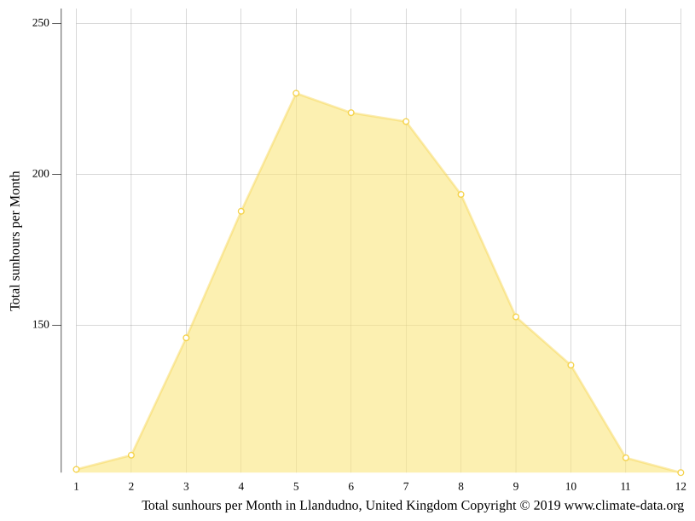
Graph and information found from Climate-data.org.
Climate-data.org, hours of sunshine in Llundudno, 2021
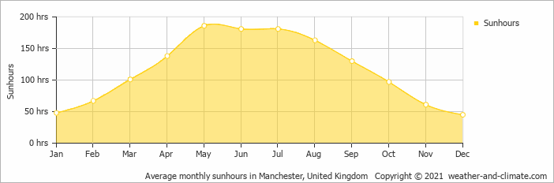
Using another graph sourced from Weather&climate.com and recorded later than the one previously shown, it shows very similar results, with May having the most sunshine hours and December having the least. The site also estimates that the annual number of sunshine hours in Llandudno is about 1420 hours.
Weather & Climate, Average monthly hours of sunshine in Llandudno (Gwynedd, 2021)
Jan | Feb | Mar | Apr | May | Jun | Jul | Aug | Sep | Oct | Nov | Dec
50 | 68 | 107 | 145 | 186 | 180 | 180 | 160 | 140 | 99 | 60 | 45

Calculation of average wind speeds
Wind speed charts
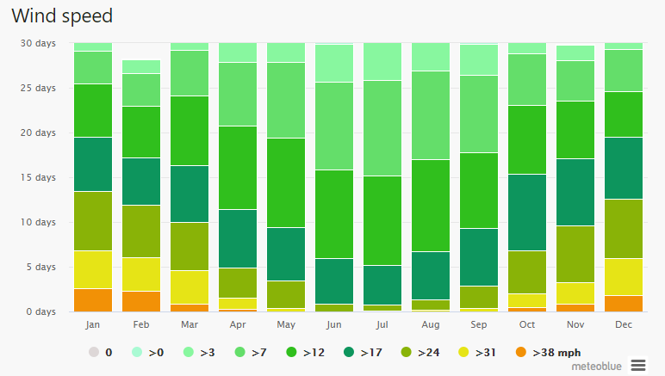
Meteoblue, Simulated historical climate & weather data for Llandudno, 2006-2022
Wind Table
January
Wind Speed mph | 0 | >0 | >3 | >7 | >12 | >17 | >24 | >31 | >38
Days | 0 | 0 | 1.8 | 3.6 | 6 | 6 | 6.7 | 4.2 | 2.6
February
Wind Speed mph | 0 | >0 | >3 | >7 | >12 | >17 | >24 | >31 | >38
Days | 0 | 0.1 | 1.6 | 3.6 | 5.8 | 5.3 | 5.8 | 3.8 | 2.3
March
Wind Speed mph | 0 | >0 | >3 | >7 | >12 | >17 | >24 | >31 | >38
Days | 0 | 0 | 1.8 | 5.1 | 7.8 | 6.3 | 5.4 | 3.7 | 0.9
April
Wind Speed mph | 0 | >0 | >3 | >7 | >12 | >17 | >24 | >31 | >38
Days | 0 | 0 | 2.3 | 7.1 | 9.4 | 6.5 | 3.4 | 1.2 | 0.3

May
Wind Speed mph | 0 | >0 | >3 | >7 | >12 | >17 | >24 | >31 | >38
Days | 0 | 0 | 3.1 | 8.5 | 10 | 5.9 | 3.1 | 0.4 | 0
June
Wind Speed mph | 0 | >0 | >3 | >7 | >12 | >17 | >24 | >31 | >38
Days | 0 | 0.1 | 4.2 | 9.8 | 9.9 | 5.1 | 0.9 | 0 | 0
July
Wind Speed mph | 0 | >0 | >3 | >7 | >12 | >17 | >24 | >31 | >38
Days | 0 | 0.1 | 5.1 | 10.7 | 10 | 4.4 | 0.7 | 0.1 | 0
August
Wind Speed mph | 0 | >0 | >3 | >7 | >12 | >17 | >24 | >31 | >38
Days | 0 | 0.1 | 4.1 | 9.9 | 10.3 | 5.4 | 1.1 | 0.2 | 0
September
Wind Speed mph | 0 | >0 | >3 | >7 | >12 | >17 | >24 | >31 | >38
Days | 0 | 0.1 | 3.5 | 8.6 | 8.5 | 6.4 | 2.5 | 0.4 | 0
October
Wind Speed mph | 0 | >0 | >3 | >7 | >12 | >17 | >24 | >31 | >38
Days | 0 | 0 | 2.1 | 5.7 | 7.7 | 8.6 | 4.8 | 1.5 | 0.5
November
Wind Speed mph | 0 | >0 | >3 | >7 | >12 | >17 | >24 | >31 | >38
Days | 0 | 0.1 | 1.7 | 4.5 | 6.5 | 7.5 | 6.3 | 2.4 | 0.9
December
Wind Speed mph | 0 | >0 | >3 | >7 | >12 | >17 | >24 | >31 | >38
Days | 0 | 0 | 1.6 | 4.7 | 5.1 | 6.9 | 6.6 | 4.2 | 1.8
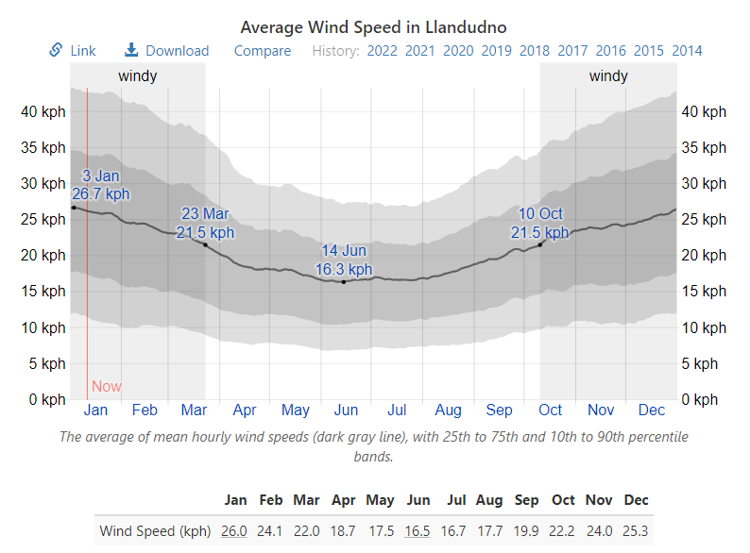
Average monthly wind speeds in meters per second
Jan | Feb | Mar | Apr | May | Jun | Jul | Aug | Sep | Oct | Nov | Dec
7.2 | 6.7 | 6.1 | 5.2 | 4.9 | 4.6 | 4.6 | 5 | 5.6 | 6.2 | 6.6 | 7
 |  |  | Average winds speed per hour |  |  | Average wind speed per day |  |  | Average wind speed per year
Total Average Wind speed |  |  | 5.8m/s |  |  | 139.2m/s |  |  | 50,808m/s
Weather Spark, Climate and average weather year-round in Llandudno, Cedar Lake Venture Inc.
If I choose to use the wind turbines supplied from windenergy.com I will have an estimate of 33 days a year of inactivity due to a lack of wind.
The wind turbines have a survival speed of 70m/s (meters per second) which when converted in MPH (miles per hour) is roughly 156 MPH. Due to this high survival speed there will not be a situation in which the turbines would need to be shut down to overly high winds as the highest average wind speed for Llandudno is 38 MPH.

My Decision
I have decided to use wind turbines as my energy source of choice as Wales is a naturally windy country and I will be able to make more use of the benefits of utilizing wind energy more than any solar. Solar farms might also become more of a liability due to the immense space required, the extreme amount of maintenance and the fact that compared to other countries the amount generated would suffer greatly during winter seasons where our skies are particularly grey.

Wind Turbines
I initially looked at several wind turbines in my research and compared their production and costs. (See chart above for details) I looked at the Goldwind -GW8S which stands at a height of 110 meters and has its rotors diameter at 175 meters. It has a rated power of 8 Mega Watts (MW) and has a rated windspeed of 12 meters per second (m/s). For starting up is needs a windspeed of about 3m/s and it for safety reasons must be deactivated at windspeeds of 25m/s and above. The price of the turbine is 170,000 pounds for both manufacturing and installation including VAT. However, the GW8S would need only one wind turbine to provide enough power to the village within 2 hours off use. It was also a big financial outlay, and this gave me the need to start my research for a cheaper and more viable option.
I then decided to look at other turbines that were smaller and more specific, which could generate power that I needed. The Wind turbine which I decided to go with is the Hummer H25.0.-200KW. I decided to use the Hummer H25.0 as I could purchase 2 turbines which would cost approximately 150,000 pounds. It can produce the power needed for my specifications and was financially prudent.
The wind turbine H25.0-200KW is a production of Anhui Hummer Dynamo Co, Ltd a manufacturer from China. The rated power of the Hummer H25.0 is 200kW. AT wind speed of 11.5 and the survival wind speed is 50 m/s.
Rotor: the rotor diameter of the Hummer H25.0-200 KW is 25 m. The rotor area amounts to 491 m2 and maximum speed is 50.0U/min. The number of blades is 3 in total and the material of blade is fiberglass composite.
Gear Box and Generator: the type of gearbox be longs to direct drive and the ration of it is 23:1. The type of generator is permanent magnet alternator. SCF technology and the number is one. The maximum speed of generator is 50.0/min and the voltage amounts to 690 V. (Hummer, 2018)
The average wind speed of Llandudno is about 5.8m/s calculation is: 7.2+6.7+6.1+5.2+4.9+4.6+5+5.6+6.2+6.6+7=65.1
65.1/12=5.8m/s
Due to this the average power production of a single turbine will be around 34kW an hour.
I have decided to calculate the price of the nation grid energy if Llandudno were to rely on purchasing energy instead of producing their own as it could potentially be financially damaging in the long term. (See calculation below)
Total demand of 1 year: 402595kW X 1.8p = 724671p or £7246.71
I have also calculated the cost of energy for ten years.
Total demand of 10 years: 4025950kW X 1.8p = 7,246,710p or £72,467

Number of turbines needed
With my average hourly generated power being 34kW according to the wind curves average wind speed being 5.8 m/s as shown in the figure below, I wanted to find the yearly generated power, to do this I took the hourly power and multiplied it by the hours in a day and then the days in a year (34x24x365).
The total of power generated is 34x24x365= 297840kW per year. My yearly power demand for the village is 402595kW. To find how many turbines I would need to cover the demand I decided to divide the demand by the amount generated (402595/297840). My result of this calculation was 1.35, meaning I will need two wind turbines to meet the yearly demand.
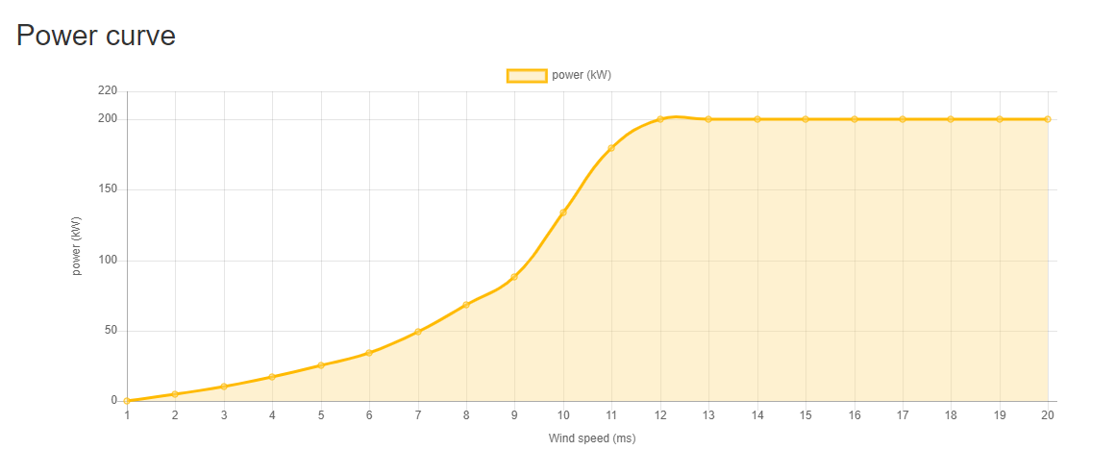

Different Wind Turbines
Vestas V17  Power: 90 kW, three phase  Voltage 480Y/277VAC (standard, other voltages available)  Rotor: 17.0m (55.8 ft) diameter  Tower: 22.5m (73.8 ft) tubular  Yaw system: active yaw  Cut-in windspeed: 3.3 m/s (7.4 mph)  Rated windspeed: 16.8 m/s (37.6 mph) | Hummer H25.0  Rated power: 200 kW  Cut-in wind speed: 2.5m/s  Rated wind speed: 11.5m/s  Cut-out wind speed: 20m/s  Survival wind speed: 50m/s  Number of rotor blades: 3  Generator type: Permanent magnet alternator.SCF technology
GW S8  Rated power: 8 MW  Rotor diameter: 175m  Hub Height: 110m  Cut-in wind speed: 3m/s  Rated wind speed: 12m/s  Cut-out wind speed: 25m/s  IEC wind speed: S  Operating temperature: -10c to 40c  Survival temperature: -20c to 50c | SG 2.6-114  Power: 2.625 MW  Rotor diameter: 114m  Hub heights(m): 63, 68, 75, 80, 88, 93, 125  Frequency: 50/60Hz  IEC wind speed: IA, IIA, S  Operating temperature: -20c to 35c  Gearbox: 3 stages  Control: pitch and variable speed

Hummer H25.0
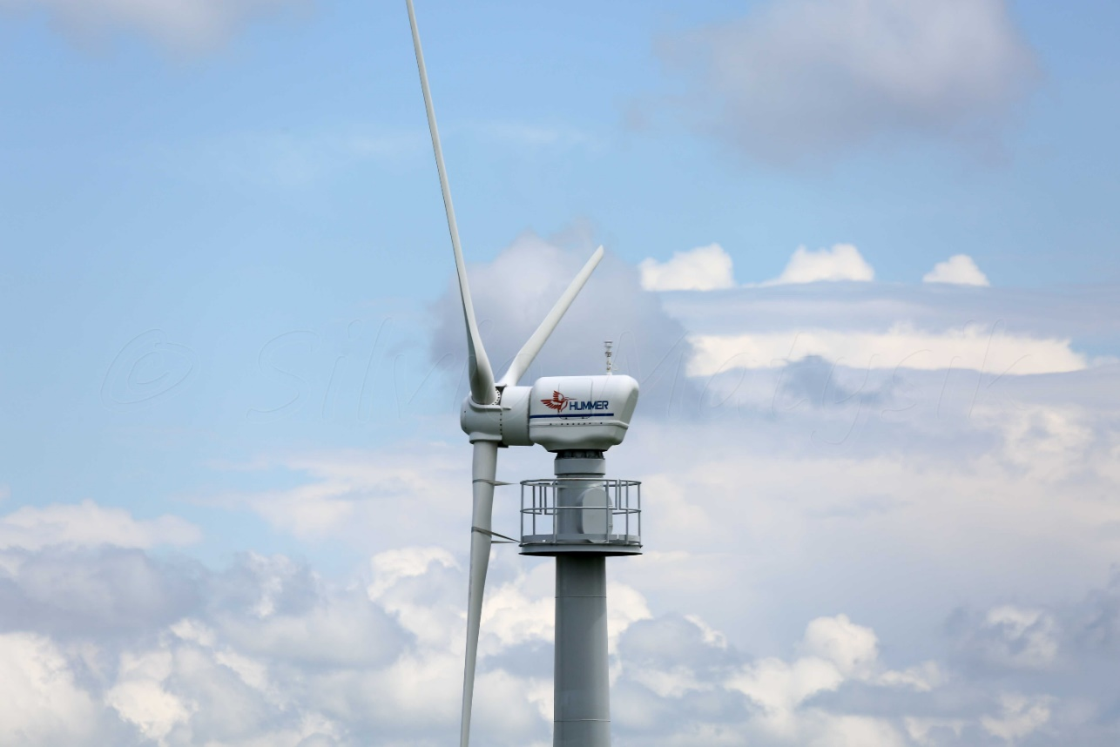
GW 6S/8S


Batteries
It should be noted that during the summer months there will be roughly ten days where the turbines would be unable to operate due to low wind speeds. Because of this the best solution would be to install battery banks to store excess energy form windier days to be used during low wind speeds, this can also act as a form of emergency if the wind turbine were to be damaged or need maintenance. The batteries will need to be replaced every 10 years.

Converter
For the small off-grid wind power generation system, due to the unstable rotational speed of the generator, the electric energy emitted by the generator is also unstable and cannot be directly used by the user. The method is to integrate the alternating current emitted by the generator into direct current and then charges to the battery and supplying It to the AC load through the grid converter. Due to the change in the power of the battery charged and the discharge of the battery, it is required that the inverter be able to function within the range of the larger dc voltage, and to ensure that the output voltage is stable. At present independent wind power system used in remote areas, the operation and maintenance conditions are relatively poor, high reliability is the inverter- particularly important requirement.

Wind turbines impact on the environment
When constructing wind farms, it is important to consider the location as to not harm the local environment for instance, the common migration paths for birds must be considered to minimize the causality rate caused by the turbines. It is also required that they are placed away from trees and forests as to prevent risk of harming bats. This is the most prevalent concern regarding wind turbines and efforts are being made in finding a solution to this issue, or to at the least minimise the impact.
It should also be noted that wind turbines take up only a small portion of wind farm space. The reason for this is because the turbines need a large amount of space between each other in order to accommodate for wind direction and prevent collision. This causes wind farms to dedicate massive areas of land to operate.
On rare occasions wind turbines can catch fire and even leak lubricating fluids onto the ground below.
Although a less prevalent issue, it is known that wind turbines tend to cause a lot of bother to locals who live around them, the shadows they cast can sometime cause a flickering effect as the blades rotate, usually dependant of the wind speed. The blades can also reflect sun light which can be seen from long distances and cause irritation to people's eyes.
Local Government Association, Benefits and potential impacts of wind energy, 2022
Union of concerned scientists, Environmental impact of wind power, Mar 13th
EIA, U.S. Energy Information Administration, Wind Explained, December 17 2021
Alternative energy tutorials, Environmental impact of wind energy, 2010
Energy.gov, Environment impact and siting of wind projects, 2021

Conclusion
In summary, wind turbine is a viable option for power production as you can produce enough wind power to meet the demand of the village of Llandudno. The batteries plan for storing energy will help maintain the village on less windy days, especially during the summer.
By only using two turbines I can keep operations flowing in case of emergency repairs being needed, also due to the small scale of the wind farm the environmental risk to local wildlife is minimized. I feel as though the advantages that the wind turbines offer outweighs the potential downsides, which will benefit the village. Wind turbines are effective source of power as they will end recouping initial costs with power production, with energy left to sell to the grid. Wind power is also a reliable source of sustainable energy sources which is less harmful and environmentally friendly for the planet.

References
Climate-data.org, hours of sunshine in Llundudno, 2021
https://en.climate-data.org/europe/united-kingdom/wales/llandudno-10892/
Weather & Climate, Average monthly hours of sunshine in Llandudno (Gwynedd, 2021)
https://weather-and-climate.com/average-monthly-hours-Sunshine,llandudno,United-Kingdom
Weather Spark, Climate and average weather year round in Llandudno, Cedar Lake Venture Inc. 2021
https://weatherspark.com/y/37922/Average-Weather-in-Llandudno-United-Kingdom-Year-Round
Local Government Association, Benefits and potential impacts of wind energy, 2022
https://www.local.gov.uk/benefits-and-potential-impacts-wind-energy#:~:text=Impacts%20on%20the%20environment&text=If%20inappropriately%20located%2C%20wind%20turbines,collision%2C%20disturbance%20or%20habitat%20damage.&text=Wind%20turbines%20can%20also%20be%20harmful%20to%20bats%2C%20in,similar%20way%20to%20bird%20populations.
Meteoblue, Simulated historical climate & weather data for Llandudno, 2006-2022 https://www.meteoblue.com/en/weather/historyclimate/climatemodelled/llandudno_united-kingdom_2644120
Union of concerned scientists, Environmental impact of wind power, Mar 13th
https://www.ucsusa.org/resources/environmental-impacts-wind-power
EIA, U.S. Energy Information Administration, Wind Explained, December 17 2021
https://www.eia.gov/energyexplained/wind/wind-energy-and-the-environment.php
Alternative energy tutorials, Environmental impact of wind energy, 2010
https://www.alternative-energy-tutorials.com/wind-energy/environmental-impact-of-wind-energy.html
Energy.gov, Environment impact and siting of wind projects, 2021
https://www.energy.gov/eere/wind/environmental-impacts-and-siting-wind-projects

Turbine references
Halus Power systems, Turbine specifications, Turbine models, 2021
http://www.halus.com/turbinespec.html
Goldwind, Smart wind power, GW 6S/8S, 2021
https://www.goldwind.com/en/windpower/product-gw6s/
Siemens Gamesa, Products and services, SG 2.6-114
https://www.siemensgamesa.com/products-and-services/onshore/wind-turbine-sg-2-6-114
(Hummer), wind-turbine-models.com, Turbines, Hummer H25.0-200kW
https://en.wind-turbine-models.com/turbines/1681-hummer-h25.0-200kw

Appendix
Rauman Energy, 2021
https://farm-energy.extension.org/wp-content/uploads/2019/04/3.5kW_Spec_Sheet.pdf

