Nia Lawrence (2100633)

Learning in the digital era
BMPS4009

Contents Page

Preparing for Higher Education Page 1

Becoming a Digital Learner Page 2

Becoming a Team Player Page 3

Reflection Page 4

Reference List Page 5

Preparing for Higher Education (Unit 0)

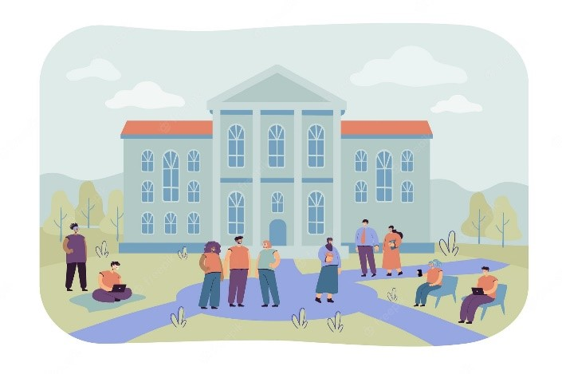
Learning how to study effectively comes down to how you plan your tasks; allocating timeslots for yourself to follow, taking regular breaks, prioritising tasks, and avoiding common obstacles like procrastination and perfectionism. Planning can be a way of reducing stress when completing assignments, it helps students to create a realistic view of how much they can achieve in each timeslot (Richardson 2019).
When preparing for higher education there are basic essential digital skills that you need to know, these skills being knowing your way around programmes like Microsoft Word, PowerPoint, Outlook, and Microsoft Teams.

Online safety is important too, students should be limiting the amount of personal information that they are putting online as things online could potentially affect you in the future. Alongside this, you should be thinking about what you are clicking on and downloading as this could lead to viruses. Antiviruses can be installed on the devices that you use to help prevent viruses as your computer may contain flaws in the programming which creates security risks that other people can exploit (Pérez-Sánchez and Palacios 2022).

Referencing and giving credit to previous academic sources is a way of producing authentic work. Referencing is important for students and lecturers for many reasons these being: it helps students to support the key points that they are trying to get across, it helps lecturers to trace student’s sources and examine the accuracy of them; and prevents cases of academic misconduct (Neville 2009).

Before starting assignments, you must always read the question and establish what is being asked of you using command verbs and key words, this can also help you understand what type of assignment you need to create The Open University (2022).

Becoming a Digital Learner (Unit 1)

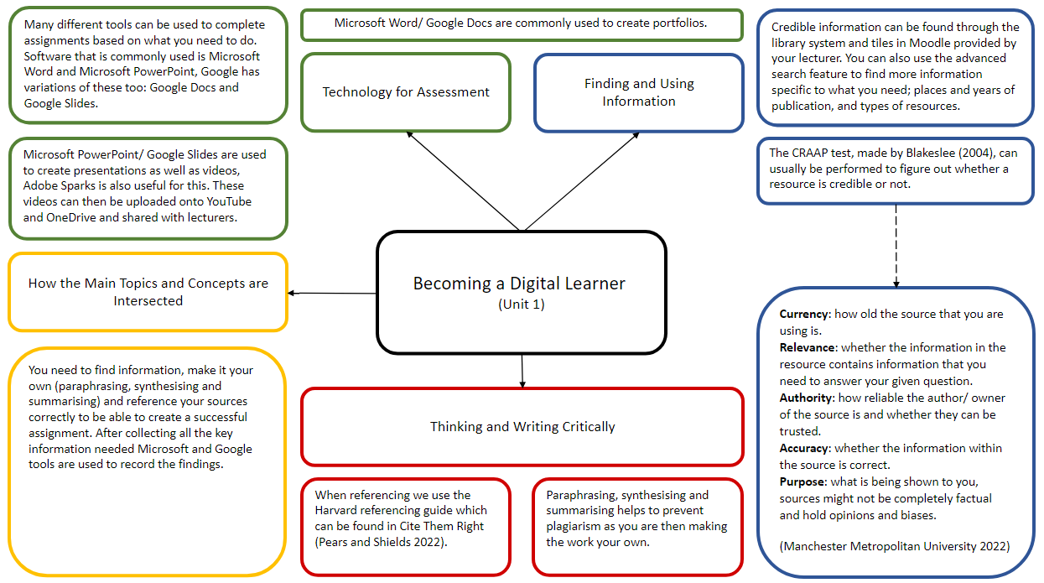

Becoming a Team Player (Unit 2)

Video Link: https://youtu.be/TOJBgNkRqBM

Reflection

Starting University
I am resitting level 4 this year. I have met a lot of new people and I have seen a lot of people that I met last year, and I was quite nervous to resit the course because of the stigma around it and how people would view me. Now that I have restarted the year, I feel as though I had focused too much on other people’s opinions when they should not matter. As I get further into the year, I need to focus on myself and not put myself in the same situation as I did last year and concentrate in class and on the work that I am doing.

Getting to Grips with Online Learning and Resources
Currently I feel as though I am quite familiar with the online learning and resources that have been given to me and for me to find through Moodle and the Library. So, I will continue to use the resources provided to help me create assignments to a good quality.

Process of Writing Your First Assignments
The process of writing my first assignments has not gone as well as I hoped that it would go. I have not been working through my assignments throughout the term, so I am behind, but I have started to designate time for them with allocated time for breaks so that I do not burn out. This has made me realise that I need to work on and improve my time management and planning skills. Ways I could work through this could be having a diary with all the tasks that I need to complete in a day and allocate timeframes for each one (Forsyth 2013). Another option that I could take while completing the assignments would be to organise my thoughts so that I can properly understand the question given to me, I can do this by creating mindmaps and working off them (McMillan and Weyers 2012).

Reference List
​
Blakeslee S (2004) ‘The CRAAP Test’, LOEX Quarterly, 31 (3) Available at: https://commons.emich.edu/ (Accessed: 14/11/2022)​

Fearon J (1999) What is Identity (As we Now Use the Word)? Available at: http://www.web.stanford.edu/ (Accessed 17/11/2022)​

Forsyth, P. (2013) Successful time management. 3rd ed. Philadelphia, Pa: Kogan Page Ltd.

Immigration Advisors Authority (2022) Personal beliefs, values, attitudes and behaviour. Available at: https://www.iaa.govt.nz/ (Accessed 18/11/2022)

Manchester Metropolitan University (2022) Evaluating Sources of Information Available at: https://www.mmu.ac.uk/ (Accessed: 14/11/2022)​

McMillan, K. and Weyers, J.D.B. (2012) The study skills book. Third edition. Harlow, England: Pearson.

Neville, C. (2009) How to improve your assignment results. Maidenhead: McGraw Hill Open University Press.

Pears, R. and Shields, G.J. (2022) Cite Them Right: The Essential Referencing Guide. 12th Edition. New York: Bloomsbury Academic.

Pérez-Sánchez A and Palacios R (2022) ‘Evaluation of Local Security Event Management System vs. Standard Antivirus Software’, Applied Sciences, 12(3), p. 1076 Available at: https://doi.org/ (Accessed 15/11/2022)

Rajala K, Sourice M, Thomas V (2020) ‘The meaning(s) of place: Identifying the structure of sense of place across social-ecological landscape’ People and Nature, 2(3), p. 718-733 Available at: https://besjournals.onlinelibrary.wiley.com (Accessed: 17/11/2022)​

Richardson B (2019) Time Management: The Importance of Planning Available at: https://development-academy.co.uk/ (Accessed 15/11/2022)

The Open University (2022) Preparing Assignments: Understanding the Question. Available at: https://help.open.ac.uk/ (Accessed 15/11/2022)

