Student Name: Chis Ileana Ioana
Student ID: 1818454

Lecturer Name: Anita an
Submission date: 26 August 2019

Academic and Employability skills

Executive summary
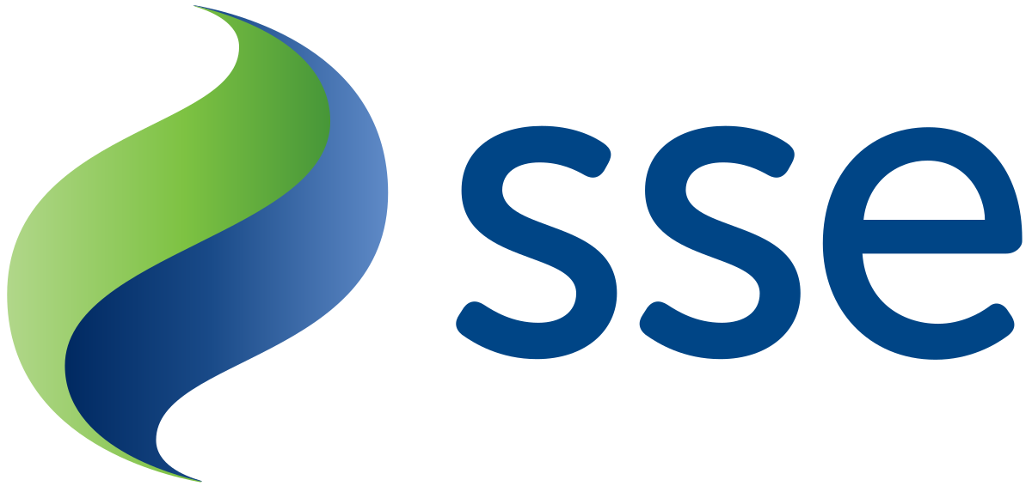
Currently, for any job companies desire and hire the persons or candidates who have relevant skills which are demanded by the specific organization or company .There is going on a skill gap across the world or more specifically among the candidates of different jobs or positions for which organizations and companies are crazier currently on relevant skills and qualifications of candidates (Publishing, 2014). Various skills of candidates get developed in different levels of their life while most of the skills get developed in the academic life of them while rest of them developed in professional or personal life. In that perspective ,skills required in case of meeting the objectives of the academic life is defined as academic skills and in the same way for job or employment required skills are called employability skills and lastly the combination of these two sorts of skills is defined as academic and employability skills .This report will explore different aspects or skills regarded to my academic and employability areas while I am interested to have job in SSE an international company of the UK which deals with energy products and services and at this moment I am near to accomplish my graduation .

Contents
Executive summary 1
Introduction 3
Literature review 3
Report on the way I fell first week till last and the way I learn as well as my understanding 4
Already developed skills and skills required to prove 4
An Academic report 5
Case study analysis 6
Conclusion 8
References 9

Introduction
SSE is an energy company of the UK which has businesses in the multinational levels .As, I would like to have job in this company as it is a multinational company so ,definitely it will have the need for various academic and employability skills in order to meeting the job requirements .The report will describe broadly the experience of mine on first to last weeks and my understanding ,for meeting the job requirements skills I have already in and what I should demonstrate in order to get the job, and in conclusion both a report and case study should be demonstrated in the perspectives of academic and employability skills.

Literature review
For conducting the research and carrying out the report on academic and employability skills the research articles which go mostly are-
- Nisha, Subbu M.; Rajasekaran they conducted the study which provides knowledge on the employability skills which are required to meet the demands of the current workplace as well as for coping up with the current and dynamic business world(Nisha,2018) .Moreover, they provided a nice description on how can the skills can be achieved or developed by individuals .
- F Suleman conducted a significant study on the graduates of higher education about identification of employability skills. In this study different aspects of the higher education graduates came forward (Suleman, 2016). Some of them were very shocking while some were interesting and encouraging. Most of the students don’t have the required skills while some have extraordinary skills which are with this advanced world situations and dynamics.

Report on the way I fell first week till last and the way I learn as well as my understanding
From both of my educational side and the experiences of seeking jobs I have some ideas on academic and employability skills .During my first weeks, for me there has little knowledge on different skills or qualifications. From the investigation and knowledge from various incidents I found during first weeks that for employment some recognized skills are required which we have been hearing from our rudimentary levels like market research , presentation and so on (Harrison, Soars and Soars, 2011). Throughout the last weeks in different times my notion changed on skills and qualifications. During last moments I got ideas that the world of business is not as the traditional one this has much changed with time and now just the mentioned areas are not enough for employment and academic activities rather many more skills are on the card for learning which constitute parts of modern jobs or employment .different ways and methods I applied on the way of gathering the knowledge like conducting research , analyzing and going through the relevant research and literatures on the academic and employment , interviews of the CEOs of different organization and employees and finally , some of my friends who are currently on internships in different world-class organizations who provided me information on the issues . Moreover, I currently have understanding and knowledge on the required skills. like for better employment and academic excellence there need advanced robotics , computer and programming skills , management and controlling skills ,and effective communication skills alongside of the traditional skills .

Already developed skills and skills required to prove
From my rudimentary level I have been achieving different skills and qualifications .My desire is that I would like to be an HR manager of the SSE which is internationally recognized. While the HR is the most demanding and crucial sector for now-a-days in different organizations as the business world is getting changed with the influences of the advanced technologies and customer cultures. And due to that, HR managers have to take responsibility to train and adapt employees in line with the demands of the modern world of business. Apart from that, I have some soft and hard skills like pressure management, effective communication, and some skills on robotics alongside of the traditional different skills. But these, I know, are not enough to get the desired job which is very sensitive a job or position currently and needs to maintain various issues to cope up with the demands of the business world (Rasmussen.edu, 2019). Hence, the required skills and the objects which needed to show from my side are advanced robotics, computer and programming skills, management and controlling skills, and effective communication skills. Moreover, some context or job related skills which might be provided by the authorities concerned to the desired workplace or position and I think these will be achieved when I will be in my desired position by the organization. Apart from that, the coordination from the organizational side is the best way for the interested ones to get into these desired jobs.

An Academic report
Here, in this segment I wrote a report which is intended to the CEO of SSE on my current skills and qualifications as well as the cooperation which I need to develop for getting the job with the articulation of my desire for getting job in this company.
Receiver: CEO of the SSE, London, UK.
Executive summary
I am near to accomplish my graduation from a world-class university of the UK on Business Management course which provided and still providing me knowledge on various aspects of business and current business world dynamics which I think I will be able to apply for my job or position. Recently , getting job is one of the difficult tasks ever as there have skills gaps and need for highly qualified candidates for different positions .For the post I would like to get on I need these skills and some of which I have already (dummies, 2019) . Apart from that, this report is about my current skills and qualifications as well as the cooperation which I need to develop for getting the job with the articulation of my desire for getting job in this company.
Introduction
The skills and qualifications which the job or position needed I have most of them again, I need some others. Therefore, this report is about the skills, I have and what I need, and the expression of my interest to get on this job.
Body
It is known to everybody that for international level jobs there need skills and qualifications which are in line with the international standards. Businesses now-a-days have enormous risks if they cannot maintain pace with the current world changes. Better prediction, productive research and qualified staffs are very required to do so or accomplish so otherwise business will be in failure. for getting rid of from the failure and regression businesses are choosing and recruiting the candidates who have the required skills and the skills which are advanced (dummies, 2019).To the CEO of SSE , I have some skills like pressure management , effective communication , and some skills on robotics alongside of the traditional different skills .But, I know these skills are not enough for the job I am desiring for in your organization , I need some more skills which I think your organization will be providing me through which I will be perfect for that job and I can assure that I will try my level best to carry out all of the responsibilities which will be assigned on me from the side of organization.
Conclusion
Considering all the facts above your organization and you will make the path for me to get on the relevant skills. I know that without qualified person that position you will not all to be fulfilled as this department will do all the activities to prepare an organization to fight.

Case study analysis
Through the following case study my skills for the jobs will be elaborated –
Introduction
Academic and employability skills are the fundamental ones to get job desired. In academic levels the skills lessons which are relevant to the employment level are taught and practiced through various ways and activities .Nevertheless, some skills stay still out of the realm therefore, these are needed to attain for a desired position. As a dreamer of corporate sector, I need to master on these extra skills and I would like to analyze on my strong sides and weak sides in this case study.

Backdrop
SSE is a multinational organization which has businesses in several countries and every year it recruits the qualified candidates for fulfilling its different vacancies .As, day on day, the requirements for different jobs have been changing due to the influences of various factors there in the business world therefore, the company is also changing its recruitment styles and job requirements (Sse.com, 2019). From my perspective, I for the last several months came to the ideas that international level jobs are currently not so easy to get due to various complexities related to them in terms of skills requirement and changes .Therefore , as I would like to be a part of this organization and in doing so several skills I achieved like pressure management , effective communication , and several skills on robotics alongside of the traditional different skills but I don’t have advanced robotics , computer and programming skills ,and management and controlling skills.
Alternatives
To get on the skills which I don’t have to develop there are many organizations which provide knowledge on my required skills, when it might be the target organization of mine or any other. I might need for internship in such sort of organization. I might go for business consultants or consultancy organization .These are the alternatives.
Solutions
Getting rid of the lacking is the perfect way to get on the dream and for doing so , I would like to go for consultancy firms , training organizations , clubs where skills are taught , coaching center for the relevant skills achievement (Canter, 2007).The best solutions out of the demonstrated ones are provided here.
Recommendation
Skills get developed or achieved by various ways therefore, just established organizations are not the solutions for skills development rather the self-trying can do a lot for skills development .Apart from that, I should try at first developing skills then the organizations should come .

Conclusion
As, time is changing and technology is advancing so doing the skills as well as the business world. For the business world dynamics, changes there need proper skills and tools from both organizational and candidate sides to face the changes which can contribute to reducing the risks and thus, help in growing an organization (Quendler, 2017). Several skills I achieved to get employed in the world-class organization and multinational ones but I need more which are currently required. Apart from these, this report took on some areas like broadly the experience of mine on first to last weeks and my understanding, for meeting the job requirements skills I have already in and what I should demonstrate in order to get the job, and in conclusion both a report and case study should be demonstrated in the perspectives of academic and employability skills from the perspectives of SSE which is an energy company of the UK that has businesses in the multinational levels.

References
- Canter, R. (2007). Make the right career move. Hoboken, N.J.: John Wiley & Sons.
- Dummies. (2019). Skills and Personal Qualities that Employers Want - dummies. [online] Available at: https://www.dummies.com/careers/find-a-job/skills-and-personal-qualities-that-employers-want/ [Accessed 25 Aug. 2019].
- Harrison, R., Soars, L. and Soars, J. (2011). Academic skills. Oxford: Oxford University Press.
- Publishing, O. (2014). OECD Skills Outlook 2015 Youth, Skills and Employability. Paris: OECD Publishing.
- Quendler, E. (2017). Organisational resilience: building business value in a changing world. J. for International Business and Entrepreneurship Development, 10(2), p.101.
- Rasmussen.edu. (2019). 9 Top Human Resources Job Skills Employers Are Seeking | Rasmussen College. [online] Available at: https://www.rasmussen.edu/degrees/business/blog/human-resources-job-skills-employers-want-to-see/ [Accessed 25 Aug. 2019].
- Sse.com. (2019). SSE plc - The UK's broadest-based energy company. [online] Available at: https://sse.com/ [Accessed 25 Aug. 2019].
- SM Nisha, (2018). Employability Skills: A Review.pp.123-128.
- Suleman, F. (2016). Employability Skills of Higher Education Graduates: Little Consensus on a Much-discussed Subject. Procedia - Social and Behavioral Sciences, 228, pp.169-174.



