


LOCATION: Swansea | LLEOLIAD: abertawe
LEVEL 7 | LEFEL 7
EXAMINATION PERIOD | CYFNOD ARHOLIADAU
MAy 2019 | MAI 2019

MODULE CODE: M7X01696
IP SWITCHED NETWORK PRACTICAL

Name :

Student ID :

Date & Time :

This is an individual practical lab-test, held under examination conditions. You will be assigned four switches, you should configure these Switches based on the following specifications.

This paper is marked out of 100.

You will have 3 hours to complete this task.

TOPOLOGY

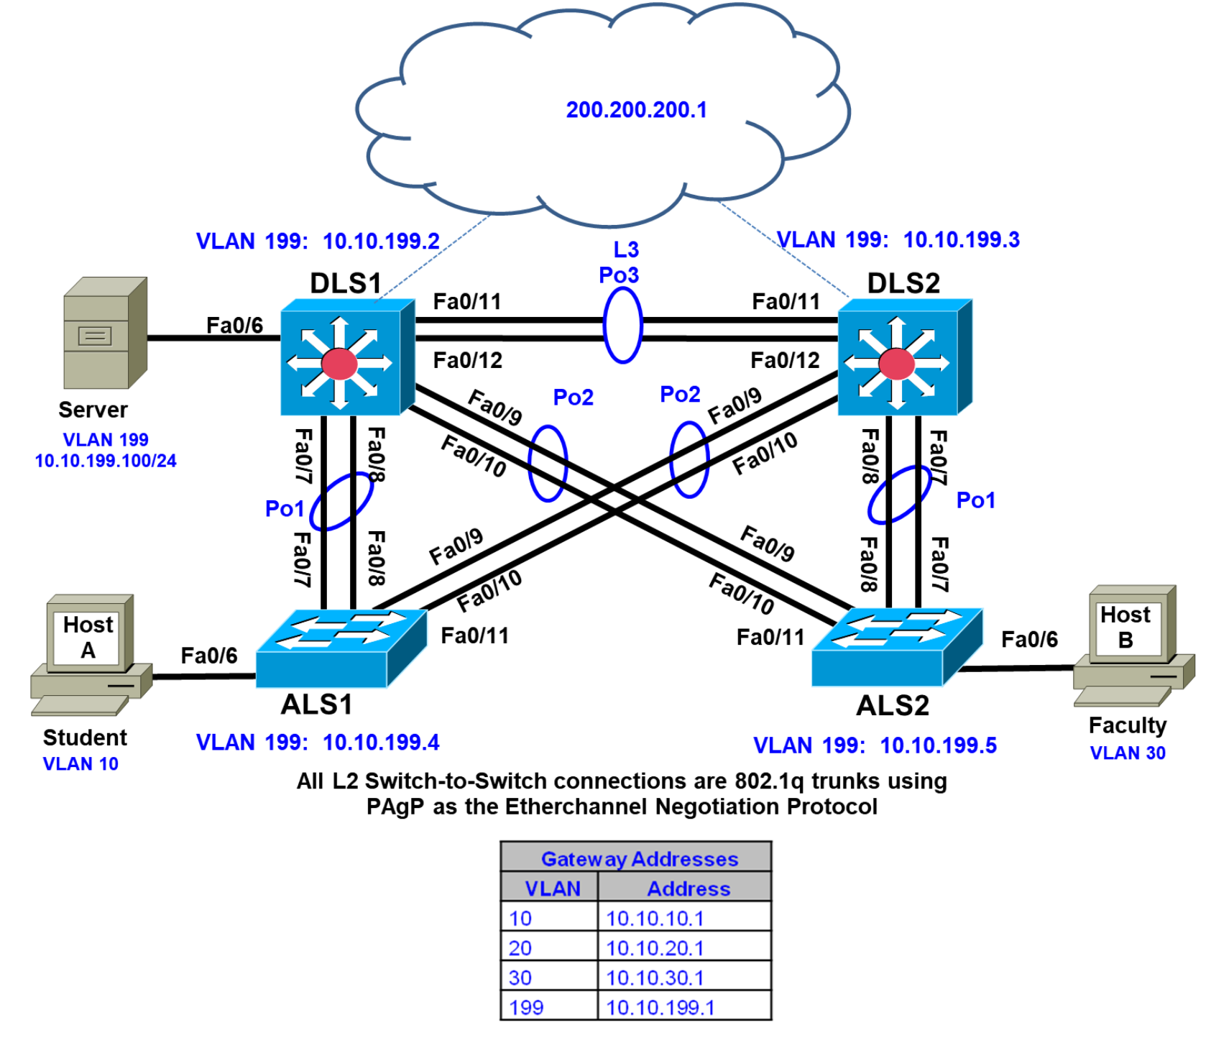

Task 1 – Network Connections

Physically cable the network as shown in the topology diagram.
Configure all switches with hostname as shown in the topology.

Task 2 – Configure the network according to specification (80 marks)

- Ensure that the VLAN 1 interface on all switches is not used for administrative management or user traffic . Shutdown all ports. Activate ports as necessary in configuration of these interfaces. As a security best practice, ensure that unused ports are moved to the Parking_LOT VLAN and are statically configured as access ports. Set all basic administration passwords and remote login passwords to cisco unless otherwise specified.
- Configure the Fa0/11-12 link between DLS1 and DLS2 as a Layer 3 EtherChannel and assign a subnet to it. (See chart in step 6 for subnet information.) Do not use a negotiation protocol.
- Bind all inter-switch links in an EtherChannel using LACP.
- Statically set all other inter-switch links as 802.1Q trunks. Ensure that the NATIVE VLAN is altered to VLAN 777. Restrict trunks to only allow VLAN traffic from only VLANs used in this scenario. Disable trunk negotiation.
- Place all switches in the VTP domain LAB_TEST with all switches in VTP transparent mode to support local VLANs.
- Use the table below to create local VLANs used in the campus network.

VLAN | VLAN Name | Subnet
10 | Client | 10.10.10.0/24
20 | VOICE | 10.10.20.0/24
30 | Server | 10.10.30.0/24
199 | Management | 10.10.199.0/24
777 | Native_VLAN
900 | Parking_LOT
L3 Subnet |  | 10.10.12.0/30

- Configure MSTP on all switches in the region TEST_LAB. Assign VLANs 10 and 20 to instance 1, and VLANs 30 and 199 to instance 2. Ensure that DLS1 becomes the spanning-tree root for instance 1 and the backup root for instance 2. DLS2 should become the root for instance 2 and the backup root for instance 1.
- On DLS1 and DLS2, configure SVIs and HSRP to provide gateway redundancy for access layer clients in VLANs 10, 20, 30, and 199. Create an SVI in VLANs 10, 20, 30, and 199, each with an IP address and mask. Reference the chart below for IP address information. Map the HSRP group number to the VLAN number.

DLS1 | DLS2 | ALS1 | ALS2 | HSRP VIP
10.10.10.2/24 | 10.10.10.3/24 |  |  | 10.10.10.1
10.10.20.2/24 | 10.10.20.3/24 |  |  | 10.10.20.1
10.10.30.2/24 | 10.10.30.3/24 |  |  | 10.10.30.1
10.10.199.2/24 | 10.10.199.3/24 | 10.10.199.4 | 10.10.10.199.5 | 10.10.199.1/24

- Configure DLS1 as the active HSRP router for VLANs 10 and 20 with a priority value of 120, and configure DLS2 as the backup. Configure DLS2 as the active router for VLANs 30 and 199 with a priority value of 120, and configure DLS1 as the backup.
- On DLS1, configure the loopback address of 200.200.200.1/24. This loopback address will be used in conjunction with HSRP interface tracking.
- Configure a tracked object on DLS1 to check for reachability of the 200.200.200.1 loopback address using an IP SLA. If reachability is lost, DLS1 should relinquish its role to as active router for VLANs 10 and 20.
- Configure DLS1 as a DHCP server for VLAN 10 and DLS2 as DHCP server for the VLAN 30. Exclude the first 10 addresses from each pool. Name the pool with VLAN number and name, i.e., VLAN_10_STUDENT. Set the DNS server to the loopback 200.200.200.1 address.
- Configure all switches with DHCP snooping on VLAN 10, and 30 to guard against DHCP spoofing and man-in-the-middle attacks.
- On ALS1 and ALS2, create an SVI for MGMT VLAN 199 with an IP address from the VLAN 199 subnet assigned in Step 9.
- For ALS1 and ALS2, specify the HSRP gateway address of VLAN 199 as the default gateway.
- Enable PortFast on all access layer switch ports.
- On ALS1, configure Fa0/6 as an access port using a MACRO and configure the the CLIENT to have access to VLAN 10.
- Configure Fa0/6 with a rate limit of 10 pps to prevent DHCP starvation attacks.
- On ALS1, configure port Fa0/6 with port security. Allow up to two MAC addresses to be learned for IP phone support. Enable sticky learning. Shut down the port if a violation occurs.
- On ALS1, enable error disable autorecovery for the switchport in the event of a port security violation. Set the auto recovery period to 30 seconds.
- On ALS2, configure port Fa0/6 as an access port in FACULTY VLAN 30.
- Configure IP routing on DLS1 and DLS2, and use OSPF to advertise 10.10.0/16. Ensure that the routing information is only exchanged over the layer 3 EtherChannel. Hard code the router-id on both devices. DLS1 should use 1.1.1.1 and DLS2 should use 2.2.2.2.
- Configure all switching devices to synchronize using NTP with authentication. Use a NTP password of s3cureNTP. DLS1 should be set as the NTP master. Ensure the clocks are accurate on all devices.
- Configure remote login on all switching devices using SSH version 2. Restrict remote login on the VTY lines to only allow the management VLAN using the SSH protocol.
- Configure client PC-A and PC-B to obtain an IP address from the DHCP server.

Task 3 – Test network connectivity and path control (20 marks)
- Create a Tcl script to test connectivity from each distribution layer switch to the addresses you assigned in the topology.
Note: The Cisco IOS Software for the access layer switches does not support Tcl scripting.
tclsh

foreach address {
10.10.10.1
10.10.10.2
10.10.10.3
10.10.20.1
10.10.20.2
10.10.20.3
10.10.199.1
10.10.199.2
10.10.199.3
10.10.199.4
10.10.199.5
10.10.12.1
10.10.12.2
10.10.10.11 (Obtain the IP from PC-A IP address)
10.10.30.1
10.10.30.2
10.10.30.3
10.10.30.12 (Obtain the IP from PC-B IP address)
} {
ping $address }

- What is the show command used to verify that the correct VLANs exist on all switches and contain the correct ports? _____________________________________________________________________
- What is the show command used to verify that the EtherChannel between switches is configured correctly?_______________________________________________________
- What is the show command used to verify the spanning-tree configuration and root bridge (DLS1 or DLS2) for each VLAN?____________________________________________
- What is the show command used to verify that the correct SVIs exist and that the correct HRSP routers are primary and standby for each VLAN?________________________
- What is the command used to verify the IP SLA configuration? _______________________________
- What is the command used to verify that client PC-A can ping server PC-B?____________
- What is the command used to verify the traced route from client PC-A to server PC-B.___________
- Test the HSRP configuration by shutting down the loopback interface on DLS1. Initiate a continuous ping from the student VLAN PC. DLS1 should relinquish the HSRP active role. The host on the student VLAN should see minimal disruption. Verify the result
- Verify the routing configuration. Are DLS1 and DLS2 only neighboring across the Po3 interface? What is the appropriate show command to verify.

Submission Requirements:

On each Router the following outputs should be copied on to a text file. The file name should be Surname_Sno_Switchname.txt

Show running-configuration
Show ip interface brief
Show vlan brief
Sh vtp status
Sh etherchannel summary
Sh spanning-tree root
Sh standby brief

All documentation for your solution should be submitted electronically on Moodle.
It is your responsibility that you copy all the files correctly.

