Reflective account:

Over the time of this assignment I have been made quite a few improvements to my skills in after effects yet certain things still seems to cast some issues even if those issues aren’t great but as they say, practice makes perfect so I’ll keep at it.
I started simply by reviewing the footage I intended to use by watching it over a few times to look for when the camera shifts or what not so I’d be able to work with the flow and pick the best piece of footage I could.
I planned to use my own assets rather than use existing ones to make my own rhythmic background with light and colours very similar to the robot eye lab task we did to give it a some what high tech vibe with darker colours to add an air of edge to it as to fit my own personal vibe since I starred in the footage with my guitar.
I experimented with features to remove the green screen such as starting with the key light setting but unfortunately it kept including the black tracking marks on the green screen so I switched tactics to manually masking it and shifting the keyframes per frame to stay following the motion.
The manual masking is not the most practical choose as it can be quite slow but if I am careful I can get it done right though it could take a while.
In preparation for the way I want the designs to flow, I made a storyboard to map the background effects as accurately to what I want to do as I could as in the footage, I don’t move too much, leaving most the motion being what I add.
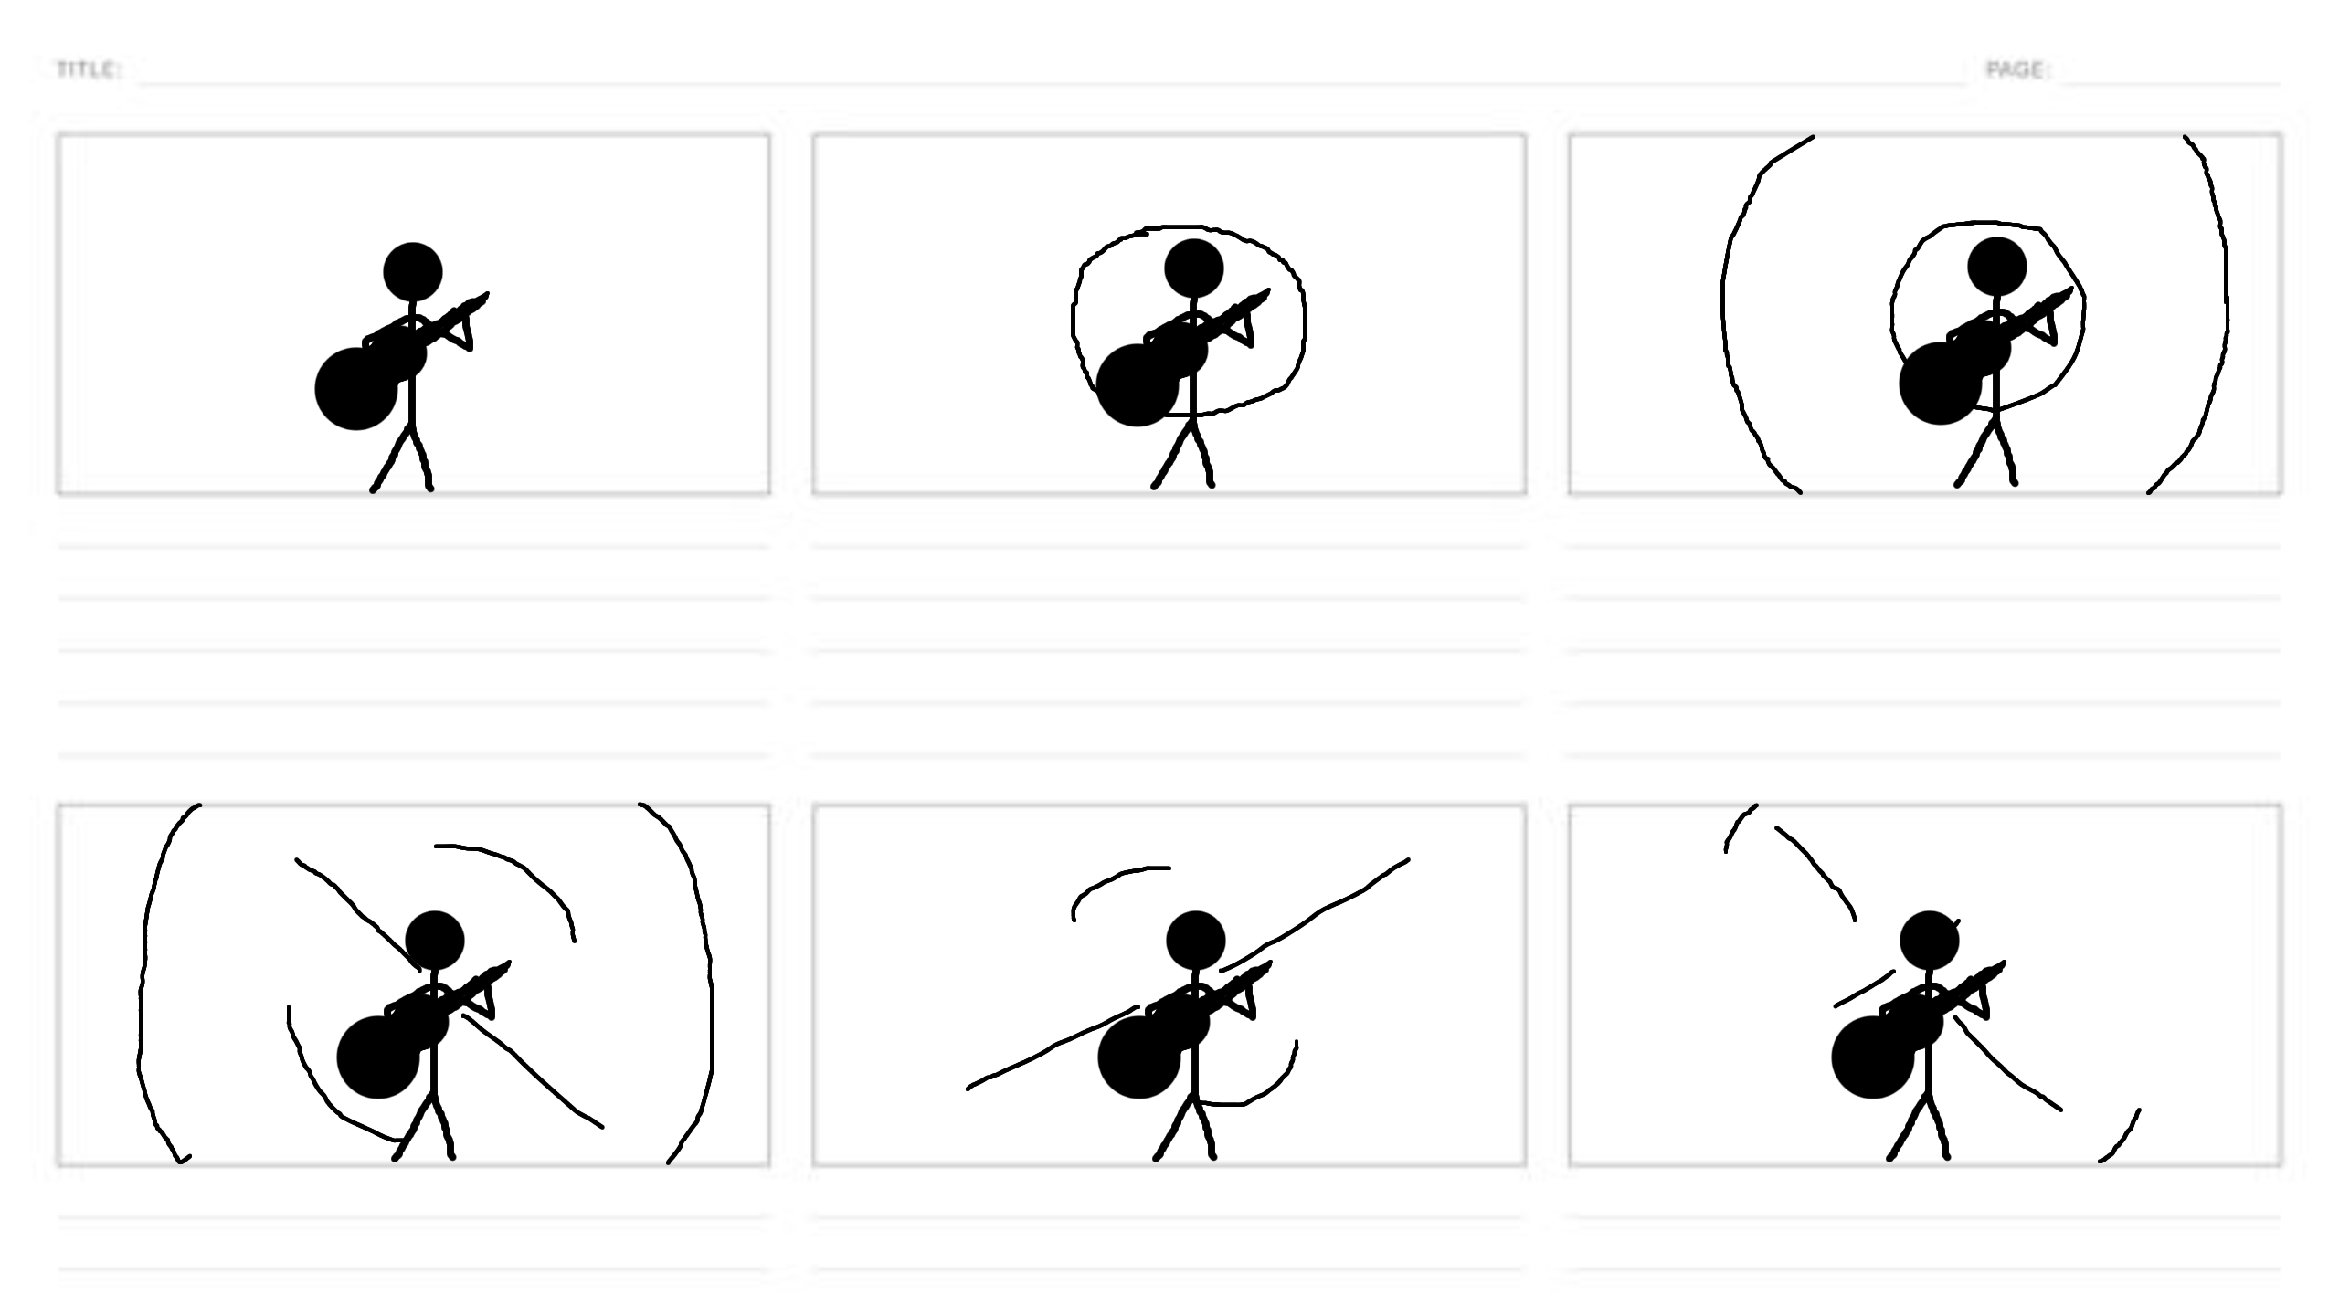
The storyboard is very minimalistic in style but that works fine as a storyboard is not suppose to be incredibly detail but instead just show the flow of motion before it is set to animate and given my background I plan to be consistent of moving animated parts to make something of my own, I’ve mapped the motion I want from them such as them rippling out and rotating and shifting like a physical embodiment of the musical tempo of the song playing in the background and I wanted to use colours such as black and red with some glow effects to make it seem more like an elaborate light show.
I continued to work on parts of my work over the time off at home on my computer which doesn’t seem to have done much as my computer has been lagging, making After Effects progress slow and I appear to have made a dumb mistake of instead of just copying what little I had from the Uni computer, I moved the whole thing and built off it and cause of the recent snow in my area, I had a power cut on my street that seems to have messed up my device a bit with the abrupt turn off, I seem to have lost a lot of my work and am left with a few words and a few seconds of masking on the Uni computer I use with not a lot of time left to fix it all and on a side note I also lost game progress on my computer to as a save file is missing which is annoying.
I have now spent my free time trying to recover my work and since proper recover isn’t working, I’ve now decided to rewrite it all as best I can so I’m sorry if the order seems weird if it does.
I have rewritten my idea and found the image of my storyboard again which is good cause even though it wasn’t har to make originally, it saves me even a few seconds of time but unfortunately the footage is still limited but I’ve made sure to inform of my bad luck over the time off so the reason for the absence of video is understood as an unfortunate accident and not lack of effort cause I tried hard with this like I did with each of the lab tasks which I enjoyed doing.
Given my lack of footage to evaluate I’ve decided it would be best to evaluate what put me in the rushed position I’m in for future reference and to ensure caution going forward so with that said I shall evaluate how things went. I had a good start to things with the idea being achievable and still a good display of technical skills and the storyboard was decent and the masking and such was coming along nicely but given my lack of foresight and caution in not noticing what I did with sending my work over to my home computer, I messed myself up and left myself open to major drawbacks if anything was to happen as something did happen so you can know that from now one I will be making sure to back my work up on everything and carefully watch what I’m doing instead of acting without thinking as to not repeat any of these mistakes again. Its evident this was a mistake caused by my own negligence which I’ll take responsibility for and work to not have this happen again and while of course I couldn’t have known it would snow, I should’ve still been more careful with my work.
Unfortunately I lack any other visual media of my work to provide outside of a few seconds of masking and the storyboard which is annoying but it can’t be helped now so I’ll hand in what I have with my explanation provided to explain the situation as best I can. If I could try this again, I would have everything saved 3 times over on whatever devices I choose to use through out the duration of all of this so if another unexpected power cut occurred, I wouldn’t have to worry about my work being lost again like it was.

