Drivers Comparison through Data Analysis Using MoTeC-i2
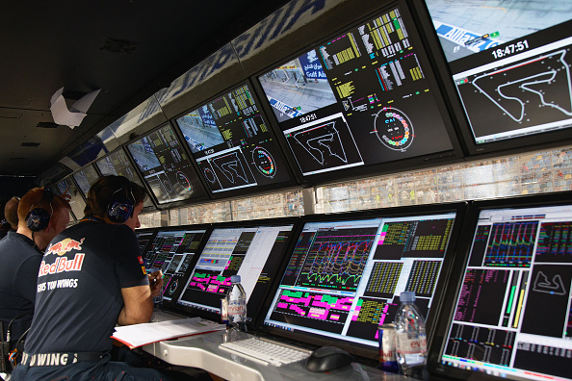
By
YOUSOUF BOUKRA
1700055

Submitted to the Faculty of Engineering
Automotive/Motorsport Department
University of Wales Trinity Saint David

An assignment for Race Engineering Module
December 2019.

Contents

1. Introduction: 3
2. Planning and Data Collection: 4
3. Data Acquisition Analysis: 5
3.1 Data from 1st Session 6
3.1.1 Driver 1 Vs Benchmark Data: 7
3.1.2 Driver 2 Vs Benchmark Data: 10
3.2 Data from 2nd Session 12
3.2.1 Driver one 1St Vs 2nd Test Data: 12
3.2.2 Driver Two 1St Vs 2nd Test Data: 13
3.2.3 Driver three 1st Vs 2nd Test Data: 14
3.2.4 Understeer, Steering and Throttle Speed Data: 15
4. Conclusion: 18
References 19
Appendices 20

Table of Figures

Figure 1 Brand Hatch Indy 6
Figure 2 First test Lap time table 7
Figure 3 Driver 1 G-G diagram 7
Figure 4 Experienced driver G-G diagram 7
Figure 5 Driver 2 G-G diagram 8
Figure 6 Driver 1 Vs benchmark Data Throttle Application turn 1 and 2. 8
Figure 7 Driver 1 Vs Benchmark Data Throttle Application turn 3, 4, and 5. 9
Figure 8 Driver 1 and benchmark data Combined G plot 10
Figure 9 Driver 2 Vs Benchmark data Throttle Application turn 1 and 2. 11
Figure 10 Driver 2 Vs Benchmark data Throttle Application turn 4 and 5 12
Figure 11 driver2 vs Benchmark data Long G force 12
Figure 12 second test Lap time table 13
Figure 13 Driver one braking and throttle improvement 13
Figure 14: Driver one RPM, Gear, and Steering 14
Figure 15 driver 2 G force long improvement 14
Figure 16 half throttle at turn 4 15
Figure 17 driver 3 Track line adjustment 15
Figure 18 MATH Work 16
Figure 19 Theoretical Steering Pct and Understeer 16
Figure 20 Steering AND Throttle Speed 17
Figure 21 Driver 2 and experienced driver Understeer Trace 18
Figure 22 Throttle Speed comparison 18

Introduction:
‘Braking is the most important thing, if you can really brake five or 10 meters later, it is enough to overtake’ (Kamui Kobayashi). ‘…And you are very conscious of the car that you are overtaking, his position. And you judge your position. And you judge your braking from where he brakes. But it’s within a split second, a tenth of a second. From where he brakes, you want to brake after him and then hope you make the corner’ (Lewis Hamilton). ‘There was a situation when I was racing Lewis and his engineers did a great job because they would always tell him what I was doing with my engine and if I increased my boost. So he would increase his boost when I did and when I came back down, he came back down… Now we can use our own tactics and try to get the other guy with that’ (Nico Rosberg) (Autosport, 2014, p.24-25). Braking, steering, acceleration, and many other parameters which are controlled by the driver are the key to separate a professional driver from an amateur driver, it is a matter of a tenth of a second as described by Lewis Hamilton, a winner in Formula One racing. It is impossible for a driver to enhance his performance by a few seconds or even a split of a second without a precise and vast amount of information coming from engineers. Data acquisition systems made this possible, and engineers have developed enormous skills of analysing a variety of data to assist their drivers, those data analysis skills distinguish the winners from the other competitors as described by Lopez and Seaber in 2009.
In the late 1980s, Metz and Williams stated that while racing teams collect data and critically analyse it to improve performance, race drivers always aim to select control inputs such as steering, braking, and acceleration, in order to minimise lap times. Moreover, Braghin et al., (2008) explained that the best race driver is that who can drive a given vehicle in the shortest possible time on a given track. Race drivers must be capable to push a racing car to its highest performance, using all the friction forces developed within the tire/road interface with respect to the constraints imposed by vehicle handling characteristics, and available traction and braking power. Thus, Martin and Law stated in a 2002 paper that, an optimum use of data acquisition and computer aided engineering tools is essential to analyse test data and utilise it as the basis for recommendations to drivers’ techniques.
The process described in this paper was used to compare drivers’ techniques and performance to enhance their driving skills, through the use of data acquisition system (MoTeC-i2) post collecting test data. Drivers were required to conduct several track tests using loop simulator, the MCR car was used and Brand Hatch circuit was selected for all drivers.
Two amateur drivers were selected to complete the test. The drivers were asked to drive around the chosen circuit for a couple of rounds with minimum instruction and recommendations, utilising their own judgment on how to control inputs such as the degree of steering, braking time, throttle application, and many more. Such data from drivers was critically analysed and compared to a benchmark data, conducted by an experienced driver. Following that, drivers were asked to conduct a second test, but with maximum information and recommendation from analysis engineers. This project highlighted the importance and benefits of using data acquisition in motorsport racing, by comparing drivers’ results before and after the support from engineers, which was derived from data analyses.

Planning and Data Collection:
In order to successfully employ the use of data analysis techniques through data acquisition tools (MoTeC-i2), carefully planned test methodology needed to be established. Two amateur drivers and an experienced driver were selected to drive an MCR race car through Brand Hatch circuit (Figure 1) using loop simulator facilities at UWTSD. This allows three test data to be collected for further analysis and comparison. Each driver performed two test sessions, which are described in detail below. The first test drive was performed under no guidance or recommendations. Whereas, the second test drive was completed after analysing first test data and fully guided the drivers, providing them with recommendations on parameters such as braking point, throttle applications, steering input etc.
The first test session ran for one hour, the team managed to successfully complete this first test based on an established plan, which was designed and practised several days prior step-in the simulator room to conduct the official test. The plan consisted of splitting roles between team members which included: data collection from the sim software to keep the test files well organised and ensuring no data is missing; live data monitoring using the live video recording to identify driver behaviours such as oversteer/understeer, parameters like that may become confusing if it is only recorded as an input graphical data; live gathering of the information in a hand written document to make sure all details are recorded and noted; and team management which was designated to one member, ensuring the team is working efficiently and to provide assistant when required.
The three drivers were given similar tasks to help on making a logical comparison further on through the project. Each driver was asked to drive around the circuit for 10 laps, in order for them to be well stagnated and to develop familiarisation with the circuit. Following that, drivers had 5 recorded laps to achieve best lap time possible. Using their own judgement on how to drive through the circuit, particularly how to undertake the 5 corners of the Brand Hatch, drivers were controlling the recorded variables including minimum and maximum speeds, steering value which is recorded as a percentage, throttle and braking applications which are also recorded as percentages, and gear selection which can be read through the RPM data recorded.
Post analysing the first session data using data acquisition tools (MoteC-i2), the drivers were asked to undertake a second test session similar to the first one, but with given instructions based on the data analysis made upon their first performance (see Appendix 8).

Data Acquisition Analysis:
Motorsports engineers use a variety of techniques to analyse data on the track, or to analyse recorded data. The technique which will be followed to analyse data in this project will be consisted of plotting drivers input channels as function of distance. Engineering in the motorsports arena of ten use a detailed comparison of two laps of data. Thus, plotting data acquisition channels as a function of distance allows the analysis of driver performance at the same point on the track. This distance is calculated in the software from the start to the finish line or at a placed timing beacon (Mitchell, 1998). This method of data alignment using distance was also used in a study conducted by Honda and Transportation Research Center, for the aim of developing a driver training program for test engineers to improve their driving skills (Mitchell et al, 2000).
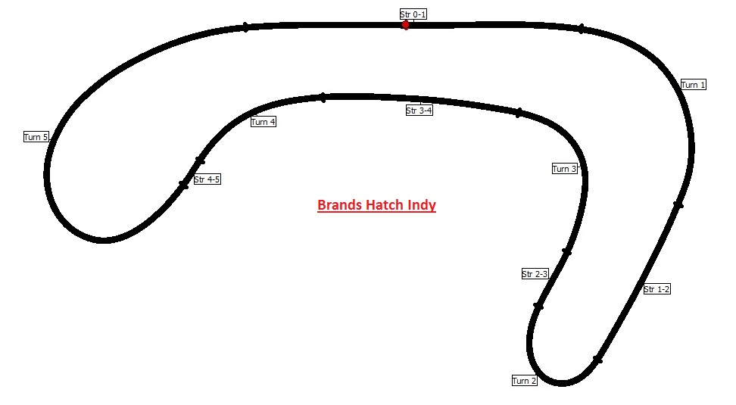
Figure 1 Brand Hatch Indy

3.1 Data from 1st Session
The table presented below, highlights the shortest lap time achieved by the three drivers, and the other four laps completed during this test.
Lap | Driver 1 | Driver 2 | Driver 3 Benchmark
1 ~ 5 | 0:57.187 | 0:48.986 | 0:49.685
2 ~ 5 | 0:50.434 | 0:48.904 | 0:52.606
3 ~ 5 | 0:51.618 | # 0:47.865 | 0:48.158
4 ~ 5 | # 0:50.069 | 0:48.406 | 0:48.695
5 ~ 5 | 0:51.098 | 0:58.947 | # 0:47.429
Figure 2 First test Lap timetable
The analysis carried out on the following sections, will predominantly focus on best lap records of each driver.
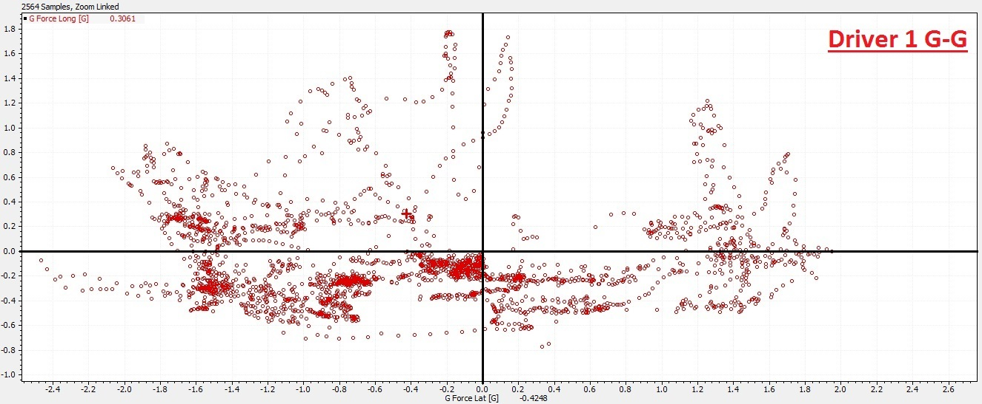
Blending, braking, cornering and acceleration can maximise the performance of tires and car, that was clearly mentioned by Mitchell et al, (2000). The scatter plot in figure 3, 4, and 5, shows traction circles during best lap records of each driver.
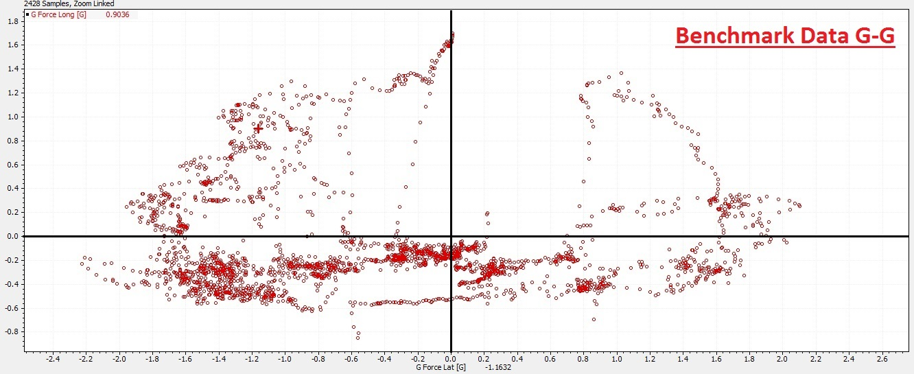
The experienced driver who set the benchmark data, have more G forces and is more consistent. As by observing his G-G diagram, he uses more of the circle and moves away from the centre lines most of the time.
Figure 3 Driver 1 G-G diagram
Driver 1 shows a bit of inconsistency, and generated less lateral G and Longitudinal G as he spent more time near the centre lines, which decreased his usage of the friction circle.
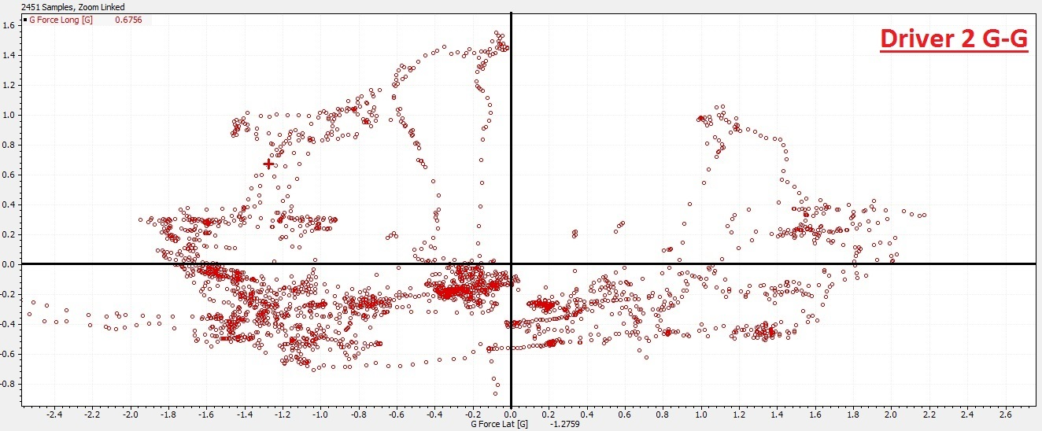
G-G diagrams are nearly identical with Driver 2 and the Benchmark, driver 2 is more consistent than driver 1. But he generated less Long G due to his braking techniques (less braking force) when compared to the experienced driver.
Figure 4 Experienced driver G-G diagram
However, as Mitchell et al said, G-G diagrams don’t often show the crucial difference in speed, throttle, or braking forces when the performance gap between the compared drivers is small.

Figure 5 Driver 2 G-G diagram

3.1.1 Driver 1 Vs Benchmark Data:
Throttle graphs clearly demonstrate how much throttle is being applied, including drivers’ techniques of using it. Throttle trace is instantly recognisable because it is fully used between 60 to 80% on each lap (Templeman, 2008, p.38). Appendix 1, 2, and 3 represents the throttle percentage usage around the track for driver 1, 2, and 3, respectively.
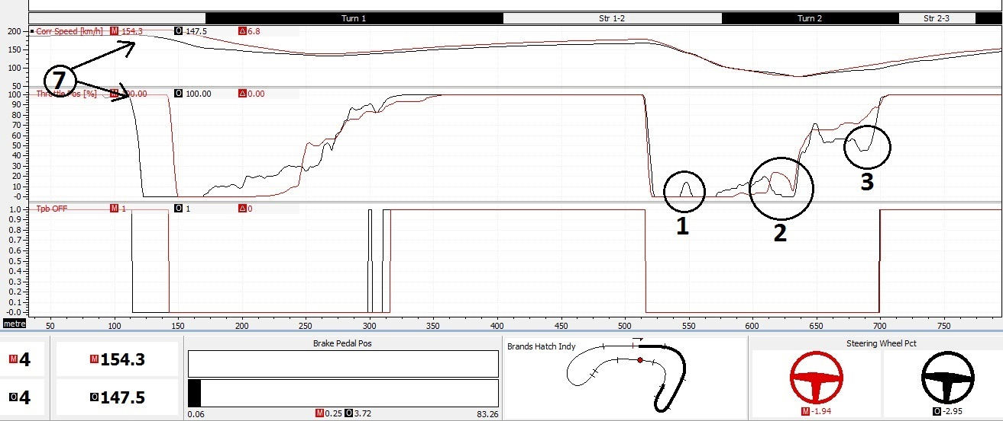
Figure 6 Driver 1 Vs benchmark Data Throttle Application turn 1 and 2.
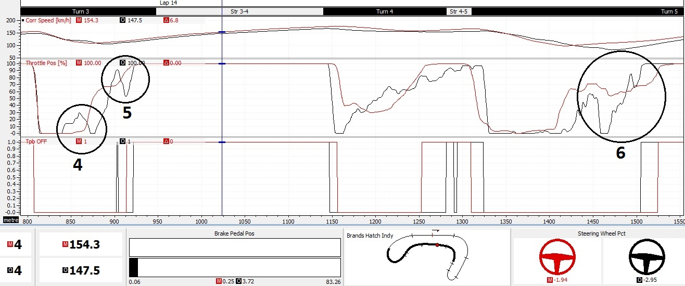
Figure 7 Driver 1 Vs Benchmark Data Throttle Application turn 3, 4, and 5.

Figure 6 and 7, represent data from driver 1 (black line) and benchmark data (red line) in three graphical channels: corr speed, Throttle percentage, and Tpb OFF which represent the distance were the throttle is not fully used (less than 90%). Tpb OFF was created using the Math channel in appendix 4.
Driver 1 shows a lot of inconsistency once getting back on throttle at the exit of the corner ‘point 1, 2, 3, 4, 5, and 6’, this can be an indication that the driver is not confident on his judgment of the right time to get on the throttle. Those juggling point in the figures also can be a sign that the driver is not handling the car very well and can cause oversteer or understeer.
Point 7 in figure 6, shows that driver 2 approach the corner with lower speed than driver 3, and also lift off the throttle earlier.
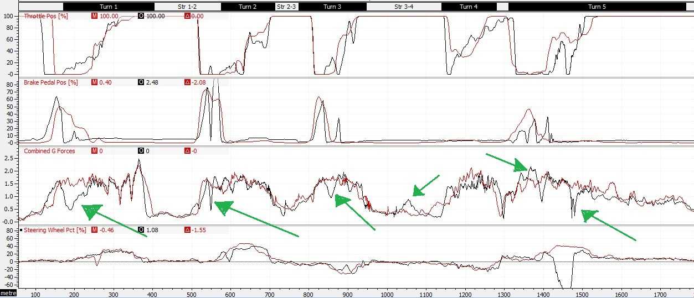
Figure 8 Driver 1 and benchmark data Combined G plot
In figure 8, combined G force graph for drive 1 is fluctuating often, experienced driver has a consistent Combine G. That is due to difference in techniques of braking, throttling, and steering, between the two drivers.

3.1.2 Driver 2 Vs Benchmark Data:
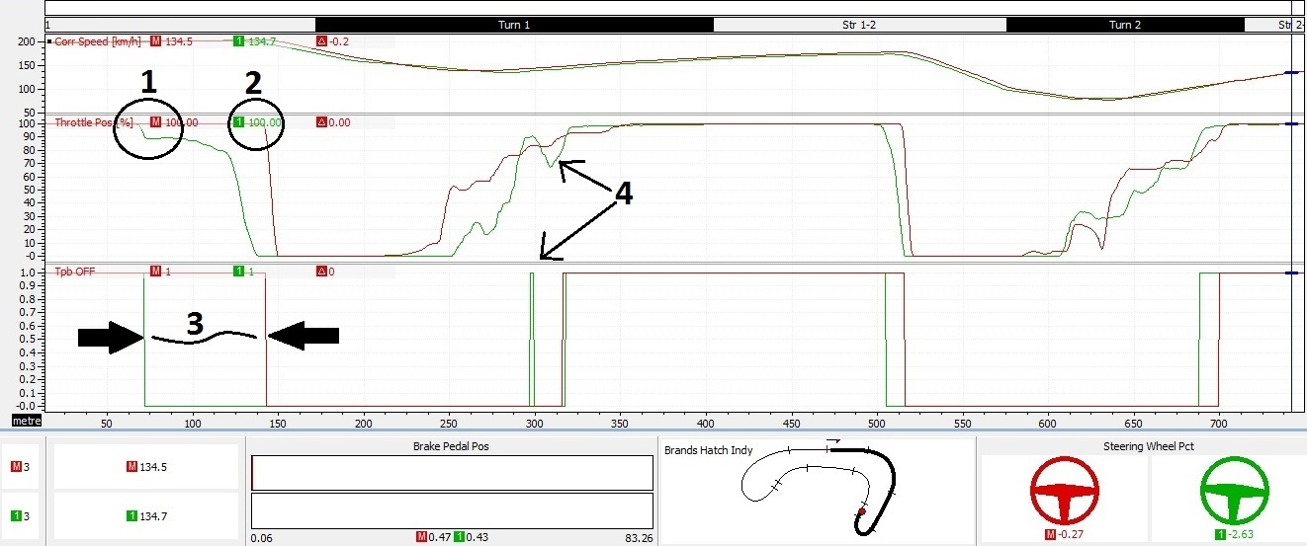
Figure 9 Driver 2 Vs Benchmark data Throttle Application turn 1 and 2.
In figure 9, driver 2 (green line) lift off the throttle significantly earlier ‘point 1’ than the experienced driver who lift off the throttle closer to the first corner’s entry ‘point 2’. In the same time, experienced driver gets back on throttle before driver 2 and with a modest amount, to maintain his speed till he reach full throttle at the exit of the corner. Whereas, driver 2 gets back on throttle rapidly, but before he reaches full throttle must lift off throttle ‘point 4’ and reduce acceleration so that he can make the exit of the corner, in 2000, Mitchell and colleagues analysed a similar behaviour of throttle usage between unexperienced and experienced drivers. Tpb OFF channel clearly demonstrates the time lost by driver 2 not using the full throttle at both end of the corner ‘point 3’. This gap can make a significant decrease in lap time, Fey stated that throttle graph can also indicate oversteer or understeer when aligned with steering and G’s graph (Fey, 1993, p.7-8). Appendix 5 shows an example of oversteer from driver 2 data.
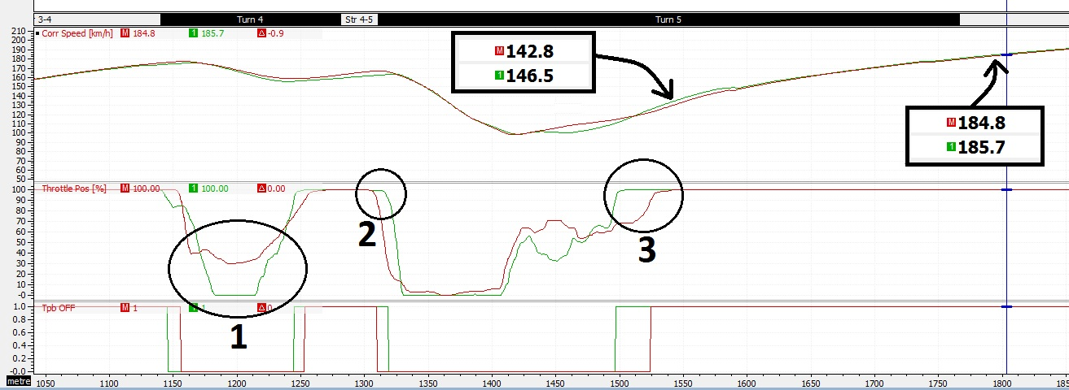
Figure 10 Driver 2 Vs Benchmark data Throttle Application turn 4 and 5
‘Point 1’ in figure 10, conveys a significant gap where lap time can be reduced for driver 2. The experienced driver is aware that he only needs to half lift off the throttle in turn 4, whereas driver 2 misjudged the intensity of the corner and fully lift off the throttle, leading his speed to significantly reduce.
In turn 5, driver 2 overtook the experienced driver by choosing a faster line in the track, this was found by observing the steering channel and video data. Driver 2 kept wide after exiting turn 4 and took the late apex of turn 5, this provided him the opportunity to lift off throttle after the experienced driver ‘point 2’, and also to get back on full throttle earlier ‘point 3’. Throttle techniques on this corner clearly highlight the crucial importance of throttle application, as driver 2 exits the corner faster and even maintains higher speed than the experienced driver through the following straight.
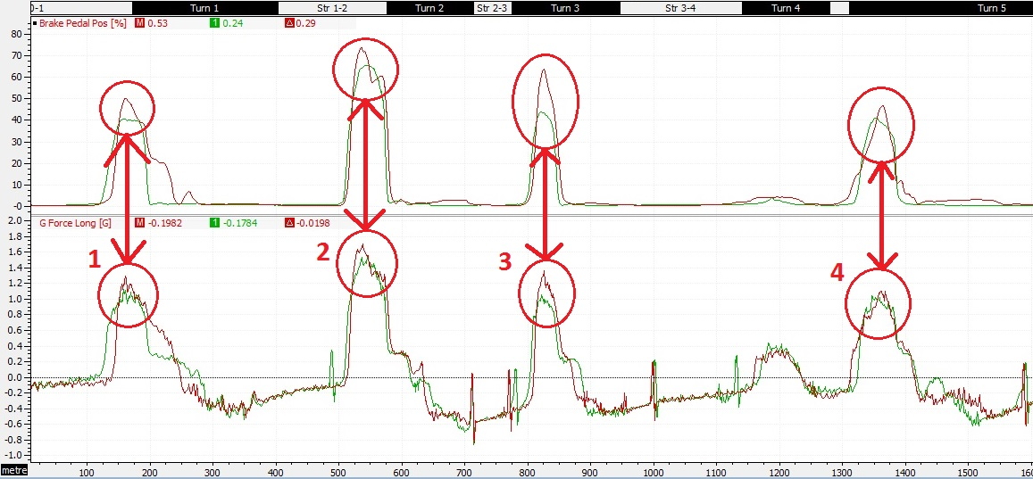
Figure 11 driver2 vs Benchmark data Long G force
Figure 11, shows that the experienced driver has more G force long over driver 2 in all turns (point 1 to 4). That is because the experienced driver approaches the corner with high speed and hit the brakes harder than driver 1. Braking generates long g force when applied correctly with the maximum usage of throttle, as Templeman explains that long g trace demonstrates how well the driver is controlling the brakes, and how well the car responds.

Data from 2nd Session
Best lap timetable of both tests.
Test | Driver 1 | Driver 2 | Driver 3 Benchmark
Test N°1 | 0:50.069 | 0:47.865 | 0:47.429
Test N°2 | 0:48.978 | 0:47.810 | 0:47.544
Time Diff | 0:01.091 | 0:00.055 | +0:00.115
Figure 12 second test Lap timetable
The above table shows that, driver one significantly decreases his lap time (1.09 sec) by applying the instructions, which has been derived from data acquisition analysis. Driver two and three however, did not massively decrease their lap time, but there was a significant improvement in the driving performance, which will be discussed further down.

3.2.1 Driver one 1St Vs 2nd Test Data:
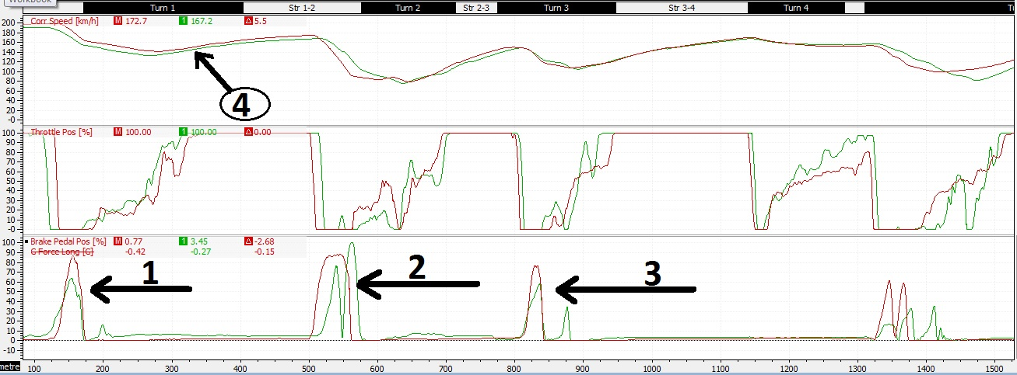
Figure 13 Driver one braking and throttle improvement
Figure 13 portrays the braking and throttle techniques of driver one, for the first and second test session. A noticeable improvement in those two inputs is evident here, point 1, 2, and 3 shows that the driver is more confident and competent with his braking and benefits from the maximum usage of brake pedal as this will increase his long G force, however, more improvement is needed as the brake pedal is not 100% used when applied. Point 4 is another way to show the driver’s confidence, as he drives with a higher speed in comparison to the first session in majority of the track.
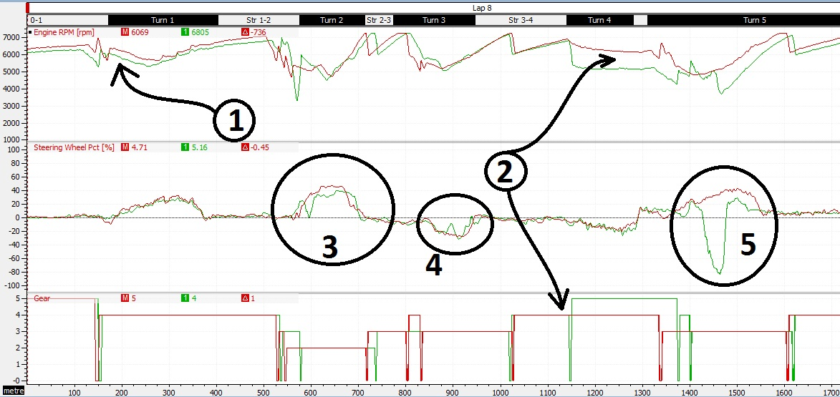
Figure 14: Driver one RPM, Gear, and Steering
It can be observed from figure 14, that driver 1 is driving at a higher rpm compared to his first session which proves that his throttle and gear selection techniques have improved, which can also be seen at point 2. Another improvement in terms of steering is shown at point 3, 4, and 5, here the driver is utilising better control over the steering wheel and has more stability compared to his first session.

3.2.2 Driver Two 1St Vs 2nd Test Data:
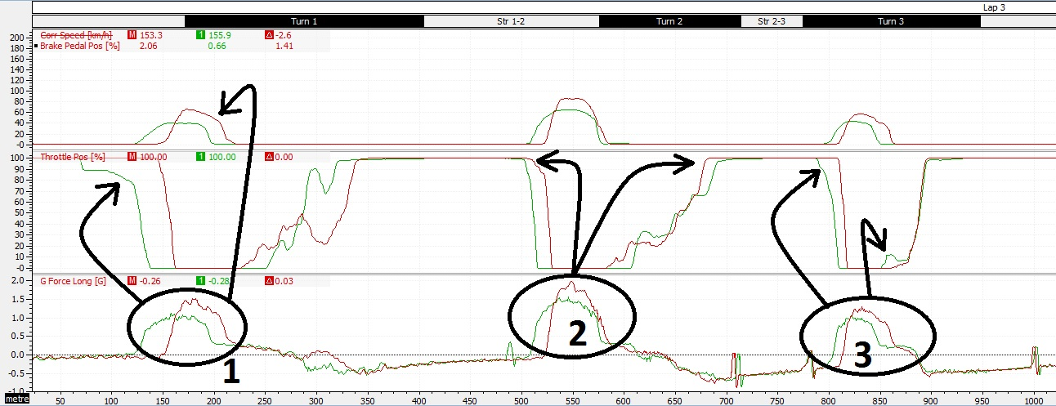
Figure 15 driver 2 G force long improvement
Driver 2 has clearly enhanced his g force long (point 1, 2, and 3; figure 15) simply by implementing the instructions provided to him, maximising throttle and brake pedal application at both ends of the corners. At point 2, driver is increasing the distance at which the throttle has been applied, by lifting off late and coming back on-throttle early.
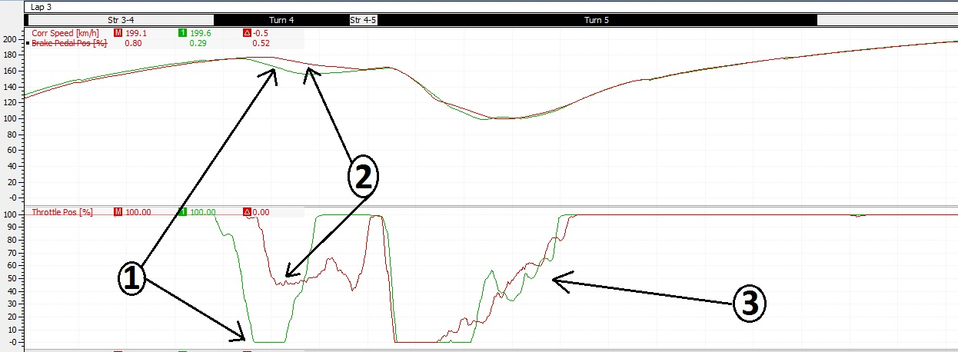
Figure 16 half throttle at turn 4
Figure 16, shows that the driver applied the instructions given to him, which is to only half lift off-throttle at turn 4. This massively effected his speed compared to his first session (point 1 and 2), which will directly contribute to his time lap. The driver is also confident when he is back on-throttle at turn 5, in contrast to his first session (point 3).

3.2.3 Driver three 1st Vs 2nd Test Data:
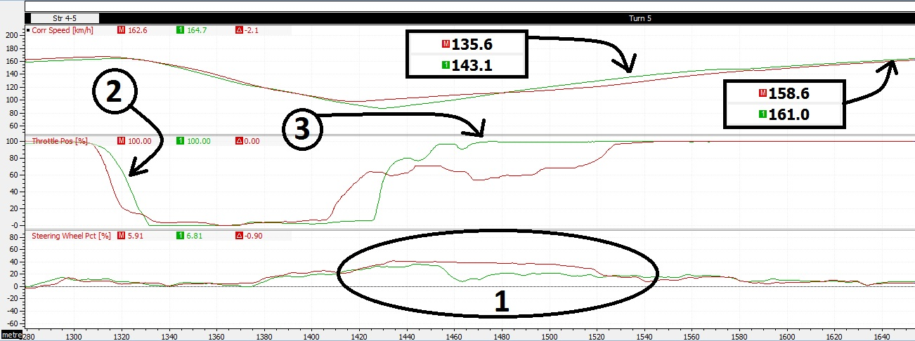
Figure 17 driver 3 Track line adjustment
The experienced driver has been given advice to change his track line based on the previous data analysis, even though the adjustment of the track line (point1) did not affect the overall lap time. The particular line (green graph) increased the speed the driver undergo at the corner exit, and during the following straight as shown in figure 17. It also enables the driver to be back on full throttle earlier than the previous track line (point 3).

3.2.4 Understeer, Steering and Throttle Speed Data:
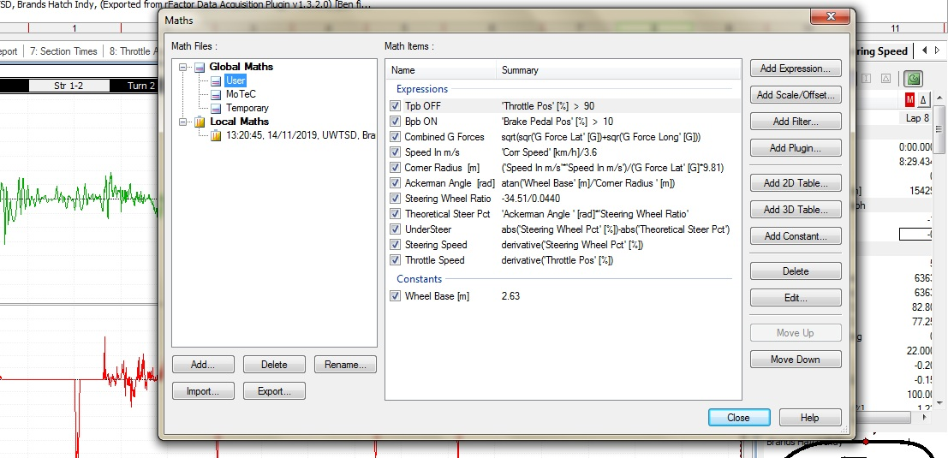
Figure 18 MATH Work
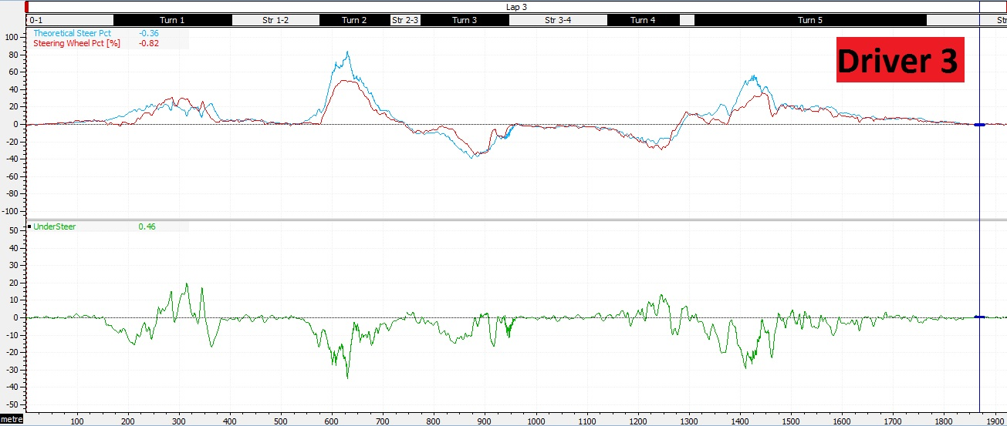
Figure 19 Theoretical Steering Pct and Understeer
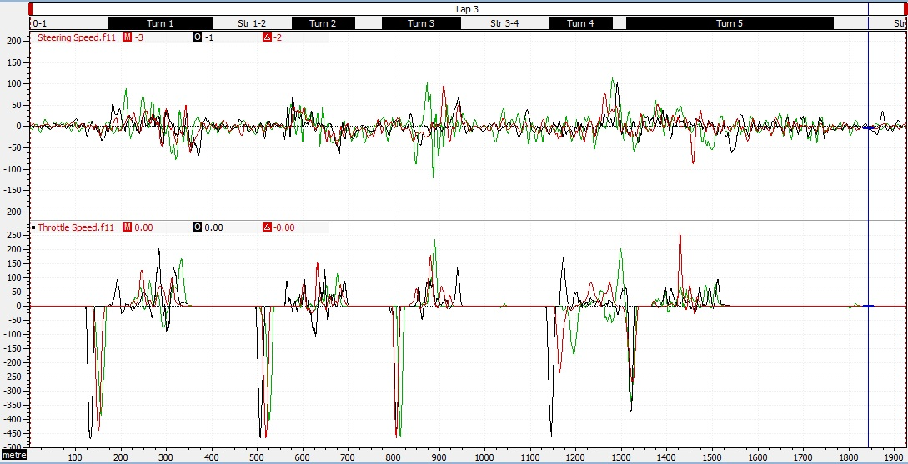
Figure 20 Steering AND Throttle Speed
The theoretical steering angle and understeer channel shown in figure 19, was created using the Maths tool (figure 18). This required steering angle as described by Templeman, is useful because it is related to the actual path followed by the car, therefore, comparing this with the steering input from the driver will allow the understeer and oversteer to be measured. However, this only works if the steering channel is properly calibrated (Templeman, 2008, p.68).
Figure 20 represents throttle and steering speed, those channels can help in adjusting the driver’s style if the driver seems to be jumping a lot on the throttle, and not gently feed it in as quickly as the car allows (within the limit of car handling). The math used to create those channel is simply the derivative of throttle or steering (Templeman, 2008, p.101). However, throttle and steering speed graphs need to be filtered as the data produces a noisy trace (Appendix 7), the method used to filter the data was to make it smooth by 11 samples (Appendix 6). Adjusting the sampling rate as Templeman noted in his book, is important to provide an understandable trace.
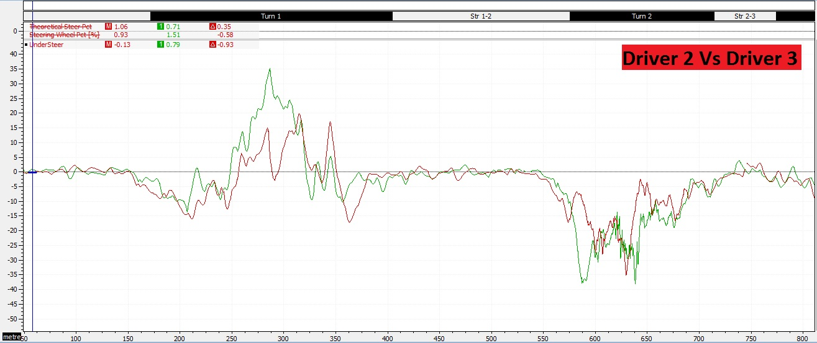
Figure 21 Driver 2 and experienced driver Understeer Trace
Understeer channel presented in figure 21, clearly shows the difference in oversteer and understeer between driver 2 and the experienced driver. As mentioned before, the channel allows not only to detect over/under steer but further measures the amount of which the steering deviated from the required value. In turn 1, driver 2 (green line) have doubled the value of understeer than the experienced driver, and also in turn 2, driver 2 is slightly oversteering higher than experience driver.
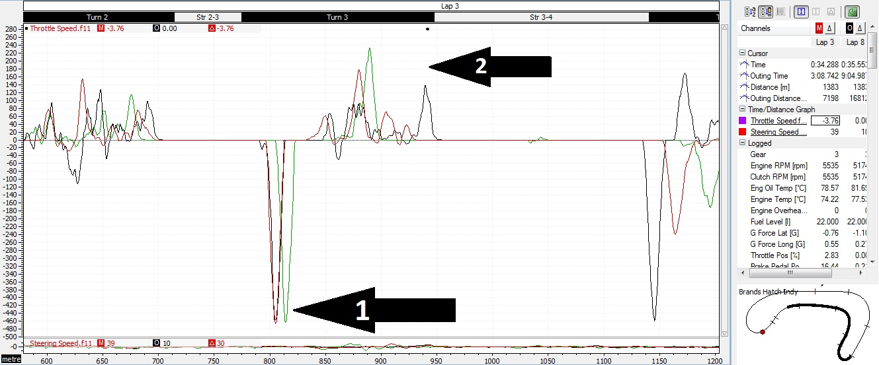
Figure 22 Throttle Speed comparison
The throttle speed channel above, shows that all three drivers have similar speed lifting off the throttle pedal (point1), however, driver 2 gets back on the throttle faster than other drivers (point2), whereby driver 1 response of getting back on throttle is slow in comparison to others in this particular corner.

Conclusion:
By using a detailed data analysis approach using MoteC-i2, Driver 1 and driver 2 clearly improved their driving performance. Driver 1 decreased his lap time by 1.019 second, and even though driver 2 did not significantly enhance his lap time performance, his driving style was noticeably improved.
The largest change made was through looking at the drivers throttle application. Drivers positively affected their driving performance, through the adjustment of throttle On/Off timing at both ends of each corner, based on their primary test data. This is important because throttle application dictates the whole speed down the next straight, and as expressed by Templeman, throttle trace is instantly recognisable because it is fully on for 60 to 80 per cent of the lap.
A specific trace has been noticed while analysing driver 1’s data, throttle speed channel shows that the driver gets off-throttle quickly but gets back on-throttle slow. The driver’s confidence on exiting corners with high speed, may be the cause of this issue.

References
Autosport. (2014) ‘THE ART OF OVERTAKING: Passing Acquaintances’, Autosport, 2nd October, p. 24-25.
Braghin, F., Cheli, F., Melzi, S. and Sabbioni, E. (2008) ‘Race Driver Model’, Computer & structures, 86(13-14), pp.1503-1516.
DOI: 10.1016/j.compstruc.2007.04.028
Lopez, G. and Seaber, A. (2009) ‘The theory and practice of race vehicle data acquisition and analysis in motor sports engineering education’, American Society for Engineering Education.
DOI: https://peer.asee.org/4814
Martin, B. and Law, E. (2002) ‘Development of an Expert System for Race Car Driver & Chassis Diagnostics’, SAE Technical Paper Series.
DOI: 10.4271/2002-01-1574
Metz, D. and Williams, D. (1989) ‘Near time-optimal control of racing vehicles’, Automatica, 25(6), pp.841-857.
DOI: 10.1016/0005-1098(89)90052-6
Mitchell, W. (1998) ‘A Method of Data Alignment’, SAE Technical Paper Series, pp. 1-9.
DOI: 10.4271/983087
Mitchell, W., Unger, M., Schroer, R. and Grisez, D. (2000) ‘Training Test Drivers with Data Acquisition’, SAE Technical Paper Series.
DOI: 10.4271/2000-01-3568
Templeman, G. (2008) The competition car data logging manual. Dorchester: Veloce publishing Limited.
Fey, B. (1993) DATA POWER: using racecar data acquisition. Tennessee: Walter R. Fey Jr. and Towery Publishing Inc.

Appendices

Appendix 1:
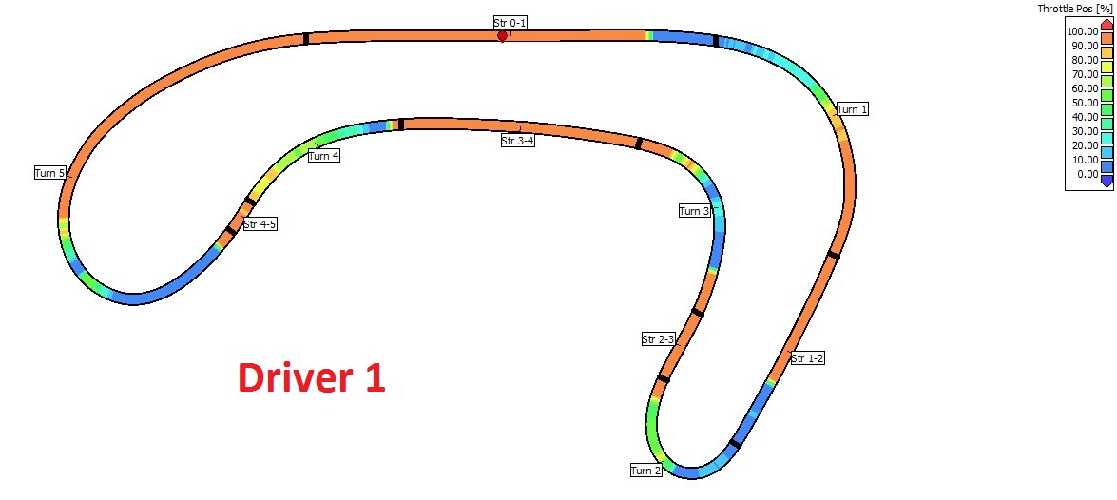
Appendix 2:
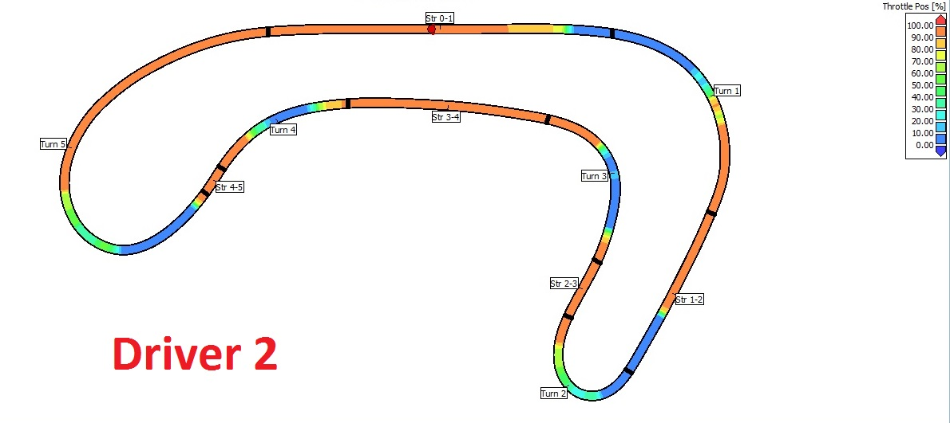

Appendix 3:
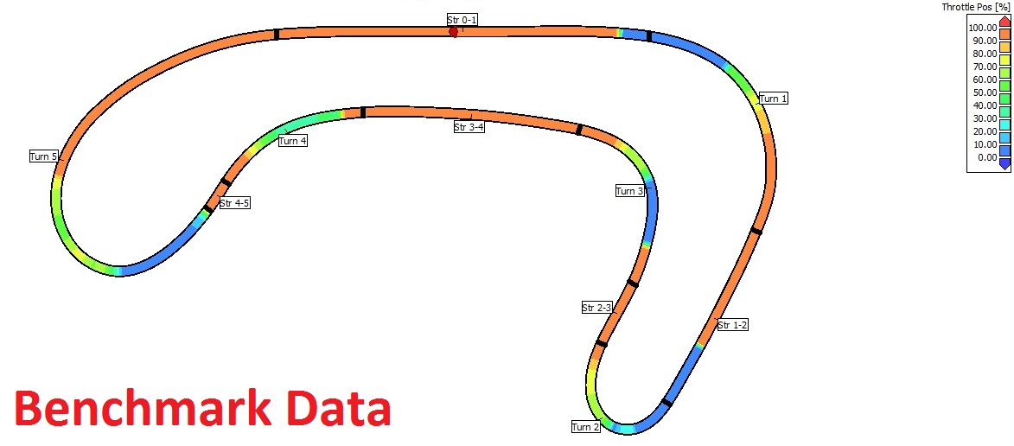
Appendix 4:
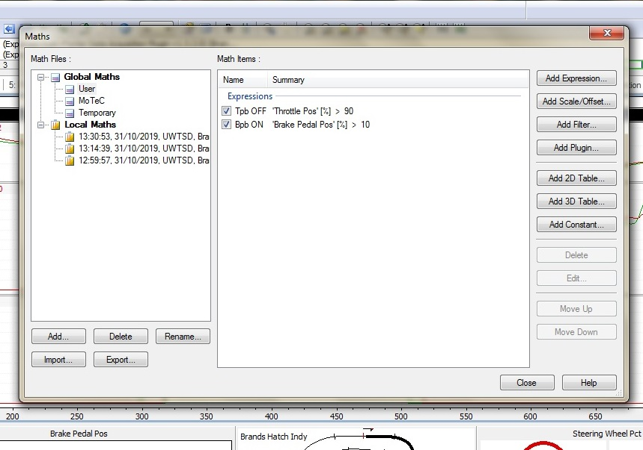

Appendix 5:
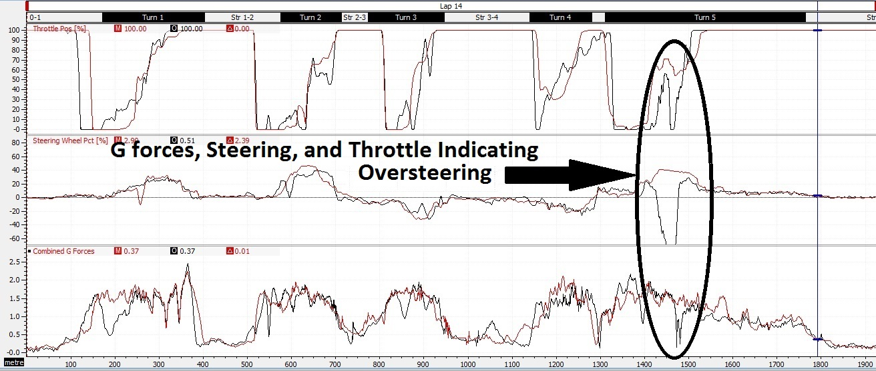
Appendix 6:
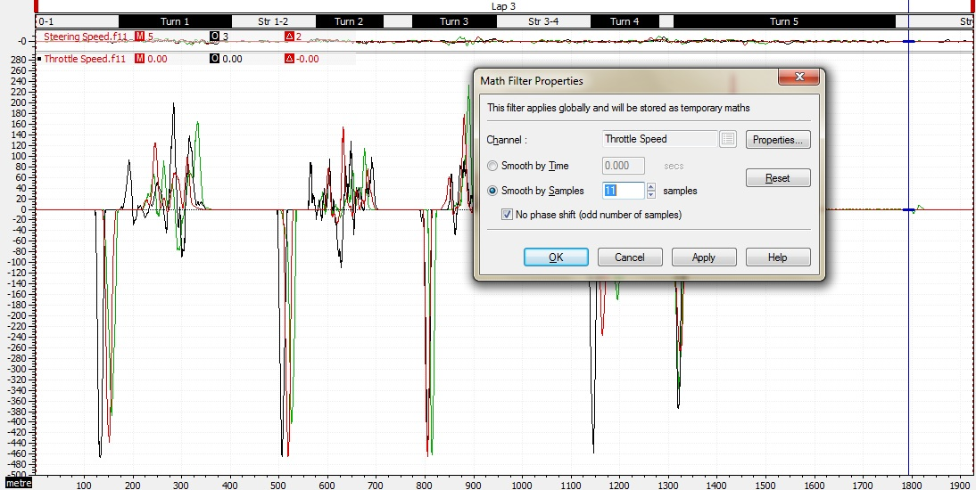

Appendix 7:
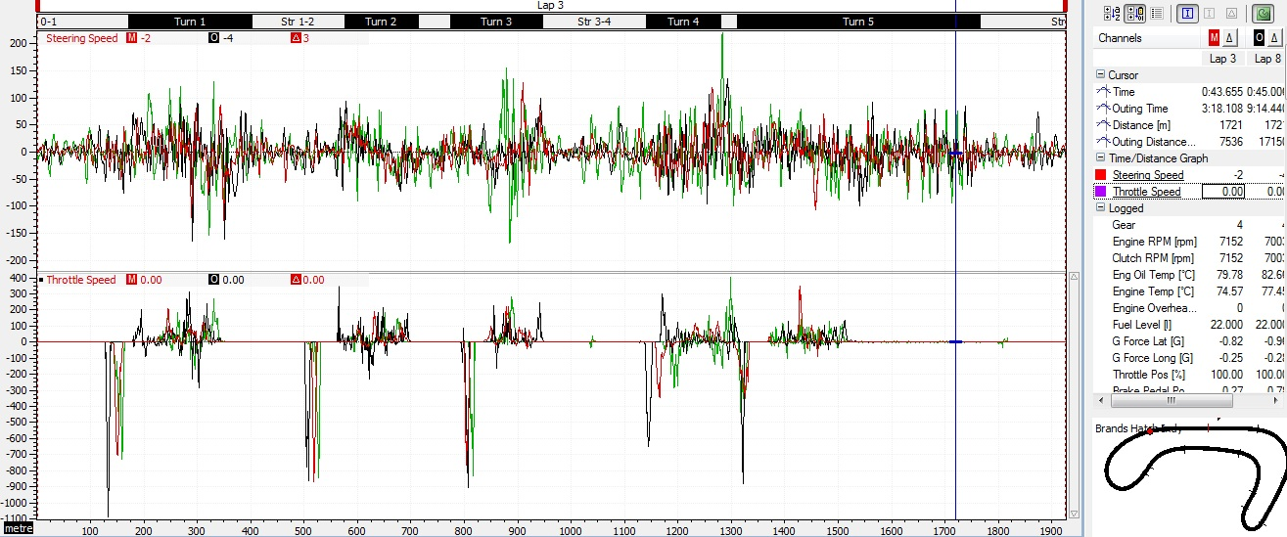

Appendix 8:

