University of Wales Trinity St David
(UWTSD)
Institute of Science & Art



Engine Performance
Characteristics
Powertrain Technology ACHA4029

Name: Harry Glynn
Student Number: 2505630
Date of Report: 03/2026

Contents
1 Introduction 3
2 Equipment and Methods 4
2.1 Equipment: 5
2.2 Method: 5
3 Spread Sheets 5
4 Graphs 7
5 Graphs And Result Evaluations 8
5.1 SFC vs Engine Speed 9
5.2 Torque vs Engine Speed 9
5.3 Brake Power vs Engine Speed 10
5.4 Overall Summary 11
6 Improvements 11
7 Bibliography 12

Tables and Figures
Figure 1 Snippet of Spread Sheet 1 6
Figure 2 Snippet of Calculations Sheet 6
Figure 3 SFC vs Engine Speed Graph 7
Figure 4 Torque vs Engine Speed Graph 7
Figure 5 Brake Power vs Engine Speed Graph 8

Introduction
Our job was to use a Schenk W230 eddy-current dynamometer to measure how torque, brake power, SFC, BMEP, and overall thermal efficiency change with engine speed when the load is constant. (Honda Motor Co., n.d.) ((300) Engine Dynamometer Overview - YouTube, n.d.). We collected raw dynamometer data so that we could figure out the values listed above (Torque, Brake Power, BMEP, SFC, thermal efficiency) and the corrected power/torque after making the corrections. We collected ambient values like barometric pressure, humidity, and temperature so that we could make corrections to the results.

Equipment and Methods

Equipment:
In this experiment the equipment that was utilised was UWTSD’s engine dyno room with all the relevant safety measures in place, the engine used was a Honda D16 1.6 L connected to a Schenk W230 eddy-current dynamometer(300) Engine Dynamometer Overview - YouTube, n.d.). The Dynamometer can handle rpm up to 10,000 with a max load of roughly 230 kW. The torque is calculated via a calibrated load cell attached to an arm with a known length. The torque arm length used for torque conversion is 0.815776 m, which was used throughout this assignment. Attached to the dynamometer are a range of sensors including a coolant temperature gauge, a lambda sensor, fuel-flow meter, a throttle position sensor/control, and an exhaust extraction channel/pipe. The data that was measured and recorded was the barometric pressure, humidity, ambient temperature, engine speed (rpm), load (N), fuel flow (L/min) and the lambda. All done through the various and relevant sensors attached to the dynamometer.

Method:
To start the engine must be connected to the dynamometer while doing so you must ensure proper calibration of the torque arm and load sensor and then make sure fuel system readings are correct and check the calibration of the lambda sensor. This must also be done for the other sensors that readings are gathered from or used to prevent issues arising. And then data collection starts, the engine is ran across the rpm range (1000–5500 rpm) with increments of roughly 50 rpm while recording the Load (N), rpm, fuel flow (L/min) and lambda for each step. Once collated the data will be put in an excel spreadsheet and then all the relevant calculations done. This calculated data can then be used to create graphs to provide a visual representation of the data.

Spread Sheets
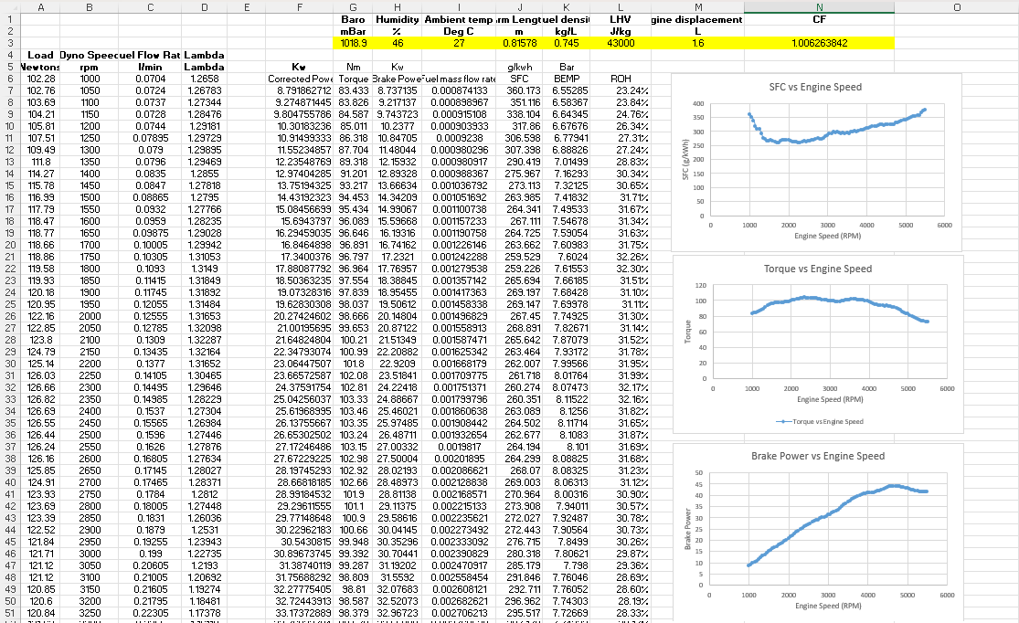
Figure 1 Snippet of Spread Sheet 1
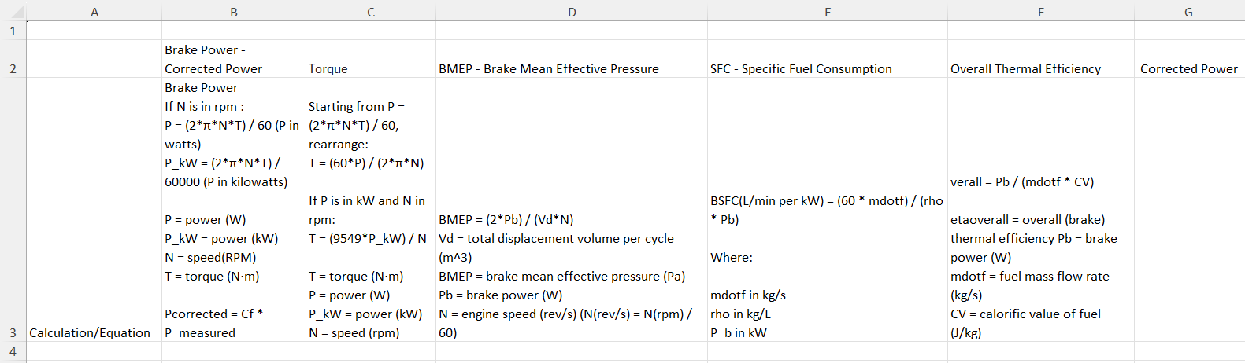
Figure 2 Snippet of Calculations Sheet
Spread sheet is attached to view for any more information on the calculations etc.

Graphs

Figure 3 SFC vs Engine Speed Graph

Figure 4 Torque vs Engine Speed Graph

Figure 5 Brake Power vs Engine Speed Graph

Graphs And Result Evaluations

SFC vs Engine Speed
The SFC versus engine speed graph shows that specific fuel consumption is at its highest at the lowest engine speed (around 1000 rpm). And it decreases as it moves up to and through the mid-range reaching a minimum roughly around 2500 and 3500 rpm, and it then rises again as the speed approaches the end of the test at around 5500 rpm. This characteristic U-shaped or bathtub curve is well documented and is explained by the balance between thermodynamic efficiency and mechanical losses across the engine speed. Heywood (2018) explains that at low engine speeds, friction losses in components such as piston rings and bearings remain relatively constant while brake power output is low. This means a disproportionately large fraction of the fuel energy is consumed by these losses rather than being converted to useful work/power. Heat transfer losses to the cylinder walls are also proportionally higher at low speeds (Heywood, 2018). In the mid-range, the engine typically achieves its best efficiency and more complete combustion, meaning the useful work done per unit of fuel consumed is at its best which leads to SFC hitting its minimum value. Stone (2012) notes that this mid-speed region is where intake and exhaust tuning effects work together the best with combustion chamber turbulence to produce the most efficient burning of fuel. At higher engine speeds however, friction power increases approximately with the square of engine speed (Pulkrabek, 2014). There is also the fact there is the reduced time available for combustion at higher rpm which can lead to incomplete burning of the fuel-air mixture, further increasing SFC (Taylor, 1985). The lambda values recorded during testing supports this interpretation. At low rpm the lambda indicated a lean mixture, while at higher rpm lambda trended closer to slightly rich. This suggests the engine management system was compensating for reduced airflow but at the cost of increased fuel consumption.

Torque vs Engine Speed
The torque versus engine speed graph shows torque rising from around 59 Nm at 1000 rpm to a peak of around 73 Nm near 2500 rpm which is then followed by a gradual decline toward approximately 51 Nm at 5500 rpm. This behaviour is a standard characteristic of small displacement naturally aspirated petrol engines and is governed primarily by volumetric efficiency, which describes how effectively the engine fills its cylinders with fuel and air on each intake stroke (Heywood, 2018). At low speeds the intake air velocity is relatively low, resulting in incomplete cylinder filling and therefore lower torque. As engine speed increases into the mid-range the intake system tuning effect becomes much more efficient the intake valves open at the right moment to assist cylinder filling, and in-cylinder turbulence improves fuel-air mixing which contribute to higher peak cylinder pressures and therefore greater torque (Stone, 2012). Pulkrabek (2014) explains that torque reaches its maximum at the speed where volumetric efficiency peaks, which for most production engines is typically in the lower to middle portion of the operating speed range. Beyond this peak however, torque can be seen to take a decline because the intake valves are not open long enough to allow complete cylinder filling at higher piston speeds, and flow restrictions through the intake port, throttle body and exhaust system become increasingly significant (Taylor, 1985).

Brake Power vs Engine Speed
The brake power graph shows power increasing steadily from approximately 6.2 kW at 1000 rpm to a peak of around 51 to 52 kW near 4300 to 4500 rpm, after which it declines as the engine approaches 5500 rpm. This pattern is explained by the fundamental relationship between power, torque and rotational speed, expressed as P equals 2πNT divided by 60, where P is power in watts, N is speed in revolutions per minute, and T is torque in newton metres (Stone, 2012). Because power is the product of torque and angular velocity, it continues to rise even after torque has peaked, provided the increase in speed more than compensates for the reduction in torque.

Overall Summary
Taken together, the three graphs illustrate a consistent and well-understood picture of naturally aspirated petrol engine performance. The mid-range is where the engine operates most efficiently, offering the best compromise between torque output, rotational speed and fuel economy. At low rpm, high SFC reflects the dominance of constant parasitic losses over modest power output, while at high rpm, reductions in torque caused by breathing limitations and increasing friction lead to declining power and rising fuel consumption per kilowatt produced. These trends are entirely consistent with established internal combustion engine theory as described in the literature cited above.

Improvements
To improve I will treat the dyno work as a tidy repeatable workflow that I can reuse in the future. I will plan a simple data model that separates inputs calculations and outputs, and I will place constants at the top of the spreadsheet including the arm length, the fuel density and the energy content of the fuel together with the engine displacement. I will create a template for each measurement containing the inputs Load, rpm, Fuel Flow, Lambda and ambient indicators and I will calculate Torque, Brake Power, Fuel Flow to mass flow, SFC and BMEP and Thermal Efficiency using a fixed set of formulas across all rows. I will make the units uniform and keep the same scales for all charts, so comparisons are straightforward. I will annotate each formula with a brief note describing its purpose so anyone can reproduce the calculations. I will implement basic data validation to catch obviously incorrect entries such as negative rpm or unrealistic fuel flow, and I will add a quick check row that compares the calculated metrics against expected ranges to raise a flag if something looks wrong. This would make the spreadsheet robust to minor data entry mistakes and easy to update. I will create a dedicated results sheet that displays the input table the calculated metrics and the three plots SFC versus engine speed Torque versus engine speed and Brake Power versus engine speed all with clearly labelled axes and consistent formatting. I will link the charts directly to the inputs so updates to the data automatically refresh the graphs. I will maintain a short change log that records modifications to constants formulas and workflow so I can track how the analysis evolves over time and I will save versioned copies after major changes to preserve a history of the work.

Bibliography
(300) Engine Dynamometer Overview - YouTube (no date). Available at: https://www.youtube.com/watch?v=-WajOAp2LUE (Accessed: 15 March 2026).
Brake-specific fuel consumption - Wikipedia (no date). Available at: https://en.wikipedia.org/wiki/Brake-specific_fuel_consumption (Accessed: 15 March 2026).
Honda Motor co., L. (no date) Shop Manual Honda Civic Coupe CRX. Available at: https://uowtsd-my.sharepoint.com/personal/2505630_student_uwtsd_ac_uk/Documents/Assignments/Semester%202/Powertrain%20Assignment/CRX_Workshop_Manual.VTec%201.6%202020-10-27%2012_57_06.pdf?CT=1773727962409&OR=ItemsView (Accessed: 15 March 2026).
Mean effective pressure - Wikipedia (no date). Available at: https://en.wikipedia.org/wiki/Mean_effective_pressure (Accessed: 15 March 2026).
Volumetric efficiency - Wikipedia (no date). Available at: https://en.wikipedia.org/wiki/Volumetric_efficiency (Accessed: 15 March 2026).

