Ben Shepherd
2419241@student.uwtsd.ac.uk

ACBA4016 Assignment
Construction Materials - Habitable Buildings

Contents

The Burj Khalifa (Concrete Frame)

Background Information………………………………………………….2

Structure of the Burj Khalifa……………………….…………………....2

Location of the Burj Khalifa……...……………………………………...4

Production Process of Concrete…….…………………………………5

How is Concrete Use?..…………………………………………………..6

The Shard (Steel Frame)

Background Information………………………………………………….7

Structure of the Shard……………………………….…………………....8

Location of the Shard………..…………………………………………....9

Production Process of Steel…….……………………………………..10

How is Steel Used?……………………………………………………….11

Advantages and Disadvantages

Table of Concrete and Steel Characteristics……………………...12
References

In Text References……….………………………………………………..14

Figure References.………………………………………………............16

Table Data References ………………………………………………….17

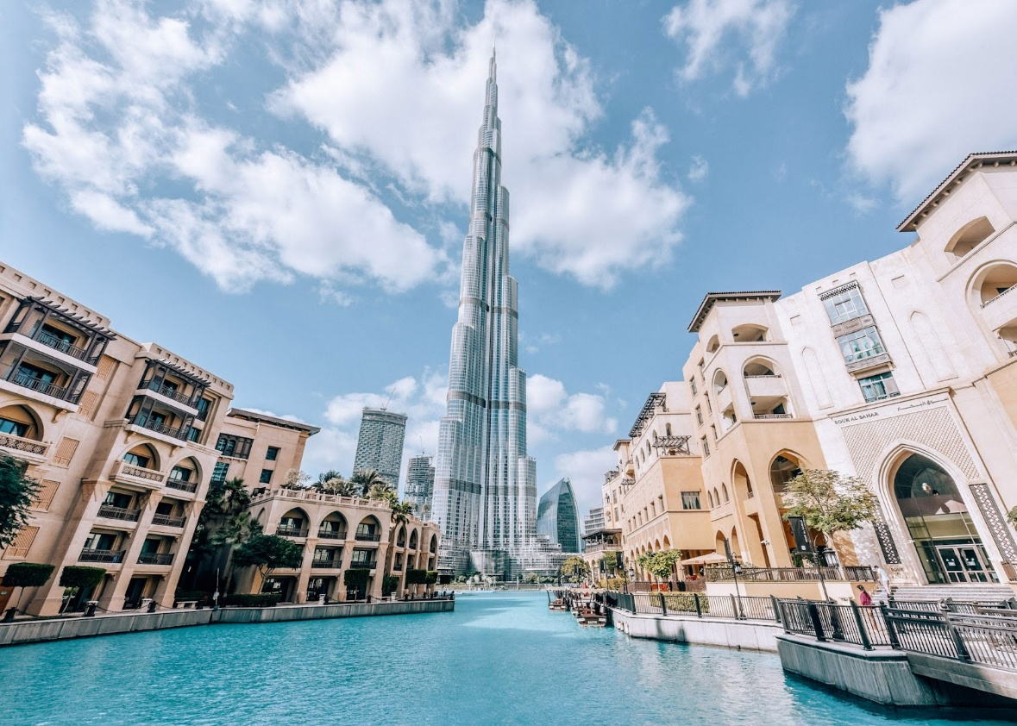
The Burj Khalifa (Concrete Frame)
Figure 1 - (Izkiz.co.uk, 2017)
Background Information
The Burj Khalifa, located within the city of Dubai is not just the tallest building in the UAE, but instead in the entire world as of 2025. This significant feature has caused the popularity of the building to skyrocket as it stands at 828m (prior record was 509.2m, Taipei Tower) (Wikipedia Contributors, 2019). This was the main feature intended of the building from a tourist perspective, however it does have a significant design and development process allowing the materials in the foundations to support the weight of the tallest building in the world and withstand the incredible amount of force applied on them. Due to the scale of the building there are multiple functions which include a Giogio Armani Hotel, Residential suites, offices, and a retail centre. (Jamal, 2017)
Structure of the Burj Khalifa
The building is classified as a Hybrid frame due to the wide Y-shaped base being predominately a concrete frame, compared to the highest floors converting into a steel frame formation due to the strength to weight ratio as well as being more resistant to the environmental factors (Wind and Temperature change) at this altitude compared to ground level, which can cause wear and tear more easily for concrete. Within the Y-shaped base of the Burj Khalifa, a 3.7m foundation of concrete is used as a base plate to help construct from which was poured in 4 pours with a total of 12,500-metre cube of concrete. To help solidify this base plate, 194 piles at 1.5m in diameter and 43m long into the ground due to the ground formation being sand at the shallow regions (The Constructor, 2017).
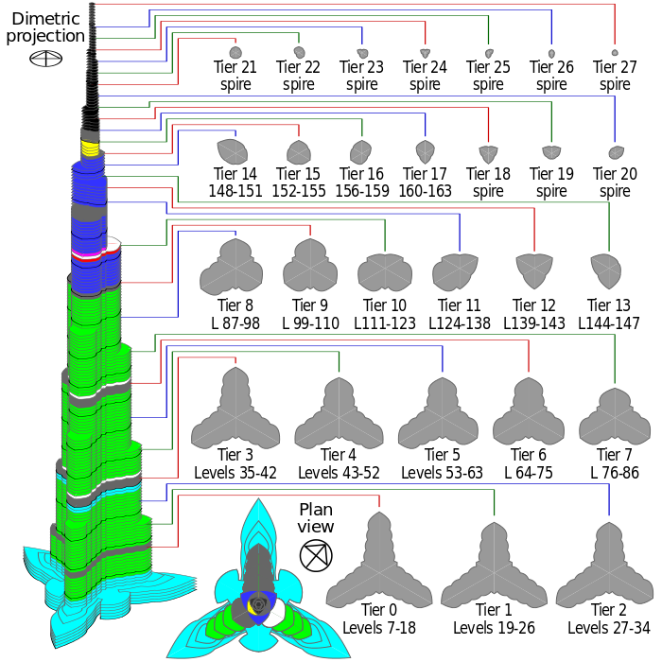
Figure 2 - (salzman, 2015)
The large base has helped dissipate the immense pressure from the weight of the building and other external forces such as wind which has been delegated with the implementation of the shape of the building’s foundation and spiral step design transversing through each layer of the building.
Additionally, the towers irregular shape varying as you increase in height helps dissipate pickets of wind circulation of high and low pressure, reducing the force applied to the building. Tiers 0,1 and 2 are the larger is area as they are constructed on top of the large base, helping to support the immense mass of the fifteen habitable tiers above and the ten tiers of the spires. A concrete frame is used at this part of the building with rebar due to the weight to strength ratio not being a significant factor, at the spire of the tower where the strength to ratio does matter, steel frame is preferred.
Location of Burj Khalifa
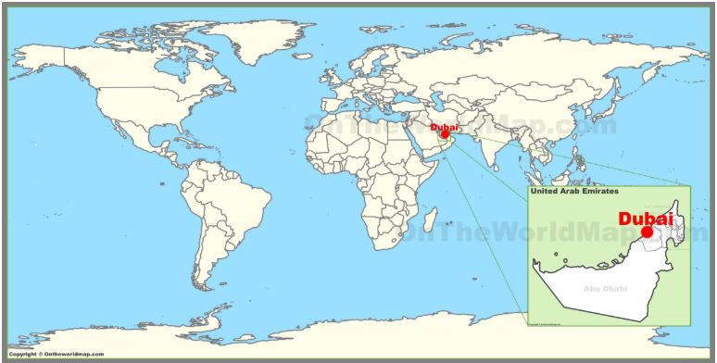
Figure 3 - (Github.io, 2022)
Dubai, located within the United Arab Emirates (UAE) in Figure 3, is exposed to some of earths hottest conditions due to its lateral position on the planet being situated on the Tropic of Cancer. Due to the city being within the desert and having to withstand these harsh conditions, the materials chosen for development in this region need to be specific to try and mitigate the local areas affects. The elevated temperature in the day and cooler nights will influence the materials rigidity, especially with concrete as this is the most prone method for cracking to form because of expansion and contraction (Dynamic Concrete Pumping, 2021). This same change of shape can also be found within steel meaning that when they are combined within a frame there needs to be room for this expansion to occur otherwise a risk of build-up in tension could cause severe damage.
Additionally, the effects of the extreme winds that build up over the dunes of the outskirts of the city have a significant effect on the Berj Khalifa due to it sticking above the nearby skyscrapers, causing it to not be protected. As a result of this is, in the design phase 40 wind tunnel tests completed, the Y-shape helping to deflect the force away from the core of the building (Report, 2019).
Production Process of Concrete
Concrete production is one of the highest contributors of carbon dioxide with 8-9% of global carbon emissions (Rodgers, 2018). In the base of the Burj Khalifa, there was 12,500 metres cube of concrete (let alone the concrete for each tier as shown in Figure 2). Per cubic meter of concrete, 200 to 300 kg of CO2 is released meaning that in the base of the building alone, over 3.1 million Kg (3100 tonnes) of CO2 was released (Concrete CO 2 Fact Sheet, 2008). Excluding the transportation and other uses of energy to create the building, this has a significant carbon footprint which is going to be difficult to nullify in this environment due to the harsh conditions making it difficult for vegetation to grow.
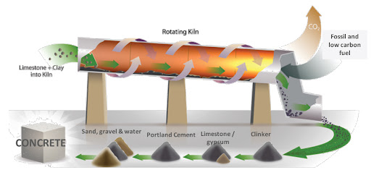
Figure 4 - (concrete-info, 2021)
As seen in Figure 4, sand, water, cement, and aggregate is combines to create concrete. Depending on the required type of concrete, different mixes and size of aggregates can be used to succeed this. Knowledge and skill for succeeding this is important as well as performed correctly to not cause long term health issues arising.
Additional to the environmental impacts, the production of concrete has a remarkably considerable risk on the people creating the cement which is one of the fundamental materials required for concrete. This is due to the concrete dust getting into the lungs causing respiratory issues short term or long term in the form of cancer. Additionally, the workers also have an elevated risk of potentially becoming contaminated due to the use of radioactive material such as Uranium and Raddon which is common when mined for rubble. These two affects can have the extreme of causing life threatening injuries or even death making negative effect when working with concrete on a large scale as it becomes more dangerous (Wikipedia Contributors, 2019b).
How is Concrete Used?
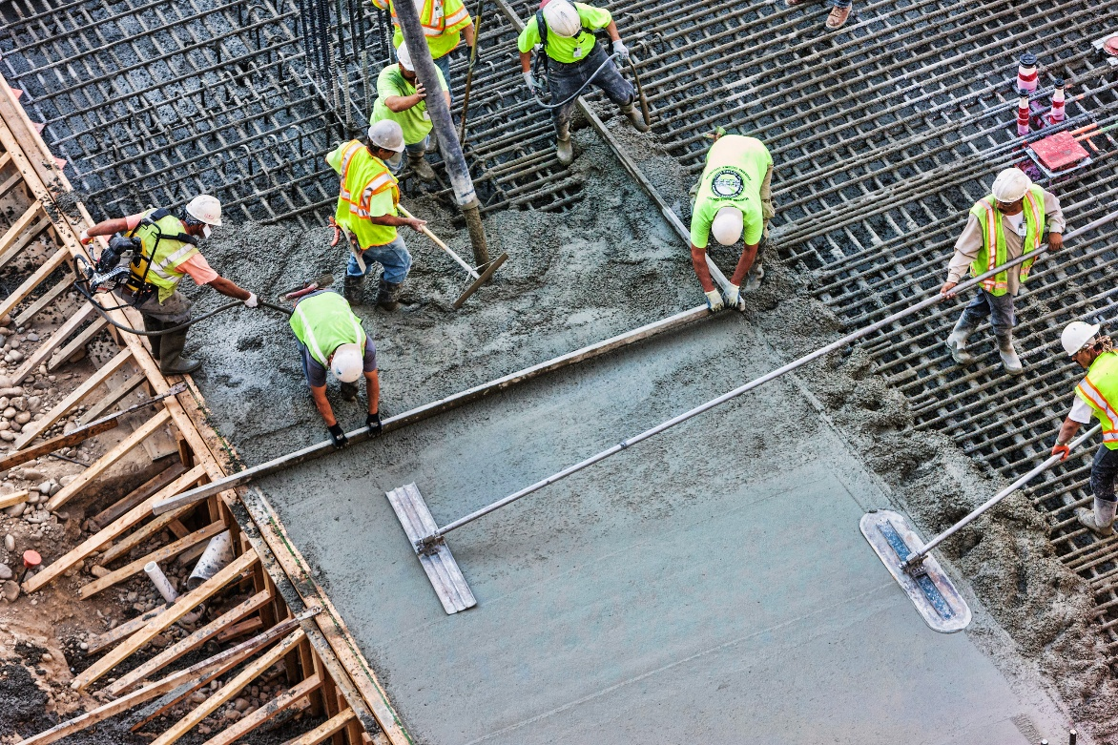
Figure 5 - (Quotesgram.com, 2025)
Unlike steel beams, concrete is not pre-manufactured to its precise measurements before being brought to site. Depending on the scale of the concrete required, it can either be made in a cement factory and brough by a mixer to site so that it does not solidify or can be made using bags for small scale on site (which wouldn’t be the case for the Burj Khalifa due to the scale). Due to the concrete only having between 30mins to 6hours (Powerblanket, 2019) for the initial set (depending on the type of mixture), the pour needs to be planned and poured in the correct conditions otherwise it will have a higher risk of failure in the future.
In the Burj Khalifa’s base, this was done in 4 separate pours due to the scale, allowing them to correctly pour the concrete under the harsh conditions of the UAE. In higher temperature climates, concrete sets more rapidly due to the evaporation of water leaving the solution at a faster rate. Typically, concrete gains 70% of its overall strength within the first 7 days after the initial pour. After 28 days of curing 90% of overall strength is gained (L, 2024).
The Shard
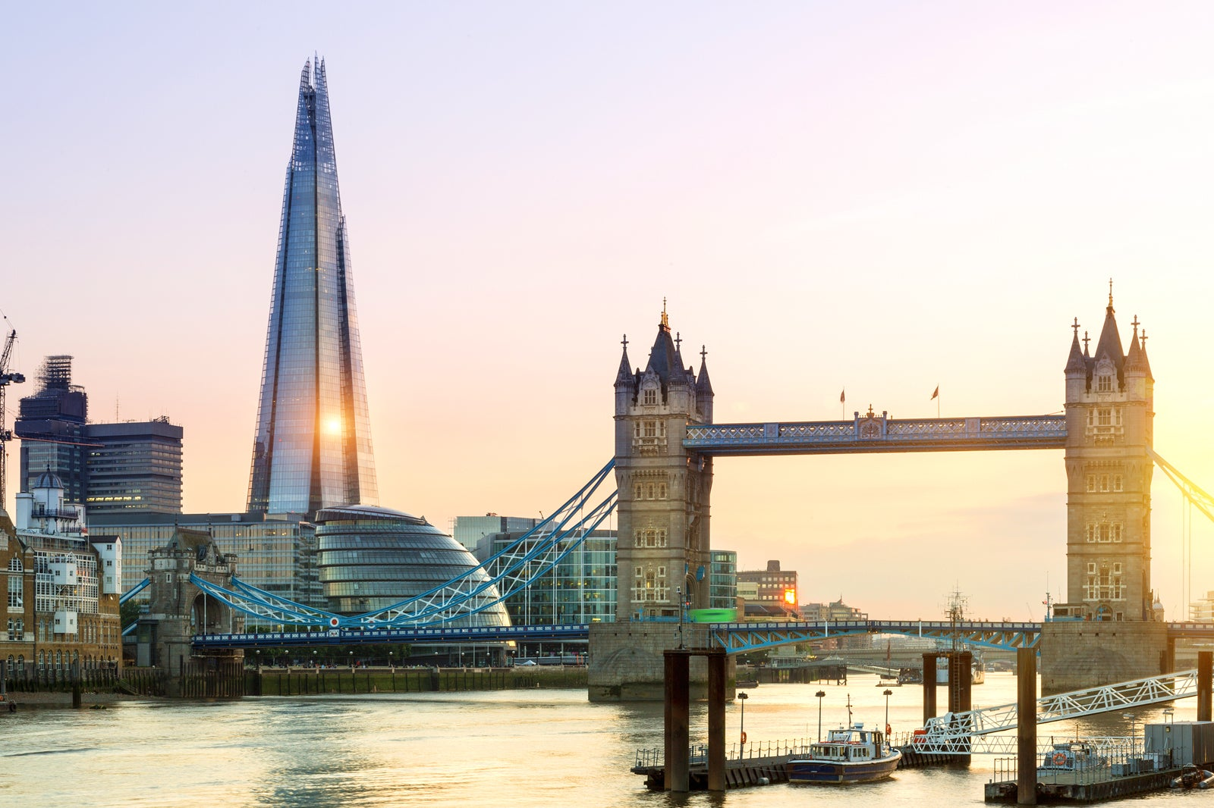
Tower Bridge

Figure 6 - (Mungfali, 2023)
Background Information
The Shard was constructed in London during 2012, is the tallest building within Western Europe at 309m tall (Wikipedia Contributors, 2019c). With its iconic ‘glass shard’ look making it stand out from the rest of the skyscrapers within London, the building has an average of 1.4 million tourists annually due to it being the best place to oversee the city (Answers, 2025). Within the 72 floors of the shard, 26 are office space, 19 floors are apart of the Shangri-La Hotel and the remaining 13 floors are residential apartments or the highest public viewing gallery of London which also includes a restaurant/ bar.

Structure of the Shard
Unlike the Burj Khalifa with its wide Y-shape base, the Shard has a steep gradient, with one continuous vertical shape stretching from the ground to the top. As a result of this the building has been constructed on a steel frame which is continuous throughout 2 sections with a concrete mass in-between helping to increase the buildings rigidity.
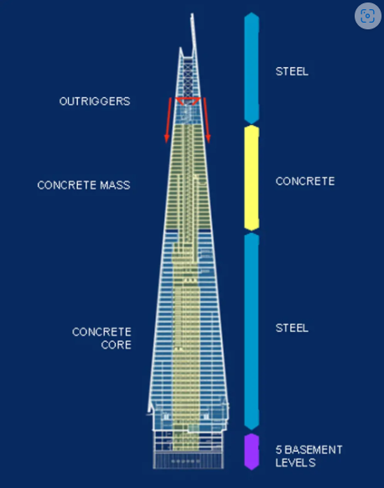
Figure 7- (Engineering, 2012)
Due to the strength to weight ratio of steel, each level has a larger surface area than if we used concrete frame. As shown in Figure 7, the building is separated into concrete and steel masses. Most of the building is steel frame due to the benefits mentioned before however concrete mass is used to help reduce the effects caused with swaying from the wind. This helps dampen this motion and therefore unlike in modern skyscrapers around the world which have a tuned mass damper at the top, the Shard can save the most ‘important’ part of the tower which brings the tourist in, the viewing platform (Structures Insider, 2023). This design helps create more space thus having more room for residential space which makes more economic gain when selling these luxury apartments.

Location of the Shard
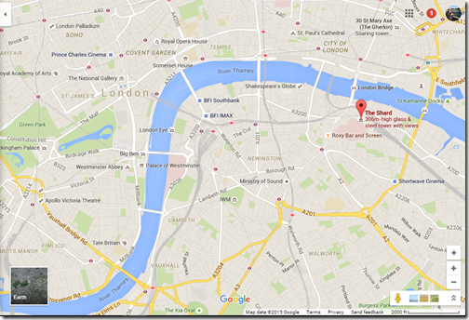
Figure 8 - (Garrido, 2015)
The Shards is built within Southwark (London), seen in Figure 8, which is also situated with other high-rise buildings nearby as well as being on top of London Bridge Station. Due to London being a low-lying city, it is common for high gusts of winds to travel directly into the city and is especially affective to building that rise above the rest like the Shard due to the lack of protection from any other structures.
Unlike the UAE, the UK is not known for having dramatic temperature changes meaning that the materials are unlikely to have significant effects from the environment. Due to the glass shape of the building, most of the radiant heat from the sun is reflected however the steel frame still would need some spacing from the potential for expansion and contraction which could in balance the tension of the building. As the temperature change not being dramatic, the steel frame will only change slightly however due to the scale of the building this could build up into a noticeable difference meaning it needs to be accounted for.

Production Process of Steel
Within the shard 11,836 tonnes of steel was used in the creation of the Shard (DGB and DGB, 2012). Unlike most projects in the UK where the steel is made from abroad such as China, the shards steel was produced by the leading UK structural steel company, Severfield (Admin, 2015).
Steel is a compound of material with iron being the most prominent. During the creation of steel, elements are removed or added into the iron to make the steel a specific way for its appropriate use. The Uk steel industry is still large with it contributing £2.3 billion in 2023 which is 1% of total manufacturing output, however there are growing industries in the US and especially in Asia with countries like Japan and China already have a well-established global supply.
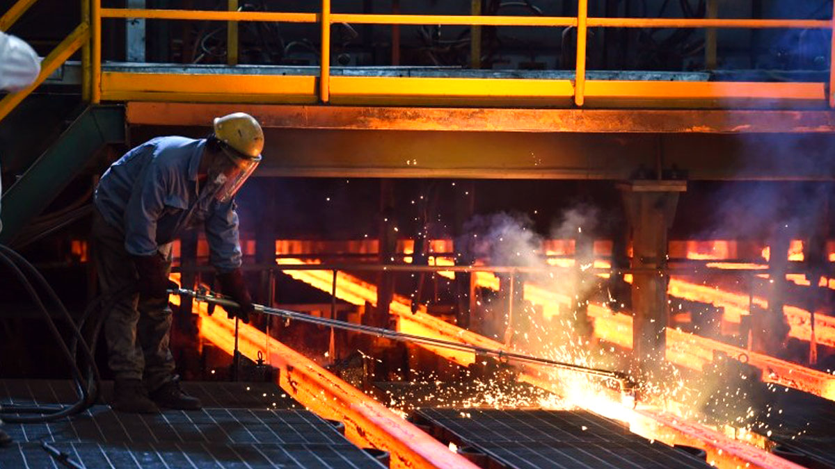
Figure 9 - (ING, 2023)
Environmentally to produce steel is not great due to the air emissions, wastewater contaminants, hazardous waste and solid wastes produced. Examples of some air pollutants are CO, Sox, Nox and PM2 (greenspec, 2021). Additionally, there are also some health effects on humans when producing steel which if not protected from can cause some serious effects. Burning, exposure to dusts, amputees are three of the main serious categories for potential issues when producing steel. This is due to the vast amounts of heavy machinery required to lift the steel as it has a high mass and density making on safe for humans to lift (Cabaro-group.com, 2024).
How is Steel Used?
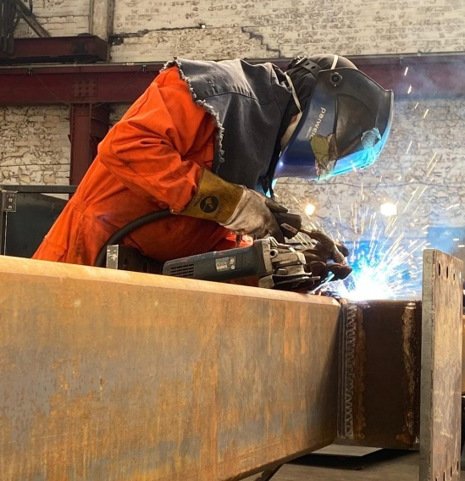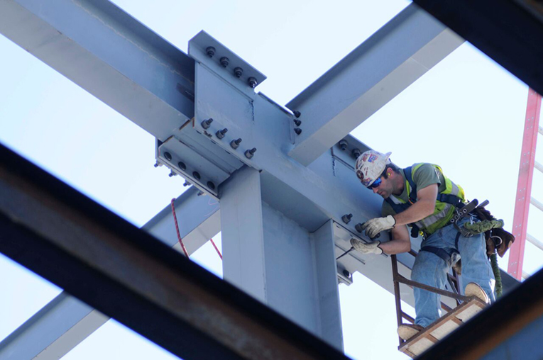
Figure 10 - (Fem Ltd, 2023) Figure 11 - (Kuang, 2018)
One of steel most beneficial characteristics compared to concrete is the premanufacture stage allowing you to accurately create each steel beam to the required specification and size. Once these beams are brought to the site such as the shard, they are put together with bolts and welds to interconnect them. This is a positive compared to concrete as the steel frame can be changed in terms of adding or subtracting to suit future designs and plan. This is not the case in concrete due to the setting process not allowing any modifications to occur as it will only break if you try to change it.
By steel having the premanufacturing stage allows the implementation of the frame to be installed at a much faster rate as everything is measured very accurately meaning that it should interconnect creating one system (Concept, 2020).

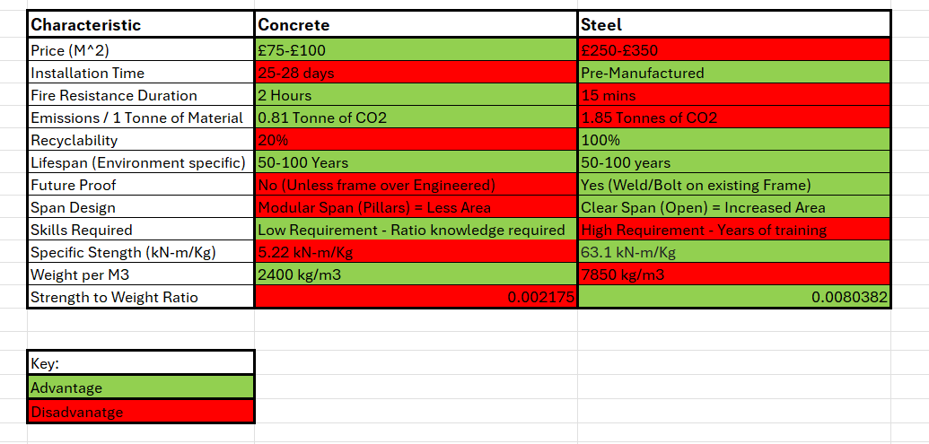
Advantage vs Disadvantage

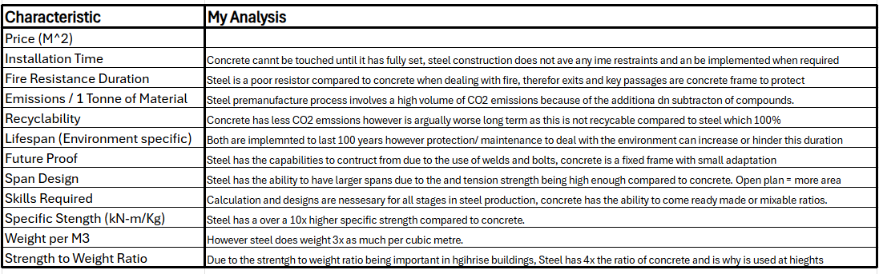

Figure 12 – My Table
After researching the characteristics of the two framing materials, both have a clear difference and situational use which has caused two modern buildings to have chosen different framing systems. For example, in the Burj Khalifa and the Shard there is a slight mix between both, however they are both clearly not the same frame overall. By looking at Figure 12, you can see some significant differences such as the strength to weight ratio that calculates steel to be 4x stronger per kg of mass compared to concrete.
This is why steel is used at the higher stages of the buildings as weight becomes an increasing factor that needs to be accounted for, unlike when near to the surface. This also helps when funding a project as concrete is significantly cheaper than steel meaning that its more suitable to use in large bases like the Burj Khalifa however in the Shard which is narrower and more confined Steel is a more suitable option. This is due to the area of the base cannot span as much to help dissipate the load of the building as London is tightly packed in this region as shown in Figure 8.

Reference List
In Text References
Admin (2015). Severfield plc. [online] Construction & Civil Engineering magazine. Available at: https://ccemagazine.com/news/severfield-plc/ [Accessed 28 Feb. 2025].
Answers. (2025). How many people visit The Shard each year? - Answers. [online] Available at: https://www.answers.com/sociology/How_many_people_visit_The_Shard_each_year [Accessed 28 Feb. 2025].
Cabaro-group.com. (2024). Discover the Top 10 Safety Risks Faced in the Steel Industry Today. [online] Available at: https://blog.cabaro-group.com/10-common-hazards-in-the-steel-industry/ [Accessed 28 Feb. 2025].
Concept, C. (2020). Steel Vs Concrete - Advantages and Disadvantages With features. [online] Civil Concept. Available at: https://www.civilconcept.com/steel-vs-concrete/ [Accessed 28 Feb. 2025].
Concrete CO 2 Fact Sheet. (2008). Available at: https://greenconcrete.info/downloads/11_ConcreteCO2.pdf [Accessed 26 Feb. 2025].
DGB and DGB (2012). The Shard: The Glazing Industry’s Showpiece. [online] Double Glazing Blogger. Available at: https://www.doubleglazingblogger.com/2012/02/the-shard-the-glazing-industrys-showpiece/ [Accessed 28 Feb. 2025].
Dynamic Concrete Pumping (2021). Understanding Concrete Expansion. [online] Dynamic Concrete Pumping. Available at: https://www.dcpu1.com/blog/understanding-concrete-expansion/ [Accessed 26 Feb. 2025].
greenspec (2021). Steel Production & Environmental Impact. [online] www.greenspec.co.uk. Available at: https://www.greenspec.co.uk/building-design/steel-products-and-environmental-impact/ [Accessed 28 Feb. 2025].
Jamal, H. (2017). Design, Construction and Structural Details of Burj al Khalifa | Tallest Skyscraper Engineering Construction. [online] www.aboutcivil.org. Available at: https://www.aboutcivil.org/burj-khalifa-design-construction-structural-details.html [Accessed 26 Feb. 2025].
L, M. (2024). Introduction to Concrete Setting and Curing. [online] craftingwithconcrete.com. Available at: https://craftingwithconcrete.com/how-long-does-it-take-for-concrete-to-set/ [Accessed 28 Feb. 2025].
Linkedin.com. (2024). LinkedIn. [online] Available at: https://www.linkedin.com/pulse/role-metal-constructing-burj-khalifa-mjulf [Accessed 26 Feb. 2025].
Powerblanket. (2019). How Long Does Concrete Take To Set? | Concrete Cure TImes. [online] Available at: https://www.powerblanket.com/blog/long-concrete-take-set/ [Accessed 28 Feb. 2025].
Report, W. (2019). 5 challenges faced while building Dubai’s Burj Khalifa. [online] Khaleej Times. Available at: https://www.khaleejtimes.com/uae/5-challenges-faced-while-building-dubais-burj-khalifa [Accessed 26 Feb. 2025].
Rhodes, C. (2020). UK steel industry: statistics and policy. commonslibrary.parliament.uk. [online] Available at: https://commonslibrary.parliament.uk/research-briefings/cbp-7317/ [Accessed 28 Feb. 2025].
Rodgers, L. (2018). Climate change: The massive CO2 emitter you may not know about. BBC News. [online] 17 Dec. Available at: https://www.bbc.co.uk/news/science-environment-46455844 [Accessed 26 Feb. 2025].
Structures Insider (2023). A Structural Review: The Shard | London designed by WSP. [online] Structures Insider. Available at: https://www.structuresinsider.com/post/a-structural-review-the-shard-london-designed-by-wsp [Accessed 28 Feb. 2025].
The Constructor (2017). Structural Details of Burj Khalifa - Concrete Grade and Foundations. [online] The Constructor. Available at: https://theconstructor.org/structures/structural-details-burj-khalifa-concrete-grade-foundations/20512/ [Accessed 26 Feb. 2025].
Wikipedia Contributors (2019a). Burj Khalifa. [online] Wikipedia. Available at: https://en.wikipedia.org/wiki/Burj_Khalifa [Accessed 26 Feb. 2025].
Wikipedia Contributors (2019b). Environmental impact of concrete. [online] Wikipedia. Available at: https://en.wikipedia.org/wiki/Environmental_impact_of_concrete [Accessed 26 Feb. 2025].
Wikipedia Contributors (2019c). The Shard. [online] Wikipedia. Available at: https://en.wikipedia.org/wiki/The_Shard [Accessed 28 Feb. 2025].

Figure References
Figure 1 – Izkiz.co.uk. (2017). The Burj Khalifa. [online] Available at: https://www.izkiz.co.uk/burj-khalifa-dubai/ [Accessed 3 Mar. 2025].
Figure 2 - salzman, rachel (2015). Condominium Floor Plan. [online] Pinterest. Available at: https://uk.pinterest.com/pin/379076493612202767/ [Accessed 3 Mar. 2025].
Figure 3 – Github.io. (2022). Dubai On World Map – Topographic Map of Usa with States. [online] Available at: https://topographicmapofusawithstates.github.io/new-142-dubai-on-world-map-photos/ [Accessed 3 Mar. 2025]
Figure 4 – concrete-info (2021). How Cement Is Made? - Concrete Information. [online] Concrete Information. Available at: https://www.concrete-info.com/how-cement-is-made/ [Accessed 4 Mar. 2025].
Figure 5 – Quotesgram.com. (2025). Pouring Concrete Quotes. QuotesGram. [online] Available at: https://quotesgram.com/pouring-concrete-quotes/ [Accessed 4 Mar. 2025].
Figure 6 – Mungfali. (2023). The Shard Of London Images, Photos | Mungfali. [online] Available at: https://mungfali.com/explore/The-Shard-of-London [Accessed 3 Mar. 2025].
Figure 7 – Engineering, R.A. of (2012). Building the Shard. [online] Ingenia. Available at: https://www.ingenia.org.uk/articles/building-the-shard/ [Accessed 3 Mar. 2025].
Figure 8 – Garrido, R. (2015). Thames Walk Westminster Palace to Tate Britain. [online] Loyalty Traveler. Available at: https://loyaltytraveler.boardingarea.com/2015/12/18/thames-walk-westminster-palace-to-tate-britain/ [Accessed 3 Mar. 2025].
Figure 9 – ING (2023). Hydrogen sparks change for the future of green steel production. [online] ING.com. Available at: https://www.ing.com/Newsroom/News/Hydrogen-sparks-change-for-the-future-of-green-steel-production.htm [Accessed 4 Mar. 2025].
Figure 10 – Fem Ltd. (2023). Steel Beam Fabrication | Sheffield | FEM Ltd. [online] Available at: https://femltd.com/steel-beam-fabrication/ [Accessed 4 Mar. 2025].
Figure 11 – Kuang, W. (2018). Connection Erection | SkyCiv Cloud Structural Analysis Software. [online] SkyCiv Cloud Structural Analysis Software | Cloud Structural Analysis Software and Calculators. Available at: https://skyciv.com/technical/methods-of-steel-connection-erection/ [Accessed 4 Mar. 2025].
Figure 12 – My Table (References Below)

Table Data References
Price
Concreterepaircompany.uk. (2025). The Cost of Concrete Slabs in the UK: A Pricing Guide. [online] Available at: https://concreterepaircompany.uk/the-cost-of-concrete-slabs-in-the-uk-a-pricing-guide/ [Accessed 4 Mar. 2025].
Checkatrade's Professional Estimators (2023). Steel building prices. [online] Checkatrade. Available at: https://www.checkatrade.com/blog/cost-guides/steel-building-prices/ [Accessed 4 Mar. 2025].
Installation Time
Concrete Flooring Solutions. (2020). How Long Does Concrete Take to Set? Expert Advice from Concrete Specialists. [online] Available at: https://concreteflooringsolutions.co.uk/blog/how-long-does-concrete-take-to-set-expert-advice-from-concrete-specialists/ [Accessed 4 Mar. 2025].
Fire Resistance Duration
Captain, T.C. (2025). Can Concrete Get Burned? Understanding Fire Resistance And Safety Measures - ConcreteCaptain.com. [online] ConcreteCaptain.com. Available at: https://concretecaptain.com/can-concrete-get-burned/ [Accessed 4 Mar. 2025].
Fire-proof.co.uk. (2024). Fire Safety Guide #2 | Impact of Fire On Structural Steel. [online] Available at: https://fire-proof.co.uk/resources/impact-of-fire-on-structural-steel [Accessed 4 Mar. 2025].
Emissions
Wikipedia Contributors (2019). Environmental impact of concrete. [online] Wikipedia. Available at: https://en.wikipedia.org/wiki/Environmental_impact_of_concrete [Accessed 4 Mar. 2025].
A.K (2021). World Steel Association releases paper on CO2 emission reduction. [online] Recycling Today. Available at: https://www.recyclingtoday.com/news/worldsteel-co2-report/ [Accessed 4 Mar. 2025].
Recyclability
Lignacite Ltd. (2024). From Waste To Wealth: Lignacite’s Approach To Recycling In Concrete Block Manufacturing | Lignacite. [online] Available at: https://lignacite.co.uk/from-waste-to-wealth-lignacites-approach-to-recycling-in-concrete-block-manufacturing/ [Accessed 4 Mar. 2025].
Pritchard, J. (2023). Is Steel Recyclable? The Surprising Truth About Green Steel - Building Renewable. [online] buildingrenewable.com. Available at: https://buildingrenewable.com/is-steel-recyclable-green-steel/ [Accessed 4 Mar. 2025].
Lifespan
proconcretingdev (2024). How Long Does Concrete Last on Average? - Pro Concreting. [online] Pro Concreting. Available at: https://www.proconcreting.com.au/how-long-does-concrete-last-on-average/ [Accessed 4 Mar. 2025].
Steel Frame Building Supplier UK. (2024). What Is the Lifespan of a Structure Made from Structural Steel? - Steel Frame Building Supplier UK. [online] Available at: https://steelframebuildingsupplier.co.uk/what-is-the-lifespan-of-a-structure-made-from-structural-steel/ [Accessed 4 Mar. 2025].
Span Design
James (2021). Guide to Calculating Steel Beam Sizes. [online] Buy a Beam. Available at: https://buyabeam.com/blogs/steel-beams/steel-beam-calculator-guide/ [Accessed 4 Mar. 2025].
Skills required
Concept, C. (2020a). Steel Vs Concrete - Advantages and Disadvantages With features. [online] Civil Concept. Available at: https://www.civilconcept.com/steel-vs-concrete/ [Accessed 4 Mar. 2025].
Specific Strength
Wikipedia Contributors (2020). Specific strength. [online] Wikipedia. Available at: https://en.wikipedia.org/wiki/Specific_strength [Accessed 4 Mar. 2025].
Weight
Civil Sir. (2021). Unit Weight of concrete in kg/m3, kg/ft3, kN/m3, lbs/ft3 and lbs/in3. [online] Available at: https://civilsir.com/unit-weight-of-concrete/ [Accessed 4 Mar. 2025].
Concept, C. (2020b). Steel Vs Concrete - Advantages and Disadvantages With features. [online] Civil Concept. Available at: https://www.civilconcept.com/steel-vs-concrete/ [Accessed 4 Mar. 2025].

