Transition in early Years:
The importance of good communication



Source: Innovation management

A practitioners Handbook

“The Child’s own efforts to achieve a sense of continuity and coherence in the face of discontinuity and fragmentation are aided by the active participation of adults who are themselves committed to the same goals” (Bronfenbrenner 1979)
Contents:

Introduction Pg 3

Transitions Pg 3

The Needs of a child Pg 5

The Role of the Adult Pg 7

Partnerships Pg 10

Interventions and strategies Pg 12

Proposed outcomes Pg 16

Reference list Pg 17

Introduction

This handbook is an essential guide that has been developed to inform practitioners working with young children aged 3 to transition successfully into the school setting, their next big step, allowing a smooth process for all involved in the child’s journey. The common thread through this handbook, will be the importance of effective communication between partnerships involved, ensuring that the current policies, legislation, rights of the child, human behaviour theorists and government minimum standards are present throughout to ensure best practice within care to achieve positive outcomes for the child transitioning.
This handbook will outline the current policies, rights and theories collectively, to help guide practitioners in accordance with the Welsh government guidelines, placing the child and their wellbeing the forefront of everything, supporting smooth transitions by focusing on effective communication, information sharing, and collaboration between settings (Early Years Development and Childcare Partnership 2023).
The foundation Phase Framework is integral as it is specifically designed for children aged 3-7 in Wales, it emphasises play based learning, holistic development, and child centred approaches. Its principles include creating a supportive learning environment, ensuring wellbeing and the child’s involvement, and facilitating effective transitions during a child’s early years. (Foundation Phase Framework 2015)

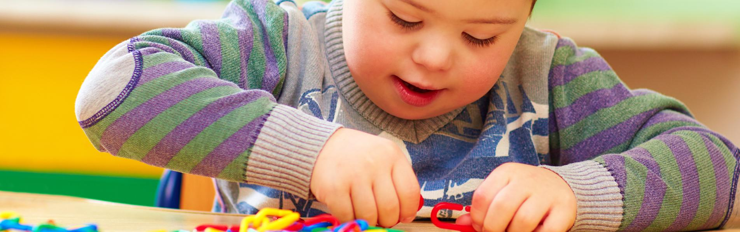
Source: Health and Wellbeing

Transitions
Transitions is a process of change that a child with go through as they move from their current setting to another. It is essential to get the transition right as it can have a significant impact on a child’s wellbeing and development. According to Dahlberg and Moss they explain that transition is a process of change that involves the child, their family and the environment. (Dahlberg G, Moss P 2005). They go on to suggest that transition should be viewed as a process rather than an event and that it is important to consider the child’s perspective and experiences during the transition process, this lines itself with the current Welsh Governments Early Years Framework (2011) and the new curriculum (2022), placing the child in the forefront of decisions and allowing them and parents, as well as caregivers to have an active role in their transition.
Following the guidance from the Early Years to 5 Matters (2021), this framework allows practitioners to consider continuity between the child’s home and new setting, this could be ensuring the parent/child’s key worker who has an established relationship with the child is fluid and included in the decision making, that there are many opportunities to visit the setting with the child and its new surroundings. The framework backs the previous theories mentioned about effective transitions being a process not a one-off event and that transitions should be planned.
Practitioners must make their settings welcome and inviting, have access for new starters to visit regularly, enabling the child and their parents/caregiver to become familiar with the setting and new staff members, building up relationships and familiarising themselves in the school setting. (Birth to 5 2021)
It is also important to visit the child in their own environment, whether that be at home or in childcare setting, the idea is to enable the child to visit new experiences with trusted adults, allowing them to navigate the new environment comfortably and where the child can see their parents/carers developing warm and positive relationships by communicating effectively and sharing concerns and expectations.


High quality transitions recognise the importance of feeling “known”. (Birth to 5 2021)
The Needs of the Child
The needs of a child encompass various aspects of their physical, psychological, and social wellbeing. One of the most influential theorists regarding human needs is Abraham Maslow’s hierarchy of needs. According to Maslow, individuals have five levels of needs that must be fulfilled in a sequence. Starting at the bottom with the basic needs, then moving up the pyramid to the more complex needs. He states that an individual must have the needs met before they can move to the next level on the pyramid. (Maslow 1962)
This is important to remember when a child is transitioning, that children need to feel safe and secure to enable them to move up the pyramid and build new relationships and develop. The aim is for the children within our care to reach self-actualization, and to achieve this, children need to feel loved and have sense of belongingpractitioners need to develop these relationships and trust within the setting, being consistent, playing with the children and showing a genuine interest for them to meet their full potential. (Maslow 1962)
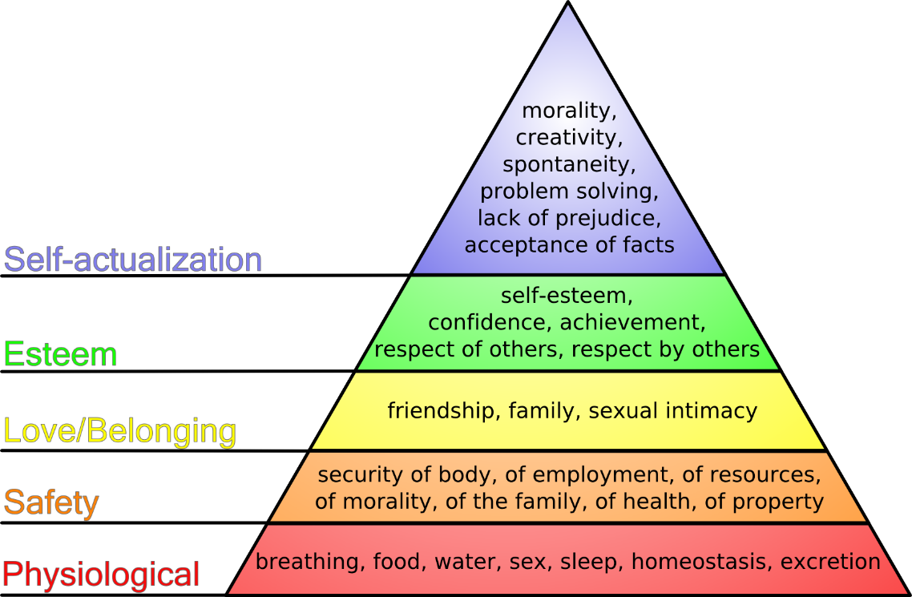

Regarding strategies to support children’s needs, it is important to consider John Bowlby’s theory of attachment (1969), Bowlby emphasized that secure attachment between children and the practitioners who work with them are crucial for their emotional development and well-being. Secure attachment helps supports brain development by strengthening neural connections and pathways related to bonding, emotional processing, and social interaction. By consistently providing a secure base the trust of the child, practitioners aid the formation of strong and healthy neural networks that promote overall brain development. Erikson believed that early patterns of trust influence a child’s social and emotional development. (Erikson 1982) Strategies to promote secure attachment may include practitioners being responsive and sensitive, acknowledging their feelings, getting to know the child’s likes, dislikes and triggers, maintaining consistent routines to feel secure and safe.
Insecure attachment- is when a child could have either ambivalent/anxious attachment, or avoidant attachment, here a child may be withdrawn, distant, angry or unresponsive. They lack a sense of trust and acceptance, how they rely on others, it affects a child’s self-worth and esteem, and brain development is hindered. According to Bowlby (1969) if a child feels unloved and their needs are not being met at home, this insecure attachment will affect the way in which a child will develop, and their outcomes will no longer be met. They will not move up the Maslow’s pyramid to reach self-actualization (Maslow 1962).
Secure attachment- is when a child is happy, secure and exploring. The child has a secured base and be confident that their parent will acknowledge their child’s needs, a child will feel loved and have a safety network, therefore easier to transition to the next stages in life. As a second-hand care giver, we can build a safe and secure bond, be their comfort and consistent care giver and work towards establishing secure attachment. Bowlby (1969)

Childrens Rights
When working with children it is essential to adhere to their human rights (UNCRC), Article 12 of the United Nations Convention on the Rights of a Child, emphasizes the right of the children to express their views freely in all matters affecting them. Children should have the opportunity to actively participate in decision-making processes that affect their lives, giving them a sense of agency and autonomy. This is reflected in the Welsh government legislation, which aims to promote children’s rights, (The rights of young Persons Wales 2011). Practitioners need to recognise the child’s ability to make decisions, at 3 years old, they may not have the cognitive maturity to fully understand situations, however by engaging in child age-appropriate discussions about their feelings, interests and preferences will help, Involving parents and other professionals such as health visitors, current nurseries and other practitioners to collaboratively work together to consider the child’s best interests, safety and wellbeing helps establish the best route for the child. (UNCRC 1989, Article 12)
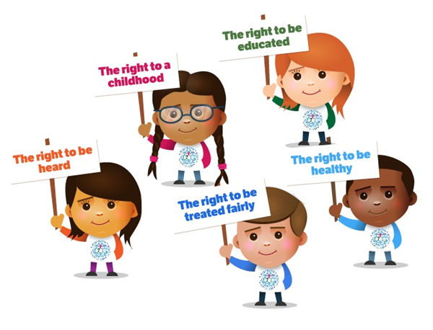

Role of the Adult
When a child first starts school, the role of adults, especially parents are crucial, they have formed the strong bond (attachment) with the child, they are the child’s safe space and know the child best. Bolby (1965). However, it is important to remember the vital role practitioners play to ensure a smooth transition and foster a strong bond between the child and their school environment.

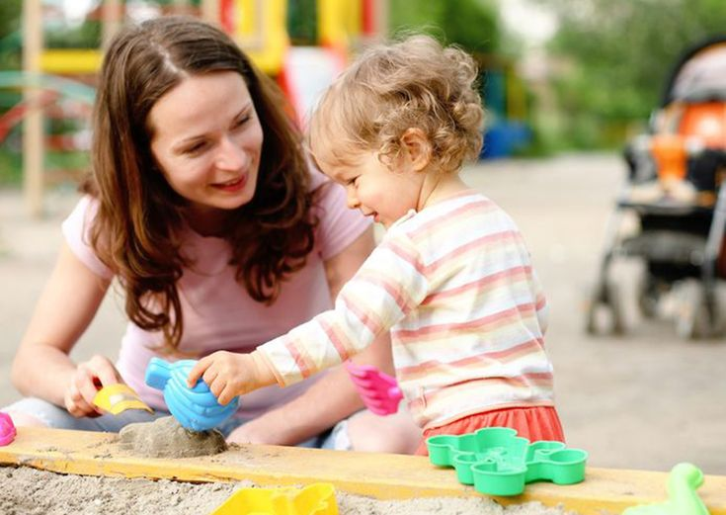

Bronfenbrenner (1989) explains that the child is centre and there are various factors around a child’s life.
Bronfenbrenner’s Ecological System Theory (1989) goes on to highlight the importance of various contexts and systems in a child’s life that influence their development. These include the microsystem (immediate environment like family, peers and school), Mesosystem (interconnections between these microsystems), Exosystem (community and social support systems), and macrosystem (cultural values and social norms).

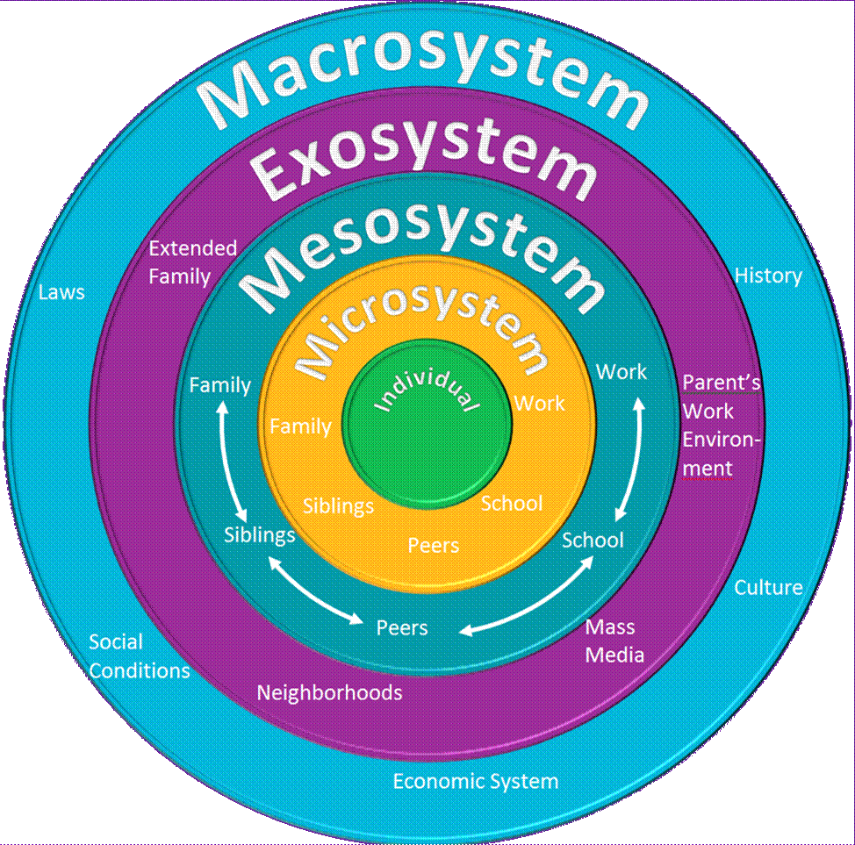

The roles of the adults play in the child’s life are shown in above in Bronfenbrenner’s system, the parents and family are placed right in the closest layer to the individual child, however it is important to see that a child’s school environment is also placed in that layer. Understanding that practitioners have equal importance as parents as practitioners spend so much time with the children within their care. Bronfenbrenner highlights the importance of having a holistic view, supporting a child’s needs requires considering the interconnectedness and impact on these systems, ensuring access to supportive environments, resources, and opportunities that promote a child’s wellbeing.
Parents Role
The role of the parent during a child’s transition from home to school is crucial, key aspects to remember are:
- Open and honest communication- maintaining regular communication with the new school, teacher and other practitioners to establish a strong connection.
- Emotional Support- talking to their child about their feelings, concerns and expectations and ensure those feelings are validated.
- Familiarization- attending meet and greet sessions, attending parent teacher meetings.
- Collaboration with Practitioners and outside agencies- discuss their child’s strengths, concerns and pertinent information about their child.

Source: Schooltastic
Practitioners Role
As a practitioner supporting a child’s transition into school, the role is to facilitate effective communication and provide support during this period of change, maintaining open and regular communication with the child and their family is important to build trust, share information, the more information a practitioner has on the child the smoother the transition.
According to Vygotsky’s social development theory (1978) he emphasizes the importance of social interaction in children’s learning and development. He believed that learning comes before a child’s development and that social interaction influences how children learn. He emphasises that relationships are the most important part of language/environment and why communicating effectively between families play an essential role, this is also underpinned in the Welsh curriculum,
“The Welsh Government recognizes the importance of communication between setting, school, and parents/carers during the transition process.” (Welsh Government 2020)
The 7C’s of communication are principles that help ensure effective and clear communication. Practitioners can apply these when working with parents and children during transition to foster better understanding and engagement, these include:
- Clear- Be clear in your communication by using clear and straightforward language, avoid using jargon on complex terms when explaining the transition process to parents.
- Concise- Keep your communication concise and to the point, avoid unnecessary or irrelevant details. Provide key information about the transition, focusing on what most is important.
- Concrete- Use concrete and specific examples when discussing the transition, this helps parents and the child visualise and understand what to expect during this period of change, making it more relatable and manageable.
- Correct- Ensure that the information you provide is accurate and correct, double check details and consult reliable sources to avoid any confusion and miscommunication. Parents and their child need accurate information to make informed decisions and feel confident about the transition.
- Complete- Provide all relevant information about the process, address any concerns, answer questions and offer comprehensive explanations about what to expect, include key dates, routines, and activities involved.
- Courteous- Show respect and empathy when communicating, transitions can be stressful, so maintaining a friendly and supportive approach helps build trust and positive relationships.
- Considerate- Taylor your communication to the specific needs and preferences of the parents and child. Consider individual circumstances, cultural backgrounds, and any additional support requirements they may have. Adapt your approach to ensure that your communication is considerate and inclusive.
By applying these 7 C’s of communication, practitioners can facilitate effective communication with parents and the child during the transition process, fostering understanding trust, and collaboration.

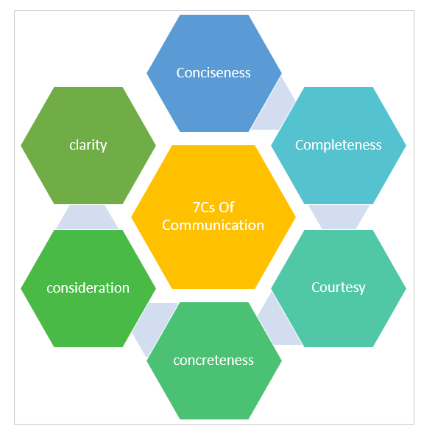
Source

Partnerships
Partnership working and multi-agency collaboration are fundamental to committing to a child’s development. Working together in the interest of the child ensures that everyone involved has a clear plan and is working towards the same goals. This approach can help to identify any potential issues early on and ensure that the child receives the support they need to thrive.
The Welsh Government offer guidelines and principles about multi-agency working and why it is key to effective safeguarding and child protection. It’s vital that practitioners work together to gain a full overview of a child’s situation and have a coordinated approach to support. It is also emphasis the importance of sharing information between agencies to ensure practitioners are aware of any risks the child is or may be exposed to and make appropriate risk assessments or take action to ensure the safety of the child. Welsh Gov (2020)
According to Bronfenbrenner’s (1979) ecological systems theory, he emphasises the importance of multiagency and collaboration when supporting children, he states that a child’s development is influenced by many factors and systems, beginning with its immediate environments for example, family and school to broader social and cultural influences. Bronfenbrenner states that not one person or practitioner can meet all the needs of a child but instead a network of different agencies and professions working collaboratively together, communicating and exchanging information and knowledge can maximize a child’s potential.

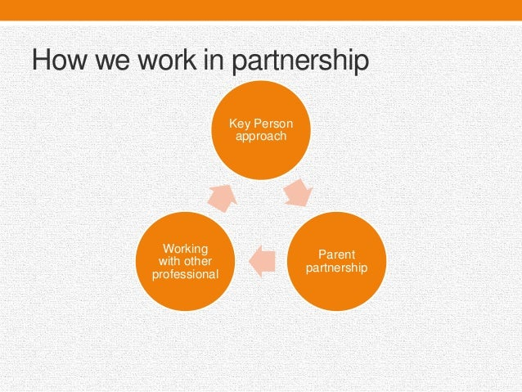

Several umbrella organizations in early childcare, including Professional Association for Childcare and Early Years (PACEY), Early Years Wales (EYW), and Association of Directors of Children’s Services (ADCS). These organizations are important in multiagency organizations because they provide a platform for collaboration and coordination among different agencies and stakeholders involved in early childcare. They help to ensure that the needs of children and families are met effectively by providing support, training, and resources to professionals working in the field.
Interventions and Strategies
Transitions from home to school can be a challenging time for children, as they are required to adapt to new routines, environments, and social dynamics.
The Donaldson report (successful futures) emphasizes a curriculum that fosters learning and wellbeing. The Welsh curriculum aims to develop a child’s characteristics of learning, including being ambitious, capable learners, ethnical individuals, and healthy and confident individuals.
Wales needs a different kind of teacher who understands why and how to work with children, “forming positive relationships based on trust and mutual respect” (Welsh gov 2022)
To support a child’s transition, the following strategies can be employed:
Welcome Pack
A welcome pack is a great way of welcoming a child and their family to the school, it includes several items to help support a smooth transition. Items to include are:
- A Welcome letter- A personalised letter to introduce the child and family to the school, highlighting information, such as the school mission statement, important contacts and resources. It creates a friendly and informative first impression.
- Your Classroom- Pictures and images of the classroom set up and outdoor spaces explaining where everything is, this is designed to prepare the child for its new environment.
- Meet the Team- Placing photographs of the Practitioners within the child’s immediate care and what their roles and responsibilities are can again help the child and family become familiar with the new environment and staff members.
- All about me/one-page profiles- are important and effective tools for supporting a child during transition in early years. They are a simple summery of what is important to the child and how they can be supported. These can be created by parents and previous care settings to build up a picture of the child, it can contain the child’s likes and dislikes, their strengths and weaknesses and where the child make need support and how best to support them. This is another great way of sharing information between practices/home and effectively communicating. (Behaviour matters 2021)
Examples of one Page profiles and all about me pages
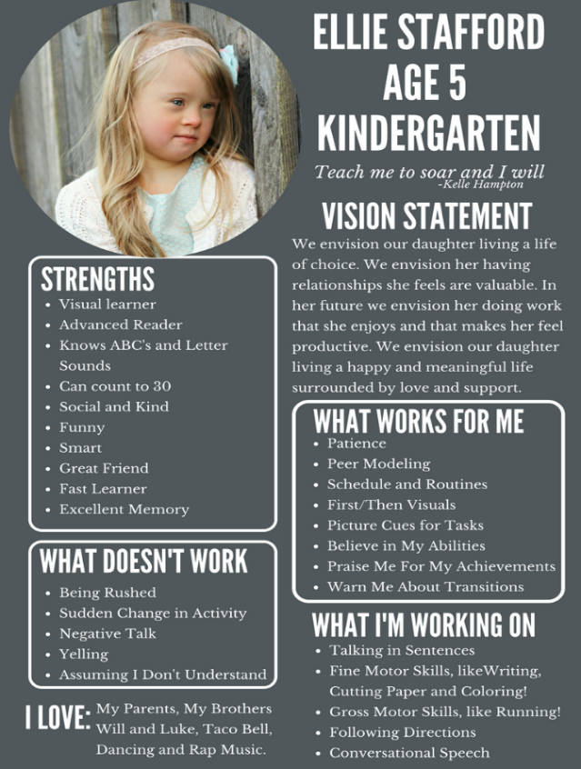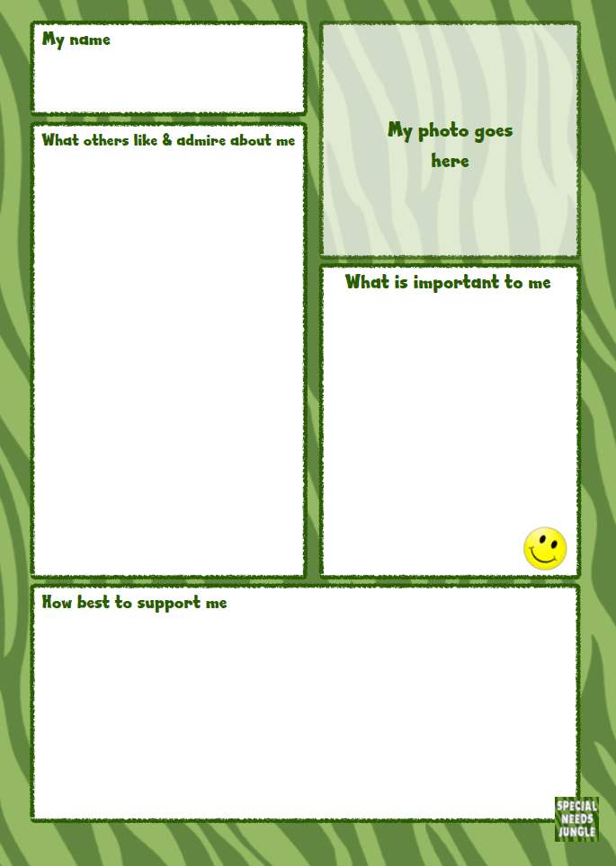
By providing a comprehensive welcome pack, schools actively support the child’s transition from home to school. It helps them feel connected, informed, and prepared to face new challenges, fostering a sense of belonging and improving overall academic and emotional well-being . (Welsh Gov 2023)

Stay and Play Sessions
Stay and play sessions are an important part of the early years transition process, they provide an opportunity for the child to become familiar with the new environment and to develop relationships with practitioners and other children.
“Play/active learning should be an essential part of the children’s curriculum. This approach should be an entitlement for all 3- to 7-year-olds in the Foundation Phase.” (Welsh Gov 2023)
Active learning and play based learning-Plan activities that engage the children in hands-on learning experiences, encourage them to play, developing social skills and promoting emotional wellbeing. Rousseau (1972) believed that children should learn from experience and more hands-on play, using all senses, think about what the child can touch, hear, see and smell. He highlighted the importance of playing outside in natural environments and encouraged spontaneity, creative play and emotions. The better the experiences the better the outcomes, this again is in line with the Welsh Curriculum for early years. (2020)
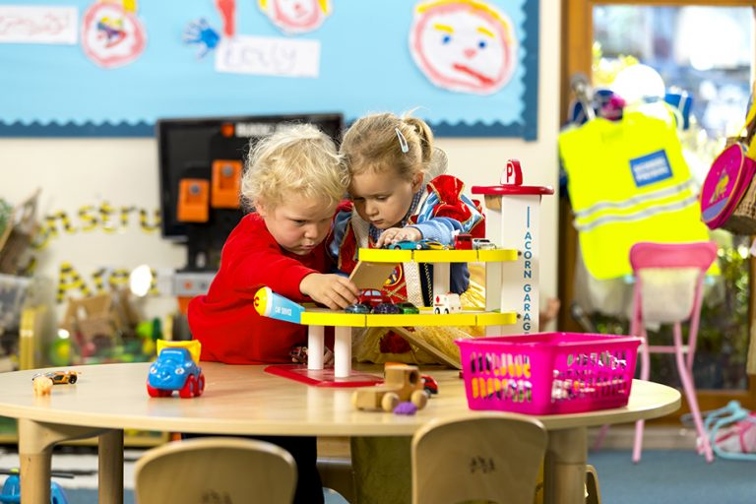

These sessions also give the opportunity for parents to meet the class teacher and staff, to ask any questions and discuss any concerns. It allows practitioners to start to build a relationship with the child and family and again ask any questions or information about the child, an information exchange.
Monitoring and recording
Recording a child’s progress supports effective communication and informs strategies for intervention. Consider the following:
Developmental milestones- Regularly monitor a child’s progress against age-appropriate milestones, such as language and cognitive skills, physical development and social-emotional development.
Piaget (1945) proposed the theory of cognitive development, which has a profound impact on understanding a child’s thinking and understanding and how they evolve and grow, he identifies different stages of development , such as the sensorimotor stage (learning though their senses and actions), the preoperational stage ( egocentric stage, where the child thinks the world is all about them),as this stage develops, the egocentrism reduces and a child will begin to enjoy the participation of other children and their games. At this stage pretend play becomes more important, language is discovered, and they are visual learners, taking in the world around them. These two stages are the stages a child may be on developmentally when transitioning into school. It is essential for a child to go through these changes but remember a child will not develop at the same rate, their development is developed by biology, environment and interaction. (Simple Phycology 2023)
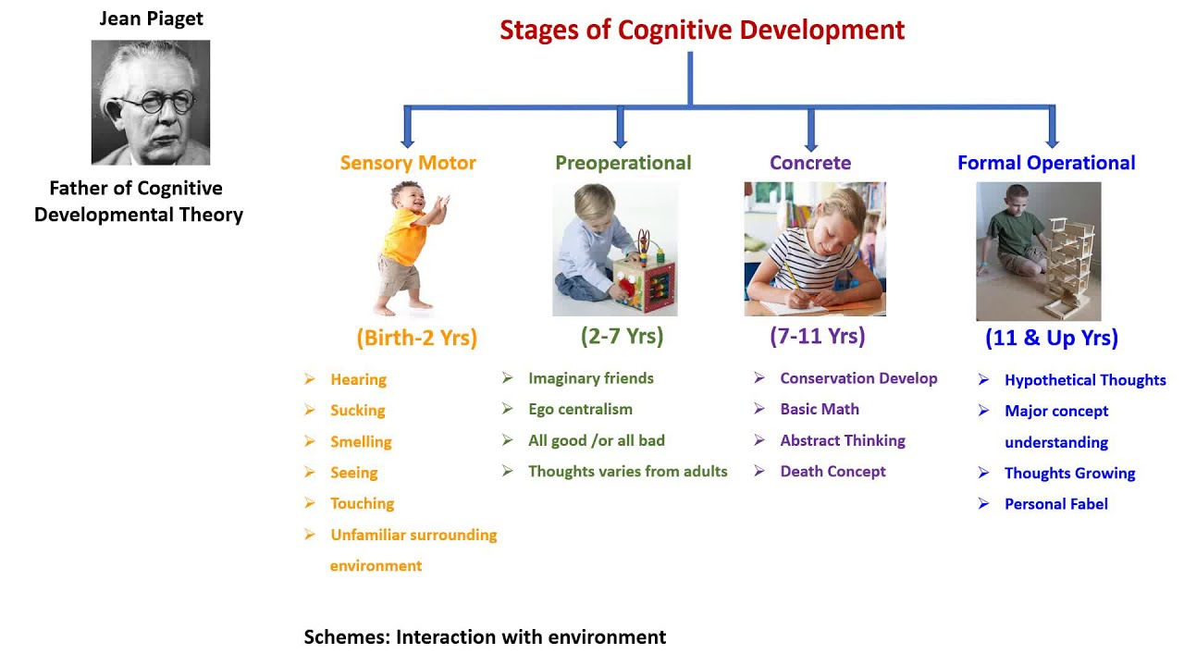

Individualized progress tracking- Record observations and assessments in a structured manner, identifying areas where additional support may be needed. Sharing information-Utilize effective communication channels to share progress updates with parents and relevant professionals. This could be using digital platforms such as Class Dojo, WhatsApp and seesaw. Hold teacher/parent meetings, emails and if necessary, phone calls home. Below is an image of dojo, a digital communication platform.

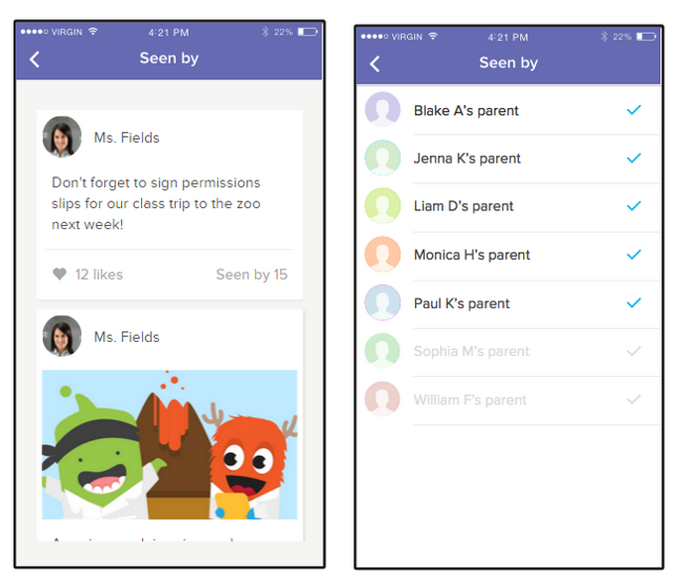

Proposed Outcomes
A successful transition will include a child that demonstrates that they are happy and settled. This will be demonstrated by the child playing independently or becoming less dependent on the practitioner in the setting and no longer looking for the reassurance. The child will begin to form healthy relationships, not only with other children in the classroom, but with the practitioners within the setting. The child will be engaging in the environment and understand the routine and expectations of the classroom and school. A settled child will start to demonstrate a sense of self, and where they fit within the classroom. They will be actively participating and playing, making progress emotionally, be responsive and can explore surroundings independently.
The New Curriculum for Wales, (Welsh Gov, 2020) sets out the principles and requirements designing a curriculum based on the four purposes of education that understands the needs and interests of each child, builds trust with children and families, share information, promote wellbeing and offers positive and inclusive learning. The outcomes are that each child in Wales will become:
- Ambitious, capable learners
- Enterprising, creative contributors
- Ethical informed citizens
- Healthy, confident individuals as valued members of society.
These underpin the core aims and proposed outcomes of children in Wales.

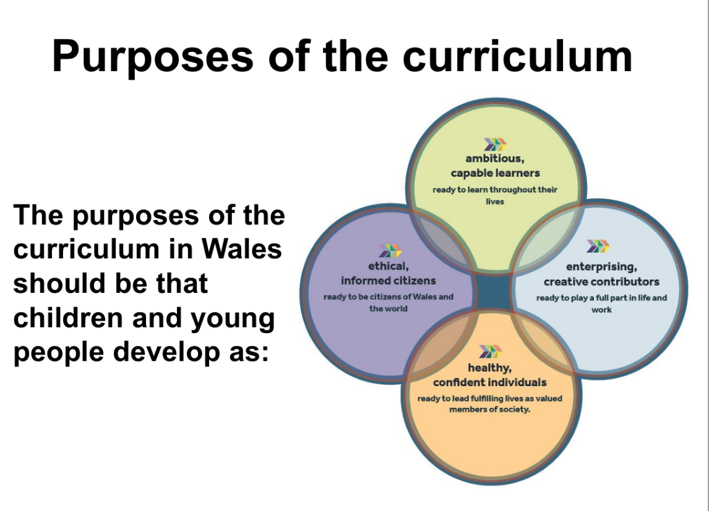

Reference list
Image: innovation management
Welsh Government. (n.d.). Early Years Development and Childcare Partnership (EYDCP). {Online}. Available at: Early years outcomes: framework (gov.wales) {Accessed 11, November 2023}
Welsh Government. (2015). Foundation Phase Framework. {Online}. Available at: foundation-phase-framework-revised-2015.pdf (gov.wales) {Accessed 11 November 2023}
Bronfenbrenner U. (1979). The ecology of human development: Experiments by design and nature. Harvard University Press.
Early Education (2021) Birth to 5 Matters: Non-statutory guidance for the Early Years Foundation Stage. Birthto5Matters-download.pdf (Accessed: 14 November 2023)
Early Education (2021) Behaviour Matters: Non-statutory guidance for the Early Years Foundation Stage. Available at: ¹ (Accessed: 14 November 2023)
Home Visiting in Early Childhood - Community Partnership of the Ozarks (cpozarks.org)
El Zaatari, W., & Maalouf, I. (2022). How the Bronfenbrenner Bio-ecological System Theory Explains the Development of Students’ Sense of Belonging to School? SAGE Open, 12(4). https://doi.org/10.1177/21582440221134089
Bronfenbrenner U. (1989). Ecological systems theory. In Vasta R. (Ed.), Annals of child development: Six theories of child development, revised formulations and current issues (Vol. 6, pp. 187–249). JAI Press.
United Nations, Convention on the rights of a child, 20 November 1989, Article 12
Children and Young Persons (Wales) Measure 2011, available at Children's rights in Wales | GOV.WALES (Accessed 16 November 2023)
The World of Work Project. (2019). The 7 C’s of Communication. [online] Available at: https://worldofwork.io/2019/07/the-7-cs-of-communication [Accessed 21 Nov. 2023}
Welsh Government. (2020). Curriculum for Wales guidance. Cardiff: Welsh Government. Available at: https://hwb.gov.wales/storage/b44ad45b-ff78-430a-9423-36feb86aaf7e/curriculum-for-wales-guidance.pdf [Accessed 21 Nov. 2023].
Vygotsky, L. S. (1978). Mind in society: The development of higher psychological processes. Cambridge, MA: Harvard University Press
Professional Association for Childcare and Early Years. (n.d.). Home. [online] Available at: ¹https://www.pacey.org.uk/ [Accessed 21 Nov. 2023].
Early Years Wales. (n.d.). Home. [online] Available at: ¹https://earlyyears.wales/ [Accessed 21 Nov. 2023].
Association of Directors of Children’s Services. (n.d.). Home. [online] Available at: ¹https://adcs.org.uk/ [Accessed 21 Nov. 2023]
Clark A, Moss P (2001) Listening to Young Children: e Mosaic Approach. National Children’s Bureau for the Joseph Rowntree Foundation: London
Dahlberg G, Moss P (2005) Ethics and Politics in Early Childhood Education. Routledge Falmer: Oxfordshire

Piaget’s Theory And Stages Of Cognitive Development
By
Saul Mcleod, PhD
Updated on
November 5, 2023
Reviewed by
Olivia Guy-Evans, MSc

