University of Wales Trinity Saint David
Jonathan Ling
0451460

Written Assignment
8th April 2022
3500 Words

Choose a priority area from the following area and conduct a force field analysis:
Awareness raising
Workforce development
IDPs and PCP
Transition (EY/Post 16)
Pupil and Parent Partnership

Critically reflect in order to write a rationale for the implementation of the priority area in one setting with reference to relevant literature and theory (including the force-field analysis).

Workforce Development
Are teaching assistants worth the time and money?
Are they effective in raising standards?

Introduction
- Background (Page 3)
- Priority Area (Page 4)
- What is a Force Field Analysis? (Page 5)
- Force Field Analysis (Page 6)
- Critical reflection and literature review in the selected setting (Page 7-11)
- Conclusion (Page 11-12)
- References (Pages 12-13)
- Appendix (Pages 14-15)

- Background
Wales is currently undergoing one of the largest periods of educational change since legislative powers were devolved to the Welsh Assembly in 2006. ‘Our national Mission’ (2017), outlines the key aspirations of Welsh Government linked to education which aims to:
“provide future generations with the skills and knowledge that they need to play a full and active role in their communities and wider society…. To do that, we will require a high-quality education workforce that is vibrant, engaged and committed to continuous learning for all.”
(Welsh Government, 2017: p.2)
Central to this educational shift in culture and ethos is the overhaul of the curriculum in Wales with the aim of raising standards for all, reducing the impact that deprivation has on academic attainment and introducing a broader range of experiences for all learners with the roll out of a new curriculum focusing on Areas of Learning Experience (Donaldson, 2015).
The importance of this background abstract is that this educational reform forms part of a wider package of pedagogical change in Wales in the sense that we are also undergoing the first significant change to special needs provision in Wales since 2004. The Additional Learning Needs and Tribunal Act (Wales) (ALNET) represents the overhaul of a system that was over 30 years old and needed updating. The old system lacked rigour and integrity whilst the aim of the new act is to provide a rights-based, ‘person centred’ approach which ensures early identification and intervention allied to the right to an inclusive education (Welsh Government, 2018). The new bill puts a greater emphasis on Governors, Headteachers and Additional Learning Needs Coordinators (ALNCOs) to work in collaboration with children/young people, parents and external agencies to ensure a robust and effective system of support. The importance of this strategic role is again acknowledged by Welsh Government (2018) where it states that the ALNCO should either form part of the senior leadership team or have a clear line of communication. The importance of this role in introducing change at this level in the context of a large comprehensive school cannot be underestimated and is well documented (Cole, 2005: Curran et. Al, 2017; Oldham & Radford, 2011). It is expected that the combination of senior leadership ALNCO status and the presence of an additional learning needs focus on the school’s improvement plan should provide the impetus and drive needed to make change possible in this setting.
My role as Acting Deputy Headteacher is responsible for (but not limited to) the following areas:
- Strategic leadership for Health & Wellbeing.
- Strategic planning of professional learning whole school and CPD.
- Senior Link for external Professional learning: Archbishop McGrath.
- Raising standards in Years 7 and 8.
- Leading excellence in teaching including marking and feedback.
- Overall research for curriculum planning 3-19.
- To lead, develop and actively engage in action research.
- Pupil engagement: Co-ordination and design of whole school.
- Pupil voice surveys incl. health, wellbeing.
As a result of the range and depth of responsibilities afforded me I have regular contact with our ALNCO (and our ALN students) on a daily basis and hence take this provision very seriously. Much of the literature points to the role of ALNCO as being one that is complex and difficult to manage despite statutory guidance that is meant to offer greater clarity (Smith & Broomhead, 2019; Curran and Boddison, 2022).
- Priority area
My choice of priority area is linked to workforce development as there is too often a tendency to think of ALN students as being the responsibility of the ALNCO or indeed the ALN department (if indeed one exists in a school). The inclusive nature of the new bill means that these students are the responsibility of all teachers, teaching assistants and support staff despite the fact that the ALNCO remains the expert. I have therefore decided to base my reflection on the following area;
Workforce Development
- Are teaching assistants worth the time and money?
- Are they effective in raising standards?
The reason for my choice is twofold. Firstly, the inclusive nature of the new act specifies that it places the learners’ views, wishes and feelings at the heart of the process of planning the support required to enable them to learn effectively and achieve their full potential (Welsh Government, 2021, 1.1 p1). Therefore, all staff who come in to proximity with ALN students are hugely important in their progress, not just the ALNCO, and my role as teacher responsible for professional development means I have a role to play in effective staff development. This leads to the second point which is at the heart of the reflection. Although benevolently intended, as Giangreco, et al (2014) point out, the effective use of Teaching Assistant support is often questioned and empirical evidence pointing to its success is sometimes limited.

- What is a Force Field Analysis?
Sociologist Kurt Lewin developed a ‘Force Field Analysis’ model (Lewin, 1951) which describes any level of performance or being as a state of equilibrium between the driving forces that encourage upward movement or improvement and the restraining forces that discourage it. Effectively this means that a balance exists between the forces acting for change and those working against it. The driving forces are primarily positive and reasonable whilst the negative forces tend to be negative and act as a brake on progress. In order for progress to take place within the constraints of the model, not only must the driving forces be sharpened and improved, but the restraining forces must also be removed so as to improve the chances of success.
Lewin’s change model has 3 steps:
- Unfreezing (reduce the restraining forces).
- Moving (developing new attitudes and behaviours).
- Refreezing (stabilising and creating a new ‘status quo’).
In the context of this assignment, the driving forces refer to the processes which improve the deployment and training of Teaching Assistants (TAs) in schools whilst the restraining forces allude to the practices and leadership of staff which hinder the progress made by students in their care.
The moving stage would involve the school developing a new culture and ethos relating to the effective use of TAs through the school’s mandated Improvement Plan which is subject to governors’ and Local authority approval. The refreezing stage would in this instance refer to the creation of new, improved practice which would be evaluated by a school’s Self Evaluation Report (SER); an annual ESTYN requirement. Some of the elements of Lewin’s change model are not too dissimilar in a sense to Tuckman’s stages of group development (Tuckman; 1965) which considers the need for different stages of development through his ‘forming-storming-norming-performing’ model which are the characteristics and actions necessary to enact the necessary change required through the force field model.

- Force field analysis
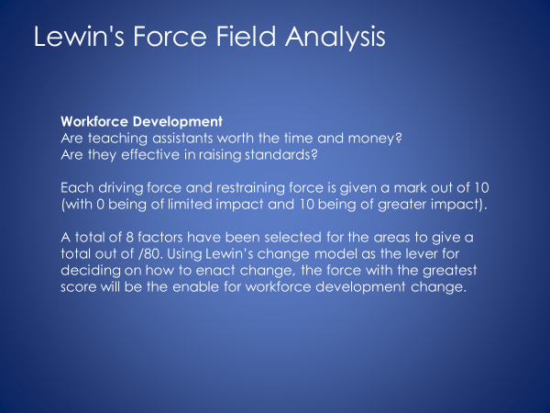
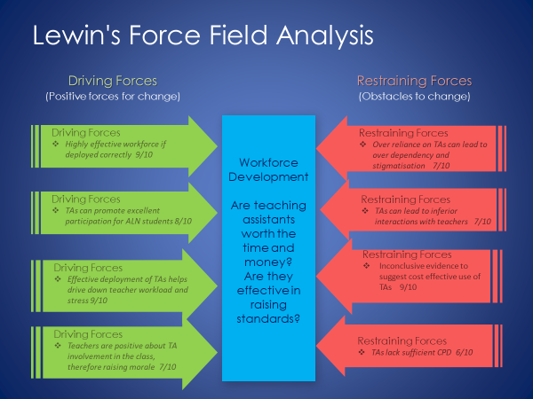
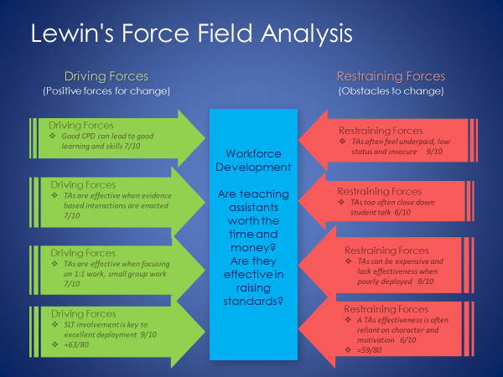

- Critical reflection and literature review
Recent research is now addressing a key but until now largely ignored feature of the classroom environment which has seen a profound increase in the number of TAs who represent approximately a quarter of the workforce across the UK (Webster et al, 2013). This means that schools now spend approximately 4.4 billion each year on TAs, corresponding to 13% of the budget in schools (Sharples, 2016). This is fundamentally as a result of 3 factors at play in education;
- Greater inclusivity in mainstream education for those with ALN and social, emotional and behavioural needs.
- A lack of teachers entering the profession.
- A plethora of Welsh Government, LA and school initiatives overburdening teaching staff. (Lee, 2002).
Research is finding that TAs are playing an increasingly significant role in meeting these needs; supporting teachers, pupils and more generally the school itself. This has not necessarily however reduced teachers’ workload as now teachers are responsible for managing additional adults in the classroom.
The purpose of my assignment is to critically reflect on a rationale for the implementation of workforce development through the use of Lewin’s Force Field Analysis as to whether;
Teaching assistants worth the time and money?
Are they effective in raising standards?

Restraining forces
The largest and most detailed study of TAs in schools to date is the Deployment and Impact of Support Staff (DISS) project, conducted between 2003 and 2008 in UK schools. Those who expected a glowing endorsement of the effective use of TAs in the classroom on pupils’ progress were surprised to find the opposite. In fact, the results showed that those receiving the most support from TAs made less progress than similar pupils who received little or no support, with the results being most stark for those with the highest level of ALN.
The restraining forces that I have highlighted are reflective of the findings that support the notion that TAs can be of significant use but only when deployed correctly. The 8 restraining factors I have highlighted above all reflect the limitations of effective TA use within schools today. Where a high score of 8, 9 or 10 has been used it represents a serious challenge to any demonstrable change being likely whilst a lower score of 3, 4 and 5 is of lesser impact and more easily rectified in my opinion due to effective school improvement planning.
Restraining forces 3, 5 and 7 all score highly in my Force Field analysis, worthy of 9/10;
- Inconclusive evidence to suggest cost effective use of TAs 9/10
- TAs often feel underpaid, low status and insecure 9/10
- TAs can be expensive and lack effectiveness when poorly deployed 9/10
The importance of the above 3 factors in limiting good use of TAs is well researched (Webster et al. 2013, Giangreco et al. 2014, Sharples et al. 2016). The fact that teaching assistants experience a variety employment challenges (low pay, low status/marginalisation, lack of job security, stressful working conditions) affecting their job satisfaction and resulting in problems for schools and students is a perennial issue particularly in Wales where schools are generally less well funded than in England. This can in turn lead to a high turnover of staff and lack of continuity for staff and students thus lessening the quality of provision. The fact that much research points to poor deployment of staff, high costs and at times poor morale for those in post leads to a high score. This is exacerbated by the fact that despite Welsh Government’s inclusivity drive with the ALN bill, it is unlikely that any more money will enter the system to fund many of the initiatives needed due to high costs, inflation and reduced budgets passed on to schools. In addition to this, current difficulties in securing the employment of support staff due to the pandemic is an added burden. According to new research, 71% of school employers are finding it hard to recruit permanent staff. This shortage of new blood is compounded by schools’ difficulties in holding onto their existing teachers. In 2020, a record one in 6 early career teachers left the teaching profession after serving just one year, while an estimated 40% of teachers leave after five years (Hays, 2022). Therefore, unless schools are provided with guidance as to the effective use of TAs, it will be hard to defend against claims that TAs are a waste of money.

- Over reliance on TAs can lead to over dependency and stigmatisation (‘Velcro’ effect) 7/10
- TAs can lead to inferior interactions with teachers 7/10
- TAs too often close down student talk 6/10
Studies have acknowledged that TAs can promote participation and learning for students with disabilities, but cautioned that their constant presence can limit students’ use of their own capabilities and may create unnecessary or unhealthy dependencies (Egilson, S. T., & Traustadottir, R. (2009). This can consequently lead to a ‘Separation effect’ where students who need high quality teacher interaction the most are cut off from this by the TA who becomes the primary educator and acts a barrier to peer interaction and everyday teacher to pupil interactions (Sharples, 2019). In an observational study highlighting differences between teacher-to-pupil and TA-to-pupil talk (Rubie-Davies et al., 2010), teachers were more likely to open up student talk, both linguistically and conceptually, as they were more focused, linked previously learned knowledge and had a more sophisticated knowledge of questioning and understanding. TAs on the other hand tended to close down student talk due to their perceived focus that their primary function was task completion and too often provide answers for students. To further compound the issue, it can be found that students with ALN receive more support from TAs therefore it is more likely that more negative effects on progress can be explained in terms of these lower quality interactions. (Webster et al., 2010, pp. 330–331).
The final restraining factors both score 6/10 according to my Force Field Analysis indicating that whilst they provide a barrier to effective use of TAs their limiting factors are not insurmountable.
- TAs lack sufficient CPD 6/10
- A TAs effectiveness is often reliant on character and motivation 6/10
Conditions of employment and effective recruitment are a key factor in determining a candidate’s suitability to work as a TA. Studies have shown that personal qualities are often seen as more important than qualifications and experience (Moyles and Suschitizky, 1997; Farrell et al., 1999). The aspects of personal qualities which are deemed particularly relevant include the ability to get on with others, teamwork, patience and a sense of humour. Whilst these characteristics remain essential to effective working, the elimination of poor candidates can be supported by a robust appointment process. In recruiting TAs, schools need to ensure that they have appropriate job descriptions which should include a clear statement of responsibilities, lines of management and outline of professional development opportunities (Lee, 2002). In doing so they will ensure that not only will they appoint the most suitable candidates for their character, but also for their motivation in fulfilling their role as an academic support in a nurturing and professional environment.
TAs are often expected to perform tasks beyond their skills and knowledge and continue to receive inadequate training (Giangreco & Broer, 2005; Suter and Giangreco, 2009). In order that TAs can feel confident in their ability to fulfil their role they need high quality, regular professional development provided by the ALNCO and other senior staff which focuses on the learning needs of their students and equips them with the skills necessary to flourish. This needs to be co-ordinated by the leadership team and involve outside agencies who are experts in their fields. If this forms part of the School Improvement Plan it is manageable and sustainable and can foster an environment of a school as a learning organisation.
Driving Forces
The above restraining forces have highlighted the difficulties that schools face in ensuring that TAs are cost effective and capable of raising standards. This section deals with the driving forces that harness the power of TAs and lead to effective deployment.
- SLT involvement is key to excellent deployment 9/10
- Effective deployment of TAs helps drive down teacher workload and stress 9/10
- Highly effective workforce if deployed correctly 9/10
The Education Endowment Foundation cannot stress highly enough the importance of senior leadership involvement in leading and managing change within a school (Sharples et al, 2016). They recommend the following improvement cycle;

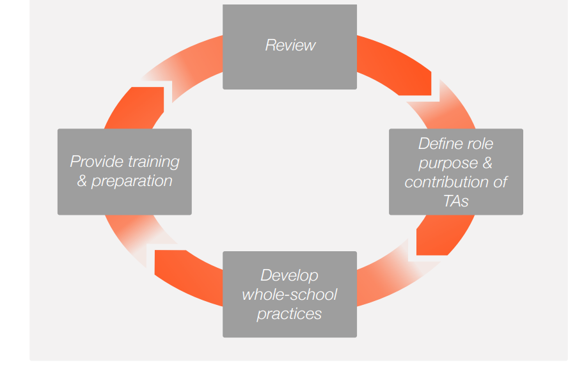
(Sharples et al, 2016)
The cycle involves the creation of a development team headed up by a senior leader (preferably the Headteacher) who would develop and communicate a clear vision for what the school needs from its TA workforce. It would involve an audit process and stress the collaborative nature of TAs with teaching staff, followed by a gradual process of testing ideas and experimentation via an annual review, feedback and target setting.
Many studies have reported the benefits to pupils and teachers of having TAs in their classroom and working throughout the school. OFSTED (2002) identify the main benefits as helping with managing behaviour, managing the class and improving the quality of teaching for all. Blatchford et al (2002) felt that TAs contributed in improving teaching effectiveness and children’s learning outcomes whilst at the same time reducing teachers’ workload.
- Teachers are positive about TA involvement in the class, therefore raising morale 7/10
The above paragraph supports the idea that TA involvement helps raise the morale of teaching staff in the classroom as an effective collaborative participation. This point of view is also supported by the DISS and project which was largely dismissive of TAs’ effectiveness but recognised that TAs can bring about workload reduction, thus raising morale. The EDTA project also highlights the positive impact of TAs in helping to maintain good morale and reduce stress in the classroom (Webster, 2013).
- TAs can promote excellent participation for ALN students 8/10
- Good CPD can lead to good learning and skills 7/10
- TAs are effective when evidence-based interactions are enacted 7/10
- TAs are effective when focusing on 1:1 work, small group work 7/10
In their guidance report on Making Best Use of Teaching Assistants, Sharples et al (2016) consider the final points in my interpretation of the importance of the driving forces on the effectiveness of TAs. They highlight that TAs should not be used as an informal teaching resource for low attaining pupils, rather that they use high quality one to one and small group work which can (according to the Nuffield Early Language Intervention (NELI)), allow pupils to make additional progress. The report goes on to recommend that interventions must be evidence based and structured in a consistent manner. Finally, these interventions must be planned and prepared as part of TA training which would address the short-term everyday planning, preparation and assessment (PPA) time. This should run alongside a longer-term Performance Management structure for support staff which would allow for effective professional development and career progression, essential for recruitment.
- Conclusion
I have shown that the effective use of TAs in schools is complex and challenging and that restraining forces have been a factor in limiting their successful implementation, at times acting as a brake in ensuring their success. Nevertheless, I believe that I have provided sufficient evidence through my research and force field analysis that if deployed correctly and supported professionally they are an incredibly important tool in not only raising standards but supporting teachers with their stress and workload. This is reflected in the Force Field Analysis scoring.
This evidence is not wholly conclusive however and more research needs to be done to provide long term empirical evidence that support my conclusion. Further to this, there still remains a need for new models of collaborative working that will support Welsh Government’s ‘inclusivity’ agenda and drive forward real improvements in ALN provision under the new bill. What is clear however is that when teachers and TAs collaborate effectively and work as a team, the effects are beneficial for teachers, pupils and teaching assistants (Lee, 2002) irrespective, in my opinion, of cost and added value.

- References:
Blatchford, P., Martin, C., Moriarity, V., Bassett, P. and Goldstein, H. (2002). Pupil Adult Ratio Differences and Educational Progress over Reception and Key Stage 1 ((DFES Research Brief 335). London; DFES.
Blatchford, P., Bassett, P., Brown, P., Martin, C., Russell, A. and Webster, R., 2009. Research brief: Deployment and impact of support staff project.
Boddison, A. and Curran, H. (2022), The experience of SENCOs in England during the COVID-19 pandemic: the amplification and exposure of pre-existing strengths and challenges and the prioritisation of mental health and wellbeing in schools. J Res Spec Educ Needs. https://doi.org/10.1111/1471-3802.12553
Cole M: Cross-Cultural and Historical Perspectives on the Developmental Consequences of Education. Human Development 2005; 48:195-216. doi: 10.
Curran, H., Mortimore, T. and Riddell, R. (2017), Special Educational Needs and Disabilities reforms 2014: SENCos’ perspectives of the first six months. British Journal of Special Education, 44: 46-64. https://doi.org/10.1111/1467-8578.12159
Donaldson G. Professor (2015, February), Successful Futures Independent Review of Curriculum and Assessment Arrangements in Wales. https://gov.wales/sites/default/files/publications/2018-03/successful-futures.pdf
Egilson, S. T., & Traustadottir, R. (2009). Assistance to pupils with physical disabilities in regular schools: Promoting inclusion or creating dependency? European Journal of Special Needs Education, 24, 21–36.
Farrell, P., Balshaw, M. and Polat, F. (1999). The management, Role and Training of Learning Support Assistants (DfEE Research Report 161). London: DfEE.
Giangreco M., Doyle M., Suter J., (2014) Teacher Assistants in Inclusive Classrooms, The Sage Handbook of Special Education (pp. 628-638), Volume 1, second edition Sage Publishers.
Hays Recruitment (2022). https://www.hays.co.uk/education-salary-guide
Lee B., (2002), Teaching assistants in schools: The current state of play, (National Foundation for Education Research), LGA Research Report 34 2002
Lewin K. (1951) 'Field Theory in Social Science', Harper and Row, New York.
Maslen R., Platts K.W. (1994) 'Force Field Analysis: A Technique to Help SMEs Realise their Intended Manufacturing Strategy', in Operations Strategy and Performance, 1st European Operations Management Association Conference, University of Cambridge, June, pp.587-588.
Moyles, J. and Suschitzky, W. (1997) ‘The employment and deployment of classroom support staff: head teachers’ perspectives’, Research in Education, 58(1), pp. 21–34. doi: 10.1177/003452379705800103.
Office for Standards in Education (2002). Teaching Assistants in Primary Schools; an Evaluation of the Quality and Impact of their work (HMI Report 434).
Oldham, J. and Radford, J., 2011. Secondary SENCo leadership: a universal or specialist role?. British Journal of Special Education, 38(3), pp.126-134.
Rubie-Davies, C., Blatchford, P., Webster, R., Koutsoubou, M., & Bassett, P., (2010) Enhancing learning? A comparison of teacher and teaching assistant interactions with pupils, School Effectiveness and School Improvement, 21:4, 429-449, DOI: 10.1080/09243453.2010.512800
Sharples, J., Blatchford, P. and Webster, R., 2016. Making best use of teaching assistants, Education Endowment Foundation. https://educationendowmentfoundation.org.uk/education-evidence/guidance-reports/teaching-assistants
Smith, M and Broomhead, KE (2019) Time, expertise and status: barriers faced by mainstream primary school SENCos in the pursuit of providing effective provision for children with SEND. Support for Learning, 34 (1). pp. 54-70. ISSN 0268-2141
Tuckman, B., (1965). "Developmental sequence in small groups". Psychological Bulletin. 63 (6): 384–99.
Webster R., Blatchford P., Russell A., (2013) Challenging and Changing how Schools use teaching assistants: findings from the Effective Deployment of Teaching Assistants Project, School Leadership and Management, 33:1, pp. 78-96, Routledge.
Webster, R., P. Blatchford, P. Bassett, P. Brown, C. Martin, and A. Russell. 2010. “Double Standards and First Principles: Framing Teaching Assistant Support for Pupils with Special Educational Needs.” European Journal of Special Needs Education 25 (4).
Welsh Government (2017) – Education in Wales: Our national mission https://gov.wales/sites/default/files/publications/2018-03/education-in-wales-our-national-mission.pdf
Welsh Government (2018) - Draft Additional Learning Needs Code for Wales December 2018 https://gov.wales/sites/default/files/consultations/2018-12/draft-additional-learning-needs-code-for-wales_0.pdf

- Appendix A – Force Field Analysis



