

CODE: BMSK4002
EFFECTIVE TEAM WORKING AND COMMUNICATION
STUDENT NAME: RICHARD OJI
STUDENT NUMBER: 2013435
LECTURER: DIYA GANGULY

TABLE OF CONTENTS
1.0 Introduction………………………………………………………………………………3
2.0 Models of Communication…………………………………………………………….3
2.1 Shannon and Weaver………………………………………………………………….,4-6
2.2 Schramm………………………………………………………………………………….7
2.3 Berlo……………………………………………………………………………………….8-10
3.0 Communication skills…………………………………………………………………10
3.1 Verbal communication…………………………………………………………………11
3.2 Non-Verbal………………………………………………………………………………..11
3.3 Listening………………………………………………………………………………….11
4.0 Poor Communication…………………………………………………………………11-13
5.0 Personal Example………………………………………………………………………..13
6.0 Sugesstion for improvement…………………………………………………………13-14
7.0 Conclusion………………………………………………………………………………….14
8.0 References…………………………………………………………………………… 15-16
9.0 Appendix………………………………………………………………………………17-18

INTRODUCTION

Communication is one of the worlds most important life tool, linking everyone together from all works of life, irrespective of barriers and different life approach.
It is the transmitting of information of different kinds through various measure from person to person and place to place (Editorial team, 2014).
Transmission of information has different models with simple measures accompanied with difficulties that could affect the massage and the complexity which arise from poor communication.
There are different ways of communication ranging from verbal, non-verbal, writing, the technical part which includes the thought, encoding and decoding which could be a one way or two-way process of ending a communication. However, we will be looking at the models of communication for better comprehension. (Steinberg, 1995)

- MODELS OF COMMUNICATION
2.1 Shannon and Weaver (1948)
2.2 Schramm (1954)
2.3 Berol (1960)
Communication models are the ways of understanding communication works better and breaking its complexity into a simpler methods and channels of communication (Businesstopia, 2019). There are different models of communication, however we will be focusing on the three above mentioned models.

2.1 Shannon and weaver (1948)
Shannon who was an American electronic engineer and mathematician in 1948 with the assistance of Weaver who was an American scientist at the time, came together and developed a mathematical theory of communication known as “Shannon and Weaver Model of Communication”. (Shannon and Weaver, 1998)
The model was a way of conveying messages from the sender to the receiver and also factoring in the affecting aspect of the communication process which is referred to as “noise” as shown in the model diagram below (Communication Theory, 2014).
As shown in the diagram below, the model involves the major elements of communication which include the source of information, the transmitting infrastructure, channel of communication reception and destination of the message.
What majorly makes it different from other models is the fact that it has factored the noise element in communication.
The Shannon-Weaver Mathematical Model of Communication 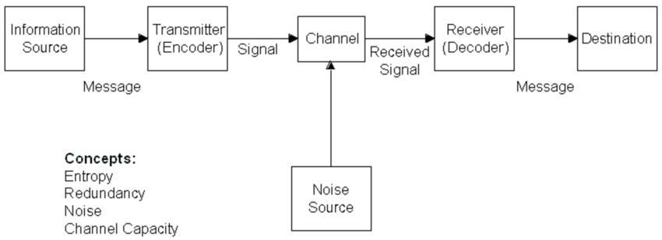

(unknown, 2021)
The above concept could be given a brief summary of the concept.
Sender (information source) This is the originator of the message and sender.
Encoder (transmitter) This transmits the message into signals. E.g., using the telephone, the voice is converted into wave signals and is transmits via cables.
Channel – The medium through which messages are sent.
Receiver (decoder) The mechanism that convert signals into message.
Receiver (destination) The person who gets the message and the place where the must get to.
Noise – This is the physical disturbance. e.g., environment, horn sounds, crowd noise which can distract the channel through the transmission process that affect the communication flow. (Shannon and Weaver, 1998).
Noise in communication can be devastating as it influences on effective communication, distortion of our communication proficiency (Vasilescu, 2006a).
Other forms of communication are physical, physiological, psychological and semantic noise.
In this model of communication, we will be using MARIA and PEDRO as a practical example of the case study for Shannon – Weaver Model of Communication.
Sender ---------------- Maria
Encoder --------------Telephone network
Channel--------------- Mobile network
Receiver (decoder) ----------- Phone / Mobile phone
Receiver (destination) ---------- Pedro
Noise ------------------------- Missing information due to Disruption
In the case study of (MARIA and PEDRO), PEDRO misunderstood MARIA due to the disruption in communication noise which influenced the interpretation of their conversation due to the physical environment (BUILDING SITE).
Shannon – Weaver Model of Communication explained this confusion in communication through its model by illustrating the impact of NOISE distraction, which affects the communication between the sender and receiver (MARIA – PEDRO) as the massage is transferred through the channel, which may be affected by physical noise and the receiver not receiving the correct message.
This could have been prevented by overcoming the noise barrier. It could be eliminated by MARIA calling PEDRO after work, sending a text message, or requesting for a call back when appropriate. PEDRO should have eliminated the physical environmental noise in his building site, by excessing himself to a quitter place for better comprehension and applying active listening which most time could be difficult while at work on a building site.
This could have been avoided if there was a feedback, which is Schramm’s model of communications dynamic important for a communication to be complete.

2.2 Schramm Model of Communication (1954)
This model could be described as a circular model, showing a two-way communication process.
Schramm believes communication is circular, measures equal, reciprocal, needs interpretation and consist of the following: Encoding, Decoding and Interpreting a message.
(chris. drew.98031506, 2019)
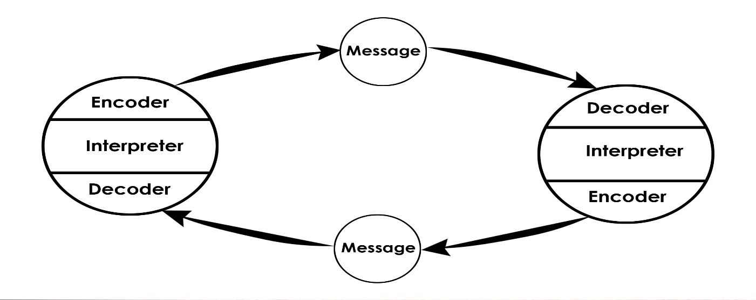 (Communication Theory, 2014b)
Encoder---------------- Sender ----we need to be clear and precise of messages we send.
Decoder----------------Receiver------we need to decode messages meaningfully for better understanding.
Interpreter-------------Understanding, perceiving or interpreting messages received for good comprehension as people understanding may differ.
Schramm model allows communication ability to encode, decode and interpret which allows equal communication model in a face-to-face conversation and information flow among individuals (Schramm, 1997).
2.3 Berol Model of Communication
Berol’s (1960) communication model focused on four main components (S M C R) which are Source, Message, Channel, Receiver, like Shannon-weaver model (Carney and Lymer, 2015)
This model defines different aspects affecting individual component of the communication model making it more effective.  (businesstopia, 2018a)
SOURCE: This is the sender of the message to the receiver (Encoder)
Communication Skills: individual communication skills, reading, speaking, writing, etc.
Attitudes: This is the attitude towards self, others, subject, environment which affects the message.
Knowledge: this facilitates and communicates the message better and effectively.
Social System: Social factors and beliefs could hinder communication method of a message.
Culture: Cultural beliefs communicates message differently as acceptance varies.
MESSAGE: This is the subject matter of thought sent by the sender.
Content: This is the entire body of the message A-Z
Elements: It involves all the component in the message. E.g., signs, body language, etc.
Treatment: This is the mannerism the message is conveyed which could affect feedback.
Structure: This is the arrangement of the message which could affect the message effectiveness.
Code: This is the way the message is sent, and it form. E.g., video, text, etc.
CHANNEL: This is the means of transmitting message which involves the five sense organs where communication flows which could affects communication channel.
They are.
Hearing-------Hearing with our Ears
Seeing--------This is visual communication channel.
Touching----Using touch as a channel of communication. E.g., hugging, holding hands, etc.
Smelling-----Using smell as a communication channel. E.g., fragrance, etc.
Tasting-------Using tongue for taste as a communication channel. E.g., food tasting, eating, etc.
RECIEVER: The person who receives the message from the Source and replies the Sender effectively. (Decoder).
For effective communication, the Sender and the receiver should have the same level of understanding (Dwyer, 2012)
We will be using BERLO Model of Communication to illustrate areal life example of this Case Study of: THE PROFESSOR and THE VILLAGE PEOPLE.
Berol’s Model of communication is a perfect illustration of the reason the villagers did not help the professor.
Q: Why didn’t the village people help the Professor?
The professor’s communication skills are way above the level of the villagers, and he refused to communicate to them on their level of understanding knowing their level of education.
Q: What should he have done to get them to help him?
The professor should have communicated with the villager on their level of understanding, clearly and precise as he did the next day, after his house was destroyed by fire.
Q: Whose model of communication do you think can explain this situation and Why?
Berol’s model of communication explains this situation perfectly as the Source/Sender (The Professor) did not consider the factors under each elements of the Model.

- Communication Skills
Communication skills could be described as the receiving and distribution of information individually and within organization which could be spoken, written, body language.
(Worth, 2004).
There are different forms of communication:
  - Verbal communication: Verbal communication are spoken, oral, written or types of information with verity of people.
  - Non-Verbal communication: Non-verbal communications are unspoken words of information with verity of people. E.g., body language, gestures, facial expression, posture, signs, signals, tone and pitch of voice, eye contact.
  - Listening: This is one of the most important form of communication skill, where information is received and interpreted effectively.
Active Listening: This form of listening requires paying attention without any distraction. For example, when a message is passed on, the ability to listen effectively and attentively is required for comprehension and better communication with various people to avoid misunderstanding and breakdown in communication flow, rather than assuming.
Empathetic Listening: This form of communication, demands the listener to put themselves in the speaker shoes, showing empathy in their thought and feelings concentrating attentively.

- Poor Communication in Workplace:
Communication as we all know is plays a vital role in life generally and the key success of many organisations.
Poor Communication could be very devastating, dangerous with tremendous effect in an organization or life in general (Krause, 2019).

Ineffective communication can be frustrating in workplace and among workmates as it breeds distrust and confusion. Poor communication among workers and management could lead to nonchalant attitude and disloyalty to the organization.
The following factors are the causes:
Communication: Poor communication skills could cause misunderstanding among colleagues if it is not clear and delivered correctly and professionally.
Too much information: Information’s are passed on so quick and fast during meetings without allowing feedback may leads to mistake most time, as most people do not understand and are afraid of being told off.
Lack of Clear Objectives: Objectives and expectations are to be made clear and communicated to staffs. Goals and objectives could easily monitor and improved on among staffs.
Leadership: leaders should have mutual professional relationship with workers for possible clarification when necessary.
Fear of punishment: Worker may hold back vital information’s from the management because of fear of the outcome due to bulling.
Misinterpretation of Vital information: Vital information’s are delayed most time due to misinterpretation of vital information due to poor management error, language barrier, accent, work pressure.
Shift Handover: Most health care staffs are over stretched due to too much workload and cannot wait to leave their duty post. They lack the extra time needed for proper handover.
Language Barrier: Multicultural differences in workplace such as language, is a major factor of poor communication in workplace as most people are no fluent or has little understanding and need to be supported.
Conflict among practitioners: Health care environment and hospitals has tendency of heated situations and gossip. (Krause, 2019).

- Personal example:
While working in a hospital, there was an incident where Romanian lady was admitted.
Unfortunately, she understood no word in English language.
She was trying to communicate with the Nurse in order to express her difficulties, but none of the Nurse understood her language and could not communicate with the lady due to language barrier.
The nurses tried everything they could in order to help her but to no avail.
The lady’s frustration grew, and she became aggressive which affected her condition her condition, pain, anxiety, blood pressure, which led to her having a cardiac arrest and was transferred to intensive care unit induced, while waiting for a Romania Nurse who could help with the translation.

- Suggestions for Improvement:
Communication in workplace is a vital necessity in a workplace and needs to be reinforced and promoted among staffs.
These are some steps that could improve communication among employees and management.
Open -door policy: Management should implement an open-door policy to encourage flexibility, transparency and cordial relationship among staffs to eliminate fear.
It will eliminate confusion, delays and enhance productivity.
Accessibility of Necessary Equipment’s / Accessories: Vital resources needed for day-to-day running of the business should be made accessible for better productivity to eliminating delay in productivity, reducing frustration.
Training: All staff should be trained through various sector, introducing a standardized policy to be followed by all as a norm.
Goals: Clear goals and measures must be made clear to all staff, what is expected of them and how they could support the company (Eisenhauer, 2020)

- Conclusion: Communication is the world’s engine room which must be encouraged through all platforms for a better tomorrow.

7.0 REFERENCE
Carney, W.W. and Lymer, L.-A. (2015). Fundamentals of Public Relations and Marketing Communications in Canada. [online] Google Books. University of Alberta. Available at: https://www.google.co.uk/books/edition/Fundamentals_of_Public_Relations_and_Mar/lyrqCQAAQBAJ?hl=en&gbpv=1&dq=berlo%27s+model+of+communication&pg=PA91&printsec=frontcover [Accessed 30 Apr. 2021].
chris.drew.98031506 (2019a). 4 Key Principles | Osgood-Schramm Model of Communication (2020). [online] Helpful Professor. Available at: https://helpfulprofessor.com/osgood-schramm/ [Accessed 29 Apr. 2021].
Communication Theory (2014a). Shannon and Weaver Model of Communication. [online] Communication Theory. Available at: https://www.communicationtheory.org/shannon-and-weaver-model-of-communication/ [Accessed 28 Apr. 2021].
Dwyer, J. (2012). Communication for Business and the Professions: Strategie s and Skills. [online] Google Books. Pearson Higher Education AU. Available at: https://www.google.co.uk/books/edition/Communication_for_Business_and_the_Profe/xhHiBAAAQBAJ?hl=en&gbpv=1&dq=berlo%27s+model+of+communication&pg=PA11&printsec=frontcover [Accessed 30 Apr. 2021].
Eisenhauer, T. (2020). 41 Smart Tips to Improve Communication in the Workplace. [online] Axero Solutions. Available at: https://axerosolutions.com/blog/41-smart-tips-to-improve-communication-in-the-workplace [Accessed 30 Apr. 2021].
Schramm, W. (1997). The Beginnings of Communication Study in America: A Personal Memoir. [online] Google Books. SAGE. Available at: https://www.google.co.uk/books/edition/The_Beginnings_of_Communication_Study_in/JZrVZaF4h9gC?hl=en&gbpv=1&dq=schramm+model+of+communication&printsec=frontcover [Accessed 29 Apr. 2021].
Vasilescu, G. (2006). Electronic Noise and Interfering Signals: Principles and Applications. [online] Google Books. Springer Science & Business Media. Available at: https://www.google.co.uk/books/edition/Electronic_Noise_and_Interfering_Signals/uQlEr5iWOdUC?hl=en&gbpv=1&dq=noise+in+communication&printsec=frontcover [Accessed 28 Apr. 2021].

THE PROFESSOR and THE VILLAGE PEOPLE
Lloyd b. 7/19

A Professor of English at a well-known Welsh University lived in a large house not far from a little village. He never went into the village, bur shopped in the town near the University because he had nothing in common with the village people, who were largely uneducated and did manual jobs.
One night, the professor fell asleep while smoking his pipe and the pipe fell onto the carpet and started a fire.
When the professor awoke and saw the house on fire, he rushed into the village, screaming:
‘The edifice is being consumed by a great conflagration!’
‘The edifice is being consumed by a great conflagration!’
The village people looked at him and continued doing what they were doing
‘Don’t you understand?’ He said. ‘‘The edifice is being consumed by a great conflagration!’
They ignored him.
When the Professor returned home, he saw that his house had been completely destroyed. He sat down on the ground and wept.
The next day, he went into the village crying. ‘Why, oh why didn’t you help me? My home has been destroyed by the fire. I came and begged you last night.’ He wept.
‘But Professor, why didn’t you say that your house was on fire? We would have helped.’

Q: Why didn’t the village people help the Professor?
Q: What should he have done to get them to help him?
Q: Whose model of communication do you think can explain this situation?
Q: Why?

MARIA and PEDRO

Pedro works on a building site and Maria is his wife.
One day Maria phoned Pedro.
‘Hello, Pedro, when you’re coming home, see if you can get me a chicken.’
‘Okay,’ replied Pedro.
When he got home, Pedro took off his boots and coat and went into the kitchen.
‘Maria, where are you?’ He said.
‘Here – in the sitting room,’ she said.
When Pedro went into the sitting room, Maria said, ‘Where is the chicken?’
‘What Chicken?’ Asked Pedro.
The one I asked you to get on your way home.’
Oh, no! I thought you said when I come home I will see you in the kitchen!

Q: Why do you think Pedro misunderstood Maria?
Q: Whose Model of Communication explains this confusion and why?
Q: How could this have been prevented?
Q: Whose Model of Communication explains how it could have been avoided?

