Seven paradigms at a glance
Table 1. The essential elements of each paradigm, summarised from the super table (2026 edition)
Element |   A Positivism | 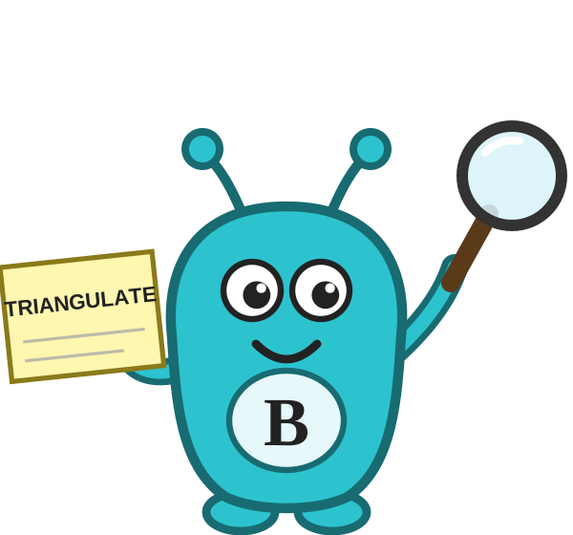  B Post-positivism |   C Interpretivism | 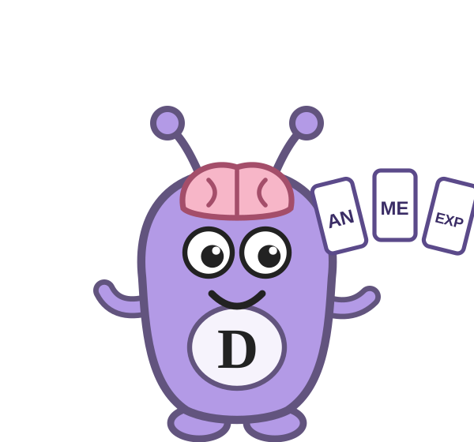  D Constructivism | 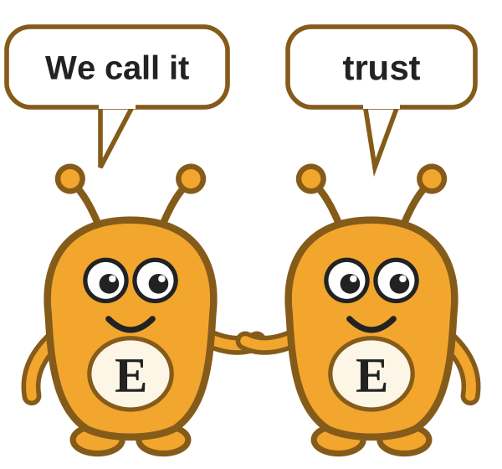  E Social constructionism | 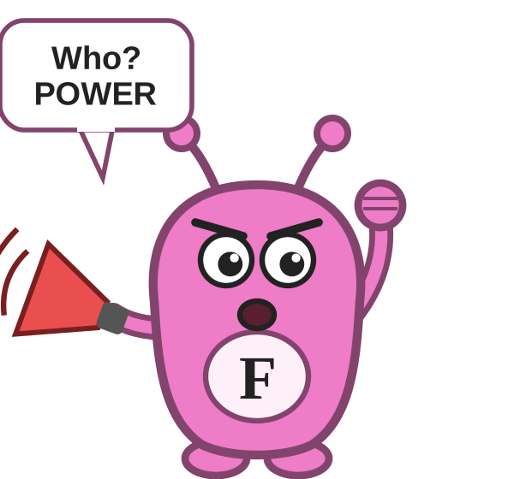  F Critical theory | 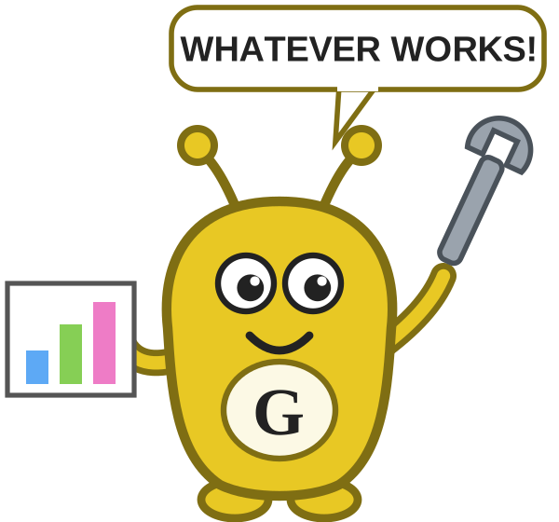  G Pragmatism
Ontology  (what is real?) | One objective reality exists independently of us and can be measured. | One objective reality exists but can only ever be known imperfectly. | Reality is subjective and multiple; each person experiences it differently. | Reality is co-constructed between people through interaction and dialogue. | Groups construct shared realities through language, practice and agreement. | Reality is shaped by power, history and material conditions. | What is real is what has practical consequences and can be acted upon.
Epistemology  (how do we know?) | Knowledge is objective and verified by testing hypotheses. The researcher stays independent of what is studied. | Knowledge is probable, never certain. Triangulation increases confidence. | Knowledge comes from understanding individual meanings and interpretations. | Knowledge is co-created by researcher and participants. The knower and the known are inseparable. | Knowledge is produced and maintained by groups and varies across groups and contexts. | Knowledge is shaped by power. Research exposes whose interests it serves. | Knowledge is what proves reliable for resolving the problem in hand (warranted assertibility).
Axiology  (role of values) | Value-free. Researcher values must be removed. | Values are acknowledged, stated and controlled. | Values are integral and examined reflexively. | Values are negotiated openly within the research relationship. | You reflect on how group membership shapes values, including your own. | Explicitly committed to social justice and change. | Values matter where they affect the problem, trust and action.
Typical methodologies | Experiments, surveys, randomised and quasi-experimental designs. | Quasi-experiments, correlational designs, mixed methods with triangulation. | Phenomenology (including IPA), narrative inquiry, interpretive case study, interpretive ethnography. | Constructivist grounded theory, co-operative inquiry, participatory designs. | Comparative case studies, discourse analysis, comparative ethnography. | Critical ethnography, participatory action research, critical discourse analysis. | Mixed methods, action research, pragmatic case study.
Reasoning | Deductive: theory to data. | Deductive, with theory refined by evidence. | Predominantly inductive; often abductive in practice through the hermeneutic circle. | Inductive, through shared interpretation. | Inductive and abductive, moving between group data and theory. | Abductive: back and forth between critical theory and data. | Abductive: back and forth between data and theory to find the most useful explanation.
Data collection and analysis | Standardised instruments; statistical testing such as regression and ANOVA. | Surveys with open questions and structured interviews; statistical plus qualitative analysis. | In-depth semi-structured interviews; reflexive thematic analysis or IPA. | Dialogic interviews and focus groups; collaborative analysis with participants. | Interviews and focus groups across groups; comparative analysis of how each group constructs the phenomenon. | Critical interviews, document and policy analysis; analysis of power, voice and ideology. | Whatever fits the problem; integrated analysis of what works, for whom and why.
Quality criteria | Validity, reliability, objectivity and generalisability. | Credible conclusions with caveats, triangulation and transparency about limitations. | Trustworthiness: credibility, transferability, dependability and confirmability (Lincoln and Guba, 1985). | Authenticity: fairness plus ontological, educative, catalytic and tactical authenticity (Guba and Lincoln, 1989). | Crystallisation rather than triangulation; variation within and across groups documented. | Catalytic, democratic and dialogic validity; critical reflexivity. | Consequential validity: does it work and is it useful and feasible?
Your stance and voice | Detached observer writing in the third person. | Engaged but boundaried; mostly third person. | Empathetic interpreter; first person welcomed. | Co-inquirer with participants; a shared we voice. | Reflexive interpreter of several group realities; comparative voice. | Activist scholar standing with marginalised groups. | Problem-solving partner working with stakeholders.
Typical business question | To what extent does board diversity predict financial performance in FTSE 100 companies? | How do small business owners understand and respond to digital banking adoption? | How do first-time founders make sense of closing their business? | How do new managers construct their understanding of leadership in their first year? | How is performance constructed differently by clinical and managerial communities in NHS trusts? | How do promotion patterns in financial services perpetuate structural inequality? | What would have helped problem gamblers exit gambling, and how effective do gamblers find responsible gambling tools?
Key to reasoning. Deductive moves from theory to data. Inductive moves from data to theory. Abductive starts from something surprising in the data and moves back and forth between data and theory to find the best explanation, a form of reasoning first described by Charles Sanders Peirce. Most qualitative doctoral studies are abductive to some degree.
References: Guba, E.G. and Lincoln, Y.S., 1989. Fourth generation evaluation. Newbury Park, CA: Sage. Lincoln, Y.S. and Guba, E.G., 1985. Naturalistic inquiry. Beverly Hills, CA: Sage.

