

Andrew Campbell

School of Applied Computing
Ordnance, Munitions and Explosives

Advanced Physics for OME
Academic Year: 2025-2026

Supervisor: Kelvin Donne
May 2026

Design of Shaped Charges

Contents
Figures 3
Tables 4
1. Abstract 5
2. Introduction 5
3. Shaped Charges 5
4. 2d Simulation 6
4.3. 2d With Foam model 10
4.4. 2d Without Foam Model 17
4.5. 2d Comparison 21
5. 3d Model 22
5.1. Design 22
5.2. Results 23
6. Conclusion 28
Bibliography 29

Figures
Figure 1: Assembly of model showing the foam, HE and, liner. 6
Figure 2: HE mesh 7
Figure 3: Foam mesh 7
Figure 4: Liner mesh 8
Figure 5: Final step of the first run showing the Liner and HE 10
Figure 6: Jet formation of the axisymmetric with Foam with the Liner highlighted showing initial Jet formation. 11
Figure 7: The 2d Linear assembly with Foam also showing the mesh. 11
Figure 8: 2d Linear with Foam test 12
Figure 9:2d Linear with Foam test 12
Figure 10: 2d Linear with Foam test 13
Figure 11:2d Linear with Foam test 13
Figure 12: 2d Linear with Foam test 14
Figure 13: 2d with Foam without Mesh 15
Figure 14: 2d with Foam without Mesh 15
Figure 15: 2d with Foam without Mesh 16
Figure 16: 2d without Foam without mesh 17
Figure 17: 2d without Foam without mesh 17
Figure 18: 2d without Foam without mesh 18
Figure 19: 2d without Foam without mesh 18
Figure 20: 2d without Foam without mesh 19
Figure 21: 2d without Foam without mesh 19
Figure 22: 3d Mesh 21
Figure 23: Cut of 3D model 22
Figure 24: Cut of 3D model 23
Figure 25: Cut of 3D model 23
Figure 26: Cut of 3D model 24
Figure 27: Cut of 3D model 24
Figure 28: 3D Liner Cut 25
Figure 29: 3D Liner Cut 25
Figure 30: 3D Liner Cut 26
Figure 31: 3D Liner Cut 26

Tables
Table 1: Johnson-Cook parameters for the foam and liner [1] [2]. 10
Table 2: JWL Material properties for PE 4 [3] [4] 10
Table 3: 2d Linear with Foam Jet Velocity 21
Table 4: 2d Linear without Foam Jet Velocity 21
Table 5: Velocity of the jet at points along the Charge 28

Abstract
This paper investigates the design of a linear shaped charge utilising foam in its construction to see how much use of foam in front of the liner effects the formation of an explosive jet. Abaqus CAE was used to simulate two designs that were tested in 2D and found that the foam does affect the velocity of the jet but not its formation. The design without foam in front of it was taken forward to 3D and simulated to get a more full understanding about its formation. It was found that the peak velocity remains the same but, it takes longer for the jet to reach that velocity.

Introduction

Shaped Charges are a design of warhead that utilise the Monroe effect to most commonly create an explosively formed jet normally used for penetrating a target (other shaped charges include Explosively Formed Projectiles, EFPs). These are most famously used in High Explosive Anti-Tank (HEAT) warheads. There had been steady development in the design of Shaped charges since they were first deployed militarily during the Second World War with them now being used both commercially as well as in Armed forces. One development is the linear shaped charge. This is where instead of a cone shaped liner with explosives packed behind it the liner is long piece with a bend in the middle to allow the focusing.
For the investigation into shaped charges the author wished to investigate linear shaped charges as they are a new developing area of the field with a broad general application. In particular, the use of foam in the construction of the shaped charge and what effect it may or may not have upon jet formation. A design would be created in Abaqus finite Elements Analysis and simulated in 2d keeping the same parameters aside from the addition of foam in front of the liner in one and the absence of the aforementioned in the other. One design would then be taken for further 3d analysis for further examination within Abaqus and an exploration into shockwave propagation throughout a linear charge.

Shaped Charges
Shaped Charges are an explosive device that utilise the Monroe effect to focus the blast energy of an explosive by causing a hollow or a void being cut into it [1]. The phenomenon was first noted by American chemist Charles E. Monroe in 1888, after whom it is named, when he observed that blocks of guncotton that had the manufacturers name embossed would leave an imprint of the name upon their target [2].
During World War I they would be experimented on with the Germans improving on the concept with the adding of a liner to the cavity as well as a stand off from the target to aid in the focusing of the blast [3]. It would be in 1938 that Swiss engineers perfected the principle, and its use was demonstrated in demolitions. With militaries around the world taking not it saw widespread adoption in anti-tank weapons in WW2.
The first dedicated anti-tank weapons that adopted it were rifle grenades employed by the British but by 1943 shaped charge warheads saw widespread use in DUKE (Dominion, United Kingdom and Empire), American and German forces with all three developing and mass deploying man portable infantry anti-tank weapons that were able to defeat armour. Something the pre-war anti-tank rifles were no longer capable of doing. These weapons all featured a fin stabilised projectile capable of penetrating at least 100mm of rolled homogenous armour [2]. One of the reasons for this was that if fired from a traditional rifled barrel the centrifugal forces imparted by the spin of the barrel would inhibit jet formation and cause the liner to splatter over the target.
In conjunction with this, shaped charges were used throughout the war in demolition and sabotage as well [4]. One notable design out of this is the Linear or cutting charge. This is a charge that acts longitudinal along a plane of symmetry with the liner and explosive creating a peaked roof shape. These charges are designed to cut through a large obstacle, such as a steel beam rather than penetrate the armour of a vehicle. As such they have both civilian and military purpose in demolitions.
Linear charges are a developing field with increasing use particularly in the civilian market and this paper will therefore investigate one such design and how its choices effect its performance.

2d Simulation
  - Reasoning for the Design
The basis for the design to be simulated was the Sabrex produced by Chemring UK [4]. This is a flexible design for a demolition cutting charge utilising a linear shaped charge to achieve its goal. The author had previously been able see one demonstrated and had indeed helped set the charge on a range trip to Findhu Glen range. This was where they had first been appraised of such shaped charges and was appreciative of their potential.
The design utilises foam around the explosive and the liner to facilitate ease of use by creating a built-in standoff, thus precluding the operator from having to set that themselves. The charge in addition is able to be cut into smaller lengths as it comes coiled in a 4m length as well as being able to be bent and shaped allowing for it to be bent round items such as steel beams to ensure that they are truly cut.
As this is a versatile, modern commercial product the author used this as the basis for their design in Abaqus with the aim to compare the effect of the foam used in the standoff upon the formation of the jet.

  - Design
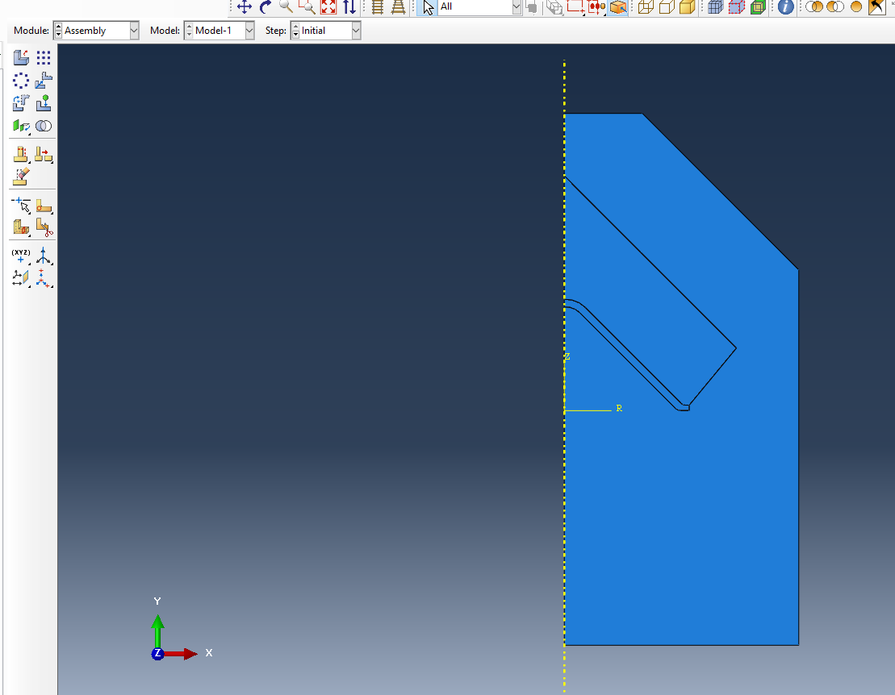
The model created was based visually off the Sabrex design and created from three parts: the foam, the High Explosive (HE), and the liner. These were sketched out and a mesh created that ultimately comprised of 13,010 elements. This was for the model that had foam in front of the liner to create the in-built standoff.
Figure 1: Assembly of model showing the foam, HE and, liner.
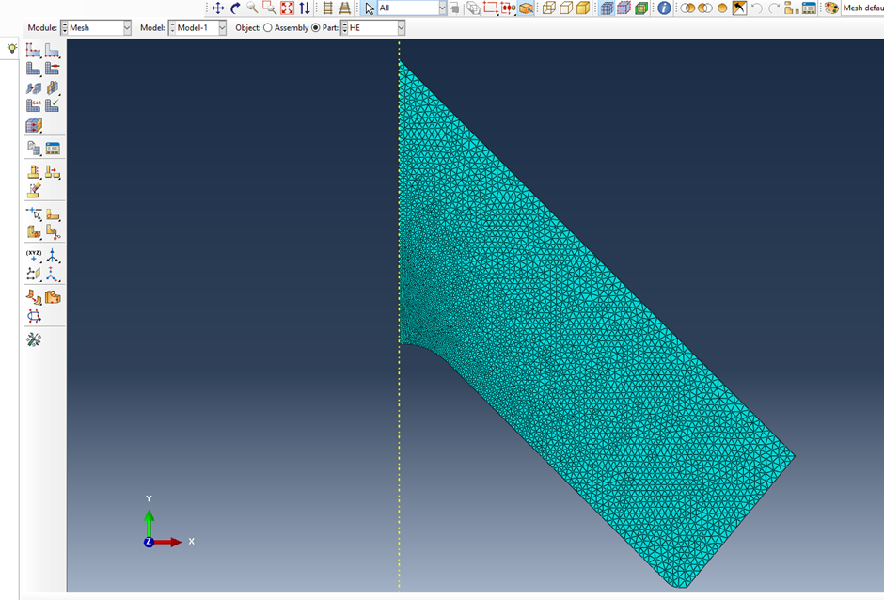
Figure 2: HE mesh
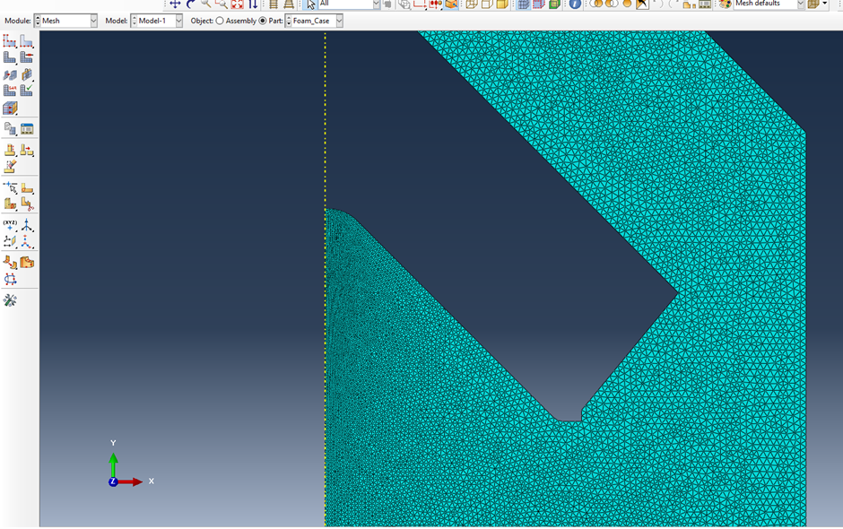
Figure 3: Foam mesh
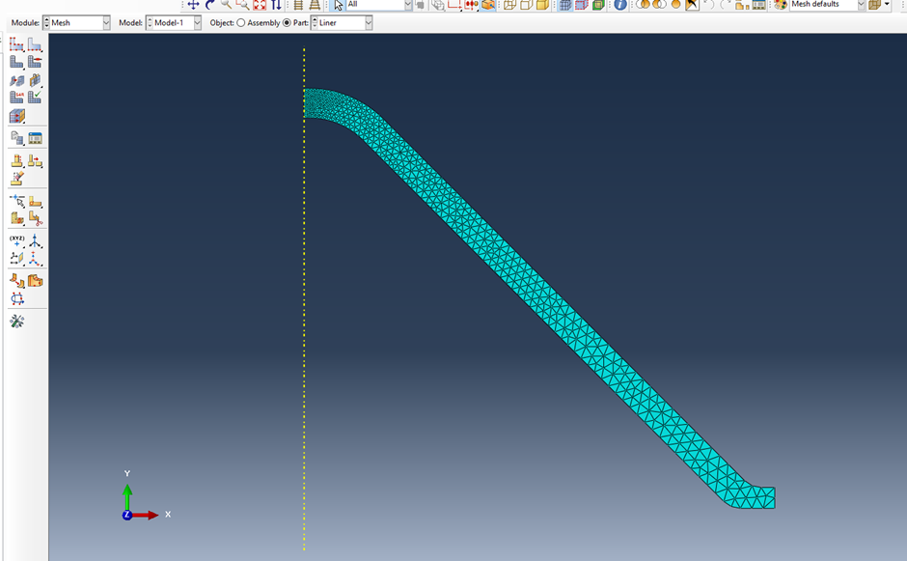
Figure 4: Liner mesh
As shown in Figures 2 – 4 local refinements of the mesh were used to ensure that the greatest density of nodes would be found at the point of the jet and the coarsest areas were those of the foam furthest away from the liner and were thus expected to have a limited interaction with the liner and explosive.
The materials used for each parts were: AISI 1006 steel for the liner, syntactic foam for the foam and, PE4 for the HE. PE4 is a standard British made high explosive with an RDX based similar to that used in the Sabrex design and to that used in industry and would provide a representative common explosive. The steel used in the liner is a mild steel that has been used in shaped charge liners before and would still be mouldable like the more common copper. There has been a trend in recent years to looking at alternatives to copper for explosive liners partly due to the cost of the material and mild steel is one of the most common alternatives. Finally, the syntactic foam. This is not a perfect representation of the sort of foam used in the Sabrex. Indeed, it does not have the flexibility and is more commonly used in maritime buoys and car crash structures thanks to its relative rigidity compared to other foams. However, no appropriate data for Johnson-Cook plasticity values could be found for a closer foam. This foam does have the compressibility but will likely offer more resistance than a polyvinyl chloride-based foam.
As noted, a Johnson-Cook plastic model was used in the model to simulate the behaviour of the materials.

Materials | A [MPa] | B [MPa] | n | m | C | έ₀ [1/s] | Ρ [kgm⁻³] | E [GPa] | v
Syntactic Foam | 15 | 0.01 | 0.0001 |  | 0.105 | 3500 | 300 | 1.65 | 0.27
AISI 1006 Steel | 350 | 275 | 0.36 | 1 | 0.022 | 1 | 7872 | 210 | 0.2
Table 1: Johnson-Cook parameters for the foam and liner [1] [2].

The Jones-Wilkins-Lee equation of state was used to model the behaviour of the explosive.
Material | ρ [kgm⁻³] | Velocity of Detonation [ms⁻¹] | A [GPa] | B [GPa] | R1 | R2 | Pre-detonation bulk modulus [GPa] | Detonation Energy Density [MJkg⁻¹]
PE 4 | 1601 | 8193 | 609.8 | 12.95 | 4.5 | 1.4 | 1.1 | 5.621
Table 2: JWL Material properties for PE 4 [3] [4]

2d With Foam model
This model was initially created as an axisymmetric model for the initial run as was common among the author’s peers however, this would be changed to linear for the final run and results but not without significant rouble shooting along the way. A general contact explicit for the interaction. The simulation was set to run for 50μs with the step interval left at the default for the beginning.

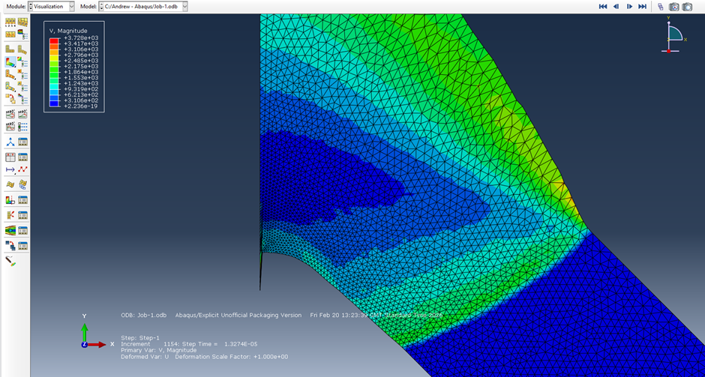
Figure 5: Final step of the first run showing the Liner and HE

This simulation did not manage to progress far before it stopped due to excessive distortion in the model. Namely at the point where the HE interacted with the peak of the liner. This was unexpected as the problems that were expected were to do with the interaction between the liner and the foam as this was expected to be extremely taxing on the modelling capabilities of Abaqus. To resolve this issue a surface-to-surface contact was created between the Liner and the HE and the model was run again. The model was able to progress another step further before it again halted. This time though, it was the expected problem of the Liner interacting with the Foam.
This took some time to correct to allow the model to run far enough to gain results with a clear jet formation and compression and deformation of the foam. To achieve this first a surface contact was created between the Foam and the Liner which gave limited additional progress. The next step was adding artificial viscosity to the foam to aid in its movement to avoid nodes of it getting entangled in the nodes of the Liner. Finally, element deletion on Foam nodes were added to allow in particular the nodes in the path of the point of the jet to avoid becoming entangled.
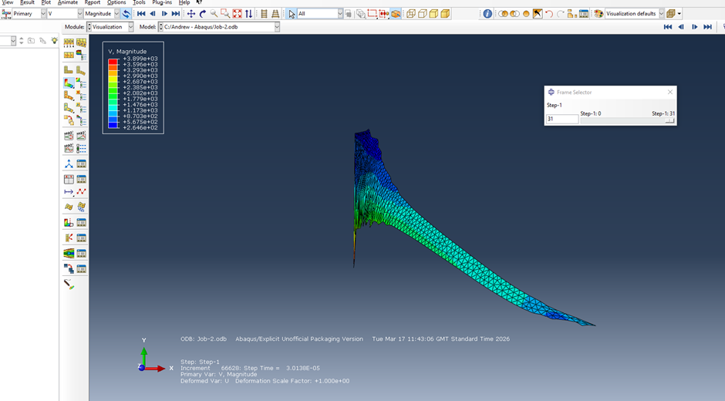
Figure 6: Jet formation of the axisymmetric with Foam with the Liner highlighted showing initial Jet formation.
This was a promising initial run, but this was currently modelling a cylindrical charge and not a linear one. Therefore, the model was changed to a linear one but, with the parameters added to aid in the running of the model added. Additionally, the model had to be mirrored about the x axis to create a 2d planar cut of the linear charge. This resulted in a mesh with 30,498 elements.
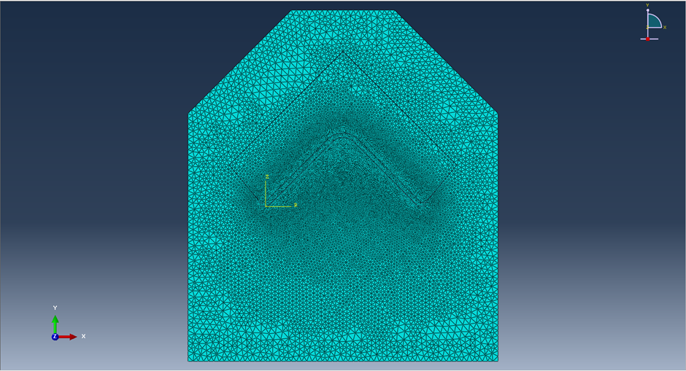
Figure 7: The 2d Linear assembly with Foam also showing the mesh.
There were, however, once again problems with the new model with the Foam becoming excessively distorted. This was not at the point of the jet but further out as well as where the explosive shockwave went upwards into the Foam where excessive distortion caused by the compression of the Foam ended the simulation. This problem was changed by the simple fix of changing the length of the simulation to 80μs and increasing the time steps from 100 to 100,000. This would normally be excessive but by massively increasing the number of steps it increases the granularity of the calculations helping delay the point at which excessive deformation occurred and allowing for significant jet formation to occur. Indeed, the main problem caused by this was the extremely large file it created.
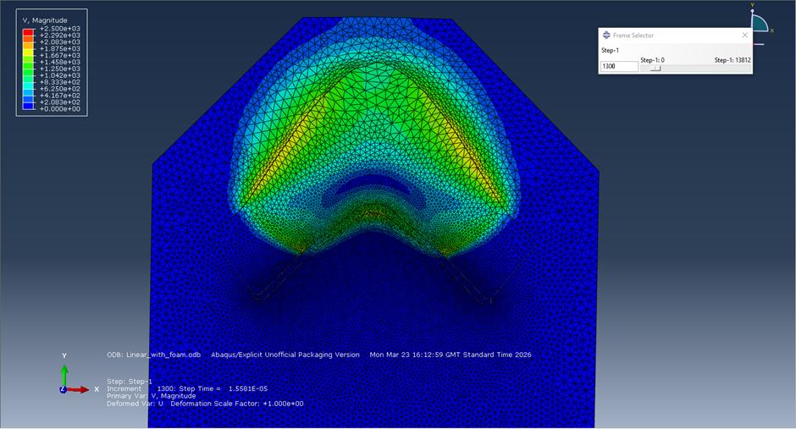
Figure 8: 2d Linear with Foam test
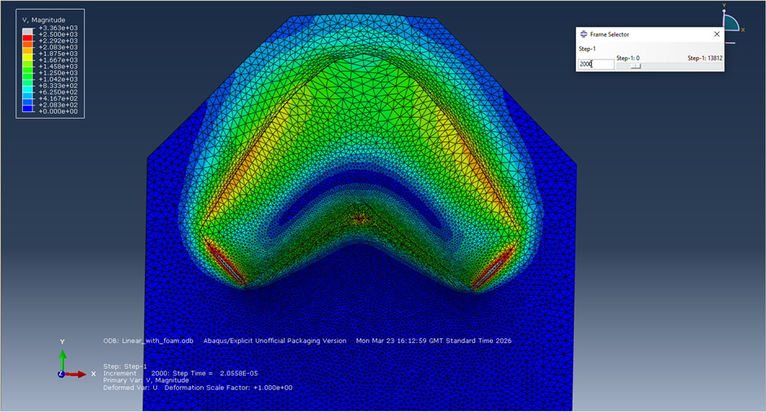
Figure 9:2d Linear with Foam test
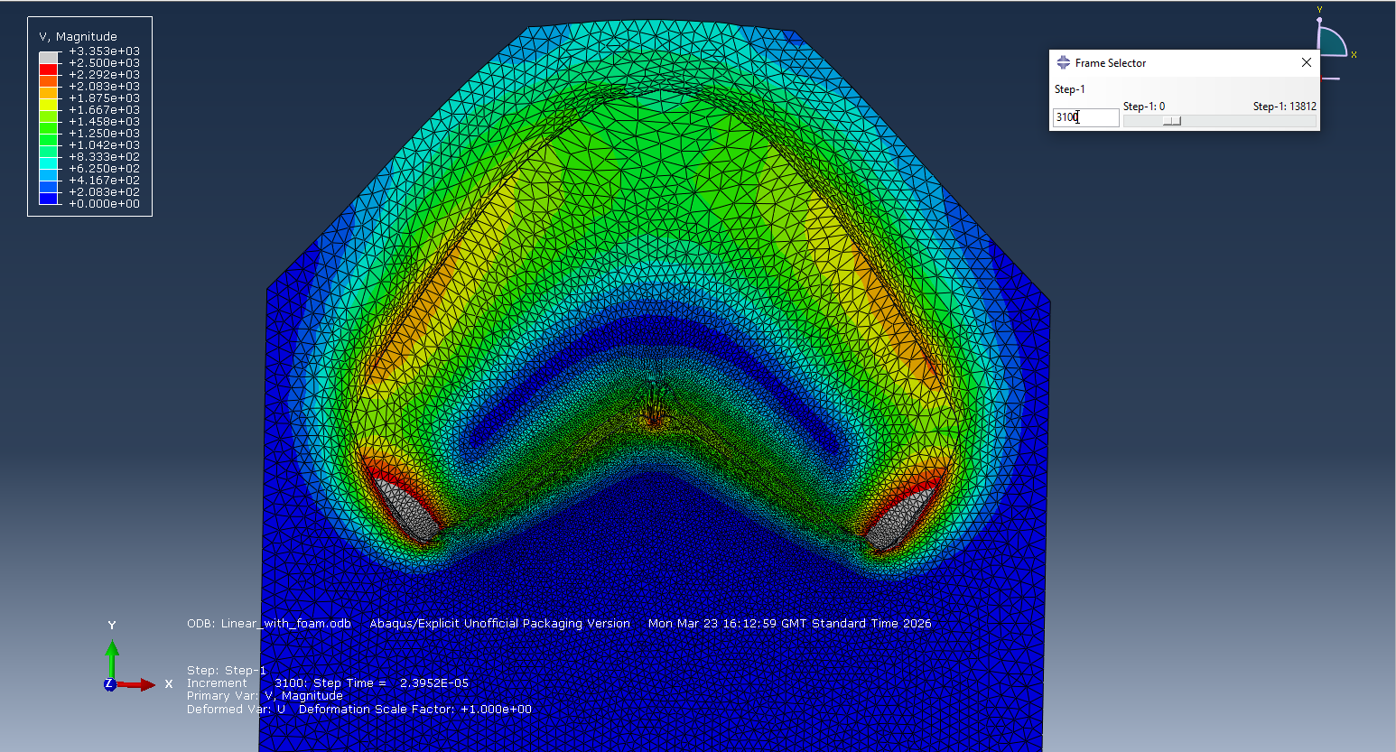
Figure 10: 2d Linear with Foam test
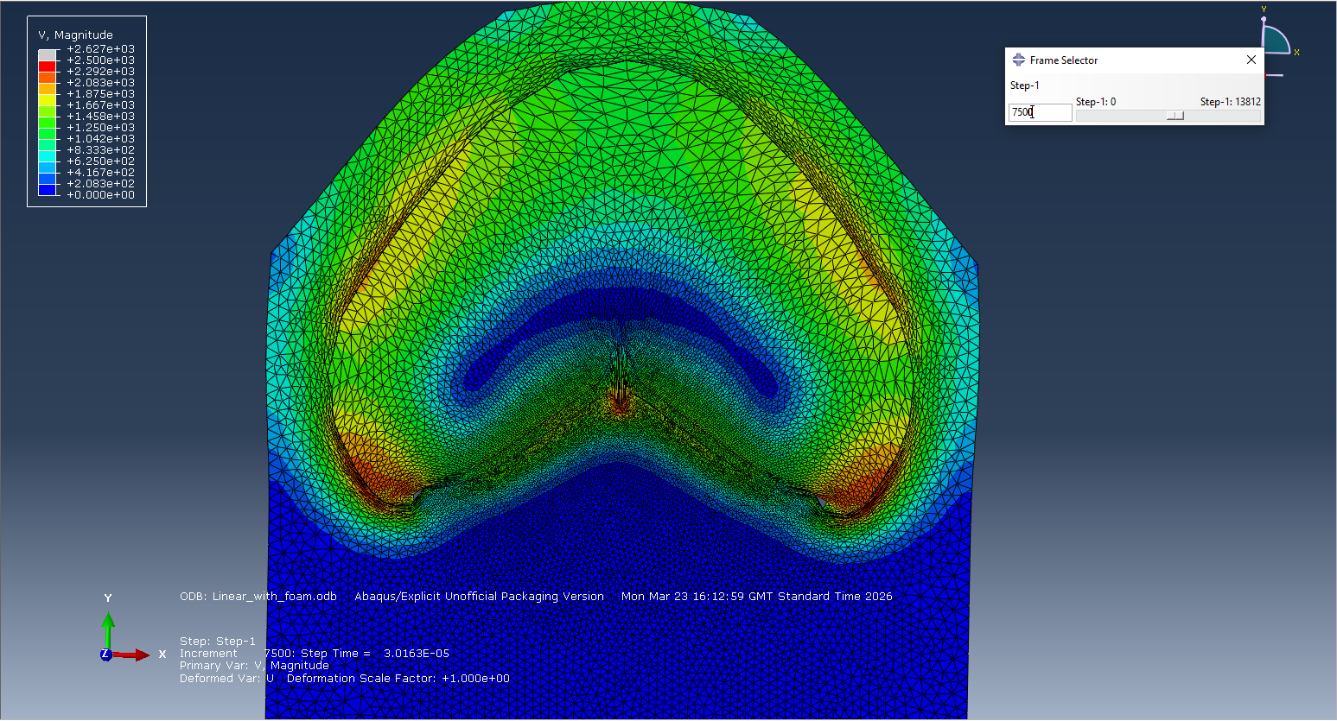
Figure 11:2d Linear with Foam test
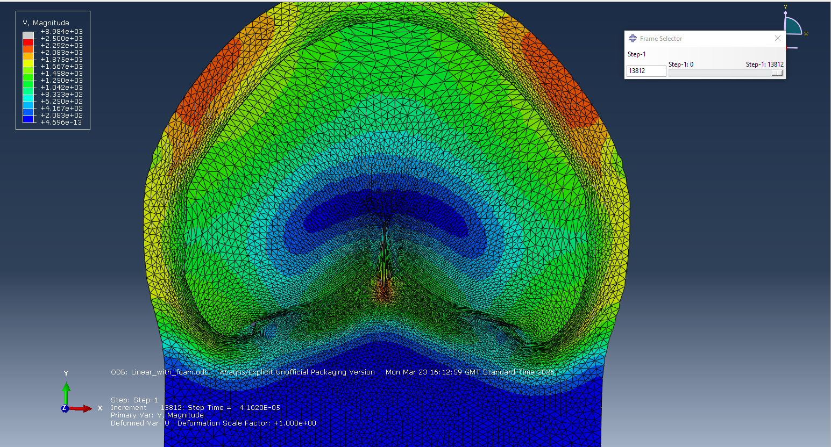
Figure 12: 2d Linear with Foam test
Above is progression of images that clearly show the formation of, and progression of a jet formed from the shaped charge. The Foam surrounding the HE compresses and expands outwards from the shockwave away from the liner as well as upwards and outwards. The latter will likely have a negative effect on the overly velocity of the jet as its effective container does not aid in containing the shockwave allowing more of its energy to be spent on the Liner. Nevertheless, the Foam as the container is the same for both of the models that are run as part of this paper and this such speculation on how great the effect of this is. is out with the bounds of it. This author would recommend experiments on a similar model with a backing plate on the foam or a thin case around the explosive. It must be noted that such plates would likely affect the usability as, the flexibility of such devices in the real world would be effected negatively.
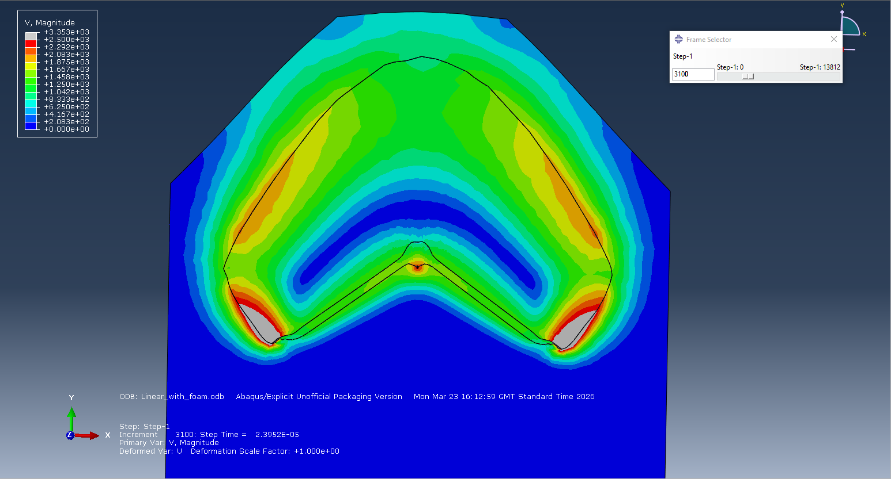
Figure 13: 2d with Foam without Mesh
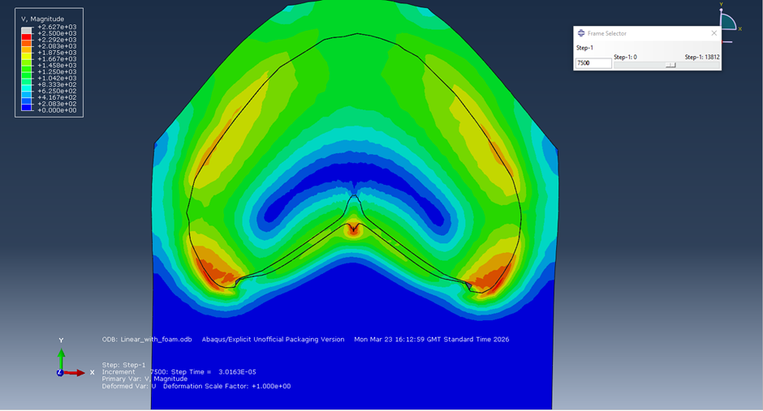
Figure 14: 2d with Foam without Mesh
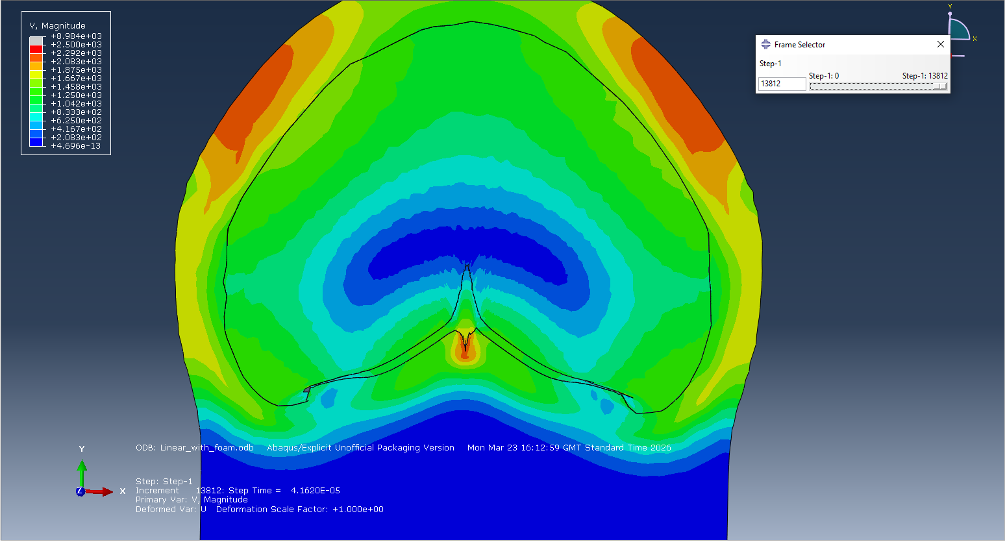
Figure 15: 2d with Foam without Mesh
With the mesh removed we can more clearly see the initial formation of the je with its distinct point and slug behind it. This does clearly show that the foam at the very least allows for the formation of the jet with a velocity on the point of it sitting at above 2,000 ms⁻¹.

2d Without Foam Model

To adjust the model so that there was no foam in the way of the formation of the jet a cut was made in the model that removed the mesh and thus the lower part of the foam from the calculations of the simulation. This resulted in a mesh of 13,010 elements.
This simulation did not go without its own problems with it encountering excessive deformation initially as well. This was found on the foam on the outside as the explosion progressed it deformed, compressed and stretched causing trouble with close to the outside in the formation of long ‘fingers’ that trailed around and below the edges of the liner. This issue was resolved by increasing the number of time steps again from 100 but, this time to merely 1,000.
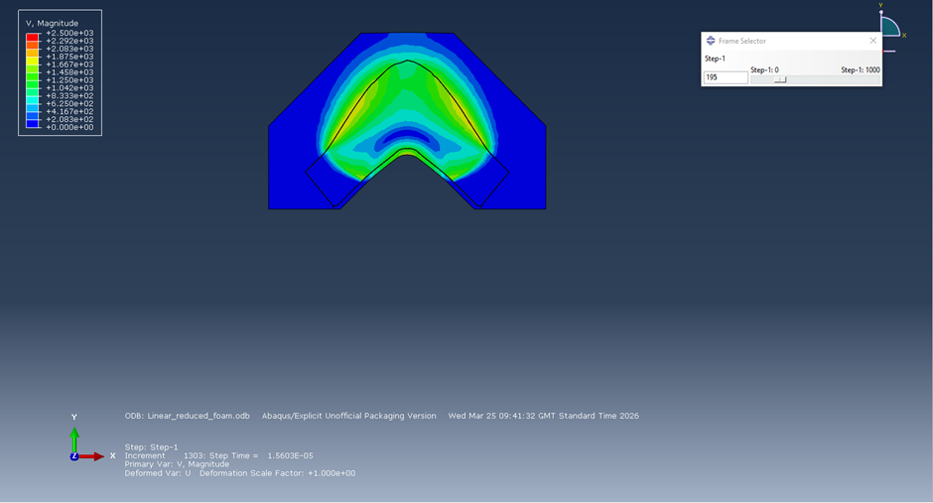
Figure 16: 2d without Foam without mesh
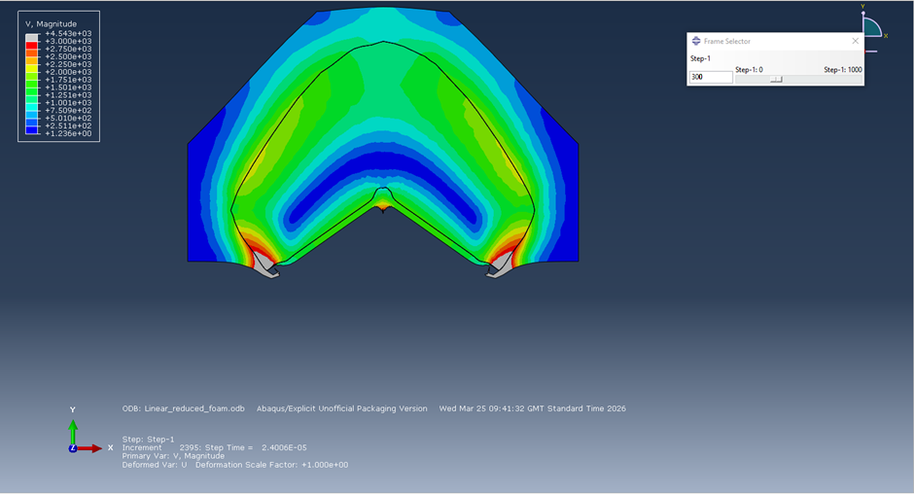
Figure 17: 2d without Foam without mesh
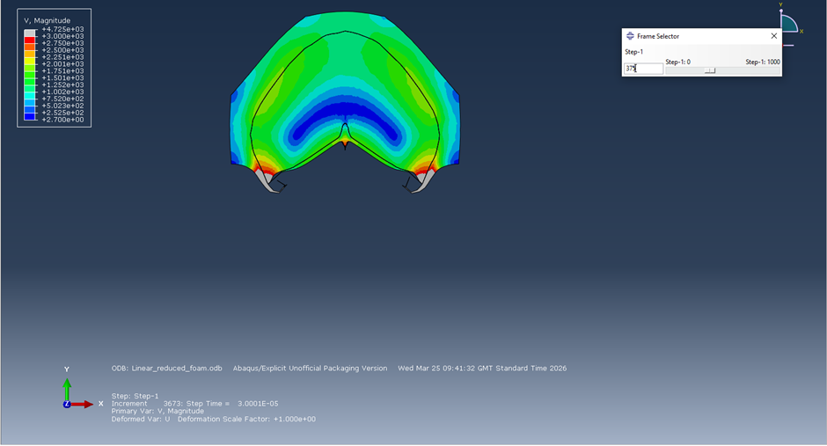
Figure 18: 2d without Foam without mesh
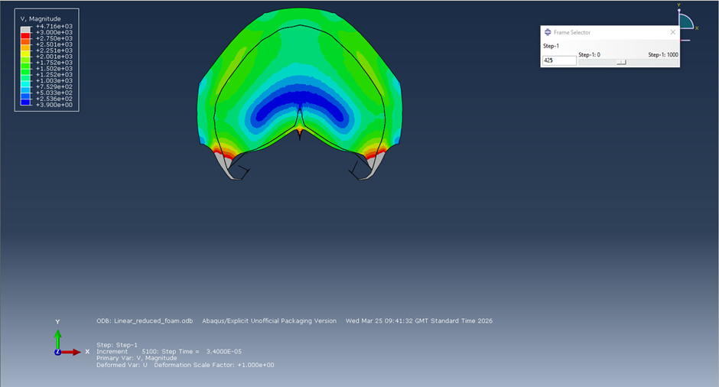
Figure 19: 2d without Foam without mesh
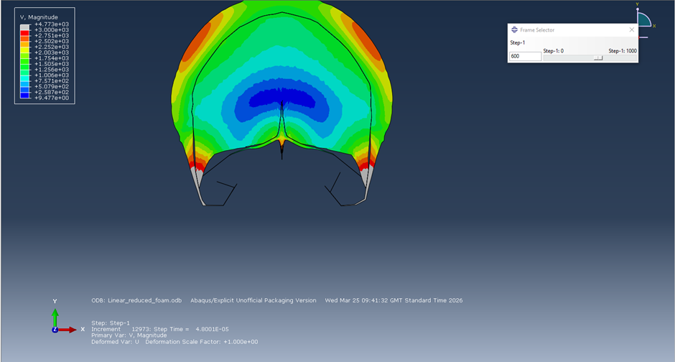
Figure 20: 2d without Foam without mesh
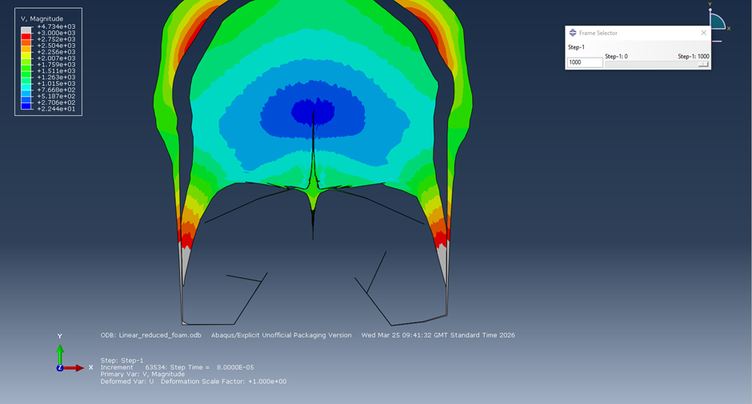
Figure 21: 2d without Foam without mesh
A much clearer picture of the jet is able to be formed owing to the simulation completing with a clear point with a slug behind it by the end. Also of note is the separation of foam from the HE as it accelerates away from the shockwave. This is possibly a result of the compression of it bouncing slightly to creating this slight increase in acceleration to be able to create this separation. It is clear from the images that jet formation was extremely successful with the point also reaching well in excess of 2,000ms⁻¹.

2d Comparison
Table 3: 2d Linear with Foam Jet Velocity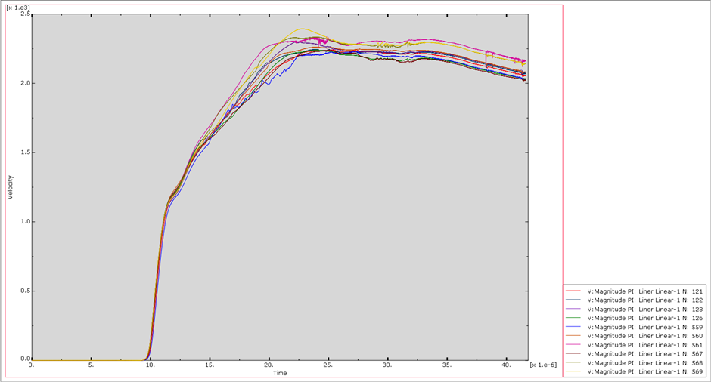
Table 4: 2d Linear without Foam Jet Velocity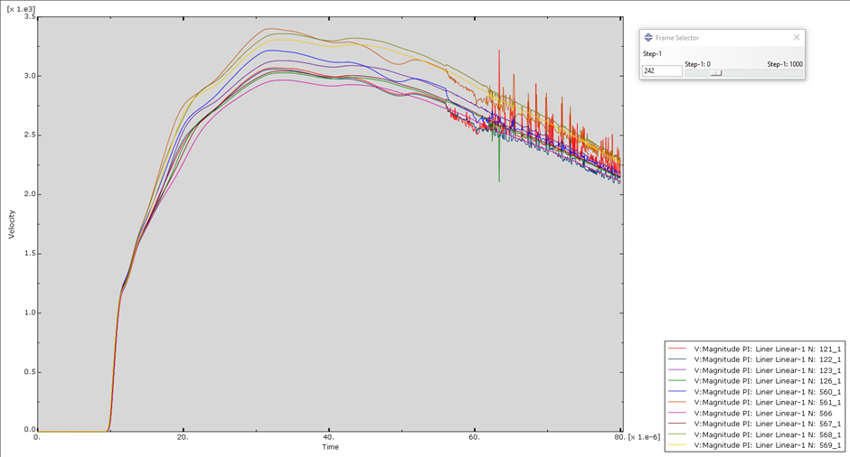
Above is plotted the velocity of several nodes that were on or next to the point of the jet on both simulations. It is clear that the model without the foam experiences a much higher jet velocity peaking at circa 1,000 ms⁻¹ faster although there is a greater preponderance of nodes at circa 3,000ms⁻¹ which is still much faster than the with Foam design. This will clearly result in better performance and penetration figures for the shaped charge against a target.
While the figures for the foam design are liable to be higher if a PVC foam was able to be used for the material in the model due to it likely offering less resistance, we can confidently say that there is an effect in limiting the velocity of the jet of the shaped charge.
To further investigate we will take the design of the model without Foam and use it to create a 3d simulation to mor thoroughly ensure that such velocities are replicated when it is not simulated as just a planar cut.

3d Model

Design

The design of the model was left the same as the 2d Model replete with the same materials and structure from the 2d Model. The model would thus retain the same shape but would be a 1m long linear charge. The change that had to occur was in the mesh which had to be made a great deal coarser due to the limitations of the software as Abaqus could not run a simulation with more than 250,000 nodes. Thus, the size of the nodes was increased in particular the foam but again retaining the smallest nodes on the liner and where the HE met the liner. This resulted in an overall mesh of 234,738 nodes.
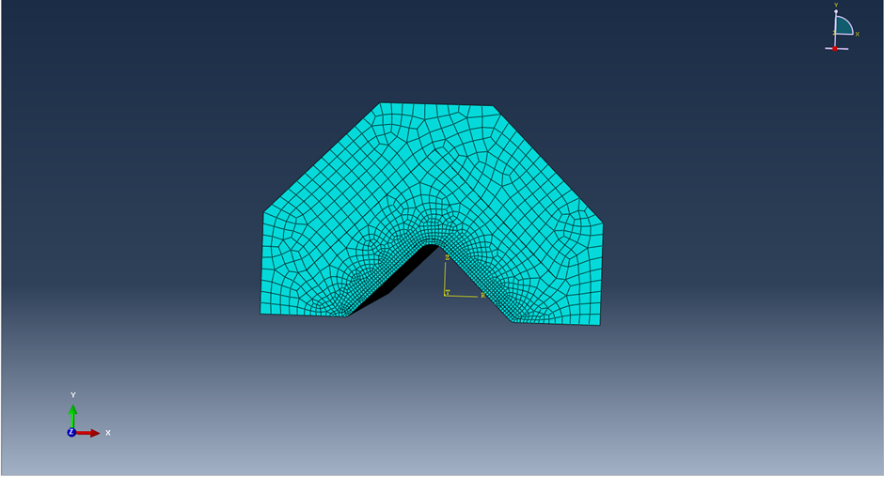
Figure 22: 3d Mesh

Results

The simulation was run over the same timescale as the 2d models of 80μs with the step intervals being 1,000. The simulation was unable to complete due to excessive distortion. Despite, repeated attempts this issue was unable to be resolved however, useful data was obtained thanks to the length of the shaped charge (one of the reasons why a length of 1m was kept as shortening the design and increasing the density of the mesh had not effect on resolving the issue).
The distortion occurred when the shockwave of the explosive reached the end of the charge and caused distortion in the mesh as Abaqus was unable to resolve how to calculate the HE expanded outwards unconfined.

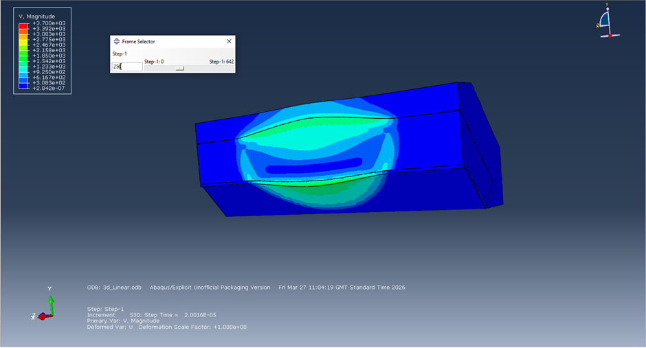
Figure 23: Cut of 3D model
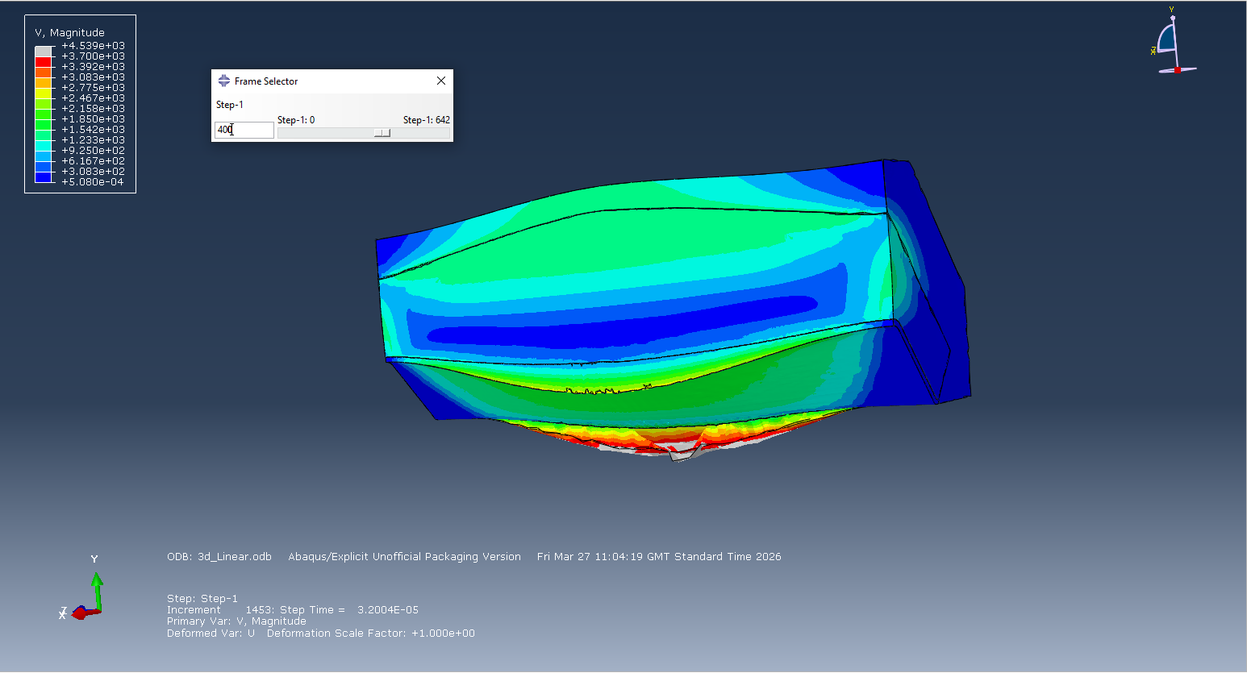
Figure 24: Cut of 3D model
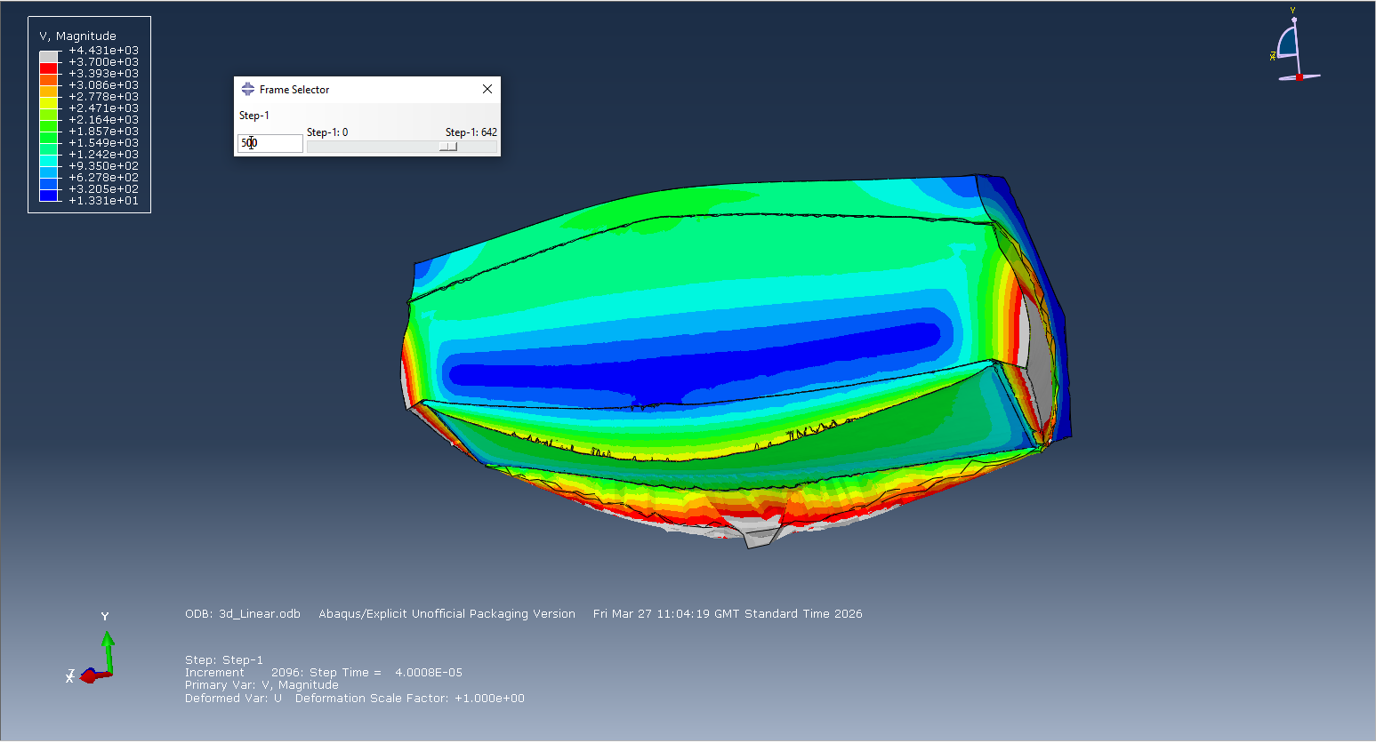Figure 25: Cut of 3D model
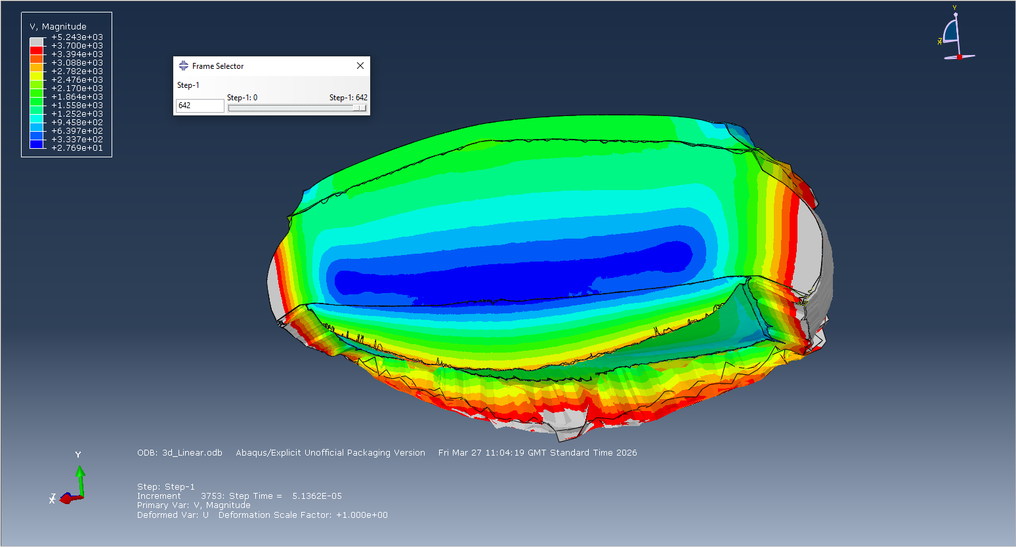
Figure 26: Cut of 3D model
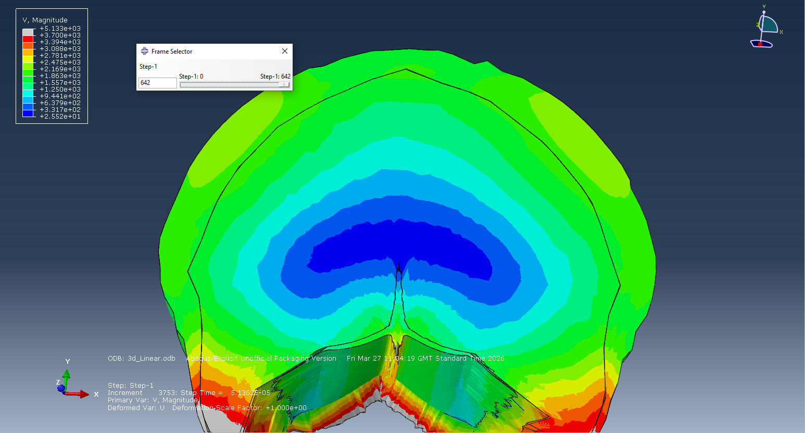
Figure 27: Cut of 3D model

From Figures 23-27 we can se the formation of the jet as an arc running along the length of the charge. This is to be expected as the detonation point is in the middle of the charge. This was chosen as it was where the author was instructed to place the detonator when they detonated a linear shaped charge. A cut made in the centre of the charge clearly shows a jet forming in the way expected from the results of the 2D simulation.

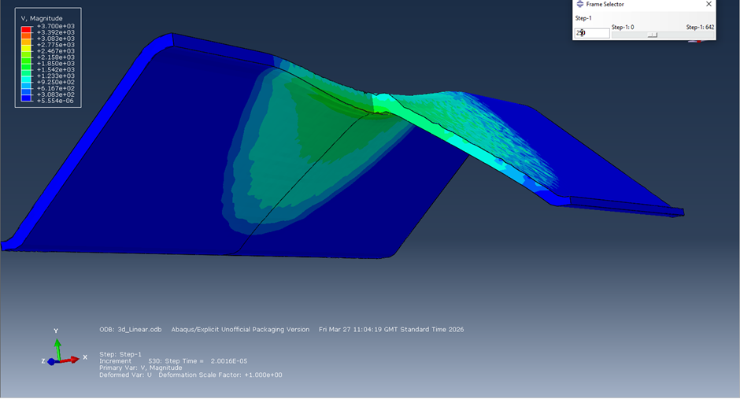
Figure 28: 3D Liner Cut

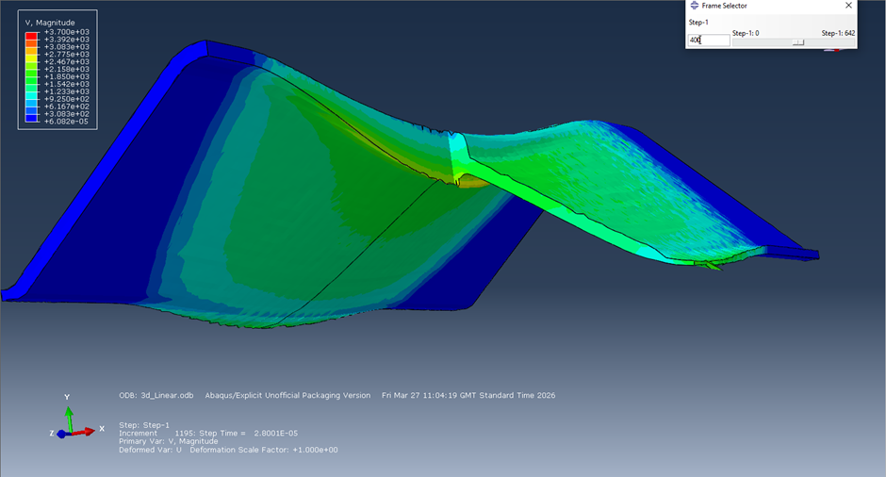
Figure 29: 3D Liner Cut
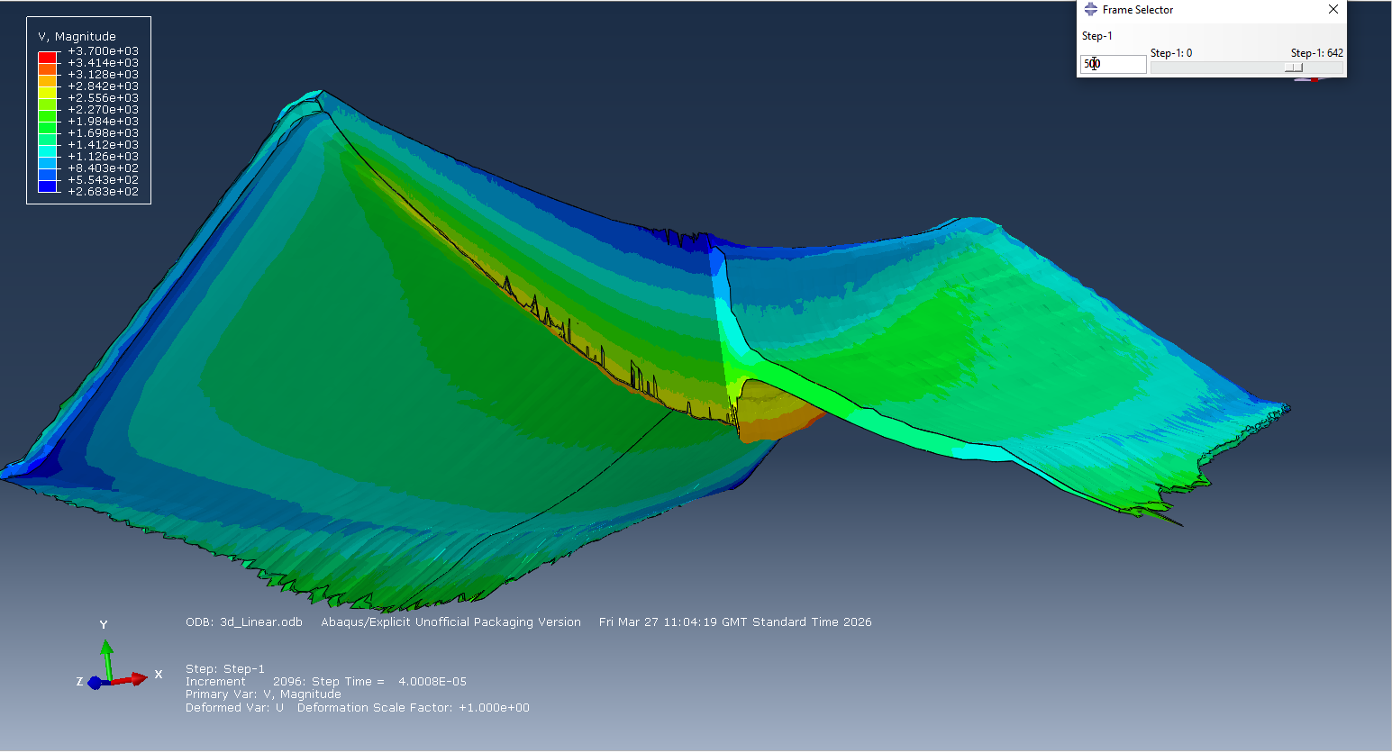
Figure 30: 3D Liner Cut
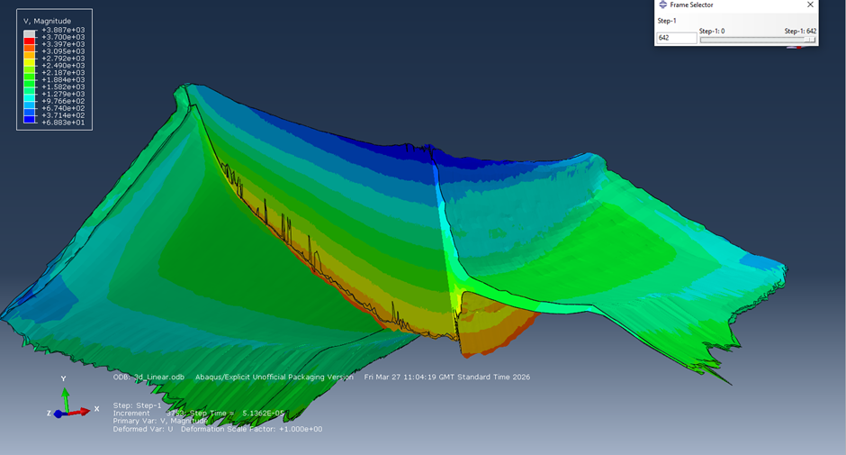
Figure 31: 3D Liner Cut

Figures 28-31 show just the liner and clearly demonstrate how the shockwave travels along the length of the charge creating the jet. There is some surface effect visible on the outer wall of the liner but, with the simulation ending at that point we are unable to ascertain what effect this would have on the jet later on its progress at the edges of it.
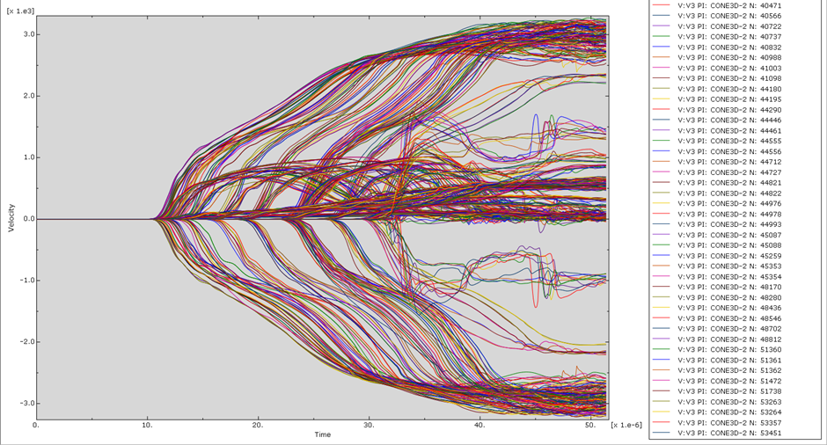
Table 5: Velocity of the jet at points along the Charge
By looking at various points along the charge we can see that the point on the jet reaches the same peak velocity with the exception of the edges of the charge. This is a similar peak velocity as the 2D non-Foam charge of circa 3,000ms⁻¹. What is different is that this peak velocity takes longer to occur and only happens once the explosive shockwave has propagated along the entire length of the charge.

Conclusion

The inclusion of foam in the design of a linear shaped charge does have an effect on the maximum velocity of the jet formed from it. With the simulation seeing a reduction of 500-750ms⁻¹ in peak velocity when foam is in front of the liner. Removing the foam still results in a viable alternative that has superior maximum velocity and should have superior penetration.
However, most importantly the foam used in these simulations is of a different type to that used on such designs and as such efforts should be made to obtain data so that these simulations can be run again but, with the correct foam.
Furthermore, data should be obtained on the effect of having both charges set against a target to compare how great an effect the built in standoff the foam creates compared to the non-foam with no standoff but greater jet velocity and whether the lower velocity but, depth given that allow for jet formation before contact with the target object.
Other considerations include what effect does different liners have in the interaction such as the still commonly used Copper or the increasingly used Magnesium.

Bibliography

[1] | J. R.Meyer, Explosives 7th Edition, Wiley-VCH Verlog GmbH & Company KGaA, 2015.
[2] | J.Akhaven, The Chemistry of Explosives 4th Edition, London: The Royal Society of Chemistry, 2022.
[3] | G. L. Rottman, World War II Infantry Anti-Tank Tactics, Oxford: Osprey, 2005.
[4] | D. R. Kennedy, “HISTORY OF THE SHAPED CHARGE EFFECT: The First Hundred Years,” D.R. Kennedy & Associates Incorporated, Mountain View, 1990.
[5] | Chemring UK, “Sabrex,” 4 2022. [Online]. Available: https://www.scribd.com/document/815770285/037. [Accessed 31 3 2026].
[6] | Y. C. a. M. Y. H. Özer, “Investigation of the Crash Boxes Light Weighting with Syntactic Foams by the Finite Element Analysis,” Acta Physica Polonica A, vol. 132, no. 3, pp. 734-737, 2017.
[7] | H. R. a. N. Yuvaraj, “Analyse the effect of clad ratio on the stress-strain curve of titanium-clad bimetallic steel for different strain rates and temperatures using Johnson-Cook model,” Materials Today: Proceedings, vol. 56, pp. 3702-3713, 2022.
[8] | P. W. S. Samuel E. RIGBY, “An Investigation of TNT Equivalenceof Hemispherical PE4 Charges,” Engineering Transactions, vol. 62, no. 4, pp. 423-435, 2014.
[9] | B. B. a. D. O. Adams, “On predicting the effective elastic properties of polymer bonded explosives using the recursive cell method,” International Journal of Solids and Structures, vol. 41, no. 2, pp. 481-509, 2004.

