Business Inquiry and Research

Qualitative and Quantitative Report
Kelly Lewis-Bennett
Student Number: 1907952

Table of Contents
Title Page……………………………………………………………………………..…………..1
Table of Contents………………………………………………….……….……..………….2
Part 1 - Qualitative Exercise…………………………………..………....……………..3
Introduction………………………………………………….…………………………..……..3
Procedure……………………………………………………….………………….……..………4
Phenomenological research paradigm……………………………….……….…….4
Ontology…………………………………………………………………………….…………….4
Thematic Analysis………………………………………………………………..…….……..4
Interviews…………………………………………………………………………………………5
Data presentation and findings…………………………………………………………6
Table summary………………………………………………………………………………….6
Interpretations and themes………………………………………………………………9
Conclusion……………………………………………………………………………………….11
References………………………………………………………………………………………12
Part 2- Quantitative Exercise……………………………………………….…………..13
Introduction……………………………………………………………………………………….13
Procedure………………………………………………………………………..……………..14
Statistics…………………………………………………………………………………………….14
Descriptive Statistics……………………………………………………………………………14
Correlation…………………………………………………………………….……………………14
Survey……………………………………………………………………………..………………….14
Data Presentation and findings………………………………………………….………16
Pivot Tables………………………………………………………………………………...………16
Conclusion……………………………………………………..………………………….……….19
References…………………………………………………………………………………..………20

Part 1 – Qualitative Exercise
Introduction
This report presents the study of a qualitative and quantitative research. The idea of qualitative inquiry is stated to be a reflective process that highlights the strengths of a qualitative approach, which refers to collecting meanings rather than numbers. This is a subjective study that will be used to capture people's feelings, social and cultural features, and day-to-day experiences (Agee, J. 2009). The reason for the research is to determine what impact of covid19 on the development of sporting athletes. Research has shown that since its onset, the COVID-19 pandemic has spread to almost all countries of the world. Many routine parts of life, including sport and physical exercise, have been interrupted as a result of social and physical distancing measures, lockdowns of businesses, schools, and overall social life, which have become standard to combat the disease's spread (United Nations. 2021).
The qualitive question in part 1 of this study is more specific to the sport of Baton Twirling and this research in this report explores what impact the Coronavirus pandemic has had on the development of Baton Twirling athletes. Baton twirling is a sport in which a metal rod is manipulated in a choreographed sequence by the hands and body. It is classified as a sport and includes a variety of disciplines such as one baton twirling, two baton twirling, three baton twirling, artistic twirling, freestyle twirling, pair twirling, teams and artistic groups (World Baton Twirling federation. 2021). Data collection for this study will be collected through informal interviews with several participants involved in the sport of Baton Twirling in order to gain their lived-in experiences during the Covid19 pandemic. The data acquired from the participants' experiences will subsequently be subjected to a thematic analysis to uncover important themes. An approach for analysing qualitative data and identifying major themes is known as thematic analysis (Terry, G. 2017).

Procedure
Phenomenological research paradigm
The Qualitative research paradigm used in this study is a phenomenological approach. Phenomenology is explained as a study of structures of consciousness experiences from the first-person point of view. Phenomenology is distinct from, but related to, other important philosophical subjects such as ontology, epistemology, logic, and ethics. Phenomenology has been around for centuries in various forms, but it really took off in the early twentieth century with the writings of Husserl, Heidegger, Sartre, Merleau-Ponty, and others (Stanford Encyclopaedia of philosophy. 2003). This study is subjective, and interviews will take place in the participants natural setting through Microsoft teams.
Ontology
Ontology and epistemology are two separate perspectives on study philosophy, according to the author. In business research, ontology is described as the science or study of being, and it deals with the nature of reality, which is the individual's lived-in experiences. Ontology is a system of belief that reflects an interpretation by an individual about what constitutes as fact. Ontology is associated with a central question of whether social entities should be perceived as objective or subjective. Accordingly, objectivism and subjectivism can be specified as two important aspects of ontology (Business research methodology. 2021). This approach provides a clear understanding and a detailed description of the individuals reality.
Thematic Analysis
In real-world psychological research, thematic analysis is a typical method of qualitative data analysis. Within a qualitative data set, this type of data analysis entails identifying, analysing, and reporting patterns of meaning, or themes. This method will be used to analyse the data collected in this study from interviews with three separate participants. Codes will be generated colour coded to in order to construct and capture key themes which will then be interpreted in a table summary. It is also stated that qualitative methodologies are extremely diverse, complicated, and nuanced, and that thematic analysis should be considered a core tool for qualitative research. It is the first qualitative method of analysis that researchers should learn since it teaches fundamental abilities that can be used to many other types of qualitative research (Donnelley, O. 2013). Thematic analysis is flexible, which is one of its advantages. They go on to say that qualitative analytic methodologies can be separated into two categories. Those related to, or emanating from, a particular theoretical or epistemological perspective fall under the first category. However, there are still certain limitations to some of these, such as conversation analysis and interpretative phenomenological analysis within the framework (Braun. V. 2006). Therefore, the methodology in this study will be collected through the process of conducting informal semi structured interviews. It is thought that an interview is a managed verbal exchange and as such its effectiveness heavily depends on the communication skills of the interviewer. These include the ability to clearly structure questions, listen attentively, pause, probe or prompt appropriately and encourage the interviewee to talk freely (Newton, N. 2010). Participants selected are associated with the sport of Baton Twirling in some form, and data gathered from the interviews will then be analysed and colour coded to in order for researcher to interpret and capture key themes which will then be presented in a table summary.
Interviews
Prior to the interviews the researcher completed and ethical form stating the purpose for the research as well as sending each of the selected participants a participant agreement form to complete. Interviews were conducted on Microsoft teams and participants were reminded for the purpose of the study as well as their right to withdraw from the interview at any time. Participants were also asked not to share the interviews due to confidentiality purposes and the identity of the participants was protected throughout the interview. On conclusion the participants were thanked for their willingness for taking part in the study as well as for their time. On submission for the report interviews and the participant agreement forms were deleted.

Data Presentation and Findings
Table Summary
Data and findings will be presented in a form of a table summary with detailed interpretations of the data collected in text form.
Label – Objects
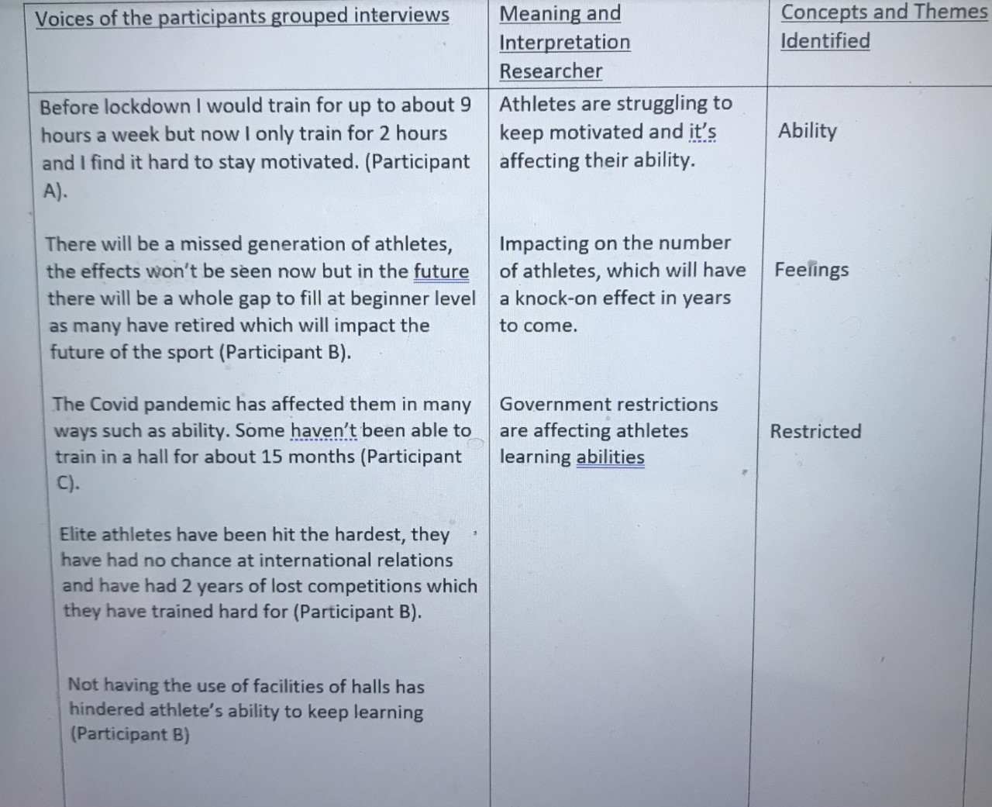

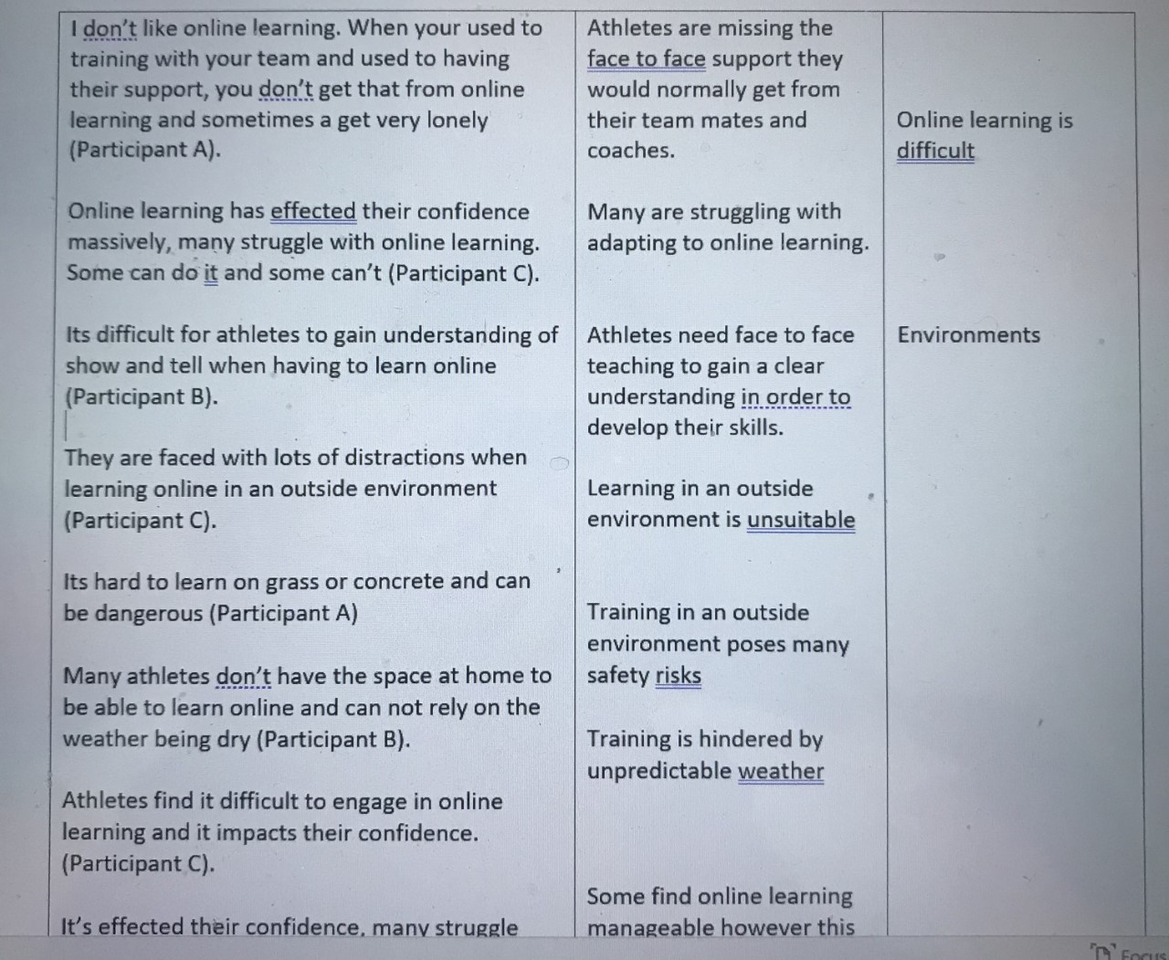
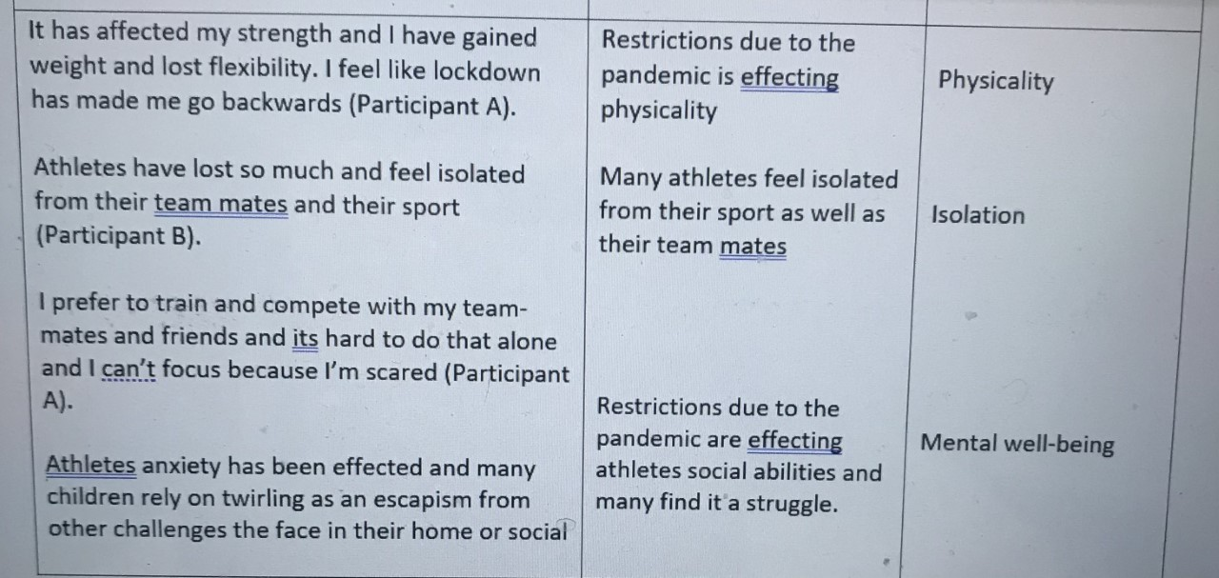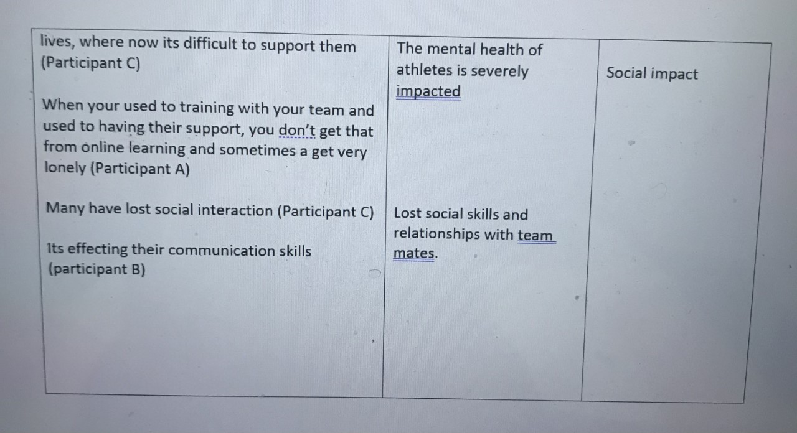
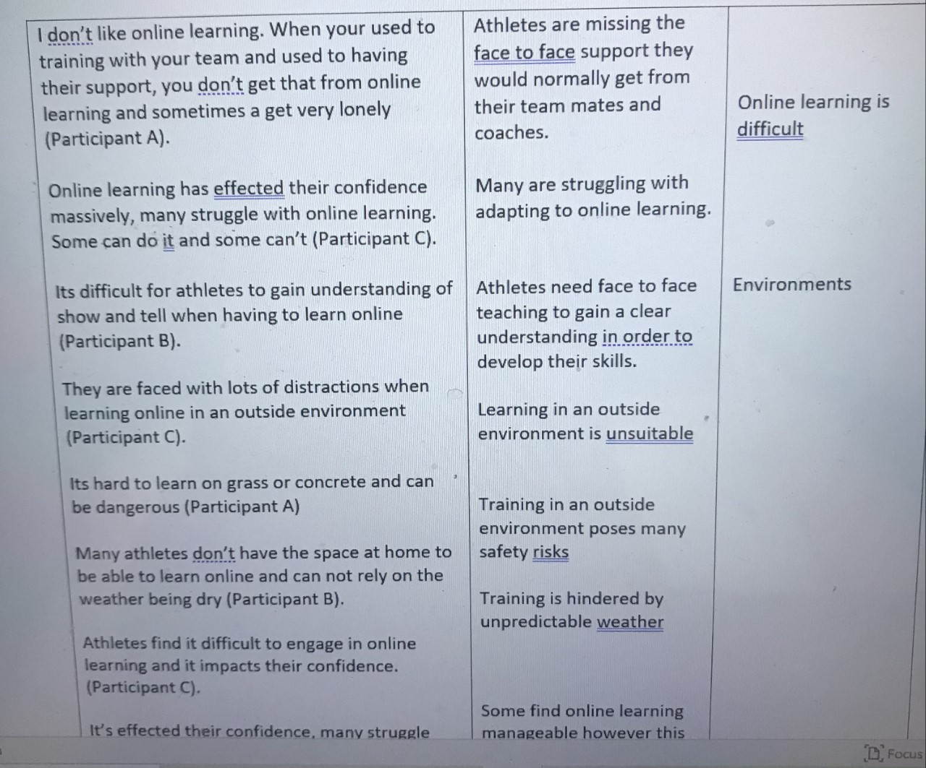

Interpretations and themes.
Impact on ability
Participants felt that athlete’s ability had been significantly affected in many ways due to the covid19 pandemic. It impacted their motivation levels and there was a significant decrease in the amount of time the spent training compared to before government restrictions. The data collected also showed a knock-on effect the sport will experience for years to come with a gap at beginner level.
Online learning
Participants felt learning skills online was challenging for many with athletes unable to gain a clear understanding of demonstrations through a screen, therefore online learning is clearly having an impact on the number on twirling athletes as many are finding it difficult to adapt and develop in this way. Therefor online learning is not considered sustainable for athletes to develop their skills and continue learning in this way.
Environment
Participants explained that training in an outside environment was not only unsafe but it also produced challenges to develop their skills, outside environments also provided many distractions such as unpredictable weather, distractions at home, those living rurally have challenges with internet connection, all of which impacted the athletes confidence and development.
Isolation
The feelings of isolation explained by the participants is extremely concerning and athletes are likely to suffer ongoing mental health problems such as anxiety and depression as a direct impact of the pandemic. All three participants explained that athletes feel isolated from their team-mates, their coaches as well as their chosen sport.
Physicality
There were many concerns with the impact on athlete’s physicality. Athletes have gained weight, lost weight, lost muscle, as well as flexibility. These are areas where athletes have spent years trying to build their fitness to ensure there are able to perform to the best of their ability and many will now face the challenge of having to start all over again as a result of the pandemic and government restrictions.
Social impact
It was also suggested that athletes have lost communication skills which will provide challenges in later life especially if they are planning on going to university, applying for jobs which again will present feelings of isolation due to being unable to interact with others and could impact on their mental health.

Conclusion
The findings in this study present a number of concerns, such as the physical and mental wellbeing impacts the pandemic has had on athletes as well as the social implications and the feelings of isolation athletes are facing as a direct result of the government restrictions due to the pandemic. Each of the participants explained a feeling of a lack of support from world organisations for National governing bodies, teams coaches and athletes which is also concerning as from the data collected many athletes rely on their sport for reasons such as mental well-being as well as escapism from the challenges they may be facing in their personal lives, therefore should there not be more support provided from such world organisations to national governing bodies as to how to support athletes during the pandemic. If the researcher chose to undertake a similar study, it would be interesting to see what impact the coronavirus pandemic was having on athletes around the globe and analysing data due to geographical locations. It is deniable from the findings that the

References
Agee, J. (2009). International Journal of Qualitative Studies in Education. Developing qualitative research questions: a reflective process. https://www.tandfonline.com/doi/full/10.1080/09518390902736512
Braun, V. and Clarke, V. (2006) Using thematic analysis in psychology. Qualitative Research in Psychology, 3 (2). pp. 77-101. ISSN 1478-0887 Available from: http://eprints.uwe.ac.uk/11735
Business Research Methodology. (2021). Ontology. https://research-methodology.net/research-philosophy/ontology/
Donnelly, Orlaith (2013) Evaluating the impact of an outdoor adventure education intervention for primary school children perceived to be vulnerable. DAppEdPsy thesis, University of Nottingham. pp 132-142 http://eprints.nottingham.ac.uk/13695/1/Final_Hardbound_Thesis.pdf
Nbta Cymru. (2021). Home. https://www.nbtacymru.co.uk/
Newton, N. (2010). The use of semi-structured interviews in qualitative research: strengths and weaknesses. https://www.academia.edu/1561689/The_use_of_semi_structured_interviews_in_qualitative_research_strengths_and_weaknesses
Stanford encyclopaedia of philosophy. (2003). Phenomenology. https://plato.stanford.edu/entries/phenomenology/
Terry, G., Hayfield, N., Clarke, V., & Braun, V. (2017). Thematic analysis. The Sage handbook of qualitative research in psychology, 17-37. https://books.google.co.uk/books?hl=en&lr=&id=AAniDgAAQBAJ&oi=fnd&pg=PA17&dq=thematic+analysis+definition&ots=doi1quEhI1&sig=u4537-21YiF1uSGOT1DPdB9XA6w#v=onepage&q=thematic%20analysis%20definition&f=false
World Baton Twirling Federation. (2021). Home. History. https://www.wbtf.org/About/History
United Nations. (2021). Department of Economic and Social Affairs Economic Analysis. https://www.un.org/development/desa/dpad/publication/un-desa-policy-brief-73-the-impact-of-covid-19-on-sport-physical-activity-and-well-being-and-its-effects-on-social-development/

Part 2- Quantitative Exercise
Introduction
This report contains the study of quantitative research. The subjective nature of qualitative analysis contrasts with the objective nature of quantitative analysis. Qualitative data analysis is based on categorising items like participants based on their properties and attributes and quantitative data pertains to quantities, and so numbers, whereas qualitative data is descriptive and pertains to phenomena that can be observed such as language. Quantitative data such as height, weight, price, age, and geographic regions can be collected and statistically analysed through surveys and other experiments. It is suggested that survey research involves the application of statistical methodologies to measure the characteristics of a particular population using scientific sampling procedures in conjunction with an established questionnaire (Apuke, D. O. 2007). Participants in this study are people who are involved in the sport of baton twirling, such as athletes over the age of 18, parents of athletes, and coaches from the Twirling community.

Procedure
Statistics
Statistics is the branch of science that studies and develops methods for gathering, analysing, interpreting, and presenting empirical data. Statistics is a highly interdisciplinary field; statistics analysis has applications in almost all scientific fields, and research problems in different scientific fields drive the creation of new statistical methods and theory. Statisticians use a range of statistical and analytical techniques to establish methods and research the theory that underpins them (UCI. 2021).
Descriptive statistics
Descriptive statistics describe the relationship between variables in a sample or population to summarise data in an ordered manner. When conducting research, calculating descriptive statistics is a critical first step that should always be completed before making inferential statistical comparisons. Nominal, ordinal, interval, and ratio variables, as well as measurements of frequency, central tendency, dispersion/variation, and location, are all included in descriptive statistics (Yellepau, V. 2018). Understanding the different strategies for presenting data, as well as being able to use frequency diagrams and scatter diagrams, as well as being able to find the mean, mode, median, quartiles, and standard deviation, are suggested as objectives of statistical analysis (CIMT.2021).
Correlation
It is suggested that methods of correlation and regression may be used to examine the degree and existence of relationships between different variables. Correlation analysis is used to understand the nature of relationships between two individual variables. In practical terms, the closer the value of ‘r' is to 1, the greater the positive impact; however, if the value of ‘r' is less than 0, the closer it is to – 1, the greater the negative impact. Spearman's Rank correlation necessitates sorting the data and assigning each value a specific rank, with 1 being assigned as the lowest value. Furthermore, if the same data value appears more than once, the average rank of the equal values will be specified. As a research method, correlation analysis has a number of advantages. This method allows for the analysis of data from multiple subjects at the same time. Furthermore, correlation analysis can investigate a wide variety of variables and their interrelationships. On the negative side, correlation findings do not imply causation, i.e. cause and effect relationships (Business research Methodology. 2021).
Survey
Survey research is the collection of information from a sample of people based on their responses to questions. This type of research allows for a variety of methods for recruiting participants, collecting data, and utilising various instrumentation methods (Ponto, J. 2015). The researcher conducted a survey of up to ten questions in Moodle files in order to collect data on the impact of the covid 19 pandemic on the development of twirling athletes. In accordance with good ethical practise, the researcher designed the survey for people over the age of 18. Once the survey was constructed, the researcher shared it on their personal social media profile and asked family and friends if they could please spare a few minutes to participate in the survey. The survey received a significant response; however, in order to tighten the results, they chose to use and analyse data from the first 40 participants. However, because the survey was incorrectly constructed, these presented challenges, and the researcher was limited in the ways in which the data generated could be analysed.
Excel ans SPSS
The researcher transferred the survey responses to Excel, which generated a spreadsheet of the data, allowing the researcher to analyse the data using pivot tables. If the researcher had gained more technological experience with software such as excel and SPSS, they would have been able to produce and determine a relationship between the nature of variables.

Data Presentation and Findings
Pivot tables
A pivot table is a special Excel tool that allows you to interactively summarise and explore data. A pivot table is a tool that allows you to interactively explore large amounts of data. Once you've created a pivot table, you can quickly convert a large number of rows and columns into a meaningful, well-formatted report (ExcelJet. 2021). ). By transferring the survey into Excel the researcher was able to analyse the findings through pivot tables.
1.The first question was related to the age of the participant completing the survey.
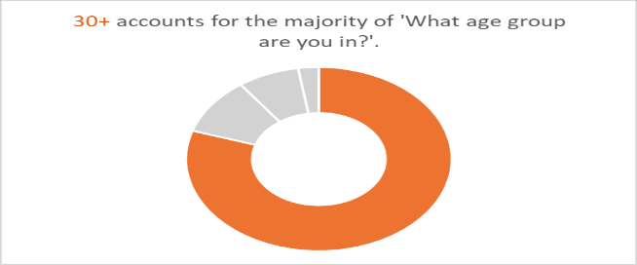
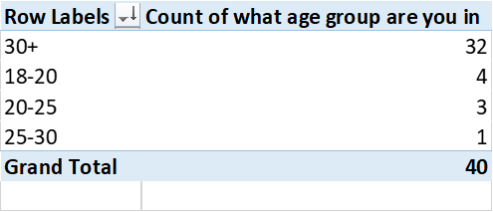
The results showed the majority of the participant who completed the survey were in the 30+ Bracket.
2. The second question asked if the participant was currently involved in the sport

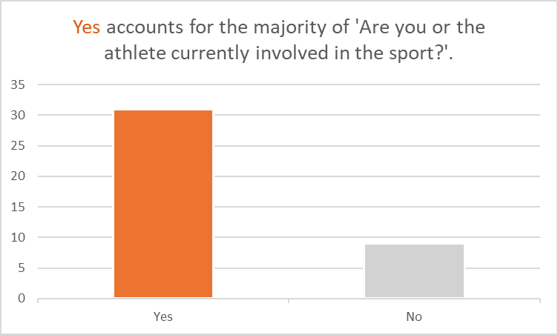
The results showed the survey was completed by 31 participants who were currently involved in the sport.
3.The third question determined the relationship of the participant to the sport.
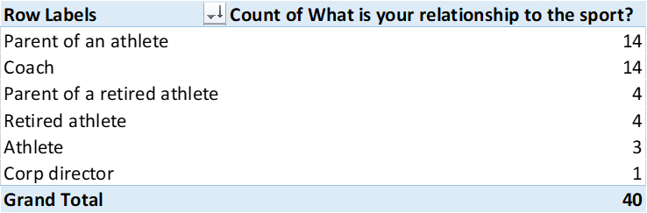
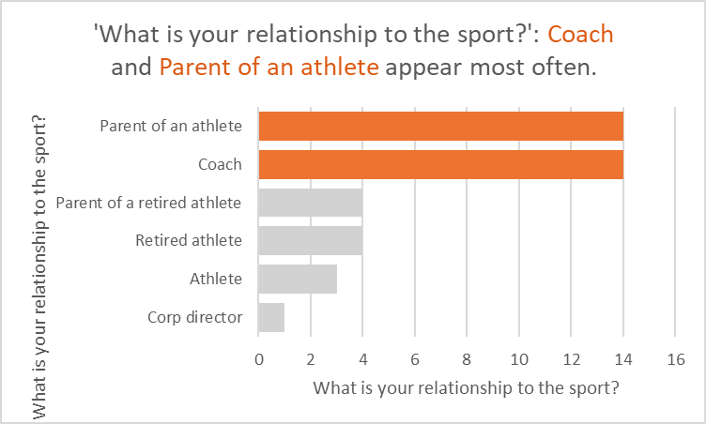

The results showed the majority of the participants that completed the survey were parents of athletes or a coach.
4.The fourth question asked if the participant felt the pandemic had impacted on the physical ability of athletes.
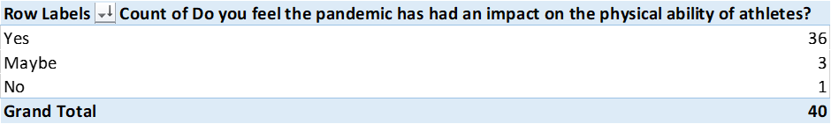
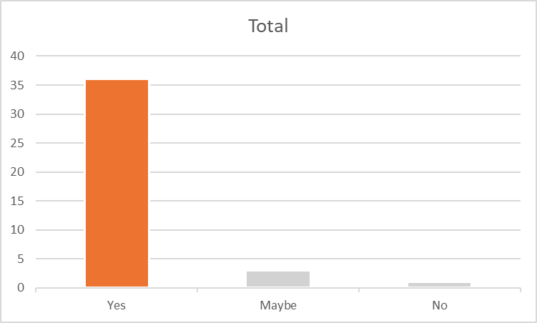

The results showed 31 participants completing the survey felt the pandemic had impacted the athletes physical abilities.
5. The fifth question asked if the participant felt that the pandemic impacted the athletes mental well-being. All 40 participants agreed that the pandemic had impacted on the athletes mental-wellbeing. However, excel was unable to analyse this data.
6. The sixth question asked if the participant or athlete had participated in online learning.

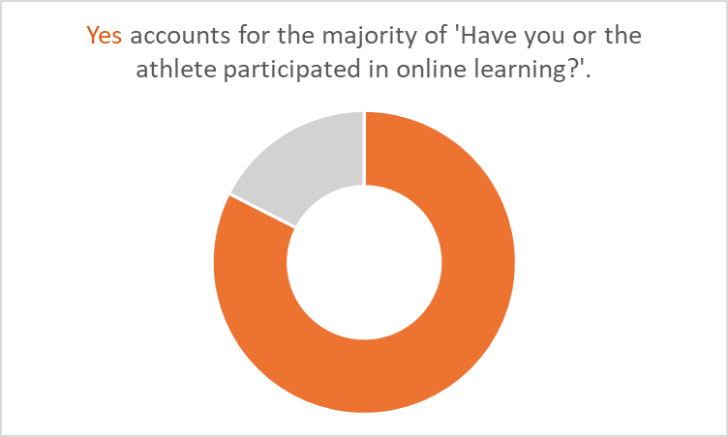

The data showed that 33 participants that completed the survey had participated in online learning.
7. The seventh question asked if the participant felt that athletes are able to develop their skills through online learning.
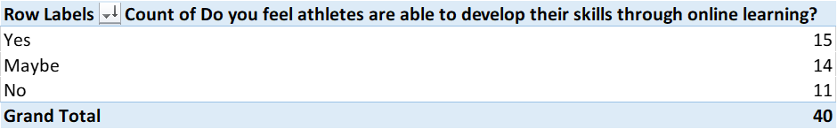
The data showed 15 participants felt athletes were able to develop their skills through online learning, while 14 were unsure and 11 felt participant were not able to develop their skills through online learning.
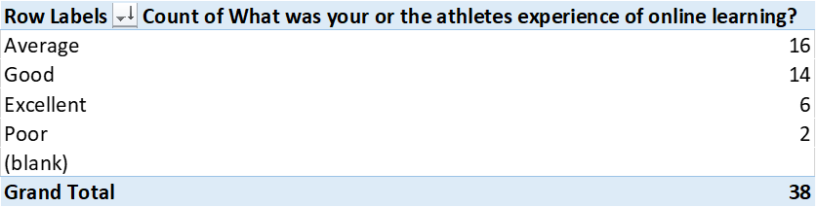
8. The eighth question asked what was the participants or athletes experience of online learning

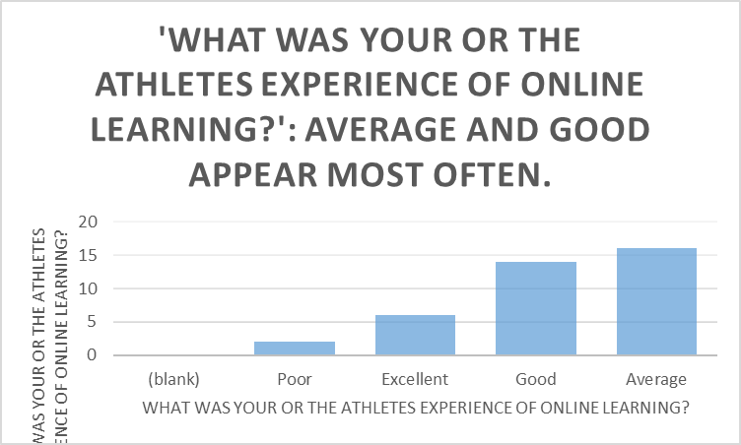

The data showed the majority felt their experience of online learning was Average, while 14 participants felt it was good.

9. The nineth question asked if the participant felt that the pandemic would impact on the number of twirling athletes
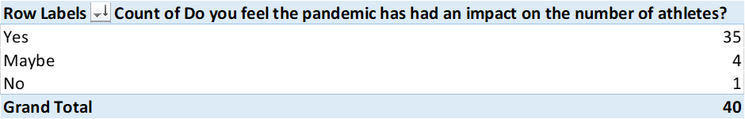

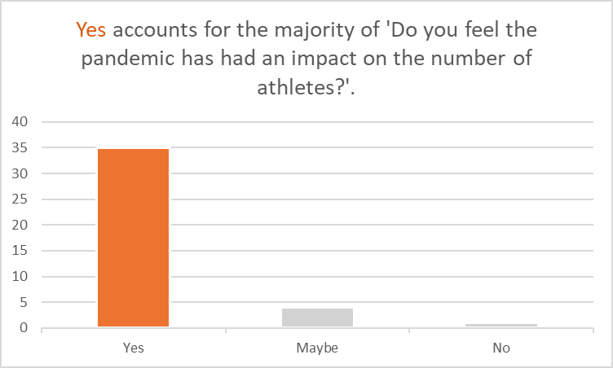

The findings showed that the majority of the participants felt that the pandemic had had an impact on the number of athletes.
10. The tenth question asked if the participant felt the pandemic would have an impact of the sport
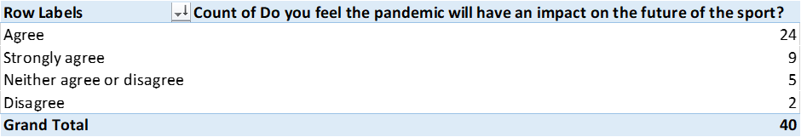

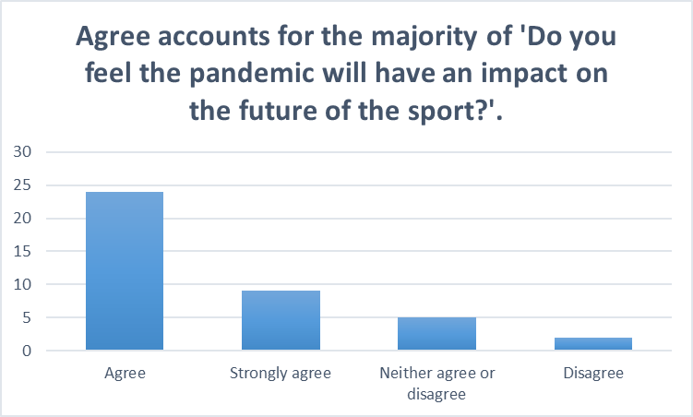

The findings showed that 24 participants felt that the pandemic would have an impact on the future of the sport.

Conclusion
Upon reflection and in moving forward had the researcher had more experience with software such as Ecxel and spss it would have enabled them to produce much better findings and it would have enabled the researcher to determine relationships between the variables which would have produced a much better analysis to include in the report, therefor it would benefit the researcher to upskill in these areas.

References
Apuke, D, O. (20170. Quantitative Research Methods : A Synopsis Approach. Arabian Journal of Business and Management Review (Kuwait Chapter) https://www.researchgate.net/publication/320346875_Quantitative_Research_Methods_A_Synopsis_Approach
Business Research Methodology. (2021). Correlation Analysis. https://research-methodology.net/research-methods/quantitative-research/correlation-regression/
CIMT. (2021). Descriptive Statistics. Centre of Innovation in Mathematics Teaching. https://www.cimt.org.uk/projects/mepres/alevel/stats_ch3.pdf
ExcelJet. (2021). What is a pivot table? https://exceljet.net/lessons/what-is-a-pivot-table
Ponto, J. (2015). Understanding and Evaluating Survey Research. NCBI. https://www.ncbi.nlm.nih.gov/pmc/articles/PMC4601897/
UCI. (2021). What is statistics? UCI Department of Statistics. https://www.stat.uci.edu/what-is-statistics/
Yellapu, V. (2018). Descriptive Statistics. International Journal of Medicine https://www.researchgate.net/publication/327496870_Descriptive_statistics

