Book
Giddens and Sutton (2013) suggested that . . . . ..
Giddens, A. & Sutton, P. W. (2013) Sociology, 7th edn. Cambridge: Polity Press.

Research Journal Article
Kwak (2017) proposed that . . . . ..
Kwak, S. (2017) ‘Approaches Reflected in Academic Writing MOOCs’, The International Review of Research in Open and Distributed Learning, 18(3), pp. 138-155.

Chapter in Book
Sarapin and Sparks (2014) critiqued current policy . . . . ..
Sarapin, S. H. & Sparks, G. G. (2014) ‘Eyewitnesses to TV Versions of Reality: The Relationship between Exposure ot TV Crime Dramas and Perceptions of the Criminal Justice System’, in Macey, D. A., Ryan, K. M. & Springer, N. J. (eds.) How Television Shapes our Worldview: Media Representations of Social Trends and Change. Plymouth: Lexington Books, pp. 145-170.

Website
Barnardo’s (2013) as an organisation outlined that . . . . ..
Barnardo’s (2019) Advocacy and Children’s Rights. Available at: https://www.barnardos.org.uk/what-we-do/protecting-children/childrens-rights-advocacy (Accessed: 15 October 2019).

Internet Image
Image 1: Extreme Poverty is Growing Rarer: But it is also Getting Harder to Root Out
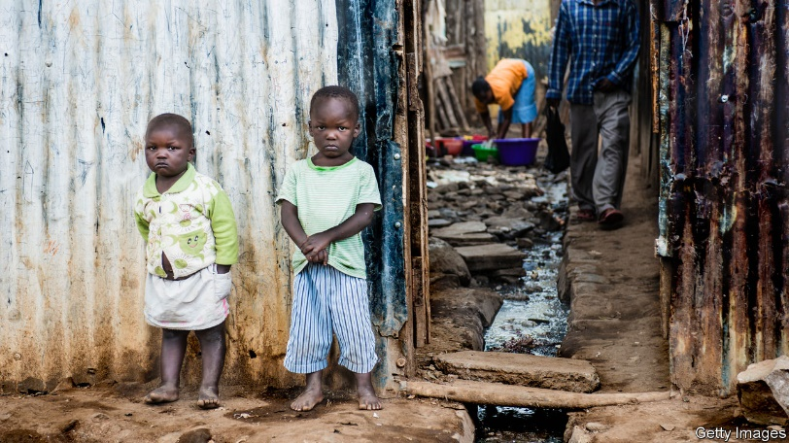
(Getty Images, 2018).

Getty Images (2018) Extreme Poverty is Growing Rarer: But it is also Getting Harder to Root Out [Online]. Available at: https://www.economist.com/finance-and-economics/2018/09/22/extreme-poverty-is-growing-rarer (Accessed: 15 October 2019).

UK Statues (Acts of Parliament)
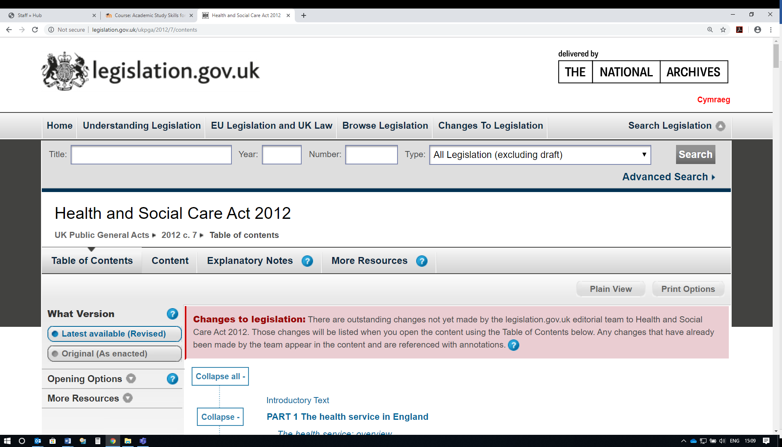
Recent UK social care legislation (Health and Social Care Act 2012) indicates that . . . .
Health and Social Care Act 2012, c. 7. Available at: http://www.legislation.gov.uk/ukpga/2012/7/contents (Accessed: 17 September 2018).
National Assembly for Wales Legislation
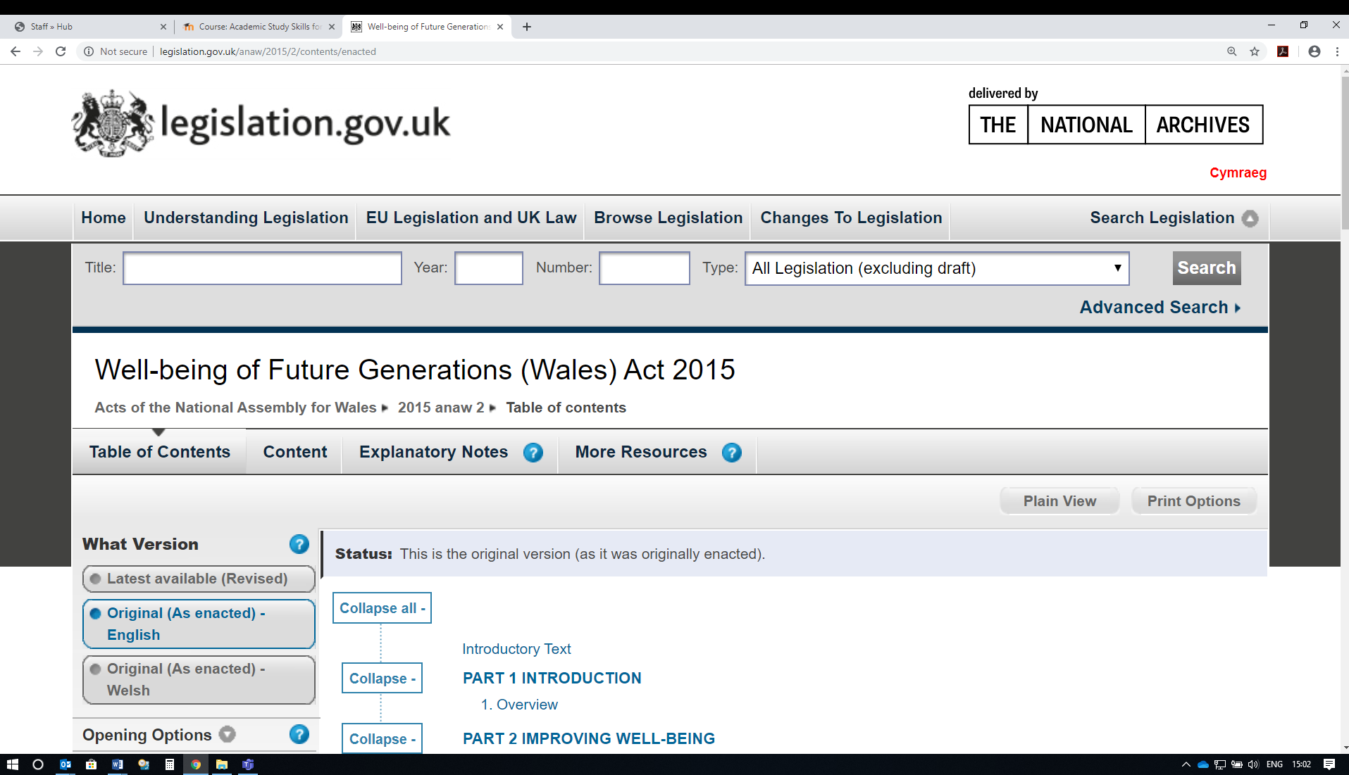
The Welsh Government (Well-being of Future Generations (Wales) Act 2015) outlined a clear set of targets for the country’s health and wellbeing.
Well-being of Future Generations (Wales) Act 2015. (SI 2015/anaw 2). Available at: http://gov.wales/topics/people-and-communities/people/future-generations-act/?lang=en (Accessed: 15 October 2019).
The highlighted text above in red is always to be found under the title of the act after the first small arrow in the text; these numbers/letters will differ according to each act/instrument.

