

Student name: | Franco Cristian Manole |  | Student ID number: |  | 2423131
Programme: | CertHE Skills for the Workplace Health and Social
Module: | Changemakers: Creativity and Value Creation
Module code: | BMHP5014 |  | Contribution to |  | 50%
Module code: | BMHP5014 |  | Overall Module  Assessment (%): |  | 50%
Assignment Title: | Online portfolio  of set exercises | Word count (or  equivalent): |  |  | 2157 words
Submission deadline: | 31st July 2026 |  | Return date of provisional marks & written feedback: |  | 28 Aug 26

Table of Contents
Subject | Page no
Introduction | 3
Task 1 | 3
Task 2 | 4
Task 3 | 5
Task 4 | 6
Task 5 | 6
Task 6 | 7
Task 7 | 8
Task 8 | 9
Reference List | 10

Introduction
Health and social care institutions need to adjust to changing population demands, personnel pressures, financial restrictions and increased expectations of customized service. To address these problems, practitioners need to develop feasible ideas, evaluate if these ideas provide substantial value and deploy them appropriately. This portfolio critically discusses the concepts of creativity, innovation, value creation and organizational transformation using examples from health and social care practice. It includes problem solving and digital technologies, research evidence, leadership and reflective learning. In the assessment academic theories and practice-based examples are utilized to analyze both the prospects and limitations of service development.
Task 1 – Defining Key Concepts in Practice
Innovation
Innovation is the deliberate introduction and use of a new concept, procedure, service or technology in a job, work team or organisation that makes a significant difference. In healthcare, it may influence how patients are viewed, heard or supported (Omachonu and Einspruch, 2010). Innovation is vital since our current service models may not be adequate to meet shifting needs. For example, a community service may provide nurse-led intravenous antibiotic treatment in patients’ homes, avoiding unnecessary hospital admissions. But innovation is not enough: the service must be safe, accessible and deliver better results. Omachonu and Einspruch’s conceptual framework also identifies technology, organizational leadership, cost and cooperation among stakeholders as determinants of innovation.
Creativity
Creativity is the generation of ideas that are both novel and useful (Runco and Jaeger, 2012). This is vital in health and social care as an uncommon idea is not much use if it is impracticable, hazardous or unpleasant to service consumers. For example, personnel in a dementia-care home might creatively change a painful bathing ritual, utilizing familiar music, personal preferences and constant carers. This method does not rely on cutting edge technology but on mixing current resources differently. Runco and Jaeger’s framework offers a relevant test: the modified routine is creative only if it is sufficiently original within that environment and improves the resident’s experience. Creativity therefore demands observation, experimentation and judgment.

Value creation

Value is created when a service generates improvements that are important to patients, relative to the inputs. Healthcare value, as emphasised by Teisberg, Wallace and O’Hara (2020), relates to measurable gains in health outcomes, not just cost reduction. For example, an integrated diabetic clinic could allow a patient to see a nurse, dietitian and podiatrist in one coordinated visit. Which could be better at controlling disease and lowering the number of visits and conflicting advice. Value is created for the patient in terms of convenience and improved results and for the system in terms of better-coordinated use of resources. But if access or quality decline then lesser expenditure can hardly be called value. Value assessment, therefore, must incorporate clinical results, patient experience, equity and total expenses.

Change
Change is the movement of individuals and organisations from an existing method of working to a new way of working. This is important because good ideas cannot improve care until they are entrenched into routine everyday. For example, implementing organized bedside handovers involves more than delivering a new template; personnel need to understand its purpose, be involved in its use and analyze its effect on safety. Implementation is explained by Normalization Process Theory that involves coherence, cognitive engagement, collaborative activity and reflexive monitoring (May and Finch, 2009). This concept underscores the social construction of change by people doing the task. Leaders, therefore, need to provide training, time, feedback and opportunity to change practice. Formal implementation may involve the fewest workers, and may not impact actual behaviour.

Task 2 – Mind Map
Low childhood vaccine uptake in underprivileged populations is a health and social care problem as protection relies on individual participation and sufficient coverage in the community. The mind map uses the 5C model: confidence, complacency, constraints, calculation and collective responsibility (Betsch et al., 2018). Low confidence can stem from disinformation or skepticism, while obstacles are transit, restrictive clinic schedules and language issues. These variables are linked rather than separate; for example, inadequate access can promote skepticism when services seem unresponsive. If participation continues low this may lead to preventable illness, local outbreaks, growing inequality and additional burden on primary and hospital care. Suitable answers include translated information, trusted community messengers, reminder systems and mobile or evening clinics. But it’s unlikely that any one campaign will address all the causes. Local services should determine the most influential 5C factor and evaluate whether the intervention enhances equitable uptake.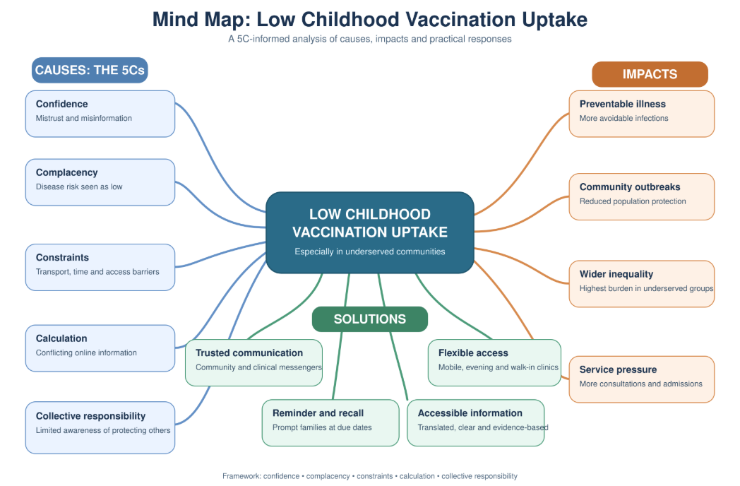

Task 3 – Self-Reflection on the Group Activity
Divergent thinking produces several different interpretations or solutions. Convergent thinking judges options to arrive at a defensible conclusion. Cropley (2006) claims that creativity involves both processes since idea production without evaluation may lead to impractical actions.
During the class debate on whether innovation always improves health and social care, I originally supported the assertion, focusing on benefits such as faster communication and earlier diagnosis. But another member of the committee highlighted the issue of digital exclusion, saying an online only program would disadvantage those without internet access. This questioned my idea that technical advancement is an automatic value generator. Then I asked the group to brainstorm some instances of positive and negative outcomes before deciding which side to take. In the end we decided that innovation only improves care when it is accessible, evidence-based and sensitive to the requirements of service-users.
In the conversation, Schön’s (1983) model was used to revisit my argument, thereby demonstrating reflection-in-action. The reflection-on-action enabled me to realise that I tend to jump to conclusions too quickly. I also learned that when various contributions are treated respectfully, disagreement can enhance logic. In future I will separate idea development from review, invite quieter members to contribute and evaluate ideas against safety, equity, feasibility and patient benefit before backing a final decision.

Task 4 – Case Study Analysis: NHS Recovery Colleges
Recovery Colleges are an innovative concept in UK mental health treatment . Traditional services may present people as passive beneficiaries of professional therapy, with few possibilities to gain knowledge, confidence or supporting relationships. Recovery Colleges therefore work with participants as students and offer educational courses on wellbeing, self-management and how to live meaningful lives with mental health difficulties. Courses are co-created and co-delivered by the professionals and the persons with lived experience (Perkins et al., 2012).
The innovation of the approach lies in the replacement of the traditional clinician-patient connection with collaborative learning. It echoes coproduction, in which service users have a direct role in creating and delivering public services rather than being engaged after decisions have been taken (Bovaird, 2007).
Research found empowering surroundings, distinct interactions and personal growth as essential processes, with documented changes in students’ confidence, social life and service usage (Toney et al., 2018). However, much of the evidence is qualitative or observational, which makes it hard to make causal claims and cost-effectiveness.

Task 5 – Research Task: Antimicrobial Resistance
Antimicrobial resistance is a present day health and social care challenge as formerly treatable infections may become more difficult, expensive and dangerous to manage. Holmes et al. (2016) recognize antibiotic exposure as an important factor. Selection pressure is created by inappropriate prescribing, insufficient treatment, widespread usage in agriculture and the presence of antimicrobials in the environment, which permits resistant organisms to persist. Weak infection-control measures and migration across hospitals, communities, and countries therefore encourage transmission.
For a more detailed explanation see Collignon et al. (2018). Their analysis at country level connects resistance with poor governance, lack of sanitation, unequal access to health care and other socio-economic factors. This implies that prescribing measures alone cannot solve settings where resistant organisms quickly propagate.
The articles agree that resistance is generated by interrelated human and systemic activity. However, while Collignon et al. (2018) focus on structural conditions, Holmes et al. (2016) emphasise biological causes and antimicrobial usage. The first article is a systematic synthesis, although based on evidence from different circumstances. The second finds important connections but cannot assess causality at the person level with country level data.

Task 6 – Exploring Digital Innovation
6.1 Wearable technologies & Parkinson disease
One big advantage of wearable equipment for a person with Parkinson’s disease is ongoing, objective symptom tracking. Wrist-worn or body-mounted sensors can capture tremor, delayed movement, stride and changes in mobility during normal living. This provides information which may not be apparent in a brief clinical session. For instance, recorded movement patterns could show when effects of medication wear off, enabling a neurologist to alter the schedule of treatment.

Espay et al. (2016) explain that digital monitoring could promote more personalized assessment and lessen reliance on infrequent clinical rating scales. Yet more data is not inevitably better care. Sensor data may not be able to capture pain, mood or other non-motor sensations therefore measurements need to be clinically valid and interpreted along with the person’s experience. Devices may also raise privacy problems, technical challenges or anxiety about being constantly monitored.

6.2 EHRs and child protection
Electronic health records have the potential to improve collaboration in child safeguarding by providing a longitudinal report available to permitted providers. A GP, emergency doctor, paediatrician and health visitor may each observe information that seems small in isolation. A common record can link repeated injuries, missed appointments, medication history and past professional concerns, in support of faster multidisciplinary review.
Menachemi and Collum (2011) list the possible benefits of EHR systems as better availability, quality and coordination of information. Electronic notifications and recorded referrals can also help clear which practitioner is accountable for follow-up. Information, however, is very delicate to protect. Access to be role-based, open to audit and proportional; Incomplete records, copied notes or incompatible systems may offer false reassurance while too many alarms may cause vital cautions to be missed. Information on social care may also be outside of health systems . EHRs encourage collaboration, however, only when professionals have correct data, speak immediately about severe concerns and follow established safeguarding measures.

6.3 Electronic fall prevention
Digital technology can help preventive care by providing older persons with tailored balance exercises at home. StandingTall is an e-health programme, which has an app that provides exercises that are gradually more hard depending on the user’s capacity. Prompts, progression and activity records can stimulate regular engagement, obviating the need for recurring medical visits.
A two-year randomised controlled experiment showed that the intervention reduced falls and injurious falls among independently living older individuals (Delbaere et al, 2021). This shows how digital interventions can tackle risk before an injury, hospital admission or loss of freedom. Safety and continued participation is key to effectiveness. Some older persons may not have an appropriate device, internet connection, confidence or a safe location for exercising.

Task 7 – Understanding the NHS Leadership Framework

7.1 Parts and meaning
The NHS Healthcare Leadership Model specifies observable behaviours that can be developed by clinical and non-clinical professionals including those without official management posts. Its nine characteristics include inspiring shared purpose, leading with care, analyzing information, linking our service, sharing the vision, engaging the team, holding to account, creating capability and influencing for results (NHS Leadership Academy, n.d.: 6). Behaviour is assessed in terms of growing levels of complexity rather than being tied to specific job titles.
The paradigm is vital because health and social care leadership demands compassion, evidence evaluation, teamwork and accountability all at the same time. According to Storey and Holti (2013), NHS leadership needs to engage with complicated organizational relationships and not rely solely on heroic individuals at the top. The concept then advocates leadership in teams and services.
Effective clinical leadership is linked to the ability to support quality, safety and professional engagement (Daly et al., 2014). But the framework cannot address dangerous staffing, lack of resources or a harsh organisational culture. There is no benefit in completing a leadership evaluation, unless followed by feedback, behavioural growth and measurable change. The dimensions should therefore be implemented according to the demands of staff, service users and the care environment concerned.

7.2 Using “Evaluating Information”
Evaluating Information” could be used by a leader to enhance the emergency care of patients who are not fluent in English. The leader would review complaints, interpreter waiting times, safety problems and delays in treatment, breaking down results by language rather than relying just on general statistics. Interviews with patients, interpreters and frontline staff might highlight issues that are not picked up by numerical data.
This could allow the team to produce possible solutions, such as clearer identification of language needs, rapid access to skilled video interpretation and visual communication resources. The leader will pilot selected ideas on a small scale and measure waiting time, understanding, safety issues and patient feedback before rolling them out more widely. This is consistent with the NHS Leadership Academy’s emphasis on leaders to explore fundamental causes and develop better processes out of evidence.

Task 8 – Self-Reflection Journal Entry
Before this module I thought innovation was about bringing in high tech. The vaccination mind map has transformed my thinking, showing that low uptake has several psychological and structural explanations. This showed that a creative response had to address the right problem, not just seem innovative. My work with the Recovery College also showed me that we may generate value by transforming connections and sharing power with people with lived experience. The antimicrobial resistance research also contradicted individualistic interpretations by showing the interaction between clinical, environmental and socioeconomic systems.
By using the Four Lenses model, I am able to reflect on practice from personal experience, service user perspective, colleague perspective and academic evidence (Brookfield, 2017). In my future position I will not take for granted that professional advice is enough. I will ask service users what matters, try out ideas with colleagues and compare outcomes with published evidence. This will enable me to promote initiatives that are realistic, inclusive and genuinely helpful.

Reference List
Betsch, C., Schmid, P., Heinemeier, D., Korn, L., Holtmann, C. and Böhm, R. (2018) ‘Beyond confidence: Development of a measure assessing the 5C psychological antecedents of vaccination’, PLOS ONE, 13(12), e0208601. Available at: https://doi.org/10.1371/journal.pone.0208601.
Bovaird, T. (2007) ‘Beyond engagement and participation: User and community co-production of public services’, Public Administration Review, 67(5), pp. 846–860. Available at: https://doi.org/10.1111/j.1540-6210.2007.00773.x.
Brookfield, S.D. (2017) Becoming a Critically Reflective Teacher. 2nd edn. San Francisco, CA: Jossey-Bass. Available at: Wiley (Accessed: 27 July 2026).
Collignon, P., Beggs, J.J., Walsh, T.R., Gandra, S. and Laxminarayan, R. (2018) ‘Anthropological and socioeconomic factors contributing to global antimicrobial resistance: A univariate and multivariable analysis’, The Lancet Planetary Health, 2(9), pp. e398–e405. Available at: https://doi.org/10.1016/S2542-5196(18)30186-4.
Cropley, A. (2006) ‘In praise of convergent thinking’, Creativity Research Journal, 18(3), pp. 391–404. Available at: https://doi.org/10.1207/s15326934crj1803_13.
Daly, J., Jackson, D., Mannix, J., Davidson, P.M. and Hutchinson, M. (2014) ‘The importance of clinical leadership in the hospital setting’, Journal of Healthcare Leadership, 6, pp. 75–83. Available at: https://doi.org/10.2147/JHL.S46161.
Delbaere, K., Valenzuela, T., Lord, S.R., Clemson, L., Zijlstra, G.A.R., Close, J.C.T., Lung, T., Woodbury, A., Chow, J., McInerney, G., Miles, L., Toson, B., Briggs, N. and van Schooten, K.S. (2021) ‘E-health StandingTall balance exercise for fall prevention in older people: Results of a two-year randomised controlled trial’, BMJ, 373, n740. Available at: https://doi.org/10.1136/bmj.n740.
Espay, A.J., Bonato, P., Nahab, F.B., Maetzler, W., Dean, J.M., Klucken, J., Eskofier, B.M., Merola, A., Horak, F., Lang, A.E., Reilmann, R., Giuffrida, J., Nieuwboer, A., Horne, M., Little, M.A., Litvan, I., Simuni, T., Dorsey, E.R., Burack, M.A., Kubota, K., Kamondi, A., Godinho, C., Daneault, J.-F., Mitsi, G., Krinke, L., Hausdorff, J.M., Bloem, B.R. and Papapetropoulos, S. (2016) ‘Technology in Parkinson’s disease: Challenges and opportunities’, Movement Disorders, 31(9), pp. 1272–1282. Available at: https://doi.org/10.1002/mds.26642.
Holmes, A.H., Moore, L.S.P., Sundsfjord, A., Steinbakk, M., Regmi, S., Karkey, A., Guerin, P.J. and Piddock, L.J.V. (2016) ‘Understanding the mechanisms and drivers of antimicrobial resistance’, The Lancet, 387(10014), pp. 176–187. Available at: https://doi.org/10.1016/S0140-6736(15)00473-0.
May, C. and Finch, T. (2009) ‘Implementing, embedding, and integrating practices: An outline of Normalization Process Theory’, Sociology, 43(3), pp. 535–554. Available at: https://doi.org/10.1177/0038038509103208.
Menachemi, N. and Collum, T.H. (2011) ‘Benefits and drawbacks of electronic health record systems’, Risk Management and Healthcare Policy, 4, pp. 47–55. Available at: https://doi.org/10.2147/RMHP.S12985.
NHS Leadership Academy (n.d.) Explore the Healthcare Leadership Model. Available at: NHS Leadership Academy (Accessed: 27 July 2026).
Omachonu, V.K. and Einspruch, N.G. (2010) ‘Innovation in healthcare delivery systems: A conceptual framework’, The Innovation Journal: The Public Sector Innovation Journal, 15(1), Article 2, pp. 1–20. Available at: The Innovation Journal (Accessed: 27 July 2026).
Perkins, R., Repper, J., Rinaldi, M. and Brown, H. (2012) Recovery Colleges. London: Centre for Mental Health. Available at: ImROC (Accessed: 27 July 2026).
Runco, M.A. and Jaeger, G.J. (2012) ‘The standard definition of creativity’, Creativity Research Journal, 24(1), pp. 92–96. Available at: https://doi.org/10.1080/10400419.2012.650092.
Schön, D.A. (1983) The Reflective Practitioner: How Professionals Think in Action. New York: Basic Books.
Storey, J. and Holti, R. (2013) Towards a New Model of Leadership for the NHS. Leeds: NHS Leadership Academy. Available at: NHS Leadership Academy (Accessed: 27 July 2026).
Teisberg, E., Wallace, S. and O’Hara, S. (2020) ‘Defining and implementing value-based health care: A strategic framework’, Academic Medicine, 95(5), pp. 682–685. Available at: https://doi.org/10.1097/ACM.0000000000003122.
Toney, R., Elton, D., Munday, E., Hamill, K., Crowther, A., Meddings, S., Taylor, A., Henderson, C., Jennings, H., Waring, J., Pollock, K., Bates, P. and Slade, M. (2018) ‘Mechanisms of action and outcomes for students in Recovery Colleges’, Psychiatric Services, 69(12), pp. 1222–1229. Available at: https://doi.org/10.1176/appi.ps.201800283.

