Kirsty Allen | 2014114
Ken O’Grady | ECYW5001
Does supporting young people’s wellbeing encourage their community engagement?
Social Research for Professional Practice.
Contents page.

 | Page
Does supporting young people’s wellbeing encourage their community engagement? Social research question. | 2-17
Reference List | 18-19
Appendix | 20-65

“Does supporting young people’s wellbeing encourage their community engagement?”

O’ Brien, et al (2010) undertook research proving that volunteering and community engagement can help improve health and wellbeing whilst building sustainable communities. Research provides positive outcomes for people's physical, social and mental wellbeing for all with different backgrounds, abilities and from social economic backgrounds.
This theory suggests that engaging with your community improves your wellbeing. I would like to research if it shows the same link in reverse for our young people. I will be studying the impact of wellbeing sessions for young people and if it then encourages their community engagement, feel good, do good. If their wellbeing is supported, creating a stable positive attitude for them, will they then join their community and benefit from it, becoming positive members of their community.
This will work in accordance with The Five Pillars of Youth work (2018) by helping young people learn and develop skills to carry out their responsibilities as citizens and members of their communities, encouraging them to engage with each other and their community that affect their lives and the lives of others around them.
By supporting young people’s wellbeing and emotional health this research also works in accordance with The Youth Work National Occupational Standards (CLD Standards Council Scotland, 2019) YW18, explains the importance of supporting young people’s emotional wellbeing and mental health through methods such as creating networks, coping strategies, social, economic and leisure activities.
The research methods I plan to use will help young people create a social network in their community with new friends, and people they can relate to, relating to the centre of this standard for young people to be socially included, as well as providing young people with activities with their peers to promote their wellbeing. Implementing a mentoring program from their support workers will minimise barriers of poor wellbeing, encourage positive mental and emotional health, providing young people with relevant resources.
Introduction:
For my social research I will critically evaluate both qualitative and quantitative research methodology, while including their strengths and weaknesses to try and prove a connection between supporting young people’s wellbeing and their community engagement through participatory research methods. This will include a critical review on my own role as the researcher, ethics and conflict of interest while working with key principles, standards and policies which underpin youth work and to help provide positive outcomes for young people and significantly strengthen the impact of youth work.
Thomas (2022) explains that The Wales Wellbeing research group - a collaboration between Swansea University, Cardiff University, and the NHS in Wales have found that there has been a significant rise in young people aged 16-24’s metal health during the Covid pandemic with many saying that it has affected their anxiety and increased their stress. Relationships play a vital part to their adolescence development and without them it has left young people without protection against anxiety, depression, and suicidal ideation.
The covid restrictions are easing, it is vital to rehabilitate young people back into their community whilst promoting their emotional and mental health. The rise in young people reporting their mental health getting worse, proving the need to act on this research. By linking both the wellbeing and the community we will hopefully encourage young people to make new relationships and help them develop for re-entering the community.
Outline design and delivery:
Robinson (2020) notes that previous studies have shown a strong connection between people helping others, the community, and their positive wellbeing against those that do not. Showing that people that do good, feel good. He explains that through the pandemic, people will often perform acts of kindness and good deeds leaving them feeling in control with bursts of euphoria, ‘the helpers high’ in the brain.
By helping young people feel this ‘helpers high’ we encourage them to do good and hopefully continue to do good. So, what if we already provide them with a good feeling, promoting their wellbeing through a range of activities and support first, will this then encourage them to do good for others and their community?
If this research proves successful it will provide young people with positive outcomes, underlined by, The National Youth Service Strategy for Wales (WAG, 2018) by ensuring young people enjoy their activities and receive a positive outcome for their mental health, making a positive contribution either by participating in social events, community events or both, improving their wellbeing, increase levels of self-motivation, confidence, and if they do participate in the community events, develop their practical skills, team building skills communication, problem solving, decision making skills as well as developing empathy for others, influencing other young people to do good in their community and build relationships.
Bloom is a new service funded by Barnardo’s offering Life Coaching, Befriending and Peer Mentoring to young people aged 16 – 25, who are care experienced as they make the transition to independence with the aim to provide positive outcomes such as improvement to their mental health, emotional wellbeing, and resilience.
This research will help us see if there is a link between providing young people with more activities to promote their wellbeing if successful in providing a better positive mindset with support from counselling, will affect their own decision to partake in activities and community engagement.
If the research shows an increase in the young people’s participation in community engagement, it shows that by organisations encouraging and supporting young people’s wellbeing and emotional health, they will help them rehabilitate into the community and help them on their way to becoming contributing members of society, creating a strong value link between all young people, youth workers, organisations, and the impact they have on the community.

Methodology.
In order to conduct this research, I will use mixed methodology, there are three methodologies I will use to measure my results: case studies, questionnaire reviews and attendance record. This will provide my research with both qualitative and quantitative data.
Case studies conducted by support workers through mentoring support, will provide the study with qualitative data, I will ask the support workers to fill out a case study report at the start and at the end, for them to measure how their young person has developed and if mentoring and wellbeing activities have had a positive effect on the community engagement.
Miller (2016) notes that the case study methodology can generate in-depth multifaceted understanding of a complex issue or person in real-life context and is extensively used in social sciences such as youth work. Although case studies come with positives such as providing evidence for practical improvements, provides a detailed and in-depth detail, holistic and provides a time scale of relevant data, considerations against this should also be considered such as, it may not apply to other cases, results may be influenced by the researcher and difficult to replicate.
Although case studies can be considered difficult to replicate and may not be applied to other cases I plan to justify this by asking multiple support workers to fill out the same case study form. All young people will be from the same service and age range, creating continuity between the case studies and with different support workers to compare results.
Multiple support workers will help provide realistic results by providing a range that is not biases by one. Results will also not be able to be influenced by support workers, as they too will not know that we are measuring the result in community engagement, rather just supplying a report on their young person’s mental health and recent activity.
Gustafsson (2017) notes that researchers using multiple case studies, using that same method provides for strong and accurate results, it minimises the open to interpretation factor by providing similar and precise results towards a theory when compared.
By asking the young people to complete their own questionnaires I am promoting their rights and encouraging them to have their own voice and say.
I understand that one of the disadvantages of questions given to young people is that they often find them time consuming and will rush them to get to the end, often resulting in unreliable results, along with peer pressure, if they are in groups, they may often answer the way their peers are answering. I plan to overcome this by making my questionnaires short, including a number scale, providing both qualitative and quantitative data (please see appendix 2).
By taking an attendance record at the wellbeing events and community events it should show as the increase of young people going to wellbeing events across the program with a correlating rise of young people attending the community events by the end of the program. This will provide me with quantitative data as it will provide me with numbers only. The disadvantages of doing this is that the young people may feel pressured to turn up and feel judged. I plan to overcome this by letting the young people know I will not be using their names; I will be keeping it confidential. I will also be reminding them at the start and end of each session that they have the right to withdraw at any time and they do not need to participate if they do not want to.

Methods.
There are two methods I will use to try and increase the young people’s overall wellbeing. Providing wellbeing activities, socialising events that they would not usually be able to do for themselves. And providing detailed support around their mental health in their weekly one-to-ones with their support worker. This will be more structured than their usual support, by providing a list of questions and prompts for the support worker to ask their young person (please see appendix 2).
This research method will take place with ten young people, over seven weeks, and I have provided a suggested schedule (please see appendix 5) that will provide structure to the research study.

Tools.
The tools I will be using for this research will consist of questionnaires, mentoring sessions, and events (please see appendix 2).
Member checking will also be applied throughout this research (please see appendix 3).

Data collection.
All data will be reviewed at the end by myself and the Blooms service manager before sharing the results with the project and relevant funders.
Data collection from the case studies will provide a detailed summary of the young person’s mental health and wellbeing and their likelihood to participate in community events. Followed by the case study filled out with an added progression section to be completed at the end of the program.
Questionnaires results will provide results for the young person’s own review of their mental health and likelihood to progress in community events.
An attendance record will be submitted as the main part of data collection, this will provide us with the number figures to show hard evidence of this research.

Data Analysis.
This will be a deductive data analysis approach as I am developing a hypothesis based on an existing theory. With the initial assumption that by promoting young people's wellbeing will encourage their community engagement. With the secondary premise in relation to this that feeling good will lead to doing good Robinson (2020) and a theory presented by O’ Brien, et al (2010) proving that community engagement promotes wellbeing. By testing this theory through a range of activities and mentoring providing both qualitative and quantitative data which will provide me with the conclusion that this research is either valid or invalid.

Evaluation/Use of Results (Actions/Recommendations/Share, etc.)
If this study proves successful this will prove that by supporting young people’s wellbeing and developing our techniques in supporting their mental health in detailed mentoring we will help better their mindset, meaning, feeling good leads to doing good. Showing the positive effects of both working together to further promote their development mentally as well as their skills and knowledge to find their way into community and society.
Hopefully the data provided at the end of this research will help influence and potentially change the policies for supporting young people’s wellbeing. Changing to provide better services, mentoring, support, and activities. Helping our service, other services, workers, volunteers, and funders to realise the importance of wellbeing in young people and how it impacts their lives and provides them with more opportunities.
Participatory Research.
I will be supporting these wellbeing sessions personally, although there will be other staff members with me, I will take lead in delivering activities. The advantage of this is that young people are used to me running actives. I will be researching in an environment that they are used to, and this will encourage natural behaviour compared to someone they do not know, meaning they would be nervous and possibly not participate fully.
I have already built a good rapport with the young people participating and by taking a lead and being involved with this project I can insure that we work in accordance with certain youth work principles, values and purposes for example to work in accordance with The Youth Work National Occupational Standards (CLD Standards Council Scotland, 2019) YW24 by monitoring and evaluating the impact of youth work activities and programmes and to recognise and encourage positive benefits and outcomes by involving young people in the community and helping them realise their own impact.
The risks of my involvement may include young people changing their behaviour to provide the outcome they think I want for the research; however, I will do my best to strive for accuracy in the results by, encouraging young people to be honest with their answers and explain to them the importance of them being honest for the service to improve for them. I also believe that my process in this research will not affect the data because the young people will remain unaware of the main aim of attendance in community events.
Mayan (2015) notes that the benefit of participatory research is to generate detailed knowledge about a particular theory and then take action to improve the lives of the people. Although time consuming and requiring patience, to provide strong data at the end requires participants to maintain their commitment throughout the process it can provide the opportunity for groups to be heard and learning skills for themselves and for their community to improve long term. And it is for this reason I believe that the young people in this study will participate fully as they have specified that they want better from the service and the community.
This participatory research works in accordance with The Youth Work National Occupational Standards (CLD Standards Council Scotland, 2019) YW02 by assisting young people to engage with youth work service, by understanding how they feel and what they can do, enabling them to express their emotions, concerns and develop their goals and help them realise their needs. Also, by monitoring young people and safeguarding their wellbeing.

Relevant to Young People.
This study is relevant to young people in two main ways. The first leads back to what they have asked for from the service (please see appendix 4). They wanted additional services, activities and support available to help them with their main issues such as mental health, someone to talk to, distractions, anxiety and depression, which all link into wellbeing. This research provides them with additional support.
The second way is the activities planned have also been activities they have asked for (please see appendix). When asked what activities they want to participate in, I have included the most popular suggestions in my schedule plan (please see appendix 5).
If this research provides data that supports my theory, this will also be relevant to young people in a third way, by developing their knowledge and making new skills, encouraging them to become more active in the community, rehabilitate into the community, encouraging social support as well as job prospects and their wellbeing.
The Youth Work National Occupational Standards (CLD Standards Council Scotland, 2019) YW23, encourages youth workers to engage with young people to inform the strategic development and delivery of youth work. It also sets a standard of ensuring young people are involved in both decision making and involvement of activities for them to understand key values within youth work.
This way the young people are involved in helping design, facilitate, and evaluate the research from the start to the extent of picking the activities, voicing their wants for more emotional support and can reflect and evaluate through mentoring sessions and questionnaires.
The need for this research was not only identified by the needs for the young people, however, the current waiting list for other services such as CAHMs mental health combined with the referrals that the Young Person’s Advisory Service (YPAS) are putting in for their young people. As well as current services reporting no participation from young people in community events (please see appendix 3).

My role in the process.
Patel (2015) explains a research paradigm as your own ontology and epistemology that creates a holistic view on your knowledge and experiences that affects methodological strategies that we use to discover it and how our awareness of this will increase the quality of research and contribute to the creativity of the research. He continues to explain that there are usually four different kinds of research paradigm: Positivists, Constructivists, Transformative and Pragmatists.
My role as the researcher is the positivist paradigm as I believe there is a single reality (feeling good leads to doing good), supporting and encouraging young people’s wellbeing will encourage their community engagement, as I have seen this happen in myself and many other young people, therefore I will use quantitative methods (attendance records, number scores in questionnaires) to measure and record this data. However, I also believe that by supporting young people’s mental health you can help provide them with a wide range of benefits, which is why I have also included qualitative methods (case studies and written questionnaires) to see the multiple realities of how we help young people by supporting young people.
As a researcher, I may be prone to researcher bias, as it is part of my role to provide wellbeing activities for young people and I strive to provide that for them. Wellbeing is something that I feel strongly about, personal interest and I am passionate about, however, to avoid this affecting my results I plan on checking results with my manager to help stay true to the data. I will also not be involved with the mentoring support provided by the support workers.
Wellbeing is an issue I relate to and feel strongly about, my own mental health and wellbeing have always suffered and stemmed from similar issues that young people in the service have experienced. However, I understand how stress affects my wellbeing, and the sensitivity of some issues. I do not see this as a possible issue to affect my role as the researcher as I have learnt how to control my triggers and know how to support young people through theirs. If anything, this will benefit the research by my ability to support young people and relate to them, helping them feel more supported as one of the research aims.
However, I understand that I have a lot of involvement in this research, although I do not feel there have been any attachments built, I have built a rapport with some of the young people that will be participating. My experience and job is to promote engagement of young people and although all of this I feel will benefit the research. I understand that this could also alter the data and influence young people’s participation, to avoid this risk I have put in multiple tools and changes to help provide true participation and data, for example, YPAS will be running mentoring sessions, member-checking has been added and encouraged, the manager of the project will check results with me and I will keep a reflective journal as the researcher to record anything I need to reflect on that might affect the research.

Ethical Considerations:
The main ethical issues that will affect this research is using indirect deception with the young people. The young people will be briefed about how their participation in this research will help provide data on how to better support young people’s wellbeing through activities and mentoring support. They will not be told that their attendance in community events will be recorded.
Sanders (2021) explains that one basic reason to use indirect deception in research is to observe genuine reactions of the participants, although it keeps them from the actual purpose of the research it prevents them from changing their behaviour based on their perceptions of the research purpose.
I will be using indirect deception to measure the young people’s participation in community events, this will help keep data true by minimising the possibility of young people changing their behaviour to prove or even disprove the theory. This is also a benefit as it puts less stress on the young people, if they feel they need to turn up for the purpose of the research. Although they will be told part of the research and attendance will be monitored for wellbeing events, I do not feel like this is too harmful to the young people as it does not stray too far from the truth.
However, I am concerned about how the young people feel afterwards knowing that the truth was withheld from them, this may be triggering, or may lead them to mistrust youth workers in the future. To try and minimise these issues I will also not be telling the YPAS that attendance will be monitored in community events, this way they have not lost their trust in their support worker. At the end of the research young people will be told the full research aims and what we are measuring for data, I will tell them here that they have the right to withdraw, and their data will not be used. I will also make sure that staff and YPAS are available and attend this too, if young people then feel like they need additional support after finding out, they will have it available.
Another ethical issue is consent. This service is provided for leaving care service, young people are aged between 16-25. Those over the age of 18 will be briefed and given their own consent form to complete. For those that are under 16, they will be brought into a meeting with their social worker where they will be briefed together, if they still want to take part in the research and their social worker agrees, the social worker will sign the consent for/with the young person giving them consent to participate. YPAS participating will also be required to sign a consent form.
Confidentiality and data protection will be used throughout this research. Young people’s names will not be used. Instead, it will be replaced with YP1, YP2, YP3 and so on, after research and data has been collected and used to finalise results, it will then be shredded, and disposed of correctly following companies’ policy.
Although some would argue that wellbeing events would be considered an incentive to participate, Blooms service provide wellbeing events for the young people. I do not consider this an ethical issue of persuading the young people that could then alter the results, as this is a standard expected from the service.
This research design will be submitted to the relevant ethical board beforehand along with a risk benefit analysis (please see appendix 1). If the ethical board agrees with the research plan the research will go ahead. However, if this research is not successful in passing the relevant ethical board, I will re-design the delivery to fit required needs. As well as this, all activities will have their own risk assessments as well as the company’s risk assessments to ensure the safety of all young people, staff, and volunteers. All staff and volunteers will have refreshment training on safeguarding to ensure maximum safety for young people.
A contract will be completed with the young people and a plan put in place for those that do not want to participate (please see appendix 3 and 6).

UNICEF (2022) explain that The United Nations Convention on the Rights of the Child (UNCRC) 1989 is a human rights treaty setting out the civil, political, economic, social, health and cultural rights of children. And it is key to remember these articles when planning research with young people to ensure that all rights are met by the young people.
Some would suggest that this research goes against article 13 of the UNCRC, giving young people all kinds of information. By withholding part of the research aim, it could be considered that the research is going against this right. However, this research supports many other articles from the UNCRC, including article 13, by giving all young people the right to express themselves their thought and feelings. Other articles, such as article 2 non-discriminatory against religion, ethnicity, gender and language (a translator will be provided for any young person to fully enjoy their activities and feel the full benefit from support). Article 24, by providing support to mental health and wellbeing. Article 31 by ensuring all young people in this research has the right to relax, play and take part in a wide range of activities.
This research works in accordance with BERA ethical guidelines in multiple ways however, with consent and the right to withdraw. BERA (2022) explains that it is important to get consent before the start of research and to remain sensitive and open to the possibility that participants can withdraw at any point. Researchers operate within ethics of respect for any person involved by treating everyone fairly, sensitively, dignity, freedom from prejudice and in recognition of all rights.
ETS (2012) explains that the Code of Occupational Ethics for Youth Work in Wales is a set of principles within the organization that guid decision making, ensuring they stay withing ethical guidelines, and this creates a cornerstone of credibility by creating five specific areas: Occupational intervention, Responsibility for young people, Responsibility to colleagues, Responsibility to employers and Responsibility to the occupation. This research works within these five areas by, having personal responsibility concerning myself and the nature of their intervention and I will monitor this by keeping a reflective diary. By enabling young people achieve the outcomes identified in the National Youth Service Strategy: active participation; wider skills development; and enhanced emotional competence. I have responsibility for young people by promoting their rights and promote policies and practice that enhance the self-determination, self-esteem, collective responsibility and the active citizenship of young people and their community.

Conclusion:
I have chosen this research as it is something that speaks strongly to me, supporting young people’s wellbeing by helping them process their thoughts, feelings and emotions clearly, helps provide them with a better quality of life, and by doing so helps them find their way happily in society and to become responsible citizens. By working in accordance with, The Youth Work National Occupational Standards (CLD Standards Council Scotland, 2019) YW15 to address and improve the wellbeing of young people and to help young people identify issues and take reasonable care for their own wellbeing
I understand that I have raised some ethical issues through this research however, if this research proves successful it benefits young people and the community with little to no harm/risk while supporting them holistically during the process.
This social research study works in accordance with, The Youth Work National Occupational Standards (CLD Standards Council Scotland, 2019) YW09 by supporting young people to become responsible citizens through active involvement with youth work activities and events. This will help all youth workers understand why this strategy is important by supporting young people in their community and helping them understand the positive outcome it has.
Mind (2022) have identified that there are five steps to wellbeing, to achieve and develop these five steps will help you maintain a strong and healthy mindset that contribute to your overall health. These five steps are: connect, be active, take notice, learn and give.
By helping the young people connect, providing support sessions and socializing opportunities. By being active in trips and the in the community. Supporting them take notice, by getting them to reflect in mentoring sessions. Developing and learning new skills such as coping mechanisms. Giving by encouraging participation in community events.

.

References:
- BERA. (2022) Ethical Guidelines for Educational Research. Available at: http://www.bera.ac.uk (Accessed 12th May 2022).
- Birt, L. (2016) Member Checking: A Tool to Enhance Trustworthiness or Merely a Nod to Validation? Available at: http://pubmed.ncbi.nlm.nih.gov (Accessed 12th May 2022).
- Cherry, K. (2020) The Hawthorne Effect and Behavioural Studies. Available at: http://www.verywellmind.com (Accessed 12th May 2022).
- ETS, (2012) Code of Occupational Ethics for the Youth Service in Wales. Available at: http://www.etswales.org.uk (Accessed 12th May 2022).
- Gustafsson, J. (2017) Single case studies vs multiple case studies: A comparative study. Available at: http://www.diva-portal.org (Accessed 12th May 2022).
- O’Brien, L, et al. (2010) ‘Doing Something Positive’: Volunteers’ Experiences of the Well-Being Benefits Derived from Practical Conservation Activities in Nature. Available at: http://link-springer-com.ezproxy.uwtsd.ac.uk (Accessed 12th May 2022).
- Mayan, J. (2015) Worth the risk? Muddled Relationships in Community-Based Participatory Research. Available at: http://www.journals.sagepub.com (Accessed 12th May 2022).
- Miller, B. (2016) 7 Pros and Cons of Case Studies. Available at: http://www.greengarageblog.org (Accessed 12th May 2022).
- Mind. (2022) 5 ways to wellbeing. Available at: http://www.mind.org.uk (Accessed 12th May 2022).
- Patel, S. (2015) The research paradigm – methodology, epistemology and ontology – explained in simple language. Available at: http:// http://salmapatel.co.uk (Accessed 12th May 2022).
- Robinson, B. (2020) Why Doing Good Boosts Health And Well-Being. Available at: http://www.forbes.com (Accessed 12th May 2022).
- Sanders, A. (2021) Deception in Psychological Research. Available at: http://www.study.com (Accessed 12th May 2022).
- The National Youth Service Strategy for Wales. (WAG, 2007) The National Youth Work Strategy for Wales. Available at: https://dera.ioe.ac.uk/ (Accessed 12th May 2022).
- Thomas, K. (2022) STUDY REVEALS LOCKDOWN IMPACT ON YOUNGSTERS’ MENTAL HEALTH. Available at: http://www.swansea.ac.uk (Accessed 12th May 2022).
- UNICEF. (2022) How we protect children’s rights. Available at: http://www.unicef.org.uk (Accessed 12th May 2022).
- The Youth Work National Occupational Standards (CLD Standards Council Scotland, 2019) Initiate, build and maintain relationships with young people. Available at: https://moodle.uwtsd.ac.uk/ (Accessed 12th May 2022).
- Wood, J. (2000) The Naomie planning model. Available at: http://www.youthworkcentarl.tripod.com (Accessed 12th May 2022).
- Youth Work In Wales. (2018) Principles And Purposes. Available at: http://www.cwvys.org.uk (Accessed 12th May 2022).

Appendix contents page.

 | Page
Appendix 1 - APPLICATION FOR ETHICAL APPROVAL | 21-44
Appendix 2 - Methodology – Attendance record, case studies, questionnaires. | 45-51
Appendix 3 - Naomie Needs Assessment. | 52-55
Appendix 4 - Participation event research and data | 56-62
Appendix 5 - Research schedule. | 63
Appendix 6 - Youth and Community Participatory Research Proposal Form. | 64-65

Appendix 1.
APPLICATION FOR ETHICAL APPROVAL

In order for research to result in benefit and minimise risk of harm, it must be conducted ethically. A researcher may not be covered by the University’s insurance if ethical approval has not been obtained prior to commencement.

The University follows the OECD Frascati manual definition of research activity: “creative work undertaken on a systematic basis in order to increase the stock of knowledge, including knowledge of man, culture and society, and the use of this stock of knowledge to devise new applications”. As such this covers activities undertaken by members of staff, postgraduate research students, and both taught postgraduate and undergraduate students working on dissertations/projects.

The individual undertaking the research activity is known as the “principal researcher”.

Ethical approval is not required for routine audits, performance reviews, quality assurance studies, testing within normal educational requirements, and literary or artistic criticism.

Please read the notes for guidance before completing ALL sections of the form.

This form must be completed and approved prior to undertaking any research activity. Please see Checklist for details of process for different categories of application.

SECTION A: About You (Principal Researcher)
1 | Full Name: |  | Kirst Allen
2 | Tick all boxes that apply: |  | Member of staff: | ☒ | Honorary research fellow: | ☐
 | Undergraduate Student | ☐ | Taught Postgraduate Student | ☐ | Postgraduate Research Student | ☐

3 | Institute/Academic Discipline/Centre: | University of Wales Trinity Saint David
4 | Campus: | Carmarthen Campus
5 | E-mail address: | 2014114@student.uwtsd.ac.uk  Kirsty.allen@barnardos.uk
6 | Contact Telephone Number: | 07546973901
 | For students:
7 | Student Number: | 2014114
8 | Programme of Study: | Youth Work and Social Education (BA)
9 | Director of Studies/Supervisor: | Angharad Lewis
SECTION B: Approval for Research Activity
1 | Has the research activity received approval in principle?  (please check the Guidance Notes as to the appropriate approval process for different levels of research by different categories of individual) |  | YES | ☐ | NO | ☐
 |  |  |  |  | Date
2 | If Yes, please indicate source of approval (and date where known): Approval in principle must be obtained from the relevant source prior to seeking ethical approval | Research Degrees Committee |  | ☐
2 |  | Institute Research Committee |  | ☐
2 |  | Other (write in) |  | ☐

SECTION C: Internal and External Ethical Guidance Materials
 | Please list the core ethical guidance documents that have been referred to during the completion of this form (including any discipline-specific codes of research ethics, location-specific codes of research ethics, and also any specific ethical guidance relating to the proposed methodology). Please tick to confirm that your research proposal adheres to these codes and guidelines. You may add rows to this table if needed.
1 | UWTSD Research Ethics & Integrity Code of Practice | ☐
2 | UWTSD Research Data Management Policy | ☐
3 | [List any other relevant documents here] | ☐

SECTION D: External Collaborative Research Activity
If there are external collaborators, then you should gain consent from the contact persons to share their personal data with the university. If there are no external collaborators, then leave this section blank and continue to section E.
1 | Institution | Blooms Project Barnardo’s
2 | Contact person name | Katie Antony (manager)
3 | Contact person e-mail address | Katie.antony@barnardos.uk
4 | Is your research externally funded? |  | YES | ☒ | NO |  | ☐
5 | Are you in receipt of a KESS scholarship? |  | YES | ☐ | NO |  | ☒
6 | Are you specifically employed to undertake this research in either a paid or voluntary capacity? | Voluntary | YES | ☐ | NO | ☒
7 |  | Employed | YES | ☐ | NO | ☒
8 | Is the research being undertaken within an existing UWTSD Athrofa Professional Learning Partnership (APLP)? | If YES, then the permission question below does not need to be answered. | YES | ☐ | NO |  | ☒
9 | Has permission to undertake the research has been provided by the partner organisation? | (If YES attach copy)  If NO the application cannot continue | YES | ☒ | NO |  | ☐

Where research activity is carried out in collaboration with an external organisation
10 | Does this organisation have its own ethics approval system? | YES | ☒ | NO | ☐
 | If yes, please attach a copy of any final approval (or interim approval) from the organisation (this may be a copy of an email if appropriate).

SECTION E: Details of Research Activity
1 | Indicative title: | “Does supporting young people’s wellbeing encourage their community engagement?”
2 | Proposed start date: | 3rd June 2022 | Proposed end date: | 15th July 2022
Introduction to the Research
The aim of this research is to find out if supporting and encouraging young people’s wellbeing will affect their involvement in the community.
To achieve this, aim a schedule has been made with a mix of activities and mentoring, young people will be referred in by their case worker and the attendance will be monitored and measured to see if there is an increase in young people’s involvement in community activities.
Young people’s participation has been involved from the start with participation events where they expressed, they need additional support with their mental health to an additional participation event where they told us what activities they would like to participate in, that I have included in the schedule.
Methodology used for this will be mixed using, case studies, questionnaires, attendance record as well and member-check-ins.
Method for this is to provide young people with a 6–7-week program with an event and mentoring meeting every week to promote their wellbeing. With additional community events set up 3 times during this program, hopefully the results will show an increase in the end for young people that participate in community engagement.
The main ethical issue for this research will be using indirect deception. Young people will be informed that we will be monitoring the effects of wellbeing and activities, however, they will not be told their attendance for the community engagement events. This could cause emotional harm to the young person however although the risk is low, I have put other measures in place to support the young person in this case.
Another ethical issue is my own involvement; however, I think my experience and closest to the research will be a positive contribution. I have put in methods to overcome my possible researcher bias.
I have worked in accordance with ethical guidelines with UNCRC, BERA Guidelines, code for occupational ethics for youth work Wales and have included the above mentioned and more ethical considerations and more in my risk benefit analysis and ethical approval form.
I understand that if my research does not meet ethical approval that I will redesign my research to meet further specifications and continue to try and measure the link between supporting young people’s wellbeing and their participation in community engagement.

3 | Purpose of Research Activity  The purpose of this research is to provide data that will help support young people’s mental health and wellbeing and show the importance of it and the positive outcome that can be made possible for the community by doing so.
4 | Research Question  “Does supporting young people’s wellbeing encourage their community engagement?”
5 | Aims of Research Activity  For my social research I will critically evaluate both qualitative and quantitative research methodology and methods while including their strengths and weaknesses to try and prove a connection between supporting young people’s wellbeing and their community engagement through participatory research methods.
6 | Objectives of Research Activity  In order to conduct this research, I will use mixed methodology, to see if there a link between young people’s wellbeing and their community engagement. If research proves successful, we will be able to use the data to better tailor support for young people to encourage they’re in their own community and benefit social development, job and housing prospects.
Proposed methods (maximum 600 words)
Provide a brief summary of all the methods that may be used in the research activity, making it clear what specific techniques may be used. If methods other than those listed in this section are deemed appropriate later, additional ethical approval for those methods will be needed. You do not need to justify the methods here but should instead describe how you intend to collect the data necessary for you to complete your project.
7 | There are two methods I use to try and increase the young people’s overall wellbeing and mental health. The first will be to provide wellbeing activities, socialising events that they would not usually be able to do for themselves. The second is to provide a more detailed support around their mental health and wellbeing in their weekly one to ones with their support worker. This will be more structured than their usual support, I will be doing this by providing a list of questions and prompts for the support worker to ask their young person.  This research method will take place with ten young people, over seven weeks, and I have provided a suggested schedule that will provide structure to the research study. There are multiple activities that we will need to access the budget for, however there are some that will not cost a lot with them only needing money to provide food. This schedule includes the steps taken and layout with providing activities with mentoring sessions and the community events.
Location of research activity
Identify all locations where research activity will take place.
8 | Info-Nation, 47 Kingsway, Swansea.  Activities to be confirmed.
Research activity outside of the UK
If research activity will take place overseas, you are responsible for ensuring that local ethical considerations are complied with and that the relevant permissions are sought. Specify any local guidelines (e.g., from local professional associations/learned societies/universities) that exist and whether these involve any ethical stipulations beyond those usual in the UK (provide details of any licenses or permissions required). Also specify whether there are any specific ethical issues raised by the local context in which the research activity is taking place, for example, particular cultural and/or legal sensitivities or vulnerabilities of participants. If you live in the country where you will do the research, then please state this.
9 | N/A  (This box should expand as you type)

10 | Use of documentation not in the public domain: Are any documents NOT publicly available? | NO | ☒
10 |  | YES | ☐
11 | If yes, please provide details here of how you will gain access to specific documentation that is not in the public domain and that this is in accordance with the current data protection law of the country in question and that of England and Wales.  (This box should expand as you type)

 | Does your research relate to one or more of the seven aims of the Well-being of Future Generations (Wales) Act 2015? | YES | NO
12 | A prosperous Wales | ☒ | ☐
13 | A resilient Wales | ☒ | ☐
14 | A healthier Wales | ☒ | ☐
15 | A more equal Wales | ☒ | ☐
16 | A Wales of cohesive communities | ☒ | ☐
17 | A Wales of vibrant culture and thriving Welsh language | ☒ | ☐
18 | A globally responsible Wales | ☒ | ☐
19 | If YES to any of the above, please give details:
A Prosperous Wales: community events will help young people learn about resources efficiently and helps them develop skills to provide employment opportunities as well as social support networks.
A Resilient Wales: this research will help young people with the skills to support, social, economic and ecosystems and the capacity to adapt change by supporting themselves, each other, and the community.
A more equal Wales: this research study allows young people to fulfil their potential no matter their background or circumstances.
A healthier Wales: This research holds young people’s mental health and wellbeing at the heart of the purpose, whilst encouraging and checking in on physical health on activities and check ins as well as supporting choices and behaviours that help their future health and help them understand how and what effects them and developing coping mechanisms.
A Wales of cohesive communities: This research has been linked to the Covid 19 pandemic and the negative impact it has had on young people’s mental health and wellbeing, showing the need for more wellbeing in the communities and theories to back that up. Showing we now need to build on this and deliver a coherent approach to planning, resourcing and delivery of services and infrastructure within communities.
A Wales of vibrant culture and thriving Welsh language: This research promotes and protects culture, heritage, and the Welsh language. Although I do not speak Welsh myself, there will always be a member of staff and volunteers that speak Welsh so support Welsh speaking young people. We will also be taking part in activities that are local to us as well as relevant arts, sports, and recreation.
A Globally responsible Wales: this research has many actions to improve the economic, social, environmental, and cultural well-being of Wales, encouraging young people to make a positive contribution to global well-being.

SECTION F: Scope of Research Activity
 | Will the research activity include? | YES | NO
1 | Use of a questionnaire or similar research instrument? | ☒ | ☐
2 | Use of interviews? | ☐ | ☒
3 | Use of focus groups? | ☐ | ☒
4 | Use of participant diaries? | ☐ | ☒
5 | Use of video or audio recording? | ☐ | ☒
6 | Use of computer-generated log files? | ☐ | ☒
7 | Participant observation with their knowledge? | ☒ | ☐
8 | Participant observation without their knowledge? | ☐ | ☒
9 | Access to personal or confidential information without the participants’ specific consent? | ☐ | ☒
10 | Administration of any questions, test stimuli, presentation that may be experienced as physically, mentally or emotionally harmful / offensive? | ☐ | ☒
11 | Performance of any acts which may cause embarrassment or affect self-esteem? | ☐ | ☒
12 | Investigation of participants involved in illegal activities? | ☐ | ☒
13 | Use of procedures that involve deception? | ☒ | ☐
14 | Administration of any substance, agent or placebo? | ☐ | ☒
15 | Working with live vertebrate animals? | ☐ | ☒
16 | Procedures that may have a negative impact on the environment? | ☐ | ☒
17 | Other primary data collection methods. Please indicate the type of data collection method(s) below. | ☒ | ☐
 | Details of any other primary data collection method:  Case Studies.  Member check ins.  Attendance records. | ☒ | ☐
If NO to every question, then the research activity is (ethically) low risk and may be exempt from some of the following sections (please refer to Guidance Notes).

If YES to any question, then no research activity should be undertaken until full ethical approval has been obtained.

SECTION G: Intended Participants
If there are no participants then do not complete this section, but go directly to section H.

 | Who are the intended participants? | YES | NO
1 | Students or staff at the University? | ☐ | ☒
2 | Adults (over the age of 18 and competent to give consent)? | ☒ | ☐
3 | Vulnerable adults? | ☒ | ☐
4 | Children and Young People under the age of 18? (Consent from Parent, Carer or Guardian will be required) | ☒ | ☐
5 | Prisoners? | ☐ | ☒
6 | Young offenders? | ☒ | ☐
7 | Those who could be considered to have a particularly dependent relationship with the investigator or a gatekeeper? | ☐ | ☒
8 | People engaged in illegal activities? | ☐ | ☒
9 | Others. Please indicate the participants below, and specifically any group who may be unable to give consent. | ☐ | ☒
 | Details of any other participant groups:  (This box should expand as you type) | ☐ | ☒

Participant numbers and source
Provide an estimate of the expected number of participants. How will you identify participants and how will they be recruited?
10 | How many participants are expected? | 10 (suitable for more young people, if more get referred)
11 | Who will the participants be? | Leaving care service users (16–18-year-olds)
12 | How will you identify the participants? | Referred from their support workers, social workers and YPAS.

 | Information for participants: | YES | NO | N/A
13 | Will you describe the main research procedures to participants in advance, so that they are informed about what to expect? | ☒ | ☐ | ☐
14 | Will you tell participants that their participation is voluntary? | ☒ | ☐ | ☐
15 | Will you obtain written consent for participation? | ☒ | ☐ | ☐
16 | Will you explain to participants that refusal to participate in the research will not affect their treatment or education (if relevant)? | ☒ | ☐ | ☐
17 | If the research is observational, will you ask participants for their consent to being observed? | ☒ | ☐ | ☐
18 | Will you tell participants that they may withdraw from the research at any time and for any reason? | ☒ | ☐ | ☐
19 | With questionnaires, will you give participants the option of omitting questions they do not want to answer? | ☒ | ☐ | ☐
20 | Will you tell participants that their data will be treated with full confidentiality and that, if published, it will not be identifiable as theirs? | ☒ | ☐ | ☐
21 | Will you debrief participants at the end of their participation, in a way appropriate to the type of research undertaken? | ☒ | ☐ | ☐
22 | If NO to any of above questions, please give an explanation
 | N/A

 | Information for participants: | YES | NO | N/A
24 | Will participants be paid? | ☐ | ☒ | ☐
25 | Is specialist electrical or other equipment to be used with participants? | ☐ | ☒ | ☐
26 | Are there any financial or other interests to the investigator or University arising from this study? | ☐ | ☒ | ☐
27 | Will the research activity involve deliberately misleading participants in any way, or the partial or full concealment of the specific study aims? | ☒ | ☐ | ☐
28 | If YES to any question, please provide full details
One of the main ethical issues that I will be facing in this research is using indirect deception with the young people. Although the young people will be briefed about how their participation in this research will help provide data on how to better support young people’s wellbeing through activities and mentoring support. They will not be told that we will then be measuring their attendance in community events.

I will be using indirect deception to measure the young people’s participation in community events, this will help keep data true by minimising the possibility of young people changing their behaviour to prove or even disprove the theory. This is also a benefit as it puts less stress on the young people, if they feel they need to turn up for the purpose of the research. Although they will be told part of the research and attendance will be monitored for wellbeing events, I do not feel like this is too harmful to the young people as it does not stray too far from the truth. However, I am concerned about how the young people feel afterwards knowing that the truth was withheld from them, this may be triggering, or may lead them to mistrust youth workers in the future. To try and minimise these issues I will also not be telling the YPAS that attendance will be monitored in community events, this way they have not lost their trust in their support worker and even then, in the sense they were in the same boat. I will also at the end of the research tell the young people the full research aims and what we are measuring for data, I will tell them here that they have the right to withdraw, and their data will not be used. I will also make sure that staff and YPAS are available and attend this too, if young people then feel like they need additional support after finding out, they will have it available.

SECTION H: Anticipated Risks

Outline any anticipated risks that may adversely affect any of the participants, the researchers and/or the University, and the steps that will be taken to address them.

If you have completed a full risk assessment (for example as required by a laboratory, or external research collaborator) you may append that to this form.
1 | Full risk assessment completed and appended? |  | Yes | ☒
1 |  |  | No | ☐
2 | Risks to participants  For example: sector-specific health & safety, emotional distress, financial disclosure, physical harm, transfer of personal data, sensitive organisational information
 | Risk to participants:  (This box should expand as you type) | - Provide Member check ins.  - Additional staff to provide support and additional activities.  - Tailored support sessions.  - Risk assessments for every activity.  - Correct disposal of all information.  - Confidential, no use of names.  - Safeguarding training provided to all staff and volunteers before starting research.
3 | If research activity may include sensitive, embarrassing or upsetting topics (e.g., sexual activity, drug use) or issues likely to disclose information requiring further action (e.g., criminal activity), give details of the procedures to deal with these issues, including any support/advice (e.g., helpline numbers) to be offered to participants. Note that where applicable, consent procedures should make it clear that if something potentially or actually illegal is discovered in the course of a project, it may need to be disclosed to the proper authorities
 | N/A
4 | Risks to the investigator  For example: personal health & safety, physical harm, emotional distress, risk of accusation of harm/impropriety, conflict of interest
 | Risk to the investigator:  (This box should expand as you type) | - Additional staff for release and support.  - Research checked through manager.
5 | University/institutional risks  For example: adverse publicity, financial loss, data protection
 | Risk to the University:  (This box should expand as you type) | - No financial loss as funding come from additional funders.  - Universes permission will be required for any media posts and publicity.  - I will uphold the universities policy on data protection.
6 | Environmental risks  For example: accidental spillage of pollutants, damage to local ecosystems
 | Risk to the environment:  (This box should expand as you type) | There will be no risk to the environment.

 | Disclosure and Barring Service
 | If the research activity involves children or vulnerable adults, a Disclosure and Barring Service (DBS) certificate must be obtained before any contact with such participants. | YES | NO | N/A
7 | Does your research require you to hold a current DBS Certificate? | ☒ | ☐ | ☐
8 | If YES, please give the certificate number. If the certificate number is not available, please write “Pending”; in this case any ethical approval will be subject to providing the appropriate certificate number. | Pending

SECTION I: Feedback, Consent and Confidentiality

1 | Feedback  What de-briefing and feedback will be provided to participants, how will this be done and when?
The last event will gather all participants and their workers to discuss the full research, the data collected and the reasons why. Additional support will be provided, and everyone will be reminded that they can withdraw if they choses to.
(This box should expand as you type)
2 | Informed consent  Describe the arrangements to inform potential participants, before providing consent, of what is involved in participating. Describe the arrangements for participants to provide full consent before data collection begins. If gaining consent in this way is inappropriate, explain how consent will be obtained and recorded in accordance with prevailing data protection legislation.
Consent will be obtained with 18+ via a meeting with their support worker, themselves, and myself where I will explain the research. I will then give a chance for the worker and young person to discuss it. I will come back answer any questions and if the young person is happy ask them to sign a consent form.

With under 18 the same process as above will be followed however, with the young person’s social worker and if they are happy for their young person to participate and the young person wants to, they will both sign a consent form.

Support workers such as the YPAS will also be taking part in the study by providing case studies. They will also have a briefing and sign a consent form.

3 | Confidentiality / Anonymity  Set out how anonymity of participants and confidentiality will be ensured in any outputs. If anonymity is not being offered, explain why this is the case.
Young people’s names will not be used instead YP (young person) followed by a number. YP1, YP2, YP3 and so on.

Young people and support workers will know their own number and will use it on the questionnaire’s forms and case studies.

All participants have the right to withdraw at any time.

SECTION J: Data Protection and Storage

 | Does the research activity involve personal data (as defined by the General Data Protection Regulation 2016 “GDPR” and the Data Protection Act 2018 “DPA”)? | YES | NO
1 | “Personal data” means any information relating to an identified or identifiable natural person (‘data subject’). An identifiable natural person is one who can be identified, directly or indirectly, in particular by reference to an identifier such as a name, an identification number, location data, an online identifier or to one or more factors specific to the physical, physiological, genetic, mental, economic, cultural or social identity of that natural person. Any video or audio recordings of participants is considered to be personal data. | ☐ | ☒
 | If YES, provide a description of the data and explain why this data needs to be collected:
2 | (This box should expand as you type)
 | Does it involve special category data (as defined by the GDPR)? | YES | NO
3 | “Special category data” means sensitive personal data consisting of information as to the data subjects’ –  (a) racial or ethnic origin,  (b) political opinions,  (c) religious beliefs or other beliefs of a similar nature,  (d) membership of a trade union (within the meaning of the Trade Union and Labour Relations (Consolidation) Act 1992),  (e) physical or mental health or condition,  (f) sexual life,  (g) genetics,  (h) biometric data (as used for ID purposes), | ☐ | ☒
 | If YES, provide a description of the special category data and explain why this data needs to be collected:
4 | N/A

 | Will data from the research activity (collected data, drafts of the thesis, or materials for publication) be stored in any of the following ways? | YES | NO
5 | Manual files (i.e., in paper form)? | ☒ | ☐
6 | University computers? | ☐ | ☒
7 | Private company computers? | ☒ | ☐
8 | Home or other personal computers? | ☐ | ☒
9 | Laptop computers/ CDs/ Portable disk-drives/ memory sticks? | ☐ | ☒
10 | “Cloud” storage or websites? | ☐ | ☒
11 | Other – specify: | ☐ | ☒
12 | For all stored data, explain the measures in place to ensure the security of the data collected, data confidentiality, including details of backup procedures, password protection, encryption, anonymisation and pseudonymisation:
 | Data stored will not have any identifiable data. And will be encrypted, only allowing authorised persons to access it.

 | Data Protection
 | Will the research activity involve any of the following activities? | YES | NO
13 | Electronic transfer of data in any form? | ☒ | ☐
14 | Sharing of data with others at the University outside of the immediate research team? | ☒ | ☐
15 | Sharing of data with other organisations? | ☒ | ☐
16 | Export of data outside the UK or importing of data from outside the UK? | ☒ | ☐
17 | Use of personal addresses, postcodes, faxes, emails or telephone numbers? | ☐ | ☒
18 | Publication of data that might allow identification of individuals? | ☒ | ☐
19 | Use of data management system? | ☐ | ☒
20 | Data archiving? | ☒ | ☐
21 | If YES to any question, please provide full details, explaining how this will be conducted in accordance with the GDPR and Data Protection Act (2018) (and any international equivalents, where appropriate):
Data will be transferred onto a word document summarising research and the results. This data will provide data to support young people’s wellbeing and the community, there for I encourage that it be used to support relevant services, organisations and to help apply for funding. However, no details of this participants in this research will be provided (no names, addresses or personal information, nothing that would be able to identify any participates).

(This box should expand as you type)
22 | List all who will have access to the data generated by the research activity:
 | Manager and I of project.
23 | List who will have control of, and act as custodian(s) for, data generated by the research activity:
 | Manager and I of project.
24 | Give details of data storage arrangements, including security measures in place to protect the data, where data will be stored, how long for, and in what form. Will data be archived – if so how and if not why.
 | Case studies, questionnaires, attendance records and any notes on member checking will be passed onto myself, the data will be analysed by myself and the manager of the project. And will be processed onto a word document making sure no names or sensitive details are included. All remaining data will be shredded and disposed of according to origination’s policy.
25 | Please indicate if your data will be stored in the UWTSD Research Data Repository (see https://researchdata.uwtsd.ac.uk/ ). If so, please explain. (Most relevant to academic staff)
 | N? A
26 | Confirm that you have read the UWTSD guidance on data management (see https://www.uwtsd.ac.uk/library/research-data-management/) | YES | ☒
27 | Confirm that you are aware that you need to keep all data until after your research has completed or the end of your funding | YES | ☒

SECTION K: Declaration
The information which I have provided is correct and complete to the best of my knowledge. I have attempted to identify any risks and issues related to the research activity and acknowledge my obligations and the rights of the participants.

In submitting this application, I hereby confirm that I undertake to ensure that the above named research activity will meet the University’s Research Ethics and Integrity Code of Practice which is published on the website: https://www.uwtsd.ac.uk/research/research-ethics/
1 | Signature of applicant: | K. Allen | Date:  12/05/2022

For STUDENT Submissions:
2 | Director of Studies/Supervisor: | Angharad Lewis | Date:  12/05/2022
3 | Signature: |  | Date:  12/05/2022

For STAFF Submissions:
4 | Academic Director/ Assistant Dean: | K. Anthony | Date:  12/05/2022
5 | Signature: |  | Date:  12/05/2022

Checklist: Please complete the checklist below to ensure that you have completed the form according to the guidelines and attached any required documentation:
☒ | I have read the guidance notes supplied before completing the form.
☒ | I have completed ALL RELEVANT sections of the form in full.
☒ | I confirm that the research activity has received approval in principle
☐ | I have attached a copy of final/interim approval from external organisation (where appropriate)
☐ | I have attached a full risk assessment (where appropriate) ONLY TICK IF YOU HAVE ATTACHED A FULL RISK ASSESSMENT
☒ | I understand that it is my responsibility to ensure that the above-named research activity will meet the University’s Research Ethics and Integrity Code of Practice.
☒ | I understand that before commencing data collection all documents aimed at respondents (including information sheets, consent forms, questionnaires, interview schedules etc.) must be confirmed by the DoS/Supervisor, module tutor or Academic Director.

RESEARCH STUDENTS AND STAFF ONLY
All communications relating to this application during its processing must be in writing and emailed to pgresearch@uwtsd.ac.uk , with the title ‘Ethical Approval’ followed by your name.
You will be informed of the outcome of your claim by email; therefore, it is important that you check your University and personal email accounts regularly.
STUDENTS ON UNDERGRADUATE OR TAUGHT MASTERS PROGRAMMES should submit this form (and receive the outcome) via systems explained to you by the supervisor/module leader.

This form is available electronically from the Academic Office web pages:
https://www.uwtsd.ac.uk/academic-office/appendices-and-forms/

Attendance record.

Date:

Event:

Young Person | Attended: YES or NO
YP1
YP2
YP3
YP4
YP5
YP6
YP7
YP8
YP9
YP10

First case study.

Name: | YP 1
Age:
How long has the young person been in the service?
Description for young person’s usual tendencies and personality.
Background information

Describe the young person’s current state of anxiety and depression.
- How would you say these effects them mentally?
- How say that effects them
What do you think the young person struggles with most?
Would you say your young person gets triggered easily?
- If yes, please describe what these triggers are.
- If no, please describe if young person has learnt how to handle triggers well and how.
Would you say your young person needs further support emotionally? (Please give details).
Would you say young person needs further support socially? (Please give details).
Would you say that your young person gets enough sleep and the connections with wellbeing?
Would you say your young person is conscious of eating healthy and the connections between food and their wellbeing?
How would you describe your young person’s behaviour towards things that may have a negative impact on their day?
Would you say your young person looks forward to doing activities or getting out?
Would you say your young person looks forward or gets involved with community events?
How have you supported this young person with their emotionally wellbeing.
What do you feel has benefited them the most?

Second/ Last Case study.

Case study or young person.

Name: | YP 1
Age:
 | Please describe how your YP had developed since the first case study. Any improvements/ deteriorations you have noticed.
How long has the young person been in the service?
Description for young person’s usual tendencies and personality.
Background information

Describe the young person’s current state of anxiety and depression.
- How would you say these effects them mentally?
- How say that effects them
What do you think the young person struggles with most?
Would you say your young person gets triggered easily?
- If yes, please describe what these triggers are.
- If no, please describe if young person has learnt how to handle triggers well and how.
Would you say your young person needs further support emotionally? (Please give details).
Would you say young person needs further support socially? (Please give details).
Would you say that your young person gets enough sleep and the connections with wellbeing?
Would you say your young person is conscious of eating healthy and the connections between food and their wellbeing?
How would you describe your young person’s behaviour towards things that may have a negative impact on their day?
Would you say your young person looks forward to doing activities or getting out?
Would you say your young person looks forward or gets involved with community events?
How have you supported this young person with their emotionally wellbeing.
What do you feel has benefited them the most?

Event questionnaire.



Mentoring questionnaire

.

Naomie Needs Assessment:

According to Wood (2000) a Naomie research model helps organizations identify the needs of a person, service or piece of work and how to meet those needs and certain criteria, how to plan out clearly how to achieve these needs and the reasons for them. It is a curtail part of work when developing youth work practices.

Needs:

The need for this research has been identified by the participatory event results. Where young people identified their own need for further mental health and wellbeing support. An event was held to create a safe place for young people to talk to us about what they want from the service. The aim of the event was explained fully to them, and they were given the choice to join in or just enjoy socialising, with music and pizza.

This participatory event was identified from the service being redesigned and how to give the young people the help and support they need and want from it. To further better the service we provide to young people and give them more opportunities we need to ask them.

This works in accordance with, The Youth Work National Occupational Standards (CLD Standards Council Scotland, 2019) YW20 to evaluate and priorities the organisation’s objectives by investigating and identifying the needs of young people and applying that to enhance the provision by, evaluating and analysing whether existing provision meets identified needs and creating opportunities for providing change to meets these needs. This research also works in accordance with this standard by identify the need of young people in the community and helping young people contribute into the local community by creating opportunities for young people to get involved in their local community as well as events and activities they have asked to go to.

Aims:

The aim is to provide research to prove the connection between young people’s mental health and a positive contribution to the community. Is these the aim is to prove that by further supporting young people’s mental health and wellbeing by providing a tailored, detailed mentoring support in their one-to-one sessions with their support workers and providing activities, trips and days out that they would not normally be able to do for themselves to help better their mindset and wellbeing being. In hope that the positive outcome for this is that their positive mindset will encourage their community engagement in the community.

Outcomes:

The outcome for this will be to provide the service, other organisations, youth work practice and funders with the prove that we need to put in for support for young people’s mental health and wellbeing and by doing so it helps rehabilitate them into their community providing further long-term support by creating support networks, social groups, learning and developing new skills and help them with future job prospects and becoming responsible citizens.

Methods:

I plan to design a research plan the allows to see the connection between young people mental health and wellbeing and their community engagement. I will do this by applying to funders to support this research and provide for a 7-week budget to access for trips, events and food. One I have planned and scheduled a mix of events the young people have asked for I will then add in weekly appointments for a more detailed support session with their support worker. Then I will add in community events and see if there is a rise in attendance for the community events. Currents there are no young people joining in community events.

I will plan and develop a range of research methodology including attendance records, case studies, questionnaires and structured mentoring. To help track the data and provide detailed results.

There will be two types of questionnaires, one for after the activities and one for after mentoring sessions. They will be kept the same for the continuity purposes to clarify results. This will also help the young people by keeping it consistent. The mentoring questionnaire will be done with them at the end of their one-to-ones, with their support worker, the young people have already built strong trusting rapports with their support workers, hopefully this will encourage truthful results. The activity questionnaire will be filled out at the end of each activity to overcome peer pressure results, the young people will be asked to fill them out on their own, however because they are short and simple and not very time consuming, this will give them a better chance to complete them with minimum influence from others. The advantages of these questionnaires will be that it collects the same data from a range of young people, straight from the young people about how they feel. Findings will track any changes in results towards the research.

The methodology of attendance records, runs the risk of young people wanting to turn up to support the study, creating unreliable results, young people will not be told their attendance will be taken at the community events, minimising the pressure to turn up, rather just monitor the positive outcome of participation.

Member checking will also be encouraged to provide the opportunity for the researcher to understand and determine any thought, feeling and actions that may have occurred and be relevant to the research. If support workers, staff or volunteers notice a change in the young people’s emotional and mental health they are encouraged to check in with them, record findings and report back to either myself or the manager of the Blooms service, any relevant data will be reported in the end results and findings.

Birt (2016) explains that although member check in can uncover sensitive issues that may leave people vulnerable, they also provide the opportunity to understand on a deeper level providing not only more care for those involved however, provides stronger results. Member check-ins also reduce the risk of participants later reporting that the researcher has misunderstood them and have dismissed their thoughts, feelings and actions.

Implications:

A contract will be made with the young people of behaviour they expect from each other at the first session and referred to as necessary, this could include, non-judgmental, no bullying, listen, respect etc. this way young people are more likely to display appropriate behaviour and minimise risk to themselves and others both physically and emotionally. This will help create a safe place for young people as well as there always being a member of staff available if a young person no longer wants to continue during activities to support them doing something else. However, all activities will start from the centre. I have chosen to do this as it is a familiar meeting place, it also provides the opportunity for any young people that change their mind and no longer want to take part to stay at the centre with the staff there where other support or activities will be provided.

Implications for this research would be that I have built a good rapport with the young people, and I wouldn’t want them changing their behaviour to get the results they think I want. Nor do I want them to alter their behaviour because they think they should out of pressure to attend, peer pressure or fear of judgement. For this reason, I will withhold part of the information about the study. Young people will be told we will be seeing how events and support will affect their wellbeing however will not be told that I will be seeing if it has a positive impact on their community engagement. This is negatively impacting the ethics of this study, forever in planning I will put in other methods of support to this.

Cherry (2020) explains that participants in a study may change their behaviour or work harder due to the attention they are receiving from the researchers rather than staying true to their nature or usual habits. This is known as the Hawthorne effect. By not explaining the full objective to the young people I should avoid this possible behaviour from having an impact on the end data. And young people should be able to enjoy their actives fully.

I have personal motivation as a support and engagement worker to encourage young people to attend wellbeing sessions and any additional support that may be beneficial to them. For this research I will ensure that I take a step back from my role to ensure that I do not put any additional pressure on attendance that could affect the data.

Although I know a lot of young people that will be referred for the research, as it is part of my job role, I feel that the normality of myself running the wellbeing activities will only encourage young people to be themselves and enjoy, I do not believe that my role will influence any behaviours as the young people will not see a difference from other wellbeing events I have run. If someone they didn't know were to run the sessions, the rapport with the young people would not be there and this can cause stress for some young people and likely to affect their participation. Along with this my experience of running sessions is strong, and this experience will help activities run smoothly and benefit the research.

Throughout my research there will always be qualified members of staff available, this means that if there are any sensitive issues uncovered during a wellbeing activity or mentoring support it will be handled, dealt with and recorded in an effective and safe way.

Evaluation:

I will not be referring to the NOS, Principles, and purposes, 5 pillars to the young people could be considered an ethical issue as they are not informed about why we are doing what we are doing. However, because it is a lot of information to take in. I will ensure that they are represented in my work and throughout this research however I see no need to possibly overwhelm the young people as I do not see it causing potential harm.

I will measure the success of this research by hopefully showing the increase in attendance records in a bar chart. I will also be able to summarise the results of case studies provided by the workers to show improvement of their young people and their likelihood of participating in community events. As well as measuring the young people’s own wellbeing and likely hood to participate in community events via the questionnaires filled out by the young people themselves.
If this social research study proves successful it works in accordance with, The Youth Work National Occupational Standards (CLD Standards Council Scotland, 2019) YW21 by helping the service provide data and research to apply for more funding through a range of youth work activities through contingency plans and other resources.

Participation event Results:
Following the redesign of front of house. I scheduled a patriation event for young people that use the service to come in and voice how they would like the service to look and what they would like available to them.
This participation even was open to all users of the service including the leaving care service. They were informed and invited by the front of house team, their support workers and it was advertised within the building too. However, 15 young people participated in the event. Young people aged between 16-22 (those under the age of 18 were given permission to participate via their social workers). The group consisted of both male, female, and transgender young people. All young people had the right to withdraw and not participate at any point. Support workers were available to see to any needs of the young people in a separate room at any point if need be.
Young people were told about this study and that the results would be used to further benefit the service depending on what they want from it within reason.
The participation event included multiple flip chart paper being displayed across the building, with the start of spider diagrams, encouraging young people to answer questions in a casual way. Questions ranged from what furniture would you like, colour schemes, to what would you like available from this service and what you like support with.
For the purpose of this research theory, I will be providing the results from ‘what would you like available’ and ‘what support do you need available’ to prove the need for the study starts with providing young people with wellbeing activities and further support with their mental health, social and emotional needs.
Bellow you can see the result from one of the flip charts papers.
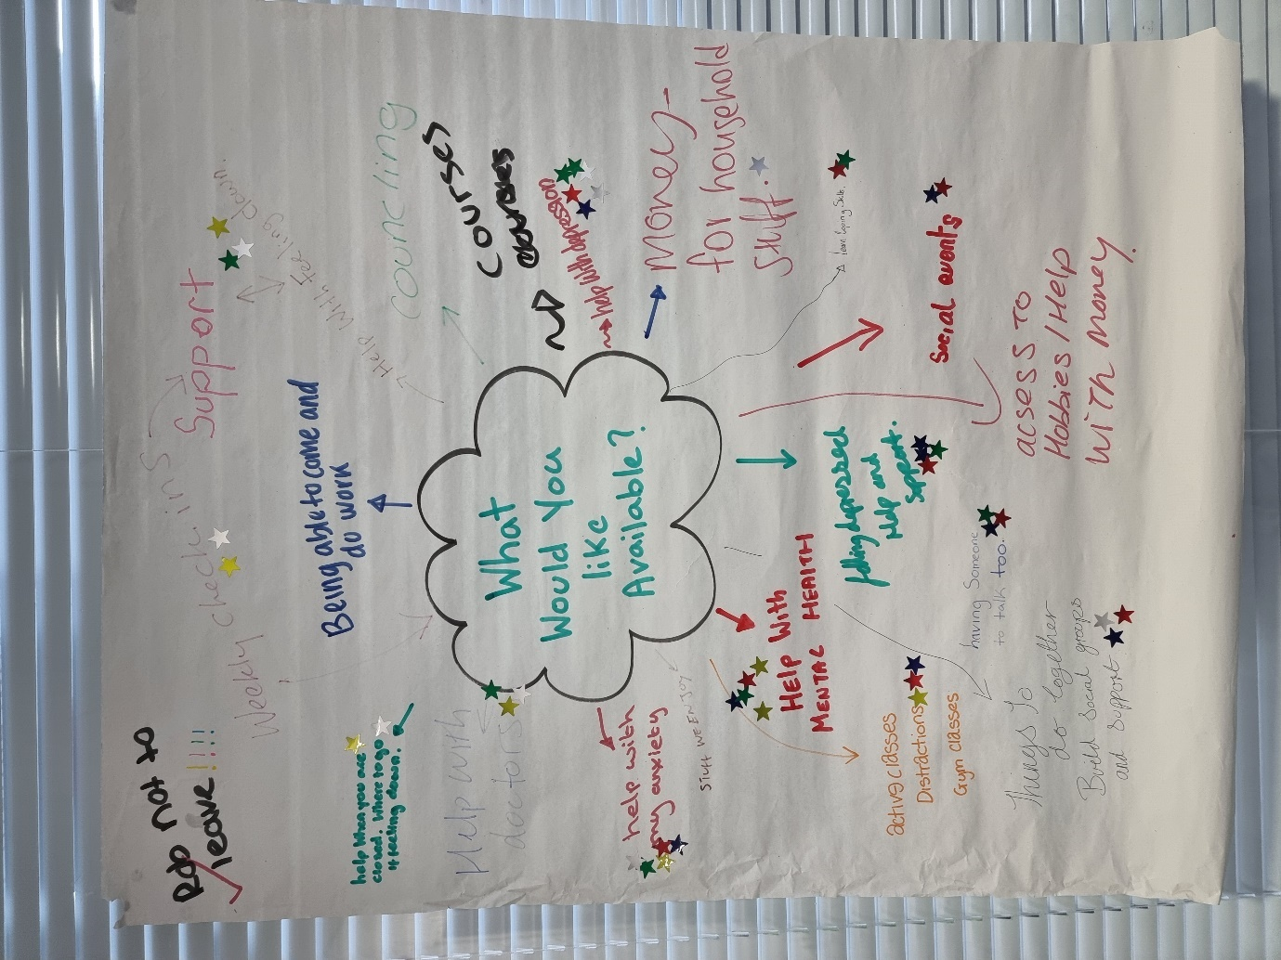
This first step for this was for the young people to take their time in a social atmosphere where they felt comfortable to wright what they wanted from this service. Before we began, I explained that they did not have to add their name, that there is no wrong answer, do not worry about asking for what you want and if they did not want to participate, they did not have to. We stated with a bubble with ‘what would you like available?’ written in the middle and the young people filled the page with their ideas.
To varier these results and to see how many of the young people also wanted the same thing they were then each given a few sticker stars and were asked to go around again and add a star to any points they felt were particular important or that they agreed with and wound also like available.
At the end of the activity the main points that were raised and most supported by the group were:
- Help with my anxiety.
- Help with mental health.
- Feeling depressed, help and support.
- Help with depression.
- Support. (Build support groups, having someone to talk to, coping skills, feeling calm, weekly check in’s and help available).
Results may have been bias due to peer pressure as this was a group activity. Some young people may have felt the need to go with what their friends were suggesting, to overcome this I also provided a small questionnaire. This was confidential I insured the young people that they did not need to put their names on it, they all looked the same and not to be afraid of what to put on it. I encouraged them to complete them on their own and at the end to slip them into a box I had provided on the desk (insuring we would not know who’s written what).
The questions looked like this:

Out of the 15 yougn people that took place in this study. 10 young people filled in these questionairs. Out of those 10, 8 yougn people filled in their qustionairs simalarly asking for further help and support with their mental health, writing about needeing safe places to talk, councing and one to ones, group activites, more oppetuinties to socialise and build their support network to needing distractions and wating to feel better.
I have included 4 examples below:

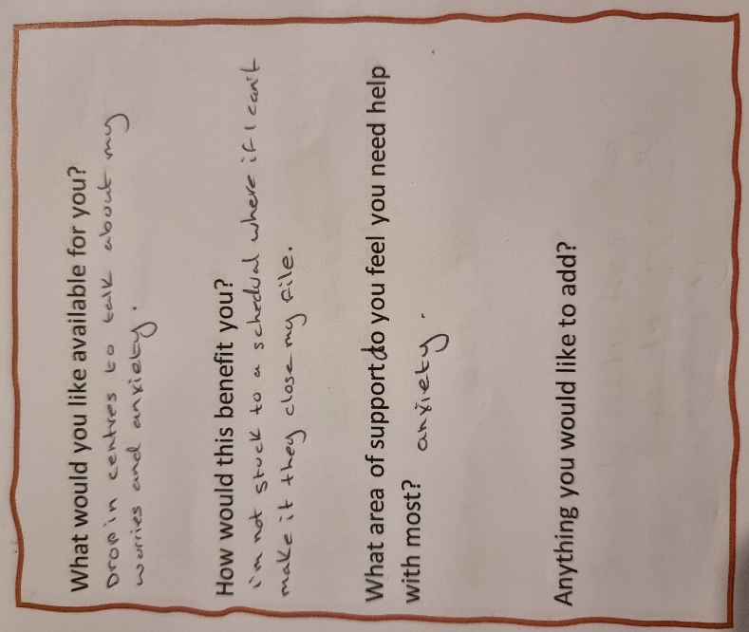
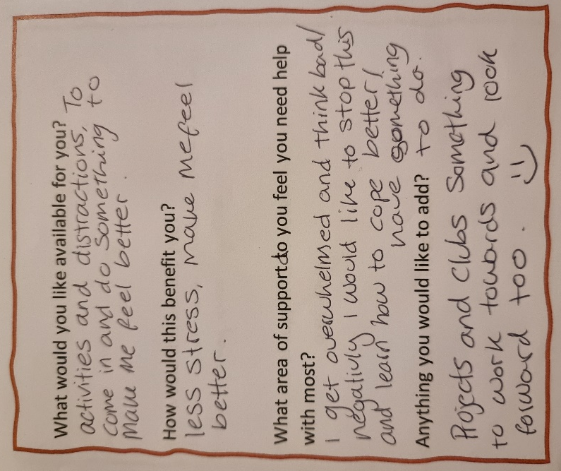
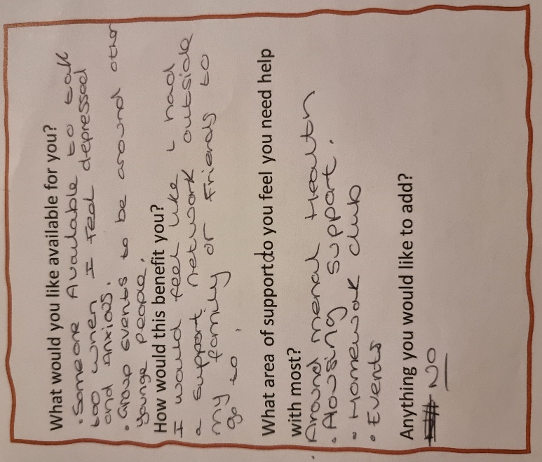
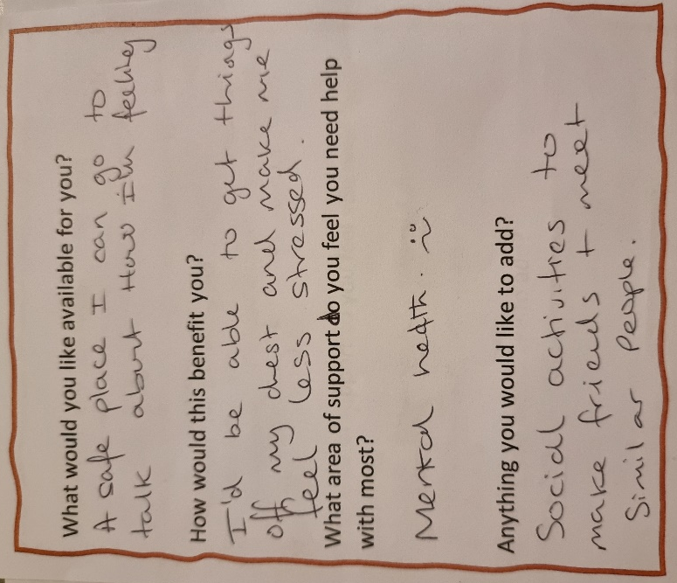
The resurch conducted was both quatative and qunatative…
From the results of this 3 part reseach it is clear to see that the yougn people that use are service are in need of further support around their mental health and well being. It goes to show that we are not supporting them enough, and there is more that they need. They have suggest in their own words what they feel would benefit them. These resurch resluts will be sent to management and funders to encorage sfuther support for workers and additional funding for wellbeing evens, activities and gifts.

To find out what events, activities and days out young people would like to do I used the same metod as above. I first asked them what they would like to do and then gave star stickes to measure how many young people would like to do the activiees and days out put forward by the others.
This was the result:

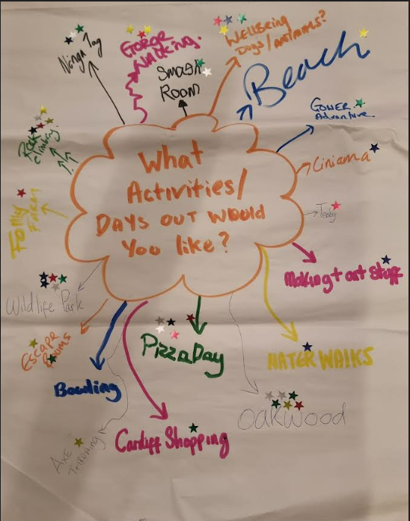
The most popular being:
- Oakwood.
- Pizza day.
- Ninja tag.
- Wellbeing days.
- Wildlife park.
- Activies shuch as rock climing and grorge walking. (Down to earth and call of the wild could be used to combind both).
These reslut will be used in future plaing when it comes to activites.

Proposed schedule for research:
The activities proposed for this research have been taken from suggestions made by the young people for what they want to do (please see above).
It is important to work with young people and allow them be part of the decision-making process.
Week. | Activity, supervision, or community event. | Fully informed or Indirect deception used
Week 1 | Introduction, Pizza social and music in hub. | Fully informed
 | Supervision meeting with support worker. | Fully informed
 | Community Event | Indirect deception used
Week 2 | Down to earth. | Fully informed
 | Supervision meeting with support worker. | Fully informed
Week 3 | Manor wildlife park | Fully informed
 | Supervision meeting with support worker. | Fully informed
Week 4 | Ninja Tag. | Fully informed
 | Supervision meeting with support worker. | Fully informed
 | Community Event. | Indirect deception used
Week 5 | Beach walk and picnic. | Fully informed
 | Supervision meeting with support worker. | Fully informed
Week 6 | Oakwood Park | Fully informed
 | Supervision meeting with support worker. | Fully informed
 | Community event | Indirect deception used
Week 7 | Conclusion, evaluation, craft session in hub. | Fully informed

Range of activities.
3 runs within the service hub or a short walk away and only food needed to cover cost.
2 locally with minim cost to support. Ninja tag: £5.50 per person, can be authorised by worker.
2 bigger activities, funders would need to support and approve.
The skills and capacity of the young people involved will range, including some young people which will have learning disabilities and behavioural issues. This research is suitable for all young people despite any issues they may have, if they choose to participate, they will have everything explained to them, with the right to withdraw if they want to, with full support of multiple workers to help them while they join in activities (disability friendly) and receive additional support. By supporting young people’s wellbeing and mental health we are supporting them develop emotionally and socially through this process.


Youth and Community Participatory Research Proposal Form
Name | Kirsty Allen
Research Aim/ Focus | “Does supporting young people’s wellbeing encourage their community engagement?”
Submission Date | 16th May 2022.
Research Ethics Form Completed | Yes.
Research Summary | The aim of this research is to find out if supporting and encouraging young people’s wellbeing will affect their involvement in the community.  To achieve this, aim a schedule has been made with a mix of activities and mentoring, young people will be referred in by their case worker and the attendance will be monitored and measured to see if there is an increase in young people’s involvement in community activities.  Young people’s participation has been involved from the start with participation events where they expressed, they need additional support with their mental health to an additional participation event where they told us what activities they would like to participate in, that I have included in the schedule.  Methodology used for this will be mixed using, case studies, questionnaires, attendance record as well and member-check-ins.  Method for this is to provide young people with a 6–7-week program with an event and mentoring meeting every week to promote their wellbeing. With additional community events set up 3 times during this program, hopefully the results will show an increase in the end for young people that participate in community engagement.  The main ethical issue for this research will be using indirect deception. Young people will be informed that we will be monitoring the effects of wellbeing and activities, however, they will not be told their attendance for the community engagement events. This could cause emotional harm to the young person however although the risk is low, I have put other measures in place to support the young person in this case.  Another ethical issue is my own involvement; however, I think my experience and closest to the research will be a positive contribution. I have put in methods to overcome my possible researcher bias.  I have worked in accordance with ethical guidelines with UNCRC, BERA Guidelines, code for occupational ethics for youth work Wales and have included the above mentioned and more ethical considerations and more in my risk benefit analysis and ethical approval form.  Young people will be told at the start and end of the research that they have the right to withdraw. Member-check-ins are encouraged throughout and if need be, the young person(s) will be reminded they have the right to withdraw. This will be underpinned in the contract they make together when they create their safe place. Other worker will be attending to provide alternative activities if the young people to not want to participate in the study.  I understand that if my research does not meet ethical approval that I will redesign my research to meet further specifications and continue to try and measure the link between supporting young people’s wellbeing and their participation in community engagement.  If this research proving successful would be providing us with data to put forward to funders to achieve additional funds for our young people, services, and communities in the future.  If the study proves to be unsuccessful, I recommend replicating the study throughout the service including more young people to try to increase possible results. However, even if this study proves unsuccessful, there will still be research providing data on the impact of wellbeing through activities and additional mentoring support for young people, through the case studies and questionnaires.  I will stay true to my research and keep my integrity throughout. I will stay honest in reporting research results and supporting young people. I will adhere to rules, regulations, and guidelines.

