Live Project
Self-Reflection

February
As a group, me, Kurtis, Chelsea and Reuben decided to work for the National Wool Museum for the live project because we thought that was the most interesting industrial heritage location.

Presentation
For the roles, we decided Kurtis will be the production manager, he worked on the script, research and worked on camera. I was in charge of sound production, so I would record the audio, for example, the actor talking. Reuben was meant to edit and help with post production and Chelsea also did research for the site and took notes of what shot we were on, on set. The cinematography was done by the all of us. We all decided where lighting would be best placed best.
The moodboard had examples of the machines that they had inside the factory, so we were thinking of filming around that. One of our worries was that it would be too loud.
The colour palette showed the location had a lot of brownish dark yellow colours, so we decided to film with that.
We decided to have group meetings every Thursday at 6pm so we could discuss how our work was going. The group got along fine, if we had ideas, people would feel comfortable explaining, and I think we got to know each other well because of the project.
In our SWOT Analysis, we said our strengths were we were walking distance from each other, we knew each other before working in the group. It was easy to communicate to each other as we had a group chat on Facebook, so it was easy to get in touch. We had chosen the roles we were comfortable with.
One of the weaknesses we had were, we didn’t have much experience in AR.
The site was a long way from our University, so it was difficult to travel there, but on the first day we wanted to go, Osian was nice enough to give us a lift. The second time I went I drove and the others got a lift again. Another weakness of ours were, we were busy with other modules, but luckily, we had enough time to film this.
What we were aiming to do was to make the experience fun for the user, benefits the client and us as a group, we also wanted it to be educational for the user and entice the user to visit the heritage site.

Research
At first, we found some information at the National Wool Museum website, we couldn’t find anything that useful there.
We got most of the research when we went to the National Wool Museum, we went on the tour and they told/showed us how the river was useful and how to make a shawl. We got to see the machines turning the wool into a piece of string. Along the walls/cages, there was information that we took pictures of, so we’d remember. Upstairs they had an example of a type of shop, so that’s where we decided to film, because the set was already there. They had examples of the type of clothing they had also.

After The Presentation
After the presentation, Kurt wrote the script and kept in contact with Osian and the National Wool Museum, to make sure the script was educationally correct and would checked when we were able to film. He also kept in touch with the actors.
Shortly after the Presentation, Reuben had left the group, so I’d replace his job of being an editor.

Actors
Kurtis is friends with one of the BA Acting students, and she helped us with having Gareth work for us.
Lauren took a couple of takes to get her lines perfectly, it’s a shame we couldn’t use her shots at the three different locations because they worked well with the sun outside and the river behind her while she was holding a baby.
Gareth took longer than Lauren to get the shots done, but then, he didn’t have enough time to learn the script, but we’re still thankful that he could do it, even though it took us longer to film.
We had to bring our own clothing for the actors and we also had to bring a baby doll for Lauren to use.

20th April
On the 20th of April, we were filming at the national Wool Museum. We all decided where we would place the camera and lighting. Kurtis was filming the actor. I was holding the microphone and Chelsea was taking notes of each take. When my arms were getting tired Chelsea did the sound for a bit. We shot the Richard Davies scenes first, we took three different angles. We did the English version and then the Welsh. After that we filmed the Nursing Shawl scene, just in English because the actress couldn’t speak Welsh, because of this, Osian didn’t want that scene as it wasn’t bilingual. We also had three different angles for this, it was a shame we couldn’t use these as they were nice shots. Then we filmed the shop clerk in English and Welsh, we also had three different angles for Osian to choose from.

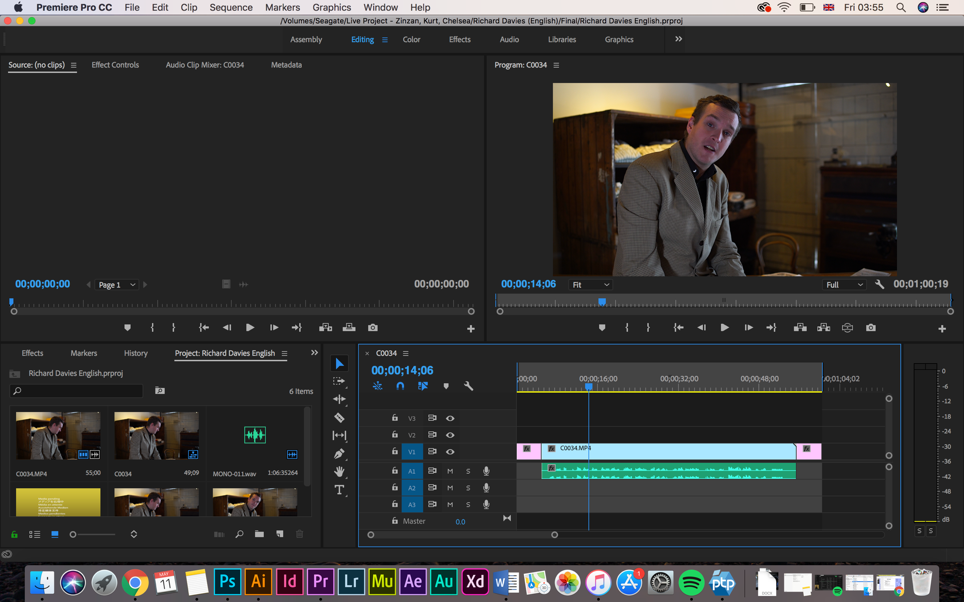
Editing
For editing this, I had the film and the audio, it was easy to synchronise in premiere pro. The most difficult part was trying to organise the files. I decided to add a 5 second still at the begging and end of the clip just in case Osian wanted to add an AR elements to it.

Equipment
The equipment we decided to bring were a Panasonic GH5, for filming. For the sound, Zoom H4N, Boom mic and XLR lead. We were planning on using LED lights. We were planning on bringing the small Manfrotto tripod as it was light. For post-production, we just used ‘Premiere Pro’.

Next time
If I were to do this again, I would like to be more involved with the production manager so that I have a clearer idea of what I was doing and what was going on with the team. I also don’t think I was really expanding my skills as I was in charge of sound production last year for a project, when it isn’t something I’m that interested in.
I was also a bit disappointed that we didn’t actually create a AR experience for Osian in the end.
It was good that we got along with Osian well and he’d respond quickly to our emails if we had any issues.

