
Business Intelligence, Data Warehousing, and Data Mining to Support Strategic Decision-Making at GreenLeaf Stores
Programme | BA (Hons) Business Management
Module | Data Handling & Business Intelligence
Module Code | LCBB5014
Assignment Title | Component 1: Coursework — Individual Report
Student Name | Maki Solomon Mandefro
Student ID | 2442578
Submission Deadline | 19/07/2026

Table of Contents
Executive Summary 3
1. Introduction 3
2. Trends in BI, DW, and DM 3
3. Data Warehousing in the Organisation 5
4. Data Mining Techniques 6
5. Predictive Analysis 7
6. Ethical and Data Security Considerations 8
7. Reporting and Dashboard Solutions 9
Conclusion 10
References 11

Executive Summary
The report discusses the potential use of Business Intelligence (BI), Data Warehousing (DW) and Data Mining (DM) as tools to assist with strategic decision making in GreenLeaf Stores, a medium-sized regional supermarket chain with 40 stores in the South West of the UK. The report critically assesses the current BI trends, suggests an architecture for data warehouse to integrate sales, inventory and customer information, describes two data mining techniques suitable for a retail decision making and recommends predictive analytics tools suitable for the size and technical capability of the organisation. The findings show that a centralised, cloud-based data warehouse and clustering and classification methods have the potential to significantly enhance the accuracy of inventory and customer targeting, if data privacy and security protocols are built in rather than bolted on. The report suggests that Power BI dashboards be introduced over a period of time to enable real-time monitoring of the operation of the store estate.

1. Introduction
GreenLeaf Stores is a medium-sized regional supermarket chain with 40 stores located throughout South West England, employing around 1200 employees and customers from the suburban and rural communities. This report is prepared for the senior management within the organisation to provide them with information about how Business Intelligence, Data Warehousing, and Data Mining can be used to aid the strategic decision of the organisation in merchandising, supply chain and Customer Relationship functions (Chen, Chiang and Storey, 2012). Competitive pressures are growing from larger national brands and online grocery companies, intensifying the need for retailers to base their decisions on data to maintain margin and market share, in a retail climate characterized by persistently low retail profitability. This report starts by considering the current trends in BI, DW, and DM, moves on to propose an architecture for a data warehouse, considers some of the appropriate data mining techniques, recommends some of the appropriate predictive analytics tools, considers ethical and security aspects, and finally recommends some of the appropriate dashboard solutions that can be used for ongoing operational monitoring throughout the organisation.

2. Trends in BI, DW, and DM
By definition, Business Intelligence is the technologies, applications and practices that are utilized to gather, combine, analyze, and share business information for better decision making (Chen, Chiang and Storey, 2012). Data Warehousing is the technology behind data storage and management, which combines data from various operational systems into a unified, structured repository that is optimized for data analysis. Data Mining is the technique used to extract patterns and relationships from large amounts of data by applying statistical and machine learning methods (Han, Kamber and Pei, 2011). Smart trend in this area is the increasing use of cloud-based data warehousing solutions, which help organisations avoid large upfront investments in infrastructure and boost scalability, and an ongoing trend of real-time BI, where dashboards and reports update in real time, rather than processing them overnight (Gartner, 2023). Another game-changer is the use of artificial intelligence, where machine learning is seamlessly integrated into the BI platform, eliminating the need for separate and disjointed analytical workflows managed by data science experts.
There are two existing frameworks that are important for GreenLeaf's context. Kimball's dimensional modelling method for data warehouse design organizes data in fact and dimension tables for individual business processes like sales transactions is an approach that is practical, incrementally deployable and suitable for a mid-sized retailer with limited IT resources, and no enterprise data warehouse (Kimball and Ross, 2013). The CRISP-DM model consists of business understanding, data understanding, data preparation, modelling, evaluation and deployment phases, and may be used to ensure that the analytical projects undertaken by GreenLeaf are based on a business need, not just a technical challenge that is of no real value to the business (Chapman et al., 2000). These frameworks together provide a coherent starting point for GreenLeaf: Kimball's methodology helps with the physical building of the warehouse itself and CRISP-DM helps to guide the scoping, execution, and evaluation of analytical projects developed on top of the warehouse, which when built together provide the technical infrastructure and analytical practice to grow at the same time rather than as separate initiatives.
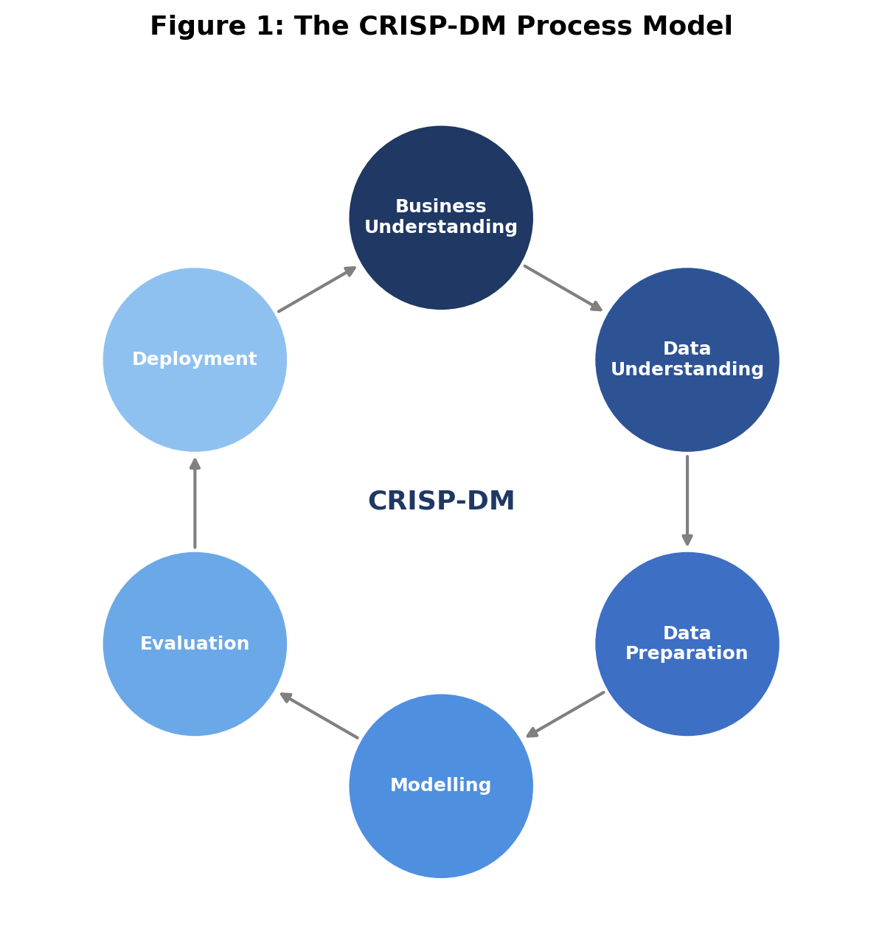
Figure 1: The CRISP-DM Process Model (Source: Author's Own, adapted from Chapman et al., 2000)

3. Data Warehousing in the Organisation
Some say that a data warehouse is a collection of data, that is subject oriented, integrated, time variant, and non-volatile and that it exists to support management decision making (Inmon, 2005). A unified data warehouse could make a significant difference for GreenLeaf Stores, which already have three distinct systems: one for point of sale transactions, one for inventory and one for their loyalty card data; the current manual process of having to reconcile the data between the sales and stock systems would be significantly improved. The centralised warehouse would allow access for regional and head office decision makers at the same time and would eliminate version control and data quality issues that will inevitably occur with siloed and manually maintained spreadsheets.
Sales reporting would be greatly improved: instead of having to wait a week for the weekly manual compilation, the category manager would have access to consolidated sales figures across all of the forty stores, and be able to view the performance of particular product lines or trends, and emerging trends in particular regions, within hours, rather than days (Provost and Fawcett, 2013). Supply chain data consolidation is another important use case, by combining supplier delivery data with in-store sales velocity, GreenLeaf could help grocery retailers save a significant amount on stockouts of fast moving products, like fresh produce, as well as costly waste and markdowns that can have an uneven impact on grocery margins. A practical implementation approach would be to create a data mart for the specific purpose of making merchandising decisions at an initial stage in a contained manner and then add the data from the workforce scheduling and customer relationship data in later stages through Kimball's incremental methodology (Kimball and Ross, 2013).
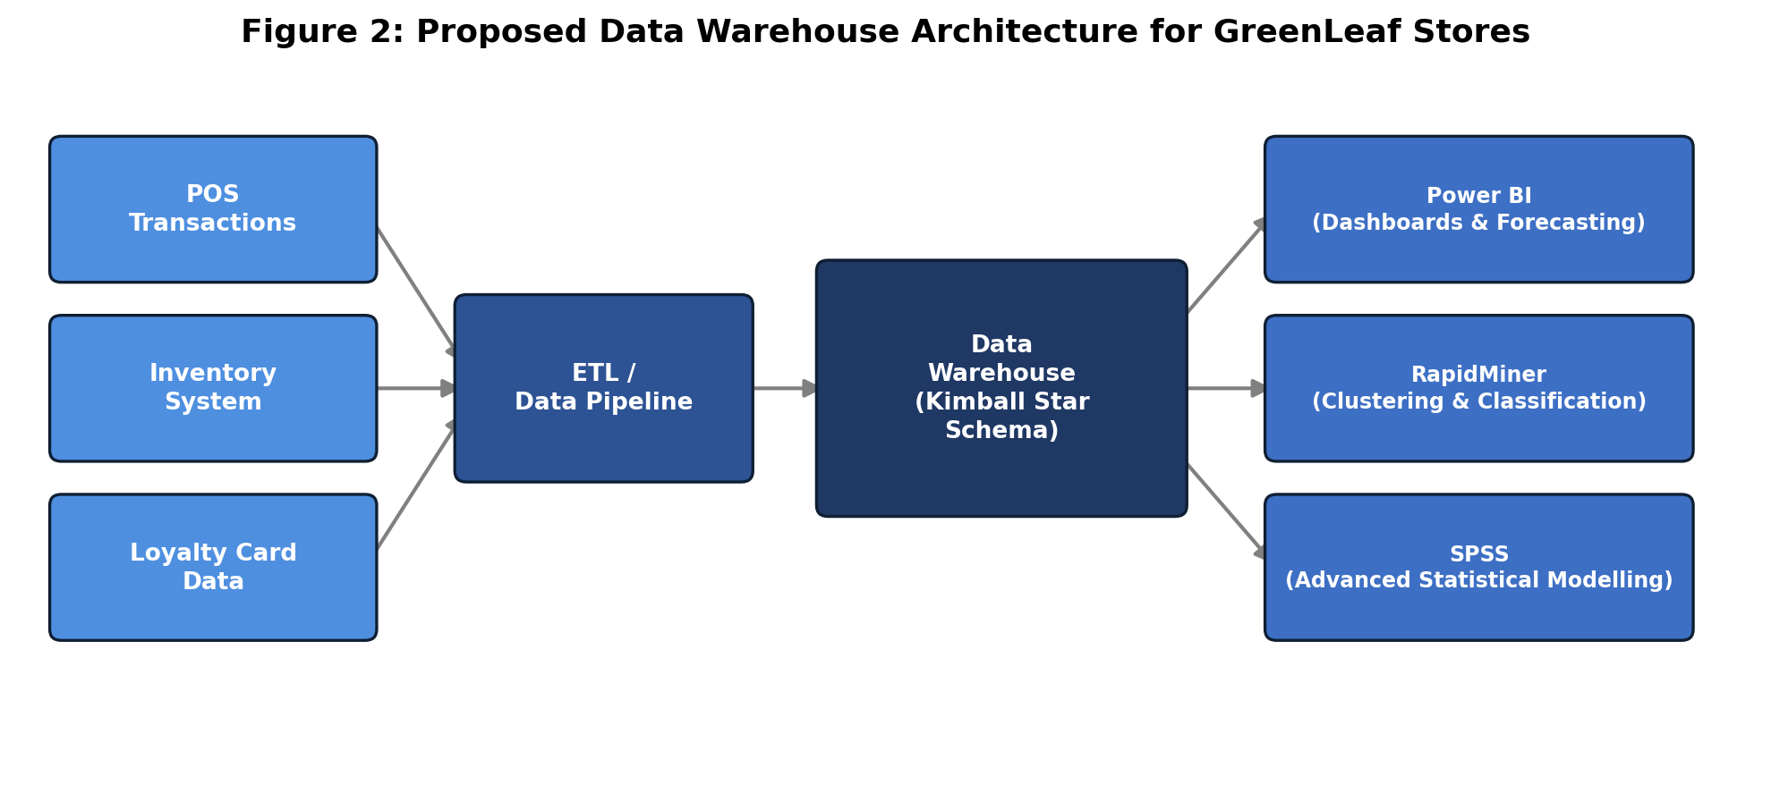
Figure 2: Proposed Data Warehouse Architecture for GreenLeaf Stores (Source: Author's Own)
For an organisation of GreenLeaf's size, a cloud-based warehousing solution like Snowflake or Microsoft Azure Synapse would make for a good fit: it would eliminate significant initial capital investments for the physical servers needed to store and process data, and it would allow the organisation to scale storage and processing resources over time as its needs evolve as it grows more analytical (Gartner, 2023). Finally, a properly designed warehouse becomes a real strategic asset for the organisation from the individual store manager to the executive board, and becomes the backbone of the data mining and predictive analyses that are the subject of the next two sections.

4. Data Mining Techniques
GreenLeaf has two data mining techniques that are ideally suited to its strategic goals. First, an unsupervised method called clustering which groups customers/products into segments depending on the similarity of their attributes would allow GreenLeaf to go beyond the traditional loyalty tiers and make true behavioural customer segmentation: a group of price-sensitive bulk shoppers, as opposed to the top-tier premium convenience shoppers, based on actual purchasing behaviours rather than on assumed demographics (Han, Kamber and Pei, 2011). This segmentation might be directly applied to marketing campaign targeting to improve the efficiency of marketing spend as it would not be a one-size-fits-all approach, as is currently the case, but a targeted one for each segment based on their purchasing behaviour.
Second, classification, a supervised method which classifies new data by patterns derived from historical labeled data, would help the inventory management system of GreenLeaf by predicting the products that are likely to be slow movers from historical patterns of sales velocity, seasonality and promotion history (Provost and Fawcett, 2013). This would make it possible to make proactive decision on markdown or reallocation, instead of the current mainly reactive way of dealing with slow moving stock that has reached a high and expensive level of accumulation. RapidMiner in particular provides a platform with readily available clustering and classification features which are accessible to existing analysts without the need to have a large programming skill set, and are suited to GreenLeaf's current analytical maturity, both of which make them see as an attainable near-term entry point to analytical maturity before the more advanced statistical software is considered for later-stage analytical development.

5. Predictive Analysis
Of the tools available for predictive analytics, Power BI is the most practical option for GreenLeaf's first implementation because it is relatively inexpensive to license, already has some built-in forecasting visualisations that require minimal extra training, and is natively integrated with Microsoft Excel, which is widely used within the existing workforce (Microsoft, 2023). On the other hand, SPSS provides much more advanced statistical modelling functions that would be especially beneficial for more in-depth analyses (e.g. regression-based forecasting of demand), but have a much steeper learning curve and higher licensing cost, which may not be warranted at the current state of GreenLeaf's analytical sophistication. RapidMiner has a nice middle ground, providing real predictive modelling functionality, including the above clustering and classification algorithms, in a drag-and-drop interface, instead of asking the existing, relatively small GreenLeaf analysts to know how to code.
Table 1: Comparison of Predictive Analytics Tools for GreenLeaf Stores
Tool | Cost | Ease of Use | Key Strength | Best Fit for GreenLeaf
Power BI | Low | High — familiar Excel-style interface | Automated dashboards, scheduled refresh, native Microsoft integration | Phase 1: reporting & forecasting
RapidMiner | Low–Medium | Medium — visual drag-and-drop workflow | Accessible clustering and classification without coding | Phase 2: customer segmentation & inventory prediction
SPSS | High | Low — steep learning curve | Advanced statistical/regression modelling | Future phase, once analytical maturity increases

In particular for reporting automation, Power BI's ability to schedule automatic data refreshes directly from the proposed data warehouse would enable category managers to get new sales and stock forecasts every morning without having to perform manual actions, thus solving the reported lag in reporting in Section 3. With limited analytics infrastructure in place at GreenLeaf, a gradual rollout starting with Power BI for reporting and forecasting and then moving on to RapidMiner for more specific, data mining-driven projects, like customer segmentation, is the most feasible and lowest risk path to rollout for the organisation.

6. Ethical and Data Security Considerations
There are several issues of ethics and law that are important when implementing BI and analytics systems at GreenLeaf. GreenLeaf is a UK organisation that processes data relating to customer loyalty cards and it is required to ensure that it complies with the UK GDPR, notably by having a clear lawful basis for processing customer purchase data, to obtaining genuine consent for collecting data for customer loyalty schemes and transparency about how customer data will be used to inform targeted marketing decisions (Information Commissioner's Office, 2023). Data ownership and data retention policies should be well documented, customers should have the right of access, correction and a right to request deletion of their personal data at any time.
Role-based access control to the data warehouse should be implemented to ensure the store-level staff can only access information that is relevant to their role, along with encryption in transit and at rest of customer information in the data warehouse. Likewise, internal threats must be taken into account, such as an employee accessing customers' purchase history, which should be closely monitored by access logging and audit trails, but also external cyber security threats (e.g. ransomware attacks on centralised data infrastructure) which should be addressed by regular security audits and a documented incident response plan (National Cyber Security Centre, 2022). Putting these safeguards in place as part of the warehouse project design process and not as a post-installation addition would significantly mitigate regulatory risk as well as the reputational harm to GreenLeaf should there be a customer data breach.

7. Reporting and Dashboard Solutions
As predicted analytics is a key focus for GreenLeaf, and the seamless integration that the combination of Power BI predictive analytics and the tool provides throughout the organisation's analytical stack, Power BI dashboards are the most appropriate reporting solution for GreenLeaf. A real-time sales performance, stock availability and waste monitoring dashboard on the regional level would enable head office to identify underperforming stores on the spot, instead of waiting for stores to report on sales performance and stock counts every month. While Tableau provides a viable alternative with so much flexibility in data visualisation, it comes with higher licensing costs, which makes it a less coherent and cost effective solution for an integrated reporting platform across the entire organisation at a higher cost than the Power BI ecosystem that is already recommended for GreenLeaf's predictive analytics requirements.
Table 2: Key Performance Indicators for the Regional Operations Dashboard
KPI | Purpose | Data Source
Daily sales variance vs forecast | Identify underperforming stores in real time | POS transactions + Power BI forecast model
Stock-out frequency by category | Flag supply chain gaps before they affect sales | Inventory system + supplier delivery data
Shrinkage / waste percentage | Monitor markdown and waste costs by store | Inventory system + till write-off records

Daily sales variance to forecast, stock out frequency by category and shrinkage or waste percentage would all be relevant KPIs that would feed into merchandising and supply chain decisions throughout this report, as summarised in Table 2 above (Few, 2013).

Conclusion
This report has proved that there is a great potential for Business Intelligence, Data Warehousing, and Data Mining to support the strategic decision making in GreenLeaf Stores merchandising, supply chain, and customer relationship. The current data fragmentation could be overcome with a centralised, cloud-based data warehouse incrementally built using Kimball's dimensional modelling approach, and more advanced customer segmentation and inventory forecasting could be achieved than GreenLeaf's existing, largely manual processes can provide by utilizing available tools like RapidMiner and Power BI, which would cluster and classify the data. It is important that ethical and security protections are built in as early as possible and not added on post implementation when the system is up and running. Based on the competition that regional grocery retailers are under, GreenLeaf should consider implementing incrementally, starting with a relatively simple data mart and Power BI reporting dashboard and moving forward to additional predictive analytics capabilities as the organisation becomes more mature with data over the next few budget cycles.

References
Chapman, P., Clinton, J., Kerber, R., Khabaza, T., Reinartz, T., Shearer, C. and Wirth, R. (2000) CRISP-DM 1.0: Step-by-Step Data Mining Guide. Chicago: SPSS Inc.
Chen, H., Chiang, R.H.L. and Storey, V.C. (2012) 'Business intelligence and analytics: from big data to big impact', MIS Quarterly, 36(4), pp. 1165–1188.
Few, S. (2013) Information Dashboard Design: Displaying Data for At-a-Glance Monitoring. 2nd edn. Burlingame, CA: Analytics Press.
Gartner (2023) Magic Quadrant for Cloud Database Management Systems. Stamford, CT: Gartner Inc.
Han, J., Kamber, M. and Pei, J. (2011) Data Mining: Concepts and Techniques. 3rd edn. Waltham, MA: Morgan Kaufmann.
Information Commissioner's Office (2023) Guide to the UK General Data Protection Regulation (UK GDPR). London: ICO.
Inmon, W.H. (2005) Building the Data Warehouse. 4th edn. Indianapolis: Wiley.
Kimball, R. and Ross, M. (2013) The Data Warehouse Toolkit: The Definitive Guide to Dimensional Modeling. 3rd edn. Indianapolis: Wiley.
Microsoft (2023) Power BI Documentation. Redmond, WA: Microsoft Corporation.
National Cyber Security Centre (2022) 10 Steps to Cyber Security. London: NCSC.
Provost, F. and Fawcett, T. (2013) Data Science for Business: What You Need to Know About Data Mining and Data-Analytic Thinking. Sebastopol, CA: O'Reilly Media.

