Jac Beynon
student number - 2116579 EMAIL ADDRESS – 2116579@student.uwtsd.ac.uk
fUnDAMENTALS OF CONSTRUCTION TECHNOLOGY

Assignment title
Right, a technical report with drawings for a new build dwelling for Miss A Client who has received planning permission for a single, two-story domestic building.
Introduction
In this report, I will outside certain areas and go into detail about them such as the roof structure and the finish which has been provided. I will also be looking at offsite solutions to see how they could be implemented into the project.

Contents Page
- Page 1 – Assignment details, introduction
- Page 2 – Contents page
- Page 3,4,5 – Offsite construction
- Page 6,7,8,9 – Roof structure and design
- Page 10 – Raft Foundation
- Page 11,12,13,14 – sketches and drawings of the proposed build
- Page 15 - Reference page

Offsite Construction
The term offsite construction is the process of completion of elements for a construction project, this would include timber frame panels, bathrooms like you see in university halls but can also be used for use in housing projects and could be a great choice for this project to reduce the time of being onsite but depending on the choice of materials used and sizes this could add cost to the project.
There are many types of offsite construction here are a couple of examples that could be implemented into this project,
- Lightweight steel and timber frame panels/buildings (Willmott Dixon, 2022)
- Factory assembled bathrooms (FABs) or pods like are seen in university accommodation halls to save on time on site and everything needed can be put in one pod and dropped into place (Willmott Dixon, 2022)
- Cross-laminated timber (Willmott Dixon, 2022)
- Prefabricated and precast concrete (Willmott Dixon, 2022)

As this proposed building is to be a timber frame with exterior blockwork/brickwork a lightweight timber frame would be suitable here as it would be constructed offsite which would mean less time on site for the contractors or more time to concentrate on another element of the job whilst the panels are being made, having the timber frame made offsite would mean the building could get put up quickly and become water-tight as soon as the walls and roof are on which will not be a long process due to the panels being made off-site.

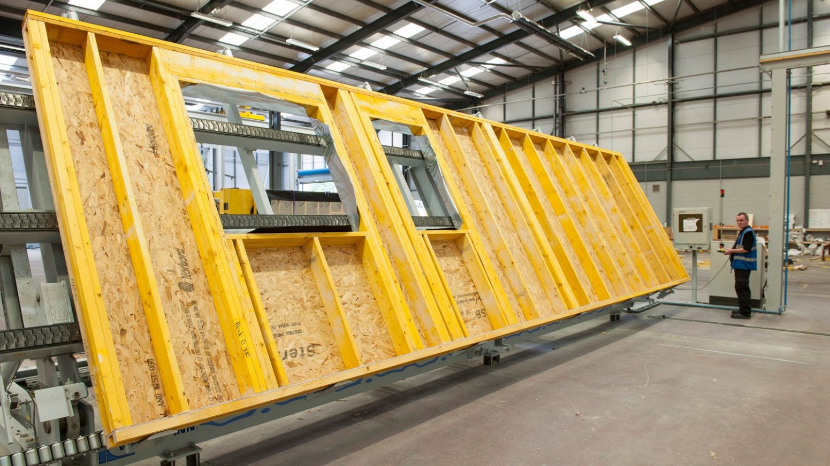

HOMAG, 2016

As you can see from the image above the timber frame panels are made in a warehouse where it is all done in a production line from the framing with C16 timber to the OSB sheathing being put on to the insulation that goes between the studs. These panels will also contain an additional insulation board within an internally battened service zone. The service zone will allow for subcontractors such as the electrician, plumbers, and M&E contractors to run cables, pipes, or any sort of equipment that needs to be hidden away. This allows for a sleek effortless installation of all services that are needed in the house.
Another type of offsite construction is FABs which are preassembled bathrooms like you see in the University accommodations but they are also used in new homes that would like a quick build time. Even though they are mostly used in accommodations you can design them yourself to create a more modern-looking design for a home as they can be made to your desires.
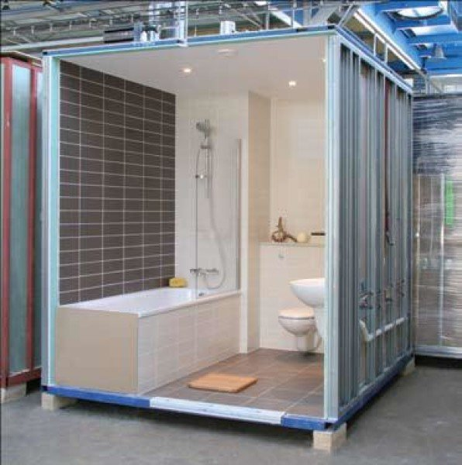
As you can see from this image the bathrooms are pod-like structures that are dropped into place when a frame is built around the desired area so that it can be permanently fixed into place.
As you can also see you can have luxury-looking designs in these pods which would fit lovely into a new build as the proposed plans and drawings show.
These are great for new build dwellings as they provide a reliable benchmark in quality and help standardize construction requirements. (Kiernan, n.d)
A disadvantage to these pods is that they are not the most suitable for disability-friendly homes they are not made to be huge structures to accompany wheelchairs or hoists to help people get around the bathroom which could be an issue, depending on the occupancy of the homes.
LTD, 2020
The all-in-one design also restricts the plumbing and electrical infrastructure (Kiernan, n.d) as the home builder will not get to choose where elements of the bathroom go as they are made with everything on one therefore some subcontractors will have to work around the pod.
They can also save you cost as they are made on a production line; therefore, they are made 100s at a time, it also means there is no need for other trades on sight when they are being made only when they come to fit it into its final position.
Another type of product that can be made off-site is cross-laminated timber which is a timber product with good structural properties and low environmental impact when it is made. CLT is also more expensive than using steel or concrete and as there are no building restrictions on building to height with timber is it worth going for materials which is more expensive to buy and that give you a disadvantage to the height of your building. (the strong-tie blog team, 2019)
Using CLT also could bring higher design costs to make the buildings strong enough to pass building regulations to be a safe building for its occupancy.

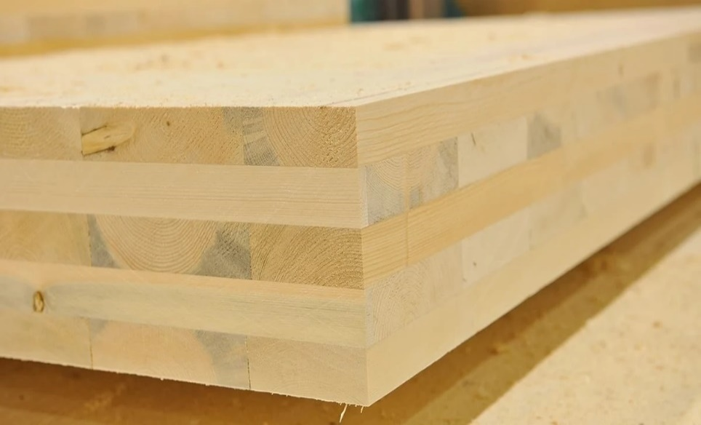
As you can see here, CLT is made by attached layers of timber at different orientations which creates strength in a lot of ways due to it mostly being made from spruce trees that have long cellulose fibers. (G2 structural Limited, n.d). CLT also provides dry, fast onsite construction as the panels themselves are made off-site and then put together on-site when they are needed. (Sutton, Black, and Walker, 2011). CLT also has the potential for good airtightness with a robust wall and floor structure, which can be used with most internal and external finished.

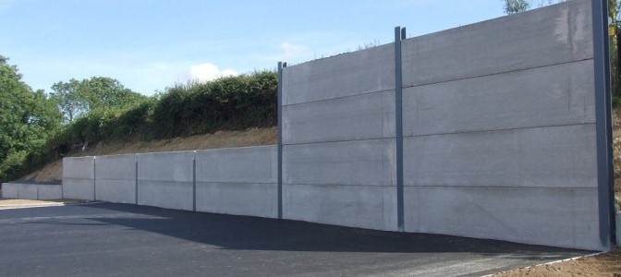
The fourth and final method of offsite, modular construction is prefabricated and precast concrete, this could come in panels like is seen in big retaining walls
(Spanwright UK ltd, n.d)

As you can see in the image above precast concrete panels can have a lot of uses such as retaining walls, floor panels for a house which could be suitable for this project as you can get smaller ones that make up a block and beam system which would be insulated and underfloor heating could be put on top which would be up to specification of the proposed house details. These have many uses therefore could be used for a range of different reasons around this proposed property.
One disadvantage to these panels (depending on the size) is their weight, it makes them hard to have around the site and difficult to put into place once they are needed unless a crane or some sort of lifting gear is on-site to assist with them being put into Place. They can also be expensive with the price of every material going up and the need for steel up-rights to support the panels it could get very expensive.

Roof Structure and Finish
The roof will have a Euroclad Vieo metal profile sheet roofing which is a standing seam roof system that locks together by upstands on either end of the roofing sheets an advantage of using this type of sheeting is that it can be used for a warm roof system or cold roof construction, therefore, there are not many limitations to this product for the proposed building. The main structure will be trussed rafters on OSB board therefore this product would work perfectly with this system.
Vieo roofing systems meet a loot of industry standards as it is a BBA certified product and also meets other relevant industry standards (Euroclad group, n.d) which is why it is such a high performing roofing system, it also meets up to date building regulations which means we should have no problem using this product on such a building as this one.
This product can be fitted to a pitch of 1 to 70 degrees (Euroclad group, n.d) which suggests we should have no problem using this product here on a pitch of this house as the average pitch of a roof is roughly 45 degrees or lower therefore this product should be suitable for this new build.
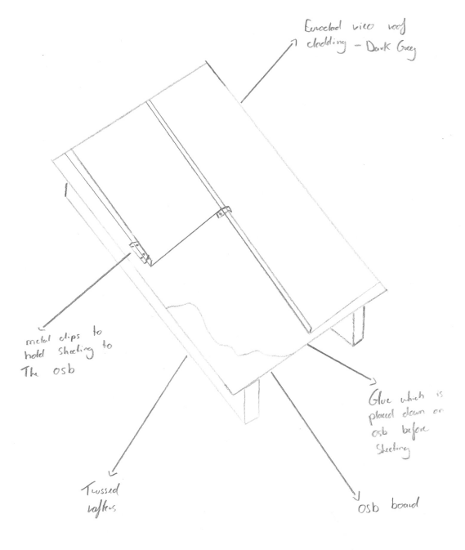

As you can see from the sketch above I have shown how the system will work, this will provide a warm, dry roof space and well insulated with insulation between the rafters and in my opinion insulated plasterboard to the ceilings of the roof place as heat is lost frequently through the roof.
Although this system is very modern looking and easy to install there are also a couple disadvantages with it such as it can get very loud when it is raining which could disturb the residents from sleeping or concentrating on work if they are working from home. To me this is a big issue as a loud roof is never ideal therefore you could look at other opinion such as a slate roof, this would contain not using OSB but using treated wooden batten with felt underneath instead.
This would not result in having a loud roof when it is raining but things such as slates falling down due to high winds or water coming through if the slating isn’t done properly, these are both things that would not happen with the proposed roof finish. These two roof finishes have some similar properties too such as they are both low maintenance and both have a long-life span.
An advantage of the sheets over the slates is the time of install as the sheets would take half if not less time to install as they interlock over each other and is an easy process after the OSB board has been put down, but with the slating first felt has too be laid down, then wooden batten on top then the slating can begin and that is without the time it takes to take all the materials on top of a scaffold to be put on the roof.
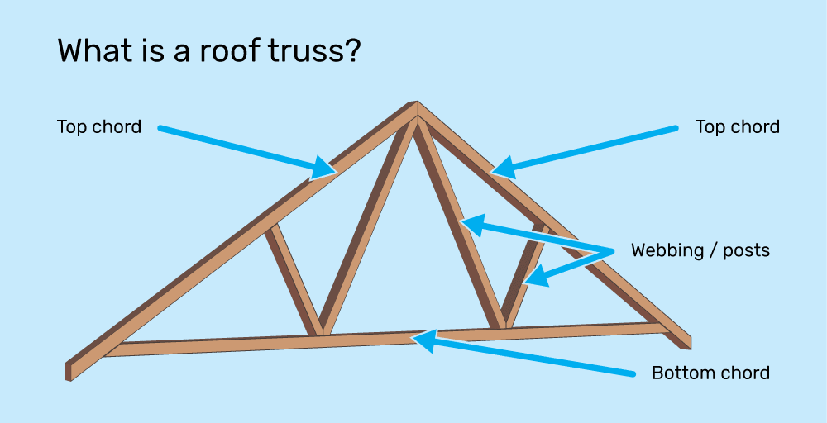

(Rafferty Roof Trusses, 2019)
As roof structures goes you can’t go wrong by using pre-made trusses like these in the picture above, they come in pre-made along with the timber framed walls and floor joists which makes the whole process of constructing a timber frame house very easy and quick and can be assembled in close to 2-3 weeks from my experience of being on site and seeing them being put up.

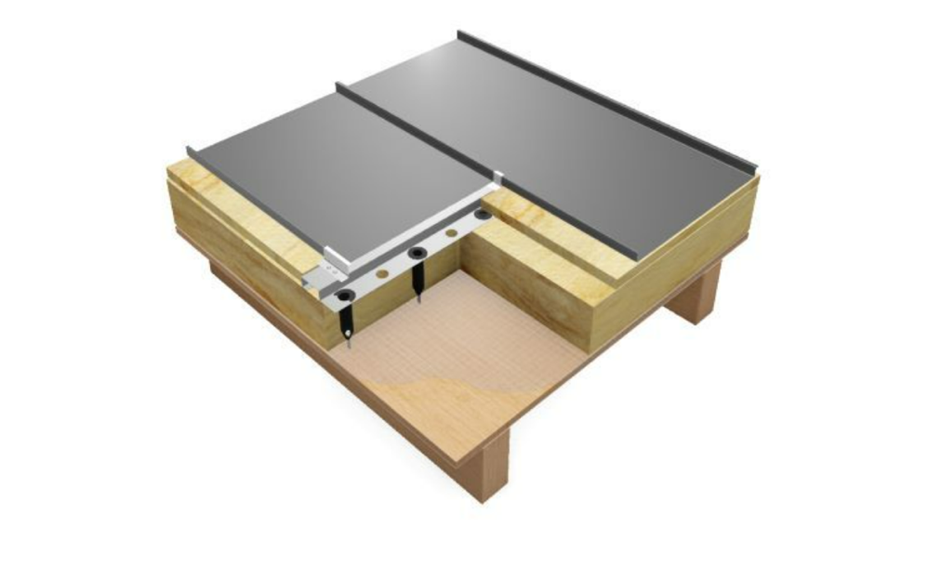

(Euroclad Group, 2019)
In terms of roof structure, you could also look at something like which would use the same sheeting but would contain another layer of insulation at around 150mm which would double the insulation in the roof and therefore giving no need to have insulated plasterboard on the inside.
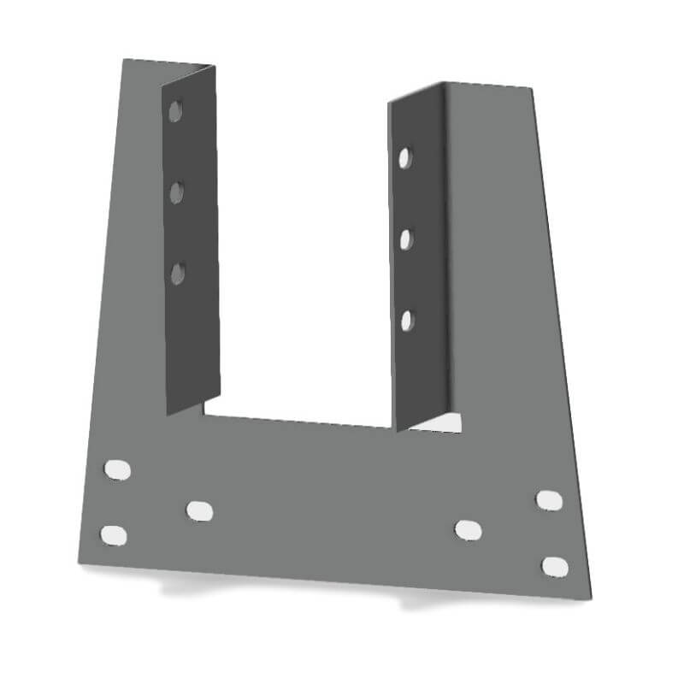

(TC Fixings, n.d)
his image above shows how trusses are fixed to the top plate of a wall, they are called truss clips and come in different shapes and sizes but these are the generic ones I have seen and used on sites in the past. They provide enough strength to hold down the trusses to the main structure of a building and does not allow the trusses to be blown off or move like they would if no clips were to be used. Restraint straps would also provide extra strength to the roof by also tying it into the walls.

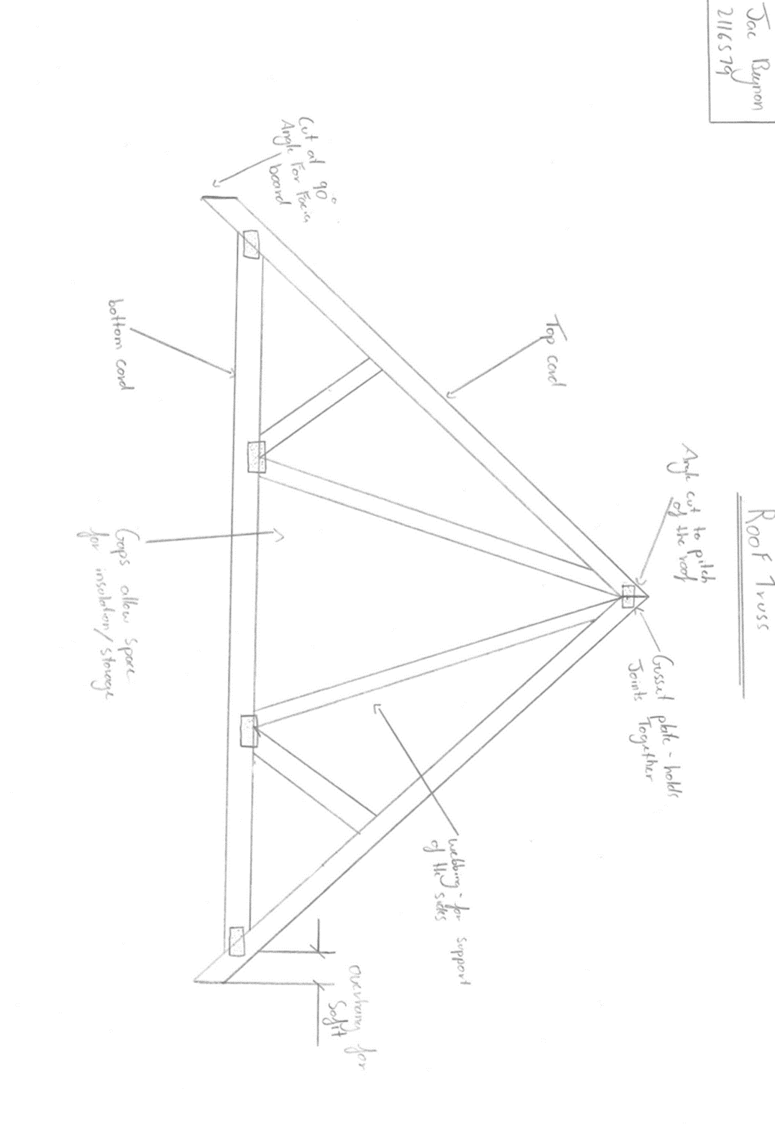

The drawing above shows the detail on the roof trusses which will be used on this house, although the roof is not a standard roof as it runs in many ways the trusses will all be made to a standard and regulations and has to be designed to BS EN 1995-1-1+A2 (shop.bsigroup.com, n.d) this would mean that the trusses are then up to the UK standard and are acceptable to use.

Raft Foundations
Since a ground report was complete and suggested that a raft foundation would be more suitable for this house due to ground conditions I have researched and used my own knowledge in the industry to create a list of the key points which should be noted about a raft foundation.
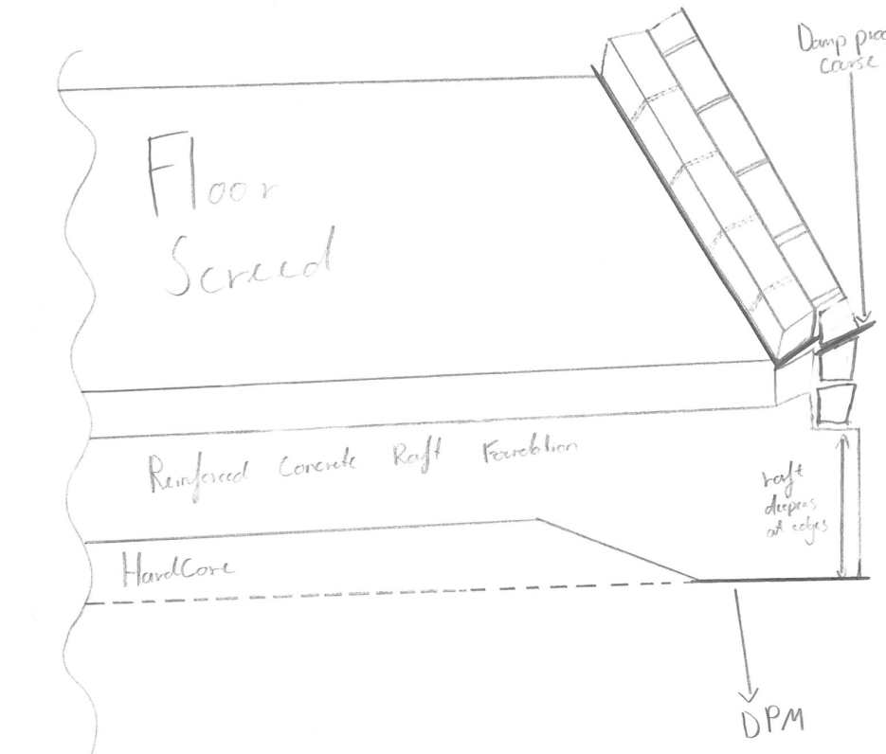

In this sketch above you can see the detail of the raft foundation (although it is not too clear) the raft foundation is more than less a mass poured concrete slab which on the edges of the foundation goes deeper to support the walls which will be built on top of it. This will double if not triple the amount of concrete needed compared to a conventional foundation.

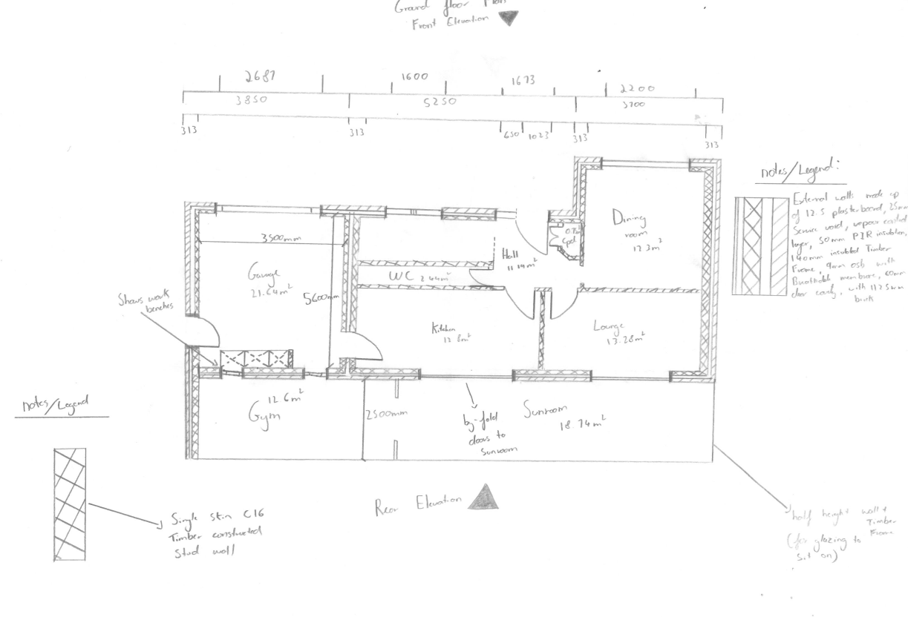
Drawings / sketches
The drawing above shows the construction ground floor plan for the proposed building, I have used my knowledge in materials and building to design a cavity wall layout which should best fit the house and be efficient for the building. Below you can see the cavity wall sketch in more detail with references to where every part of the wall is built up and where each element down to the breathable membrane.
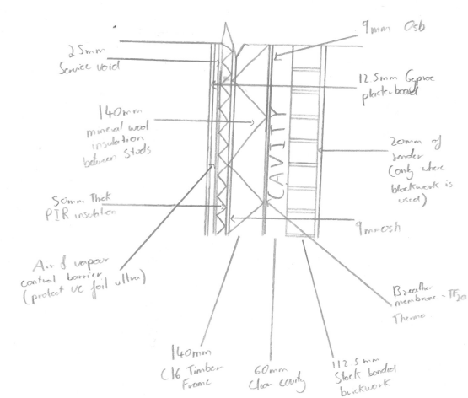

Here you can properly see the detail of the cavity wall which will be used around the house, this should properly insulate the home throughout all weather and allow proper ventilation and limit where heat is lost when the house is getting heated.

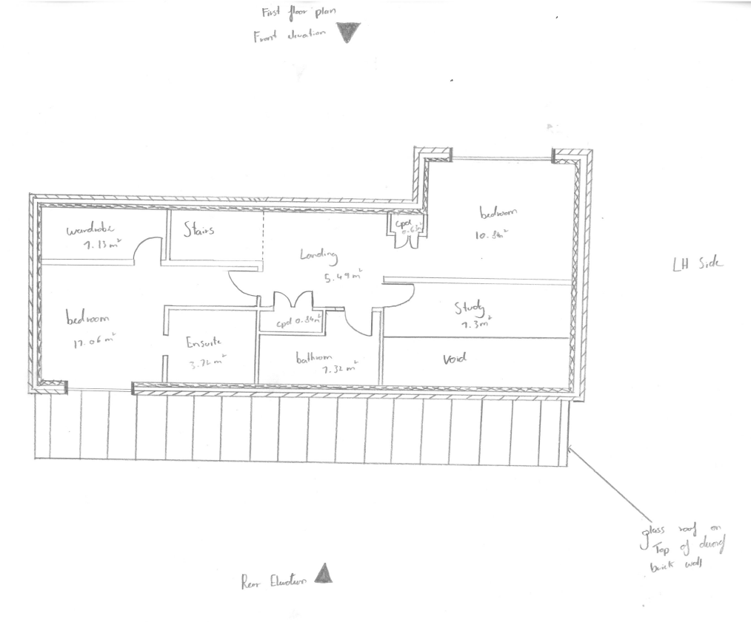

Here is the first floor plan I sketched of the home to again see the wall detail and have a real feel for the area that the house has to offer.

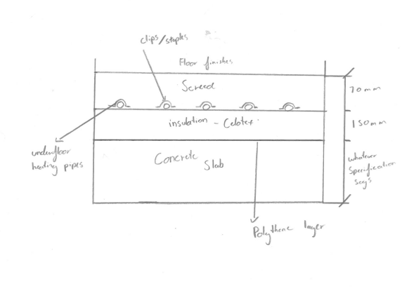
This image here shows the insulated ground floor, with under floor heating which will be covered by a layer of concrete screed to provide a smooth finish for the floor finishes to be applied too.

Reference list
- Euroclad Group (n.d.). Vieo Roof Systems. [online] Euroclad. Available at: https://www.eurocladgroup.com/products/high-level-product-group/roof-systems/vieo-roof-systems [Accessed 21 Apr. 2022].
- G2 structural Limited (n.d.). Structural Design of Cross Laminated Timber (CLT). [online] www.g2structural.co.uk. Available at: https://www.g2structural.co.uk/cross_laminated_timber.php.
- HOMAG (2016). High degree of prefabrication allows for top-quality timber frame construction | HOMAG. [online] www.homag.com. Available at: https://www.homag.com/en/news-events/case-studies/detail/high-degree-of-prefabrication-allows-for-top-quality-timber-frame-construction.
- Kiernan, M. (n.d.). Bathroom Pods Vs Shower Pods: The Pros and Cons. [online] blog.advanced-showers.com. Available at: https://blog.advanced-showers.com/bathroom-pods-vs-shower-pods-the-pros-and-cons.
- Ltd, H. (2020). Applications | Modular Construction | Bathroom Pods. [online] www.howickltd.com. Available at: https://www.howickltd.com/modular-construction/bathroom-pods.
- Rafferty roof trusses (2019). What You Need to Know About Different Roof Truss Styles. [online] www.raffertyrooftrusses.co.uk. Available at: https://www.raffertyrooftrusses.co.uk/what-you-need-to-know-about-different-roof-truss-styles [Accessed 21 Apr. 2022].
- shop.bsigroup.com. (n.d.). Loading... [online] Available at: https://shop.bsigroup.com/products/eurocode-5-design-of-timber-structures-general-common-rules-and-rules-for-buildings/standard [Accessed 27 Apr. 2022].
- Spanwright UK ltd (n.d.). Prestressed Wall Panels, Precast Concrete Walls. [online] SpanWright. Available at: https://www.spanwright.co.uk/product/prestressed-wall-panels/.
- Sutton, A., Black, D. and Walker, P. (2011). CROSS-LAMINATED TIMBER An introduction to low-impact building materials. [online] Available at: https://www.bre.co.uk/filelibrary/pdf/projects/low_impact_materials/IP17_11.pdf.
- TC Fixings (n.d.). Buy Simpson TCP Truss Clips | TCP50 Speed Prong Truss Clips 50mm. [online] www.tcfixings.co.uk. Available at: https://www.tcfixings.co.uk/product/simpson-tcp50-speed-prong-truss-clips-50mm/9974 [Accessed 23 Apr. 2022].
- the strong-tie blog team (2019). What You Should Know About Cross-Laminated Timber Construction. [online] Building Strong. Available at: https://blog.strongtie.com/what-you-should-know-about-cross-laminated-timber-construction/.
- Willmott Dixon 2022 (2022). Off-site manufacturing. [online] Willmott Dixon. Available at: https://www.willmottdixon.co.uk/expertise/off-site-manufacturing

