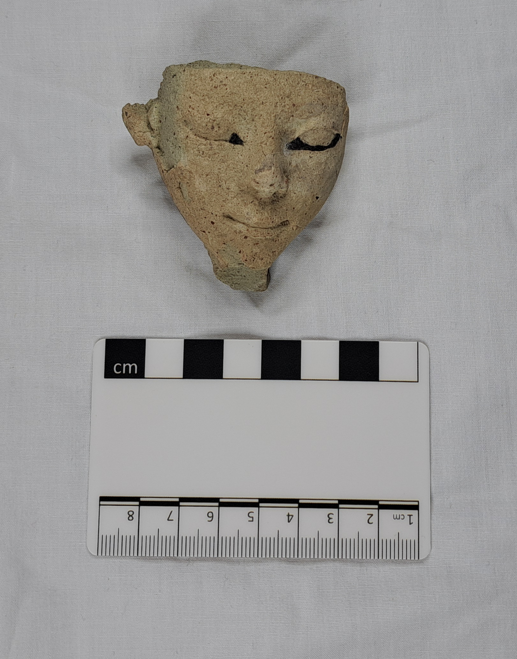 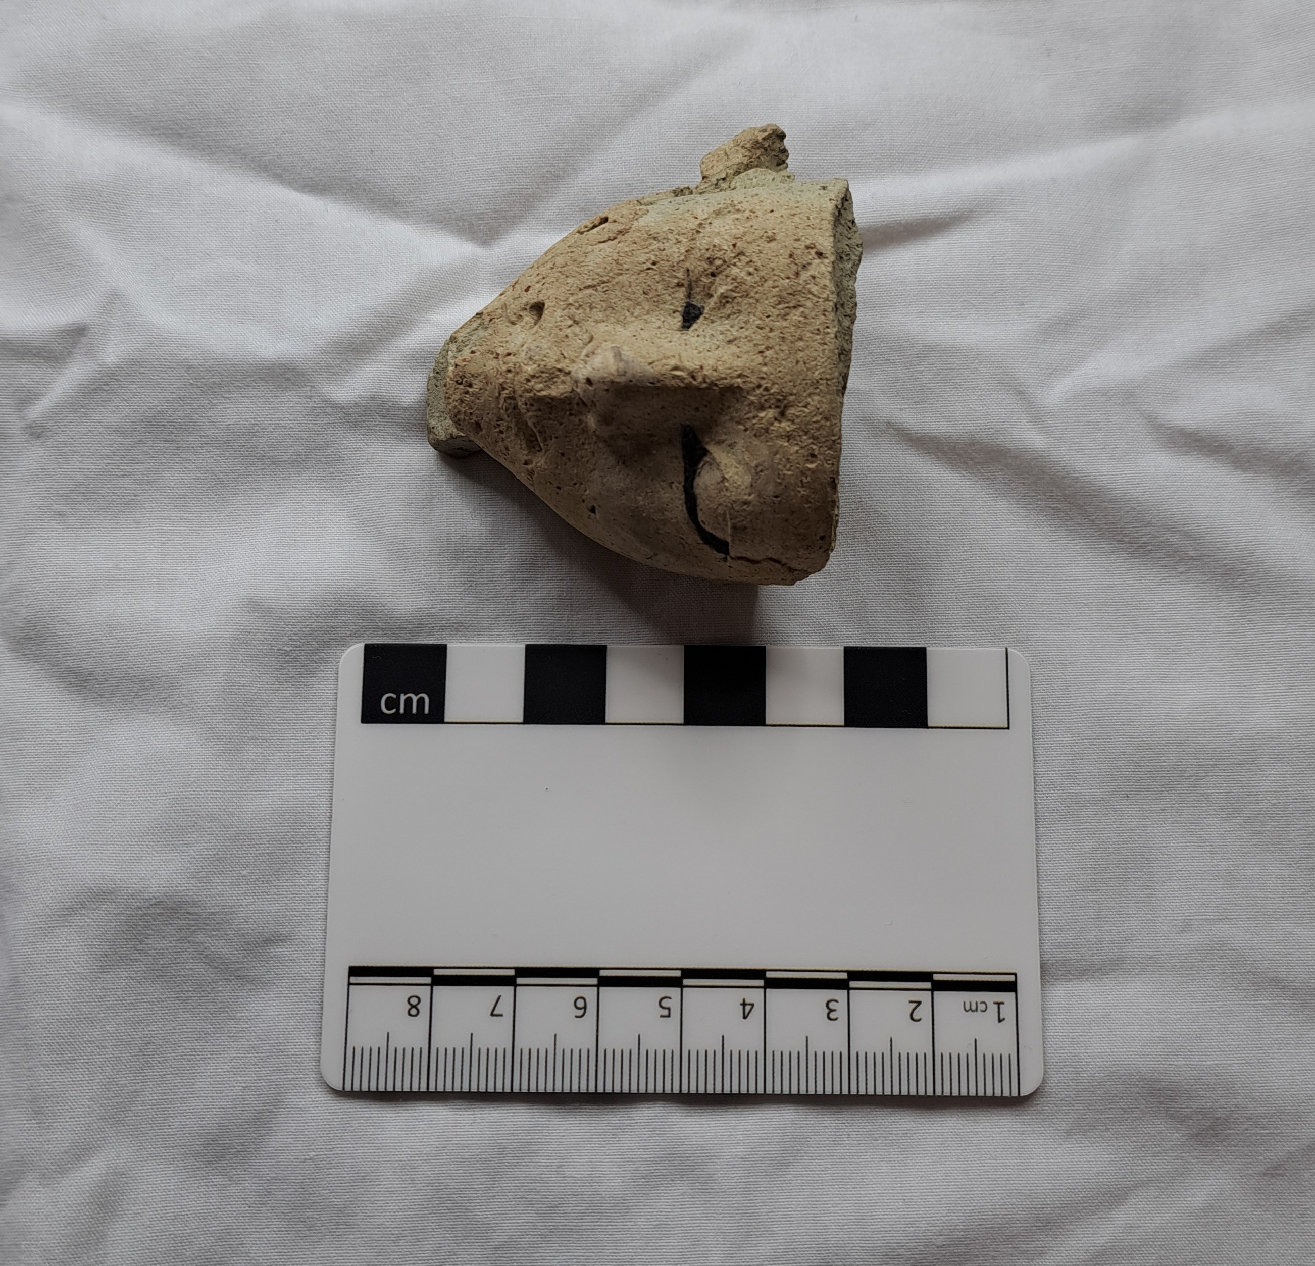 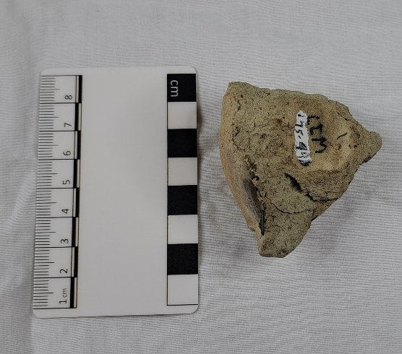
(personal, 2025)
Human Head
Cyfarthfa Castle, Myrthyr Tydfil CCM 175.996
Object Type: Mummy mask
Material: Marl A3 clay
Period: Middle Kingdom onward
Provenance: Egypt
Dimensions: Height: 5.7cm / Width; 5.7cm / Depth: 4.2cm / Groove; 1.7cm / Protruding Back #1: 2cm / Protruding Back #2: 1cm
Object analysis by Al Williams-Spooner

Description
The object depicted above in the two photographs is a part of a mummy mask. It is believed to be made out of a specific material known as Marl A3 (Arnold & Bourriau, 1993), more specifically theorized to be the subtype known as VB (Rzeuska, 2012). The texture is similar to that of stone and/or smooth sandpaper, while the colour is yellowish-beige with hints of grey and strokes of black paint along the eyelines and on the side of the neck. The artefact is visibly damaged along the top of the head and the front near the chin, as well as along the left side (from looking head-on at it) of the face. There is a groove on the back which is the size of a man’s index finger, and it believed to have been made intentionally to act as a ‘lock-in mechanism’ to attach it to the rest of the mummy mask, which we do not have. The broken front on the chin is believed to have been a beard, which, depending on the shape of it, would have been a key identifier into who the mummy mask belonged to.
When considering its material, we find that Marl A3 is primarily found in the Upper Egypt region from the Middle Kingdom onwards, although it is largely used for pottery vessels. The subtype mentioned above, VB, is a sandy pasted stone-ware that can contain remnants of quartz and feldspar grains which add to its texture. It can also harbour reddish iron oxides particles, which can be seen on the right side of the nose on our artefact. This is in comparison to the VA subtype, which is described as having a greenish colouring (Rzeuska, 2012).
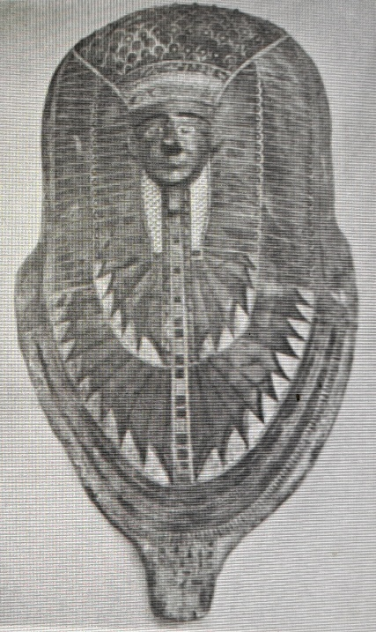
The image on the left is taken from Lythgoe, 1917, where he is discussing findings from Chamber E, Pit 3 in Thebes, particularly the mummy mask found at the east end. It bares remarkable resemblance to the rishi style coffins, which can be dated to the 17th and 18th Dynasties. Lythgoe describes the face as “wedge-shaped” and “no more than a third life size”, which is an accurate description of our artefact’s small dimensions. In the same report the face is detailed with gold, the colour which can represent the skin of the gods (Wilkinson, 1994).
Comparatively, an artefact of similar description is mentioned in Garstang, 1907 and also describes the “miniature” face as being covered with gold leaf. The exact same mask, which was found in tomb 287, is discussed in Dodson, 1998, with similar adjectives used to describe the gilded face, although there are additional details of the tomb that say it was found in possibly a re-used tomb from the late Old Kingdom period, judging by the rock-cut upper chamber. The diagnosed date of the mask itself comes from the surrounding objects it was found with, that being a bowl and a Palestinian-style juglet which can be dated, respectively, to the seventeenth/eighteenth dynasties and the Second Intermediate Period. What also helps date the mask is the polychrome rectangles on the coffin edges, which according to Dodson are reminiscent of seventeenth/eighteenth dynasty.
There are obvious comparative relations in this mummy mask style to that of the rishi coffin designs, which is noted by both Lythgoe and Garstang. The design first appeared in the Middle Kingdom and continued on until the early stages of the 18th dynasty (Miniaci, 2010). Their namesake, “rishi”, is derived from the Arabic word meaning feathered, which is a direct observation of the feathered, anthropoid shaped coffin style that is employed. The use of this style is also noted by Miniaci to be isolated to exclusively non-royal individuals when approaching the New Kingdom era, although the artistic motif of overlapping feathers does crop up in private tombs in later dynasties, but is not counted as the style of rishi.
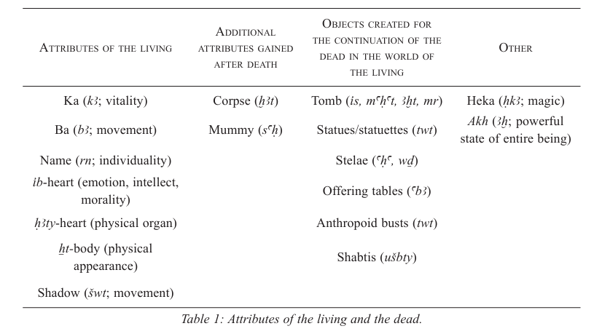
In relation to funerary beliefs, the preservation of the deceased’s body, as well as the ba, ka, and heart is tremendously important, which is where artefacts such as the human head CCM 275.996 come in. The mummy mask reinforces the facial features of the deceased, which correlates with the embalmed mummified corpse acting in place of the Xt-body (Harrington, 2013). In the table below, taken from Harrington, 2013, the purpose of funerary objects is displayed alongside aspects of the deceased’s “soul” and body.

According to the table, the human head CMM 175.996 could fall into the categories of statues/statuettes (twt) and anthropoid busts (twt) and shabtis (uSbty), meaning it could represent one of the three; the ba, the HAty-heart, or the Xt-body.
If the artefact in question was a part of a mummy mask similar to the rishi design, then it would suggest that the face was made not only to represent the individual’s facial features for the afterlife, but also the person’s ba, which is depicted as a bird-like creature with a human head and face. The ba and the corpse are described as interdependent (Žabkar, 1968), meaning that they are solely reliant on each other after death. The ba is also described as the “alter ego” of the deceased individual, which is in comparison to the Shadow that is often described as having a “close affinity with the ba” (Harrington, 2013).
This particular style of mummy mask did not seem to be widely used, or at least not permanent in Ancient Egyptian funerary spheres. Faces have been found that resemble the mummy mask, one account being from Mirgissa in Nubia (Dodson, 1998) where they discovered 50 that shared qualities of the human head CCM 175.996, but none were an exact match. This suggests that this style of mummy mask was possibly experimental and not continuously practiced.

Bibliography
- Arnold, D. & Bourriau, J. (1993). An Introduction to Ancient Egyptian Pottery. Philip Von Zabern [Accessed: 25 October 2025]
- Dodson, A. (1998) “A Funerary Mask In Durham and Mummy Adornment In the Late Second Intermediate Period and Early Eighteenth Dynasty,” The Journal of Egyptian Archaeology. Egypt Exploration Society. [Accessed: 25 October 2025]
- Garstang, J. (1907). The Burial Customs of Ancient Egypt as Illustrated by Tombs of the Middle Kingdom. London, Archibald Constable & Co. Ltd. p. 174-177 [Accessed: 25 October 2025]
- Harrington, N. (2013). Living with the Dead: Ancestor Worship and Mortuary Ritual in Ancient Egypt. Oxford, Oxbow Books [Accessed: 26 October 2025]
- Lythgoe, A.M., Lansing, A. and Norman (1917). The Egyptian Expedition 1915-16. Metropolitan Museum of Art Bulletin, 12(5), pp.1–1. doi:https://doi.org/10.2307/3253911. [Accessed: 26 October 2025]
- Miniaci, G. (2010). The Iconography of the Rishi Coffins and the Legacy of the Late Middle Kingdom. Journal of the American Research Center in Egypt, [online] 46, pp.49–61. doi: https://doi.org/10.2307/41431569. [Accessed: 25 October 2025]
- Rzeuska, T.(2012). Grain, water and wine. Remarks on the Marl A3 Transport-Storage Jars from Middle Kingdom Elephantine. [online] Academia.edu. Available at: https://www.academia.edu/1512978/Grain_water_and_wine_Remarks_on_the_Marl_A3_Transport_Storage_Jars_from_Middle_Kingdom_Elephantine [Accessed 25 October 2025].
- Wilkinson, R. H., (1994), Symbol and Magic in Egyptian Art, London, Thames and Hudson Ltd
- Žabkar, L. V. (1968), A study of the ba concept in ancient Egyptian texts. Chicago, University of Chicago Press.

